Smartline Gas versus Heat-Pump Household Comparison
Group4
MTHM604 Project

1 THE CHALLENGE
One approach to decarbonising home heating in the United Kingdom (UK) involves convincing millions of households to swap gas boilers for air-source heat pumps (ASHPs). For this change to happen, ASHPs’ advantages should be supported by substantial empirical evidence [1, 2]. The Smartline project made such evidence accessible as it fitted social-housing units across Cornwall, logged their energy use so that homes heated by gas can be compared with homes heated by ASHPs [3]. In Group4's previous attempt, we extracted a pair of homes from Smartline, both of which were similar in size, occupancy, property type and fuel-poverty status. We concluded that the ASHP home's electricity consumption stayed nearly flat throughout the year and that its bills were lower than its gas-heated counterpart's. This report audited the team’s attempt on the same Smartline data to see if its findings remained solid.
2 DATA SOURCE
All data came from the Smartline project [3], which fitted around 300 social-housing units in Cornwall with environmental and energy sensors recording at minute resolution [4]. Group4 extracted a 28-home covariate table from Smartline's survey and metadata, which included 16 gas-heated homes and 12 using ASHPs. From each home, the table recorded household size, fuel-poverty indication, property type, number of rooms, SAP energy rating, and sensor identifiers. We also produced a monthly energy table for the selected pair. It covered 26 months of data (May 2018 to June 2020), including gas readings in cubic metres and kWh, plus electricity for the gas home (UPRN 111), and electricity alone for the ASHP home (UPRN 15). The team built this table by summing Smartline's minute-level data points, which created an aggregation that smoothed over dropouts and error spikes in the raw data.
3 DATA ANALYSIS AND MODELLING METHODS
Reanalysis brought up four issues with Group4’s attempt. Firstly, we converted gas volume to energy with a factor of exactly 11.0, whereas the statutory conversion produced the value 11.221 [5]. Recomputing adds a 2% correction. Secondly, the costs columns multiplied the gas unit price by cubic metres rather than kWh, understating gas costs roughly elevenfold. Thirdly, SAP ratings were missing for 8 of the 12 ASHP homes, so insulation quality was never factored in the matching. Lastly, the raw minute-level files were not archived alongside the extracts, which limited how far anomalies could originally be traced.
This report’s pipeline had six steps, designed to run checks on Group4’s analysis and see whether its findings stand. The last limitation is resolved directly when the raw files are mounted into the rerun pipeline.
The starting point was a methodological audit of the selected gas/ASHP home pair, the monthly energy extract, and the cost spreadsheets. Four questions came up. Firstly, was this pair a good match among the recorded Smartline homes? Secondly, was the ASHP home's recorded electricity physically credible, especially during winter months when consumption is expected to peak? Thirdly, were the two homes’ bills computed on comparable terms since the gas home's bill combines gas and electricity while the ASHP home's is electricity alone, so the gas component must be priced on energy delivered (kWh) and not metered volume? Lastly, if the gas home's measured heat demand were met by a field-typical ASHP, what would be the resulting electricity use, cost and carbon?
Step 1 drew tidy tables from the two spreadsheets, then applied the statutory gas conversion, and logged any necessary corrections.
Step 2 audited the group’s comparison. Since comparison of matched pairs is only solid if the agreed recorded covariates between both can plausibly drive energy use, we cross-examined the 16 gas homes with the 12 ASHP homes and counted all combinations having all four usable covariates, which included household size, fuel poverty, property type and rooms. SAP data was too incomplete to be used [6]. The audit showed where our pair stood among the possible comparisons. Both UPRN 111 and 15 matched by fuel poverty, which remained significant in shaping heating behaviours [7].
Step 3 included descriptive analysis, covering a full 26-month data extract from Smartline, but focus was on the 24-month set forming two complete June-May yearly cycles, and each home’s seasonal analysis. Three quantities would run through the rest of the report. The summer baseline, which was average consumption from June to August. In these months, gas was used mostly for cooking and hot water since heating was off. Electricity usage was mostly for everyday appliances. The seasonal swing was the winter minus summer mean. Thus, the energy used monthly for heating would be the amount above that summer baseline.
Monthly resolution was considered to reflect the seasonal effect, and summing to months would smooth out sensor noise the same way Group4 did. Here, a small harmonic model was fitted to the gas home's monthly gas use with four parameters, including an intercept, a linear trend and one annual sine/cosine pair. Since two years of complete data remained insufficient for forecasting, ARIMA or SARIMA forecasting was no longer included. It would not serve to draw practical comparisons in actual energy use. The harmonic curve was used to visualise how regular the gas home's annual heating cycle was, thus making the absence of any such cycle in the ASHP home's electricity stood out.
Step 4 included a physics consistency check on the ASHP home. The homes were matched, so suppose the ASHP home needed some fraction f of the gas home's space heat. The gas burned above the summer baseline went to heating, assuming 85% of that turned into useful heat. We called that heat H(m). A heat pump doing the same job at a Coefficient of Performance (COP) of c produces c units of heat for every unit of electricity, so covering a fraction f of that heat would cost f·H(m)/c in electricity, on top of whatever the ASHP home's appliances already use. Read the other way round, the winter rise in the meter tells us either the COP the pump would need if it were heating as hard as its counterpart, or how little of that heat it was actually supplying if its COP was ordinary (benchmarks for seasonal COPs clustered near 2.7–3.0 in the largest UK field trial [8], and around 2.6-3.3 across a meta-analysis of European trials [9]). Domestic heat demand was strongly and predictably seasonal [10], which would make its absence from a meter noticeable. So an implied COP ten times these values did not point to an exceptional heat pump but rather to a meter that was not reading the heat pump, or a home that was scarcely heated. A result this surprising needed closer examination.
Step 5 focused on the two-year analysis, dropping the partially complete data in the third year and gas data in May 2018, leaving two complete June–May years in 2018–19 and 2019–20. With only two seasonal years, permutation tests were dropped since shuffling month labels treated months as exchangeable while they actually came with inferred weather conditions. The winter-minus-summer contrast was reported separately for each complete year. The gas home should show a large winter rise, and the ASHP meter should show a comparable heating signal if it has a working heat pump.
Step 6 looked at the economics from consumption data. Prices for the first complete June-May year were at the January-to-March 2024 Office of Gas and Electricity Markets’ (Ofgem) cap, which included 28.62p per kWh for electricity, 7.42p for gas, plus both standing charges [11]. Steps 4 and 5 had already knocked out the bill comparison between the paired homes, so the question asked instead was what would happen if the gas home switched to ASHP. Its measured gas became useful heat at 85% boiler efficiency, then delivered the same heat at the field Seasonal Performance Factor (SPF) of 2.9 [8], through the home's own electricity meter, with the gas standing charge dropped. This drew comparison between a home and itself, removing all between-household confounders. It was assumed that all gas actual uses were electrified at the same SPF, which could be quite generous for hot water and cooking. Capital and installation costs would be considered out of scope since the focus should be on running costs. And the ASHP home's meter had proven not to produce reliable data. The break-even point for making the switch was a division of SPF by boiler efficiency 2.9/0.85 = 3.41. This means if electricity costs more than 3.41 times as much as gas per kWh, the heat pump is dearer to run. Below that, it is cheaper. The analysis put boiler efficiency at 85%, SPF 2.5-3.5, electricity to gas price ratio 3.0-4.5, and converted this consumption into carbon within standard UK emission factors, 0.183 kgCO2e per kWh of gas and 0.207 per kWh of grid electricity [12].
4 RESULTS

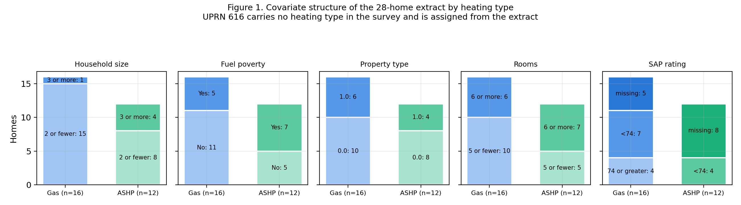

The cohort audit (Fig. 1) shows a usable but lopsided extract. Gas homes skew small, with 15 of 16 having two or fewer occupants, while 4 of the 12 ASHP homes had three or more. Fuel poverty was more common on the ASHP side, 7 of 12 against 5 of 16 gas homes. SAP ratings were recorded for 11 of 16 gas homes but only 4 of 12 ASHP homes, so insulation quality could not be included in the matching. Crossing the two groups on the four usable covariates (household size, fuel poverty, property type and rooms) gave us 11 candidate pairings. UPRN 111–15 was the pair our previous attempt selected, and one of four where both homes were recorded as fuel-poor. The design was legitimate. It was not, however, the only option available. Group4 never checked the ten other pairings matched on the same four covariates.
The contrast between the two homes (Figs. 2 and 3) was stark. The gas home's total metered energy averaged 959 kWh a month, but its winter months ran 1,053 kWh above its summer ones, giving a winter/summer ratio of 3.5. Its highest month was January 2019, at 1,838 kWh. Its lowest in the complete years was August 2019 at 290. Gas alone carried nearly all of that movement, swinging 1,020 kWh across the year. The ASHP home's electricity averaged 248 kWh a month, with a winter/summer ratio of 1.06 and a swing of 14 kWh.

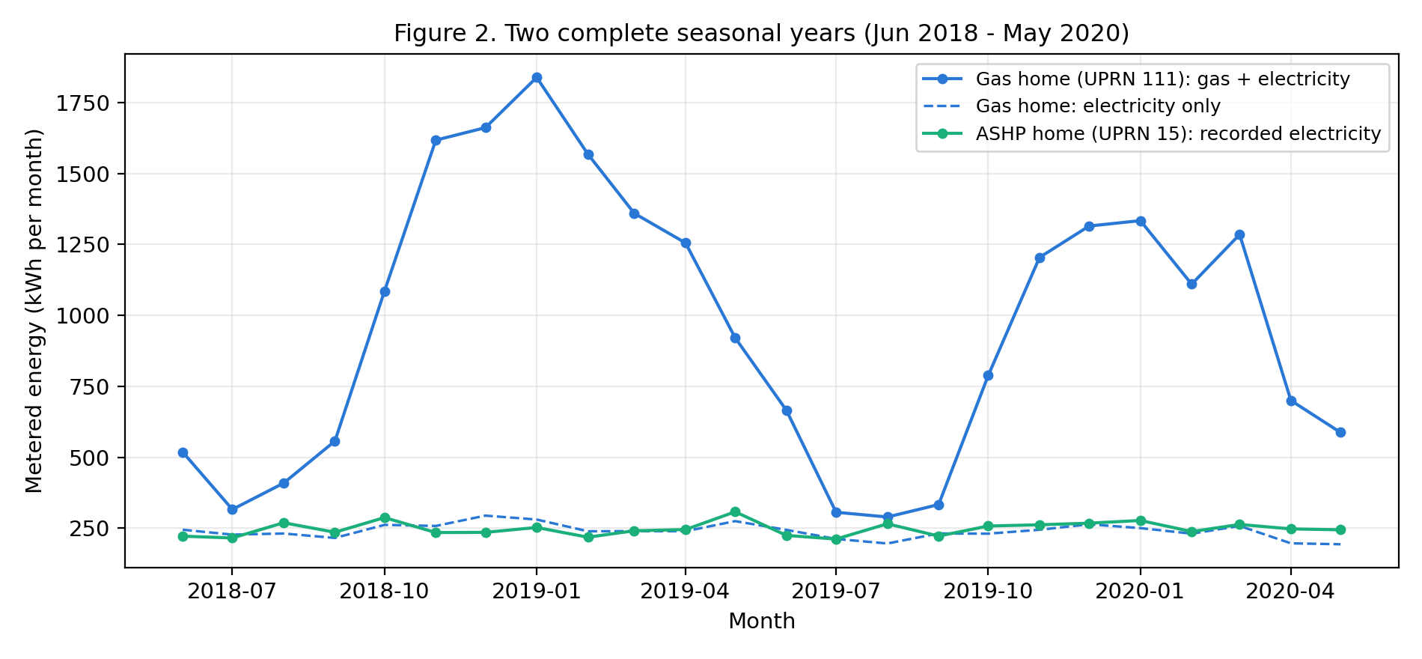
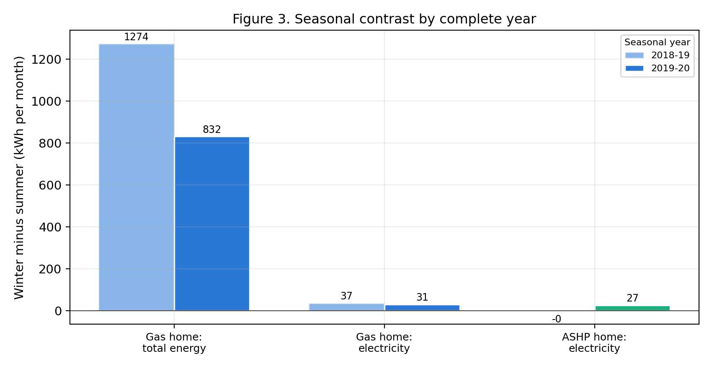

Most importantly, the ASHP home's winter uplift was lower than the gas home's own electricity uplift of 34 kWh. So the home whose heating supposedly ran on electricity responded to winter peaks less than the home whose heating runs on gas. That 34 kWh deserved a second look. It was to reflect lighting, appliances and central-heating pumps working harder in winter. The home that supposedly made its heat from electricity showed barely a third as much. Whatever was going on with UPRN 15's meter, these numbers did not describe a household comfortably heated through a Cornish winter.

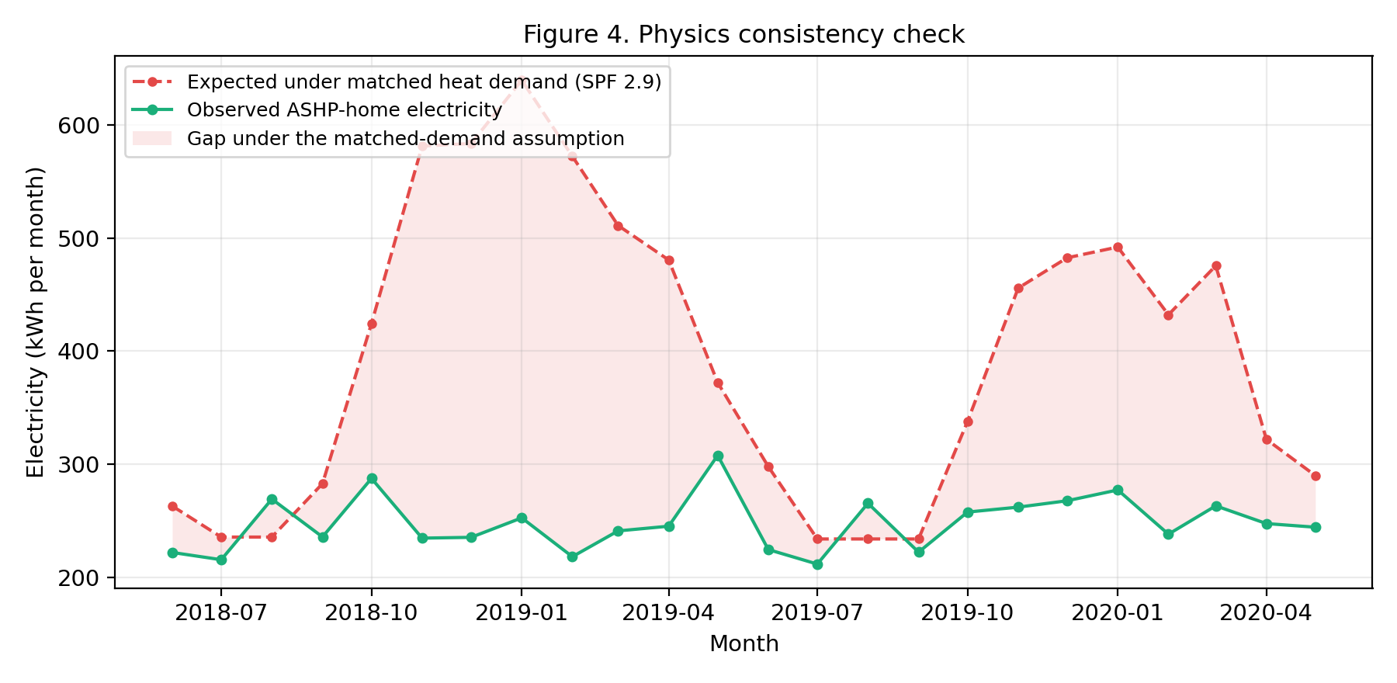
Figure 4 shows the physics check. From June 2018 to May 2019 the gas home delivered about 6,789 kWh of useful heat in the spreadsheet extract. If the ASHP home had needed the same heat at a field COP of 2.9, its January electricity should have risen by about 404 kWh above its baseline. The observed rise was only 22 kWh.
The implied COP (the efficiency a heat pump would need for this much uplift to deliver that much heat) had a median of 30.6 over the 18 core heating months, never dropped below 13.7, and showed no uplift at all three further months. Field trials’ records were at 2.7-3.0 [8]. Equivalently, at COP 2.9, the observed uplift covers 6.9% of the heat the gas home needed.
The raw data rerun had to confirm this, which it did, with a smaller margin. The seasonal swings matched the spreadsheet closely. The gas home's gas-only seasonal swing was 1,020 kWh from the group's spreadsheet and 1,020 kWh from the rerun. The implied COP fell to a median of 22.1, minimum 5.5, with the uplift covering 9.0% of the matched heat need. A median of 22 is still around eight times field performance [8], so our conclusion held. The lower minimum only means one shoulder month came close to plausible.
There are three possible explanations. Firstly, the home was severely underheated, as fuel poverty was indicated in surveyed responses. Even a quarter of its counterpart's heat need would demand three times the observed uplift. Secondly, the heat pump might sit on a separately metered circuit that Smartline never captured. Thirdly, the sensor might be faulty. We cannot tell these apart from the data. And under any of the three explanations, the previous attempt's bill comparison cannot work.
The same gap appears in both complete years. In June 2018–May 2019, the gas home's consumption rose by 1,274 kWh between summer and winter, a ratio of 4.07, while the ASHP home barely changed, only by −0.2 kWh. In June 2019–May 2020, the gas home’s still rose by 832 kWh, a ratio of 2.98, against the ASHP home's 27 kWh and a ratio of 1.12. The conclusion did not depend on a significance threshold. Even if every ASHP uplift were real, it was far too little to supply the heat the gas home implied. No p-value could change that.

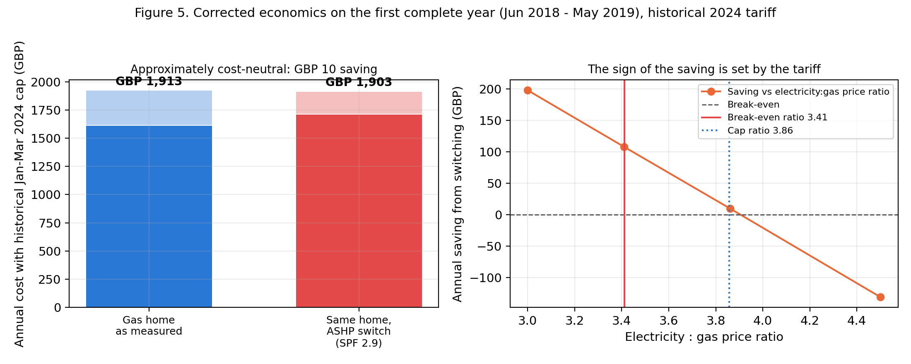

The economics of the switch (Fig. 5) needed to be revisited due to our group’s mistake. Our previous sheet multiplied the gas unit price by cubic metres instead of kWh, which understated the annual gas charge roughly elevenfold, making gas too cheap an option in the cost discussion.
Repriced at the 2024 cap, the gas home's fuel and standing charges over the first complete June–May year came to about £1,913. So the same home, running on ASHP instead of gas at SPF 2.9, would have paid £1,903 in energy bills, which could be considered cost neutral instead of saved expenses.
Electricity at the cap costs 3.86 times as much as gas per kWh, above the 3.41 threshold at which the two fuels cost the same, so the ASHP fuel slightly costs more, but the home no longer pays the £108 gas standing charges. With that charge gone, the whole bill only reaches break-even at a ratio around 3.9. How much this matters depends entirely on the effect of an existing tariff. At a price ratio of 3.0, the same home saves about £198 a year, and at 4.5 it loses about £131. Across boiler efficiencies of 0.75-0.90 and SPF values of 2.5-3.5, the annual result ranged from £183 dearer to £238 cheaper. For fuel-poor households, the implications from this report’s findings are of their dependence on the tariff.
The matter of carbon is less equivocal. The switch cuts heating emissions from about 2.47 to 1.24 tCO2e a year, a 50% cut at any of these prices, and the figure improves as the grid decarbonises [12].
The rerun also sanity-checked the switch against more than one home. Applied to the 12 of the 16 homes in Smartline's gas subset with usable electricity readings, at SPF 2.9, the same conversion raised each home's electricity consumption by about 75%, with multipliers of 1.15-2.67 and a median of 1.78. Our pair was within that range, so this case was not an outlier.
5 CONCLUSION
This report set out to deepen our group's previous analysis and improve on it. The matched pair remained a plausible choice (UPRN 111 and 15 both agreed on every usable covariate), but the group observation did not. Taken at face value, the ASHP home's flat electricity implied a heat pump running at a COP around 31 from the spreadsheet extraction, and still near 22 when the rerun drew from raw sensor data, roughly seven to eleven times anything field trials recorded [8, 9]. Across the two complete June-May years, the gas home showed a large winter increase in energy consumption while the ASHP home's levels stayed close to its summer baseline. The cause could be a separately metered circuit, severe under-heating in a fuel-poor household or a faulty sensor. Whichever it was, the flat line told us more about the meter than about the economics of swapping gas for ASHP heating. And the bill gap our group previously produced was proven unreliable.
Repriced at the 2024 Ofgem cap rates, switching this gas home to a heat pump comes out cost-neutral, about £10 a year in its favour. This outcome hung on the electricity-to-gas price ratio, in which the break-even point was 3.41, and the cap was 3.86. Additionally, the switch halved the home's heating carbon emissions either way.
We found a factor-of-eleven costing error in our group's spreadsheets. Additionally, the auditing of the pair selection produced ten other compatible pairings that were never examined in the group’s extract. We replaced the two-household bill comparison with a comparison of the gas home against itself, before and after a switch. We kept the small harmonic model (Fig. 6) as an optional extension, since it showed heating demand following a regular annual cycle. And ARIMA and SARIMA were left out, as with only two complete seasonal years, they would add nothing the argument needs. The spreadsheet extract and the raw-data rerun produced almost the same seasonal contrasts (gas-home totals being 1,289 and 1,274 in year one, 822 and 832 in year two, respectively), which upheld the group’s original extraction. However, this adjusted the implied COP median from 30.6 to 22.1.

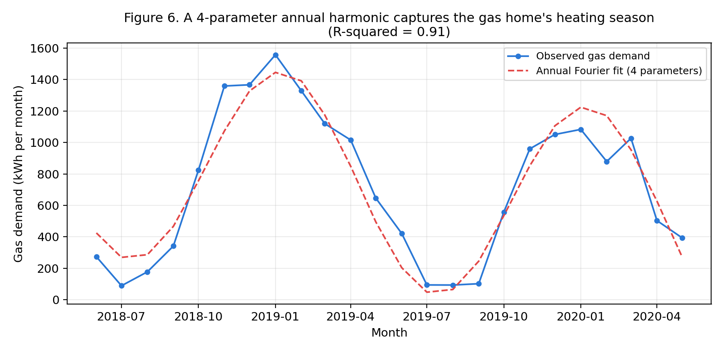
6 LIMITATIONS
The principal conclusions rested on one pair of homes and 24 complete months, with the wider 26-month extract used only as a cross-check. The ten other compatible pairings in our extract should go through the same pipeline, turning a single example into a set of comparisons. The 12 usable homes in the gas subset gave a hint of what that would look like, with switch multipliers between 1.15 and 2.67. Monthly figures can be a good fit, but they could not account for the hourly patterns that would settle the metering problem directly. A single week of the ASHP home's minute-level winter data, compared with published heat-pump profiles [8], would show at a glance whether a circuit is missing or the home is underheated. There should be installation metadata to indicate which circuits each sensor covers. Furthermore, Smartline's indoor and outdoor temperature data would also allow heat need to be estimated for each home in detail.

