“Київський фаховий коледж зв’язку”

Циклова комісія Комп’ютерної інженерії

**ЗВІТ ПО ВИКОНАННЮ**

**ЛАБОРАТОРНОЇ РОБОТИ №5**

з дисципліни: «Операційні системи»

**Тема: “Знайомство з командами навігації по файловій системі та керування файлами та каталогами”**

Виконав студент

групи БІКС-13

Когут Ігор Святославович

Береза Артем Шихайович

Перевірив викладач

Сушанова В.С.

Київ 2022

**Theme: "Introduction to file system navigation and file and directory management commands"**

Objectives:

1. Gaining practical skills in working with the Bash shell.

2. Introduction to basic file system navigation commands.

3. Learn basic commands for managing files and directories.

|  |  |
| --- | --- |
| Command name | Its purpose and functionality |
| pwd | Determines the location of the user in the file system,  shows the current working directory (print working directory) |
| cd | command with a path to a directory to change your current directory |
| echo | command below to display some other examples of using the tilde as part of the path |
| ls | To list the contents of the current directory |
| -R option | to see not only the contents of a directory, but also the contents of the subdirectories |
| ? | The ? character can be used to match exactly 1 character in a file name |
| [ ] | By using square brackets [ ] you can specify a single character to match from a set of characters. |

**Work progress ( Береза )**

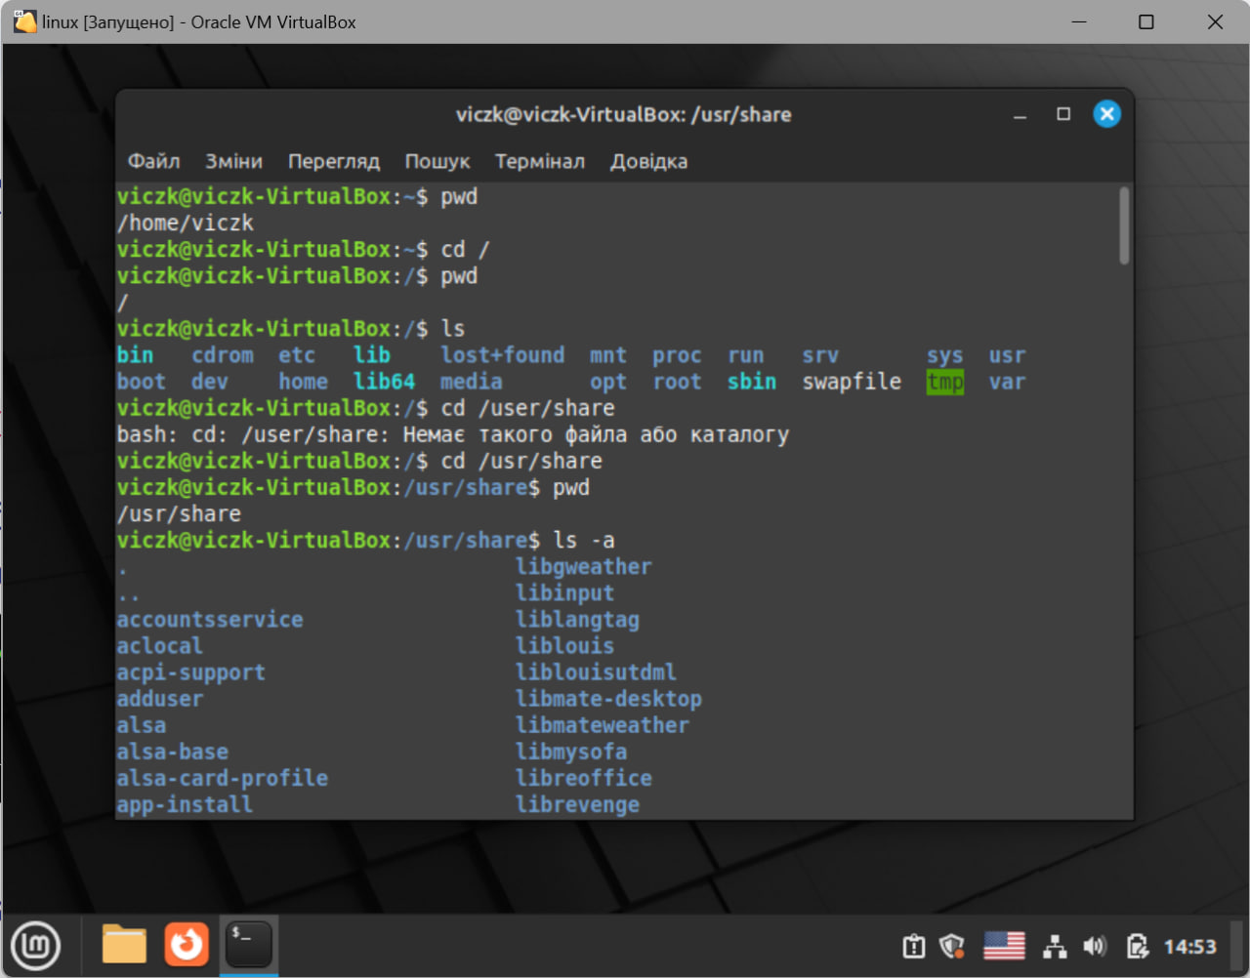

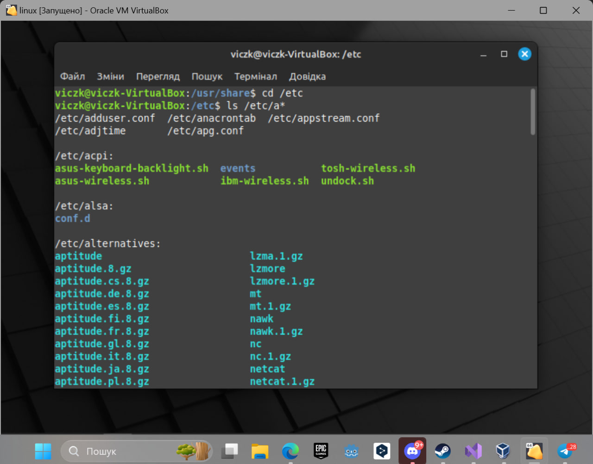

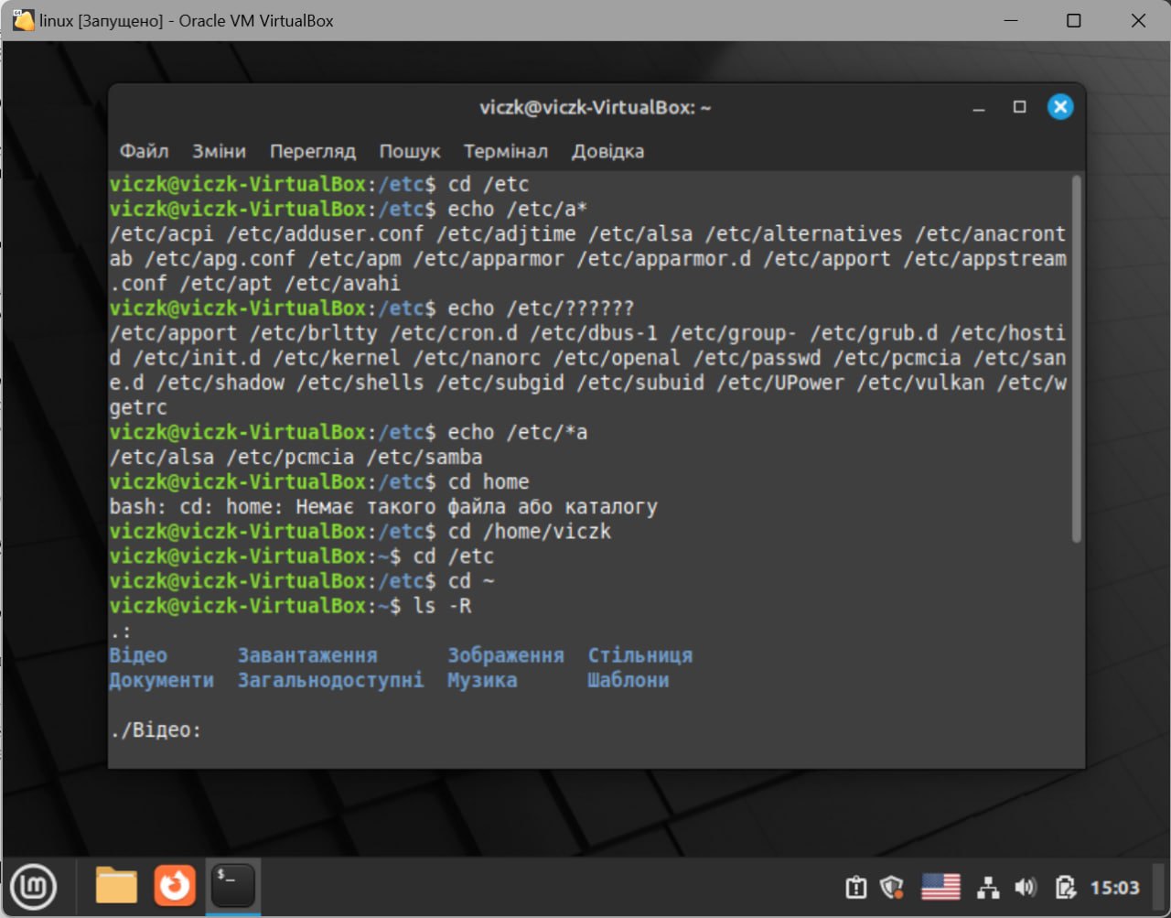

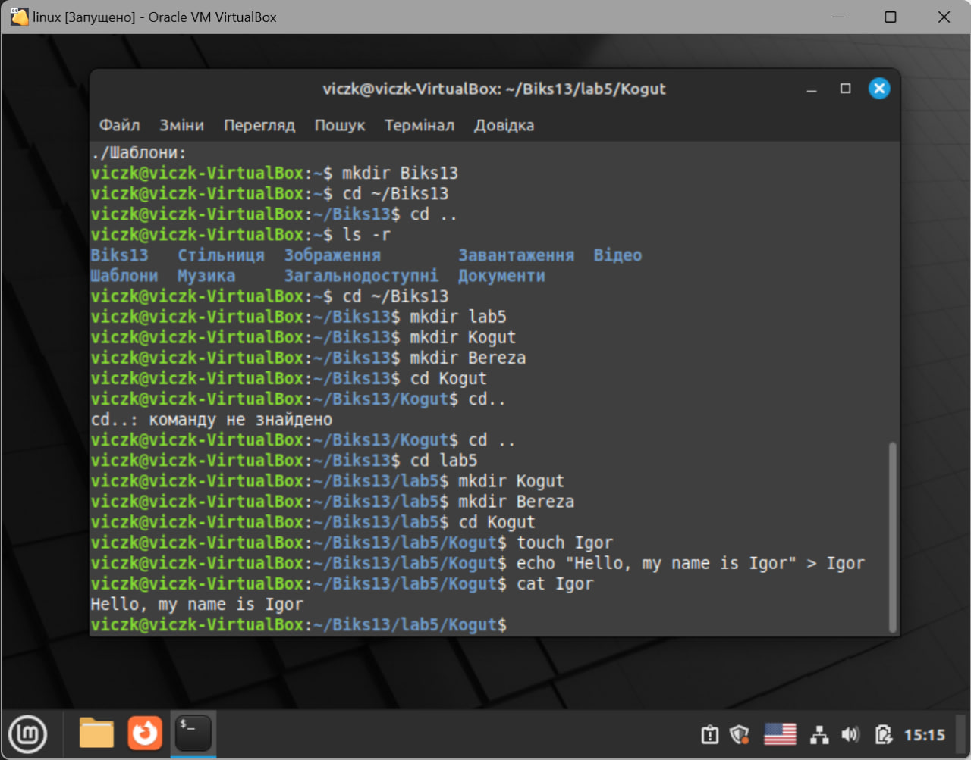

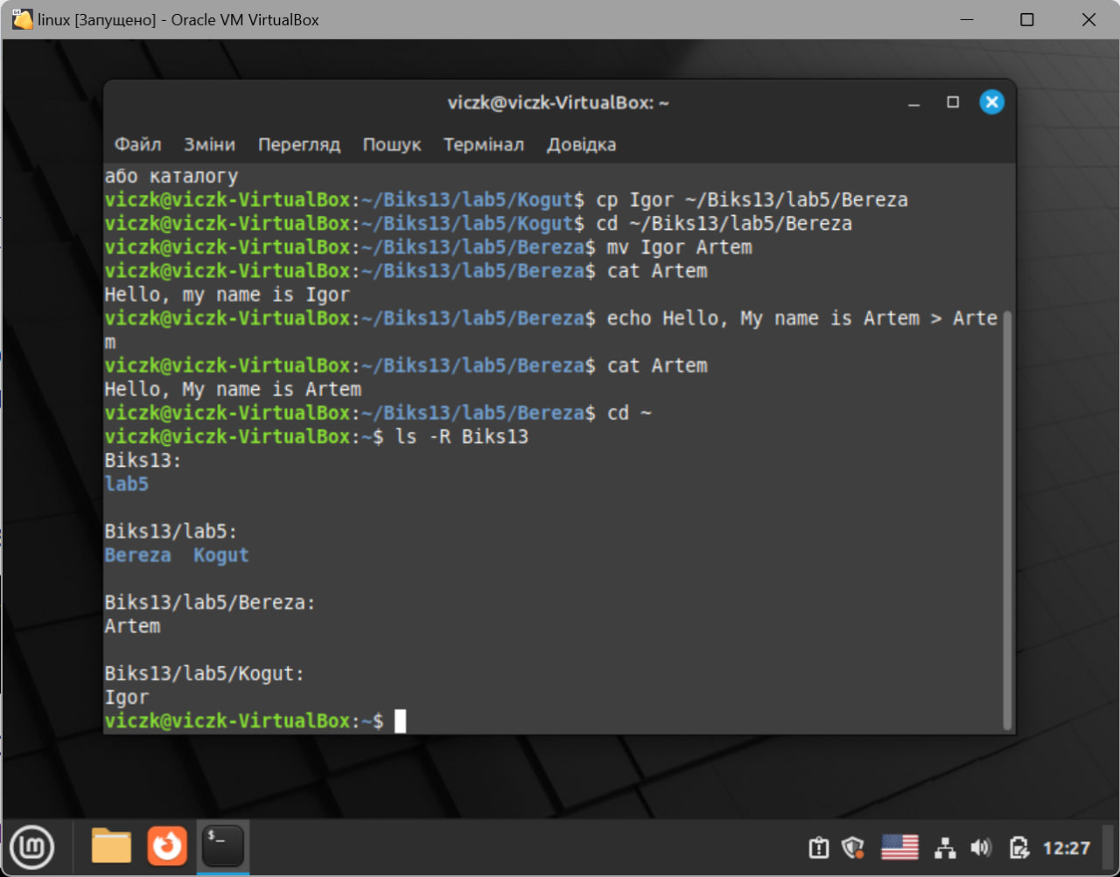

**Control questions ( Когут )**

1. 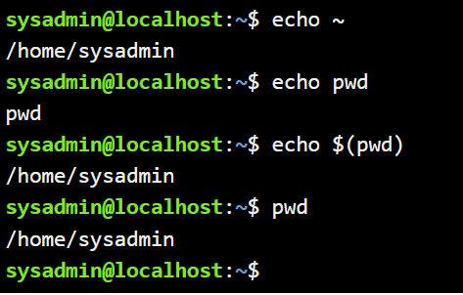
2. 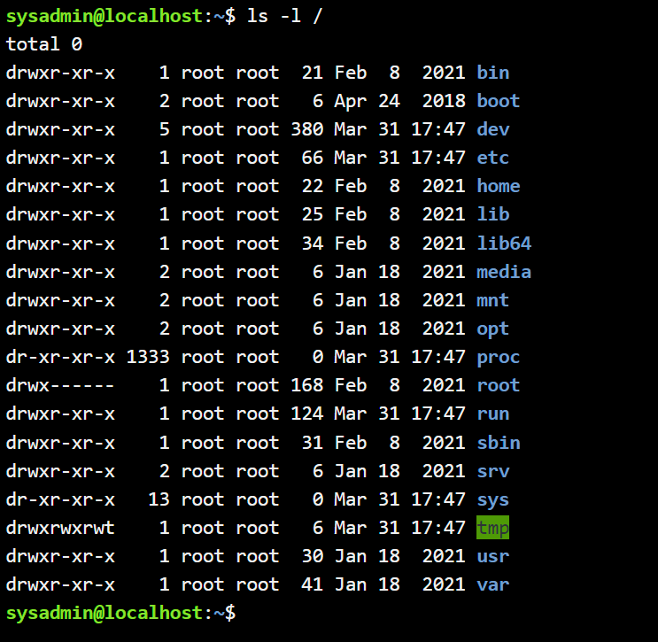
3. 
4. Для копіювання  Для видалення . Yes, if directory have file you need to use “rmdir”, because if you don`t, you remove all file inside.
5. mv /work/tech/comp.png /Desktop: This command moves the file comp.png from the /work/tech directory to the /Desktop directory. The filename remains the same (comp.png).

mv /work/tech/comp.png /work/tech/my_car.png: This command renames the file comp.png to my_car.png within the same directory /work/tech. The file stays in its original location but gets a new name.

mv /work/tech/comp.png /Desktop/computer.png: This command both moves and renames the file. The file comp.png is moved from /work/tech to /Desktop and renamed to computer.png in the new location.

**Conclusion**

We gained practical skills in working with the Bash command shell, learned basic commands for navigating and managing files and directories.