Unit Review
1. Create a concept map that links all of the terms in the list below. Give examples, where applicable, of the various terms.

• cell
• organelle
• diffusion
• concentration
• mitosis
• prophase
• anaphase
• regeneration
• differentiation
• meristematic cells
• tissue
• red blood cells
• meristamatic tissue
• stomate
• mesophyll
• xylem
• phloem
• organ
• capillaries
• organ system
• absorption
• homeostasis
• interdependent
• medical imaging
• public health strategies
• immunization
• DNA screening

Key Concepts Review

Cells are the basic unit of life and often combine with other cells to form tissues.
2. Two basic life functions of cells include waste removal and exchange of gases. Use your knowledge of cell organelles to explain how the cell accomplishes these tasks.
3. Classify the cells below as plant or animal cells, and explain your thinking.
5. Describe the sequence of events that occur in the cell cycle.
6. Explain how mitosis ensures genetic continuity from cell to cell in an organism.
7. Explain the importance of mitosis for the growth of cells and the repair of tissues.
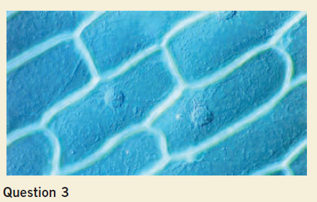
8. Describe each of the various stages in mitosis.
9. How do cancer cells differ from normal cells? Give three differences.
10. Describe the structure and function of meristematic tissue in a plant.
11. A tissue is a group of cells that work together to perform a function. Use an example from a plant and an animal to illustrate that definition.

An organ consists of groups of tissues and works with other organs to form organ systems.
12. (a) Give an example of the tissues found in a plant organ.
(b) How do the tissues help the organ function?
13. (a) Give an example of the tissues found in an animal organ.
(b) How do the tissues help the organ function?
14. An organ system is a group of organs that work together to perform a function. Use an example from an animal to illustrate that definition.
15. Describe how the integumentary system responds to various changes in the environment.
17. Explain the role of the diaphragm in the process of inhalation and exhalation.
18. (a) Describe the structure of the heart.
(b) Explain how its structure enables the heart to pump blood effectively.
19. The skin is an organ that is made of several tissues.
(a) What are the functions of the skin?
(b) Explain how the tissues interact together to enable the organ to perform its required functions.

Advances in biological technologies have an impact on individuals and society.
21. Why is the MRI scan such a popular diagnostic tool?
23. Use an example to help explain how a vaccine can be used to prevent or control the development of disease.
24. Describe how lifestyle choices can affect your health.
25. Describe some of the effects of tobacco smoke on the systems of the human body.
26. Describe some simple lifestyle changes that Ontarians can make to lessen the threat of acquiring West Nile virus.
27. Explain how gene therapy may be used to treat or prevent disease.
31. Using a city as an analogy for a cell, suggest aspects of a city that perform a function similar to the function performed by an organelle in a cell.
32. Explain why knowledge about the cell cycle is important to cancer research.
33. Describe some factors that may influence the rate of mitosis in an organism.
34. Explain why you would expect muscle cells to have a large number of mitochondria.
35. Describe how the interaction between the vascular tissue and the ground tissue is necessary for the survival of a plant.
36. Create a mind map to show relationships between the following terms: cell, tissue, organ, organ system, and organism.
37. Write a short paragraph to show the relationships between the following structures and processes involved in the
transport of materials and gas exchange in plants: roots, root hairs, root epidermis, xylem, phloem, stomate, ground tissue, and transpiration.
38. Why are cell division and cell specialization important for creating new organs in a fetus?
39. Use the terms diffusion, concentration, red blood cells, and capillaries in a paragraph to describe how gas exchange occurs in the alveoli.
40. Why does your heart rate slow down when you sleep?
41. Describe how the interaction between the human respiratory system and the circulatory system ensures survival.
42. Explain why your breathing rate may be higher when you exercise.
43. Explain why a circulatory system is a necessity for complex multicellular organisms.
44. Using a factory as an analogy for an organism, suggest aspects of the factory that perform a function similar to a function provided by an organ system.
45. When you exercise vigorously, your body temperature increases and you may begin to sweat. After rest, your body temperature returns to the normal temperature. Use your understanding of homeostasis to explain how your body reacts.
46. If you take medication to control your heart from beating too quickly and you exercise heavily, what side effects could occur?
48. Write a paragraph to explain how the ability of an organism to exchange gases with its environment is linked to its ability to maintain homeostasis.
49. Alcohol acts as a depressant to the function of the central nervous system. Caffeine is a stimulant that acts to increase the activity of the central nervous system. How can combining alcohol and caffeine influence the body’s ability to function efficiently?
50. Alcohol in the bloodstream acts as a depressant on the central nervous system. If someone with alcohol in the bloodstream were injured in an accident, how could alcohol affect that person’s ability to survive the injuries caused by the accident?
52. Compare the kind of diagnostic information provided through the use of ultrasound with the information provided by X-rays.
53. Describe three different public health strategies that are related to systems biology.
60. Assess the importance of childhood immunizations such as MMR.
61. Vaccinations are given to babies and young children to prevent deadly diseases. However, some parents choose not to vaccinate their children. Assume that you know the parent of a new baby. What information about the vaccination would that parent need to know to make a wise decision about whether to vaccinate the baby?
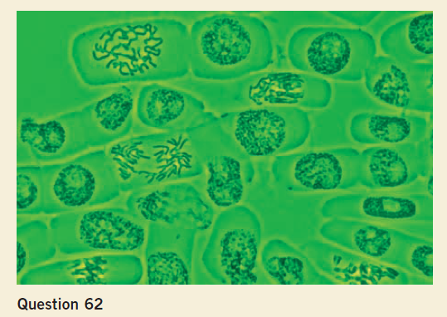
Skill Practice
62. Identify the phases of mitosis shown in the photo.
64. Examine the following photo of cells.
(a) Identify two cell structures that are visible.
(b) Describe the function of each part.
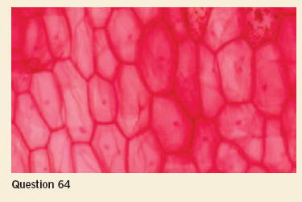
(c) Classify these cells as plant or animal cells, and explain your thinking.
65. Name the organs in the human digestive system.

Revisit the Big Ideas and Fundamental Concepts
67. Explain why biologists describe the following list as a biological hierarchy: cell, tissue, organ, organ system, and organism. a
68. Write a paragraph in which you explain how the root system and the shoot system work together in the process of photosynthesis.
69. Although mitosis ensures that all cells have the same genetic information, differentiated cells have unique structures and functions.
Explain how this works.
70. Explain how mitosis provides for growth and repair of tissues.
71. Show the importance of the cell cycle by describing the key events in the cycle.
73. Use an example to illustrate the meaning of the term “homeostasis.”
74. Explain the primary functions of the circulatory system and the respiratory system, and then show how these two systems interact within the organism.
75. Use an example to show why the interactions of different systems within an organism are necessary for the survival of the organism.
76. Write a paragraph that describes how oxygen reaches each cell of the body. Be sure to use relevant terminology including arteries, concentration, diffusion, capillaries, and red blood cells.
77. Write a paragraph that describes how the following tissues interact to carry out photosynthesis in a plant: mesophyll, phloem, xylem, and stomata.
78. Explain how cancer can affect cells.
79. How have developments in imaging technology contributed to our current understanding of cell parts and function?
Give an example in your answer.
80. The following factors are thought to impact the health of Ontarians: rates of cancer, vaccinations, and Sun protection behaviours. Choose one of these factors, and explain how public health programs or initiatives are attempting to encourage and support healthy living practices.
81. Developments in medicine and technology have social and ethical implications. Show your understanding of that statement by creating a PMI organizer (plus, minus, points of interest) for one of the following
situations: • DNA screening • stem cell research • organ transplantation • cloning • cancer screening
82. How are medical imaging technologies used in the diagnosis and treatment of heart disease?
87. Choose one topic from the following list of technological developments. Write a paragraph outlining some of the ethical implications associated with the use of this technological development. • transgenic techniques • cloning
• stem cell research

