Climate Change Exam Review

1. Create a concept map, with the term “climate change” at the centre, that links all the terms in the list below. Use additional words to clarify your understanding.

- albedo
- anthropogenic greenhouse effect
- atmosphere
- biomes
- biosphere
- carbon footprint
- carbon offsets
- carbon sink
- carbon source
- carbon tax
- climate
- conduction
- confidence level
- convection
- Coriolis effect
- economic system
- emissions trading
- fossil fuels
- global warming
- greenhouse gases
- hydrosphere
- insolation
- Kyoto Protocol
- lithosphere
- mitigation
- natural greenhouse effect
- net radiation budget
- persistence
- positive feedback loop
- potential
- radiation
- runaway positive feedback loop
- salinity
- sequestered
- solar radiation
- sustainable development
- thermal energy
- weather
- wind

2. Explain the difference between weather and climate.
3. Give an example of climate and an example of weather that illustrate the difference between these concepts.
4. Create a diagram to illustrate how convection transfers heat.
5. List the layers of Earth’s atmosphere, and note one fact about each.
6. Explain how temperature varies with altitude in Earth’s atmosphere.
7. Describe two examples of the effect of climate on your daily life.
8. In a sentence, identify the main source of Earth’s energy.
9. Define “thermal energy.”
10. Describe Earth’s biosphere.
13. Explain why Earth’s net radiation budget needs to be in balance.
14. Draw a diagram showing how thermal energy is transferred in the atmosphere.
15. Draw a diagram showing how thermal energy is transferred in the hydrosphere.
16. Make a list of the effects of thermal energy transfer on Earth.
17. In a sentence for each, explain how climate change might affect the following:
(a) coral reefs (b) Pacific salmon (c) frogs and toads (d) Naumra's jellyfish (e) clams and snails
18. Describe how people in Canada and Afganistan affect greenhouse gas emissions. How will the two societies be able to deal with the effects of climate change?
19. Distinguish between the terms natural greenhouse effect, anthropogenic greenhouse effect, and global warming.
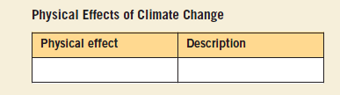
21. Give an example of and describe a physical effect of climate change that would affect you in Ontario.
22. Describe two pieces of evidence that point to the fact that climate change is occurring now.
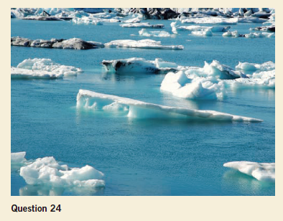
23. Draw a table like the one below, and name and describe the physical effects of climate change on Earth.
24. Describe the physical effect of climate change captured in the photograph below.
25. Different economic sectors contribute different amounts to Canada’s greenhouse gas emissions. Capture the information in this graph in two to three sentences.
26. Dealing with climate change issues will require changes in thinking as well as changes in behaviour. How do you think these issues affect the amount of evidence individuals need in order to act?
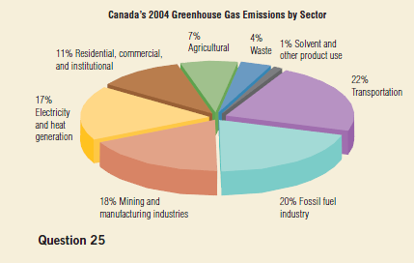
27. Describe the following initiatives: (a) ENERGY STAR
(b) Ontario’s Drive Clean program
28. How does a simple act such as hanging laundry out to dry address climate change? Think of another similar idea you would be willing to try.
29. Explain why developed and developing countries are treated differently in the Kyoto Protocol.
30. Why are the citizens of G8 countries responsible for a disproportionate amount of greenhouse gas emissions?

31. Humans will be affected greatly by the effects of climate change, but so will other organisms. Why are people concerned that some organisms would be negatively affected while others may be positively affected?
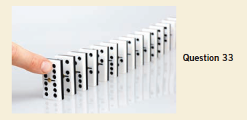
32. Why do you think it is important to learn about physical effects of climate change that may not have a direct or severe impact on your own region?
33. How does the idea in the photograph below reflect the climate change issue?
34. Why do developing and developed countries differ in their contributions to climate change?
35. Explain why gases such as carbon dioxide, methane, and nitrous oxide have a greater impact in causing changes to Earth’s climate than does water vapour.
36. What is the position of the IPCC on the relationship between the average global temperature increase and greenhouse gas emissions?
37. Thinking in terms of “systems” means that many issues must be considered at the same time in order for true solutions to arise. How does this apply to tackling climate change issues?
38. How has computer modelling influenced public opinion on climate change?
40. The physical effects of climate change will affect different parts of Earth in different ways. Pick one of the physical effects, and show how it might affect Canada, then state how it might affect a different part of the
world in a different way.
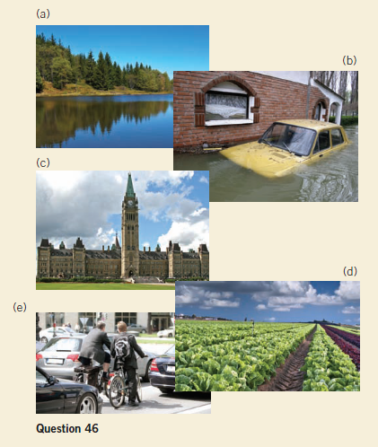
41. Write a persuasive paragraph or create a mind map to explain how the science of climate change is related to both the physical and social impacts of climate change.
42. How might science and technology play a role in minimizing the societal effects of climate change?
44. For each sector below, list an adaptation strategy and describe a possible government policy and some implementation considerations.
(a) water (b) agriculture (c) human health (d) electrical energy
45. Explain why it is important to understand principles of the natural greenhouse effect before studying the anthropogenic greenhouse effect.
46. For each photograph below, write a caption that links it to climate, climate change, and/or a regional or global consequence of climate change.
48. Imagine that farmers in an area near your community are reporting that the growing season is longer than in the past. Write a hypothesis to explain this observation. Describe how you might use weather records
to test your hypothesis.
52. Earth’s climate system is dynamic and a result of interaction among its many components. Write a paragraph or draw a picture to illustrate this idea.
53. The global climate is changing, mainly because of human activities. Write a persuasive paragraph explaining the significance of these human activities.
55. Changes in Earth’s climate will have global and regional consequences, and people have a responsibility to assess their impact on climate change and identify effective courses of action to reduce this impact. Make a list of five ways you can reduce your personal impact on climate change and three ways you can influence corporate and/or governmental action on climate change. Rank these ways in order of easiest to hardest to implement.
57. Oceans cover about 70 percent of Earth’s surface. Ocean currents affect heat transfer and precipitation patterns around the globe. As oceans become warmer, and less saline, their currents may change. This may, in turn, affect the climate.
(a) How will oceans become warmer and less saline?
(b) How could ocean warming and reduced salinity affect the mechanisms that drive the ocean currents?
(c) Will modified ocean currents affect people and/or the environment in the future?N I T

