Physics Exam Review

1. Create a mind map using the following terms. You may add more terms if you wish.

• angle of incidence
• angle of reflection
• angle of refraction
• camera
• concave mirror
• converging lens
• convex mirror
• diverging lens
• focal point
• luminescence
• magnification
• microscope
• mirage
• telescope
• virtual image

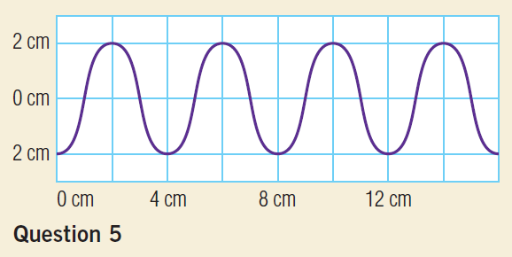
2. In a short paragraph, describe properties of light. You may wish to use some of the terms from question 1.
3. (a) Draw a sketch of the electromagnetic spectrum. (b) Label the different types of electromagnetic radiation.
4. What is the difference between electromagnetic radiation and the electromagnetic spectrum?
5. (a) What is the amplitude of the wave below?
(b) What is the wavelength of the wave below?
(c) Copy the wave into your notebook and label amplitude, wavelength, crest, trough, and resting position.
7. List the colours of the visible spectrum, from lowest to highest energy.
9. In terms of subtractive colour theory, explain why a darker coloured object will heat up faster than a lighter coloured object.
10. What colour of light would you observe if you combined equally bright lights of the three primary colours?
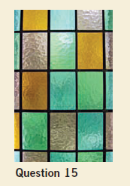
11. (a) Name seven different sources of light. (b) Give an example of each source.
12. State how fluorescence and phosphorescence are: (a) similar (b) different
13. What assumption does the ray model of light make about how light travels?
14. (a) List three terms that describe how light interacts with various materials.
(b) Give an example of each interaction.
15. Is light transmitted through the frosted glass shown below? Explain.
16. How many primary colours does an LCD or plasma display need to produce all the colours of the rainbow?
17. Use the ray model of light to describe the difference between penumbra and umbra.
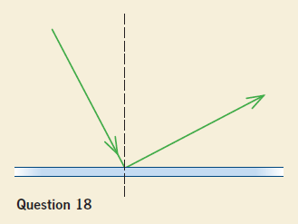
18. (a) State the law of reflection.
(b) Does the reflected ray in the illustration below obey the law of reflection? Explain why it does or does not.
19. How is a virtual image different from a real image?
20. Draw a ray diagram to show why your image is reversed in a plane mirror.
21. How is the focal point of a mirror different from the vertex?
22. (a) Draw a ray diagram of an object 0.75f from a concave mirror.
(b) Draw a ray diagram of an object 0.75f from a convex mirror.
23. What are two versions of the magnification formula?
24. State two uses for: a) a concave mirror (b) a convex mirror
25. What is the definition of refraction?
26. Which substance refracts light more, water or glass? Explain why.
27. What is the speed of light?
28. (a) What is the definition of index of refraction? (b) What is the formula for calculating the index of refraction of a material?
29. What is a common example of dispersion?
30. State the quantities that are related by Snell’s law.
31. (a) Define critical angle. (b) How can the value of the critical angle be measured?
32. How can you tell the difference between regular and diffuse reflection?
33. Which will be larger: the critical angle at an air-glass interface or the critical angle at a water-glass interface? Explain.
35. (a) Draw a ray diagram for an object 0.75f from a converging lens.
(b) Draw a ray diagram for an object 1.25f from a converging lens.
36. State the thin lens equation.
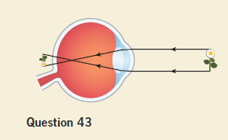
37. In the thin lens formula for a convex lens, state when the image distance is: (a) positive
(b) negative
39. List two parts of the eye that can refract light.
40. What structure controls the amount of light that enters the eye?
41. What features of an image are primarily collected by: (a) rods
(b) cones
42. State the cause of: (a) far-sightedness (b) near-sightedness
43. (a) What type of vision problem does the eye below have?
(b) Copy the diagram into your notebook. Add a correcting lens to your diagram, and show how the lens bends the light rays to focus the image on the retina.
44. Laser eye surgery can be used in some cases to correct far-sightedness and nearsightedness. What are three other conditions of the eye that can be treated with laser surgery?
50. Draw a ray diagram and write a short explanation to show why it is sometimes difficult to reach a coin that is underwater in a pond.
51. A flashlight does not lose power as you walk away from it, but as you get farther and farther, it appears to be less and less bright. Explain why.
52. Describe three situations where sunlight is seen as the visible spectrum.
54. When part of the Moon passes through Earth’s umbra, the result is a partial lunar eclipse, as shown below. What happens when the entire Moon passes through Earth’s umbra? Draw a labelled diagram as part of your answer.
57. Many grocery stores carry “reading glasses” that you can buy to help you read small print. What kind of lenses do you think these glasses use? Explain.
58. Explain why you agree or disagree with the following statements. For any you disagree
with, provide the correct statement.
(a) The normal is drawn at a 90° angle to the mirror or lens.
(b) When light is reflected from a curved mirror, the angle of incidence is twice the angle of reflection.
(c) If you want to see farther into space, build a telescope with a bigger convex mirror.
(d) The two main lenses of the microscope are the eyepiece and the objective lens.
63. A movie projector magnifies an image on 70.0-mm film to fill a screen 2.40 x 10⁴ mm wide. What is the magnification provided by the projector?
64. A concave lens produces a virtual image of a flower petal 2.00 cm from the lens. Determine the magnification of the lens if the petal is 8.30 cm from the lens.
65. When light passes through sodium gas at –272°C, it slows to 16.7 m/s. What is the index of refraction of sodium gas at this temperature?
66. Light travels through a salt crystal that has a refractive index of 1.52. What is the speed of light in the crystal?
67. Titan is a moon of Saturn that has liquid methane in the atmosphere. Liquid methane has an index of refraction of 1.29. If a beam of light from the Sun approaches the atmosphere of Titan at an angle of 36.0°, what is its angle of refraction?
68. A human hair follicle like the one in the photo below appears to be 5.5 x 10^{–3} m in width when viewed by a lens that magnifies 50 times. What is the actual width of the hair follicle?
69. A lens produces a larger, upright, virtual image that is 12.25 cm from the lens. The object is located 5.10 cm away. What is the focal length of the lens?
70. A convex lens has a focal length of 1.80 cm. If it is held 3.0 cm from an object, how far from the lens is the image formed?
71. A far-sighted person wearing a pair of glasses looks at the soup display in the grocery store. If the convex lenses in the glasses have a focal length of 2.40 m and form a virtual image 2.60 m from the lenses, how far away is the display?
72. Follow these steps to find the relationship between the focal length of a spherical concave mirror and its radius of curvature:
• Draw a concave mirror with a radius of at least 20 cm.
• Mark the centre of the mirror on the principal axis.
• Draw a ray parallel to the principal axis, no more than 3 cm away from the axis.
• Draw a dotted line from the point of incidence to the centre of the mirror.
This is the normal.
• Use the law of reflection to draw the reflected ray.
• Locate where the ray crosses the principal axis. This is the focal point.
(a) How do you know the dotted line is the normal?
(b) How can you be sure that you have found the focal point?
(c) Compare the radius and the focal length. Hypothesize their relationship.
(d) Describe how you might verify this relationship.
73. (a) Describe the differences between refraction and reflection as a way to change the direction of a light ray.
(b) Describe how our understanding of these principles benefits society.
78. How have optical fibres enhanced our ability to communicate information?

