


RDO and CentOS are both Red Hat community projects.

OPENSTACK Runs on CentOS
OpenStack can't live in a vacuum – it runs on an operating system, and has a galaxy of applications that run on it and around it, each with their own open source community. CentOS is right in the midst, participating in many of these communities.

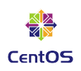
CentOS
Many large deployments of OpenStack are on CentOS Linux, including UnitedStack China and CERN.
The CentOS Project community is working with OpenStack, via the mechanism of the Cloud SIG (special interest group), to produce and maintain OpenStack packages for CentOS Linux.
The CentOS Project is also very involved in testing OpenStack.
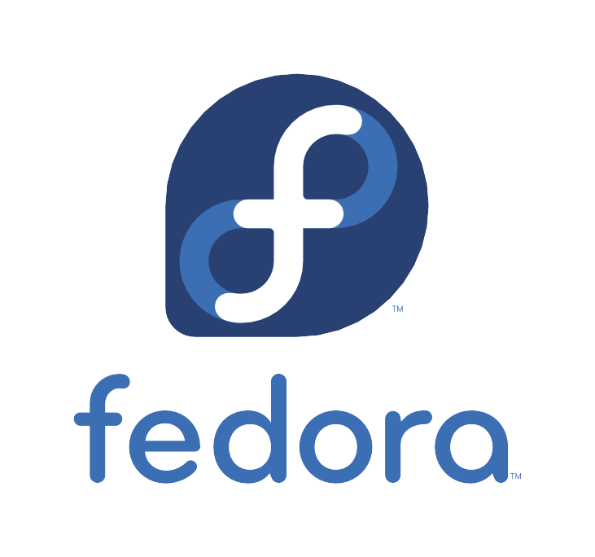
centos.org

Fedora
Fedora is the fast-moving proving ground that feeds into the stable enterprise OS Red Hat Enterprise Linux, much as RDO is the fast-paced version of Red Hat Enterprise Linux OpenStack Platform.
fedoraproject.org


ManageIQ
ManageIQ is a cloud management platform that adds additional capabilities to your existing virtualization, private cloud, and hybrid cloud infrastructure. ManageIQ provides scaleable self-service interfaces, provisions virtual system images, enables metering and billing, and provides workload optimization through established policies.
manageiq.org

Foreman

Foreman is an open source project that helps system administrators manage servers throughout their lifecycle, from provisioning and configuration to orchestration and monitoring. Using Puppet or Chef and Foreman's smart proxy architecture, you can easily automate repetitive tasks, quickly deploy applications, and proactively manage change, both on-premise with VMs and bare-metal or in the cloud.
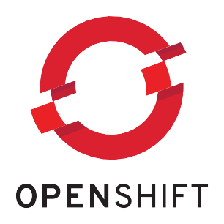
theforeman.org

OpenShift
OpenShift is Red Hat's Platform-as-a-Service (PaaS) that allows developers to quickly develop, host, and scale applications in a cloud environment. With OpenShift you have a choice of offerings, including online, on premise, and open source project options.
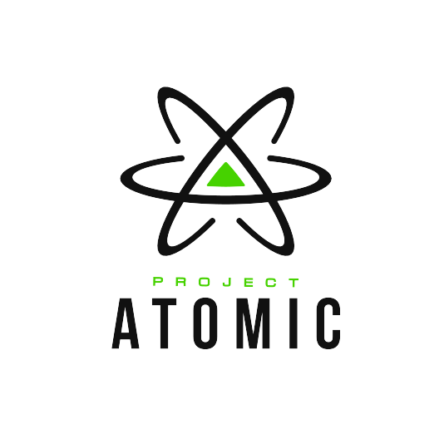
openshift.com

Project Atomic
Project Atomic integrates the tools and patterns of container-based application and service deployment with trusted operating system platforms to deliver an end-to-end hosting architecture that's modern, reliable, and secure.
projectatomic.io

