DATABASE CREATION and RECORDS

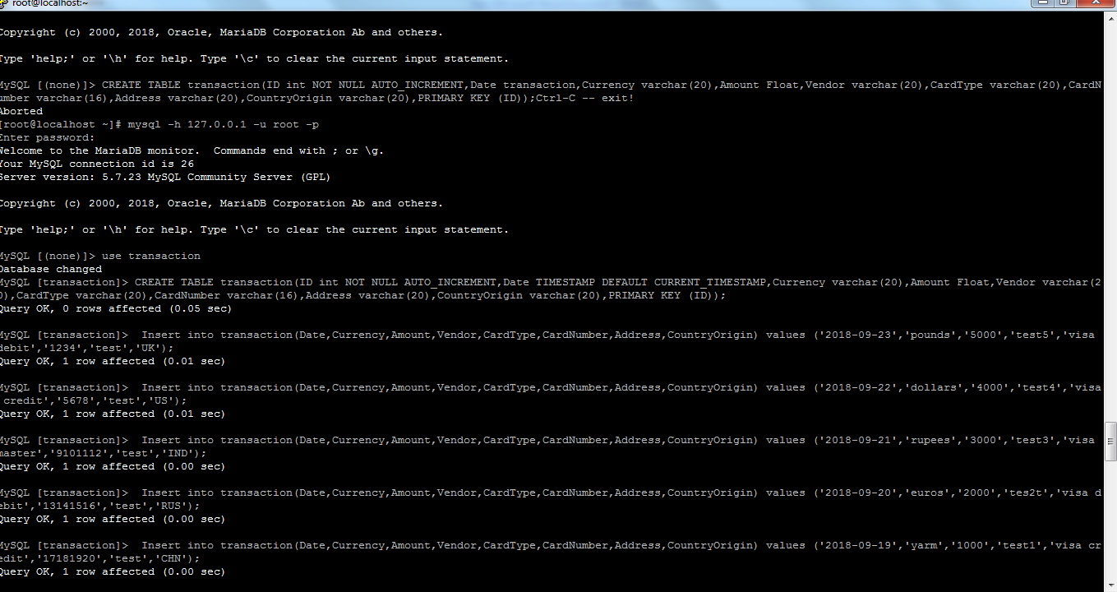

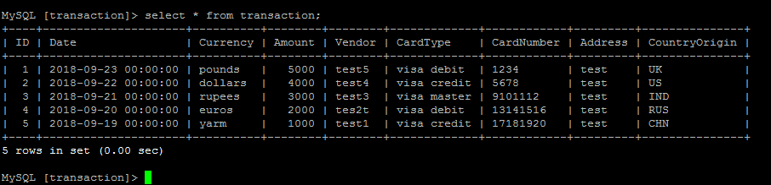

PROGRAM EXECUTION

UNIT TEST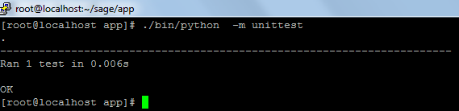

With DAYS

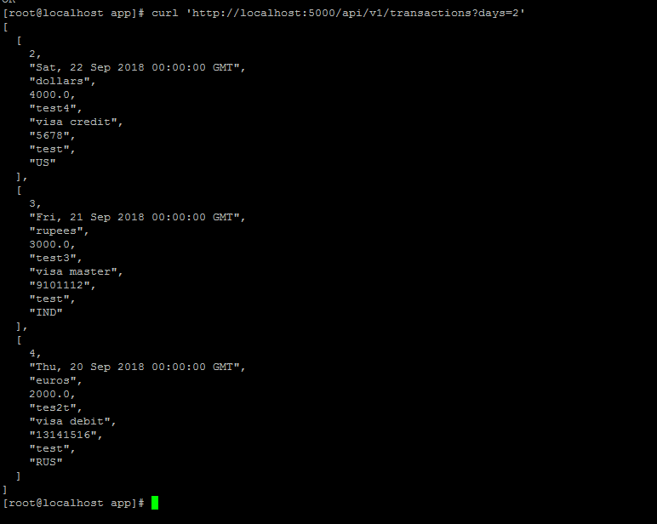

WITH DAYS and Card type

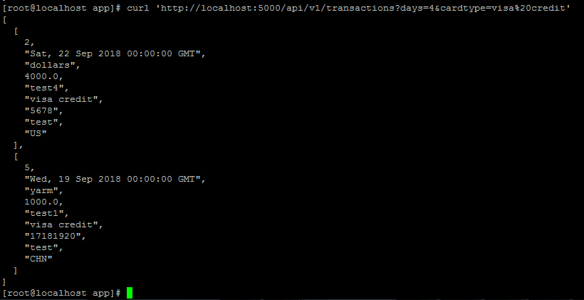

WITH DATE ,CARD TYPE,COUNTRY ORIGIN

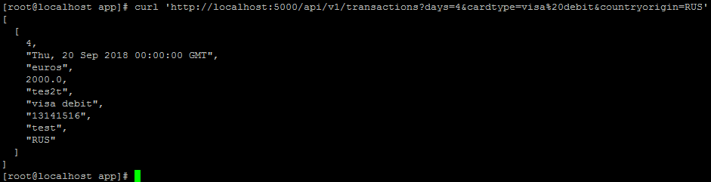

WITH DATE and AMOUNT

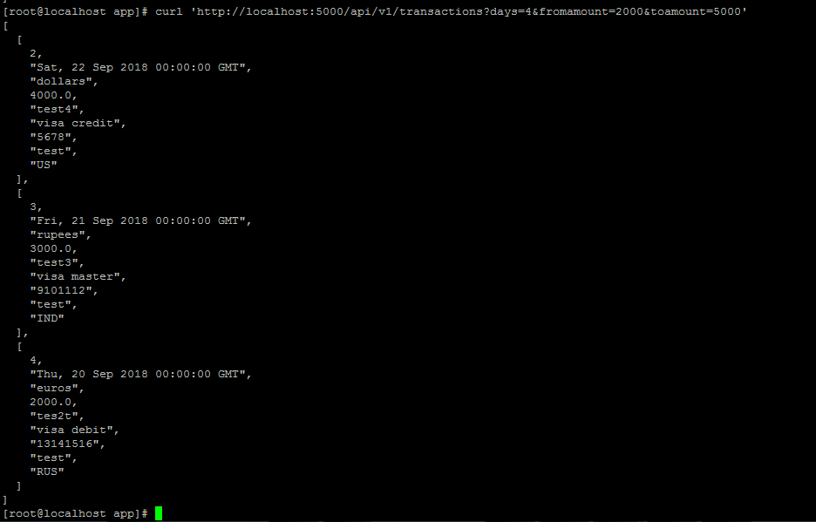

LOGS from APP

