**Lab 03 (Introduction to Cisco Network Tracer ) Name: Abdul Wahab Khan**

**Roll no: 20k-1648**

**Classwork**

Class A 0-127

Class B 128-191

Class C 192-223

Class D 224-239

Class E 240-255

1. class A
2. class B
3. class B
4. class B
5. class B
6. class A
7. Class c
8. Class c
9. Class B
10. Class A
11. Class c
12. Class C
13. Class A
14. Class C
15. Class C
16. Class A
17. Clsss C
18. Class C
19. Class A
20. class A
21. Class A
22. Class B
23. Class C

Network portion

1. **177.100**.18.4
2. **119**.18.45.0
3. **209.240.80**.78
4. **199.155.77**.56
5. **117**.89.56.45
6. **215.45.45**.0
7. **192.200.15**.0
8. **95**.0.21.90
9. **33**.0.0.0
10. **158.98**.80.0
11. **217.21.56**.0
12. **10**.250.1.1
13. **150.10**.15.0
14. **192.14.2**.0
15. **148.17**.9.1
16. **193.42.1**.1
17. **126**.8.156.0
18. **220.200.23**.1

Host portion

**1)** 10.**15.123.50**

**2)** 171.2.**199.31**

**3)** 198.125.87.**177**

**4)** 223.250.200.**222**

**5)** 17.**45.22.45**

**6)** 126.**201.54.231**

**7)** 191.41.**35.112**

**8)** 155.25.**169.227**

**9)** 192.15.155**.2**

**10)** 123.102.45.**254**

**11)** 148.17.**9.155**

**12)** 100.**35.1.1**

**13)** 195.0**.21.98**

**14)** 25.**250.135.46**

**15)** 171.102**.77.77**

**16)** 55.**250.5.5**

17) 216.155.230**.14**

**18)** 10.**250.1.1**

**Network address**

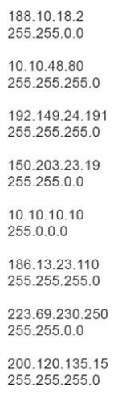

188.10.0.0

10.0.0.0

192.149.24.0

150.203.0.0

10.0.0.0

186.13.0.0

223.69.230.0

200.120.135.0

**Host Address**

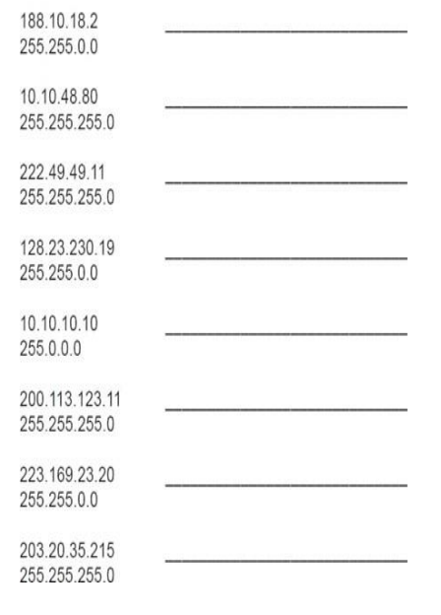

0.0.18.2

0.10.48.80

0.0.0.11

0.0.230.19

0.10.10.10

0.0.0.11

0.0.0.20

0.0.35.215

**Subnet Mask**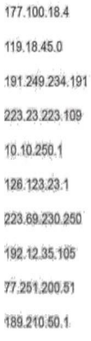

255.255.0.0

255.0.0.0

255.255.0.0

255.255.255.0

255.0.0.0

255.0.0.0

255.255.255.0

255.255.255.0

255.0.0.0

255.255.0.0

**Home Tasks Lab03**

**Task1**

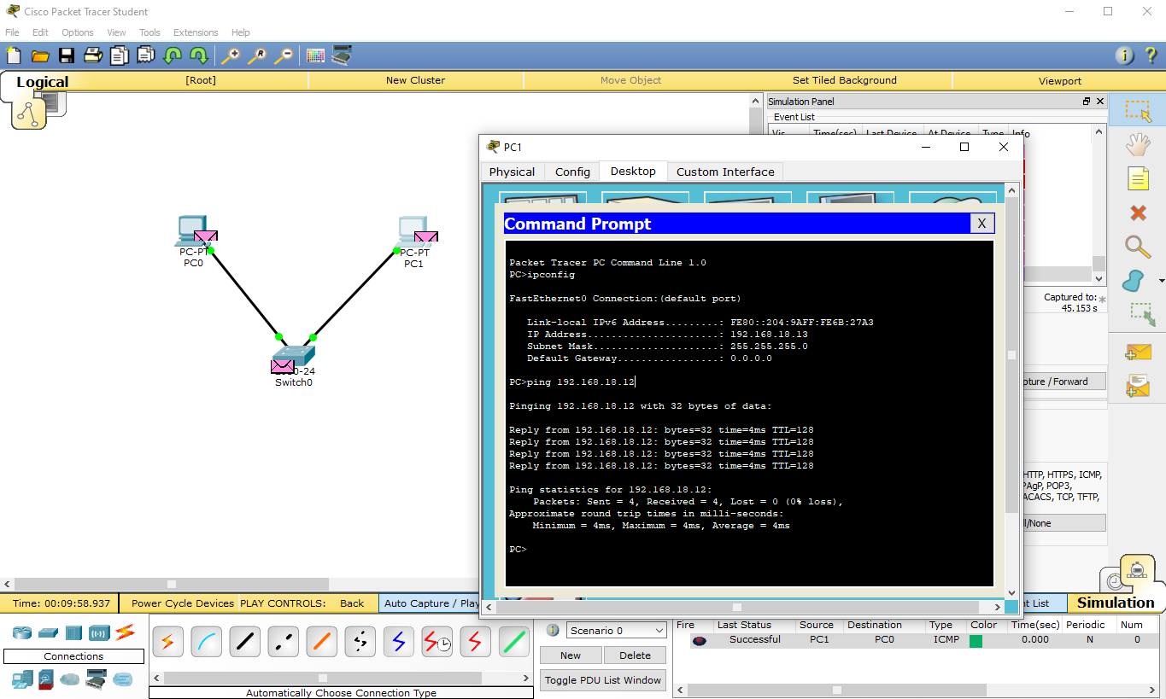

**Task2**

In this task, two types of wires are being used. One is copper straight-through wire, which is connecting the different types of devices e.g the switch and the end device(pc) and the other one is the copper cross-over wire, which is connecting the same type of devices e.g switch to switch.

Task2.pkt file shown below:

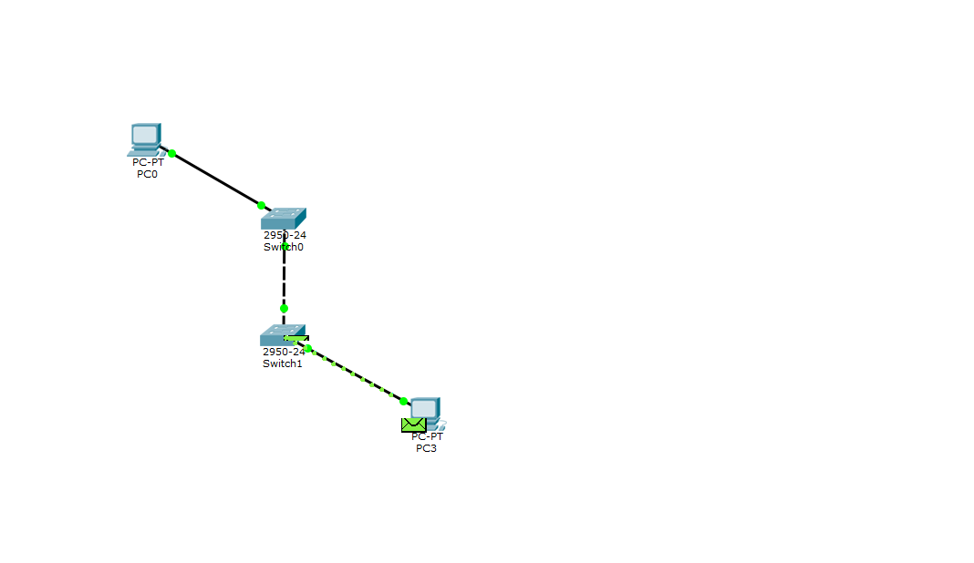

**Task3**

There are 5 main command modes:

1. User Exec mode: This does not allow you to make changes to the device’s configuration, and it is the most basic mode (user mode) and provides access to a limited set of basic monitoring commands
2. Privileged EXEC mode: Allows you to make changes to the device’s configuration and provides access to advanced monitoring commands
3. Global configuration mode: Allows you to make global changes to the device’s configuration e.g setting up the hostname, enabling and disabling interfaces, and setting passwords.
4. Interface configuration mode: Allows you to make changes to a specific interface configuration such as setting IP addresses and subnet mask, enabling or disabling the interface.
5. Subinterface configuration mode: Allows you to configure a subinterface, a logical division of a physical interface.
6. Line configuration mode: Allows you to configure a specific line such as a console or auxiliary line.

**In the picture below, I went from basic user from EXEC commands mode to privileged EXEC mode and then to line configuration mode.**

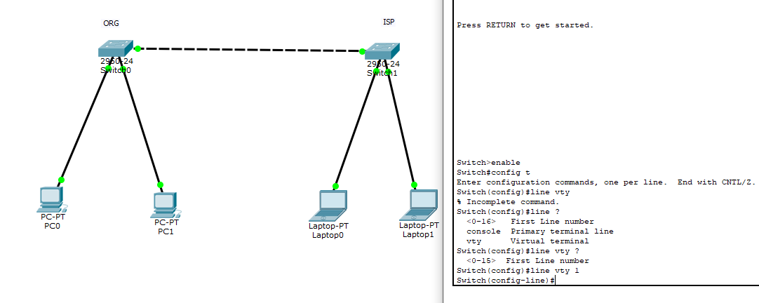

**Task4**

In the task given, there are 4 end-devices and 2 switches connected.

A switch connects devices together on a computer network, by using packet switching to receive, process and forward data to the destination device.

