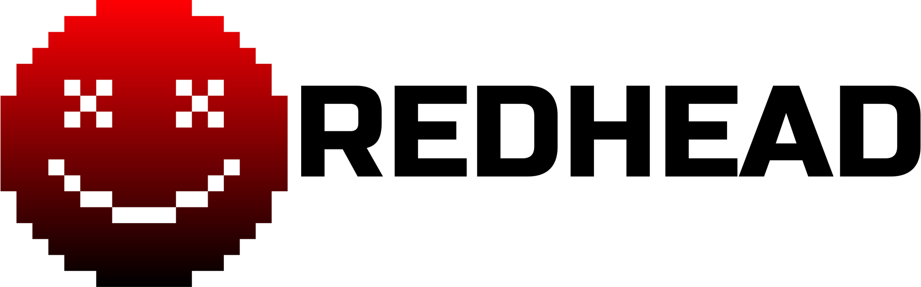
NON-DISCLOSURE AGREEMENT

This Non-Disclosure Agreement (“Agreement”) is entered into as of the date of signature below (“Effective Date”) between:
[ DATE HERE – EXAMPLE: JANUARY 1ST, 2030 – 10:00 AM EASTERN TIME ]
RedHead Industries, founded and operated by Matthew DaLuz (“Disclosing Party”), and
______________________________ (“Receiving Party”).

1. Purpose
This Agreement defines how the Receiving Party may handle information shared by RedHead Industries across its branches:
- RedHead Technologies,
- RedHead Medical,
- RIIDF (RedHead International Internet Defense Force — a virtual cybersecurity branch only, not a national defense entity).

2. Disclosure Rule (The Core Clause)
By default, the Receiving Party is permitted to share, discuss, publish, or otherwise disclose any information obtained from RedHead Industries, at any time and in any manner, unless that specific information has been explicitly marked as “Confidential” by the founder/CEO, Matthew DaLuz.

Information becomes confidential ONLY when:
1. Matthew DaLuz clearly states in writing (email, message, document, or signature) that the information is confidential, or
2. The information is delivered along with a notice, label, or message indicating confidentiality.

If the information is not labeled or declared confidential, it is free to disclose.

3. Definition of Confidential Information
“Confidential Information” refers ONLY to information explicitly designated as confidential by Matthew DaLuz under Section 2.

This includes—but is not limited to—information about:
- Software, game, or hardware prototypes,
- Experimental medical research or formulations,
- Sensitive cybersecurity tools or internal RIIDF operations,
- Private business plans or infrastructure details,
- Personal identifying or sensitive information.

If no confidentiality notice is given, the information does not count as Confidential Information.

4. Obligations of the Receiving Party
For information properly designated as Confidential:
- The Receiving Party must not disclose it to anyone without written permission from Matthew DaLuz.
- They must protect it with reasonable care.
- They may only use it for authorized collaboration with RedHead Industries.

For non-designated information:
- The Receiving Party is fully allowed to discuss, use, publish, or share it.

5. Intellectual Property
All Confidential Information remains the exclusive property of RedHead Industries unless otherwise agreed in writing. Disclosure permissions do not transfer IP ownership.

6. Term & Survival
This Agreement becomes effective on the Effective Date. Confidentiality obligations apply only to information explicitly labeled as confidential. Those limited confidentiality obligations survive indefinitely unless released in writing.

7. No Obligation to Continue Work
This Agreement does not require either Party to proceed with employment, collaboration, or development.

8. Governing Law
This Agreement is governed by the laws of Ontario, Canada.

9. Remedies
If Confidential Information (as defined under Section 2) is wrongfully disclosed, the Disclosing Party may pursue legal and equitable remedies.

10. Entire Agreement
This Agreement supersedes all prior confidentiality agreements between the Parties.

11. Signatures

Disclosing Party
RedHead Industries
Name: Matthew DaLuz
Signature: __________________________
Date: ______________________________

Receiving Party
Name: ______________________________
Signature: __________________________
Date: ______________________________

