Emergency Operation Center (Web Application)

User Manual
Client: Dr. Mark Corson
Department Chair of Natural Sciences, NWMSU

Presented By –
Pavan Kumar Reddy Byreddy
Samanth Gourineni
Anvesh Rokanlawar
Sushma Rani Reddy Aleti
Abhishek Telugu
Meghna Reddy Kunta

Table of contents:
S.no | Topics | Page no.
1. | Introduction | 3
2. | Installation Steps | 3
3. | Functional Requirements | 4-5
4. | Signup page | 6
5. | Login page | 7
6. | Managing users | 8
7. | Forgot password | 9
8. | Home page | 10
9. | Create incidents page | 11
10. | View incidents page | 12
11. | Edit incident page | 13
12. | Assign resources page | 14
13. | Resource page | 14
14. | Create Resource page | 15
15. | View Reports page | 16
16. | Create Reports page | 17
17. | Profile page | 17

Introduction:
There exist systems to manage emergency or disaster situations. However, these systems lack quick communication and the ability to predict and visualize the locations of several response teams in different areas simultaneously. We propose an approach to identify and view the rescue teams and to manage those teams using the web application with data services stored in cloud. The same data services will be used by the mobile applications, which is out of the scope of this research.

Installation Steps:
- You’ll need to have Node >= 8.10 and npm >= 5.6 on your machine.
- Run the command ‘npm i’ to install all the packages in EOC folder and client folder.
- EOC folder works as backend server and client folder works as frontend.
- Run the command ‘node server.js’ in EOC folder to start backend server
- Run the command ‘npm start’ to run front end server.
- To deploy the application in Heroku please follow the below steps.
https://devcenter.heroku.com/articles/deploying-nodejs

Functional Requirements:
- ID: FR#1
TITLE: Signup page
DESC: For a new user to login into the website, one needs to have an account. Using the registration page, user needs to set up an account.
DEP: None

- ID: FR#2
TITLE: Login page
DESC: Using the credentials, the user can login using the login page.
DEP: FR1

- ID: FR#3
TITLE: Managing users
DESC: After a user is successfully registered, a signup request is sent to the admin who can accept or reject the user.
DEP: None

- ID: FR#4
TITLE: Forgot password
DESC: If a user forgets the password, using forgot password link, the user can reset the password.
DEP: None

- ID: FR#5
TITLE: Home page
DESC: The home page consists of list of incidents created by the user.
DEP: FR2

- ID: FR#6
TITLE: Create incidents page
DESC: A user can create an incident.
DEP: None

- ID: FR#7
TITLE: View incidents page
DESC: User can view the incidents.
DEP: FR6

- ID: FR#8
TITLE: Edit incident page
DESC: User can also edit the incident.
DEP: FR7

- ID: FR#9 Assign resources page
DESC: Based on the type of incidents, the resources are allocated.
DEP: FR7

- ID: FR#10
TITLE: Resource page
DESC: The allocated resources are displayed on this page.
DEP: None

- ID: FR#11
TITLE: Create Resource page
DESC: New resources can be created.
DEP: FR10

- ID: FR#12
TITLE: View Reports page
DESC: The user can view the reports for an incident.
DEP: FR7

- ID: FR#13
TITLE: Create Reports page
DESC: Based on the incident, the user needs to create the report.
DEP: FR12

- ID: FR#14
TITLE: Profile page
DESC: The user details are displayed
DEP: None

Step-1: Signup (Anvesh)
A new user have to register first using the register page by providing all the information where necessary.

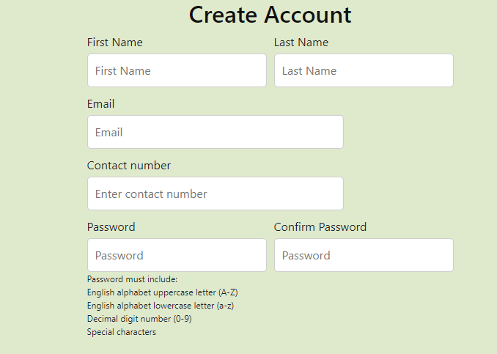

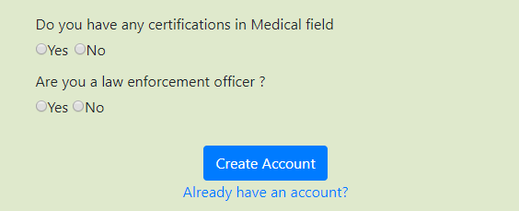

By clicking on the create account, a user is registered successfully.

Step-2: Login (Sushma)
For a new user to login into the website, one needs to have an account. Using the registration page, user needs to set up an account. Using those credentials, the user can login using the login page.
This is a login page where registered user can login to the website. By clicking the login button a user is successfully logged in and can access the website.

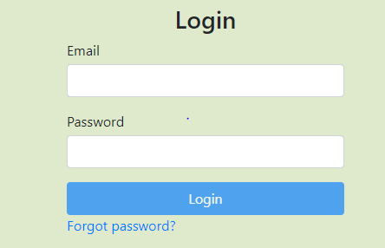

Step-3: Managing users (Pavan and Samanth)
After a user is successfully registered, a signup request is sent to the admin who can accept or reject the user. The page looks like this.

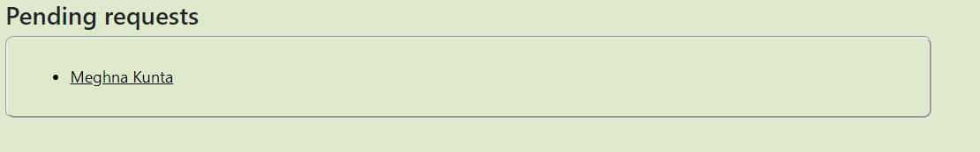

The details of the new user to the admin is shown below.

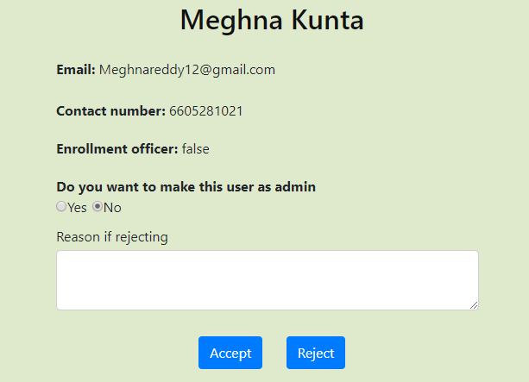

The Admin can change the new registered user to an Admin by clicking the Yes/No button.

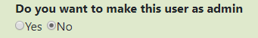

The admin can accept or reject the user by simply clicking on “Accept” or “Reject” buttons.

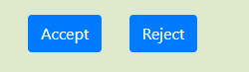

If Admin wants to reject the user, a reason should be provided on rejecting the user.

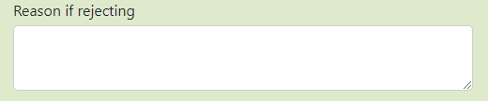

Step-4: Forgot password (Meghna and Abhishek, Reviewed)
If a user tries to login with the credentials, the user may forget the password sometimes. Using forgot password link, the user can reset the password.
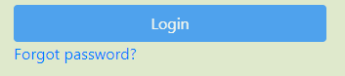
Once, the user clicks on forgot password, the page looks like this:

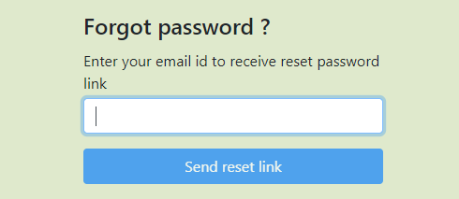
After entering the email id, click on send reset link and a link is sent to the respective user’s mail id and using that link a user can reset the password and can login.
Step-5: Home page (Sushma)
After the user login is successfully done, user is redirected to a home page. The home page consists of list of incidents created by the user. To create a new incident, there is a button called create incident.

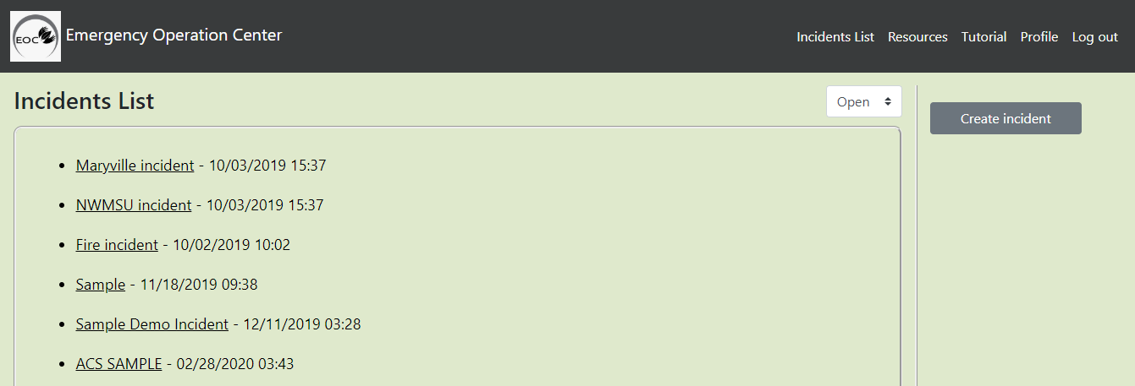

On the home page, user can check the closed incidents and open incidents by using the dropdown.

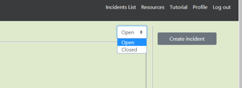

Step-6: Create incident page (Meghna)
When a disaster happens, user can create the incident using create incident button. Once all the fields are entered, click on create incident button and the incident is created.

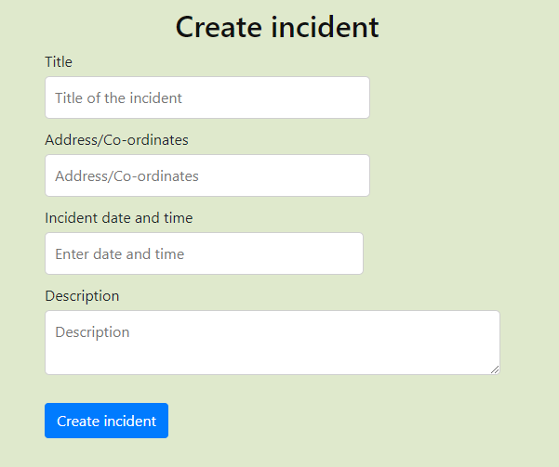

Step-7: View incidents page (Anvesh)
After an incident is created, it gets saved on to incidents list. To view particular incident, click on the incident name and the page looks like this.

For example, if user clicks on NWMSU incident, the page looks like this:

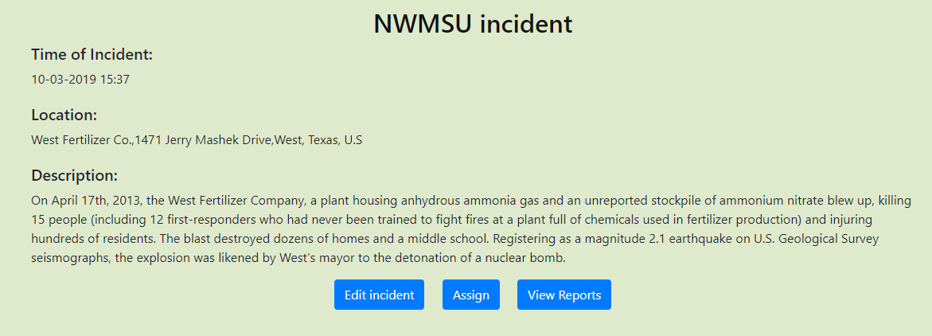

Step-8: Edit incident page (Abhishek and Samanth)
A user can also edit the incident by clicking on Edit incident. Close incident lets the user to archive the incident. Below is an example of an incident that was already created.

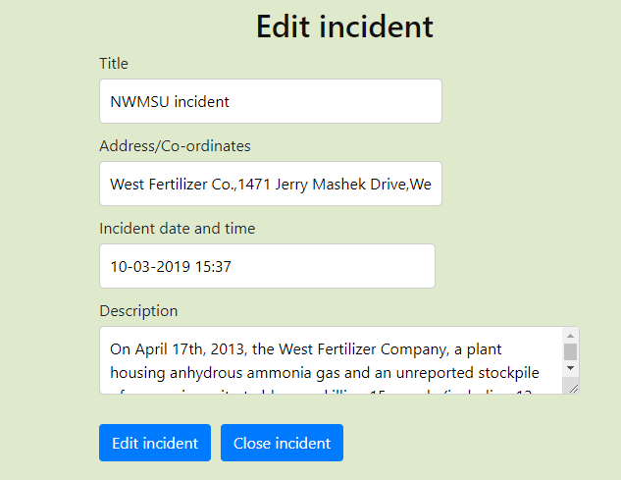

Before archiving the incident, a dialog box appears to confirm whether the user was sure to archive the incident or not. If the user clicks ‘ok’, the incident is closed.

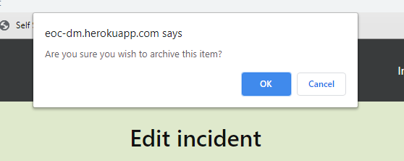

Step-9: Assign resources (Pavan)
Based on the type of incidents, the resources are allocated. For example, if a fire incident happens, a fire truck will be allocated. From the available resources, user can select a resource and when the user clicks on ‘Assign’ button, the resource is allocated.

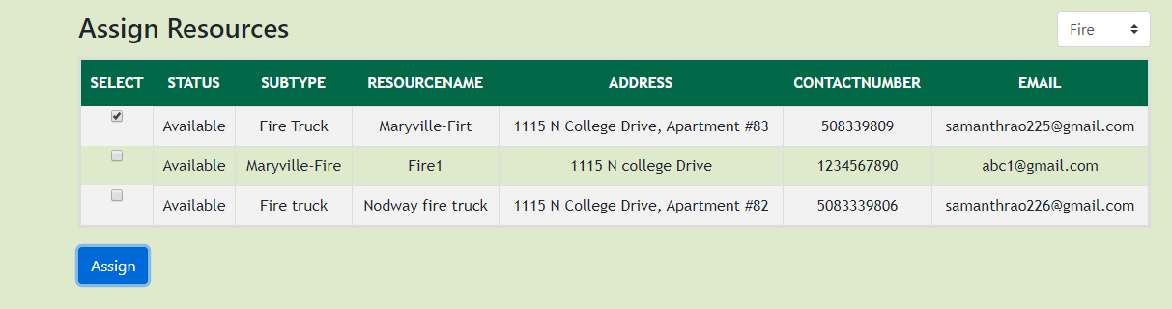

Step-10: View Resources (Anvesh)
The user can view the available number of resource and their details by navigating to the resource tab. The user has been made available with a feature to filter the different type of resource which are already created using the drop-down menu. Using this resources module user can know the current status of the resource such as (Available, Staged, and Assigned).

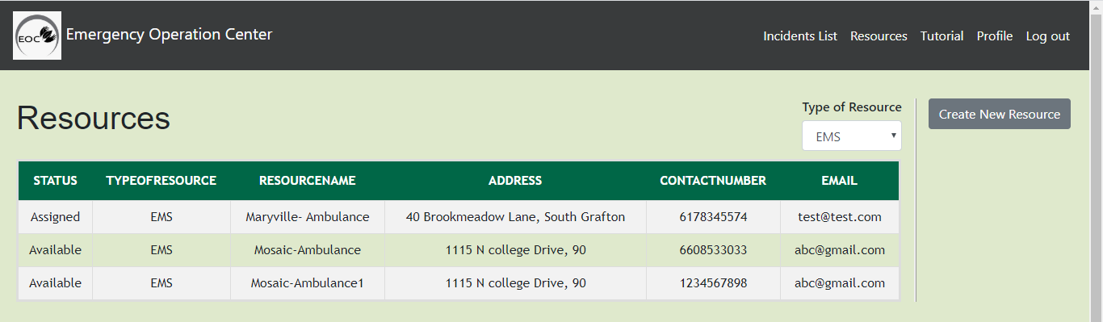

Step-11: Create Resource (Sushma & Meghana)
A new resource can be created by navigating to Resources tab → then by clicking on Create New Resource Button. Then the user will be navigated to create resource page to fill out the details.
Note * - Indicates all the fields are mandatory.

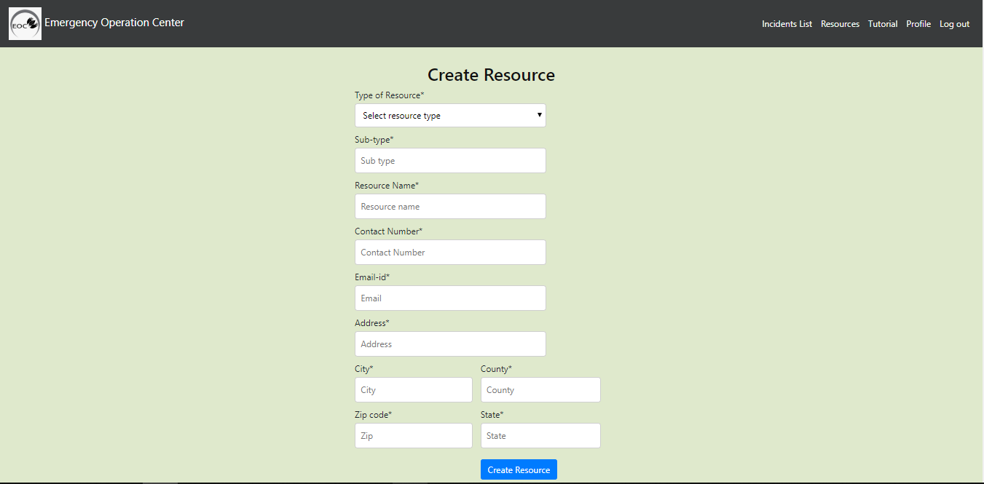

Step-12: View Reports (Abhishek)
User can able to view the report on the map which shows the location of the incident, type of the incident and the causalities. When you click on the report it shows the summary of the incident along with all the causalities like the number of red, green and so on. User can also view the report in detail when they click on show details button in the summary.

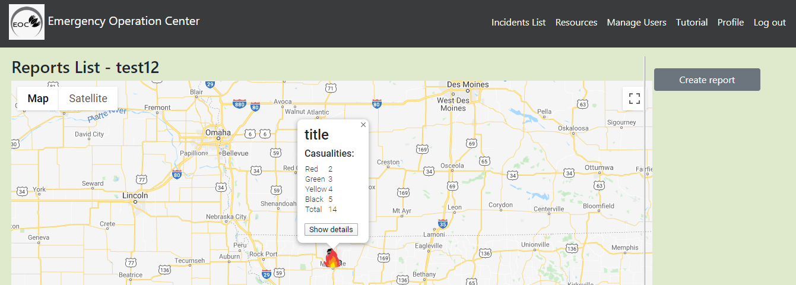

Step-13: Create Report (Samanth)
User can create a report for the incident by simply clicking on the create report button in the view reports page as shown in the screenshot above. Create report asks title, location, type of the incident along with the causalities (i.e., the number of red, yellow, green and black). They can also write a description about the incident and also can upload an image of the incident. There is also an option to enter level of impact and level of damage caused by the particular incident.

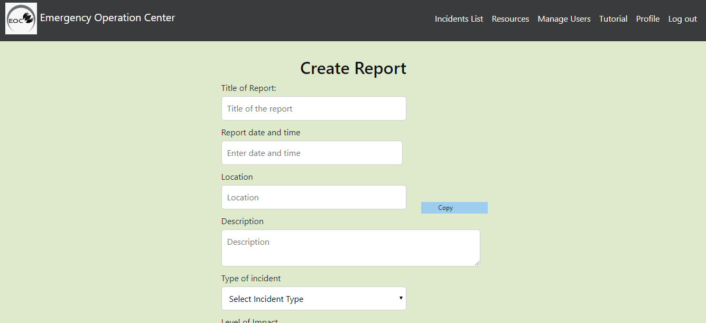

Step-14: Profile Page (Pavan)
This page shows all the details of the user that they have entered during the sign up excluding the password. This page display the content like first name, last name, and contact number and so on. User will be able to see the email of the admin to contact if the displayed information is incorrect.

