w
Contents
Pre-requisite Installation 2
Step 1: Listing grouplist packages 2
Step 2: Install Development Tools - grouplist package 2
Redis Installation 2
Step 1: Download Redis Installables 2
Step 2 : Extract Redis archives 3
Start Redis 7
Stop Redis 7
Enabling Authentication 7
Displaying Redis Server Info 8
Validation 8
Step 1 : Ensure Redis is running 8
Host and port Details 8

Pre-requisite Installation

Step 1: Listing grouplist packages
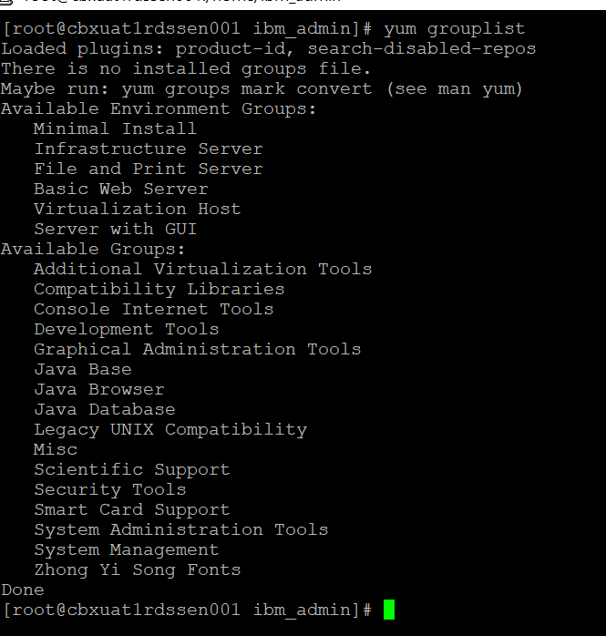

Step 2: Install Development Tools - grouplist package
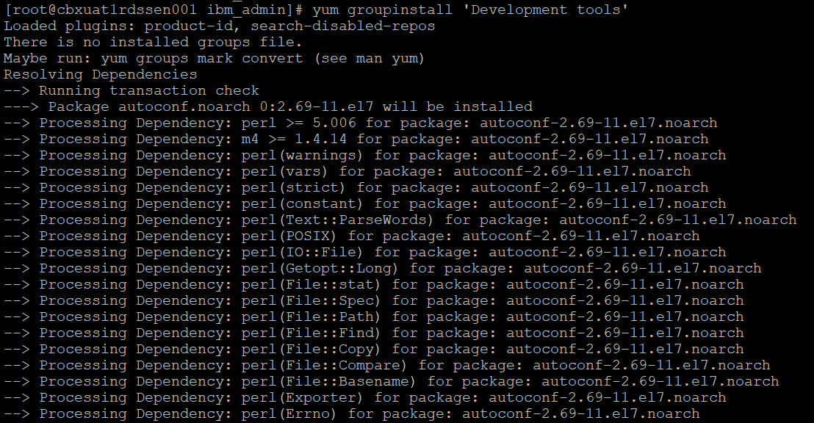

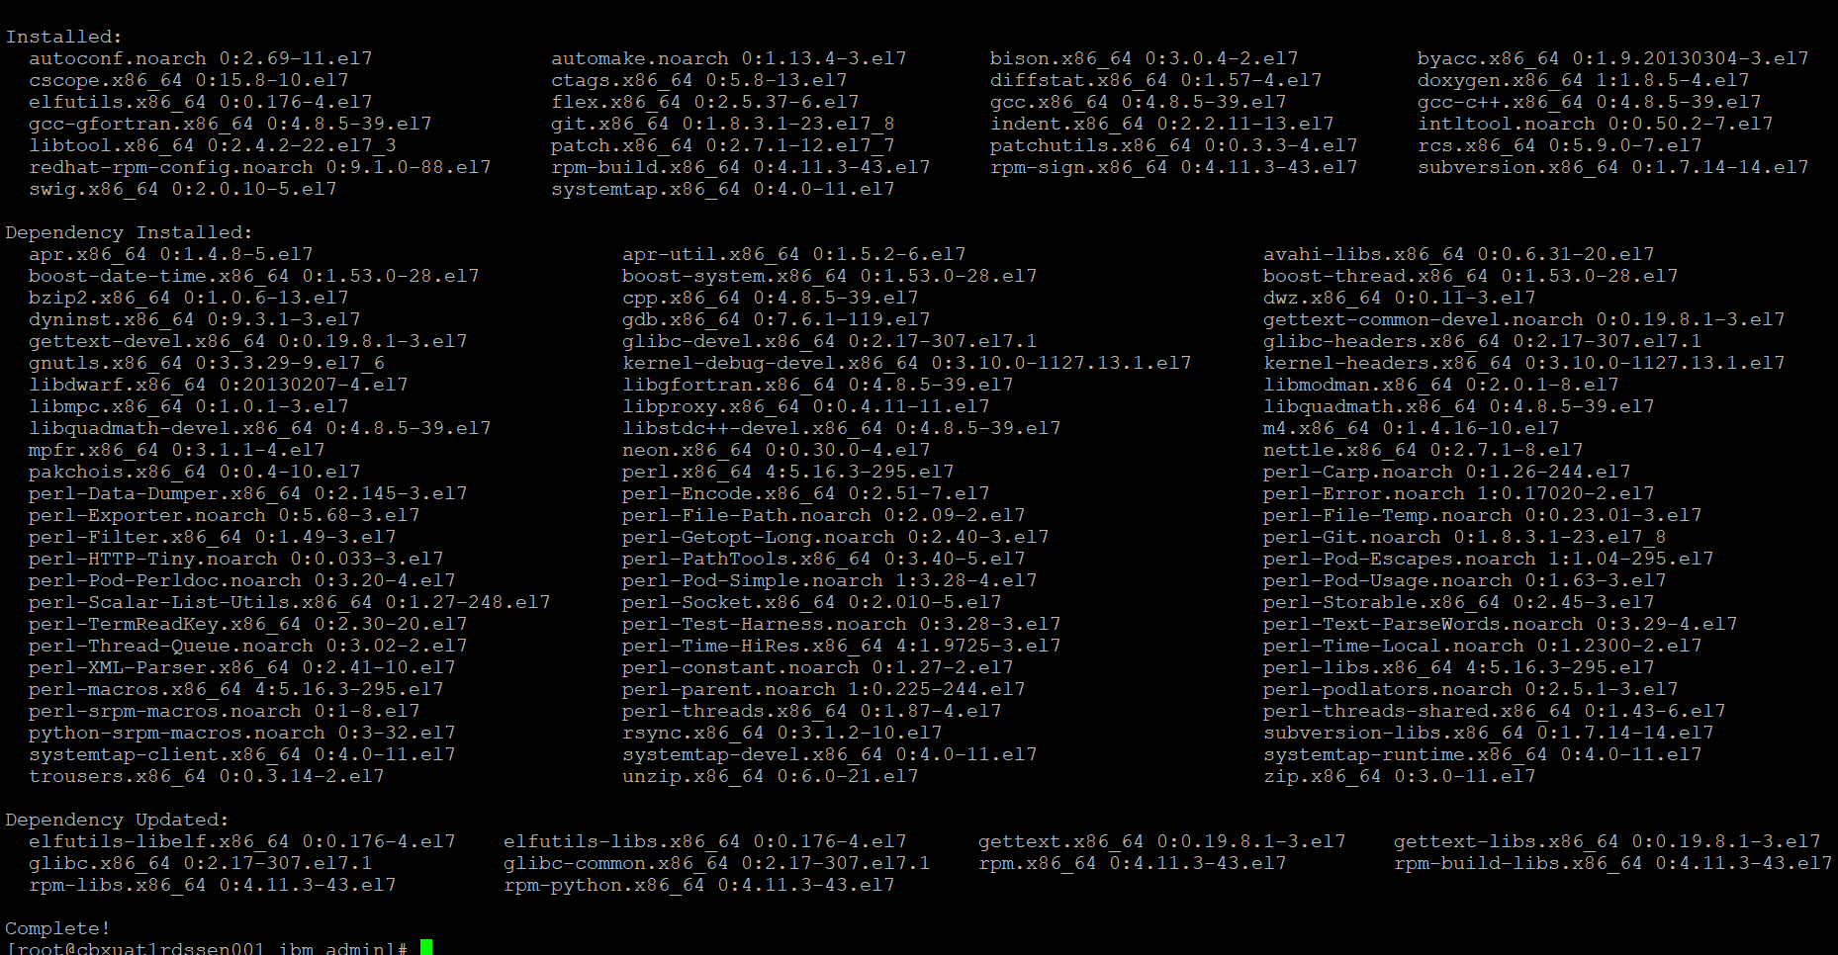

Redis Installation

Step 1: Download Redis Installables
Download Redis 7.0.2 version (redis-7.0.2.tar.gz) from –
http://download.redis.io/releases/redis-4.0.2.tar.gz
and transfer the archives to target linux machine.

Step 2 : Extract Redis archives
- Move the tar file(redis installable) to /cbxapps/
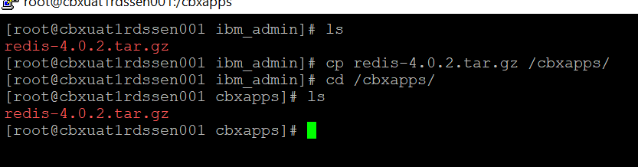
- Navigate to /cbxapps/ and run the command - tar-xvf redis-4.0.2.tar.gz
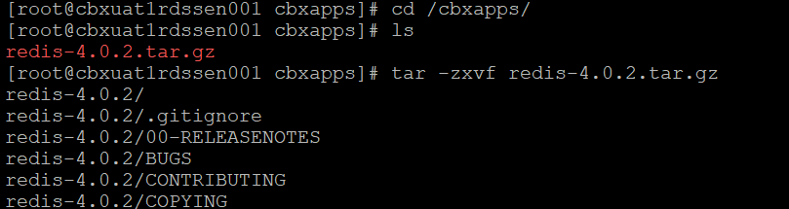
- Now navigate to the path – /cbxapps/redis-7.0.2/src and run the command – make distclean
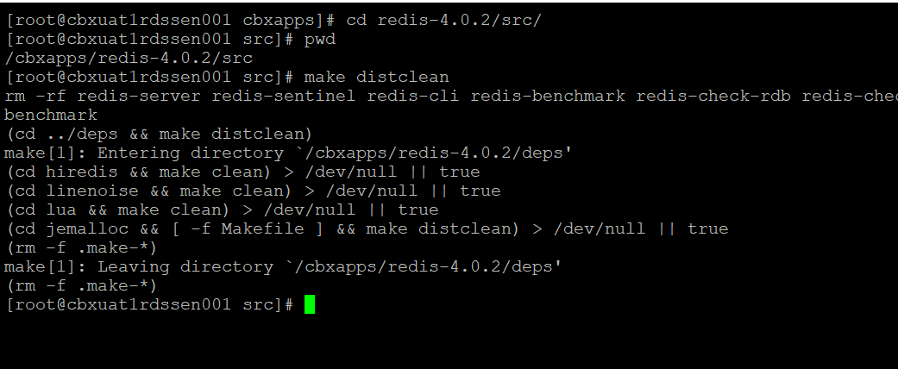

- Now execute the command – make all
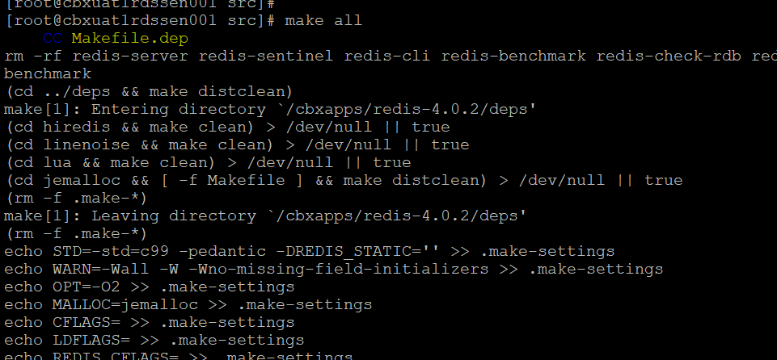
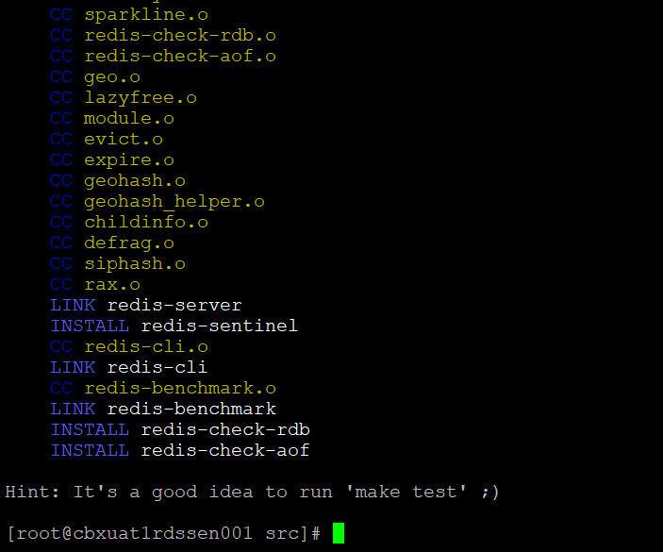
Now run Make && Make install
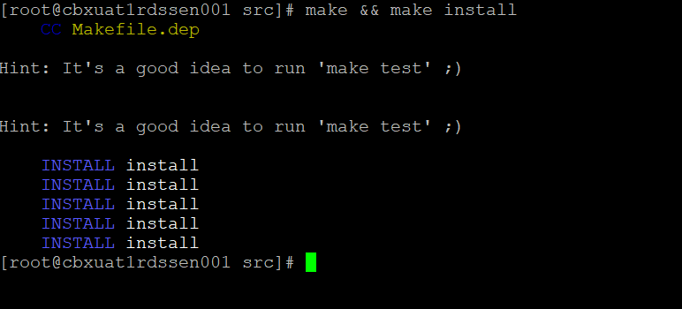
- Now navigate to the path - /cbxapps/redis-7.0.2/utils and execute the command - ./install_server.sh
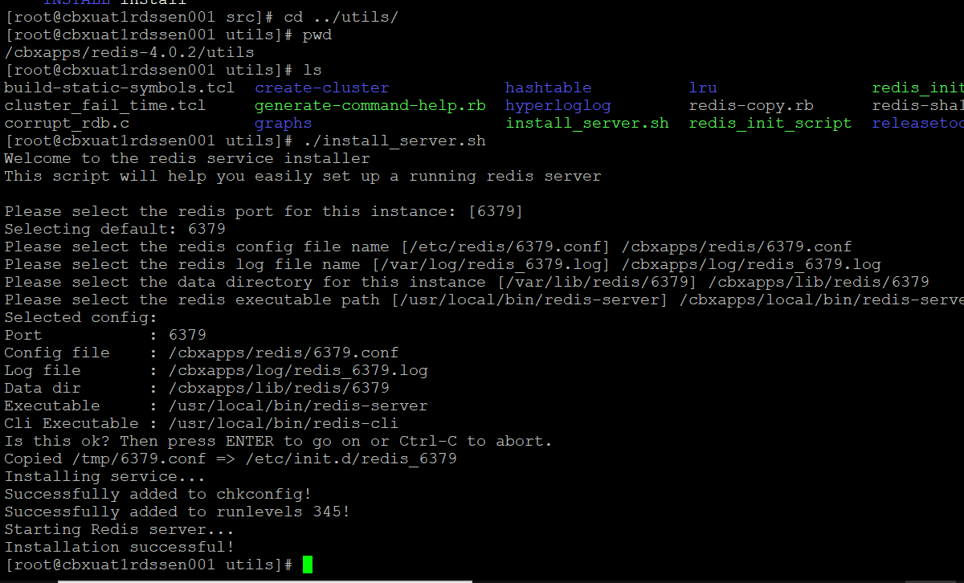

Start Redis
Use the command to start redis – sudo /etc/init.d/redis_6379 start
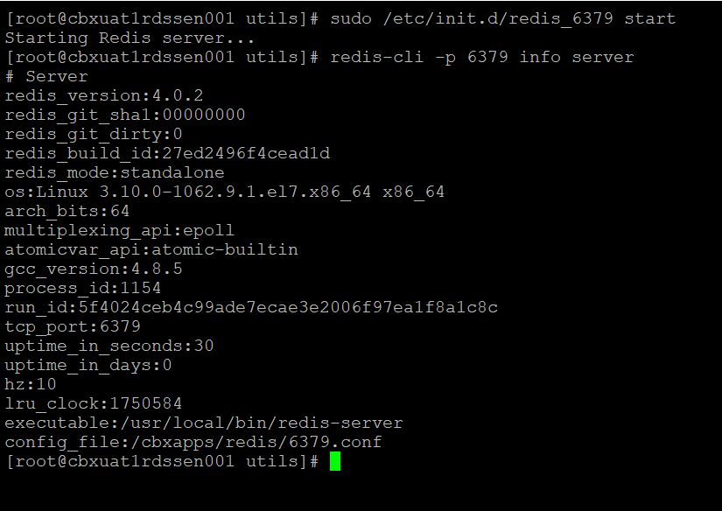

Stop Redis
Use the command to stop redis – sudo /etc/init.d/redis_6379 stop
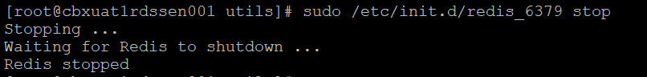

Enabling Authentication
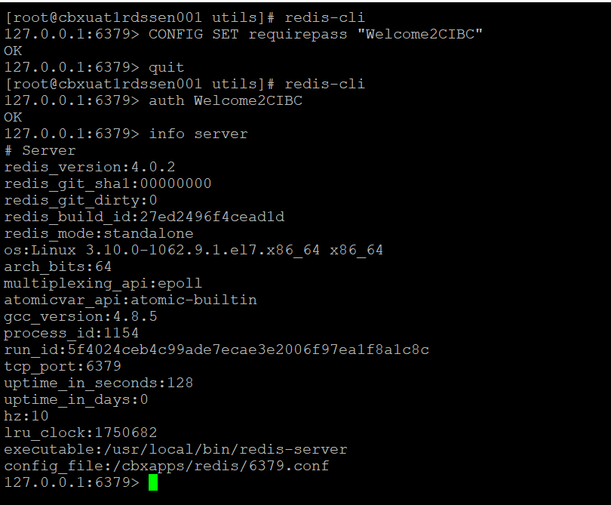

Displaying Redis Server Info
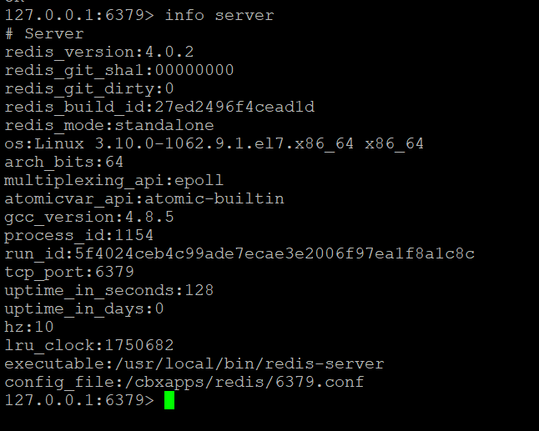

Validation

Step 1 : Ensure Redis is running
- Log in to Redis server (172.16.12.70) and enter the below command to verify redis is running
ps -ef |grep redis
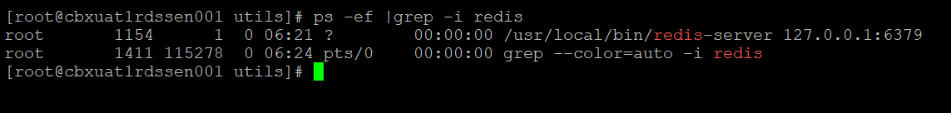

or - sudo /etc/init.d/redis_6379 status
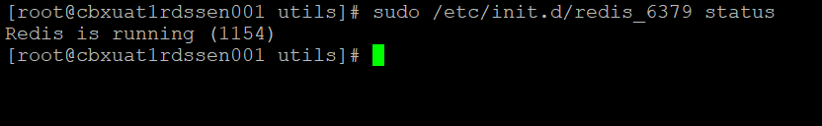

Host and port Details
REDIS_PASSWORD="************"
REDIS_HOST="************"
REDIS_HOST ADDRESS="************"
REDIS_PORT="6379"
REDIS_PROTOCOL="http"

Redis config file changes done during microservices deployment to enable ARO to connect with redis server.
Go to /cbxapps/redis/6379.conf
Change #1 ) bind 127.0.0.1 ===> changed to ===> bind 0.0.0.0
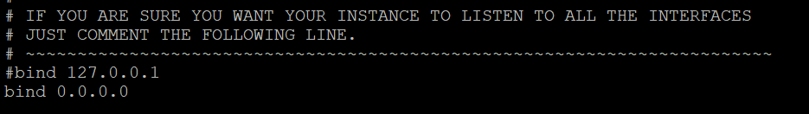

Change #2 ) requirepass foobared ===> uncommented and changed to ===> requirepass "redispassword"
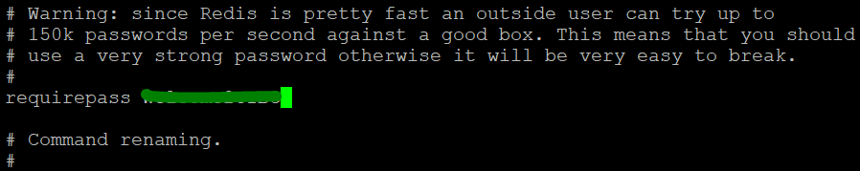
Save and exit the file and restart the redis.
After Enabling the authentication, stop and start of redis by this way:
