**Lab Instructions**

**Part 1**: **Written Portion:**

1. Write a 1-page APA formatted essay explaining each IP type (class A, B, and C). Include specifics on the amount of networks and hosts available in each type.
2. Review all lecture notes and videos from this unit’s LabSim. Write a 3-paragraph summary of what was covered.

**A.**

IP addresses are 8 bits or 4 bytes long and the maximum amount of IP addresses in the IPv4 address scope is 4,294,967,296 (IPv6 has much more, uses hex) or the maximum of a 32-bit number (2^32). Classful IP addressing divides a network into classes with fixed network values. This is opposite to classes IP addressing which uses the network values as variables rather than fixed values. Class A uses the address space of 1.0.0.1 - 126.255.255.254 and can use any subnet mask. This is because class A addresses only require the first bit (11111111) to be on, which gives it the the most hosts. There can be up to 16 million hosts on 127 networks which makes this addressing class commonly used in larger organizations where upscaling and numerous systems/addresses are required. Class B addresses range from 128.1.0.1 - 191.255.255.254 and require the first two networking bits to be on (255.255.0.0). This addressing class also allows for up to 65,000 hosts on 16,000 networks making it another viable option for an organization that may need a lot of addresses. Class C addresses range from 192.0.0.1 - 223.255.255.254 and require the first three networking bits to be on (255.255.255.0). Class C addresses are commonly used in home or small offices since its addressing scope is much smaller. Type C addresses can support up to 254 hosts across 2 million networks. There are also class D and E addresses, Class D uses the 224.0.0.0 to 239.255.255.254 addressing scope and is used for multicast applications. Multicast on this sense is used by certain network device providers (Cisco as example) to send messages to systems on the backend. Not to be confused with multicast, broadcast and unicast transmissions. Class E addresses use the 244.0.0.0 - 254.255.255.254 scope and are used for research, future, an undefined purpose by the Internet Engineering Task Force.

It is also important to note that classful private ip addresses cannot be used or assigned as the public address handed out through NAT. Attempting to use a 192.168.1, 172.16 or 10. public address will not work as it is reserved for private use. Generally, the public IP will be provided by an ISP to ensure its validity as they are the one ones who manage their public addresses.

**B.**

Section 3.2 dealt with IPv4 address classes and their addressing scopes. It went over the address ranges in them that are reserved for private use as well (10.0.0.0, 192.168.0.0, 172.16.0.0). NAT or network address translation is responsible for assigning the public IP of the default gateway (router that provides in the connection to the internet, closest to WAN) to LAN devices. All private IP addresses will generally have the same public IP address unless an additional public IP is purchased from an ISP. Static routes will need to be setup in this scenario for the NAT to function properly. This additional addressing information is also provided by the ISP.

Section 3.3 went over binary conversions, subnetting and the math behind it. Such a example of the math to subnetting would be the equation 2^# of 1s in host portion to determine the number of subnets. It went on to talk about what a subnet is and how it divides networks into segments connected by a router. The only way subnets can communicate is through a vlans or forwarding out ports of a hosts in one subnet and making that service or protocol available through the WAN address of that second router. Subnetting is also not the only possible way to separate networks, this can also be achieved through using multiple routers. Multiple routers can be used to hand out addresses within different scopes and communicate through their WAN addresses.

To sum up the two sections went over IPv4 addresses, classes and segmenting a network through subnetting.3.3.4 provided an especially useful chart which displayed information about various subnet masks without needing to do the math and conversion for /20 to /30 masks. The two sections provided the necessary information for an individual to be able to identify different IPv4 addresses and divide a network through subnetting.

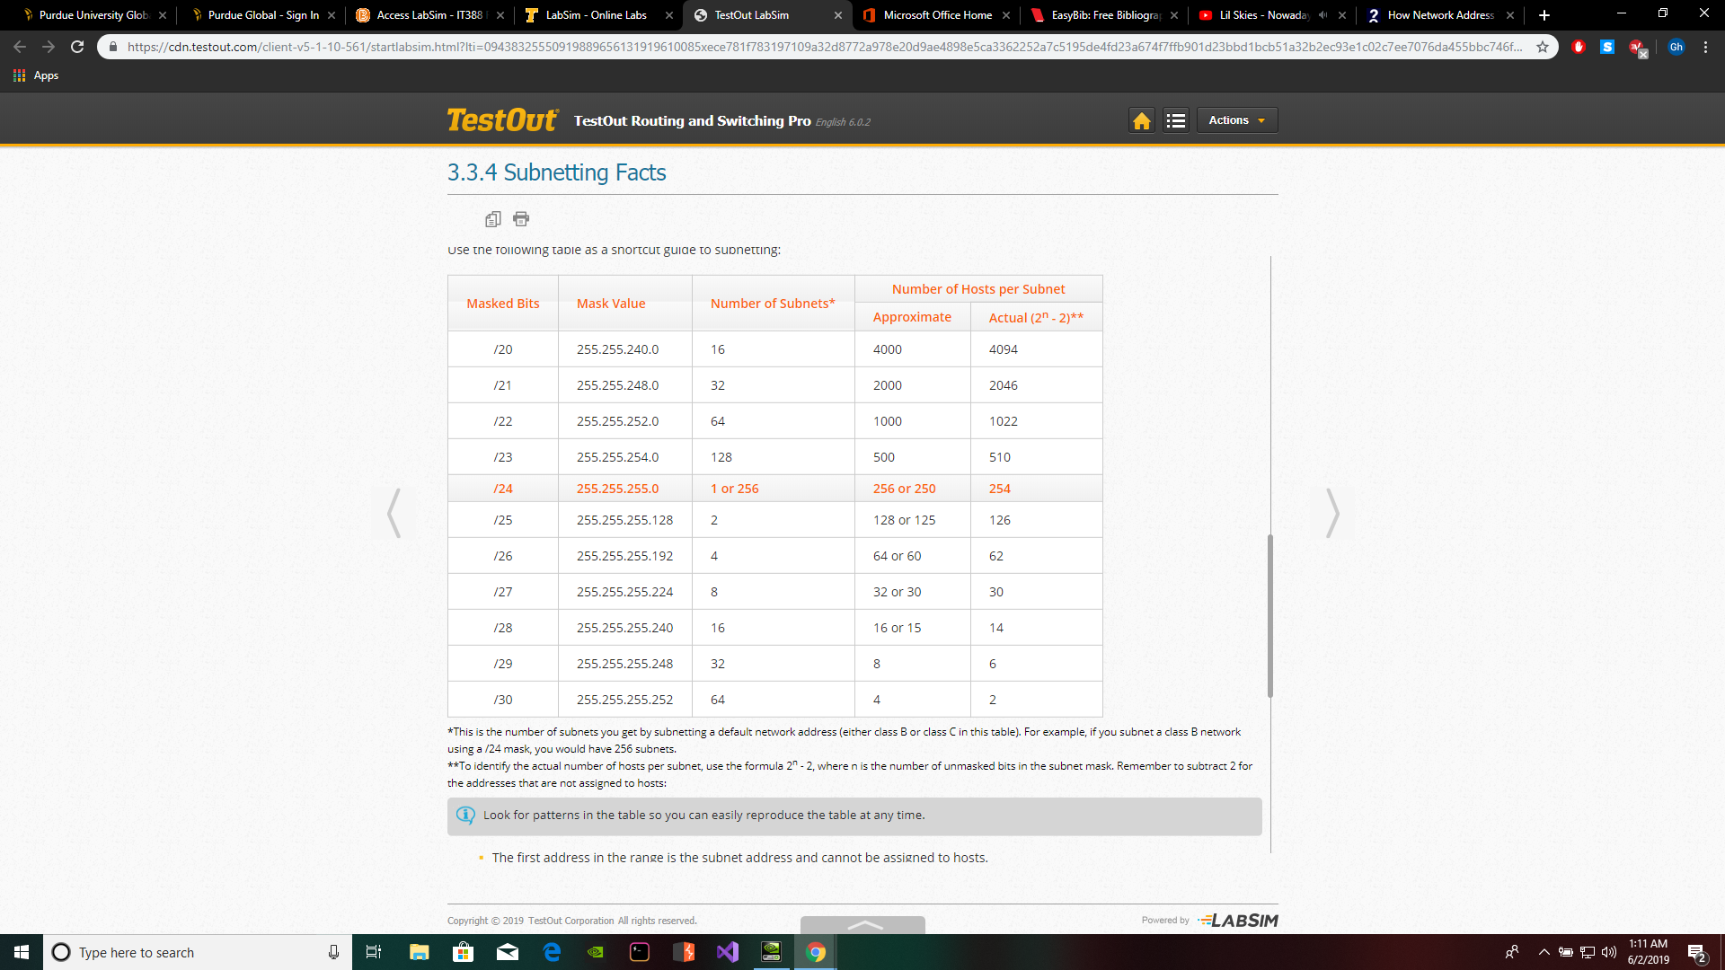

“Computer Network | Difference between Unicast, Broadcast and Multicast.” *GeeksforGeeks*, 12 Feb. 2018, www.geeksforgeeks.org/computer-network-difference-unicast-broadcast-multicast/.

“Difference Between Broadcast and Multicast (with Comparison Chart).” *Tech Differences*, 15 Feb. 2017, techdifferences.com/difference-between-broadcast-and-multicast.html.

“What Is IP (Internet Protocol)?” *Computer Hope*, 31 Jan. 2019, www.computerhope.com/jargon/i/ip.htm.

Tyson, Jeff. “How Network Address Translation Works.” *HowStuffWorks*, HowStuffWorks, 2 Feb. 2001, computer.howstuffworks.com/nat.htm.

**Part 2: LabSim:**

Complete the following in LabSim and submit the required screenshots, along with Part 1, to this unit's lab Dropbox. Take a screenshot after each lab practice subsection and then copy and paste all the screenshots into the same document you use for Part 1.

3.2.6 Practice questions- Take screenshot

3.3.5 Practice questions- Take screenshot

