PL-SQL Comments
Single-line comments:
-- single line
-- comments
Multi-line comments:
/*
multi line
comments
*/
PL-SQL Variable Declaration

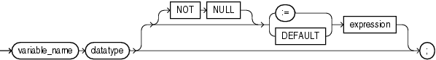

- Global v/s Local Variables

DECLARE
-- global variable
x number := 10;
BEGIN
dbms_output.put_line('x : ' || x);

DECLARE
-- local variable
x number := 20;
BEGIN
dbms_output.put_line('x : ' || x);
END;
END;

PL-SQL Blocks
Syntax

[declare]
<variables>,
<constants>
<cursors>,
<user defined exceptions>
begin
<sql statements>
<pl/sql statements>
[exception]
<action to be performed when an error occurs>
end;

