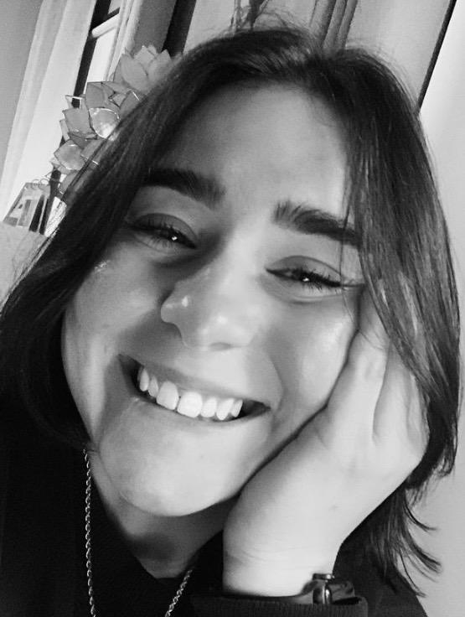
Author
Nicole Pilolli

Nicole Pilolli is a local author who published her first children’s book, Josephine’s Trip to the Beach in February 2023. A graduate of Youngstown State University as well as a Boardman High School, Nicole is a daughter, sister, and mother to a rescue cat named Cat. When she is not working at her 9-4, you can find her reading, walking in the park trying to listen to the many podcasts she subscribes to, or shopping at Target for nothing she really needs. Nicole took her chance at writing her first children’s book after she got inspired by one of her best friends and her daughter. Please enjoy her book where you will follow Josephine’s lovely story about spending time with family and honoring those we lost.

Josephine’s Trip to the Beach is available on Amazon! 