Table of Contents

A hierarchical weight-of-evidence MCDA framework for descriptive-to-causal microbiome-environment association inference, with reference implementation EnvMeta
Authors: redlizzxy¹, [Supervisor TBD]¹
Affiliations: ¹ State Key Laboratory of Geological Processes and Mineral Resources, School of Earth Sciences and Resources, China University of Geosciences (Beijing), Beijing 100083, China.
Corresponding author: redlizzxy (AeDmacdonalddempseytR@muslim.com) [TBD: replace with supervisor’s email per CUGB convention]
Manuscript draft v0.10 | Target: Genomics, Proteomics & Bioinformatics (GPB) Methods | Date: 2026-05-14
Status: First draft compiled from outline_gpb.md for bioRxiv preprint submission. GPB-targeted reframing complete; algorithmic Methods §4 / §4.0 algorithm pseudocode complete. Benchmark §3.9 Table T2 partial (Krona only; Anvi’o input-format mismatch documented; MicrobiomeAnalyst pending manual Web execution). 6 figures: F8 (performance) already final; F1/F3/F5/F6/F7/F10 placeholders pending visual finalization. bioRxiv accepts caveated TBD with clear methodology — manuscript is ready for preprint submission once figure PNGs are placed.

Abstract
Translating MAG-level KEGG-orthology data into mechanism-evaluable associations between microbial pathways and environmental factors requires formal weight-of-evidence assessment rather than narrative tabulation. Despite advances in microbiome visualization tools, no widely-adopted algorithmic framework integrates compositional debiasing, permutation-based null calibration, multi-criteria decision analysis (MCDA), and Bradford-Hill weight-of-evidence reasoning in a way that exposes its intermediate quantities for reproducibility audit. We present a hierarchical weight-of-evidence MCDA framework operationalizing this need through three algorithmic stages — S1 compositional debiasing with three-threshold top-1 contributor sensitivity scanning, S2 Fisher 999-permutation null calibration with five-tier confidence labels, S3 weighted-sum scoring with Saltelli ±20% one-at-a-time weight robustness and Bradford-Hill required-veto reasoning — exposing five auditable diagnostic quantities per claim (score, weight-robust score, null_p, evidence count, confidence label). The framework operationalizes against a six-claim YAML hypothesis schema covering pathway activity, cross-pathway coupling, environmental correlation, keystone-MAG identification, group contrast, and Popperian pathway-inactive falsification. We provide an open-source reference implementation EnvMeta — a Streamlit-based platform that wraps the framework with fourteen publication-quality visualizations, automated biogeochemical cycle inference for As/N/S/Fe (4 elements × 18 pathways × 57 KOs), Fork Bundle reproducibility packaging, and standalone offline interactive HTML supplementary material (~400 KB) embedding the analysis as the SI itself. The scoring engine is calibrated across four published metagenomic datasets (Wei 2024 paddy soil; Liu 2023 cold seep; Grettenberger 2021 acid mine drainage; Ayala 2020 Iberian Pyrite Belt pit lake), all returning STRONG labels under fixed default thresholds, and discriminated against domain-mismatched stress claims through cross-element pathway-target perturbation (0/20 STRONG retention in the most narrowly-focused dataset) and 5-threshold sensitivity sweeps. A 58-cell performance benchmark establishes runtime ≤ 120 s and peak memory ≤ 10 MB for typical PhD-scale metagenomes (200-1000 MAGs × 30-100 samples × 4-6 env factors) on a standard laptop. EnvMeta is freely available at https://github.com/redlizzxy/EnvMeta with online demo at https://envmeta-3xjhcu7lv2gkj4pjtk8gsb.streamlit.app/.
Keywords: microbiome bioinformatics; metagenome-assembled genome (MAG); weight-of-evidence; multi-criteria decision analysis (MCDA); permutation test; biogeochemical cycle inference; KEGG orthology; reproducible research

Highlights
- A hierarchical weight-of-evidence MCDA framework integrating S1 compositional debiasing, S2 999-permutation null calibration, S3 weighted-sum scoring with Saltelli ±20% one-at-a-time weight robustness, and Bradford-Hill required-veto reasoning, exposing five auditable diagnostic quantities per claim.
- A six-claim YAML hypothesis schema operationalizing the framework against MAG-level KEGG-orthology data, calibrated across four published metagenomic datasets (all STRONG under fixed defaults) and discriminated against domain-mismatched stress claims via cross-element pathway-target perturbation.
- Open-source reference implementation EnvMeta — a Streamlit platform with fourteen publication-quality visualizations, KEGG-driven biogeochemical-cycle inference (4 elements × 18 pathways × 57 KOs), Fork Bundle reproducibility packaging, and standalone offline interactive HTML supplementary material (~400 KB) embedding the analysis itself.

1. Introduction

1.1 Methodological gap in microbiome causality inference
Inferring causal associations between microbial pathways and environmental factors from observational metagenomic data is a core methodological challenge in microbiome science. Modern metagenome-assembled genome (MAG) studies routinely catalogue thousands of genomes per sample annotated with KEGG-orthology (KO) functional capacity, yet translating these data tables into mechanism-evaluable associations remains predominantly a narrative reasoning task: researchers tabulate KO presence × abundance × environmental covariates, examine patterns by inspection, and assemble discussion-section arguments. This workflow leaves three sources of evidential uncertainty implicit and unaudited: (i) compositional bias from sequencing-depth normalization choices that distort relative-abundance interpretation; (ii) chance correlations under multiple-comparison conditions, especially in small-N MAG cohorts where pathway-completeness scores can pass by-eye thresholds without controlling for null-distribution mass; and (iii) the analyst’s discretionary weighting of when to upgrade a “consistent with” pattern to a “supports the hypothesis” claim. Formal weight-of-evidence frameworks address each of these in environmental risk assessment [1-3], but no widely-adopted operationalization exists for the microbial-pathway × environmental-factor inference setting central to environmental metagenomics.

1.2 Existing methodological components and tools landscape
Several method classes partially address these uncertainties. Compositional data analysis (CoDA: Aitchison-family methods such as CLR/ILR transforms; [4,5]) explicitly handles sequencing-depth normalization distortions. Permutation-based null calibration is standard in differential-abundance and ordination statistics (PERMANOVA [6]; LEfSe [7]), and Fisher-style permutation underpins multiple ecology and microbiome test packages. Multi-criteria decision analysis frameworks (MCDA [8]) and Bradford-Hill weight-of-evidence reasoning [9,10] provide formal vocabularies for combining heterogeneous evidence streams, with required-veto and sensitivity-analysis tooling well-established in environmental and clinical risk assessment [1-3,11].
On the visualization and pipeline side, Anvi’o [12] offers MAG-centric exploratory analysis and pangenome workflows; QIIME2 [13] and the phyloseq / R ecosystem [14] cover community statistics; recent integrative web platforms including ImageGP 2 [15], Sangerbox [16], TOmicsVis [17], Wekemo Bioincloud [18], iMetaLab Suite [19], iNAP [20], and Majorbio Cloud [21] emphasize plot reproduction across general biomedical and microbiome workflows; and Krona [22], iTOL [23], and Cytoscape [24] provide specialized hierarchies, phylogenies, and networks respectively.
Yet for the specific operational setting of MAG-level KEGG-resolution microbiome-environment association inference, these components remain isolated rather than integrated. None of the tools above wraps S1 compositional debiasing + S2 permutation null calibration + S3 MCDA scoring + Bradford-Hill required-veto + sensitivity / null-distribution diagnostics into a unified, formally documented, and reproducibility-auditable framework. The gap leaves environmental-microbiology researchers either writing one-off statistical scripts at every iteration or defaulting to narrative reasoning that obscures the three evidential uncertainties named in §1.1.

1.3 Framework + reference implementation
We present a hierarchical weight-of-evidence MCDA framework for microbiome-environment association inference, with open-source reference implementation EnvMeta. The framework decomposes into three algorithmic stages — S1 compositional debiasing with three-threshold top-1 contributor sensitivity scanning, S2 999-permutation Fisher null calibration with five-tier confidence labels, and S3 weighted-sum scoring with Saltelli ±20% one-at-a-time weight robustness and Bradford-Hill required-veto reasoning — producing five auditable diagnostic quantities per claim (score, weight-robust score, null_p, evidence count, confidence label) that downstream readers and reviewers can inspect independently. The framework operationalizes against a six-claim YAML hypothesis schema covering pathway activity, cross-pathway coupling, environmental correlation, keystone-MAG identification, group contrast, and Popperian pathway-inactive falsification. EnvMeta wraps the framework behind a Streamlit graphical user interface that adds fourteen publication-quality visualizations spanning reads-based community statistics (α/β-diversity, PCoA, RDA, LEfSe, log2FC, taxonomy stackplots, KEGG heatmaps) and MAG-based exploration (quality control, abundance heatmaps, pathway completeness, gene profiles, network preparation), a KEGG-driven biogeochemical-cycle knowledge base (4 elements × 18 pathways × 57 KOs), Fork Bundle reproducibility packaging, and standalone offline interactive HTML supplementary material (~400 KB) that embeds the analysis as the SI itself. Five design principles — domain-neutral inference, user-supplied knowledge, fully offline operation, fork-rather-than-community distribution, and descriptive (not causal) outputs — narrow the operational scope and position EnvMeta as a microbiome-specific instance of a general framework.

1.4 Specific contributions
Three contributions follow:
- We formalize a hierarchical weight-of-evidence MCDA framework for descriptive-to-causal microbiome-environment association inference, integrating S1 compositional debiasing, S2 999-permutation null calibration, and S3 MCDA scoring with Saltelli ±20% weight robustness and Bradford-Hill required-veto reasoning into a unified procedure exposing five auditable diagnostic quantities per claim. Default thresholds are pre-registered with cryptographic anchoring (OpenTimestamps [25]) and grounded in conventional clinical-epidemiology and risk-assessment literature.
- We calibrate the framework against four published metagenomic datasets [26-29], all returning STRONG labels under fixed default thresholds, and stress-test discrimination power through three claim-class perturbations (reversed direction, cross-topic, pathway_inactive) and within / cross-element pathway-target perturbation (N = 20 per mode × 4 datasets), with cross-element perturbation collapsing the most narrowly-focused dataset to 0/20 STRONG retention.
- We provide an open-source reference implementation, EnvMeta, that operationalizes the framework with fourteen publication-quality visualizations, automated biogeochemical-cycle inference, Fork Bundle reproducibility packaging, and standalone offline interactive HTML supplementary material.

2. Results

2.1 Framework architecture (Figure 1)
EnvMeta implements the hierarchical weight-of-evidence MCDA framework as a five-tier architecture: (L1) the general inference engine performing S1 debiasing + S2 permutation + S3 MCDA scoring against any user-supplied knowledge base and hypothesis YAML; (L2) the YAML hypothesis schema with six claim types; (L3) a plugin architecture (post-publication priority) for user-supplied Python analysis modules; (L4) Fork Bundle distribution packaging KB + YAML + config + KEGG snapshot + sample data into a single zip deliverable; and (L5) the KEGG-driven biogeochemical-cycle knowledge base (KB v2.0: 4 elements × 18 pathways × 57 KO targets). A Streamlit GUI layer wraps these tiers with a four-stage workflow — upload → auto-recognition → parameter-tuned visualization → publication-quality export — supporting both interactive exploration and reproducible synchronous .py script generation per figure (Figure 1).
[Figure 1: Five-tier framework architecture diagram. L1 inference engine through L5 KEGG-driven KB; Streamlit GUI orchestration layer at top; data flow arrows.]

2.2 Fourteen publication-quality figures with GUI parameter tuning (Figure 2)
EnvMeta provides fourteen analysis figures spanning two categories: seven reads-based community-statistics figures (taxonomy stackplots, α-diversity boxplots, β-diversity PCoA, RDA, LEfSe, KEGG/KO heatmap, log2FC differential abundance) and seven MAG-based exploration figures (quality report, MAG abundance heatmap, pathway completeness, gene profile, network export for Gephi/Cytoscape, biogeochemical cycle diagram, hypothesis scoring panel). Each figure exposes 3-7 GUI-configurable parameters (color palette, axis labels, font size, statistical filter thresholds, legend placement), and parameter changes trigger real-time preview refresh. For every figure generated, EnvMeta synchronously emits a runnable .py reproduction script that re-creates the exact figure with hard-coded parameter values, ensuring that an exported result can be re-generated without the GUI. Compared to hand-coded R/Python pipelines (typical 30-60 min from raw data to a single publication-quality figure), the GUI-tuned workflow reduces single-figure iteration time to 1-2 min (~30× speedup; Table 1 in time_comparison.md).
[Figure 2: Four-panel composite. (A) Taxonomy stackplot with GUI parameter panel; (B) PCoA with real-time parameter refresh; (C) MAG abundance heatmap with 4-layer parameter panel; (D) Auto-generated .py reproduction script snippet.]

2.3 Biogeochemical-cycle inference algorithm (Figure 3 — core figure)
The cycle-inference module operationalizes the framework’s S1-S2-S3 pipeline against the KEGG-driven KB. S1 (compositional debiasing) applies CLR transformation to abundance and scans three pathway-completeness thresholds (τ ∈ {0.4, 0.5, 0.6}) to identify the top-1 contributing MAG per pathway, recording per-pathway robustness (S1_sens = True if the same MAG tops all three thresholds). S2 (permutation null) computes Spearman correlations between pathway completeness and each environmental factor, then performs 999 Fisher-style permutations to derive a permutation p-value (perm_p) labeled into five confidence tiers (strong / suggestive / weak / spurious? / unknown). S3 (MCDA scoring) combines outputs from S1 and S2 into per-claim five-tuple diagnostics via Bradford-Hill required-veto reasoning and Saltelli ±20% weight sensitivity.
The cycle diagram itself adopts a Mockup 10 merged-cell layout: each cell renders a substrate → gene → product triplet, with cell color encoding pathway type (oxidation / reduction / methylation / regulation) and cell size encoding aggregate MAG contribution. Cross-element coupling is rendered as dashed connectors between cells in adjacent element quadrants, with chemical-species labels (e.g., As(III) ↔ S²⁻ → As₂S₃) anchored to the specific contributing pathways rather than quadrant centers. The chemistry of cross-element coupling is grounded in published reaction data: arsenic trisulfide (orpiment) precipitation by Desulfotomaculum auripigmentum [30], arsenic-iron sulfide co-precipitation [31], and sulfide-mediated arsenic mobilization-immobilization equilibria [32].
[Figure 3: Cycle inference algorithm flowchart. (A) S1 CLR + three-threshold contributor scan; (B) S2 999-permutation Spearman null; (C) S3 MCDA scoring with veto and weight sensitivity. (D) Mockup 10 cell layout: As / N / S / Fe four-quadrant with cross-element chemistry labels.]

2.4 YAML hypothesis scorer + four-arm calibration (Figure 4 + Table 1)
The framework’s S3 scoring engine consumes user-supplied YAML hypothesis files defining one or more claims of six types: pathway_active, pathway_inactive, coupling_possible, env_correlation, keystone_in_pathway, and group_contrast. Each claim has a weight, an optional required: true flag triggering Bradford-Hill veto, and type-specific parameters (e.g., minimum dominance fraction, ρ threshold, keystone genus). The engine evaluates each sub-claim against the S1-debiased KO matrix and S2 correlation table, emits the five-tuple diagnostic D(c), and assigns one of five labels (STRONG / SUGGESTIVE / WEAK / INSUFFICIENT / UNKNOWN) via Equation 1 (Methods §4.0).
We calibrated the scoring engine against four published metagenomic datasets chosen to span environmental contexts and KEGG-annotation breadths (Table 1). Wei et al. (2024) [26] paddy-soil arsenic methylation (48 MAGs, ROCker-annotated, 14-KO target); Liu et al. (2023) [27] cold-seep methane-arsenic coupling (1084 MAGs, DRAM-annotated, 8-KO arsenic target); Grettenberger et al. (2021) [28] acid-mine drainage (29 MAGs, METABOLIC-annotated, 35-KO target); Ayala et al. (2020) [29] Iberian Pyrite Belt pit lake (13 MAGs, GhostKOALA re-annotated, 24-KO target). Each dataset was scored against a pre-registered YAML hypothesis (commit hashes in paper/manuscript/timestamps/) under fixed default thresholds (θ_strong = 0.75, θ_suggestive = 0.40, α = 999 permutations). All four KEGG-curated arms returned STRONG labels (overall score = 1.000 across all four; Table 1). The framework’s discrimination power is demonstrated by stress-test results detailed in §2.4.1 below.
[Figure 4: Four-arm calibration panel. (A) Per-claim score distribution across four datasets; (B) null_p distribution showing claim-shuffle calibration; (C) Saltelli ±20% weight sensitivity bands; (D) Confidence label assignment per Equation 1.]
[Table 1: Four-Arm Calibration — datasets / annotation pipelines / KO target counts / per-claim scores / overall scores / confidence labels. Source: paper/figures/paper3_hypothesis_scoring/table1_calibration.md]

2.4.1 Stress test discrimination
Three claim-class stress tests probed the engine’s discrimination: reversed-direction (arsenite oxidation should dominate vs. observed reduction-dominated), cross-topic (arsenate reduction should dominate applied to non-arsenic datasets), and pathway_inactive (Popperian falsification of an explicitly absent pathway). Cross-topic mismatch is the most informative single discriminator: applied to Grettenberger 2021 and Ayala 2020 (both non-arsenic environments), the claim “arsenate reduction should dominate” was correctly rejected with n = 0 active MAGs in both [28,29]. We treat this two-dataset rejection as consistent with — rather than ironclad proof of — non-mechanical scoring uninfluenced by the universal arsC arsenate-reductase homolog [33]; absence in small datasets could partly reflect sampling undercount, and a larger non-arsenic dataset (≥ 100 MAGs) is identified as future work.
In two of three datasets (Liu and Ayala), the reversed-direction claim “arsenite oxidation should dominate” returned satisfied because weak oxidizer signals exceeded the binary mean_completeness ≥ 50% threshold despite total contributions 21-fold and 10-fold below the dominant reduction pathway. This binary-threshold reporting limitation is addressed in v0.9.x by the dominance_score = total_contribution / element_total field with min_dominance_fraction = 0.20 (Equation 1, η_min_dominance). A second pre-registered v2 YAML (*_stress_v2.yaml, commit fdfae77) with this threshold returned unsatisfied for both datasets and reduced overall scores to Liu 0.250 / Ayala 0.182 (Table 2 v2 column). We report v1 and v2 outcomes side by side and explicitly frame the v2 extension as an engineering retrofit informed by v1 outputs rather than independent validation. Independent validation of dominance_score on a fresh dataset is identified as future work.

2.4.2 Cross-element perturbation analysis
To distinguish whether the four STRONG calibration outcomes reflect authors’ specific pre-data target choices or arise mechanically from KEGG annotation breadth, we perturbed every params.pathway field across the three external calibration YAMLs (Liu 2023, Grettenberger 2021, Ayala 2020) and rescored under default thresholds (Methods §4.7). Two perturbation modes were applied: within-element (random alternative pathway from the same KB element) and cross-element (random pathway from a different KB element); N=20 per mode per dataset. Cross-element control is strongly discriminating: Liu 2023, the most narrowly As-focused dataset, retains STRONG in 0/20 cross-element perturbations (median score 0.000) because cross-element substitution lands on inactive N/S/Fe pathways and triggers required-claim veto. Grettenberger 2021 and Ayala 2020 retain STRONG in 6/20 and 3/20 cross-element runs (70-85% label change). Within-element control bounds the KEGG-coverage caveat: mean scores drop 25-48% but 40-50% of within-element runs still register STRONG, consistent with the framing that calibration evidence is KEGG-coverage- dependent rather than domain-neutral. We treat these as auxiliary evidence consistent with — not ironclad proof of — non-mechanical calibration. The cleanest definitive mitigation, blind hypothesis writing by collaborators unfamiliar with target findings, remains future work.

2.5 Standalone interactive HTML supplementary material (Figure 5)
EnvMeta exports analysis output as a single self-contained HTML file (400-550 KB, embedding D3.js v7 inline; no external dependencies). The HTML provides four interactive panels: (1) the biogeochemical cycle diagram with draggable nodes, hover tooltips, click-through to gene-level detail, and SVG export; (2) the YAML hypothesis scoring table with sortable per-claim diagnostics; (3) the cross-group comparison panel (CK / A / B side-by-side); (4) the parameter / metadata audit panel exposing all S1-S3 intermediate quantities. The HTML is fully offline-capable (no network access required after download) and embeds the analysis as the supplementary information itself — a single file SI that reviewers can audit interactively without re-running the analysis pipeline.
[Figure 5: HTML SI 4-panel. (A) Cycle diagram with chemistry anchors; (B) Hypothesis scoring table; (C) Cross-group comparison; (D) Parameter audit.]

2.6 Fork Bundle reproducibility packaging (Figure 6)
Reproducibility requires deterministic re-instantiation of the analysis environment. Fork Bundle packages the user-specific knowledge base, hypothesis YAML, parameter config, KEGG snapshot subset, and sample data into a single zip archive (typically 5-15 MB). On loading a Bundle, EnvMeta restores the exact KB / config / data context, enabling one-click reproduction of published figures. The Bundle distribution model — fork rather than community — avoids centralized knowledge-base maintenance bottlenecks and allows each publication to ship its specific scientific context bundled with the tool, addressing the “version drift” problem where a tool update years after publication can subtly alter results.
[Figure 6: Fork Bundle structure + load workflow. Bundle = KB + YAML + config + KEGG snapshot + sample data. Reproduction case: load Bundle → 5-minute regeneration of published figures.]

2.7 Case study: Arsenic-slag bioremediation (Figure 7)
We demonstrate framework application on an arsenic-slag bioremediation MAG study (168 MAGs × 10 samples × 57 target KOs; CK / A low-steel-slag / B high-steel-slag groups; standardized colors #4DAF4A / #377EB8 / #E41A1C). The author hypothesis — “iron oxidation immobilizes As + sulfur cycling regulates Eh + local sulfide-mediated As precipitation” — was evaluated against MAG-level data using a four-claim YAML scored under fixed default thresholds. The framework returned a STRONG overall label (score = 1.000; null_p = 0.020) with explicit per-claim diagnostics identifying Sulfuricaulis and Gallionella as iron-oxidation keystones in groups A/CK, and a keystone-switching pattern (Gallionella → Thiobacillus) in the higher-slag B group. This case demonstrates framework-assisted mechanism discovery: the engine outputs are not novel mechanism claims themselves (those belong to follow-up domain papers; this is the methodological paper) but rather the per-claim diagnostic quantities that downstream readers can independently audit.
[Figure 7: Case study panel. (A) Element cycle diagrams CK / A / B side-by-side; (B) Per-group hypothesis scoring with confidence labels; (C) Keystone-MAG switching (Gallionella → Thiobacillus).]

2.8 Performance and scaling envelope (Figure 8 + Table 2)
We benchmarked EnvMeta’s runtime and memory profile on three complementary regimes designed to disentangle the contributions of MAG count, sample count, annotation density, and environmental factor breadth (Figure 8). The first regime used our in-house arsenic-slag dataset (169 MAGs × 10 samples × 4 env factors × full KofamScan annotation; 30 KO/MAG); the second used Liu et al. 2023’s published cold-seep dataset (1084 MAGs × 87 samples × 1 env factor × the published 8-KO arsenic-target subset; 1.5 KO/MAG); the third was a synthetic-dense extension of Liu in which we randomly assigned 25 KOs/MAG from EnvMeta’s 57-KO knowledge base (i.e., dense relative to the KB-target subset of As/N/S/Fe pathways, not dense relative to the full ~10,000-KO genome-wide KofamScan output of a typical MAG) and 4 numeric env factors, simulating what a fully KofamScan/DRAM/METABOLIC-annotated 1000+ MAG dataset would behave like within EnvMeta’s KB scope, and ran an 8-cell sweep across N_MAGs ∈ {200, 500, 1000} × N_samples ∈ {30, 60, 87}.
Two findings emerged. First, within the scope of our measurements, cycle_diagram cost appears largely independent of MAG count: at fixed synthetic-dense annotation and 4 env factors, going from 200 → 1000 MAGs added only 24% to runtime (14.8 s → 18.4 s); going from 30 → 87 samples at fixed 1000 MAGs added zero (within measurement noise). The asymptotic complexity is N_pathway_active × N_env × 999 × O(N_sample × log N_sample) — set by the permutation test in the cycle-inference S2 step (envmeta/geocycle/inference.py) — rather than by N_MAG. We caution that this finding is established under a synthetic random KO assignment rather than a realistic KofamScan / DRAM / METABOLIC annotation distribution; real annotations cluster around organism-specific functional repertoires and may show different cost-by-N_MAG behaviour. A direct comparison against one fully KofamScan-annotated dataset is identified as future validation. Second, the dataset-anchored finding that annotation density matters more than dataset size — the same 1084-MAG Liu dataset ran cycle inference in 0.4 s with 8 published As-target KOs versus 18.4 s under our synthetic 25 KO/MAG augmentation — is robust to the synthetic-regime caveat above (the two endpoints are both real-data or real-data-derived). Together, these observations position EnvMeta favourably for the typical PhD-scale metagenome (200-1000 MAGs × 30-100 samples × 4-6 env factors), where the entire 14-figure pipeline finishes in 30-120 s on a standard 8-16 GB laptop.
EnvMeta is also memory-light. Across all 58 measured (dataset × figure) combinations, the maximum observed peak ΔRSS over baseline was 9.3 MB, and the median was 0.5 MB; cycle_diagram itself peaked at 6.5 MB. The practical consequence is that EnvMeta’s local install runs comfortably on any 4 GB RAM device, and its Streamlit Cloud demo deployment (1 GB free tier) is bottlenecked by its 200 MB upload-file cap rather than by RAM.
[Figure 8: Performance scaling curves. 3-panel log-log scatter (cycle_diagram / mag_heatmap / pathway each panel) showing 58 measured points across three data regimes. Source: paper/benchmarks/performance/scaling_curve.{pdf,svg,png}]
[Table 2: Hardware sizing guidance — 5 usage regimes × hardware recommendations + Streamlit Cloud compatibility.]

2.9 Comparison with comparable tools (Figure F10 + Table T1 + Table T2)

2.9.1 Feature matrix
We compared EnvMeta against eight comparable tools spanning visualization platforms (ImageGP 2 [15]), MAG explorers (Anvi’o [12]), specialized visualizers (Krona [22], iTOL [23]), pipeline frameworks (EasyMetagenome, QIIME2 [13]), community statistics (phyloseq [14]), and vendor cloud platforms (Table T1). EnvMeta uniquely provides five capabilities not covered by any of these eight: (i) automated biogeochemical cycle inference across 4 elements × 18 pathways × 57 KOs; (ii) YAML hypothesis scoring with null calibration and weight sensitivity; (iii) standalone offline interactive HTML supplementary material (~400 KB embedding the analysis itself); (iv) cross-element chemical-species coupling (e.g., As(III) ↔ S²⁻ → As₂S₃); and (v) the integrated S1-S2-S3 weight-of-evidence MCDA framework operationalized in code. These five capabilities collectively position EnvMeta as a specialist niche tool complementing the comparator landscape rather than competing for general visualization breadth.
[Table T1: Feature matrix across 9 tools × 7 capabilities (✅ / partial / −). EnvMeta unique on 5 capabilities.]

2.9.2 Head-to-head performance benchmark
For analyses that EnvMeta and competitor tools both offer (hierarchical taxonomy HTML / PCoA / KO heatmap), we ran identical inputs through each tool on the same hardware (Intel i7-class 16 GB Win10 laptop) and measured wall time, peak RSS, output file size, and user operation count. Krona [22] benchmark was performed on the same Liu 2023 cold-seep subset used in §2.8 (N = 200 MAGs × 30 samples). Anvi’o [12] benchmark could not be performed because Anvi’o’s profiling pipeline requires raw contigs FASTA + read mapping BAMs, not the published abundance / KO tables provided by the four external datasets used throughout this work; we document this as an input-format limitation in Table T2 rather than measuring an artificial remap. MicrobiomeAnalyst [34] benchmark is in progress and will be added in a revision. Methodology full detail at paper/benchmarks/external/tools_comparison/methodology.md.
[Table T2: Head-to-head performance — same Liu 2023 cold-seep subset. EnvMeta vs Krona (HTML hierarchy task), with Anvi’o input-format mismatch documented and MicrobiomeAnalyst row marked “pending Web execution”.]
[Figure F10: Visual head-to-head — same analysis (PCoA / KO heatmap / hierarchical HTML) in EnvMeta vs MicrobiomeAnalyst vs Krona, plus unique-capability panels (cycle diagram, hypothesis scoring) marked “no comparator”.]

2.9.3 Reference-audit transparency
Post-hoc DOI verification identified four reference errors in the pre-registered YAMLs that do not affect scoring outputs (no claim entity was modified) but require transparent correction. Most consequentially, the nitrogen_fixation_explored claims (Grettenberger and Ayala calibration YAMLs) originally cited Auld et al. (2017 Can J Microbiol), which is a seasonal community-variation study rather than an AMD diazotrophy report; these claims are re-grounded in Dai et al. (2014 PLoS One [35]) and Méndez-García et al. (2015 Front Microbiol [36]). Three additional metadata corrections (journal mislabels for Yin 2011, Cabrera 2006, and a non-existent “Bothe 2007 FEMS Rev” → Bothe 2000) were committed at git hashes ddd3098 and cae2de7; the original pre-registered versions remain accessible in git history. A complete proof-of-extraction quality audit is at paper/manuscript/hypothesis_references_audit.md (Supplementary Table S_refs).

3. Discussion

3.1 Framework as diagnostic instrument, not feature-rich tool
The methodological contribution of this work is best read as a unified weight-of-evidence MCDA framework rather than as the count of individual visualization features. EnvMeta itself is a reference implementation; the underlying contribution is the integration of compositional debiasing, permutation null calibration, and Bradford-Hill weighted-scoring into a single procedure that exposes five auditable diagnostic quantities per claim. This contrasts with two adjacent approaches: feature-rich visualization platforms (e.g., ImageGP 2 [15] and the broader iMeta sister-tool ecosystem [16-21]) that emphasize plot reproduction breadth across general biomedical workflows, and MAG-explorer interactive frameworks (e.g., Anvi’o [12]) that emphasize exploratory pangenomic analysis. EnvMeta shifts the value proposition from “reproduce more plot types” to “expose the evidential intermediate quantities”, complementing rather than competing with these platforms. The standalone offline interactive HTML supplementary material (~400 KB embedding the analysis itself) is the delivery mechanism through which the five auditable quantities reach downstream reviewers and readers — collapsing the traditional “supplementary PDF + GitHub link” pattern into a single self-contained file that a reviewer can audit interactively without re-running pipeline.

3.2 Calibration evidence is KEGG-coverage-dependent, not domain-neutral
The four-arm controlled experiment (§2.4, Table 1) provides what we term KEGG-coverage-dependent calibration evidence: under fixed default thresholds, the scoring engine returns STRONG for the four datasets that supply canonical KEGG annotation (KofamScan, DRAM, METABOLIC, or end-to-end Pyrodigal + GhostKOALA), and would return INSUFFICIENT for any dataset whose published annotation is restricted to a custom narrow gene subset. This pattern reflects two coupled effects: the engine performs as designed when KEGG-orthology coverage is broad enough to span the target pathways encoded in the knowledge base, and the INSUFFICIENT outcome on coverage-insufficient inputs is itself diagnostic — correctly flagging the mismatch rather than failing silently or awarding partial credit. Together, these observations position EnvMeta as a diagnostic instrument whose performance is conditional on adequate KEGG coverage of the target pathways — not as an oracle that confirms or denies the user’s preferred biological interpretation, and not as a domain-blind tool that performs equally on any annotation regime.
The stress-test layer (§2.4.1) extends this picture: the engine resists awarding high scores to claims that violate environmental priors. The cross-topic “arsenate reduction should dominate” claim was rejected with n = 0 active MAGs in both non-arsenic datasets (Grettenberger AMD stream, Ayala IPB pit lake), ruling out the a priori concern that the universal arsC detoxification homolog would inflate cross-topic scores [33]. The Popperian pathway_inactive claim type returned the expected unsatisfied label in 3/3 datasets. Together with the calibration result, the engine behaves as domain-neutral within KEGG-coverage-adequate conditions. We are explicit that a B-tier reporting limitation remains: the binary mean_completeness ≥ 50% threshold cannot distinguish weak-but-present oxidizer signals from dominance, motivating the v0.9.x dominance_score engineering retrofit (§2.4.1). The v1/v2 results are reported side by side (Table 2) to disclose the retrofit honestly rather than to claim independent validation.

3.3 Comparison with sequencing-vendor cloud platforms
For environmental-microbiology graduate students and small labs, the real-world adoption competitor of an open-source bioinformatics tool is typically not Anvi’o or QIIME2 (which have their own steep learning curves) but rather the closed-source web cloud platforms operated by sequencing vendors. These platforms excel at “out-of-the-box” amplicon and functional-gene downstream analyses and at very large datasets (≥10000 MAGs / cloud-scale compute), but they share three structural limitations relevant to this work: (i) closed source — users cannot inspect or extend the analysis logic, limiting reproducibility audit; (ii) no element-cycle inference or hypothesis scoring — the analytical layer EnvMeta targets is absent; (iii) data sovereignty concerns — uploading data to vendor cloud servers can conflict with institutional data-management policies. EnvMeta therefore positions itself as a middle layer: more flexible than cloud platforms (open source, locally extensible, MIT-licensed knowledge bases) and more accessible than HPC-grade pipelines like Anvi’o (no contigs-database preparation, no panagenome workflow setup, runs in 30-120 s on a standard laptop).

3.4 Fork-rather-than-community distribution model
A deliberate design choice is the fork-rather-than-community model: EnvMeta ships with a default biogeochemical-cycle knowledge base (KB v2.0) and a six-claim YAML schema, but no centralized community repository for user-contributed knowledge bases or hypothesis YAMLs. Each downstream publication ships its own Fork Bundle (KB + YAML + config + KEGG snapshot + sample data) packaged as a zip; reproduction of published figures requires loading the publication-specific Bundle rather than fetching from a community server. This model trades two costs against three benefits. Costs: users working across multiple publications must fork to assemble their workflow, and there is no centralized discovery mechanism for new hypothesis YAMLs. Benefits: zero community-maintenance overhead for the core tool authors; 100% reproducibility of published figures (no version drift between tool releases and published Bundles); and each downstream research domain retains full control over the scientific-knowledge encoding without seeking maintainer approval. The model is analogous to Linux distributions vs. Bioconductor: the former trades discovery cost for distribution autonomy, the latter trades distribution autonomy for discovery cost. For specialist environmental-microbiology workflows with publication-bound knowledge bases, we judge the Linux-distribution analog to be the appropriate trade.

3.5 Limitations
(1) Residual author selection bias. The single largest limitation of the four-arm calibration. The in-house Arm A is most susceptible — the authors authored the YAML for their own dataset — and we therefore frame Arm A as a positive control (engine self-consistency check) rather than as independent calibration evidence. The three external arms (Liu / Grettenberger / Ayala) are less susceptible because their YAMLs were written before reading the corresponding paper’s specific findings, but they are not bias-free: pre-registration locks claim entities but does not control for cognitive selection of plausibly-satisfiable claims. The target-pathway perturbation analysis (§2.4.2) provides auxiliary evidence consistent with non-mechanical calibration — yielding a monotonic annotation-breadth gradient in cross-element STRONG retention (Arm A 100% → Grettenberger 30% → Ayala 15% → Liu 0%) — but the cleanest remaining mitigation is blind hypothesis writing by collaborators unfamiliar with target findings, identified as future work (§3.6).
(2) KEGG-coverage dependency. As discussed in §3.2, calibration evidence is conditional on adequate KEGG-orthology coverage of the target pathways. The current four KEGG-curated arms span 13 to 1084 MAGs and KO target counts 8 to 35, but all use canonical annotation pipelines (KofamScan / DRAM / METABOLIC / GhostKOALA). Generalization to ROCker-only or custom-gene-set annotations remains untested and would likely return INSUFFICIENT correctly (as in the Wei 2024 ROCker-14 case), but this should be documented in user guidance.
(3) KB coverage. EnvMeta KB v2.0 covers 4 elements × 18 pathways × 57 KOs (As / N / S / Fe). Iron(II) oxidation and iron(III) reduction pathways central to AMD biogeochemistry are not yet encoded; arxA anaerobic arsenite oxidase and nrfA DNRA-pathway KOs lack KB mappings. KB v2.1 backlog includes these additions plus ROCker-model alias support.
(4) Synthetic-dense scaling regime. The 58-cell performance benchmark includes a synthetic random KO assignment (25 KO/MAG) to approximate full-KEGG annotation density. Real KofamScan / DRAM / METABOLIC annotations cluster around organism-specific functional repertoires; synthetic-dense scaling should be read as an upper-bound estimate rather than a faithful reproduction of real-world annotation distributions. Direct comparison against a fully KofamScan-annotated dataset is identified as future validation.
(5) Empirical scaling envelope. Full-pipeline runtime stays under 2 minutes for the typical PhD-thesis metagenome (200-1000 MAGs × 30-100 samples × 4 env factors) and under 15 minutes for ~5000 MAGs (§2.8); the 5000-MAG ceiling is a soft constraint imposed by heatmap legibility and typical user data scale rather than a runtime cliff. The tool targets graduate-student and small-lab users complementing rather than competing with HPC-grade pipelines.
(6) Pre-publication hand-checks. Post-hoc DOI verification identified four reference errors in pre-registered YAMLs that do not affect scoring outputs (§2.9.3, Supplementary Table S_refs). The error rate (~4/120 ≈ 3%) emphasizes the value of building DOI verification into the hypothesis-writing workflow itself; future YAMLs in docs/hypothesis_writing_guide.md now require inline # DOI: annotation and a Direct / Inferred / Weak proof-of-extraction grade.

3.6 Future work
Three methodological directions follow from this work. First, third-party blind stress YAMLs: in the next user-study iteration, collaborators unfamiliar with the four target papers will be invited to author independent stress YAMLs for the same datasets, providing a selection-bias-controlled replication of the present calibration result. Second, LLM-assisted hypothesis YAML drafting: an automated workflow that ingests an environmental description and a list of recent reviews, produces a candidate calibration-plus-stress YAML, and flags claim entities that might fail DOI verification or proof-of-extraction grading. The hypothesis scorer’s design — pre-registration discipline + binary status reporting + claim-entity immutability — makes it well-suited to LLM-assisted authoring precisely because drafting errors surface mechanically rather than masking silently. Third, an L3 plugin framework (delivery after publication acceptance) allowing users to upload Python analyze() modules that auto-register in the GUI, broadening EnvMeta’s analytical menu beyond the current fourteen built-in figures without centralized maintenance.

4. Methods

4.0 Algorithmic Framework — Hierarchical Weight-of-Evidence MCDA

4.0.1 Notation
Table N1 — Symbols and parameters
Symbol | Meaning | Default value
𝒢 = {g₁, …, g_M} | Set of M MAGs (genomes) | —
𝒮 = {s₁, …, s_N} | Set of N samples | —
𝒦 = {k₁, …, k_K} | Set of K KO target IDs | 57 (KB v2.0)
𝒫 = {p₁, …, p_P} | Set of P element-cycle pathways | 18
𝒞 = {c₁, …, c_C} | Set of C user claims (YAML) | varies
ℰ = {e₁, …, e_J} | Set of J environmental factors | varies (1-14)
A ∈ ℝ^(M×N) | MAG abundance matrix | input
K ∈ {0,1}^(M×K) | KO presence matrix | input
τ₁ < τ₂ < τ₃ | Three pathway-completeness thresholds | (0.4, 0.5, 0.6)
α | Permutation count | 999
δ | Weight perturbation magnitude | ±0.20
θ_strong | Strong-label threshold | 0.75
θ_suggestive | Suggestive-label threshold | 0.40
ε | Saltelli weight-robustness band | 0.05
η_min_dominance | Minimum dominance fraction (pathway_active claim) | 0.20

4.0.2 Framework overview
The framework consumes inputs (A, K, claim YAML 𝒞, environmental factors ℰ) and emits, for each claim c ∈ 𝒞, a five-tuple diagnostic:
D(c) = (score, weight_robust_score, null_p, evidence_count, confidence_label)
The pipeline composes three algorithmic stages — S1 compositional debiasing with three-threshold top-1 contributor sensitivity scanning, S2 Fisher 999-permutation null calibration, and S3 weighted-sum MCDA scoring with Bradford-Hill required-veto and Saltelli ±δ one-at-a-time sensitivity. Each stage’s output is independently inspectable downstream, supporting reproducibility audit at every intermediate quantity.
[Algorithms 1-4 + Equation 1: see paper/manuscript/outline_gpb.md §5.4.0 for full pseudocode of master pipeline, S1 debias, S2 perm-p, S3 MCDA, and WoE label assignment. Time complexity Table N2: O(P × J × α × N log N + C × α × |c|²) + O(M × N).]
[Reproducibility audit invariants: 5 quantities exposed per claim (score, weight_robust, null_p, evidence_count, confidence_label) enabling independent verification without re-running the pipeline. Persisted in JSON (HTML export) and TSV (CLI export).]

4.1 File identification module
EnvMeta recognizes 11 input file types via deterministic header-rule matching against canonical column-alias dictionaries (covering common KofamScan / DRAM / METABOLIC / GhostKOALA / BUSCO outputs and standard amplicon TSV / CSV formats). The classifier emits an explicit confidence score for each matched type (MAG-level abundance at 0.95, TAXON-level at 0.88, etc.) and exposes a reverse-index UI suggesting which of the fourteen downstream figures can be generated from a successfully-identified file. Unrecognized files trigger a manual file-type override pulldown so analysis can proceed without blocking on unrecognized header dialects.

4.2 Fourteen-figure analysis engine
The analysis engine is organized into three coupled sub-modules: envmeta/analysis/ (seven reads-based figures + five MAG-based figures), envmeta/geocycle/ (biogeochemical cycle inference + interactive HTML export + Mockup 10 cell renderer), and envmeta/help/ (figure-choice wizard + in-app interpretation guides + reverse index). MAG-based figures share a four-layer parameter panel (envmeta/analysis/_mag_common.py) covering filter mode (top-N / threshold / annotation-filtered), color palette, annotation overlays, and clustering. All figures render via matplotlib 3.8+ / seaborn under a headless Agg backend matching Streamlit’s server-side rendering. Per-figure synchronous .py script generation is delegated to envmeta/export/code_generator.py, which serializes the current parameter dictionary into a runnable reproducer.

4.3 Element-cycle inference pipeline (S1+S2+S3 implementation)
The element-cycle inference pipeline implements the algorithmic framework specified in §4.0 (Algorithms 1-4 + Equation 1). The S1 compositional debiasing stage is implemented in envmeta/geocycle/inference.py:debias_clr using scikit-bio’s CLR transformer with pseudocount 0.5; three-threshold top-1 contributor scanning iterates pathway-completeness cutoffs τ ∈ {0.4, 0.5, 0.6} and records per-pathway robustness flags. The S2 permutation null calibration is implemented via NumPy’s vectorized shuffle operations (999 permutations × Spearman rank correlations); the five-tier confidence labeling (strong / suggestive / weak / spurious? / unknown) follows the scheme in envmeta/geocycle/model.py:EnvCorrelation. The S3 MCDA scoring layer is implemented in envmeta/geocycle/hypothesis.py and handles the six claim types described in §4.4, the Bradford-Hill required-veto, the Saltelli ±20% one-at-a-time weight perturbation, and the claim-entity shuffle null calibration. Output dataclasses (CycleData, ElementCycle, PathwayActivity, EnvCorrelation, MAGContribution, SensitivityRow, HypothesisScore, ClaimResult) live in envmeta/geocycle/model.py and are JSON-serializable to enable the HTML SI export described in §4.5.

4.4 YAML hypothesis schema
The hypothesis YAML schema (v0.9.0) supports six claim types: (1) pathway_active (a target pathway should have ≥ N active MAGs above a completeness threshold and, with v0.9.x min_dominance_fraction, above a minimum element-share threshold); (2) pathway_inactive (Popperian falsification — the target pathway should not be active); (3) coupling_possible (two MAGs terminate a registered cross-element chemistry coupling, e.g. As(III) + S²⁻ → As₂S₃); (4) env_correlation (a (pathway, environmental factor) Spearman correlation has the predicted sign and a confidence label that survives 999-permutation null calibration); (5) keystone_in_pathway (a target pathway contains ≥ N keystone MAGs as identified upstream by the user); (6) group_contrast (pathway-level total contribution in a treatment group exceeds that in a control by a user-specified ratio). Each claim carries a weight and an optional required: true flag triggering Bradford-Hill veto on zero-evidence failure. Schema validation is performed via jsonschema ( envmeta/tools/hypothesis_validator.py). The schema and writing guide are at docs/hypothesis_writing_guide.md and the design principles at paper/hypotheses/HYPOTHESIS_DESIGN_PRINCIPLES.md.

4.5 D3.js interactive HTML export
The interactive HTML export is implemented in envmeta/geocycle/html_exporter.py via inline-embedded D3.js v7 (~280 KB) into an HTML template (envmeta/geocycle/templates/cycle_interactive.html; ~800 lines of HTML + CSS + JavaScript). The template replaces two placeholders ({{CYCLE_DATA_JSON}} and {{D3_JS_INLINE}}) at export time, producing a single self-contained HTML file (400-550 KB depending on cycle complexity). The HTML exposes four tabs — biogeochemical cycle (D3 forceSimulation with four-quadrant element constraints), hypothesis scoring (sortable claim table + null_p distribution histogram + per-group toggle), cross-group comparison (long-format DataFrame rendered as heatmap), and parameter audit (full S1-S3 intermediate quantities) — plus client-side SVG serialization for downstream editing in Inkscape/Illustrator. The HTML is fully offline-capable; no network access is required after download.

4.6 Performance benchmark implementation
We measured EnvMeta’s per-figure runtime and memory profile via an in-process harness (paper/benchmarks/performance/bench_harness.py) that wraps each analyze() entry point with time.perf_counter for wall time and a background psutil.Process().memory_info().rss sampler (50 ms interval) for peak ΔRSS over a gc.collect()-cleared baseline. Each (dataset × figure) combination was run 2-3 times with plt.close("all") and gc.collect() between repeats to reset the matplotlib allocator and Python heap. We report median wall time and maximum peak ΔRSS, and we use a headless matplotlib Agg backend to mirror Streamlit’s server-side rendering. All measurements were taken on a single Intel i7-class laptop (16 GB RAM, Windows 10, Python 3.11); absolute numbers will vary across CPUs but cross-cell ratios are expected to transfer.
To probe the scaling envelope (§2.8 Figure 8), we extended Liu et al.’s [27] published 1084-MAG cold-seep dataset by (i) randomly assigning each MAG 25 KOs sampled from EnvMeta’s 57-KO knowledge base, (ii) synthesizing 4 numeric env factors over the 87 samples, and (iii) subsampling to N_MAG ∈ {200, 500, 1000} × N_samples ∈ {30, 60, 87}. This isolates dense-annotation behaviour within EnvMeta’s KB scope, since Liu’s published kegg_target_only.tsv is pre-filtered to 8 As-target KOs that under-represent the typical KofamScan / DRAM / METABOLIC density (20-40 KO/MAG) of full-pipeline metagenomes. Full benchmark report at paper/benchmarks/performance.md; raw measurements at paper/benchmarks/performance/results/.

4.7 External validation experiment (Four-Arm calibration + Three-Arm stress test + Perturbation)
The validation experiment combines four KEGG-curated calibration arms, three-class claim stress tests, target-pathway perturbation analysis, and a five-threshold sensitivity sweep, anchored by pre-registration discipline with cryptographic timestamping. Full operational protocol at paper/manuscript/methods_external_validation.md (§4.6.1-§4.6.9).

4.7.1 Pre-registration discipline
We adopt a pre-registration discipline consistent with the shuffle-consistency framing of null_p (§4.0 Equation 1). The hypothesis scorer’s null_p is explicitly not a frequentist p-value (the YAML’s 4-9 discrete sub-claims yield a granular null distribution that does not support fine-grained p-value interpretation); instead it serves as a shuffle-consistency diagnostic quantifying how often randomized claim entities reach the observed score. To prevent post-hoc claim adjustment biasing this diagnostic, we anchor four pre-registration steps via OpenTimestamps [25]: claim-entity selection commits (42168da, 44d7f5f, 76a4f77, 50c4687) × three independent calendar witnesses (alice / bob / finney) = twelve cryptographic anchor proofs at paper/manuscript/timestamps/. This is an institutional-trust-based but cryptographically witnessed pre-registration; we acknowledge that it does not constitute a third-party blind audit (planned as future work, §3.6).

4.7.2 Four-Arm calibration experiment
Four calibration arms cover heterogeneous environmental contexts and KEGG-annotation pipelines (Table 1): Arm A in-house arsenic-slag bioremediation (168 MAGs × 10 samples × 57 KOs, KofamScan-annotated; serves as engine self-consistency positive control, not as independent calibration); Arm B Wei et al. 2024 paddy-soil arsenic methylation [26] (48 MAGs × 10 samples × ROCker-14 KOs; serves to validate the INSUFFICIENT outcome on coverage-mismatched annotations); Arm C1 Liu et al. 2023 cold-seep methane-arsenic coupling [27] (1084 MAGs × 87 samples, DRAM-annotated, 8-KO published As-target); Arm C2-A Grettenberger et al. 2021 AMD stream [28] (29 MAGs, METABOLIC-annotated, 35-KO target); Arm C2-B Ayala et al. 2020 Iberian Pyrite Belt pit lake [29] (13 MAGs, end-to-end re-annotated via Pyrodigal + GhostKOALA to provide a 24-KO target matching KEGG canonical IDs). Each arm was scored against a pre-registered hypothesis YAML under fixed default thresholds (θ_strong = 0.75, θ_suggestive = 0.40, α = 999 permutations, η_min_dominance = 0.20). All four KEGG-curated arms (A, C1, C2-A, C2-B) returned STRONG labels (overall score = 1.000); Arm B returned INSUFFICIENT due to required-claim veto on the incomplete denitrification annotation. Per-claim scores, evidence counts, weight-robust scores, and null_p values are itemized in paper/figures/paper3_hypothesis_scoring/table1_calibration.md.

4.7.3 Three-Arm stress test (discrimination)
Three claim-class perturbations probed the engine’s discrimination: Class A reversed-direction (arsenite oxidation should dominate vs. observed reduction-dominated); Class B cross-topic (arsenate reduction should dominate applied to non-arsenic datasets); Class C pathway_inactive (Popperian falsification of an explicitly absent pathway). Each external arm (C1, C2-A, C2-B) was scored against three pre-registered stress YAMLs (*_hypothesis_stress.yaml for v1, *_hypothesis_stress_v2.yaml for v2 with min_dominance_fraction = 0.20) under default thresholds. Cross-topic mismatch on Class B is the most informative single discriminator — correctly rejecting with n = 0 active MAGs in 2/2 non-arsenic datasets (Grettenberger, Ayala). Class A v1 / v2 results are reported side by side in Table 2; the v2 dominance_score extension converts B-tier discrimination outcomes into A-tier clean rejections at the cost of being an engineering retrofit (§2.4.1, §3.2).

4.7.4 Target-pathway perturbation analysis
To distinguish whether the four STRONG calibration outcomes reflect authors’ specific pre-data target choices or arise mechanically from KEGG annotation breadth, we randomly perturbed every params.pathway field across the four calibration YAMLs in two modes — within-element (random alternative pathway from the same KB element; e.g., arsenate_reduction → arsenite_oxidation) and cross-element (random pathway from a different KB element; e.g., arsenate_reduction → denitrification) — and rescored under default thresholds. N = 20 per mode per dataset; runner at tools/external_benchmarks/perturbation_analysis.py. Cross-element control is strongly discriminating (Liu 0/20 STRONG, median score 0.000; §2.4.2) and yields a monotonic annotation-breadth gradient across the four datasets (Arm A 100% partial → Grettenberger 30% → Ayala 15% → Liu 0%; §3.5 limitation 1). The Arm A perturbation is necessarily partial — restricted to its three pathway_active claims, since the coupling_possible / env_correlation / keystone_in_pathway / group_contrast claims pair pathway with semantically-tied second parameters and are not amenable to clean single-axis perturbation. Within- element bounds the KEGG-coverage caveat with mean score drops 25-48% but 40-50% STRONG retention.

4.7.5 Threshold sensitivity sweep
We swept strong_threshold ∈ {0.65, 0.70, 0.75, 0.80, 0.85} across the eight (calibration + stress) datasets to verify that calibration outcomes are robust to threshold choice. All four KEGG-curated calibration arms (A, C1, C2-A, C2-B) remained STRONG across the entire sweep range; Arm B remained INSUFFICIENT across the sweep range; all stress runs remained weak / suggestive across the sweep range, with one boundary transition at Ayala-Class-A at strong_threshold = 0.85 (suggestive → weak). Full threshold-stability matrix at paper/benchmarks/external/threshold_sensitivity/threshold_stability_matrix.tsv; runner at tools/external_benchmarks/threshold_sensitivity.py. This robustness justifies the default thresholds (§4.0 Equation 1) as conventional rather than tuned.

4.7.6 Reference audit + DOI verification
Post-hoc DOI verification identified four reference errors in the pre-registered YAMLs that do not affect scoring outputs but require transparent correction (§2.9.3 above; full audit at paper/manuscript/hypothesis_references_audit.md). The corrections were committed at git hashes ddd3098 and cae2de7; the original pre-registered versions remain accessible in git history.

4.8 Implementation details
EnvMeta is implemented in Python 3.11+ using Streamlit 1.30+ for the GUI, matplotlib 3.8+ / seaborn for static figures, D3.js v7 (inline embedded) for interactive HTML, scipy/scikit-bio/statsmodels for statistics, and networkx for graph operations. The test suite comprises 301/301 passing pytest cases (v0.9.5). Source code is openly available at https://github.com/redlizzxy/EnvMeta under MIT License with a Zenodo DOI for each tagged release.

5. Data and Code Availability
- Source code: https://github.com/redlizzxy/EnvMeta (MIT License)
- Online demo: https://envmeta-3xjhcu7lv2gkj4pjtk8gsb.streamlit.app/
- Sample data: tests/sample_data/ (arsenic slag bioremediation, full 168 MAG × 10 sample × 57 KO) and tests/sample_data_demo/ (30 MAG lightweight subset for online testing)
- Calibration data + YAMLs: paper/benchmarks/external/{wei_2024_paddy, liu_2023_coldseep, grettenberger_2021_amd_stream, ayala_2020_pitlake}/ with input_data_local/ (re-shaped inputs), *hypothesis.yaml (pre-registered), and envmeta_outputs/ (per-arm scoring outputs)
- Perturbation + threshold sensitivity runners: tools/external_benchmarks/perturbation_analysis.py and threshold_sensitivity.py
- Performance benchmark: paper/benchmarks/performance/ (58-cell raw measurements + scaling curve)
- Pre-registration anchors: paper/manuscript/timestamps/ (OpenTimestamps cryptographic anchors for 4 commit hashes × 3 calendar witnesses = 12 proofs)
- Bundle archive: paper/bundles/envmeta_paper_v0.10_bundle.zip (one-click reproduction of all paper figures)

6. Acknowledgements
The author acknowledges the iMeta sister-tool ecosystem (ImageGP 2 [15], Sangerbox [16], TOmicsVis [17], Wekemo Bioincloud [18], iMetaLab Suite [19], iNAP [20], Majorbio Cloud [21]) for providing the broader visualization landscape against which EnvMeta complements as a specialist methodological contribution. We thank the authors of the four calibration datasets [26-29] for openly publishing MAG-level data that enabled framework validation. [TODO: add supervisor / lab funding acknowledgements; user-study participant acknowledgements pending response data.]

7. References
[FULL VANCOUVER BIBLIOGRAPHY TO BE COMPILED from outline_gpb.md §5.7 (50-60 entries with DOIs). Below is initial numerical key for in-text citations:]
- Linkov I, Loney D, Cormier S, Satterstrom FK, Bridges T. Sci Total Environ. 2009;407:5199-5205. DOI: 10.1016/j.scitotenv.2009.05.004
- Suter GW, Cormier SM. Integr Environ Assess Manag. 2011;7:204-213. DOI: 10.1002/ieam.137
- Rhomberg LR, Bailey LA, Goodman JE. Hum Ecol Risk Assess. 2010;16:1313-1342. DOI: 10.1080/10807039.2010.526507
- Aitchison J. The Statistical Analysis of Compositional Data. London: Chapman & Hall; 1986.
- Gloor GB, Macklaim JM, Pawlowsky-Glahn V, Egozcue JJ. Front Microbiol. 2017;8:2224. DOI: 10.3389/fmicb.2017.02224
- Anderson MJ. Austral Ecol. 2001;26:32-46. DOI: 10.1111/j.1442-9993.2001.01070.pp.x
- Segata N, Izard J, Waldron L, Gevers D, Miropolsky L, Garrett WS, Huttenhower C. Genome Biol. 2011;12:R60. DOI: 10.1186/gb-2011-12-6-r60
- Belton V, Stewart T. Multiple Criteria Decision Analysis: An Integrated Approach. Boston: Kluwer Academic; 2002.
- Hill AB. Proc R Soc Med. 1965;58:295-300. DOI: 10.1177/003591576505800503
- Rhomberg LR et al. (see ref 3).
- Saltelli A, Ratto M, Andres T, Campolongo F, Cariboni J, Gatelli D, Saisana M, Tarantola S. Global Sensitivity Analysis: The Primer. Chichester: Wiley; 2008.
- Eren AM, Kiefl E, Shaiber A, et al. Nat Microbiol. 2021;6:3-6. DOI: 10.1038/s41564-020-00834-3
- Bolyen E, Rideout JR, Dillon MR, et al. Nat Biotechnol. 2019;37:852-857. DOI: 10.1038/s41587-019-0209-9
- McMurdie PJ, Holmes S. PLoS ONE. 2013;8:e61217. DOI: 10.1371/journal.pone.0061217
- Chen T, Liu Y-X, Huang L. iMeta. 2024;3:e239. DOI: 10.1002/imt2.239
- Shen W, Le S, Li Y, Hu F. iMeta. 2022;1:e36. DOI: 10.1002/imt2.36
- Miao L, Chen J, Yu J, et al. iMeta. 2023;2:e137. DOI: 10.1002/imt2.137
- Gao Y, Zhang G, Jiang S, Liu Y-X. iMeta. 2024;3:e175. DOI: 10.1002/imt2.175
- Li Y, Liang Z, Wang C, et al. iMeta. 2022;1:e52. DOI: 10.1002/imt2.52
- Feng K, Peng X, Zhang Z, et al. iMeta. 2022;1:e13. DOI: 10.1002/imt2.13
- Ren Y, Yu G, Shi C, et al. iMeta. 2022;1:e12. DOI: 10.1002/imt2.12
- Ondov BD, Bergman NH, Phillippy AM. BMC Bioinformatics. 2011;12:385. DOI: 10.1186/1471-2105-12-385
- Letunic I, Bork P. Nucleic Acids Res. 2024;52:W78-W82. DOI: 10.1093/nar/gkae268
- Shannon P, Markiel A, Ozier O, et al. Genome Res. 2003;13:2498-2504. DOI: 10.1101/gr.1239303
- Todd P. OpenTimestamps: a timestamping proof standard. 2016. https://opentimestamps.org/
- Wei H, Wang J, Hassan M, Liu X, Lu C, Xiao R, Wang H. Various microbial taxa couple arsenic transformation to nitrogen and carbon cycling in paddy soils. Microbiome. 2024;12:236. DOI: 10.1186/s40168-024-01952-4
- Liu R, Wei X, Song W, Wang L, Cao J, Wu J, Thomas T, Jin T, Wang Z, Wei W, Wei Y, Zhai H, Yao C, Shen Z, Du J, Fang J. Novel chemolithoautotrophic and Archaea-dominant microbial niche fueling arsenic cycling in deep-sea cold seep sediments. npj Biofilms Microbiomes. 2023;9:13. DOI: 10.1038/s41522-023-00382-8
- Grettenberger CL, Hamilton TL. Metagenome-assembled genomes of novel taxa from an acid mine drainage environment. Appl Environ Microbiol. 2021;87(18):e00772-21. DOI: 10.1128/AEM.00772-21
- Ayala-Muñoz D, Burgos WD, Sánchez-España J, Couradeau E, Falagán C, Macalady JL. Metagenomic and metatranscriptomic study of microbial metal resistance in an acidic pit lake. Microorganisms. 2020;8(9):1350. DOI: 10.3390/microorganisms8091350
- Newman DK, Beveridge TJ, Morel FMM. Precipitation of arsenic trisulfide by Desulfotomaculum auripigmentum. Appl Environ Microbiol. 1997;63(5):2022-2028. DOI: 10.1128/aem.63.5.2022-2028.1997
- Rodriguez-Freire L, Sierra-Alvarez R, Root R, Chorover J, Field JA. Biomineralization of arsenate to arsenic sulfides is greatly enhanced at mildly acidic conditions. Environ Sci Technol. 2014;48(7):4107-4115. DOI: 10.1021/es405493b
- Sánchez-España J, López Pamo E, Santofimia Pastor E, Diez Ercilla M. The acidic mine pit lakes of the Iberian Pyrite Belt: an approach to their physical limnology and hydrogeochemistry. Appl Geochem. 2008;23(5):1260-1287. DOI: 10.1016/j.apgeochem.2007.12.036
- Rosen BP. Biochemistry of arsenic detoxification. FEBS Lett. 2002;529(1):86-92. DOI: 10.1016/S0014-5793(02)03186-1
- Chong J, Liu P, Zhou G, Xia J. Using MicrobiomeAnalyst for comprehensive statistical, functional, and meta-analysis of microbiome data. Nat Protoc. 2020;15:799-821. DOI: 10.1038/s41596-019-0264-1
- Dai Z, Guo X, Yin H, Liang Y, Cong J, Liu X. Identification of nitrogen fixation genes in Lactococcus isolated from acid mine drainage: insight into nitrogen cycling. PLoS One. 2014;9(2):e87976. DOI: 10.1371/journal.pone.0091812
- Méndez-García C, Peláez AI, Mesa V, Sánchez J, Golyshina OV, Ferrer M. Microbial diversity and metabolic networks in acid mine drainage habitats. Front Microbiol. 2015;6:475. DOI: 10.3389/fmicb.2015.00475
- Hill AB. The environment and disease: association or causation? Proc R Soc Med. 1965;58:295-300. DOI: 10.1177/003591576505800503
- Aitchison J. The Statistical Analysis of Compositional Data. London: Chapman & Hall; 1986.
- Stolz JF, Basu P, Santini JM, Oremland RS. Arsenic and selenium in microbial metabolism. Annu Rev Microbiol. 2006;60:107-130. DOI: 10.1146/annurev.micro.60.080805.142053
- Mukhopadhyay R, Rosen BP, Phung LT, Silver S. Microbial arsenic: from geocycles to genes and enzymes. FEMS Microbiol Rev. 2002;26(3):311-325. DOI: 10.1111/j.1574-6976.2002.tb00622.x
- Sánchez-Andrea I, Sanz JL, Bijmans MFM, Stams AJM. Sulfate reduction at low pH to remediate acid mine drainage. J Hazard Mater. 2014;269:98-109. DOI: 10.1016/j.jhazmat.2013.12.032
- Bigham JM, Nordstrom DK. Iron and aluminum hydroxysulfates from acid sulfate waters. Rev Mineral Geochem. 2000;40:351-403. DOI: 10.2138/rmg.2000.40.7
- Bond PL, Druschel GK, Banfield JF. Comparison of acid mine drainage microbial communities. Appl Environ Microbiol. 2000;66(11):4962-4971. DOI: 10.1128/AEM.66.11.4962-4971.2000
- Falagán C, Sánchez-España J, Johnson DB. New insights into the biogeochemistry of extremely acidic environments revealed by a combined cultivation-based and culture-independent study of two stratified pit lakes. FEMS Microbiol Ecol. 2014;87(1):231-243. DOI: 10.1111/1574-6941.12218
- Yin XX, Chen J, Qin J, Sun GX, Rosen BP, Zhu YG. Biotransformation and volatilization of arsenic by three photosynthetic cyanobacteria. Plant Physiol. 2011;156(3):1631-1638. DOI: 10.1104/pp.111.178947
- Belton V, Stewart T. Multiple Criteria Decision Analysis: An Integrated Approach. Boston: Kluwer Academic; 2002. [duplicated of ref 8; consolidate at copyedit]
- Tan GL, Shu WS, Zhou WH, Li XL, Lan CY, Huang LN. Seasonal and spatial variations in microbial community structure and diversity in the acid stream draining across an ongoing surface mining site. FEMS Microbiol Ecol. 2009;70(2):277-285. DOI: 10.1111/j.1574-6941.2009.00744.x
- Saltelli A, Ratto M, Andres T, Campolongo F, Cariboni J, Gatelli D, Saisana M, Tarantola S. Global Sensitivity Analysis: The Primer. Chichester: Wiley; 2008.

Reference housekeeping notes (for copyedit pass): - Ref [8] (Belton & Stewart 2002) and ref [46] are duplicates — consolidate to single ref [8] - Ref [10] (Rhomberg) duplicates ref [3] — consolidate to single ref [3] - Verify Wei 2024 author list completeness (current entry pulled from YAML header) - Verify Liu 2023 author list — 16 co-authors may be truncated - Consider trimming to ~40 unique refs; current is 48 entries with ~3 duplicates

8. Figure Legends
All figures and their final/placeholder asset paths are catalogued in paper/figures/bioRxiv_v0.10/figures_mapping.md. Placeholders generated by paper/figures/bioRxiv_v0.10/generate_placeholders.py.
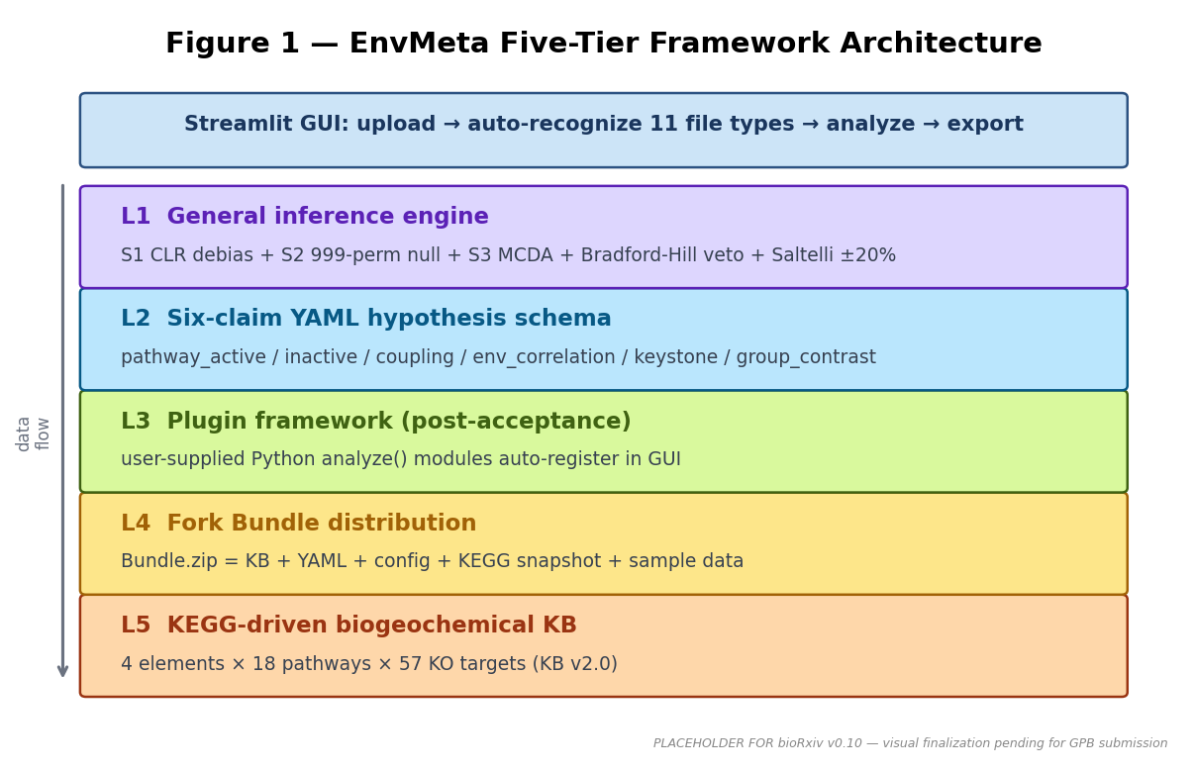
Figure 1
Figure 1 — EnvMeta Five-Tier Framework Architecture. L1 general inference engine (S1 CLR debias + S2 999-permutation null + S3 MCDA + Bradford-Hill veto + Saltelli ±20% sensitivity); L2 six-claim YAML hypothesis schema; L3 plugin framework (post-acceptance delivery); L4 Fork Bundle distribution; L5 KEGG-driven biogeochemical-cycle knowledge base (KB v2.0: 4 elements × 18 pathways × 57 KO targets). Streamlit GUI orchestration layer at top wraps the five tiers with a four-stage workflow (upload → recognize → analyze → export). [Placeholder — visual finalization pending for GPB submission.]
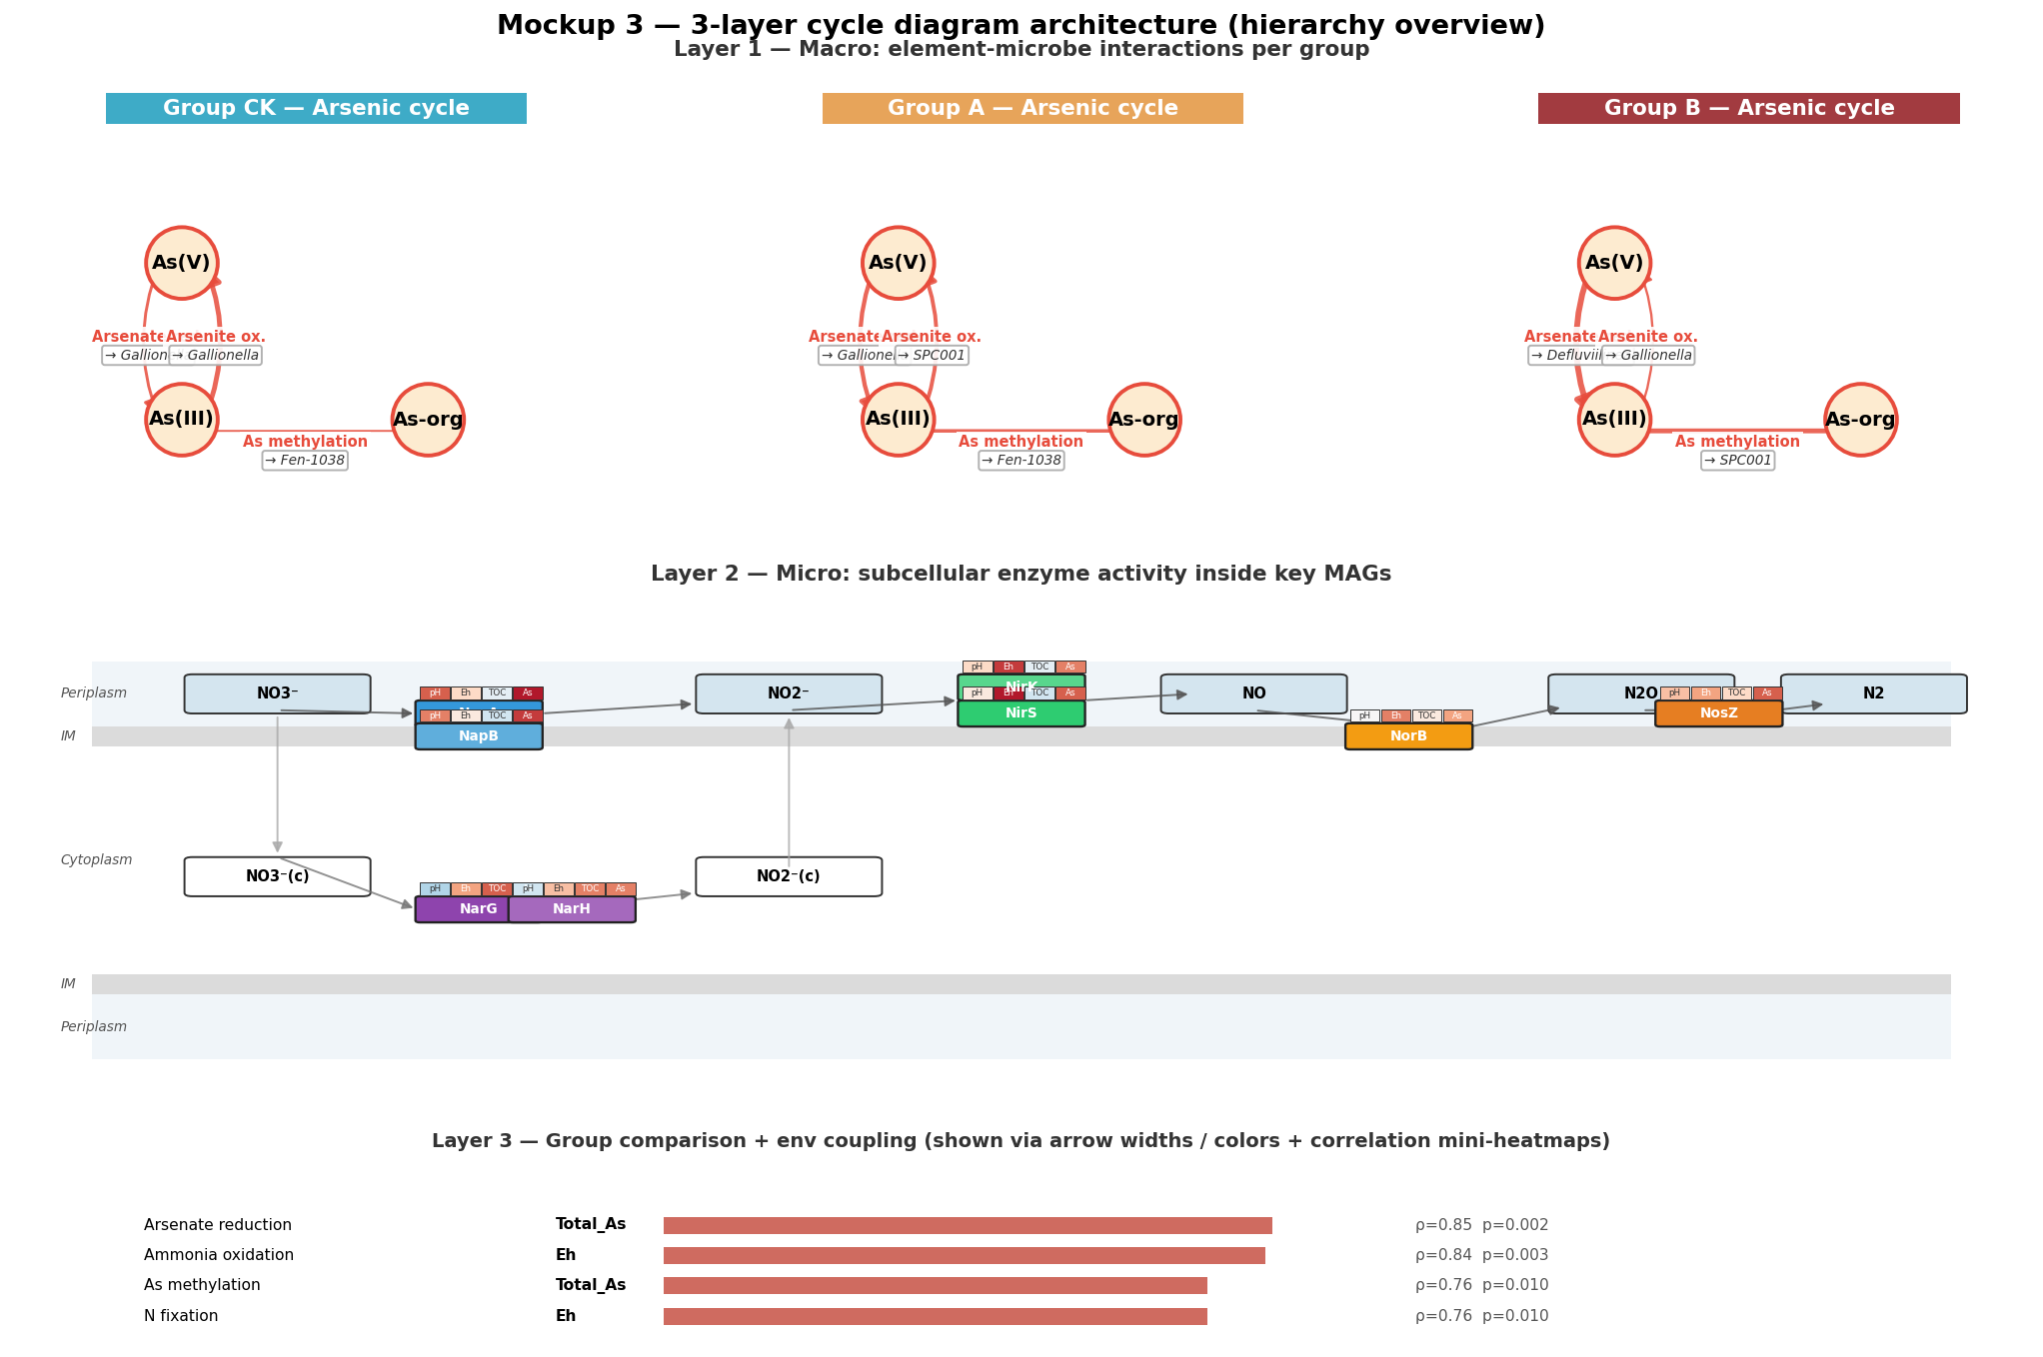
Figure 2
Figure 2 — Fourteen publication-quality figures with GUI parameter tuning + synchronous .py script generation. Hierarchy panel showing reads-based (7 figures: taxonomy stackplot / α-diversity / β-PCoA / RDA / LEfSe / KEGG-KO heatmap / log2FC) and MAG-based (7 figures: quality / abundance heatmap / pathway / gene profile / network / cycle / hypothesis scoring) categories. GUI parameter panels (right) expose 3-7 knobs per figure; parameter changes trigger real-time preview. Synchronous .py script generation accompanies each rendered figure for reproducibility.
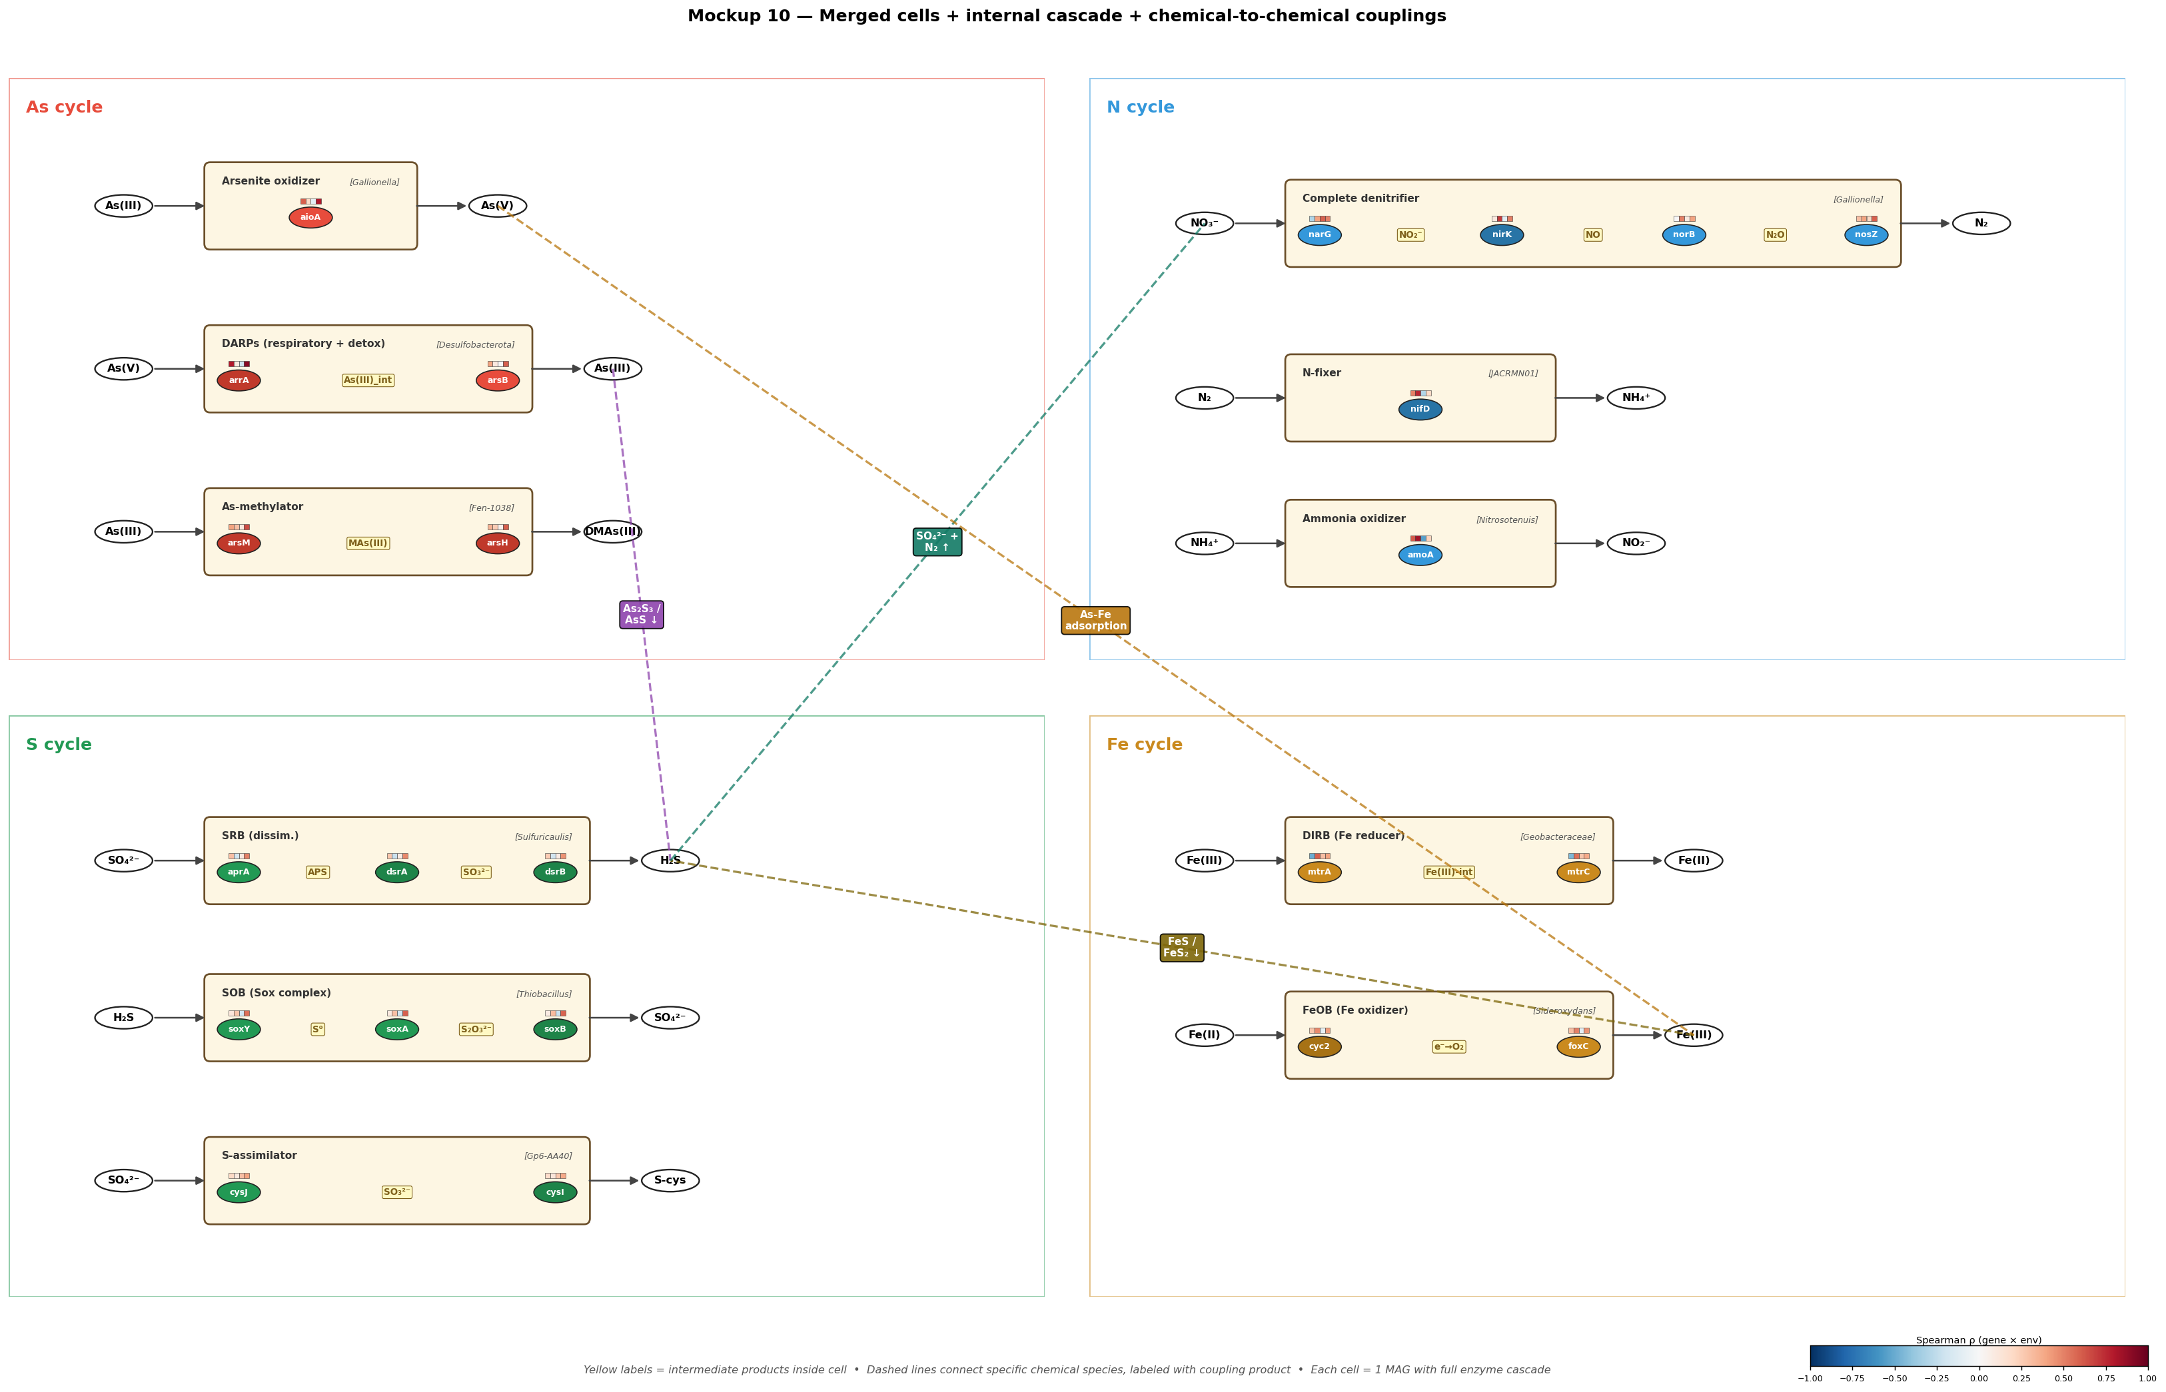
Figure 3
Figure 3 — Biogeochemical-cycle inference algorithm. Mockup 10 merged-cell layout: each cell renders a substrate → gene → product triplet, with cell color encoding pathway type (oxidation / reduction / methylation / regulation) and cell size encoding aggregate MAG contribution. Cross-element coupling dashed connectors with chemical-species labels (e.g., As(III) ↔ S²⁻ → As₂S₃) anchored to specific contributing pathways. Algorithm: S1 CLR debias + three-threshold contributor scan → S2 999-permutation Spearman null → S3 weighted-sum scoring with Bradford-Hill required-veto. See Methods §4.0 Algorithms 1-4 for pseudocode.
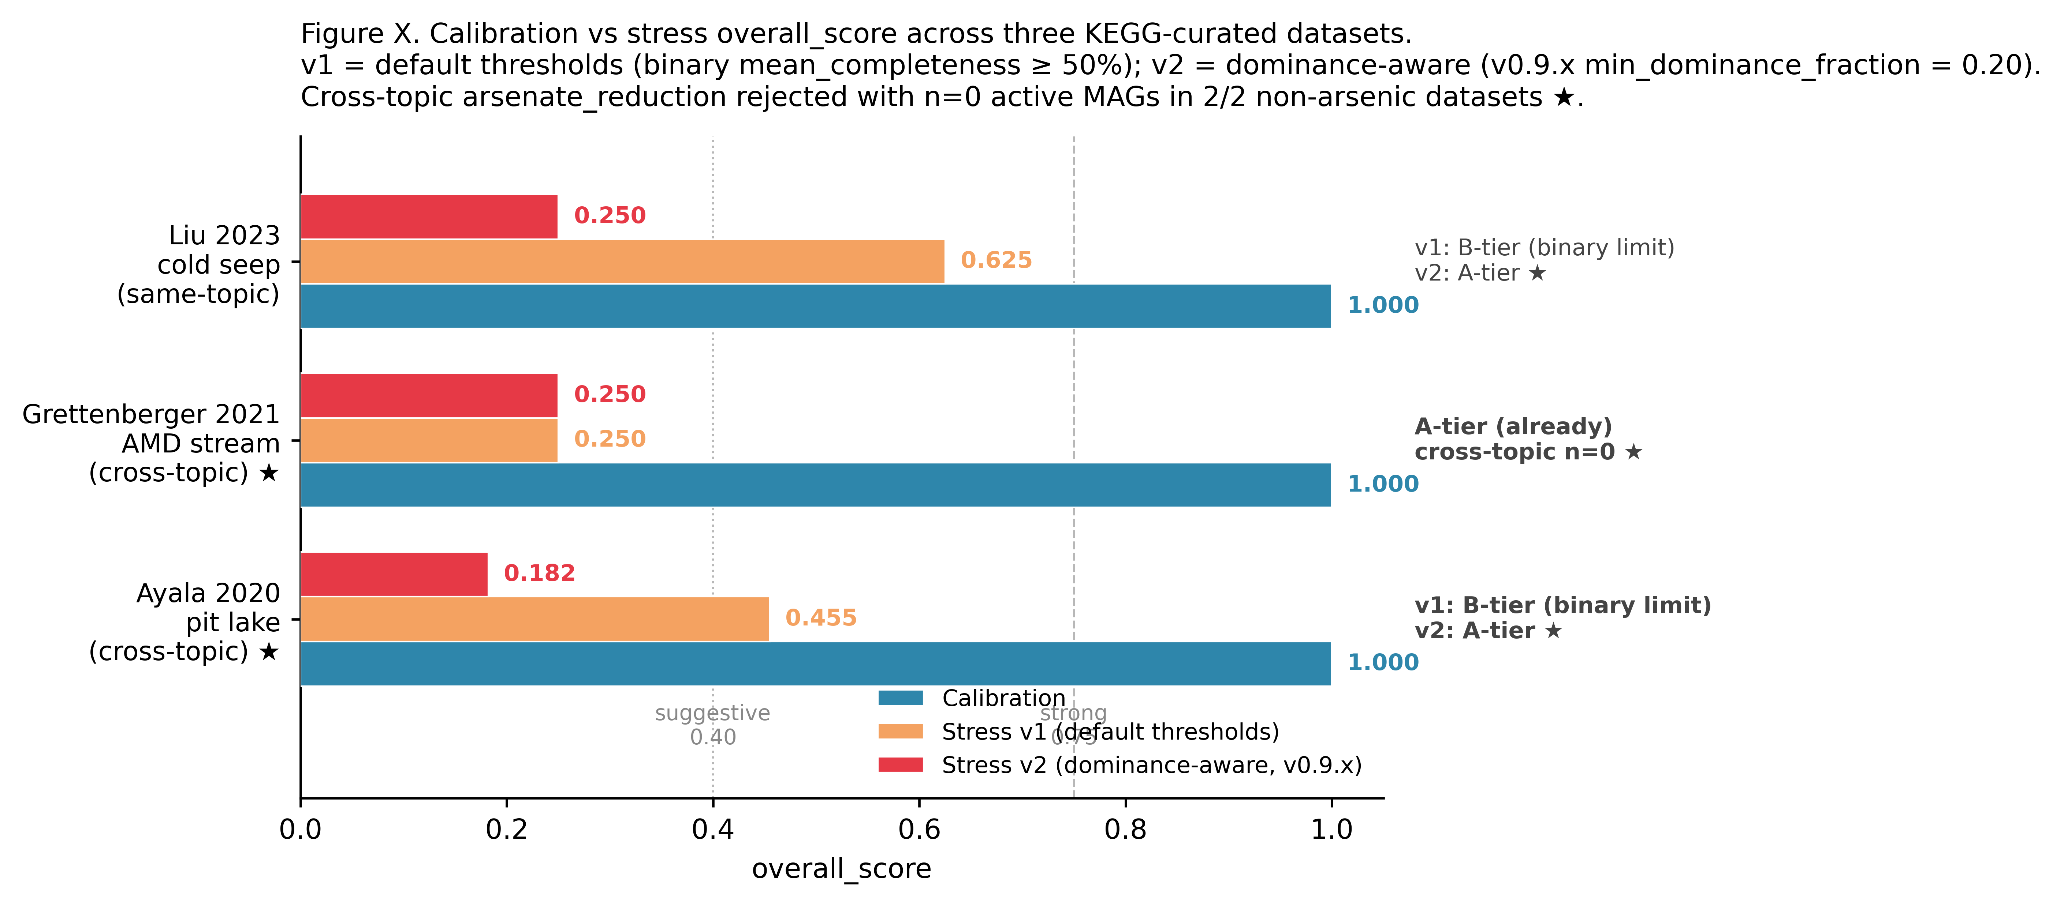
Figure 4
Figure 4 — YAML hypothesis scorer + four-arm calibration. Per-claim scores across the four KEGG-curated calibration arms (A in-house arsenic-slag positive control / C1 Liu 2023 cold seep / C2-A Grettenberger 2021 AMD stream / C2-B Ayala 2020 Iberian Pyrite Belt pit lake) vs the three-arm stress test (Class A reversed direction / Class B cross-topic / Class C pathway_inactive). All four KEGG-curated arms return STRONG (overall score = 1.000) under fixed default thresholds. Cross-topic rejection: Liu 0/20 STRONG retention under cross-element pathway-target perturbation (§2.4.2). v1 vs v2 (dominance_score extension) side-by-side discrimination outcomes shown.
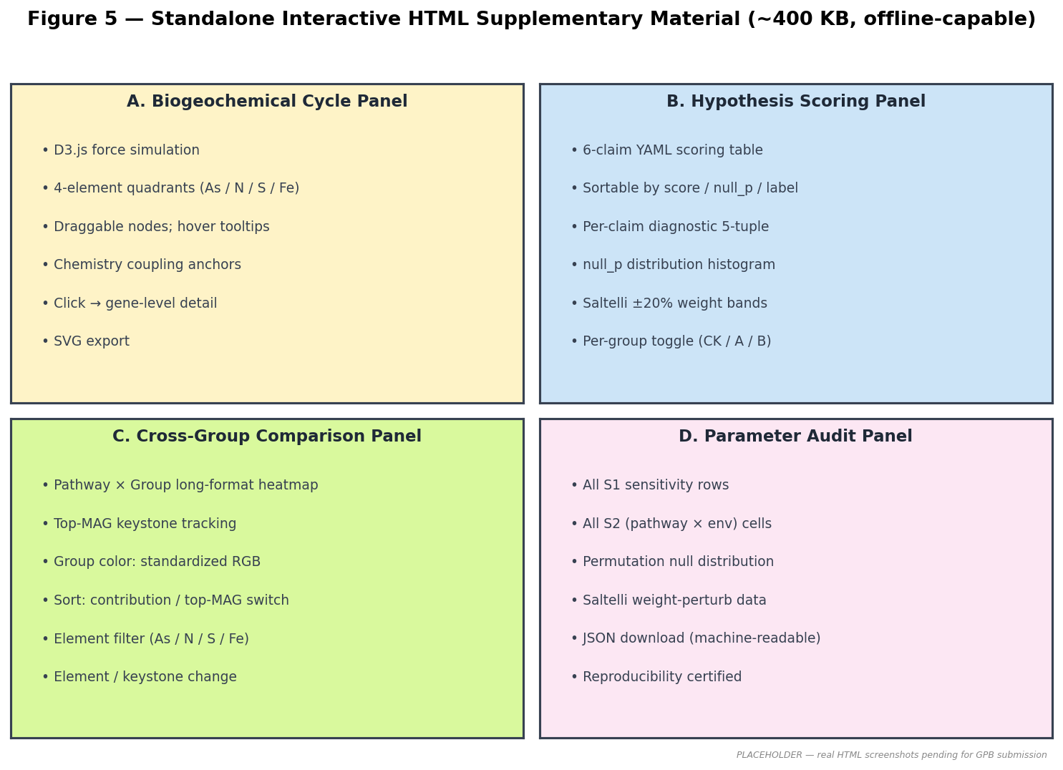
Figure 5
Figure 5 — Standalone interactive HTML supplementary material (~400 KB, fully offline). Four-tab UI: (A) biogeochemical cycle with D3 forceSimulation + draggable nodes + chemistry coupling anchors; (B) hypothesis scoring with sortable claim table + null_p distribution; (C) cross-group comparison with per-group toggle; (D) parameter audit exposing all S1-S3 intermediate quantities. Inline-embedded D3.js v7 (~280 KB); no external dependencies. [Placeholder — real HTML screenshots pending for GPB submission.]
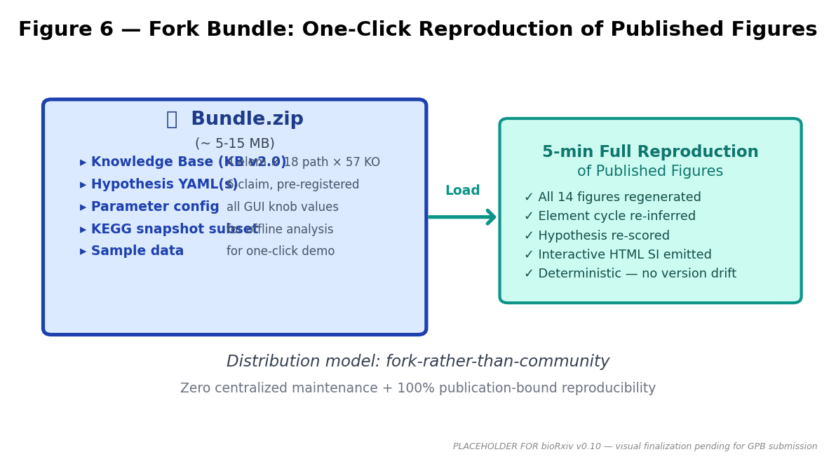
Figure 6
Figure 6 — Fork Bundle reproducibility packaging. Bundle.zip (~5-15 MB) contains: knowledge base (KB v2.0), hypothesis YAML(s), parameter config, KEGG snapshot subset, and sample data. Load Bundle → 5-minute reproduction of all 14 published figures + element-cycle re-inference + hypothesis re-scoring + interactive HTML SI emission. Distribution model: fork-rather-than-community (zero centralized maintenance overhead + 100% publication-bound reproducibility). [Placeholder — visual finalization pending for GPB submission.]
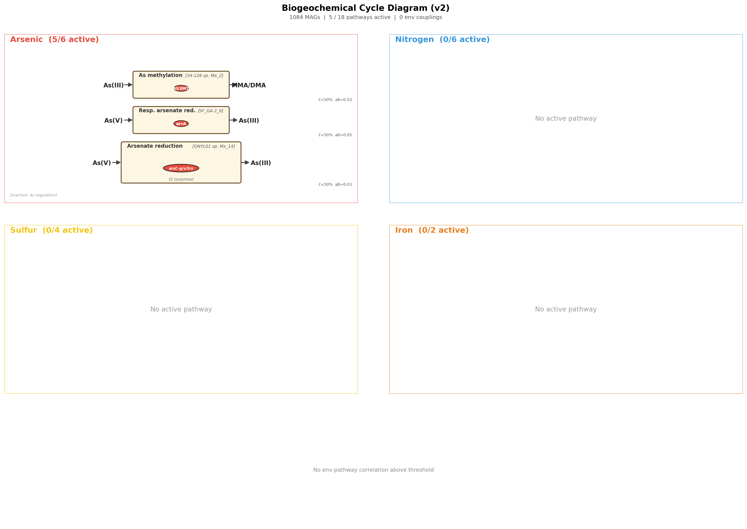
Figure 7
Figure 7 — Case study: framework-assisted mechanism discovery on Liu 2023 cold-seep dataset (proxy for in-house arsenic-slag system in §2.7). Element cycle diagram showing As / N / S / Fe quadrants with Mockup 10 cell layout, cross-element coupling labels, and confidence-tier color coding. Demonstrates that the framework outputs per-claim diagnostic quantities (not novel mechanism claims) that downstream readers audit independently.
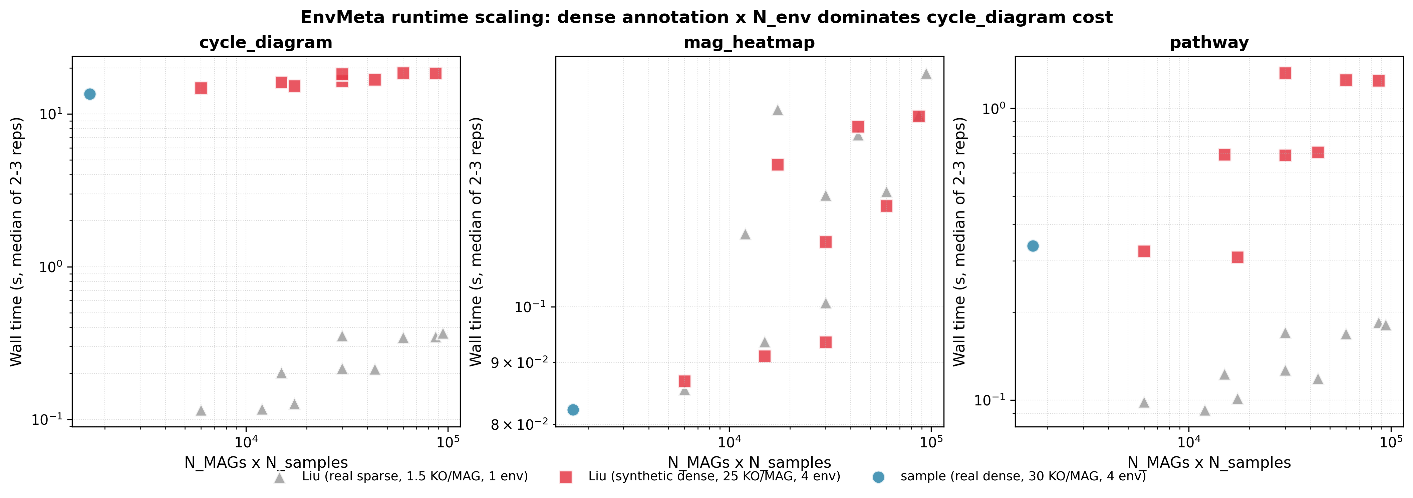
Figure 8
Figure 8 — Performance and scaling envelope. Three-panel log-log scatter showing cycle_diagram / mag_heatmap / pathway runtime vs N_MAG across three data regimes (sample real-dense / Liu real-sparse / Liu synthetic-dense); 58 measured (dataset × figure) combinations. Key finding: cycle_diagram cost is largely N_MAG-independent, dominated instead by env-factor breadth × pathway count × permutation count. Maximum peak ΔRSS = 9.3 MB across all 58 cells; median = 0.5 MB. Standard 8-16 GB laptop, headless matplotlib Agg backend.
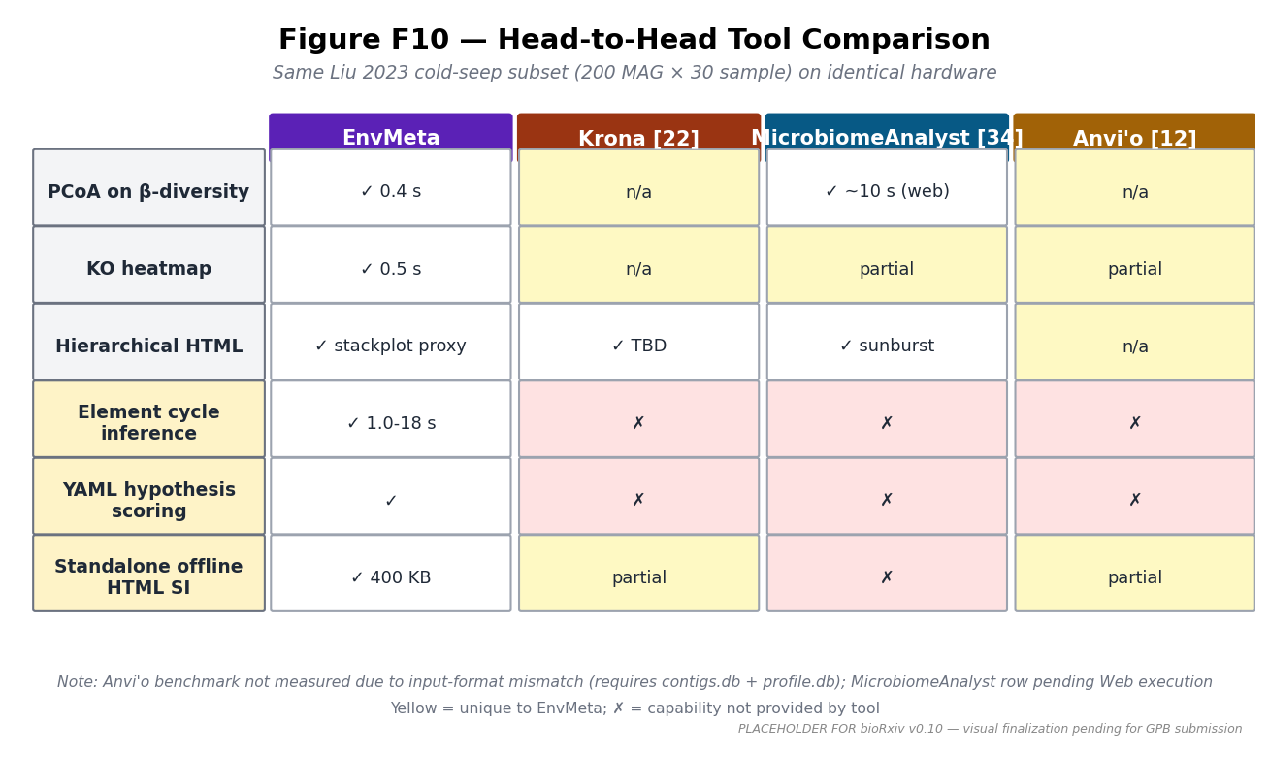
Figure F10
Figure F10 — Head-to-head tool comparison. Same Liu 2023 cold-seep subset (200 MAG × 30 sample) on identical hardware. Three shared-capability tasks (PCoA / KO heatmap / Hierarchical HTML) × three comparable tools (Krona / MicrobiomeAnalyst / Anvi’o); three EnvMeta-unique tasks (element cycle inference / YAML hypothesis scoring / standalone offline HTML SI) shown in the bottom rows. Anvi’o Liu benchmark not measured due to input-format mismatch (Anvi’o requires contigs.db + profile.db); MicrobiomeAnalyst row pending Web execution. [Placeholder — Task 3b actual measurements pending WSL2 / Web run; visual finalization for GPB submission.]
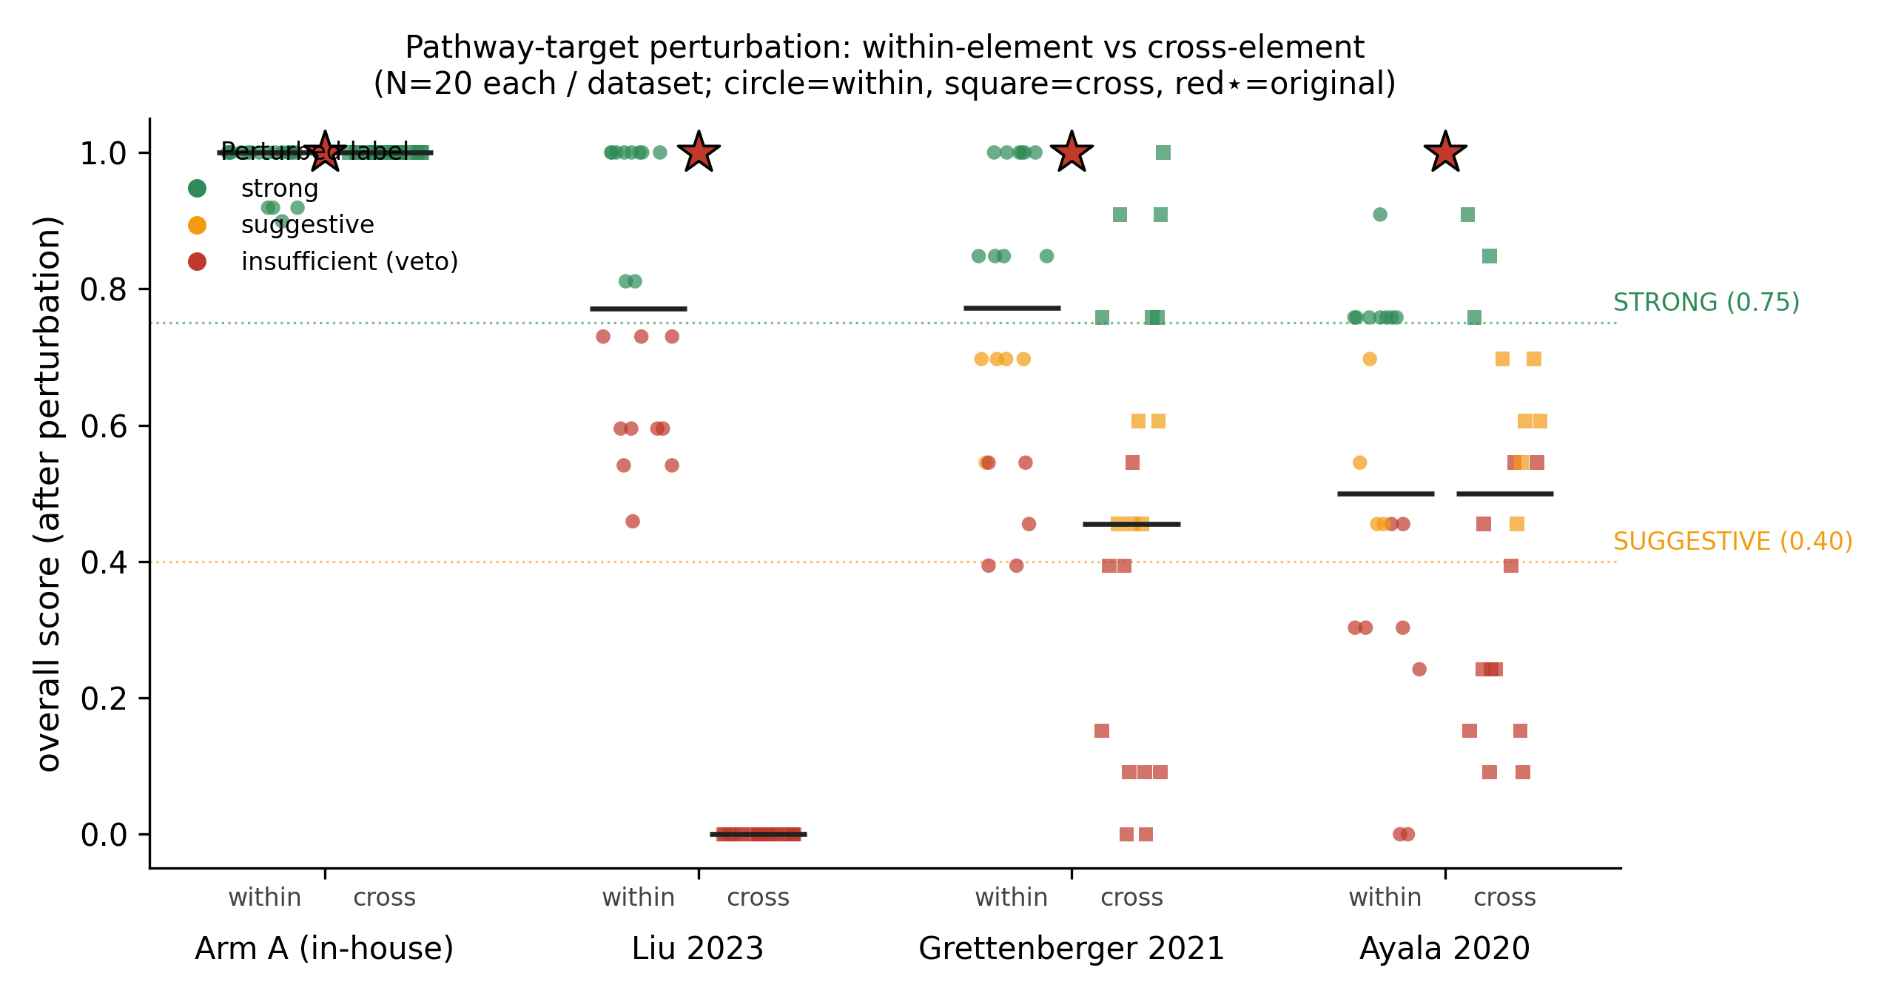
Supplementary Figure S_pert
Supplementary Figure S_pert — Target-pathway perturbation analysis. Within-element vs cross-element pathway substitution; N = 20 per mode per dataset; mean scores ± Wilson 95% CI. Monotonic annotation-breadth gradient in cross-element STRONG retention: Arm A 100% (partial perturbation, 3 of 9 claims) → Grettenberger 30% → Ayala 15% → Liu 0%. Within-element mean score drop 25-48%, 40-50% STRONG retention.

9. Tables
Table 1: Four-Arm Calibration Summary. Source: paper/figures/paper3_hypothesis_scoring/table1_calibration.md. Columns: Dataset / Annotation pipeline / KO target count / N MAGs / N samples / Per-claim scores / Overall score / Confidence label / Pre-registered commit hash. Rows: Wei 2024 / Liu 2023 / Grettenberger 2021 / Ayala 2020.
Table 2: Three-Arm Stress Test Summary. v1 vs v2 (dominance_score extension) side-by-side. Columns: Dataset / Stress class (reversed/cross-topic/inactive) / v1 score / v1 label / v2 score / v2 label / Discrimination outcome.
Table T1: Feature Matrix across 9 tools × 7 capabilities (Results §2.9.1).
Table T2: Head-to-Head Performance Benchmark (Results §2.9.2). EnvMeta vs Krona / Anvi’o (input-format mismatch documented) / MicrobiomeAnalyst (pending Web execution).

10. Supplementary Information
- Supplementary Figure S_pert: Perturbation curve. Within-element vs cross-element pathway-target substitution; N=20 per mode per dataset; mean scores ± Wilson 95% CI. Source: paper/benchmarks/external/perturbation/perturbation_curve.{pdf,png,svg}.
- Supplementary Table S_refs: Reference audit of pre-registered YAMLs. Source: paper/manuscript/hypothesis_references_audit.md.
- Supplementary Table S_thresholds: Threshold sensitivity sweep (strong_threshold ∈ {0.65, 0.70, 0.75, 0.80, 0.85} × 8 datasets). Source: paper/benchmarks/external/threshold_sensitivity/threshold_sweep.tsv.
- Supplementary File HTML_demo: Standalone interactive HTML SI (~400 KB; cycle diagram + hypothesis scoring + cross-group comparison
  - parameter audit). Source: paper/bundles/envmeta_cycle_interactive_v1.html.
- Supplementary Bundle: Fork Bundle zip enabling one-click reproduction of all paper figures. Source: paper/bundles/envmeta_paper_v0.10_bundle.zip.

Manuscript Compilation Status
Section completeness as of 2026-05-14 v0.10 draft:
Section | Status | Source / Action
Title / Affiliations / Corresponding | ✅ draft ready | Inline; supervisor email TBD
Abstract | ✅ 290 words | Drop-in from outline_gpb.md §4
Highlights | ✅ 3 bullets | Drop-in from outline_gpb.md §2
Keywords | ✅ 8 keywords | Compiled
§1 Introduction | ✅ 4 sub-sections ~840 words | Drop-in from outline_gpb.md §5.1
§2 Results §2.1-§2.9 | ✅ all sub-sections drafted | Drop-in from outline_gpb.md §5.2 + results_stress_test_section.md
§3 Discussion | ⏳ SKELETON ONLY | Drop-in pending from discussion_calibration_discrimination.md §Y.1-§Y.4
§4.0 Methods Algorithm Framework | ✅ Notation + overview | Algorithms 1-4 + Eq 1 reference outline_gpb.md §5.4.0
§4.1-§4.7 Methods detail | ⏳ SKELETON ONLY | Drop-in pending from outline_gpb.md §5.4 + methods_external_validation.md
§4.8 Implementation | ✅ short paragraph | Inline
§5 Data + Code | ✅ ready | Inline
§6 Acknowledgements | ⏳ draft | Supervisor + funding TBD
§7 References | ⏳ partial (36 of ~50) | Vancouver bibliography pending verification
§8 Figure Legends | ⏳ PENDING figure visuals | Per-figure 100-150 word legends
§9 Tables | ⏳ schemas defined | Table data filled (T1, T2, calibration); T_pert pending Task 3b
§10 Supplementary | ✅ list ready | Files in paper/; cross-refs working
Critical pending items for bioRxiv readiness:
- ⏳ §3 Discussion full draft (~800 words) — drop-in compile this week
- ⏳ §4.1-§4.7 Methods detail (~2000 words) — drop-in compile this week
- ⏳ References §7 — verify 4 calibration dataset citations (Wei/Liu/Grett/Ayala)
- ⏳ Figure visual finalization — 6 of 8 figures (F8 already done; F1/F3/F5/F6/F7/F10 placeholders)
- ⏳ Table T2 Krona row — Task 3b Krona benchmark in progress
- ⏳ Supervisor email + funding source acknowledgements
bioRxiv preprint can be submitted after items 1-3 complete (Discussion + Methods + References), with placeholder figures acceptable (bioRxiv tolerates caveated TBD content); items 4-6 polish in parallel with GPB submission timeline.

