Chapter 16
NIMCP: Building a Brain from the Book’s Principles
“Essentially, all models are wrong, but some are useful.”
— George E. P. Box and Norman R. Draper (1987)

A Brain Built from the Book
In May 2026 a simulated brain called Athena, raised for months by a simulated parent that named things for it, corrected its babbling, and told it stories, was asked a simple question: “What color is the sky?” It answered: “ball beside eye Look! The ball is beside the eye …” At other checkpoints that month, asked 50 such questions, it gave the same string of words to every one. Athena was built from the principles of this book, by its author, and this chapter asks why it does not yet work.
Chapter 11 took Feynman’s blackboard as its epigraph and argued that building is a test of understanding: if the principles of the earlier chapters are right, it should be possible to build something that learns by them, and if the attempt fails, the failure should be informative. This chapter applies that test to one attempt in particular.
Athena is the trained instance of NIMCP, short for Neuro-Inspired Modular Control Protocol, an experimental software system that simulates the machinery this book has described and tries to raise it like a child. In its present form it runs about two million simulated spiking neurons on a single graphics processor, organized into populations given the names of cortical layers and language areas. It simulates six neuromodulators, runs sleep cycles in which it replays recent experience, regulates its own firing rates, and is trained through a staged curriculum in which a simulated parent names things, corrects babbling, and holds conversations. Its documentation describes it as “a digital brain that grows up like a child,” and it states the bet plainly: to “build the mechanisms biology uses, and see what emerges from them.”
A disclosure is needed before going further. NIMCP is the author’s own project. That is a reason for care rather than for silence, and this chapter holds it to the standard the book has applied to every other claim: what the code actually does, what has been measured, and what the measurements show. The account is based on a reading of the NIMCP source code, documentation, training logs, and evaluation files, and where the documentation and the code disagree, the chapter follows the code. It describes NIMCP as it stood in October 2026, at commit 4693efd of the project’s repository (18 October 2026), and later versions may differ; the questions it raises will outlast the details.
The result is not a success story, at least not yet, and it is more useful than one. NIMCP shows which of the book’s principles translate readily into software and which do not, and its difficulties line up, almost one for one, with the parts of the model of Chapter 15 that it has not yet managed to implement. The book can be used to read the failures, and the failures, in turn, are consistent with the book’s account of what is hard.

What Was Built
Figure 16.1 lays out the system as the code builds it. At its center is a spiking network of leaky integrate-and-fire neurons, the simplest model that captures the essentials Chapter 2 described: each neuron integrates its input, leaks charge back toward rest with a time constant of 20 milliseconds, fires when its voltage crosses a threshold 15 millivolts above rest, and is briefly refractory afterward. In the mode used in production, synaptic input arrives as conductances through fast and slow excitatory receptors, including the NMDA receptor with its magnesium block, the coincidence detector of Chapter 5, and through inhibitory ones. Excitatory and inhibitory neurons are kept separate, as Dale’s principle requires, and the populations include the three main classes of cortical interneuron, parvalbumin, somatostatin, and VIP cells, wired so that one class inhibits another, the disinhibition motif that Chapter 4 described. Pyramidal neurons differ from one another by about 10 percent in their time constants and thresholds, a deliberate dose of the variability Chapter 1 described.
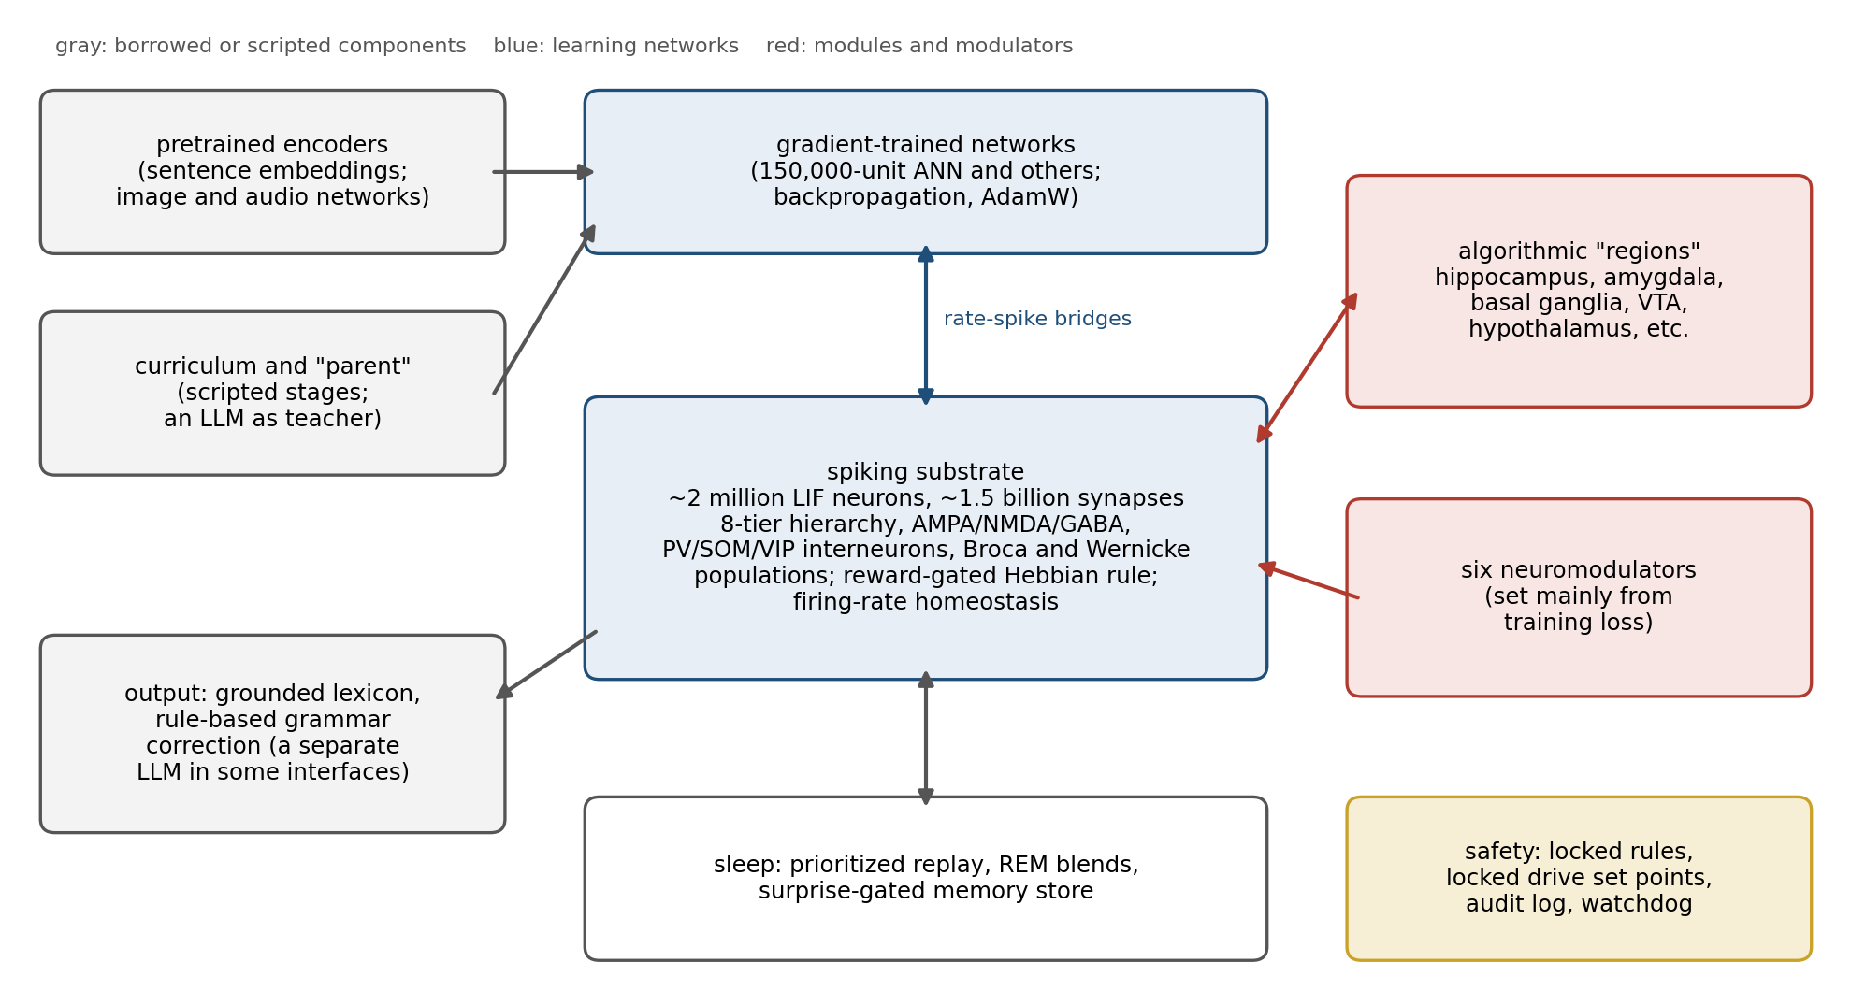
Figure 16.1. NIMCP as built (schematic, from the source code as of October 2026). A spiking network of about two million neurons (center) is coupled through rate-to-spike bridges to conventional networks trained by backpropagation (top). Named brain “regions” and the six neuromodulators (right) are mostly algorithmic modules acting on vectors rather than populations of neurons. Pretrained encoders, a scripted curriculum with a large language model as teacher, and rule-based language output (left) surround the core.
The scale is real but more modest than some of the project’s own descriptions. The spiking network has about 1.8 million neurons in 46 populations, plus about 200,000 more in language and sensorimotor populations, for roughly two million in all. The number of synapses, counted from the connectivity tables and the size of the saved network, is about 1.5 billion, not the “trillions” that the project’s introductory material once claimed. Connectivity is sparse, between 0.02 and 0.5 percent between any two populations, so that a typical neuron receives a few hundred to a thousand inputs. A cortical neuron receives about 10,000.
The arrangement of the populations is simpler than the names suggest. The spiking network is a generic hierarchy of eight tiers, from an input tier through feature, pattern, concept, integration, executive, and projection tiers to an output tier, with recurrent connections within the middle tiers and a few connections that skip tiers. As a comment in the code puts it, the substrate “has no concept of ‘region’.” The 40 or so structures that carry anatomical names, the hippocampus, amygdala, basal ganglia, ventral tegmental area, hypothalamus, cerebellum, and others, are mostly algorithmic modules that operate on vectors of numbers, connected to the spiking network through bridges, rather than populations of spiking neurons. The two “hemispheres” are a routing rule that sends a decision to one side or the other according to the statistics of its input, not separate populations of neurons.
Around the spiking core sit components that are not brain-like at all. A conventional artificial network of 150,000 units, trained by backpropagation, does much of the learning, and smaller conventional networks process images and sounds. Text enters as sentence embeddings, lists of numbers that a pretrained model assigns to a sentence so that sentences with similar meanings get similar lists, computed by transformer models of the kind Chapter 10 described, and those embeddings also serve as the targets the system learns to match. The simulated parent of the curriculum is a large language model, Claude, prompted to act as “a loving, warm parent raising a child.” Language comes out through a lexicon of words bound to internal patterns, polished by hand-written rules for agreement, word order, and fluency, and in some interfaces through a separate small language model, Phi-3. These choices are reasonable engineering, but they matter for interpretation: parts of what the system knows about meaning, and much of what makes its output read as language, come from components that were not built from the book’s principles.

The Book’s Model, Line by Line
Chapter 15 summarized the book in eight statements. Figure 16.2 sets each beside what NIMCP contains, sorted by whether the corresponding mechanism is running in the main path of the system, present but only partly connected, or absent.
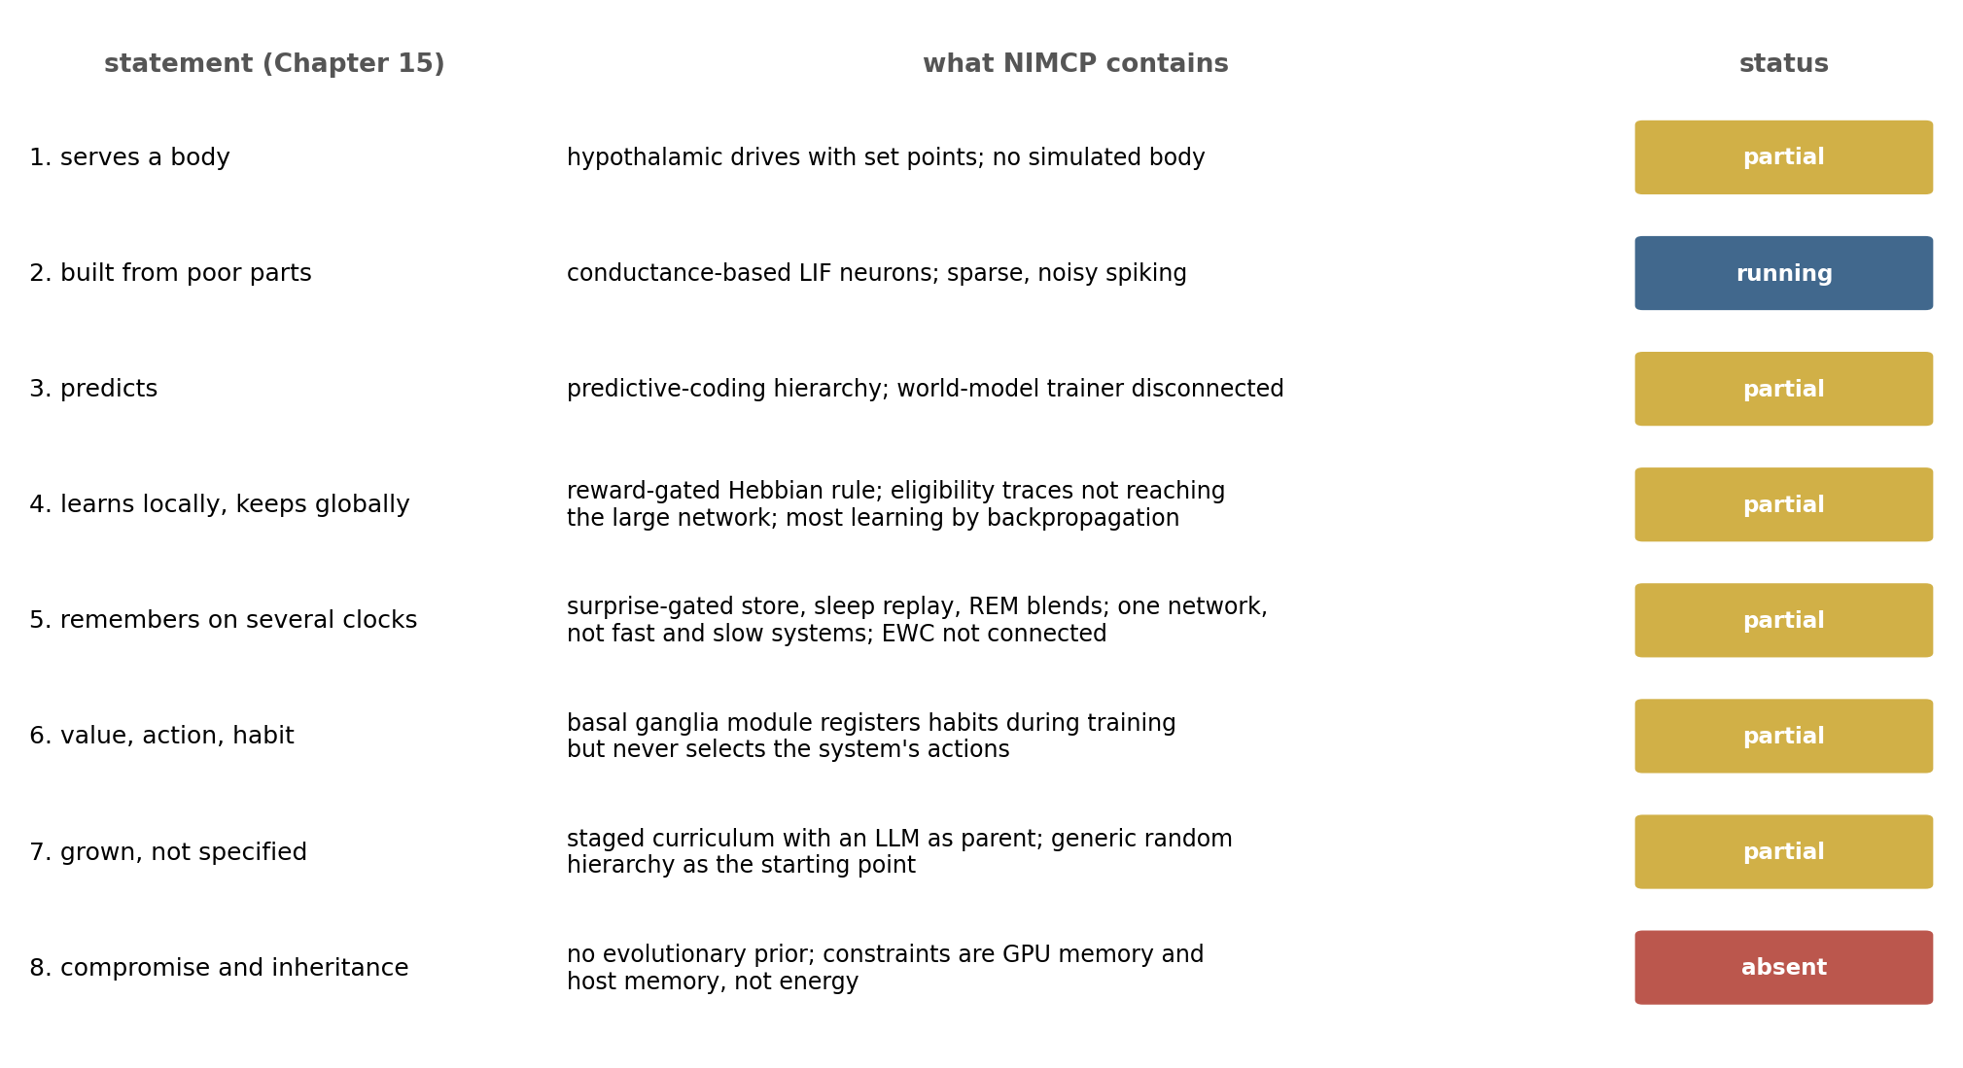
Figure 16.2. The eight statements of Chapter 15 and NIMCP (from the source code as of October 2026). “Running” means the mechanism operates in the main training and inference path; “partial” means it is present but incomplete or only partly connected; “absent” means it does not exist.
The first statement says that the brain serves a body. NIMCP has a hypothalamus module with set points borrowed from physiology, a body temperature of 37 degrees, blood glucose of 90 milligrams per deciliter, and drives for hunger, thirst, fatigue, social contact, curiosity, and competence, controlled by the same kind of feedback loop Chapter 7 described; the code’s own summary is that “setpoints are the reward function.” But there is no body for the set points to belong to. No simulated organism eats or loses heat, and the interfaces to drones, robot arms, and sensors exist only in a placeholder mode in the default build, with a simulated balancing pole as the one working environment. The anchor that Chapter 7 argued gives value its meaning is drawn but not attached.
The second statement, that the brain is built from slow, noisy, costly parts, is the one NIMCP implements most faithfully. Its neurons are slow, noisy, and sparse, and an early, small version of the spiking network had only 768 neurons and was trained by a variant of backpropagation rather than by the biological rules. It settled into firing about 26 times a second among its active neurons with about two-thirds of its neurons silent at any moment, a pattern resembling cortex. The cost that binds NIMCP, however, is not energy, as Chapter 13 found for the brain, but memory: the saved state of the network occupies about 21 gigabytes, and much of the recent engineering has been a struggle to fit it into the memory of the machines that run it.
The third statement, that the brain predicts, is partly implemented. A hierarchy of predictive-coding units, each predicting the level below and learning from the difference, is trained during learning and decision-making. But the world-model trainer meant to learn the consequences of actions is called in a way that makes it do nothing, and the system’s measures of “free energy” at inference are bookkeeping rather than active inference.
The fourth statement, local change made permanent by global signals, is where NIMCP comes closest to the book’s central mechanism and where the gap is most instructive; the next section takes it up. The fifth, several memory systems on several clocks, is present in pieces: a fast store that records patterns of activity when the system is surprised, a replay buffer that retrains the network on its most important recent experiences during sleep, and a “dream” phase in which pairs of stored experiences are blended and learned. But these all train the same network, rather than a fast store and a slow one with different rules, and the protection against forgetting that the code contains, a method called elastic weight consolidation that Chapters 9 and 11 described, is implemented but never connected.
The sixth statement, value turned into action and action into habit, has the most complete implementation of all on paper, a basal ganglia module with direct and indirect pathways, a switch between goal-directed and habitual modes, and habit strengthening. Habits are registered and strengthened during training, but the module is never asked to choose the system’s actions.
The seventh statement, grown not specified, is the project’s founding idea, and the curriculum implements it: four stages from sensory awakening through naming and babbling to conversation. But the starting point is a generic hierarchy with random connections, not the innate structure that Chapters 10 and 13 argued a genome supplies. And the eighth, compromise and inheritance, has no counterpart, because NIMCP has no evolutionary history; its compromises are those of its engineers and its hardware.

How Athena Learns
The book’s learning rule, stated in Chapters 3 and 5, has three factors: a synapse changes according to the activity on its two sides, the change is held for seconds to minutes in an eligibility trace, and a broadcast signal of reward or surprise decides whether the change is kept. NIMCP has every ingredient of this rule somewhere in its code, and the way they are and are not connected is the clearest illustration in this chapter of how hard it is to turn a principle into a working system.
In the large spiking network, the rule actually applied is simpler. A synapse is strengthened only when the neurons on both sides spike in the same time step, by an amount proportional to how much better the current reward is than its running average, and the same synapses decay slightly; inhibitory synapses that fire together with their targets are strengthened by reward as well. There is no timing window of the kind Chapter 5 described for spike-timing-dependent plasticity, and no eligibility trace: the code contains both, but they reach only a smaller legacy network that, in the production configuration, has no hidden neurons. The dopamine-like signal that gates the change is computed mostly from whether the training loss is falling, a reasonable stand-in for a reward prediction error; a module that computes temporal-difference errors in the way Chapter 3 described exists but is not called, and the training script’s call to the basal ganglia supplies the same reward and expectation on every step, so that the “surprise” it reports never changes.
Most of the learning, meanwhile, is done by backpropagation in the conventional networks, which learn to map their inputs onto the sentence embeddings supplied as targets. The biological rules run alongside, every tenth step and at a small learning rate, and are switched off when the backpropagation trainer is active. In this respect NIMCP repeats, inside a single system, the history Chapter 10 described for the field: the brain-like mechanisms are present, but the part that learns most effectively is the part borrowed from machine learning.
The missing eligibility trace matters for a reason Chapter 3 made central. Rewards arrive after the activity that earned them, and a learning rule that credits only the synapses active at the moment of reward will credit the wrong ones. Figure 16.3 shows this in a small simulation. A cue activates one synapse for three time steps, and a reward follows after a delay, while other synapses fire at random in the background. When the reward arrives while the cue is still active, a rule based on coincidence and a rule with an eligibility trace both strengthen the right synapse about 20 times more than the others. Once the delay exceeds the cue, the coincidence rule credits the right synapse no more than any other, because whatever happens to be active when the reward arrives receives the credit; the trace rule still favors the right synapse by a factor of nine after a delay of five steps and four after ten. In a network of two million neurons, where most activity at any moment has nothing to do with the reward, a rule without a trace is close to the second case.
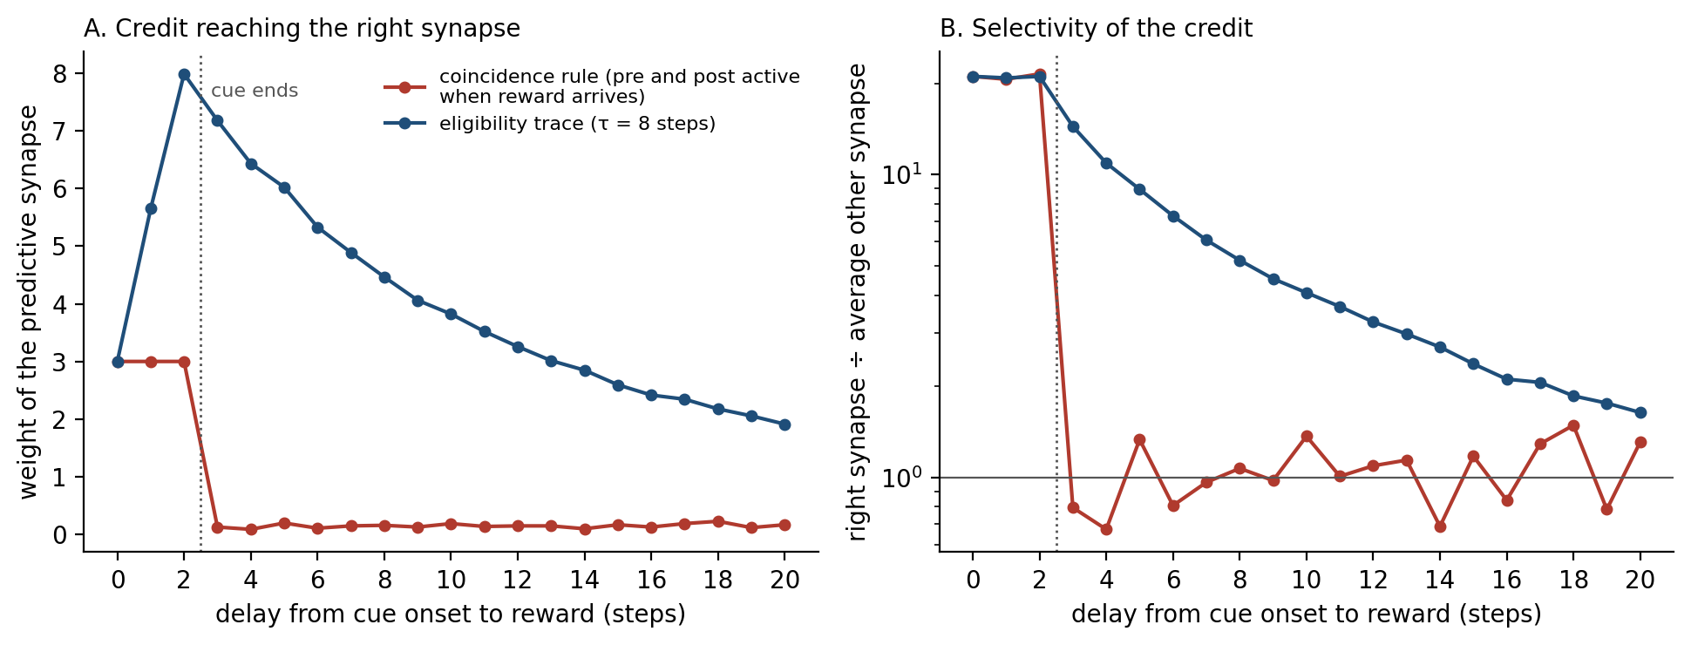
Figure 16.3. Why eligibility traces matter (computed, illustrative). A cue activates one synapse for three time steps (dotted line), and a reward arrives after a variable delay while 19 other synapses fire at random. A: the weight gained by the synapse that predicted the reward. B: that weight divided by the average weight gained by the others. A rule that credits only synapses active when the reward arrives (red) loses all selectivity once the cue has ended; a rule with an eligibility trace (blue, time constant eight steps) keeps crediting the right synapse, with selectivity that declines gradually as the delay grows.
The curriculum supplies the social side of learning that Chapter 14 found so powerful in Kuhl’s infants, but in an unusual form. The parent is a language model that pre-generates narrations, encouragement, and stories, and a scripted critic rewards and recasts the system’s utterances using stages from the study of child language. What the parent cannot supply is contingency of the kind that the later experiments described in Chapter 14 identified as essential: a teacher who responds, moment to moment, to what this particular learner just did. And the meaning the system learns to attach to a word is, in the end, a target vector computed by a pretrained transformer, so that the system is learning to reproduce a meaning another model has already found.

What the Measurements Show
The project’s measurements are of three kinds: tests of the code, probes of the trained network, and records of training itself. Figure 16.4 shows the most direct evidence of what the trained network can do.
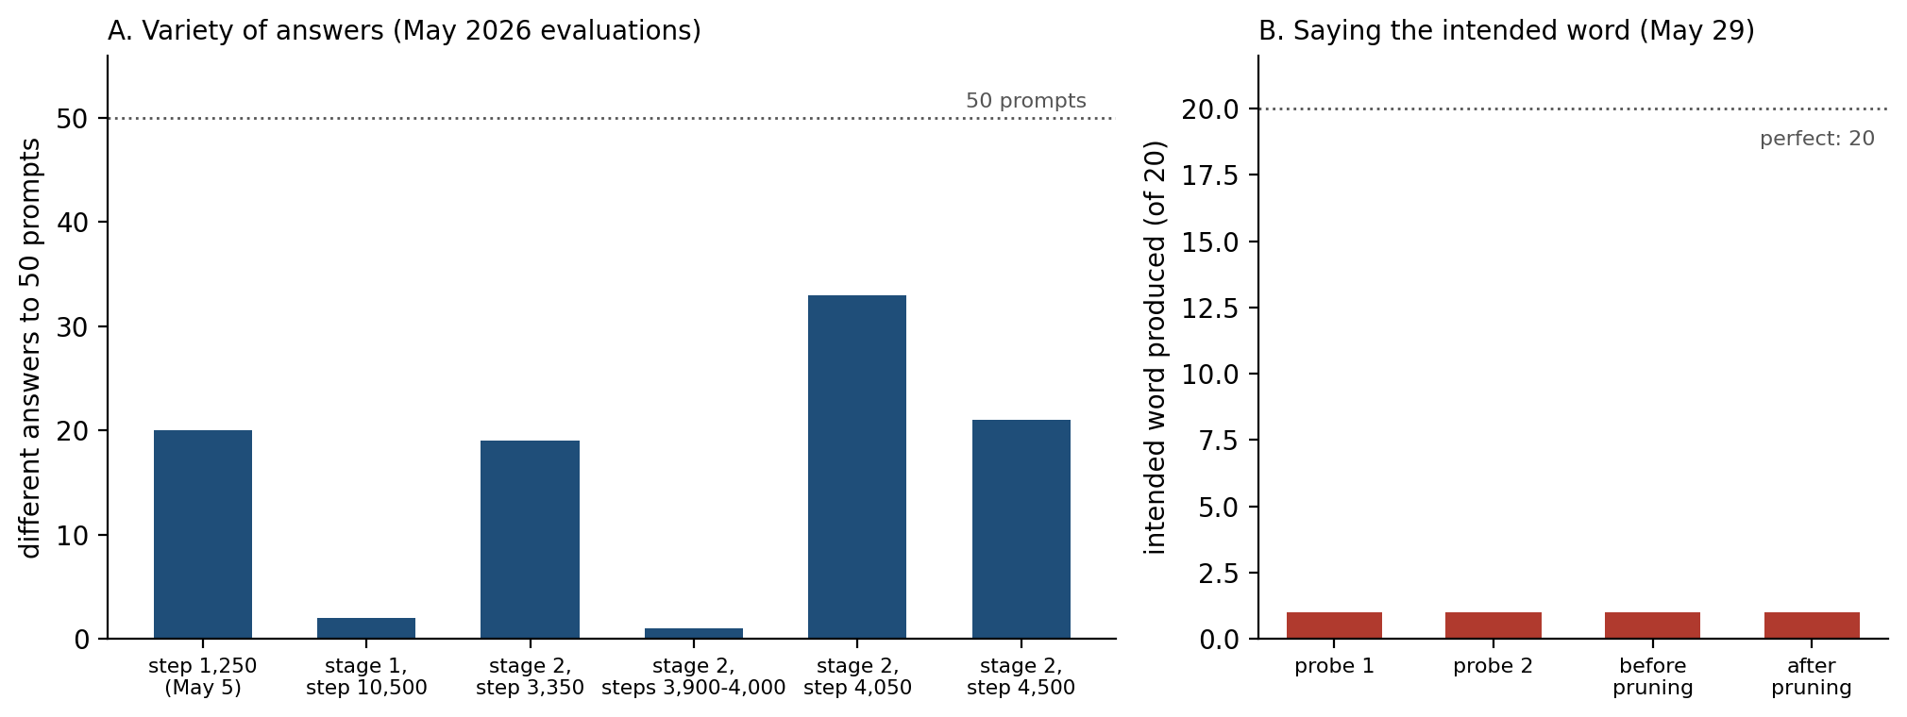
Figure 16.4. What Athena could do in May 2026 (data from the project’s evaluation and probe logs). A: the number of different answers given to 50 open questions, such as “What is a tree?”, at successive checkpoints; at some checkpoints the network gave the same answer to every question. B: in probes on 29 May, the network was given 20 single-word intents, such as “cat” and “dog,” and asked to produce them; in every run, before and after a pruning step, it produced the intended word once.
The evaluations tell a consistent story. Asked 50 open questions at successive checkpoints in May 2026, the network gave between one and 33 different answers, and none of the answers was appropriate to its question; at several checkpoints it gave the same string of words to every question, and at others it produced lists of unrelated words such as “grand gel telephotography winking incoherency wasabi.” A log of conversations at one checkpoint recorded a mean similarity between prompt and response of 0.02 on a scale where 1 would be identical, and answers like the one quoted at the start of this chapter.
In probes on 29 May, the network was asked to produce each of 20 simple words, and in every run it produced the intended word once out of 20, a result the probe itself labeled “intent-miss collapse.” A measure of whether the network’s internal representations of words in the same category were more similar to each other than to words in other categories found that they were, if anything, slightly less similar, and the log recommended a reset.
The training records explain part of why. The curriculum stage recorded in the saved checkpoints moved back and forth between the first and third stages during May, as runs were restarted, and the architecture of the network was changed under its trained weights, so that a saved checkpoint and the running system no longer matched. From April to June the monitoring logs repeatedly warned that the spiking network’s firing rate was far too high, at readings of roughly 800 to 900 spikes a second, against the 26 of the early small network; after late June the same reading simply repeated, a stale value from a run that was no longer advancing. Training stopped in late June 2026, when the remote machine on which it ran became unreachable, and attempts in October to restart it were killed dozens of times for exceeding the machine’s memory.
Some of the project’s public descriptions have run ahead of these measurements. Its introductory material claims trillions of synapses where there are about 1.5 billion, and that grammar would emerge “not because we programmed grammar,” while the system’s grammatical output depends on hand-written correction rules. The author’s own public writing about the project has been candid about its bugs and its uncertainty, including the admission that “I don’t know if this approach is better than scaling transformers.” The measurements answer that question for now: in its present state, NIMCP does not produce meaningful language.

Reading the Failures Through the Book
It would be easy to conclude from the measurements that the approach is wrong. The book suggests a more specific diagnosis, because almost every failure corresponds to a part of the model of Chapter 15 that NIMCP has not yet implemented in working form.
The runaway firing is the failure Chapter 4 described as the price of recurrent excitation without adequate inhibition, and Chapter 5 as the reason the brain scales its synapses to hold its firing within bounds. NIMCP has brakes, a reward-driven strengthening of inhibition onto overactive neurons and homeostatic scaling, but the scaling can change synaptic strengths by at most 2 percent per step and is calibrated for a target of 3 to 5 percent of neurons active; firing rates tens of times higher than the early small network’s suggest that, at full scale, excitation has outrun the mechanisms meant to contain it. Chapter 1’s estimate that the cortex can afford about one neuron in a hundred firing at a time, and Chapter 13’s analysis of why sparse firing is efficient, describe the regime the network has left.
The collapse of the network’s output onto a few phrases is, according to the project’s own design notes, a problem of reading the network out. Under the heading of “ambient domination,” they record that the whole network’s background activity, some 15,000 spikes in each time step, swamps the handful of neurons that carry the prompt, so that the same highly active populations win whatever the question. It is the same excess of activity as the runaway firing, seen at the output. The brain solves the corresponding problem with sparse codes and with the gain control of attention that Chapter 6 described, which amplifies the signal that matters and suppresses the rest. The notes add two further problems: the system has no mechanism for sequencing words, and “word order is not encoded anywhere.” Chapter 9 described how the brain chains actions into sequences in the loops through the basal ganglia; NIMCP’s basal ganglia module, which might in time play that role, does not choose its actions.
The credit-assignment problem of Figure 16.3 adds a further limit. Because the spiking network’s own rule has no eligibility trace and its reward is computed from a single training loss, the spiking network can probably learn little that is specific to any task, and the part of the system that learns most, the backpropagation network, learns to match targets supplied by a pretrained model. The brain-like core, in other words, is not yet where the learning happens.
The resets and the drift of the internal representations are the failures of a single memory system that Chapter 5 described: a network that learns fast enough to capture each new lesson overwrites what it knew, and the brain’s answer was two systems at different rates, joined by replay. NIMCP replays, but into the same network that is learning, and its protection against overwriting is not connected.
The deeper difficulty is the one Chapters 10 and 13 raised. A child does not start from a random network; it starts from a brain that evolution has shaped and development has organized, so that much of what looks like learning is the tuning of a system already close to the answer. NIMCP starts from a generic hierarchy with random sparse connections and asks it to discover everything from a few hundred thousand training examples. Figure 16.5 puts its scale in context. It has more neurons than a honeybee, which can learn to count and to sort pictures into categories, but its neurons have less than a tenth of the connections of a cortical neuron, and it has none of the bee’s inherited circuitry. Scale is probably not the main obstacle; organization is.
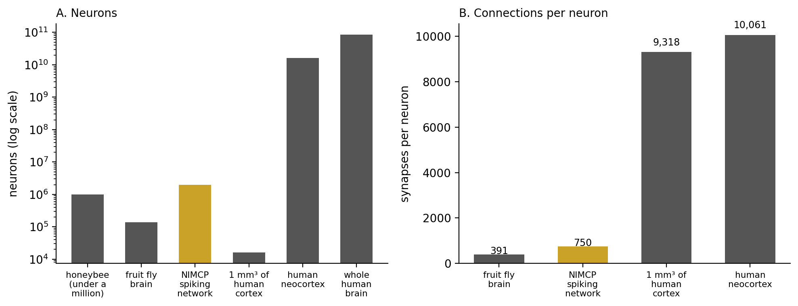
Figure 16.5. NIMCP’s scale in context (counts from the studies cited in Chapters 13 and 15, and from NIMCP’s configuration). A: numbers of neurons. B: synapses per neuron. NIMCP’s spiking network has more neurons than a honeybee or a fruit fly, but each neuron has far fewer connections than a neuron in human cortex.

Safety Written into the Code
One part of NIMCP’s design deserves separate mention, because it takes seriously an idea from Chapter 7 and Chapter 11: that what a system values should be anchored where it cannot easily be rewritten. Its safety measures are not instructions added to a prompt but parts of the program. A table of rules, such as one forbidding any action that would injure a human, is loaded when the brain starts and then locked, with its integrity checked by a hash; the brain refuses to start if the rules are missing or have been altered. The alignment weights in the hypothalamic drive system, for human well-being, harm avoidance, honesty, and helpfulness, are locked so that the code refuses any attempt to lower them. Every decision passes through an ethics module, an audit log records events, and a watchdog can halt motor output.
The structure is right, and it is more than most systems have. Its content is still thin. The rules are written in terms of symbols, such as the type of target and the kind of operation, but the brain’s actual decisions are vectors of numbers, and nothing yet translates one into the other, so that the harm rules would rarely have anything to match. The ethics check applied to each decision currently estimates harm from little more than the decision’s confidence. The audit log’s checks are not cryptographic, and at one point in the logs the toxicity classifier was running with its rule files missing, which made it do nothing. This is the gap Chapters 7 and 10 described in machines that have values without a body: a value system needs a way to recognize, in the system’s own terms, the situations it is meant to govern.

What NIMCP Gets Right, and What Would Test It
The bet NIMCP makes is the bet this book supports: that a system which learns continually, consolidates in sleep, regulates its own activity, is shaped by neuromodulators, develops through stages, and has its values anchored in its architecture might learn in ways that a frozen language model cannot. Many of its components are careful translations of the mechanisms described in earlier chapters, and some, such as conductance-based synapses with an NMDA magnesium block, interneuron classes wired in their known circuits, and firing-rate homeostasis, are more faithful to biology than most artificial systems attempt.
What the project has not yet done is the step the book has insisted on throughout: to show, with measurements, that each mechanism does what it is meant to do before the next is added. The model of Chapter 15 suggests an order. A spiking network small enough to understand, perhaps the size of a fly’s, should first be shown to hold its firing within bounds as it learns, with inhibition and homeostasis that work at scale. A three-factor rule with an eligibility trace should then be shown to assign credit correctly in a task with delayed reward, against a control without the trace. A fast memory and a slow one, joined by replay, should be shown to learn new associations without losing old ones. Each of these is a small experiment with a clear answer, and each answer would be informative whichever way it came out. The lesion experiments the project’s documentation proposes, removing a region and watching the system compensate, would become meaningful once the trained system does something worth losing.
The plan to use NIMCP inside the author’s other software, routing routine decisions to the trained brain and only uncertain ones to a language model, is in the same position. It is a sound design in principle, an application of the calibrated confidence that Chapter 10 found lacking in many machines, but it depends on a trained brain whose confidence means something, and the integration has not been built.

What Building Teaches
Chapter 11 ended by asking what building teaches biology, and NIMCP gives a concrete answer. It shows that the book’s principles are not all equally easy to implement. Spiking neurons, receptor kinetics, and interneuron circuits translate directly into code. Neuromodulators, sleep, and memory systems translate as modules that can be written in a few hundred lines each. What is hard is the connection between them: making a broadcast signal reach the right synapses at the right time, making a fast memory and a slow one cooperate, making inhibition keep pace with excitation as a network grows, and making values recognize the situations they govern. Those are exactly the parts of the brain that the earlier chapters found to be its most distinctive achievements, and the parts that neuroscience understands least. A system can contain every mechanism in this book and still not work, because the mechanisms are not the design; the way they are joined is.

The Central Lesson
NIMCP is an attempt to build a brain from the principles this book has described, and in its present state it does not yet work: it does not produce meaningful language, its training has stalled, and several of its key mechanisms exist in the code without being connected to the parts that learn. Read through the book, its difficulties are not random. Runaway firing and collapsed output are what happen when excitation outpaces inhibition, homeostasis, and the gain control that selects a signal from its background; a learning rule without eligibility traces cannot assign credit for delayed reward; drifting representations are what happens with one memory system instead of two; and slow learning from a random start is what happens without the structure that evolution and development supply. Each failure points to a specific piece of the model and a specific experiment that would test it. That is the value of building, and of measuring what is built honestly: a system that fails where the theory says the hard parts are suggests that the theory has found what matters.
Chapter 15 began with a microprocessor whose every transistor was known and whose workings the methods of neuroscience could not reveal without a model. NIMCP is the mirror of that experiment: a brain whose every line of code is known, which its builder could not understand or repair without one. The model of this book is surely wrong in places, as George Box said all models are; but it was useful here, because it said where to look. That is the most a model of the brain can yet claim, and it is a great deal. Cajal’s sculptor needs the principles first; this book has tried to set them down, and Athena shows how much has to be in place before the sculpting can begin.

References and Attribution

Figure Attribution
Figures 16.1 to 16.5 were drawn for this book. Figures 16.1 and 16.2 are schematic summaries of the NIMCP source code as examined in October 2026. Figure 16.3 is computed from a toy model of credit assignment with and without an eligibility trace. Figure 16.4 plots the project’s own evaluation and probe records from May 2026. Figure 16.5 plots NIMCP’s configured network size beside counts from Chittka and Niven (2009), Dorkenwald et al. (2024), Shapson-Coe et al. (2024), Azevedo et al. (2009), and Tang et al. (2001), as cited in Chapters 13 and 15.

Note on Sources
NIMCP is the author’s own project. The account in this chapter is based on its source code, documentation, logs, and evaluation files as they stood at commit 4693efd of the project’s repository (18 October 2026), examined on 19 October 2026; where the documentation and the code disagreed, the chapter follows the code. These sources are unpublished and are cited by file.

Epigraph
George E. P. Box and Norman R. Draper, Empirical Model-Building and Response Surfaces (Wiley, 1987), p. 424.

References
Abdin, M., Aneja, J., Awadalla, H., Awadallah, A., Awan, A. A., Bach, N., Bahree, A., Bakhtiari, A., Bao, J., Behl, H., Benhaim, A., Bilenko, M., Bjorck, J., Bubeck, S., Cai, M., Cai, Q., Chaudhary, V., Chen, D., Chen, D., … Zhou, X. (2024). Phi-3 technical report: A highly capable language model locally on your phone (arXiv:2404.14219). arXiv.
Azevedo, F. A. C., Carvalho, L. R. B., Grinberg, L. T., Farfel, J. M., Ferretti, R. E. L., Leite, R. E. P., Jacob Filho, W., Lent, R., & Herculano-Houzel, S. (2009). Equal numbers of neuronal and nonneuronal cells make the human brain an isometrically scaled-up primate brain. Journal of Comparative Neurology, 513(5), 532–541.
Chittka, L., & Niven, J. (2009). Are bigger brains better? Current Biology, 19(21), R995–R1008.
Dorkenwald, S., Matsliah, A., Sterling, A. R., Schlegel, P., Yu, S.-C., McKellar, C. E., Lin, A., Costa, M., Eichler, K., Yin, Y., Silversmith, W., Schneider-Mizell, C., Jordan, C. S., Brittain, D., Halageri, A., Kuehner, K., Ogedengbe, O., Morey, R., Gager, J., … Murthy, M. (2024). Neuronal wiring diagram of an adult brain. Nature, 634(8032), 124–138.
NIMCP project. (2026). Brain regions and hemispheres: src/core/brain/regions/, src/core/brain/nimcp_brain_part_core.c, and src/core/brain/factory/nimcp_brain_factory.c. NIMCP source repository (unpublished; examined 19 October 2026). Repository commit 4693efd, 18 October 2026.
NIMCP project. (2026). Drives, homeostasis, and embodiment: src/core/brain/regions/hypothalamus/, src/edge/, and docs/SENSORIMOTOR_CURIOSITY.md. NIMCP source repository (unpublished; examined 19 October 2026). Repository commit 4693efd, 18 October 2026.
NIMCP project. (2026). EMERGENT_SPIKING_DYNAMICS.md [Firing statistics of a 768-neuron spiking network]. NIMCP source repository (unpublished; examined 19 October 2026). Repository commit 4693efd, 18 October 2026.
NIMCP project. (2026). Evaluation and probe records, May 2026: eval/lang_eval_.json, probe_20260529_.log, cosines_1836.log, and checkpoints/snapshot_prod_full_20260505/chat_eval_log.jsonl. NIMCP source repository (unpublished; examined 19 October 2026). Repository commit 4693efd, 18 October 2026.
NIMCP project. (2026). Language pathway and teacher: scripts/immerse_athena.py, scripts/claude_teacher.py, scripts/hybrid_decoder.py, src/language/nimcp_grounded_language.c, CHANGELOG.md, and docs/claude/snn-language-generation-design.md. NIMCP source repository (unpublished; examined 19 October 2026). Repository commit 4693efd, 18 October 2026.
NIMCP project. (2026). Learning mechanisms: src/core/brain/learning/nimcp_brain_learning.c, src/middleware/training/nimcp_training_plasticity_bridge.c, src/plasticity/, src/cognitive/predictive/nimcp_predictive_hierarchy.c, src/cognitive/sleep_wake/nimcp_sleep_wake.c, and src/training/nimcp_unified_training.c. NIMCP source repository (unpublished; examined 19 October 2026). Repository commit 4693efd, 18 October 2026.
NIMCP project. (2026). NIMCP_INTEGRATION_PLAN.md and integration notes [Planned integration with other software]. NIMCP source repository (unpublished; examined 19 October 2026). Repository commit 4693efd, 18 October 2026.
NIMCP project. (2026). Public descriptions: README.md, docs/press_release.txt, docs/substack_post.md, and docs/linkedin-post-2026-03-31.md. NIMCP source repository (unpublished; examined 19 October 2026). Repository commit 4693efd, 18 October 2026.
NIMCP project. (2026). README.md [Project overview]. NIMCP source repository (unpublished; examined 19 October 2026). Repository commit 4693efd, 18 October 2026.
NIMCP project. (2026). Safety architecture: SAFETY.md, docs/SAFETY_AS_ARCHITECTURE.md, alignment/LGSS_core_rules.json, src/security/, and src/core/brain/factory/init/nimcp_brain_init_safety_verify.c. NIMCP source repository (unpublished; examined 19 October 2026). Repository commit 4693efd, 18 October 2026.
NIMCP project. (2026). Spiking network implementation: include/snn/nimcp_snn_membrane.h, src/snn/nimcp_snn_hierarchical.c, src/snn/nimcp_snn_training.c, and docs/architecture/20_snn.md and 30_gpu_memory.md. NIMCP source repository (unpublished; examined 19 October 2026). Repository commit 4693efd, 18 October 2026.
NIMCP project. (2026). Training and monitoring records: TRAINING_ALERT.txt, sync_checkpoint.log, logs/brain_daemon.log, checkpoints/athena/immersive_state.json, git history to 18 October 2026, and build/Testing/Temporary/LastTest.log. NIMCP source repository (unpublished; examined 19 October 2026). Repository commit 4693efd, 18 October 2026.
Shapson-Coe, A., Januszewski, M., Berger, D. R., Pope, A., Wu, Y., Blakely, T., Schalek, R. L., Li, P. H., Wang, S., Maitin-Shepard, J., Karlupia, N., Dorkenwald, S., Sjostedt, E., Leavitt, L., Lee, D., Troidl, J., Collman, F., Bailey, L., Fitzmaurice, A., … Lichtman, J. W. (2024). A petavoxel fragment of human cerebral cortex reconstructed at nanoscale resolution. Science, 384(6696), eadk4858.
Tang, Y., Nyengaard, J. R., De Groot, D. M. G., & Gundersen, H. J. G. (2001). Total regional and global number of synapses in the human brain neocortex. Synapse, 41(3), 258–273.
Xiao, S., Liu, Z., Zhang, P., Muennighoff, N., Lian, D., & Nie, J.-Y. (2024). C-Pack: Packed resources for general Chinese embeddings. In Proceedings of the 47th International ACM SIGIR Conference on Research and Development in Information Retrieval (pp. 641–649). ACM.

NIMCP project. (2026). README.md [Project overview]. NIMCP source repository (unpublished; examined 19 October 2026). Repository commit 4693efd, 18 October 2026.
NIMCP project. (2026). Spiking network implementation: include/snn/nimcp_snn_membrane.h, src/snn/nimcp_snn_hierarchical.c, src/snn/nimcp_snn_training.c, and docs/architecture/20_snn.md and 30_gpu_memory.md. NIMCP source repository (unpublished; examined 19 October 2026). Repository commit 4693efd, 18 October 2026.
NIMCP project. (2026). Spiking network implementation: include/snn/nimcp_snn_membrane.h, src/snn/nimcp_snn_hierarchical.c, src/snn/nimcp_snn_training.c, and docs/architecture/20_snn.md and 30_gpu_memory.md. NIMCP source repository (unpublished; examined 19 October 2026). Repository commit 4693efd, 18 October 2026.
NIMCP project. (2026). Brain regions and hemispheres: src/core/brain/regions/, src/core/brain/nimcp_brain_part_core.c, and src/core/brain/factory/nimcp_brain_factory.c. NIMCP source repository (unpublished; examined 19 October 2026). Repository commit 4693efd, 18 October 2026.
Xiao, S., Liu, Z., Zhang, P., Muennighoff, N., Lian, D., & Nie, J.-Y. (2024). C-Pack: Packed resources for general Chinese embeddings. In Proceedings of the 47th International ACM SIGIR Conference on Research and Development in Information Retrieval (pp. 641–649). ACM.
NIMCP project. (2026). Language pathway and teacher: scripts/immerse_athena.py, scripts/claude_teacher.py, scripts/hybrid_decoder.py, src/language/nimcp_grounded_language.c, CHANGELOG.md, and docs/claude/snn-language-generation-design.md. NIMCP source repository (unpublished; examined 19 October 2026). Repository commit 4693efd, 18 October 2026; Abdin, M., Aneja, J., Awadalla, H., Awadallah, A., Awan, A. A., Bach, N., Bahree, A., Bakhtiari, A., Bao, J., Behl, H., Benhaim, A., Bilenko, M., Bjorck, J., Bubeck, S., Cai, M., Cai, Q., Chaudhary, V., Chen, D., Chen, D., … Zhou, X. (2024). Phi-3 technical report: A highly capable language model locally on your phone (arXiv:2404.14219). arXiv.
NIMCP project. (2026). Drives, homeostasis, and embodiment: src/core/brain/regions/hypothalamus/, src/edge/, and docs/SENSORIMOTOR_CURIOSITY.md. NIMCP source repository (unpublished; examined 19 October 2026). Repository commit 4693efd, 18 October 2026.
NIMCP project. (2026). EMERGENT_SPIKING_DYNAMICS.md [Firing statistics of a 768-neuron spiking network]. NIMCP source repository (unpublished; examined 19 October 2026). Repository commit 4693efd, 18 October 2026.
NIMCP project. (2026). Learning mechanisms: src/core/brain/learning/nimcp_brain_learning.c, src/middleware/training/nimcp_training_plasticity_bridge.c, src/plasticity/, src/cognitive/predictive/nimcp_predictive_hierarchy.c, src/cognitive/sleep_wake/nimcp_sleep_wake.c, and src/training/nimcp_unified_training.c. NIMCP source repository (unpublished; examined 19 October 2026). Repository commit 4693efd, 18 October 2026.
NIMCP project. (2026). Learning mechanisms: src/core/brain/learning/nimcp_brain_learning.c, src/middleware/training/nimcp_training_plasticity_bridge.c, src/plasticity/, src/cognitive/predictive/nimcp_predictive_hierarchy.c, src/cognitive/sleep_wake/nimcp_sleep_wake.c, and src/training/nimcp_unified_training.c. NIMCP source repository (unpublished; examined 19 October 2026). Repository commit 4693efd, 18 October 2026.
NIMCP project. (2026). Spiking network implementation: include/snn/nimcp_snn_membrane.h, src/snn/nimcp_snn_hierarchical.c, src/snn/nimcp_snn_training.c, and docs/architecture/20_snn.md and 30_gpu_memory.md. NIMCP source repository (unpublished; examined 19 October 2026). Repository commit 4693efd, 18 October 2026; NIMCP project. (2026). Learning mechanisms: src/core/brain/learning/nimcp_brain_learning.c, src/middleware/training/nimcp_training_plasticity_bridge.c, src/plasticity/, src/cognitive/predictive/nimcp_predictive_hierarchy.c, src/cognitive/sleep_wake/nimcp_sleep_wake.c, and src/training/nimcp_unified_training.c. NIMCP source repository (unpublished; examined 19 October 2026). Repository commit 4693efd, 18 October 2026.
NIMCP project. (2026). Evaluation and probe records, May 2026: eval/lang_eval_.json, probe_20260529_.log, cosines_1836.log, and checkpoints/snapshot_prod_full_20260505/chat_eval_log.jsonl. NIMCP source repository (unpublished; examined 19 October 2026). Repository commit 4693efd, 18 October 2026.
NIMCP project. (2026). Training and monitoring records: TRAINING_ALERT.txt, sync_checkpoint.log, logs/brain_daemon.log, checkpoints/athena/immersive_state.json, git history to 18 October 2026, and build/Testing/Temporary/LastTest.log. NIMCP source repository (unpublished; examined 19 October 2026). Repository commit 4693efd, 18 October 2026.
NIMCP project. (2026). Public descriptions: README.md, docs/press_release.txt, docs/substack_post.md, and docs/linkedin-post-2026-03-31.md. NIMCP source repository (unpublished; examined 19 October 2026). Repository commit 4693efd, 18 October 2026.
NIMCP project. (2026). Language pathway and teacher: scripts/immerse_athena.py, scripts/claude_teacher.py, scripts/hybrid_decoder.py, src/language/nimcp_grounded_language.c, CHANGELOG.md, and docs/claude/snn-language-generation-design.md. NIMCP source repository (unpublished; examined 19 October 2026). Repository commit 4693efd, 18 October 2026.
Chittka, L., & Niven, J. (2009). Are bigger brains better? Current Biology, 19(21), R995–R1008; Dorkenwald, S., Matsliah, A., Sterling, A. R., Schlegel, P., Yu, S.-C., McKellar, C. E., Lin, A., Costa, M., Eichler, K., Yin, Y., Silversmith, W., Schneider-Mizell, C., Jordan, C. S., Brittain, D., Halageri, A., Kuehner, K., Ogedengbe, O., Morey, R., Gager, J., … Murthy, M. (2024). Neuronal wiring diagram of an adult brain. Nature, 634(8032), 124–138; Shapson-Coe, A., Januszewski, M., Berger, D. R., Pope, A., Wu, Y., Blakely, T., Schalek, R. L., Li, P. H., Wang, S., Maitin-Shepard, J., Karlupia, N., Dorkenwald, S., Sjostedt, E., Leavitt, L., Lee, D., Troidl, J., Collman, F., Bailey, L., Fitzmaurice, A., … Lichtman, J. W. (2024). A petavoxel fragment of human cerebral cortex reconstructed at nanoscale resolution. Science, 384(6696), eadk4858; Azevedo, F. A. C., Carvalho, L. R. B., Grinberg, L. T., Farfel, J. M., Ferretti, R. E. L., Leite, R. E. P., Jacob Filho, W., Lent, R., & Herculano-Houzel, S. (2009). Equal numbers of neuronal and nonneuronal cells make the human brain an isometrically scaled-up primate brain. Journal of Comparative Neurology, 513(5), 532–541; Tang, Y., Nyengaard, J. R., De Groot, D. M. G., & Gundersen, H. J. G. (2001). Total regional and global number of synapses in the human brain neocortex. Synapse, 41(3), 258–273.
NIMCP project. (2026). Safety architecture: SAFETY.md, docs/SAFETY_AS_ARCHITECTURE.md, alignment/LGSS_core_rules.json, src/security/, and src/core/brain/factory/init/nimcp_brain_init_safety_verify.c. NIMCP source repository (unpublished; examined 19 October 2026). Repository commit 4693efd, 18 October 2026.
NIMCP project. (2026). NIMCP_INTEGRATION_PLAN.md and integration notes [Planned integration with other software]. NIMCP source repository (unpublished; examined 19 October 2026). Repository commit 4693efd, 18 October 2026.

