Chapter 9
Habits, Skills, and Automaticity: How Practice Turns Choices into Routines
“Civilization advances by extending the number of important operations which we can perform without thinking about them.”
— Alfred North Whitehead, An Introduction to Mathematics (1911)

What Practice Changes
Chapter 8 closed on habits that have outlived their reasons, and on rats that kept pressing a lever for food they would no longer eat. After enough training, an action that had begun as a choice, made because of what it produced, had become something the animal simply did when it found itself in front of the lever. Chapter 8 showed why that can be a sensible policy. This chapter shows what it achieves: the same process that makes a habit blind to its outcome is the one that lets a pianist play a passage too fast to think about, a driver hold a conversation on a familiar road, and a reader take in this sentence without sounding out its letters.
In the 1950s the British engineer E. R. F. W. Crossman studied the operators of cigar-making machines in a factory. Each operator fed tobacco leaf to a machine whose own cycle time set a floor on how fast a cigar could be made. Crossman found that the operators kept getting faster for years, over millions of cigars, and that their speed stopped improving only as it approached the limit of the machine. No one would have said that an operator in a third year was still learning, and yet she was. Practice does not stop working when a skill feels finished.
Whitehead, who supplies this chapter’s epigraph, added that operations of thought are like cavalry charges in a battle: strictly limited in number, they require fresh horses, and must be made only at decisive moments. Chapter 8 met the same economy in the cost of thinking. A brain that could not hand routine work to something cheaper would spend its limited thought on tying shoes.
The argument of this chapter is that practice works in several circuits, each described in terms the earlier chapters introduced: the cerebellum recalibrates movements that have drifted out of true (Chapter 4); the basal ganglia and the dopamine signal of Chapter 3 bind actions into units, hand their control from circuits that deliberate to circuits that execute, and keep the variations that work; and the cortex builds and then protects a few new connections. What results is automaticity: performance that is fast, consistent, and cheap in attention, and for the same reasons hard to inspect and hard to change.

The Shape of Practice
Crossman’s operators improved quickly at first and then more and more slowly, and almost every skill that has been measured does the same. Plotted on ordinary axes, time per trial falls steeply and then flattens into what looks like a plateau. Plotted on logarithmic axes, with the number of practice trials and the time per trial both on log scales, the same data often fall close to a straight line until they meet a floor (Figure 9.1). A straight line on log-log axes is a power function, and Allen Newell and Paul Rosenbloom, surveying tasks from cigar rolling to proof writing and card games, called the regularity the power law of practice. Its meaning is that each doubling of practice buys about the same proportional gain.
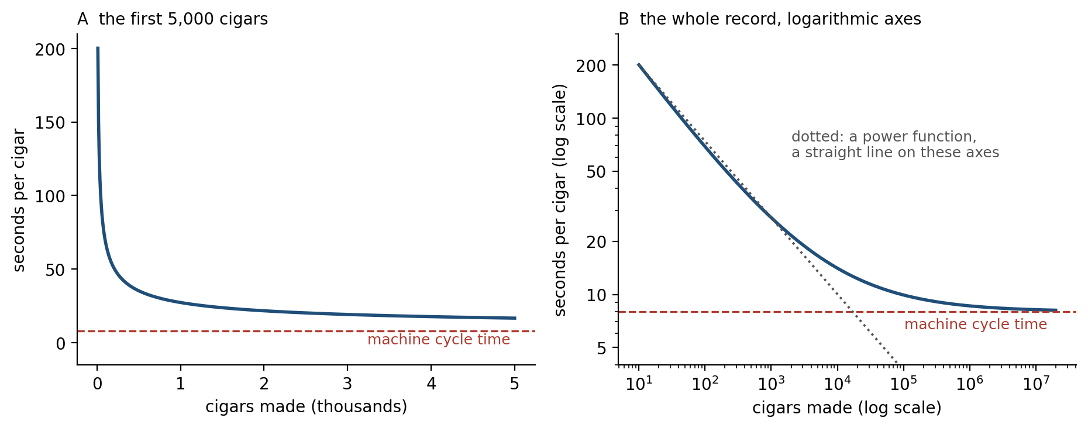
Figure 9.1. The shape of practice (illustrative, after Crossman 1959). A: over the first few thousand cigars, time per cigar falls steeply and then slowly. B: on logarithmic axes the early record is close to a straight line, the signature of a power function, and it bends away from the line as times approach the machine’s cycle time.
The law is less universal than its name. Andrew Heathcote, Scott Brown, and Douglas Mewhort showed that averaging curves across people manufactures a power function even when every individual improves along a different curve, and that individual curves are often better fitted by an exponential, which levels off more abruptly. What survives is the qualitative shape: rapid early gains, slow late gains, and improvement that continues long after the learner has stopped noticing it.
Psychologists have long described the course of a skill in stages. Paul Fitts and Michael Posner distinguished a cognitive stage, in which the learner works out what to do and talks through each step; an associative stage, in which the pieces are linked and errors fall; and an autonomous stage, in which the skill runs with little attention and the learner may no longer be able to say how it is done. Nearly 70 years earlier, William Bryan and Noble Harter had described the same progression in telegraph operators learning Morse code, who first received letters one at a time, then whole words, and finally phrases, building what they called a hierarchy of habits. The stages are a description, not a mechanism, but they name the change this chapter explains: the same performance, produced first by deliberation and later by something else.

Habits and Skills
Two words have been used loosely so far, and they mean different things. A habit, in the sense of Chapter 8, is an action triggered by a situation rather than chosen for its outcome, and its signature is insensitivity to devaluation. A skill is an improvement in how well an action is done. John Krakauer and his colleagues define it by the trade-off between speed and accuracy that Chapter 8 met in decisions. Anyone can trace a difficult path accurately by going slowly, or quickly by accepting errors; a skilled performer is faster at the same accuracy, or more accurate at the same speed, so practice shifts the whole curve relating the two. Habits and skills usually develop together, because the practice that makes a movement better also makes it more automatic, but they can be pulled apart. A musician can play a piece deliberately, choosing every phrasing; a person can have a strong habit, such as reaching for a phone, that involves no skill at all.
Both are forms of what Chapter 5 called procedural memory, and both survive damage that abolishes memory for events. Chapter 5’s patient H.M., who learned mirror tracing while denying each day that he had seen the task, also improved over days, Suzanne Corkin found, at keeping a stylus on a moving target. Barbara Knowlton, Jennifer Mangels, and Larry Squire later showed the converse. In a task in which people learned by trial and error to predict the weather from combinations of cards, amnesic patients improved as fast as healthy people, at least early in training, while being unable to recall the training sessions; patients with Parkinson’s disease, whose striatum has lost most of its dopamine, remembered the sessions and failed to improve. Amnesic patients even learn a repeating sequence hidden in a stream of lights, responding faster to it without knowing it is there. Knowing that something happened and knowing how to do something depend on different circuits.

Recalibration
The simplest thing practice does is keep movements accurate as the body and the world change. Reza Shadmehr and Ferdinando Mussa-Ivaldi had people reach to targets while holding the handle of a robot arm that pushed sideways with a force proportional to the speed of the hand. The first reaches curved wildly. Over a few hundred movements they straightened. When the force was then switched off without warning, the reaches curved the other way, in a mirror image of the original error: the brain had learned to produce a force that canceled the robot’s, and went on producing it after the robot stopped. This mirror-image error, called an aftereffect, is the signature of adaptation: the motor system has recalibrated, and must recalibrate back.
The same thing happens with vision. Thomas Thach and his colleagues had people throw balls at a target while wearing prism glasses that shifted the visual scene to one side. The first throws missed, and over successive throws they came back onto the target; when the glasses came off, the throws missed to the other side until the adaptation washed out. Patients with damage to the cerebellum or to the inferior olive, the source of the climbing fibers that Chapter 4 described as the cerebellum’s error signal, went on missing: adaptation is cerebellar learning.
Ya-weng Tseng, Amy Bastian, and colleagues showed that adaptation is driven by a sensory prediction error, the difference between where the brain predicted the hand would go and where it was seen to go, rather than by failure to reach the goal. Pietro Mazzoni and Krakauer made the distinction vivid. They rotated the cursor that showed people where their hand was by 45 degrees and then told them the trick: aim at the target 45 degrees away, and the cursor will land on the one you want. The strategy worked at once. Then, over the next few dozen reaches, the cursor began to miss, by larger and larger amounts, in the direction of the strategy. An implicit system had noticed that the hand was not going where the brain had aimed it, and it went on correcting that discrepancy even though the correction spoiled the performance the participants were trying to produce.
Jordan Taylor, Krakauer, and Richard Ivry later asked people to report, before each reach, where they were aiming, and found that the explicit strategy accounted for the fast part of learning and an implicit recalibration for the slow remainder. Adaptation has a memory with more than one timescale. Spontaneous recovery is the strangest sign of it. Adapt a person for a long time, then briefly the other way until performance is back at baseline, then run trials on which the error is held at zero whatever the hand does: the person drifts back toward the first adaptation. Maurice Smith, Ali Ghazizadeh, and Shadmehr explained this with a model of two processes running in parallel, a fast one that learns quickly and forgets quickly and a slow one that learns slowly and holds on (Figure 9.2). Brief counter-training cancels the fast process while the slow one still carries the old learning, so when errors stop, the fast process decays and the slow one shows through. The model also explains part of savings, the faster relearning of a perturbation met a second time. When the first learning has been fully washed out, however, savings seem to depend on something else: remembering the aiming strategy that worked before.
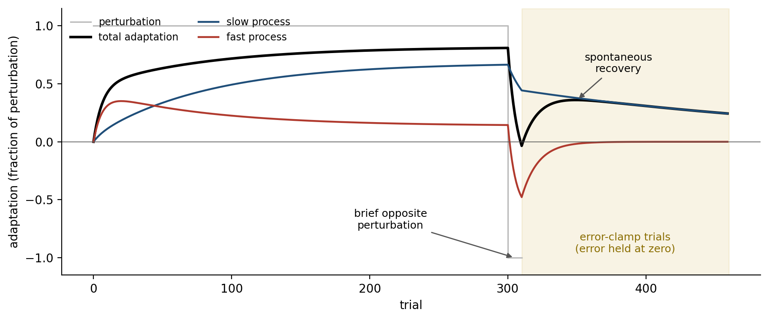
Figure 9.2. Two timescales of adaptation (simulated, two-state model after Smith, Ghazizadeh & Shadmehr 2006). A long perturbation is learned mostly by the slow process; a brief opposite perturbation drives the fast process negative until the total returns to zero; on the following error-clamp trials (error held at zero), the fast process decays and the slow process reappears as spontaneous recovery.
Error is not the only teacher. Repeating a movement biases later movements toward it, a use-dependent learning that needs no error at all. And people can learn from success and failure alone, as an animal learns from reward: Amanda Therrien, Daniel Wolpert, and Bastian found that patients with cerebellar damage, who adapt poorly to sensory errors, could still improve their reaching when told only whether each movement had succeeded.
Adaptation, however learned, returns a person to their previous level of performance under new conditions; it does not teach them to do what they could not do before. Krakauer has argued that much of what was studied as motor learning for decades was adaptation, and that skill, the acquisition of new capability, is a different and slower process that depends on other circuits. The rest of this chapter is about that process.

Chunking
In 1951 Karl Lashley pointed out a problem with the then-dominant idea that a sequence of actions is a chain in which each movement is triggered by the sensation of the one before. A pianist’s fingers, or a speaker’s tongue, move too fast for feedback from one movement to arrive in time to trigger the next, and errors of serial order, such as the typist’s transposed letters or the speaker’s spoonerism, show that later elements of a sequence are prepared before earlier ones are executed. Sequences must be represented as wholes, planned in advance and run off as units.
George Miller had called such units chunks, in the context of memory: people can hold about seven items in mind (later estimates put the limit nearer four), but an item can be a digit, a familiar date, or a word, so what can be held depends on how the material is grouped. William Chase and Herbert Simon showed what expertise does with this. Chess masters shown a position from a real game for five seconds could reconstruct far more of it than weaker players, but for pieces placed at random their advantage largely disappeared. The masters were not remembering pieces; they were recognizing familiar configurations, each a single chunk.
K. Anders Ericsson, Chase, and Steve Faloon took an undergraduate with an ordinary memory span of seven digits and, over more than 230 hours of practice across nearly two years, watched him raise it to 79. He was a runner, and he had learned to code groups of digits as running times; his span for letters, which his codes did not cover, stayed at about six. His skill was not a bigger memory. It was a larger vocabulary of chunks.
Motor sequences are chunked in the same way. Okihide Hikosaka and colleagues trained people on long sequences of key presses and found that each person, without being told to, came to perform the sequence in groups, fast within a group and with a pause between groups, and that the grouping differed from person to person. When the sequence was later rearranged in a way that broke a person’s own chunks, performance suffered more than when it was rearranged to preserve them. Nicholas Wymbs, Scott Grafton, and colleagues found that over three days of training, activity in the sensorimotor putamen, the part of the striatum tied to motor cortex, rose with how strongly the elements of a sequence were joined into chunks, while regions of frontal and parietal cortex were more active when a sequence was being divided into chunks.
Recordings in animals show what a chunk looks like in the striatum. Mandar Jog, Ann Graybiel, and colleagues recorded from the sensorimotor striatum of rats learning to run a T-shaped maze, turning left or right according to a tone. Early in training, neurons fired throughout the run. With extended training, the activity reorganized: more and more of it concentrated at the start of the run and at its end, with relatively little in between (Figure 9.3). Terra Barnes and colleagues later found that the pattern faded when the reward was withdrawn and came back when it was restored, as if the run had been packaged as a unit marked at its boundaries. Graybiel called this task-bracketing and proposed that it is how the basal ganglia chunk action repertoires. Later work found that the striatal pattern forms early, before the behavior becomes insensitive to devaluation, and tracks how automatic the running is. A similar pattern appears in the infralimbic cortex, a small region of the medial prefrontal cortex, only late in overtraining, just as the habit sets in.
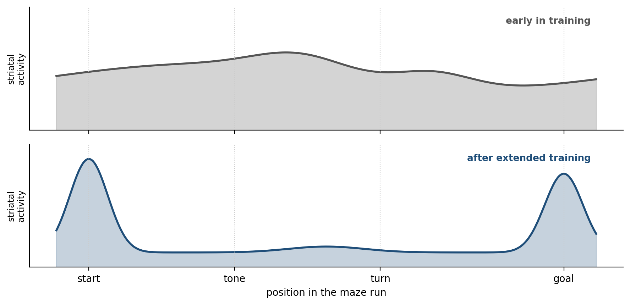
Figure 9.3. Task-bracketing in the striatum (illustrative, after Jog et al. 1999 and Barnes et al. 2005). Early in training, striatal activity is spread across the maze run; after extended training it concentrates at the start and the end of the run, marking the boundaries of the action as a unit.
Xin Jin and Rui Costa trained mice to press a lever in a rapid sequence for a reward and found neurons in the striatum and in the dopamine-producing substantia nigra that fired specifically at the start or the end of each sequence. This start and stop activity emerged during learning, and when striatal function was genetically altered it failed to develop and the sequences were not learned. Jin, Fatuel Tecuapetla, and Costa later found, alongside the start and stop neurons, others whose activity stayed up or stayed down for the whole of a sequence, as if binding its elements together. The direct and indirect pathways, the striatum’s two routes to its output nuclei described in Chapter 4, were both active as a sequence began and then behaved differently while it ran. Once an action is bracketed, it can be selected by the basal ganglia as if it were a single movement, and Amir Dezfouli and Bernard Balleine have argued that many habits are exactly this: sequences chunked so that their parts are no longer evaluated one by one. A chunked sequence is cheap to select, and for the same reason it cannot be revised in the middle.

From Planning Circuits to Doing Circuits
Practice moves an action from the goal-directed control of the dorsomedial striatum to the habitual control of the dorsolateral striatum (Chapter 8), and the shift has now been watched as it happens. Henry Yin, Rui Costa, and colleagues trained mice to stay on an accelerating rotating rod, a skill that improves over days. Neurons in the dorsomedial striatum changed their firing early in training and those in the dorsolateral striatum later, and in slices taken from trained animals the excitatory synapses onto dorsolateral neurons, especially those of the indirect pathway, had been strengthened. Mice with lesions of the dorsomedial striatum were impaired in the early sessions and then caught up; mice with lesions of the dorsolateral striatum were impaired throughout.
People show the same shift. Stéphane Lehéricy, Julien Doyon, and colleagues scanned people practicing a finger sequence over four weeks and found activity moving from the associative striatum, linked to prefrontal cortex, early in learning to the posterior putamen, linked to motor cortex, once the sequence was overlearned.
Dopamine is needed for the handover. Alexis Faure and colleagues found that rats whose dopamine supply to the dorsolateral striatum had been destroyed went on learning to press a lever but never became habitual, staying sensitive to devaluation after training that made normal rats indifferent to it. The anatomy shows how dopamine could pass the handover along. Suzanne Haber and colleagues traced connections between the striatum and the midbrain dopamine neurons and found that they form an ascending spiral: each striatal region influences the dopamine neurons that project to the next region along, from the ventral striatum of motivation, through the associative striatum, to the sensorimotor striatum. Learning in one loop can thus shape what dopamine teaches in the next (Figure 9.4).
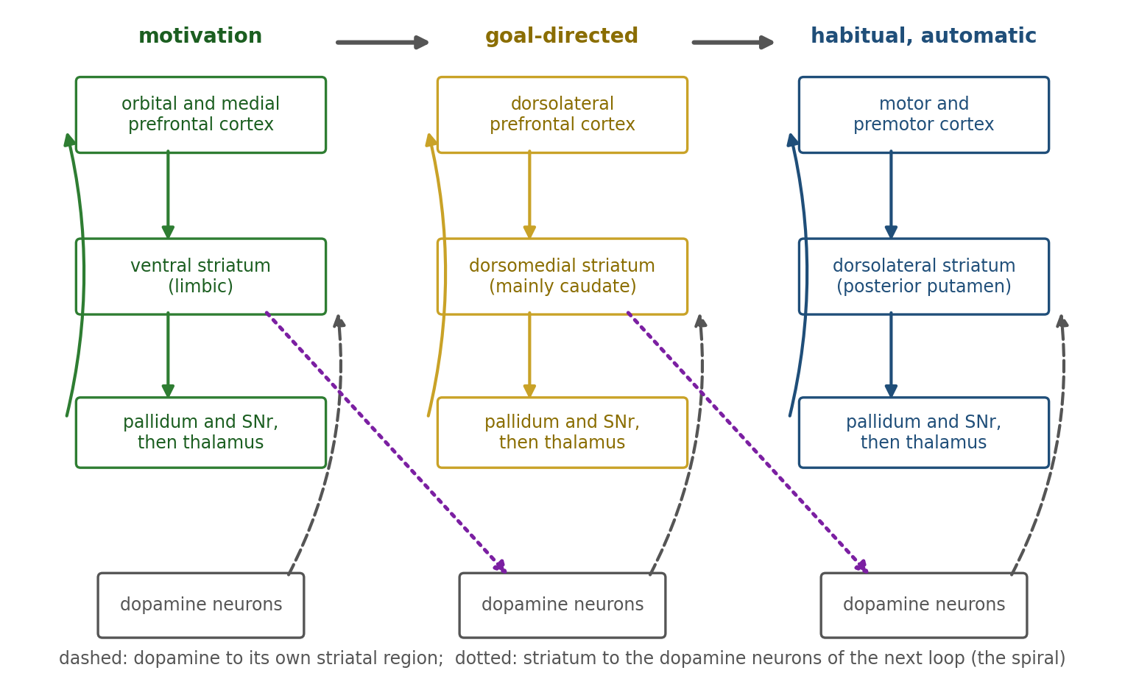
Figure 9.4. From motivation to deliberation to execution. Three parallel loops run from cortex through the striatum and, by way of the pallidum and the substantia nigra pars reticulata (SNr) and then the thalamus, back to cortex: a limbic loop through the ventral striatum, an associative loop through the dorsomedial striatum (mainly caudate), and a sensorimotor loop through the dorsolateral striatum (posterior putamen). Each striatal region sends signals to the dopamine neurons that project to the next region (dotted arrows), forming a spiral; with practice, control of an action moves rightward.
Cortex does not let go of a habit even after the striatum has taken it over. Kyle Smith, Graybiel, and colleagues overtrained rats to run a maze for a reward and then devalued the reward. The rats kept running to it, as habitual animals do. When the infralimbic cortex was briefly silenced with light, the rats stopped running to the devalued reward, as if their goal-directed control had been released; when a new habit had formed in its place, silencing the same region brought the old habit back. A habit is not only stored; it is continuously permitted.
Is cortex needed to execute a skill at all? Risa Kawai, Bence Ölveczky, and colleagues trained rats to press a lever twice with a precise interval between the presses, a skill each rat performed with its own idiosyncratic movements. Lesions of motor cortex made after training had no discernible effect: the rats produced their own particular movements on the first day after surgery. Lesions made before training left the rats unable to learn the task. Motor cortex, on this evidence, tutors subcortical circuits during learning and is then not needed to run what they have learned. Ashesh Dhawale, Ölveczky, and colleagues then showed that the sensorimotor striatum is needed to produce the detailed movements of such a learned skill, and that it does so without input from motor cortex.
Whether this generalizes is debated. Gregory Ashby, Brian Turner, and Jon Horvitz argue from human and primate evidence that, for skills and categorization, the striatum trains cortex and that fully automatic performance is eventually carried by direct connections between cortical areas. The rodent results suggest the reverse: cortex trains subcortical circuits and the basal ganglia carry the finished skill. The two views may describe different kinds of skill, dexterous movements in which motor cortex is indispensable and stereotyped sequences in which it is not. Both agree on the principle. The circuits needed to learn a skill are not the circuits that run it.

Variability as Exploration
Even the most practiced movements vary slightly from one repetition to the next. That variability is often treated as noise, but it may be the motor system exploring. For a movement, the exploration of Chapter 8 means trying slightly different versions and keeping what works. Howard Wu, Maurice Smith, and colleagues found that people whose movements varied more along the dimension that mattered to the task learned faster, and that the nervous system reshaped its variability toward that dimension during training, though later studies have not consistently found the same relation for learning from errors.
Songbirds show the mechanism most clearly. A young zebra finch learns its song by trial and error over weeks, comparing its own singing with a memorized song of an adult tutor. The song system has a motor pathway that produces the song and a side loop, the anterior forebrain pathway, that runs through a part of the bird’s basal ganglia called Area X and ends in a nucleus that projects back onto the motor pathway (Figure 9.5). Ölveczky, Aaron Andalman, and Michale Fee found that when that nucleus was silenced in juvenile birds, the variability of their song immediately collapsed. The basal ganglia loop injects variation into the song. Evren Tumer and Michael Brainard showed, in adult Bengalese finches, that song which seems fixed is still adjustable through its remaining small variability. They played a burst of noise whenever a bird sang a particular syllable at a slightly lower pitch than usual, and within hours the birds shifted the pitch of that syllable upward, away from the noise.
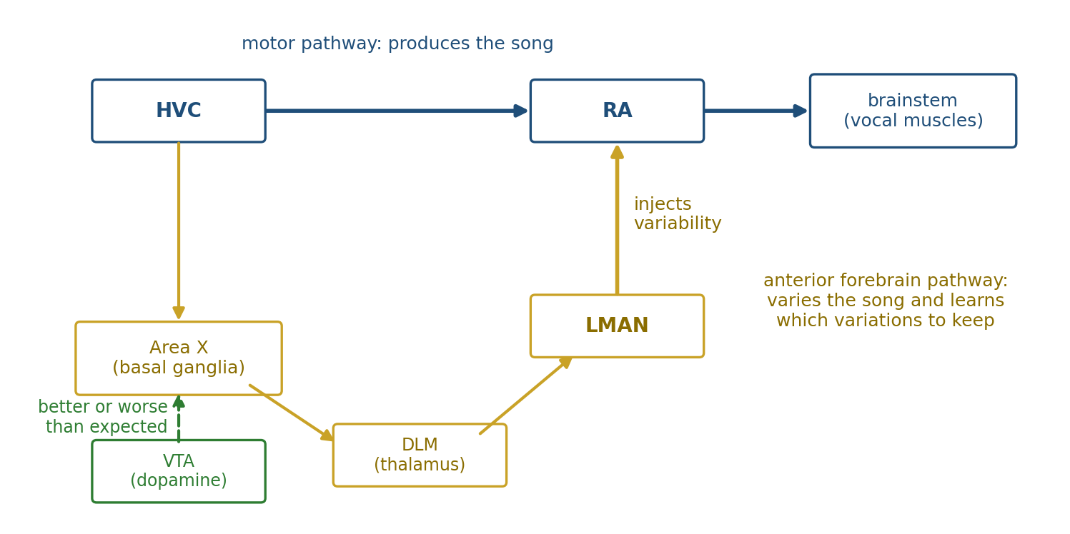
Figure 9.5. The songbird’s learning circuit (the song nuclei are known by their abbreviations). A motor pathway from HVC to RA to the brainstem produces the song; an anterior forebrain pathway through Area X, part of the basal ganglia, the thalamic nucleus DLM, and LMAN injects variability into RA. Dopamine neurons in VTA tell Area X whether a rendition sounded better or worse than expected.
What decides which variations are kept? Vikram Gadagkar, Jesse Goldberg, and colleagues recorded the dopamine neurons that project to Area X in singing birds. When the experimenters distorted a syllable as the bird sang it, by playing a sound over it, the neurons were suppressed; when a syllable that was often distorted came out clean, they fired more. That is the reward prediction error of Chapter 3, applied to the quality of a performance rather than to food. Fee and Goldberg have proposed that the circuit implements reinforcement learning: the side loop makes the song vary, dopamine reports whether a variation sounded better than expected, and Area X biases the variation toward the better versions until the song itself has moved. Practice, on this view, is the learning rule of choice applied to the fine details of a movement.

The Cortex Rewires
Whatever runs a finished skill, practice changes motor cortex on the way. Randolph Nudo, Michael Merzenich, and colleagues mapped the motor cortex of squirrel monkeys, region by region, with small electrical currents, before and after the monkeys learned to retrieve food pellets from small wells, a task requiring fine finger control. The area from which finger movements could be evoked expanded, at the expense of the area for the wrist and forearm.
Alvaro Pascual-Leone and colleagues had people practice a five-finger piano exercise for two hours a day for five days and mapped their motor cortex each day with the magnetic pulses through the scalp that Chapter 8 described. The area from which the finger muscles could be activated grew over the days. People who only imagined playing the exercise, without moving, showed a similar if smaller change. Long practice leaves a lasting mark. Thomas Elbert, Edward Taub, and colleagues found that the representation of the fingers of the left hand in the somatosensory cortex of string players, who use those fingers to stop the strings, was enlarged, most of all in those who had begun to play young.
At the level of synapses, the change can now be watched in a living animal. Tonghui Xu, Yi Zuo, and colleagues imaged the dendritic spines, the small protrusions that carry most excitatory synapses, on output neurons of the mouse motor cortex while the mice learned to reach for seeds. New spines formed within an hour of the first training. Over the following days, older spines were eliminated and the overall number returned to its starting level, but a fraction of the new spines was stabilized and persisted for months after training ended. Guang Yang, Feng Pan, and Wen-Biao Gan found the same in mice learning to run on the rotating rod: a small fraction of the spines formed during learning lasted for the rest of the animal’s life. Akiko Hayashi-Takagi, Haruo Kasai, and colleagues then made the link causal. They tagged the spines that had grown during learning with a light-sensitive protein, shrank those spines selectively with light, and found that the learned skill was disrupted. A skill, at this level, is a small set of new connections that practice built and then protected.
Not every claim of cortical change in people has survived better methods. Eva Berlot, Nicola Popp, and Jörn Diedrichsen pointed out that a practiced sequence is also performed faster, so changes in imaging signals may reflect the speed of performance rather than learning. When they controlled for this, after five weeks of practice they found little change in primary motor cortex and clearer changes in premotor and parietal areas. Where in human cortex a skill comes to reside is less settled than the earlier imaging studies implied.

Learning Between Sessions
Chapter 5 described how sleep consolidates memory, and skills seemed to offer a striking case. Matthew Walker, Robert Stickgold, and colleagues trained people on a finger-tapping sequence and found that after a night’s sleep they were about 20 percent faster, with no loss of accuracy, while an equal interval awake brought no significant gain. Later work found that much of this was an artifact. Timothy Rickard and colleagues showed that performance at the end of a training session is depressed by fatigue, and that once time of day, fatigue, and the way trials were averaged were controlled, the overnight gain disappeared. A meta-analysis by Steven Pan and Rickard concluded that most of the apparent sleep benefit for motor sequences is explained by such confounds, though sleep may still protect what was learned from being lost.
A newer finding moved the question to a much shorter timescale. Marlene Bönstrup, Leonardo Cohen, and colleagues had people type a sequence as often as possible in ten-second bursts separated by ten seconds of rest, and found that in the early part of training almost all the improvement happened during the rests, not during the typing. Ethan Buch, Cohen, and colleagues recorded brain activity during those rests with magnetoencephalography, which measures the magnetic fields produced by neural currents, and found the neural pattern of the practiced sequence replayed, compressed many times over, in the hippocampus and the sensorimotor cortex; the more replay, the larger the gain. This is the replay of Chapter 5, during waking rest, at work on a skill. But Mohini Gupta and Rickard argue that these gains during rest, too, may be recovery from a short-lived fatigue built up during each burst of typing. Whether skill is consolidated offline, and on what timescale, is an open question.

Automaticity
William James wrote in 1890 that “habit diminishes the conscious attention with which our acts are performed.” The modern study of automaticity began with experiments that measured that attention directly. Walter Schneider and Richard Shiffrin had people search displays for target letters among distractors. When targets and distractors kept the same roles across thousands of trials, search eventually became nearly as fast for many items as for one, as if the targets popped out; when the roles were mixed from trial to trial, search stayed slow and effortful however long people practiced. When targets and distractors that had kept consistent roles were then exchanged, the old automatic responses went on interfering for a very long time. Automatic processing, they concluded, is fast, effortless, and parallel, and it develops only when the mapping from situation to response is consistent. Once developed, it is hard to suppress.
The oldest demonstration of that last property is John Ridley Stroop’s. Naming the color of the ink in which a word is printed takes much longer when the word itself names a different color, as when “red” is printed in green, because reading has become automatic and the word is read whether or not reading is wanted.
Gordon Logan proposed a simple account of how computation turns into automaticity. Each time a task is performed, the situation and the answer are stored as an instance. When the situation recurs, two processes race: the original procedure, which computes the answer, and retrieval of past instances, any of which can supply it. Whichever finishes first determines the response. With practice the number of stored instances grows, and the fastest of many retrievals is faster than the fastest of a few, so the response gets faster and the procedure stops winning the race (Figure 9.6). Under simple assumptions about how long retrievals take, the fastest of many falls as a power function of their number, so instance theory predicts the power law of practice; it also predicts, as later experiments bore out for many tasks, that the variability of response times shrinks along with their mean. On this account automaticity is not a faster algorithm but the replacement of computing with remembering: the child who has done enough sums stops adding seven and five and knows that the answer is twelve.
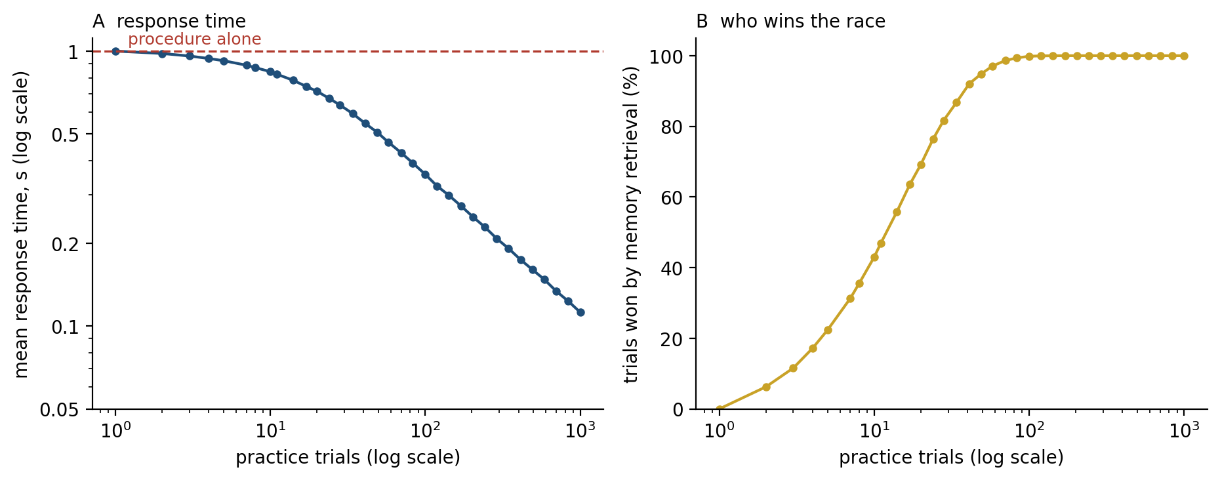
Figure 9.6. Automaticity as a race (simulated, after Logan 1988). Each practice trial stores an instance; on each trial the response is given by whichever finishes first, the original procedure (a fixed time) or the fastest retrieval of a stored instance. As instances accumulate, mean response time, after a slow start, falls along a near-straight line on logarithmic axes (A), and retrieval wins the race more and more often (B).
When a skill is automatic, attending to it can make it worse. Sian Beilock, Thomas Carr, and colleagues had experienced golfers putt and experienced soccer players dribble a ball through cones, either while attending to a part of their own movement, such as the moment the club stopped, or while monitoring a stream of tones for a target. The experts did worse when attending to their movements and were barely affected by the tones; novices showed the opposite pattern. Pressure can have the same effect, by drawing attention back to steps that run better unwatched, which is one account of choking, the collapse of a practiced skill under pressure. Richard Masters taught people to putt either with explicit instructions or while saying random letters aloud, which prevented them from forming explicit rules, and found that under pressure the explicitly taught group faltered and the implicitly taught group did not.
In the brain, automaticity looks less like a move to a new region than like doing the same work with less. Russell Poldrack and colleagues trained people on a sequence until a second task performed at the same time no longer slowed them, and found that activity declined in several regions, including lateral prefrontal cortex, as the cost of the second task disappeared. The prefrontal resources that Chapter 8 called costly are released for other use.

How Practice Should Be Practiced
Practice works, but not all practice works equally. K. Anders Ericsson, Ralf Krampe, and Clemens Tesch-Römer studied violin students at a Berlin music academy and found that the best of them had accumulated, by their estimates, about 10,000 hours of solitary practice by the age of 20, more than the merely good students and far more than those training to be music teachers. They argued that deliberate practice, effortful work on specific weaknesses with feedback, accounts for most of the difference between experts and others. Malcolm Gladwell later popularized the finding as a “10,000-hour rule.”
The claim has been tested many times since and has not held in its strong form. Brooke Macnamara, David Hambrick, and Frederick Oswald, in a meta-analysis across music, games, sports, education, and professions, found that deliberate practice explained about 12 percent of the variation in performance overall, more in games and music and very little in professions. Macnamara and Megha Maitra repeated the violin study with a double-blind design; practice still predicted skill, but much less strongly than in the original, and it did not separate each level of skill from the next. Practice is necessary for expertise, but the amount alone does not explain who becomes expert.
How practice is arranged matters as well as how much. John Shea and Robyn Morgan had people learn three patterns of rapid arm movements, knocking down small barriers in a set order as fast as possible. One group practiced each pattern in a block before moving to the next; another practiced them in a random order. The random group was slower during practice, but faster when tested ten minutes and ten days later, and on a new pattern (Figure 9.7). The effect is called contextual interference, and Richard Schmidt and Robert Bjork found the same paradox across verbal and motor learning: conditions that make practice look worse, such as interleaving, spacing, and reduced feedback, often make learning better. One explanation is that each switch forces the learner to retrieve and rebuild the movement plan, which is the same work that the later test requires. The effect is reliable in the laboratory and smaller, though still present, in applied settings such as sport.
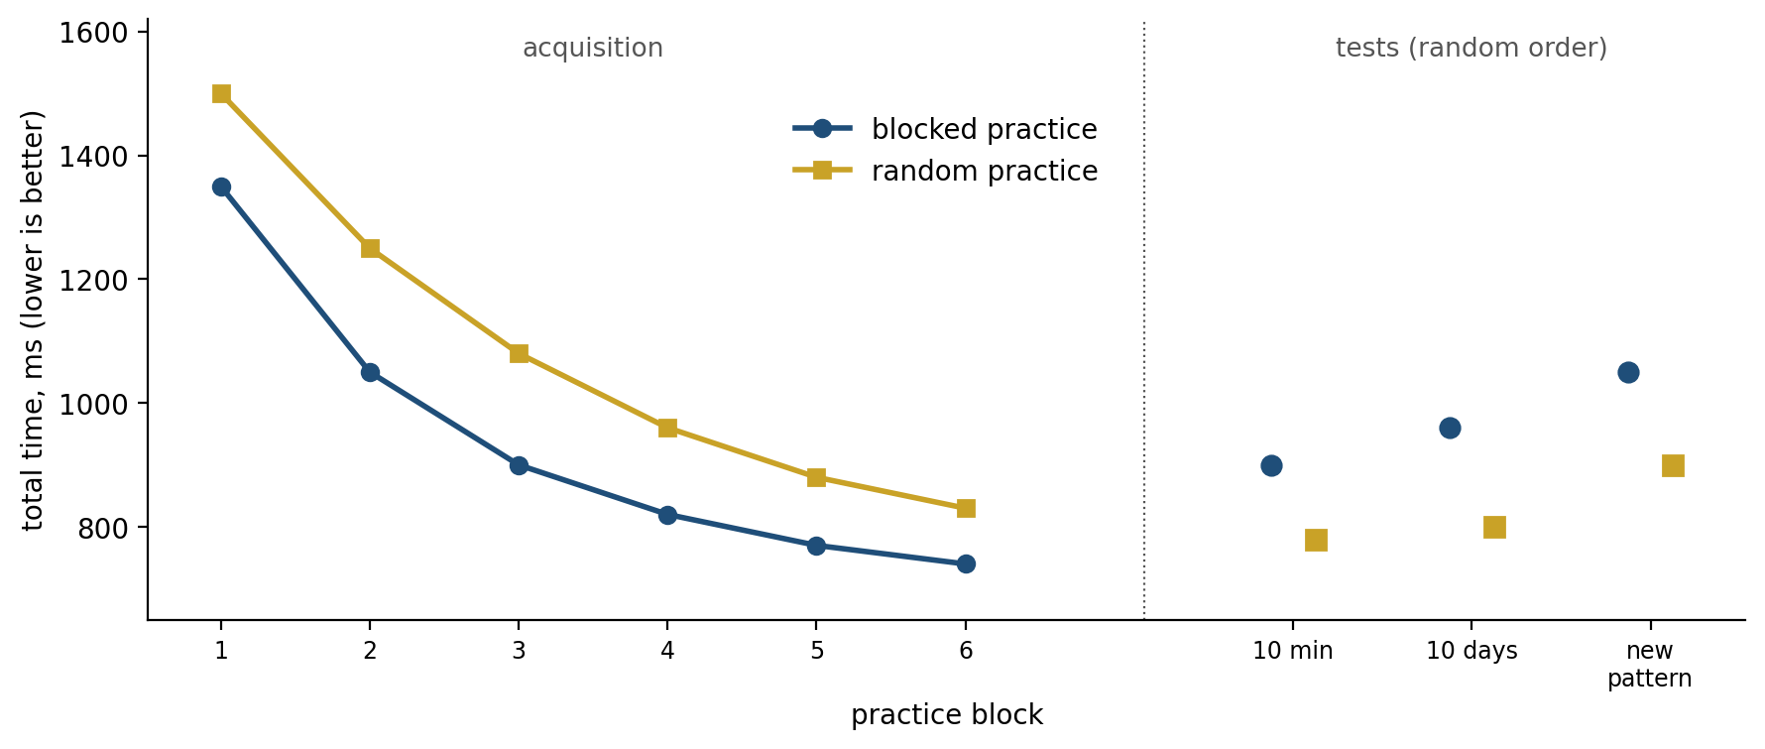
Figure 9.7. Contextual interference (illustrative, after Shea & Morgan 1979). Blocked practice produces faster performance during acquisition; random practice produces faster performance at the retention tests ten minutes and ten days later (shown here for tests in random order) and on transfer to a new pattern.
Variety helps in a related way. Robert Kerr and Bernard Booth had children aged eight and 12 throw beanbags at a target on the floor without seeing it as they threw, before and after a 12-week physical education program. The groups differed only in their practice throws before each test: one practiced at the test distance, the other only at a nearer and a farther target. At the end of the program, the group that had never practiced at the test distance was the more accurate at it. Richard Schmidt’s schema theory explains why: practicing several versions of a movement teaches the rule that relates them, which then serves for versions never practiced.

Habits in Daily Life
Outside the laboratory, habits fill much of the day. Wendy Wood, Jeffrey Quinn, and Deborah Kashy asked students to record what they were doing, thinking, and feeling every hour, and found that about 43 percent of their actions were performed almost every day in the same place, usually while they were thinking about something else. Phillippa Lally, Jane Wardle, and colleagues asked 96 volunteers to take up a new daily behavior, such as eating a piece of fruit with lunch or going for a run before dinner, and to rate each day how automatic it felt. Automaticity rose along a curve that leveled off, like the practice curves of Figure 9.1. The time to reach 95 percent of each person’s plateau ranged from 18 to 254 days, with a median of 66, and missing a single day made little difference. As Chapter 8 noted, laboratory attempts to make people habitual by overtraining a single response for an hour or a few days have often failed, so the habits of daily life may be built from many repetitions in stable contexts over months.
Habits outside the laboratory show the insensitivity to outcome that Chapter 8 measured in rats. David Neal, Wood, and colleagues gave people at a cinema either fresh popcorn or popcorn that was a week old. People who rarely ate popcorn at the cinema ate less of the stale popcorn; people with a strong cinema-popcorn habit ate as much stale as fresh. The habit held only in the cinema, its context, and it broke when people were asked to eat with their other hand, which prevented the practiced movement from running. Habits are cued by context, and Wood and Dennis Rünger argue that this is the lever for changing them: moving house, starting a new job, or altering the setting of a behavior disrupts the cues and opens a window in which a new routine can form.

When Routines Go Wrong
Because the routes to automaticity are specific circuits, their failures are specific too. In Parkinson’s disease, the loss of dopamine is earliest and most severe in the posterior putamen, the sensorimotor striatum that carries habits. Peter Redgrave, José Obeso, and colleagues argue that patients therefore lose automatic control first, and must perform by deliberate effort actions that used to run on their own. Walking becomes a task that needs attention, and it worsens when the patient talks at the same time. Tao Wu and Mark Hallett found that patients could still make a sequence automatic, but only with more training and with more brain activity than healthy people needed. Meg Morris and colleagues showed that patients’ short, shuffling steps lengthen to nearly normal when they step over lines marked on the floor, because the visual cue lets goal-directed circuits do the work that the damaged habit circuit no longer does.
Practice itself can go wrong. In 1964 the American pianist Leon Fleisher, then in his thirties and one of the leading pianists of his generation, found the fourth and fifth fingers of his right hand curling under whenever he played. For three decades he played only music written for the left hand, and taught and conducted. In the 1990s, after the condition had been identified as focal dystonia and treated with injections of botulinum toxin and a deep-tissue massage called Rolfing, he began to play with both hands again, and in 2004 he recorded his first two-handed album in four decades. The recovery was partial and depended on continuing injections.
About one in 100 professional musicians develops musician’s dystonia, a loss of voluntary control that appears only in the extensively trained movements of playing. Nancy Byl, Merzenich, and colleagues trained owl monkeys to squeeze a handle over and over and found that some developed a similar movement disorder, along with a blurring of the normally separate representations of the fingers in somatosensory cortex. One hypothesis is that the plasticity that enlarges a string player’s finger map can, pushed further, merge the maps until the fingers cannot be moved independently.
Addiction has been described as a habit gone wrong. Barry Everitt and Trevor Robbins argue that drug-seeking begins as goal-directed action, becomes habitual as control moves from the ventral to the dorsal striatum along the spiral of Figure 9.4, and finally becomes compulsive, persisting despite punishment. Lee Hogarth argues the opposite: that in people, drug choice remains sensitive to its outcome and is driven by excessive goal-directed pursuit of relief from negative feelings, not by habit. In each of these disorders the machinery of routine works too well, too little, or in the wrong place.

Implications for Artificial Intelligence
Where Chapter 8 asked how machines choose, this section asks how they stop having to. Artificial intelligence has met the economy of habit directly, and some of its most successful systems resemble the brain’s arrangement closely.
First, the best game-playing systems turn search into reflex. Chapter 8 described AlphaGo pairing fast networks with search. Its successor, AlphaGo Zero, went a step further: it chose its moves by a search that simulated future play, and its network was trained to predict the moves that the search chose; over training, the network alone, choosing moves at a glance without any search, became a strong player. Thomas Anthony, Zheng Tian, and David Barber described the same scheme, which they called expert iteration, explicitly as fast intuition trained by slow deliberation. That is Logan’s instance theory and the shift from dorsomedial to dorsolateral striatum in engineering form: an expensive procedure generates good answers, and a cheap one learns to reproduce them. Researchers have begun to train language models the same way, using answers first reached by step-by-step reasoning as targets so that the model learns to give them directly.
Second, what is cached is brittle in the way habits are. A network trained to copy a search reproduces the search’s answers in the situations it was trained on and does not consult the outcome. If the goal changes, it goes on producing what used to be right. Most artificial systems that cache have no way to notice this, and a change in the objective requires retraining.
Third, varied practice is how robots generalize. Josh Tobin and colleagues trained robot vision in simulation with colors, textures, and lighting randomized far beyond anything realistic, and the result worked on the real robot without ever having seen it. OpenAI’s robot hand learned to manipulate a Rubik’s cube in the real world, turning it through a solution supplied by a standard solver, after training only in simulations whose physics were randomized, with the range of randomization widened automatically as the hand improved. That is Kerr and Booth’s beanbags at scale: a learner that never practiced the test condition does well on it because it practiced around it.
Fourth, the brain largely adds skills without erasing old ones. A network learning a new skill tends to overwrite the ones it has, the catastrophic interference of Chapter 5, and methods that protect important weights, such as James Kirkpatrick and colleagues’ elastic weight consolidation, are partial remedies. Motor cortex instead forms new spines for a new skill and keeps a few of them for life while leaving the old ones in place. The brain is not immune to interference: two conflicting adaptations learned close together do disrupt each other.
Fifth, the brain lets the slow system interrupt the fast one. Practice adds a twist to Chapter 8’s arbitration between planning and habit: a routine runs only while a supervisor permits it, as the infralimbic experiments show. A pianist plays automatically until a wrong note, then attends; a driver converses until the car ahead brakes. Artificial systems with both fast and slow modes rarely decide for themselves when to switch from one to the other, and it is that decision, as much as either mode, that makes a skilled human reliable. Whether machines can learn it, and what else they lack, is the question of Chapter 10.

The Central Lesson
Practice is how the brain spends deliberation once so that it need not spend it again. Each repetition hands a little more of an action to circuits that do not think: the cerebellum keeps it calibrated, the basal ganglia package it into units that run whole, dopamine keeps the variations that worked, and motor cortex builds and then protects the few connections that hold it. The result is Whitehead’s economy, an answer remembered rather than computed, and its price is Chapter 8’s rat, still pressing for food it will not eat. The brain can afford that price because it never lets the slow system go: deliberation moves to the edges of a routine and stands guard, ready to take control back when the expected outcome fails to arrive. Expertise is the freedom to spend thought only where it is needed.

Next Chapter
Chapter 10: What Artificial Intelligence Gets Right and Wrong: Machine Learning Measured Against the Brain

References and Attribution

Figure Attribution
Figures 9.1 to 9.7 were drawn for this book. The curves in Figure 9.1 are illustrative, after the pattern reported by Crossman (1959), not recorded data. Figure 9.2 is a simulation of the two-state model of Smith, Ghazizadeh, and Shadmehr (2006) with illustrative parameters. The activity profiles in Figure 9.3 are illustrative, after the patterns reported by Jog et al. (1999) and Barnes et al. (2005). Figure 9.6 is a simulation of the instance theory of Logan (1988). The values in Figure 9.7 are illustrative, after the pattern reported by Shea and Morgan (1979). Figures 9.4 and 9.5 are schematic diagrams; Figure 9.4 follows the striatonigrostriatal spiral of Haber, Fudge, and McFarland (2000).

Epigraph
Alfred North Whitehead, An Introduction to Mathematics, chapter 5, “The Symbolism of Mathematics” (Williams & Norgate, London; Henry Holt, New York, 1911).

References
Altenmüller, E., & Jabusch, H.-C. (2010). Focal dystonia in musicians: Phenomenology, pathophysiology, triggering factors, and treatment. Medical Problems of Performing Artists, 25(1), 3–9.
Anthony, T., Tian, Z., & Barber, D. (2017). Thinking fast and slow with deep learning and tree search. In Advances in Neural Information Processing Systems 30 (pp. 5360–5370).
Ashby, F. G., Turner, B. O., & Horvitz, J. C. (2010). Cortical and basal ganglia contributions to habit learning and automaticity. Trends in Cognitive Sciences, 14(5), 208–215.
Barnes, T. D., Kubota, Y., Hu, D., Jin, D. Z., & Graybiel, A. M. (2005). Activity of striatal neurons reflects dynamic encoding and recoding of procedural memories. Nature, 437(7062), 1158–1161.
Beilock, S. L., & Carr, T. H. (2001). On the fragility of skilled performance: What governs choking under pressure? Journal of Experimental Psychology: General, 130(4), 701–725.
Beilock, S. L., Carr, T. H., MacMahon, C., & Starkes, J. L. (2002). When paying attention becomes counterproductive: Impact of divided versus skill-focused attention on novice and experienced performance of sensorimotor skills. Journal of Experimental Psychology: Applied, 8(1), 6–16.
Berlot, E., Popp, N. J., & Diedrichsen, J. (2020). A critical re-evaluation of fMRI signatures of motor sequence learning. eLife, 9, e55241.
Brady, F. (2004). Contextual interference: A meta-analytic study. Perceptual and Motor Skills, 99(1), 116–126.
Brashers-Krug, T., Shadmehr, R., & Bizzi, E. (1996). Consolidation in human motor memory. Nature, 382(6588), 252–255.
Brawn, T. P., Fenn, K. M., Nusbaum, H. C., & Margoliash, D. (2010). Consolidating the effects of waking and sleep on motor-sequence learning. Journal of Neuroscience, 30(42), 13977–13982.
Bryan, W. L., & Harter, N. (1899). Studies on the telegraphic language: The acquisition of a hierarchy of habits. Psychological Review, 6(4), 345–375.
Buch, E. R., Claudino, L., Quentin, R., Bönstrup, M., & Cohen, L. G. (2021). Consolidation of human skill linked to waking hippocampo-neocortical replay. Cell Reports, 35(10), 109193.
Byl, N. N., Merzenich, M. M., & Jenkins, W. M. (1996). A primate genesis model of focal dystonia and repetitive strain injury: I. Learning-induced dedifferentiation of the representation of the hand in the primary somatosensory cortex in adult monkeys. Neurology, 47(2), 508–520.
Bönstrup, M., Iturrate, I., Thompson, R., Cruciani, G., Censor, N., & Cohen, L. G. (2019). A rapid form of offline consolidation in skill learning. Current Biology, 29(8), 1346–1351.
Chase, W. G., & Simon, H. A. (1973). Perception in chess. Cognitive Psychology, 4(1), 55–81.
Corkin, S. (1968). Acquisition of motor skill after bilateral medial temporal-lobe excision. Neuropsychologia, 6(3), 255–265.
Cowan, N. (2001). The magical number 4 in short-term memory: A reconsideration of mental storage capacity. Behavioral and Brain Sciences, 24(1), 87–114.
Crossman, E. R. F. W. (1959). A theory of the acquisition of speed-skill. Ergonomics, 2(2), 153–166.
de Wit, S., Kindt, M., Knot, S. L., Verhoeven, A. A. C., Robbins, T. W., Gasull-Camos, J., Evans, M., Mirza, H., & Gillan, C. M. (2018). Shifting the balance between goals and habits: Five failures in experimental habit induction. Journal of Experimental Psychology: General, 147(7), 1043–1065.
Deng, Y., Prasad, K., Fernandez, R., Smolensky, P., Chaudhary, V., & Shieber, S. (2023). Implicit chain of thought reasoning via knowledge distillation. arXiv, 2311.01460.
Dezfouli, A., & Balleine, B. W. (2012). Habits, action sequences and reinforcement learning. European Journal of Neuroscience, 35(7), 1036–1051.
Dhawale, A. K., Wolff, S. B. E., Ko, R., & Ölveczky, B. P. (2021). The basal ganglia control the detailed kinematics of learned motor skills. Nature Neuroscience, 24(9), 1256–1269.
Diedrichsen, J., & Kornysheva, K. (2015). Motor skill learning between selection and execution. Trends in Cognitive Sciences, 19(4), 227–233.
Diedrichsen, J., White, O., Newman, D., & Lally, N. (2010). Use-dependent and error-based learning of motor behaviors. Journal of Neuroscience, 30(15), 5159–5166.
Doyon, J., Bellec, P., Amsel, R., Penhune, V., Monchi, O., Carrier, J., Lehéricy, S., & Benali, H. (2009). Contributions of the basal ganglia and functionally related brain structures to motor learning. Behavioural Brain Research, 199(1), 61–75.
Elbert, T., Pantev, C., Wienbruch, C., Rockstroh, B., & Taub, E. (1995). Increased cortical representation of the fingers of the left hand in string players. Science, 270(5234), 305–307.
Ericsson, K. A., Chase, W. G., & Faloon, S. (1980). Acquisition of a memory skill. Science, 208(4448), 1181–1182.
Ericsson, K. A., Krampe, R. T., & Tesch-Römer, C. (1993). The role of deliberate practice in the acquisition of expert performance. Psychological Review, 100(3), 363–406.
Everitt, B. J., & Robbins, T. W. (2005). Neural systems of reinforcement for drug addiction: From actions to habits to compulsion. Nature Neuroscience, 8(11), 1481–1489.
Everitt, B. J., & Robbins, T. W. (2016). Drug addiction: Updating actions to habits to compulsions ten years on. Annual Review of Psychology, 67, 23–50.
Faure, A., Haberland, U., Condé, F., & El Massioui, N. (2005). Lesion to the nigrostriatal dopamine system disrupts stimulus-response habit formation. Journal of Neuroscience, 25(11), 2771–2780.
Fee, M. S., & Goldberg, J. H. (2011). A hypothesis for basal ganglia-dependent reinforcement learning in the songbird. Neuroscience, 198, 152–170.
Fitts, P. M., & Posner, M. I. (1967). Human Performance. Brooks/Cole.
Fleisher, L., & Midgette, A. (2010). My Nine Lives: A Memoir of Many Careers in Music. Doubleday.
Gadagkar, V., Puzerey, P. A., Chen, R., Baird-Daniel, E., Farhang, A. R., & Goldberg, J. H. (2016). Dopamine neurons encode performance error in singing birds. Science, 354(6317), 1278–1282.
Gladwell, M. (2008). Outliers: The Story of Success. Little, Brown.
Graybiel, A. M. (1998). The basal ganglia and chunking of action repertoires. Neurobiology of Learning and Memory, 70(1–2), 119–136.
Graybiel, A. M. (2008). Habits, rituals, and the evaluative brain. Annual Review of Neuroscience, 31, 359–387.
Gupta, M. W., & Rickard, T. C. (2022). Dissipation of reactive inhibition is sufficient to explain post-rest improvements in motor sequence learning. npj Science of Learning, 7, 25.
Haber, S. N., Fudge, J. L., & McFarland, N. R. (2000). Striatonigrostriatal pathways in primates form an ascending spiral from the shell to the dorsolateral striatum. Journal of Neuroscience, 20(6), 2369–2382.
Haith, A. M., Huberdeau, D. M., & Krakauer, J. W. (2015). The influence of movement preparation time on the expression of visuomotor learning and savings. Journal of Neuroscience, 35(13), 5109–5117.
Hayashi-Takagi, A., Yagishita, S., Nakamura, M., Shirai, F., Wu, Y. I., Loshbaugh, A. L., Kuhlman, B., Hahn, K. M., & Kasai, H. (2015). Labelling and optical erasure of synaptic memory traces in the motor cortex. Nature, 525(7569), 333–338.
He, K., Liang, Y., Abdollahi, F., Fisher Bittmann, M., Kording, K., & Wei, K. (2016). The statistical determinants of the speed of motor learning. PLoS Computational Biology, 12(9), e1005023.
Heathcote, A., Brown, S., & Mewhort, D. J. K. (2000). The power law repealed: The case for an exponential law of practice. Psychonomic Bulletin & Review, 7(2), 185–207.
Hogarth, L. (2020). Addiction is driven by excessive goal-directed drug choice under negative affect: Translational critique of habit and compulsion theory. Neuropsychopharmacology, 45(5), 720–735.
James, W. (1890). The Principles of Psychology (Vol. 1). Henry Holt.
Jin, X., & Costa, R. M. (2010). Start/stop signals emerge in nigrostriatal circuits during sequence learning. Nature, 466(7305), 457–462.
Jin, X., Tecuapetla, F., & Costa, R. M. (2014). Basal ganglia subcircuits distinctively encode the parsing and concatenation of action sequences. Nature Neuroscience, 17(3), 423–430.
Jog, M. S., Kubota, Y., Connolly, C. I., Hillegaart, V., & Graybiel, A. M. (1999). Building neural representations of habits. Science, 286(5445), 1745–1749.
Kawai, R., Markman, T., Poddar, R., Ko, R., Fantana, A. L., Dhawale, A. K., Kampff, A. R., & Ölveczky, B. P. (2015). Motor cortex is required for learning but not for executing a motor skill. Neuron, 86(3), 800–812.
Kerr, R., & Booth, B. (1978). Specific and varied practice of motor skill. Perceptual and Motor Skills, 46(2), 395–401.
Kirkpatrick, J., Pascanu, R., Rabinowitz, N., Veness, J., Desjardins, G., Rusu, A. A., Milan, K., Quan, J., Ramalho, T., Grabska-Barwinska, A., Hassabis, D., Clopath, C., Kumaran, D., & Hadsell, R. (2017). Overcoming catastrophic forgetting in neural networks. Proceedings of the National Academy of Sciences, 114(13), 3521–3526.
Knowlton, B. J., Mangels, J. A., & Squire, L. R. (1996). A neostriatal habit learning system in humans. Science, 273(5280), 1399–1402.
Krakauer, J. W., Hadjiosif, A. M., Xu, J., Wong, A. L., & Haith, A. M. (2019). Motor learning. Comprehensive Physiology, 9(2), 613–663.
Lally, P., van Jaarsveld, C. H. M., Potts, H. W. W., & Wardle, J. (2010). How are habits formed: Modelling habit formation in the real world. European Journal of Social Psychology, 40(6), 998–1009.
Lashley, K. S. (1951). The problem of serial order in behavior. In L. A. Jeffress (Ed.), Cerebral Mechanisms in Behavior: The Hixon Symposium (pp. 112–146). Wiley.
Lehéricy, S., Benali, H., Van de Moortele, P.-F., Pélégrini-Issac, M., Waechter, T., Ugurbil, K., & Doyon, J. (2005). Distinct basal ganglia territories are engaged in early and advanced motor sequence learning. Proceedings of the National Academy of Sciences, 102(35), 12566–12571.
Logan, G. D. (1988). Toward an instance theory of automatization. Psychological Review, 95(4), 492–527.
Logan, G. D. (1992). Shapes of reaction-time distributions and shapes of learning curves: A test of the instance theory of automaticity. Journal of Experimental Psychology: Learning, Memory, and Cognition, 18(5), 883–914.
Macnamara, B. N., & Maitra, M. (2019). The role of deliberate practice in expert performance: Revisiting Ericsson, Krampe & Tesch-Römer (1993). Royal Society Open Science, 6(8), 190327.
Macnamara, B. N., Hambrick, D. Z., & Oswald, F. L. (2014). Deliberate practice and performance in music, games, sports, education, and professions: A meta-analysis. Psychological Science, 25(8), 1608–1618.
Martin, T. A., Keating, J. G., Goodkin, H. P., Bastian, A. J., & Thach, W. T. (1996). Throwing while looking through prisms. I. Focal olivocerebellar lesions impair adaptation. Brain, 119(4), 1183–1198.
Masters, R. S. W. (1992). Knowledge, knerves and know-how: The role of explicit versus implicit knowledge in the breakdown of a complex motor skill under pressure. British Journal of Psychology, 83(3), 343–358.
Mazzoni, P., & Krakauer, J. W. (2006). An implicit plan overrides an explicit strategy during visuomotor adaptation. Journal of Neuroscience, 26(14), 3642–3645.
Miller, G. A. (1956). The magical number seven, plus or minus two: Some limits on our capacity for processing information. Psychological Review, 63(2), 81–97.
Morris, M. E., Iansek, R., Matyas, T. A., & Summers, J. J. (1996). Stride length regulation in Parkinson’s disease: Normalization strategies and underlying mechanisms. Brain, 119(2), 551–568.
Neal, D. T., Wood, W., Wu, M., & Kurlander, D. (2011). The pull of the past: When do habits persist despite conflict with motives? Personality and Social Psychology Bulletin, 37(11), 1428–1437.
Newell, A., & Rosenbloom, P. S. (1981). Mechanisms of skill acquisition and the law of practice. In J. R. Anderson (Ed.), Cognitive Skills and Their Acquisition (pp. 1–55). Lawrence Erlbaum.
Nissen, M. J., & Bullemer, P. (1987). Attentional requirements of learning: Evidence from performance measures. Cognitive Psychology, 19(1), 1–32.
Nudo, R. J., Milliken, G. W., Jenkins, W. M., & Merzenich, M. M. (1996). Use-dependent alterations of movement representations in primary motor cortex of adult squirrel monkeys. Journal of Neuroscience, 16(2), 785–807.
OpenAI, Akkaya, I., Andrychowicz, M., Chociej, M., Litwin, M., McGrew, B., Petron, A., Paino, A., Plappert, M., Powell, G., Ribas, R., Schneider, J., Tezak, N., Tworek, J., Welinder, P., Weng, L., Yuan, Q., Zaremba, W., & Zhang, L. (2019). Solving Rubik’s cube with a robot hand. arXiv, 1910.07113.
Pan, S. C., & Rickard, T. C. (2015). Sleep and motor learning: Is there room for consolidation? Psychological Bulletin, 141(4), 812–834.
Pascual-Leone, A., Nguyet, D., Cohen, L. G., Brasil-Neto, J. P., Cammarota, A., & Hallett, M. (1995). Modulation of muscle responses evoked by transcranial magnetic stimulation during the acquisition of new fine motor skills. Journal of Neurophysiology, 74(3), 1037–1045.
Poldrack, R. A., Sabb, F. W., Foerde, K., Tom, S. M., Asarnow, R. F., Bookheimer, S. Y., & Knowlton, B. J. (2005). The neural correlates of motor skill automaticity. Journal of Neuroscience, 25(22), 5356–5364.
Reber, P. J., & Squire, L. R. (1994). Parallel brain systems for learning with and without awareness. Learning & Memory, 1(4), 217–229.
Redgrave, P., Rodriguez, M., Smith, Y., Rodriguez-Oroz, M. C., Lehericy, S., Bergman, H., Agid, Y., DeLong, M. R., & Obeso, J. A. (2010). Goal-directed and habitual control in the basal ganglia: Implications for Parkinson’s disease. Nature Reviews Neuroscience, 11(11), 760–772.
Reis, J., Schambra, H. M., Cohen, L. G., Buch, E. R., Fritsch, B., Zarahn, E., Celnik, P. A., & Krakauer, J. W. (2009). Noninvasive cortical stimulation enhances motor skill acquisition over multiple days through an effect on consolidation. Proceedings of the National Academy of Sciences, 106(5), 1590–1595.
Rickard, T. C., Cai, D. J., Rieth, C. A., Jones, J., & Ard, M. C. (2008). Sleep does not enhance motor sequence learning. Journal of Experimental Psychology: Learning, Memory, and Cognition, 34(4), 834–842.
Sakai, K., Kitaguchi, K., & Hikosaka, O. (2003). Chunking during human visuomotor sequence learning. Experimental Brain Research, 152(2), 229–242.
Schmidt, R. A. (1975). A schema theory of discrete motor skill learning. Psychological Review, 82(4), 225–260.
Schmidt, R. A., & Bjork, R. A. (1992). New conceptualizations of practice: Common principles in three paradigms suggest new concepts for training. Psychological Science, 3(4), 207–217.
Schneider, W., & Shiffrin, R. M. (1977). Controlled and automatic human information processing: I. Detection, search, and attention. Psychological Review, 84(1), 1–66.
Shadmehr, R., & Mussa-Ivaldi, F. A. (1994). Adaptive representation of dynamics during learning of a motor task. Journal of Neuroscience, 14(5), 3208–3224.
Shea, J. B., & Morgan, R. L. (1979). Contextual interference effects on the acquisition, retention, and transfer of a motor skill. Journal of Experimental Psychology: Human Learning and Memory, 5(2), 179–187.
Shiffrin, R. M., & Schneider, W. (1977). Controlled and automatic human information processing: II. Perceptual learning, automatic attending, and a general theory. Psychological Review, 84(2), 127–190.
Shmuelof, L., Krakauer, J. W., & Mazzoni, P. (2012). How is a motor skill learned? Change and invariance at the levels of task success and trajectory control. Journal of Neurophysiology, 108(2), 578–594.
Silver, D., Schrittwieser, J., Simonyan, K., Antonoglou, I., Huang, A., Guez, A., Hubert, T., Baker, L., Lai, M., Bolton, A., Chen, Y., Lillicrap, T., Hui, F., Sifre, L., van den Driessche, G., Graepel, T., & Hassabis, D. (2017). Mastering the game of Go without human knowledge. Nature, 550(7676), 354–359.
Smith, K. S., & Graybiel, A. M. (2013). A dual operator view of habitual behavior reflecting cortical and striatal dynamics. Neuron, 79(2), 361–374.
Smith, K. S., Virkud, A., Deisseroth, K., & Graybiel, A. M. (2012). Reversible online control of habitual behavior by optogenetic perturbation of medial prefrontal cortex. Proceedings of the National Academy of Sciences, 109(46), 18932–18937.
Smith, M. A., Ghazizadeh, A., & Shadmehr, R. (2006). Interacting adaptive processes with different timescales underlie short-term motor learning. PLoS Biology, 4(6), e179.
Stroop, J. R. (1935). Studies of interference in serial verbal reactions. Journal of Experimental Psychology, 18(6), 643–662.
Taylor, J. A., Krakauer, J. W., & Ivry, R. B. (2014). Explicit and implicit contributions to learning in a sensorimotor adaptation task. Journal of Neuroscience, 34(8), 3023–3032.
Therrien, A. S., Wolpert, D. M., & Bastian, A. J. (2016). Effective reinforcement learning following cerebellar damage requires a balance between exploration and motor noise. Brain, 139(1), 101–114.
Tobin, J., Fong, R., Ray, A., Schneider, J., Zaremba, W., & Abbeel, P. (2017). Domain randomization for transferring deep neural networks from simulation to the real world. In 2017 IEEE/RSJ International Conference on Intelligent Robots and Systems (IROS) (pp. 23–30). IEEE.
Tseng, Y.-W., Diedrichsen, J., Krakauer, J. W., Shadmehr, R., & Bastian, A. J. (2007). Sensory prediction errors drive cerebellum-dependent adaptation of reaching. Journal of Neurophysiology, 98(1), 54–62.
Tumer, E. C., & Brainard, M. S. (2007). Performance variability enables adaptive plasticity of ‘crystallized’ adult birdsong. Nature, 450(7173), 1240–1244.
Verplanken, B., & Wood, W. (2006). Interventions to break and create consumer habits. Journal of Public Policy & Marketing, 25(1), 90–103.
Walker, M. P., Brakefield, T., Morgan, A., Hobson, J. A., & Stickgold, R. (2002). Practice with sleep makes perfect: Sleep-dependent motor skill learning. Neuron, 35(1), 205–211.
Whitehead, A. N. (1911). An Introduction to Mathematics. Williams & Norgate.
Wolff, S. B. E., Ko, R., & Ölveczky, B. P. (2022). Distinct roles for motor cortical and thalamic inputs to striatum during motor skill learning and execution. Science Advances, 8(8), eabk0231.
Wood, W., & Rünger, D. (2016). Psychology of habit. Annual Review of Psychology, 67, 289–314.
Wood, W., Quinn, J. M., & Kashy, D. A. (2002). Habits in everyday life: Thought, emotion, and action. Journal of Personality and Social Psychology, 83(6), 1281–1297.
Wu, H. G., Miyamoto, Y. R., Gonzalez Castro, L. N., Ölveczky, B. P., & Smith, M. A. (2014). Temporal structure of motor variability is dynamically regulated and predicts motor learning ability. Nature Neuroscience, 17(2), 312–321.
Wu, T., & Hallett, M. (2005). A functional MRI study of automatic movements in patients with Parkinson’s disease. Brain, 128(10), 2250–2259.
Wymbs, N. F., Bassett, D. S., Mucha, P. J., Porter, M. A., & Grafton, S. T. (2012). Differential recruitment of the sensorimotor putamen and frontoparietal cortex during motor chunking in humans. Neuron, 74(5), 936–946.
Xu, T., Yu, X., Perlik, A. J., Tobin, W. F., Zweig, J. A., Tennant, K., Jones, T., & Zuo, Y. (2009). Rapid formation and selective stabilization of synapses for enduring motor memories. Nature, 462(7275), 915–919.
Yang, G., Pan, F., & Gan, W.-B. (2009). Stably maintained dendritic spines are associated with lifelong memories. Nature, 462(7275), 920–924.
Yin, H. H., Mulcare, S. P., Hilário, M. R. F., Clouse, E., Holloway, T., Davis, M. I., Hansson, A. C., Lovinger, D. M., & Costa, R. M. (2009). Dynamic reorganization of striatal circuits during the acquisition and consolidation of a skill. Nature Neuroscience, 12(3), 333–341.
Zarahn, E., Weston, G. D., Liang, J., Mazzoni, P., & Krakauer, J. W. (2008). Explaining savings for visuomotor adaptation: Linear time-invariant state-space models are not sufficient. Journal of Neurophysiology, 100(5), 2537–2548.
Ölveczky, B. P., Andalman, A. S., & Fee, M. S. (2005). Vocal experimentation in the juvenile songbird requires a basal ganglia circuit. PLoS Biology, 3(5), e153.

Crossman, E. R. F. W. (1959). A theory of the acquisition of speed-skill. Ergonomics, 2(2), 153–166.
Whitehead, A. N. (1911). An Introduction to Mathematics. Williams & Norgate. The quotation and the image of the cavalry charge are from chapter 5, “The Symbolism of Mathematics.”
Newell, A., & Rosenbloom, P. S. (1981). Mechanisms of skill acquisition and the law of practice. In J. R. Anderson (Ed.), Cognitive Skills and Their Acquisition (pp. 1–55). Lawrence Erlbaum.
Heathcote, A., Brown, S., & Mewhort, D. J. K. (2000). The power law repealed: The case for an exponential law of practice. Psychonomic Bulletin & Review, 7(2), 185–207.
Fitts, P. M., & Posner, M. I. (1967). Human Performance. Brooks/Cole.
Bryan, W. L., & Harter, N. (1899). Studies on the telegraphic language: The acquisition of a hierarchy of habits. Psychological Review, 6(4), 345–375.
Reis, J., Schambra, H. M., Cohen, L. G., Buch, E. R., Fritsch, B., Zarahn, E., Celnik, P. A., & Krakauer, J. W. (2009). Noninvasive cortical stimulation enhances motor skill acquisition over multiple days through an effect on consolidation. Proceedings of the National Academy of Sciences, 106(5), 1590–1595; Shmuelof, L., Krakauer, J. W., & Mazzoni, P. (2012). How is a motor skill learned? Change and invariance at the levels of task success and trajectory control. Journal of Neurophysiology, 108(2), 578–594; Krakauer, J. W., Hadjiosif, A. M., Xu, J., Wong, A. L., & Haith, A. M. (2019). Motor learning. Comprehensive Physiology, 9(2), 613–663.
Corkin, S. (1968). Acquisition of motor skill after bilateral medial temporal-lobe excision. Neuropsychologia, 6(3), 255–265.
Knowlton, B. J., Mangels, J. A., & Squire, L. R. (1996). A neostriatal habit learning system in humans. Science, 273(5280), 1399–1402.
Nissen, M. J., & Bullemer, P. (1987). Attentional requirements of learning: Evidence from performance measures. Cognitive Psychology, 19(1), 1–32; Reber, P. J., & Squire, L. R. (1994). Parallel brain systems for learning with and without awareness. Learning & Memory, 1(4), 217–229.
Shadmehr, R., & Mussa-Ivaldi, F. A. (1994). Adaptive representation of dynamics during learning of a motor task. Journal of Neuroscience, 14(5), 3208–3224.
Martin, T. A., Keating, J. G., Goodkin, H. P., Bastian, A. J., & Thach, W. T. (1996). Throwing while looking through prisms. I. Focal olivocerebellar lesions impair adaptation. Brain, 119(4), 1183–1198.
Tseng, Y.-W., Diedrichsen, J., Krakauer, J. W., Shadmehr, R., & Bastian, A. J. (2007). Sensory prediction errors drive cerebellum-dependent adaptation of reaching. Journal of Neurophysiology, 98(1), 54–62.
Mazzoni, P., & Krakauer, J. W. (2006). An implicit plan overrides an explicit strategy during visuomotor adaptation. Journal of Neuroscience, 26(14), 3642–3645.
Taylor, J. A., Krakauer, J. W., & Ivry, R. B. (2014). Explicit and implicit contributions to learning in a sensorimotor adaptation task. Journal of Neuroscience, 34(8), 3023–3032.
Smith, M. A., Ghazizadeh, A., & Shadmehr, R. (2006). Interacting adaptive processes with different timescales underlie short-term motor learning. PLoS Biology, 4(6), e179.
Zarahn, E., Weston, G. D., Liang, J., Mazzoni, P., & Krakauer, J. W. (2008). Explaining savings for visuomotor adaptation: Linear time-invariant state-space models are not sufficient. Journal of Neurophysiology, 100(5), 2537–2548; Haith, A. M., Huberdeau, D. M., & Krakauer, J. W. (2015). The influence of movement preparation time on the expression of visuomotor learning and savings. Journal of Neuroscience, 35(13), 5109–5117.
Diedrichsen, J., White, O., Newman, D., & Lally, N. (2010). Use-dependent and error-based learning of motor behaviors. Journal of Neuroscience, 30(15), 5159–5166.
Therrien, A. S., Wolpert, D. M., & Bastian, A. J. (2016). Effective reinforcement learning following cerebellar damage requires a balance between exploration and motor noise. Brain, 139(1), 101–114.
Krakauer, J. W., Hadjiosif, A. M., Xu, J., Wong, A. L., & Haith, A. M. (2019). Motor learning. Comprehensive Physiology, 9(2), 613–663; Diedrichsen, J., & Kornysheva, K. (2015). Motor skill learning between selection and execution. Trends in Cognitive Sciences, 19(4), 227–233.
Lashley, K. S. (1951). The problem of serial order in behavior. In L. A. Jeffress (Ed.), Cerebral Mechanisms in Behavior: The Hixon Symposium (pp. 112–146). Wiley.
Miller, G. A. (1956). The magical number seven, plus or minus two: Some limits on our capacity for processing information. Psychological Review, 63(2), 81–97; Cowan, N. (2001). The magical number 4 in short-term memory: A reconsideration of mental storage capacity. Behavioral and Brain Sciences, 24(1), 87–114.
Chase, W. G., & Simon, H. A. (1973). Perception in chess. Cognitive Psychology, 4(1), 55–81.
Ericsson, K. A., Chase, W. G., & Faloon, S. (1980). Acquisition of a memory skill. Science, 208(4448), 1181–1182.
Sakai, K., Kitaguchi, K., & Hikosaka, O. (2003). Chunking during human visuomotor sequence learning. Experimental Brain Research, 152(2), 229–242.
Wymbs, N. F., Bassett, D. S., Mucha, P. J., Porter, M. A., & Grafton, S. T. (2012). Differential recruitment of the sensorimotor putamen and frontoparietal cortex during motor chunking in humans. Neuron, 74(5), 936–946.
Jog, M. S., Kubota, Y., Connolly, C. I., Hillegaart, V., & Graybiel, A. M. (1999). Building neural representations of habits. Science, 286(5445), 1745–1749.
Barnes, T. D., Kubota, Y., Hu, D., Jin, D. Z., & Graybiel, A. M. (2005). Activity of striatal neurons reflects dynamic encoding and recoding of procedural memories. Nature, 437(7062), 1158–1161.
Graybiel, A. M. (1998). The basal ganglia and chunking of action repertoires. Neurobiology of Learning and Memory, 70(1–2), 119–136; Graybiel, A. M. (2008). Habits, rituals, and the evaluative brain. Annual Review of Neuroscience, 31, 359–387.
Smith, K. S., & Graybiel, A. M. (2013). A dual operator view of habitual behavior reflecting cortical and striatal dynamics. Neuron, 79(2), 361–374.
Jin, X., & Costa, R. M. (2010). Start/stop signals emerge in nigrostriatal circuits during sequence learning. Nature, 466(7305), 457–462.
Jin, X., Tecuapetla, F., & Costa, R. M. (2014). Basal ganglia subcircuits distinctively encode the parsing and concatenation of action sequences. Nature Neuroscience, 17(3), 423–430.
Dezfouli, A., & Balleine, B. W. (2012). Habits, action sequences and reinforcement learning. European Journal of Neuroscience, 35(7), 1036–1051.
Yin, H. H., Mulcare, S. P., Hilário, M. R. F., Clouse, E., Holloway, T., Davis, M. I., Hansson, A. C., Lovinger, D. M., & Costa, R. M. (2009). Dynamic reorganization of striatal circuits during the acquisition and consolidation of a skill. Nature Neuroscience, 12(3), 333–341.
Lehéricy, S., Benali, H., Van de Moortele, P.-F., Pélégrini-Issac, M., Waechter, T., Ugurbil, K., & Doyon, J. (2005). Distinct basal ganglia territories are engaged in early and advanced motor sequence learning. Proceedings of the National Academy of Sciences, 102(35), 12566–12571; Doyon, J., Bellec, P., Amsel, R., Penhune, V., Monchi, O., Carrier, J., Lehéricy, S., & Benali, H. (2009). Contributions of the basal ganglia and functionally related brain structures to motor learning. Behavioural Brain Research, 199(1), 61–75.
Faure, A., Haberland, U., Condé, F., & El Massioui, N. (2005). Lesion to the nigrostriatal dopamine system disrupts stimulus-response habit formation. Journal of Neuroscience, 25(11), 2771–2780.
Haber, S. N., Fudge, J. L., & McFarland, N. R. (2000). Striatonigrostriatal pathways in primates form an ascending spiral from the shell to the dorsolateral striatum. Journal of Neuroscience, 20(6), 2369–2382.
Smith, K. S., Virkud, A., Deisseroth, K., & Graybiel, A. M. (2012). Reversible online control of habitual behavior by optogenetic perturbation of medial prefrontal cortex. Proceedings of the National Academy of Sciences, 109(46), 18932–18937.
Kawai, R., Markman, T., Poddar, R., Ko, R., Fantana, A. L., Dhawale, A. K., Kampff, A. R., & Ölveczky, B. P. (2015). Motor cortex is required for learning but not for executing a motor skill. Neuron, 86(3), 800–812.
Dhawale, A. K., Wolff, S. B. E., Ko, R., & Ölveczky, B. P. (2021). The basal ganglia control the detailed kinematics of learned motor skills. Nature Neuroscience, 24(9), 1256–1269; Wolff, S. B. E., Ko, R., & Ölveczky, B. P. (2022). Distinct roles for motor cortical and thalamic inputs to striatum during motor skill learning and execution. Science Advances, 8(8), eabk0231.
Ashby, F. G., Turner, B. O., & Horvitz, J. C. (2010). Cortical and basal ganglia contributions to habit learning and automaticity. Trends in Cognitive Sciences, 14(5), 208–215.
Wu, H. G., Miyamoto, Y. R., Gonzalez Castro, L. N., Ölveczky, B. P., & Smith, M. A. (2014). Temporal structure of motor variability is dynamically regulated and predicts motor learning ability. Nature Neuroscience, 17(2), 312–321; He, K., Liang, Y., Abdollahi, F., Fisher Bittmann, M., Kording, K., & Wei, K. (2016). The statistical determinants of the speed of motor learning. PLoS Computational Biology, 12(9), e1005023.
Ölveczky, B. P., Andalman, A. S., & Fee, M. S. (2005). Vocal experimentation in the juvenile songbird requires a basal ganglia circuit. PLoS Biology, 3(5), e153.
Tumer, E. C., & Brainard, M. S. (2007). Performance variability enables adaptive plasticity of ‘crystallized’ adult birdsong. Nature, 450(7173), 1240–1244.
Gadagkar, V., Puzerey, P. A., Chen, R., Baird-Daniel, E., Farhang, A. R., & Goldberg, J. H. (2016). Dopamine neurons encode performance error in singing birds. Science, 354(6317), 1278–1282.
Fee, M. S., & Goldberg, J. H. (2011). A hypothesis for basal ganglia-dependent reinforcement learning in the songbird. Neuroscience, 198, 152–170.
Nudo, R. J., Milliken, G. W., Jenkins, W. M., & Merzenich, M. M. (1996). Use-dependent alterations of movement representations in primary motor cortex of adult squirrel monkeys. Journal of Neuroscience, 16(2), 785–807.
Pascual-Leone, A., Nguyet, D., Cohen, L. G., Brasil-Neto, J. P., Cammarota, A., & Hallett, M. (1995). Modulation of muscle responses evoked by transcranial magnetic stimulation during the acquisition of new fine motor skills. Journal of Neurophysiology, 74(3), 1037–1045.
Elbert, T., Pantev, C., Wienbruch, C., Rockstroh, B., & Taub, E. (1995). Increased cortical representation of the fingers of the left hand in string players. Science, 270(5234), 305–307.
Xu, T., Yu, X., Perlik, A. J., Tobin, W. F., Zweig, J. A., Tennant, K., Jones, T., & Zuo, Y. (2009). Rapid formation and selective stabilization of synapses for enduring motor memories. Nature, 462(7275), 915–919.
Yang, G., Pan, F., & Gan, W.-B. (2009). Stably maintained dendritic spines are associated with lifelong memories. Nature, 462(7275), 920–924.
Hayashi-Takagi, A., Yagishita, S., Nakamura, M., Shirai, F., Wu, Y. I., Loshbaugh, A. L., Kuhlman, B., Hahn, K. M., & Kasai, H. (2015). Labelling and optical erasure of synaptic memory traces in the motor cortex. Nature, 525(7569), 333–338.
Berlot, E., Popp, N. J., & Diedrichsen, J. (2020). A critical re-evaluation of fMRI signatures of motor sequence learning. eLife, 9, e55241.
Walker, M. P., Brakefield, T., Morgan, A., Hobson, J. A., & Stickgold, R. (2002). Practice with sleep makes perfect: Sleep-dependent motor skill learning. Neuron, 35(1), 205–211.
Rickard, T. C., Cai, D. J., Rieth, C. A., Jones, J., & Ard, M. C. (2008). Sleep does not enhance motor sequence learning. Journal of Experimental Psychology: Learning, Memory, and Cognition, 34(4), 834–842; Brawn, T. P., Fenn, K. M., Nusbaum, H. C., & Margoliash, D. (2010). Consolidating the effects of waking and sleep on motor-sequence learning. Journal of Neuroscience, 30(42), 13977–13982.
Pan, S. C., & Rickard, T. C. (2015). Sleep and motor learning: Is there room for consolidation? Psychological Bulletin, 141(4), 812–834.
Bönstrup, M., Iturrate, I., Thompson, R., Cruciani, G., Censor, N., & Cohen, L. G. (2019). A rapid form of offline consolidation in skill learning. Current Biology, 29(8), 1346–1351.
Buch, E. R., Claudino, L., Quentin, R., Bönstrup, M., & Cohen, L. G. (2021). Consolidation of human skill linked to waking hippocampo-neocortical replay. Cell Reports, 35(10), 109193.
Gupta, M. W., & Rickard, T. C. (2022). Dissipation of reactive inhibition is sufficient to explain post-rest improvements in motor sequence learning. npj Science of Learning, 7, 25.
James, W. (1890). The Principles of Psychology (Vol. 1). Henry Holt. The sentence is from chapter 4, “Habit.”
Schneider, W., & Shiffrin, R. M. (1977). Controlled and automatic human information processing: I. Detection, search, and attention. Psychological Review, 84(1), 1–66; Shiffrin, R. M., & Schneider, W. (1977). Controlled and automatic human information processing: II. Perceptual learning, automatic attending, and a general theory. Psychological Review, 84(2), 127–190.
Stroop, J. R. (1935). Studies of interference in serial verbal reactions. Journal of Experimental Psychology, 18(6), 643–662.
Logan, G. D. (1988). Toward an instance theory of automatization. Psychological Review, 95(4), 492–527; Logan, G. D. (1992). Shapes of reaction-time distributions and shapes of learning curves: A test of the instance theory of automaticity. Journal of Experimental Psychology: Learning, Memory, and Cognition, 18(5), 883–914.
Beilock, S. L., Carr, T. H., MacMahon, C., & Starkes, J. L. (2002). When paying attention becomes counterproductive: Impact of divided versus skill-focused attention on novice and experienced performance of sensorimotor skills. Journal of Experimental Psychology: Applied, 8(1), 6–16.
Beilock, S. L., & Carr, T. H. (2001). On the fragility of skilled performance: What governs choking under pressure? Journal of Experimental Psychology: General, 130(4), 701–725.
Masters, R. S. W. (1992). Knowledge, knerves and know-how: The role of explicit versus implicit knowledge in the breakdown of a complex motor skill under pressure. British Journal of Psychology, 83(3), 343–358.
Poldrack, R. A., Sabb, F. W., Foerde, K., Tom, S. M., Asarnow, R. F., Bookheimer, S. Y., & Knowlton, B. J. (2005). The neural correlates of motor skill automaticity. Journal of Neuroscience, 25(22), 5356–5364.
Ericsson, K. A., Krampe, R. T., & Tesch-Römer, C. (1993). The role of deliberate practice in the acquisition of expert performance. Psychological Review, 100(3), 363–406.
Gladwell, M. (2008). Outliers: The Story of Success. Little, Brown.
Macnamara, B. N., Hambrick, D. Z., & Oswald, F. L. (2014). Deliberate practice and performance in music, games, sports, education, and professions: A meta-analysis. Psychological Science, 25(8), 1608–1618.
Macnamara, B. N., & Maitra, M. (2019). The role of deliberate practice in expert performance: Revisiting Ericsson, Krampe & Tesch-Römer (1993). Royal Society Open Science, 6(8), 190327.
Shea, J. B., & Morgan, R. L. (1979). Contextual interference effects on the acquisition, retention, and transfer of a motor skill. Journal of Experimental Psychology: Human Learning and Memory, 5(2), 179–187.
Schmidt, R. A., & Bjork, R. A. (1992). New conceptualizations of practice: Common principles in three paradigms suggest new concepts for training. Psychological Science, 3(4), 207–217.
Brady, F. (2004). Contextual interference: A meta-analytic study. Perceptual and Motor Skills, 99(1), 116–126.
Kerr, R., & Booth, B. (1978). Specific and varied practice of motor skill. Perceptual and Motor Skills, 46(2), 395–401.
Schmidt, R. A. (1975). A schema theory of discrete motor skill learning. Psychological Review, 82(4), 225–260.
Wood, W., Quinn, J. M., & Kashy, D. A. (2002). Habits in everyday life: Thought, emotion, and action. Journal of Personality and Social Psychology, 83(6), 1281–1297.
Lally, P., van Jaarsveld, C. H. M., Potts, H. W. W., & Wardle, J. (2010). How are habits formed: Modelling habit formation in the real world. European Journal of Social Psychology, 40(6), 998–1009.
de Wit, S., Kindt, M., Knot, S. L., Verhoeven, A. A. C., Robbins, T. W., Gasull-Camos, J., Evans, M., Mirza, H., & Gillan, C. M. (2018). Shifting the balance between goals and habits: Five failures in experimental habit induction. Journal of Experimental Psychology: General, 147(7), 1043–1065.
Neal, D. T., Wood, W., Wu, M., & Kurlander, D. (2011). The pull of the past: When do habits persist despite conflict with motives? Personality and Social Psychology Bulletin, 37(11), 1428–1437.
Wood, W., & Rünger, D. (2016). Psychology of habit. Annual Review of Psychology, 67, 289–314; Verplanken, B., & Wood, W. (2006). Interventions to break and create consumer habits. Journal of Public Policy & Marketing, 25(1), 90–103.
Redgrave, P., Rodriguez, M., Smith, Y., Rodriguez-Oroz, M. C., Lehericy, S., Bergman, H., Agid, Y., DeLong, M. R., & Obeso, J. A. (2010). Goal-directed and habitual control in the basal ganglia: Implications for Parkinson’s disease. Nature Reviews Neuroscience, 11(11), 760–772.
Wu, T., & Hallett, M. (2005). A functional MRI study of automatic movements in patients with Parkinson’s disease. Brain, 128(10), 2250–2259.
Morris, M. E., Iansek, R., Matyas, T. A., & Summers, J. J. (1996). Stride length regulation in Parkinson’s disease: Normalization strategies and underlying mechanisms. Brain, 119(2), 551–568.
Fleisher, L., & Midgette, A. (2010). My Nine Lives: A Memoir of Many Careers in Music. Doubleday.
Altenmüller, E., & Jabusch, H.-C. (2010). Focal dystonia in musicians: Phenomenology, pathophysiology, triggering factors, and treatment. Medical Problems of Performing Artists, 25(1), 3–9.
Byl, N. N., Merzenich, M. M., & Jenkins, W. M. (1996). A primate genesis model of focal dystonia and repetitive strain injury: I. Learning-induced dedifferentiation of the representation of the hand in the primary somatosensory cortex in adult monkeys. Neurology, 47(2), 508–520.
Everitt, B. J., & Robbins, T. W. (2005). Neural systems of reinforcement for drug addiction: From actions to habits to compulsion. Nature Neuroscience, 8(11), 1481–1489; Everitt, B. J., & Robbins, T. W. (2016). Drug addiction: Updating actions to habits to compulsions ten years on. Annual Review of Psychology, 67, 23–50.
Hogarth, L. (2020). Addiction is driven by excessive goal-directed drug choice under negative affect: Translational critique of habit and compulsion theory. Neuropsychopharmacology, 45(5), 720–735.
Silver, D., Schrittwieser, J., Simonyan, K., Antonoglou, I., Huang, A., Guez, A., Hubert, T., Baker, L., Lai, M., Bolton, A., Chen, Y., Lillicrap, T., Hui, F., Sifre, L., van den Driessche, G., Graepel, T., & Hassabis, D. (2017). Mastering the game of Go without human knowledge. Nature, 550(7676), 354–359.
Anthony, T., Tian, Z., & Barber, D. (2017). Thinking fast and slow with deep learning and tree search. In Advances in Neural Information Processing Systems 30 (pp. 5360–5370).
Deng, Y., Prasad, K., Fernandez, R., Smolensky, P., Chaudhary, V., & Shieber, S. (2023). Implicit chain of thought reasoning via knowledge distillation. arXiv, 2311.01460.
Tobin, J., Fong, R., Ray, A., Schneider, J., Zaremba, W., & Abbeel, P. (2017). Domain randomization for transferring deep neural networks from simulation to the real world. In 2017 IEEE/RSJ International Conference on Intelligent Robots and Systems (IROS) (pp. 23–30). IEEE.
OpenAI, Akkaya, I., Andrychowicz, M., Chociej, M., Litwin, M., McGrew, B., Petron, A., Paino, A., Plappert, M., Powell, G., Ribas, R., Schneider, J., Tezak, N., Tworek, J., Welinder, P., Weng, L., Yuan, Q., Zaremba, W., & Zhang, L. (2019). Solving Rubik’s cube with a robot hand. arXiv, 1910.07113.
Kirkpatrick, J., Pascanu, R., Rabinowitz, N., Veness, J., Desjardins, G., Rusu, A. A., Milan, K., Quan, J., Ramalho, T., Grabska-Barwinska, A., Hassabis, D., Clopath, C., Kumaran, D., & Hadsell, R. (2017). Overcoming catastrophic forgetting in neural networks. Proceedings of the National Academy of Sciences, 114(13), 3521–3526.
Brashers-Krug, T., Shadmehr, R., & Bizzi, E. (1996). Consolidation in human motor memory. Nature, 382(6588), 252–255.

