Chapter 3
Neuromodulation: How Chemical Context Shapes Learning and Behavior
"The brain is a world consisting of a number of unexplored continents and great stretches of unknown territory."
— Santiago Ramón y Cajal

Why Neurons Alone Are Not Enough
In the previous chapters, we described neurons as electrically excitable cells. They receive inputs, integrate those inputs within the soma, and—when a threshold is crossed—emit action potentials that propagate along axons and influence other neurons through synapses. This description captures how information moves through the brain on very short timescales.
It does not explain learning.
If neural function were entirely determined by fast electrical signaling and fixed synaptic wiring, the brain would behave like a complex but rigid machine. The same sensory input would reliably produce the same output. Learning would occur whenever neurons fired. Internal state would play only a minor role.
This is not what we observe.
In real organisms, identical sensory inputs can produce radically different outcomes depending on context. A sound may be ignored in one moment and trigger rapid learning in another. A mistake may be shrugged off today and permanently reshape behavior tomorrow. Even when the same neurons fire in similar patterns, learning may or may not occur.
Electrical signaling explains how neurons communicate, but not when learning happens, what is worth learning, or why internal state matters so profoundly. To answer those questions, we must consider the chemical environment in which neural activity unfolds.
That environment is shaped by neuromodulation.

Fast Signals and Slow Control
Neural communication operates on multiple timescales.
At the fastest scale, action potentials propagate in milliseconds. Synaptic transmission is brief, spatially precise, and localized. These fast signals support perception, reflexes, and moment-to-moment decision-making.
Learning, however, is not fast. Learning requires stability. It requires that some experiences leave lasting traces while others do not. If every neural fluctuation produced learning, the system would be unstable.
Neuromodulators operate on slower timescales—seconds to minutes, sometimes longer. They do not carry detailed sensory information. Instead, they regulate how neural circuits respond to information. They alter excitability, bias competition between neural pathways, and gate whether synapses are permitted to change.
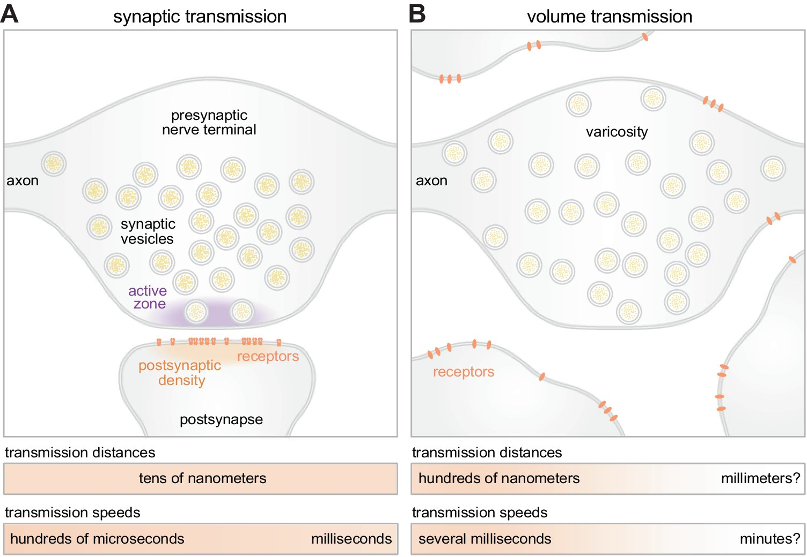
Figure 1. Synaptic transmission (A) versus volume transmission (B).
This separation between fast signaling and slow control allows the same neural circuitry to behave very differently depending on internal state.
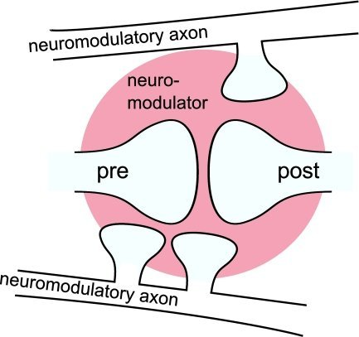
Figure 2. Neuromodulators create chemical context at synapses.

A Note on Neurotransmitter-Based Naming
Neurons communicate using chemical messengers called neurotransmitters. When a neuron fires, it releases neurotransmitter molecules into the synapse, where they bind to receptors on a neighboring neuron and alter that neuron's behavior.
Neuroscientists often classify neurons by which neurotransmitter they primarily release. The suffix "-ergic" simply means using or releasing.
Thus:
• dopaminergic neurons release dopamine
• noradrenergic neurons release norepinephrine
• serotonergic neurons release serotonin
• cholinergic neurons release acetylcholine
These terms do not describe what a neuron "represents." They describe the chemical influence it exerts on other neurons.

Why Neuromodulatory Systems Are Diffuse
Neuromodulatory neurons are few in number but extraordinarily influential.
Small clusters of cells—often located in the brainstem or basal forebrain—send axons that project widely across the cortex, hippocampus, basal ganglia, and other regions. A single neuromodulatory neuron can influence tens of thousands of synapses.
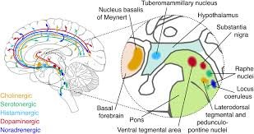
Figure 3. Major neuromodulatory systems in the brain.
From an engineering perspective, this architecture may seem inefficient. Why broadcast a signal so broadly rather than target specific circuits?
The answer is that neuromodulators provide global context, not local instruction. They signal whether the organism is safe or threatened, whether outcomes are better or worse than expected, whether the environment is stable or unpredictable.
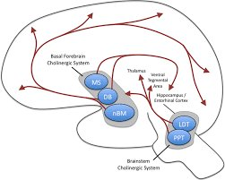
Figure 4. The cholinergic system projections.
Diffuse projection allows a small number of neurons to coordinate the behavior of millions without centralized control.

Dopamine: Learning, Prediction, and Value
Dopamine is often described as a "reward" or "pleasure" chemical. This description is misleading.
Dopamine encodes prediction error—the difference between what was expected and what actually occurred.
When outcomes are better than expected, dopamine activity increases. When outcomes are worse than expected, dopamine activity decreases. When expectations are met, dopamine remains near baseline.
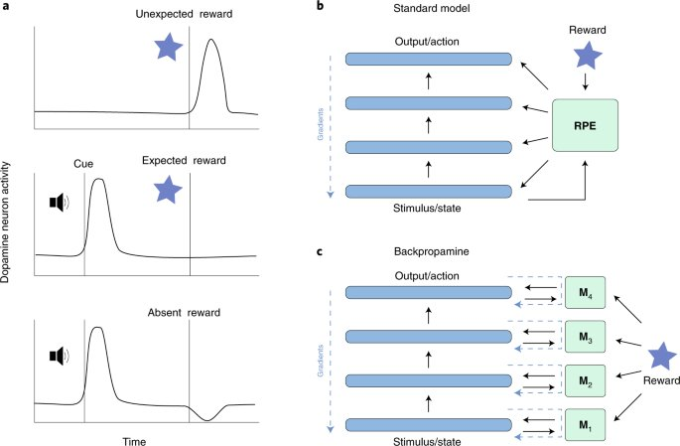
Figure 5. Dopamine encodes reward prediction error.
Learning depends on surprise. If the world unfolds exactly as predicted, there is nothing new to learn. Dopamine marks the moments when predictions fail.
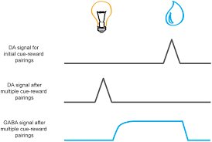
Figure 6. Dopamine signals shift to predictive cues after learning.
Crucially, dopamine does not specify what should be learned. It does not identify which neurons were responsible. It signals only that learning should occur now.

Credit Assignment: What Should Change?
At the heart of learning lies a deceptively simple question: what should change?
When an action leads to success or failure, a learning system must determine which internal components deserve credit or blame. This is known as the credit assignment problem.
In engineered systems, credit assignment is deliberately made solvable. In digital neural networks, the architecture is explicit, the objective function is known, and an error signal can be computed by comparing outputs to correct answers. Algorithms such as backpropagation propagate this error backward through the network, assigning each weight a precise update proportional to its contribution.
The brain cannot do this.

Why the Brain Cannot Solve Credit Assignment Precisely
The brain does not receive labeled data. It is not told the correct answer. Outcomes are delayed, noisy, and ambiguous. Neural circuits are recurrent and overlapping rather than neatly layered. Neurons participate in many functions simultaneously. There is no central controller that can trace an outcome backward through the system.
By the time an outcome becomes apparent, the detailed causal chain that produced it has already been overwritten by ongoing activity.
In many cases, the question "which synapse caused this outcome?" has no well-defined answer. Credit assignment in biological systems is not merely difficult—it is physically ill-posed.

Learning Under Uncertainty
Because the brain cannot identify exact causes, it must learn under uncertainty.
It does not know which synapse mattered or which action was decisive. It only knows that something important just happened.
Neuromodulatory systems provide an approximate solution. When outcomes are better or worse than expected, dopamine broadcasts a global signal marking the recent past as significant. Synapses that were active shortly before this signal become eligible for modification.
The resulting changes are small and probabilistic. No single update is guaranteed to be correct.

Eligibility Traces: A Physical Solution
Synapses maintain short-lived biochemical states known as eligibility traces.
When a synapse is active, molecular processes place it into a transient modifiable state. These traces decay over seconds. If a neuromodulatory signal arrives while the trace persists, the synapse is modified. If not, the trace fades without lasting effect.
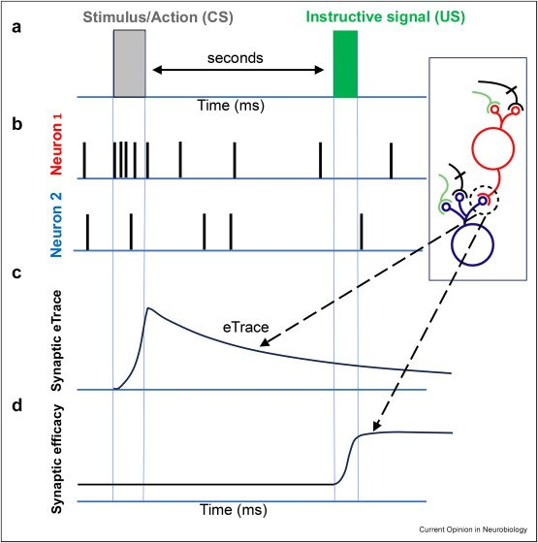
Figure 7. Eligibility traces bridge temporal gaps between activity and learning signals.
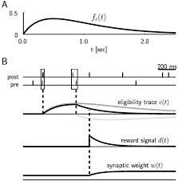
Figure 8. Mathematical representation of eligibility traces.
Eligibility traces allow learning to bridge the temporal gap between action and outcome without explicit causal knowledge.

Bias as a Learning Strategy
Over time, these small probabilistic updates accumulate.
Patterns of activity that tend to precede successful outcomes become more likely. Patterns of activity that tend to precede failure become less likely. The system develops biases—statistical tendencies that guide future behavior.
Bias here does not mean error. It means gradual shaping of probability under uncertainty.
Biological systems do not optimize a loss function. They adapt.

Other Neuromodulators: Regulating State and Strategy
Dopamine is not alone.
Noradrenergic systems increase alertness and responsiveness under uncertainty. Serotonergic systems promote stability and dampen impulsive reactions. Cholinergic systems regulate attention and influence whether the brain encodes new information or recalls existing knowledge.
Together, these systems regulate not what the brain thinks, but how it thinks.

What Changes When a Synapse Changes
A synapse is not merely a gap. It is a complex molecular structure.
Learning can alter receptor density, neurotransmitter release probability, protein scaffolding, dendritic spine shape, and gene expression. Memory is stored in altered structure and altered probability.

Neuromodulation as the Gatekeeper of Plasticity
If synapses changed whenever neurons fired, the brain would be unstable.
Neuromodulation gates plasticity so that learning occurs only when conditions warrant change. This separation between activity and learning is a fundamental design principle of biological intelligence.

Clinical Evidence
Pharmacology, neuromodulatory disorders, and interventions such as deep brain stimulation demonstrate that altering neuromodulatory tone can profoundly change learning and behavior without rewiring underlying circuitry.
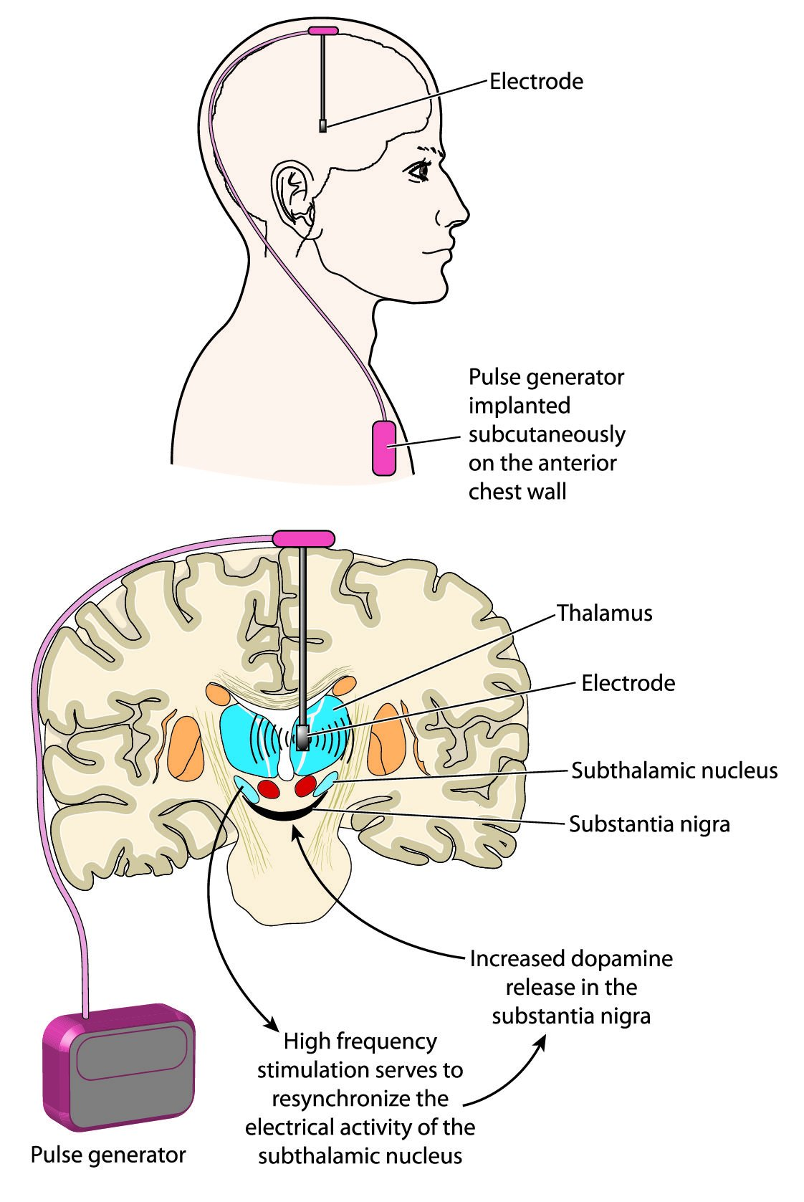
Figure 9. Deep brain stimulation system with electrode placement.
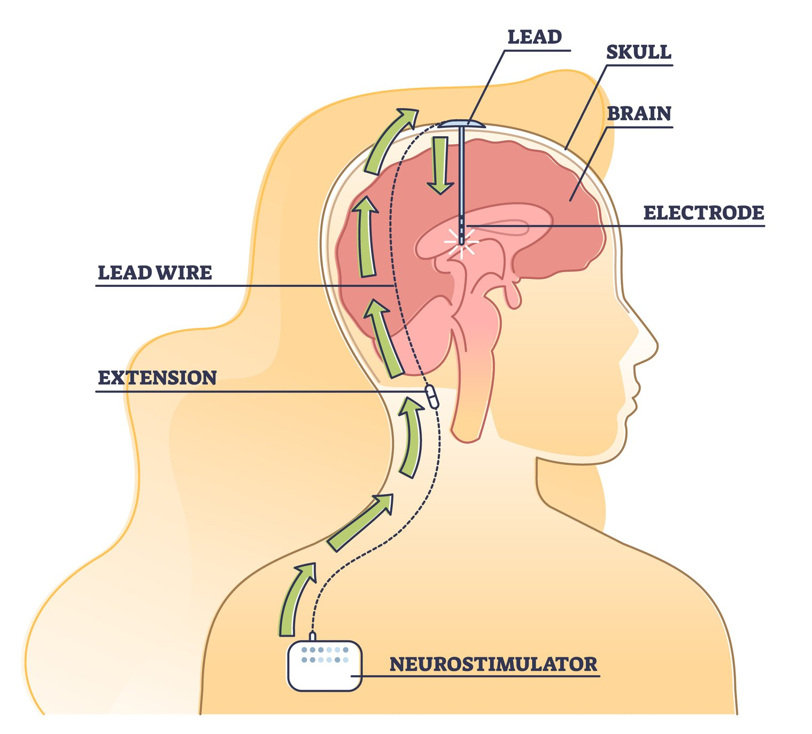
Figure 10. Neurostimulator system schematic.

Implications for Artificial Intelligence
Modern artificial neural networks are extraordinarily powerful within the constraints they were designed for. They learn quickly when objectives are explicit, feedback is immediate, and architectures are fixed. Under these conditions, precise credit assignment through backpropagation is not only possible but optimal.
Biological intelligence evolved under none of these assumptions.
Real organisms learn in environments where goals are ambiguous, feedback is delayed, and the causal structure of outcomes is opaque. The brain's learning mechanisms reflect this reality. Rather than computing exact gradients, it relies on global modulatory signals, local eligibility traces, and incremental biasing of behavior over time.
This has several implications for AI design.
First, it suggests that separating activity from learning—as the brain does—can dramatically improve stability. In most artificial systems, every forward pass is also a learning opportunity. In biological systems, learning is gated. Nothing changes unless the context says it should.
Second, it highlights the importance of state-dependent learning. Neuromodulators alter how the same neural activity is interpreted. For artificial agents operating in non-stationary environments, this suggests architectures in which learning rules themselves are modulated by internal state, uncertainty, or novelty.
Third, biological systems show that approximate credit assignment can be sufficient. Precise attribution is not always necessary for useful adaptation. Over time, probabilistic biasing can produce robust behavior without brittle optimization.
Finally, neuromodulation reframes the goal of learning. The brain is not optimizing a loss function. It is maintaining viability under uncertainty. Success is defined operationally, not mathematically.
As artificial systems move out of curated datasets and into open-ended interaction with the world, these principles may prove more important than further refinements of gradient descent.

The Central Lesson
Because the brain cannot identify exact causes, learning occurs through small probabilistic adjustments that gradually bias neural activity and behavior toward patterns that tend to succeed.

Next Chapter
Chapter 4: Circuits, Networks, and Coordinated Behavior

