EduFlow
Complete School Management Platform
Screen & Access Design Document
A visual documentation of the clickable website prototype, including role-specific navigation, dashboards, operational screens, parent experience, and access boundaries.
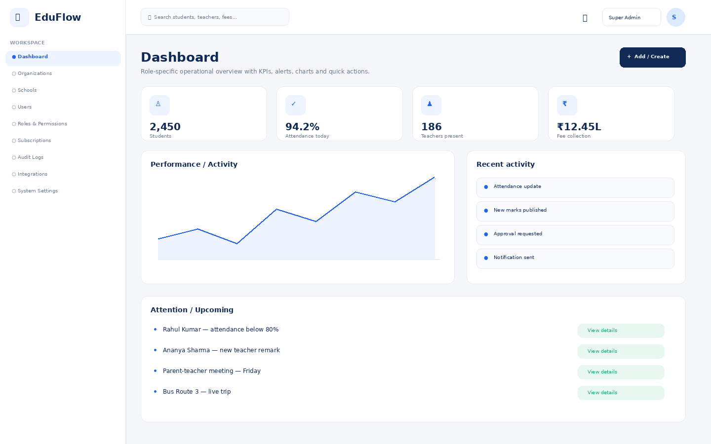

1. Platform Structure
The platform uses one application shell with role-based navigation. A user sees only the modules and records permitted by their role, action permissions, and data scope.
- User → Role → Module → Action → Data Scope → Record
- Examples: Teacher → Attendance → Edit → Assigned Classes; Parent → Student → View → Own Children.
- Sensitive operations such as marks changes, refunds, attendance corrections and document downloads should be audited.

2. Role Matrix
Role | Primary Goal | Main Access | Data Scope
Super Admin | Operate the SaaS platform | Organizations, schools, users, roles, subscriptions, audit | All organizations
School Owner | Run the complete school | All school modules and settings | School / campuses
Principal | Manage school performance | Students, academics, staff, finance, approvals, reports | Entire school
Teacher | Teach and manage assigned classes | Attendance, marks, homework, remarks, messages | Assigned classes
Parent | Stay informed about children | Attendance, marks, remarks, homework, fees, bus, alerts | Own children
Student | Manage learning activities | Timetable, attendance, homework, exams, results | Own record
Accountant | Manage school finances | Fees, payments, receipts, refunds, reports | Finance records
HR Manager | Manage employees | Staff, attendance, leave, recruitment, payroll | Staff records
Librarian | Manage circulation | Books, members, issue/return, fines | Library records
Transport Manager | Manage school transport | Vehicles, drivers, routes, trips, tracking | Transport records
Hostel Manager | Manage residential operations | Buildings, rooms, allocation, attendance, outpass | Hostel records

3. Visual Screen Documentation
Each screen below is shown using the same visual language as the website prototype: fixed left navigation, top search/user bar, rounded cards, tables, filters, status pills, blue primary actions and role-specific content.

Super Admin
9 screens in this role experience.

Dashboard
Role-specific operational overview with KPIs, alerts, charts and quick actions.
Access notes: Platform-level access across organizations. This role should be tightly restricted and fully audited.

Organizations
Module workspace with role-based navigation, filters, records, actions and status information.
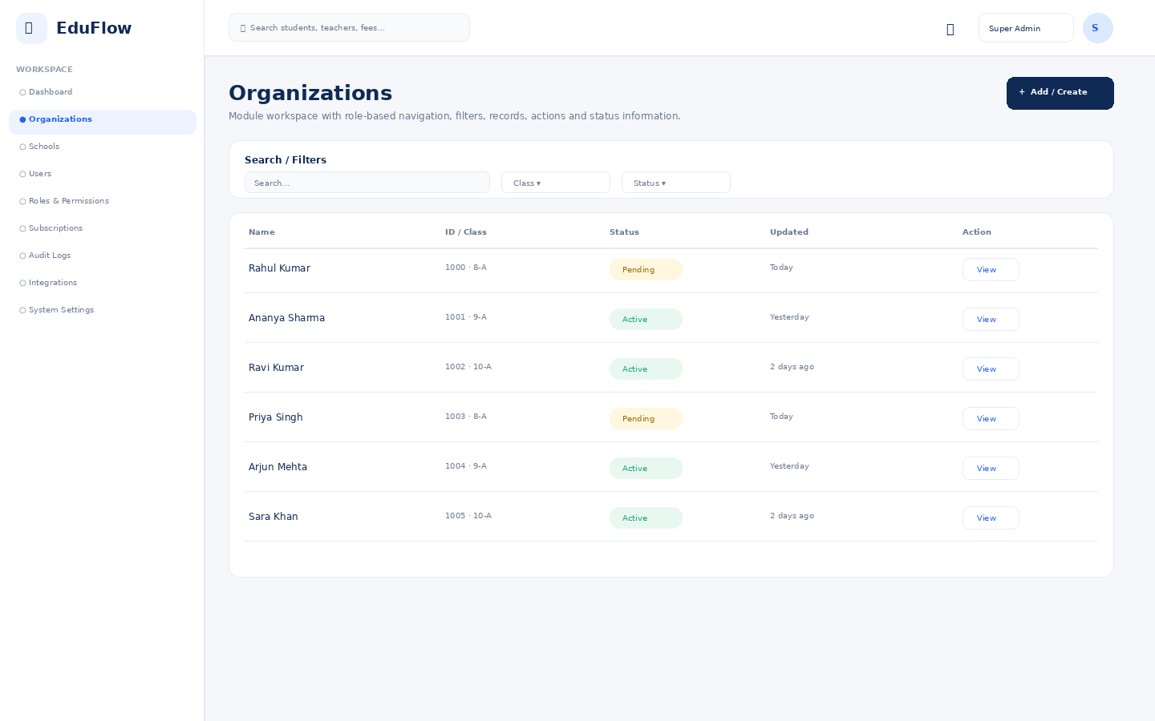
Access notes: Platform-level access across organizations. This role should be tightly restricted and fully audited.

Schools
Module workspace with role-based navigation, filters, records, actions and status information.
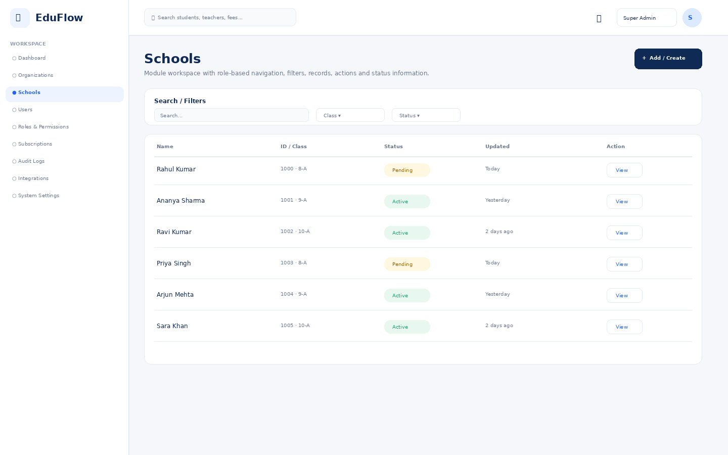
Access notes: Platform-level access across organizations. This role should be tightly restricted and fully audited.

Users
Module workspace with role-based navigation, filters, records, actions and status information.
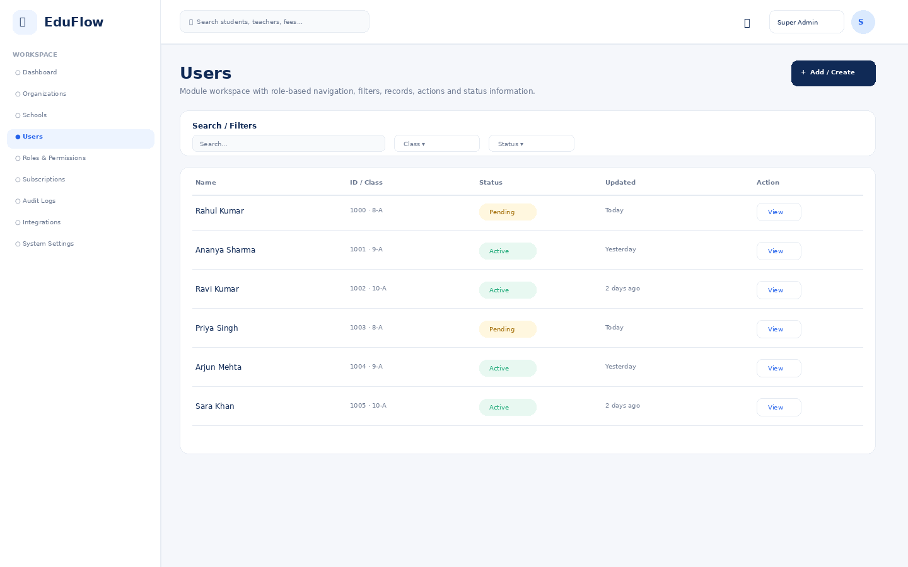
Access notes: Platform-level access across organizations. This role should be tightly restricted and fully audited.

Roles & Permissions
Granular RBAC configuration by module, action and data scope.
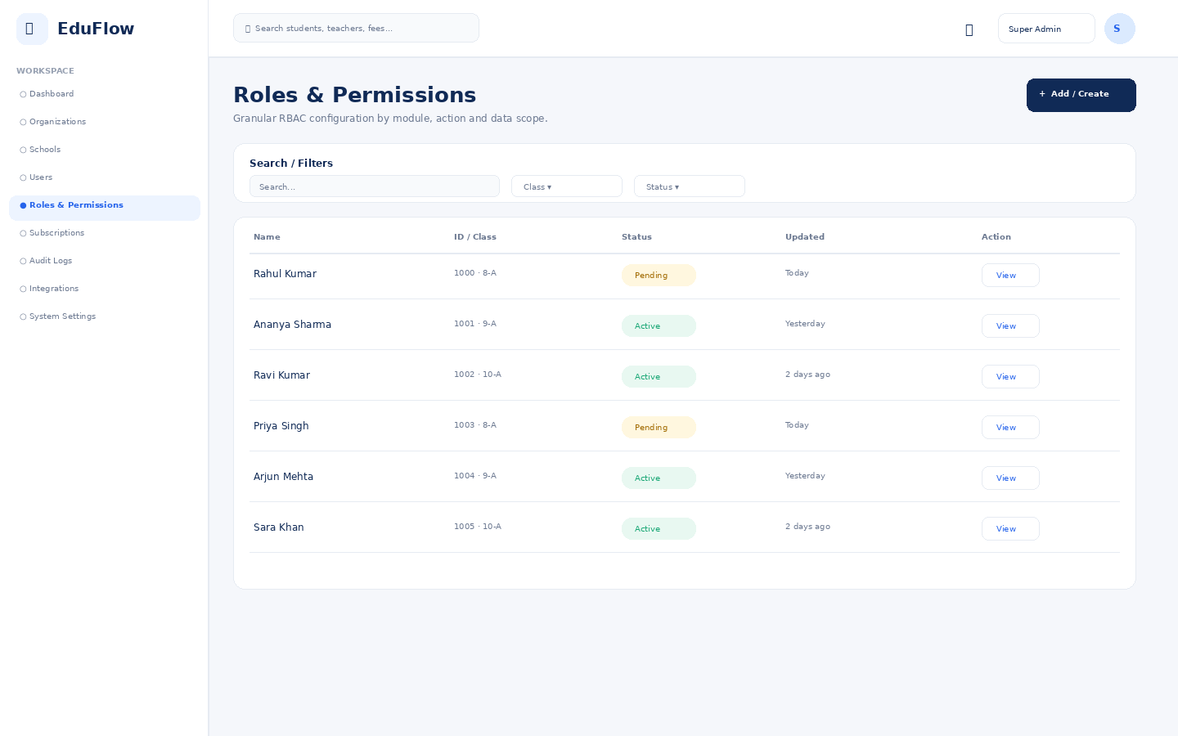
Access notes: Platform-level access across organizations. This role should be tightly restricted and fully audited.

Subscriptions
Module workspace with role-based navigation, filters, records, actions and status information.
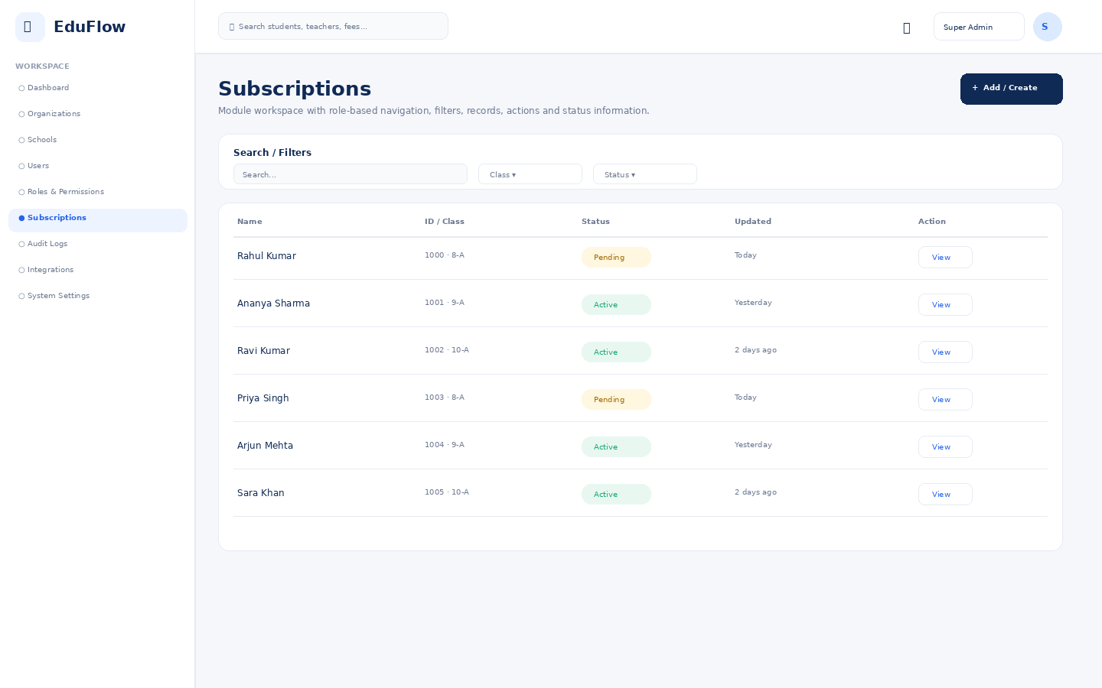
Access notes: Platform-level access across organizations. This role should be tightly restricted and fully audited.

Audit Logs
Immutable history of sensitive changes and administrative activity.
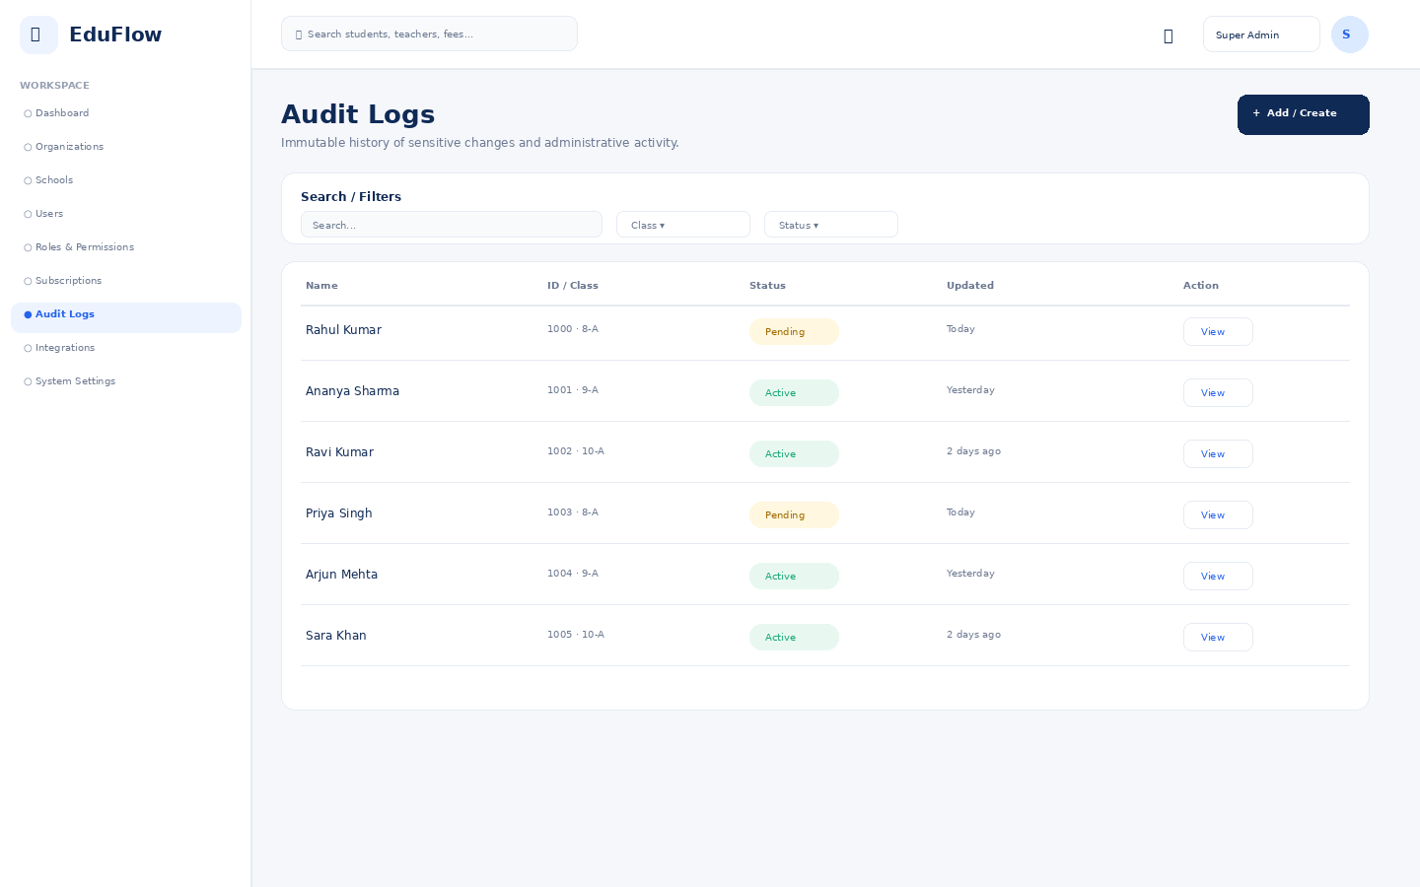
Access notes: Platform-level access across organizations. This role should be tightly restricted and fully audited.

Integrations
Module workspace with role-based navigation, filters, records, actions and status information.
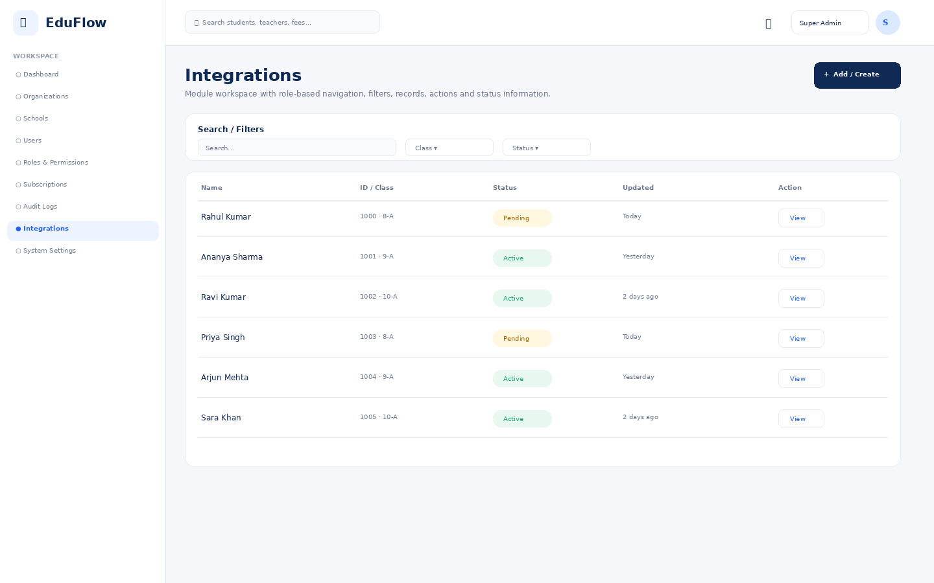
Access notes: Platform-level access across organizations. This role should be tightly restricted and fully audited.

System Settings
Module workspace with role-based navigation, filters, records, actions and status information.
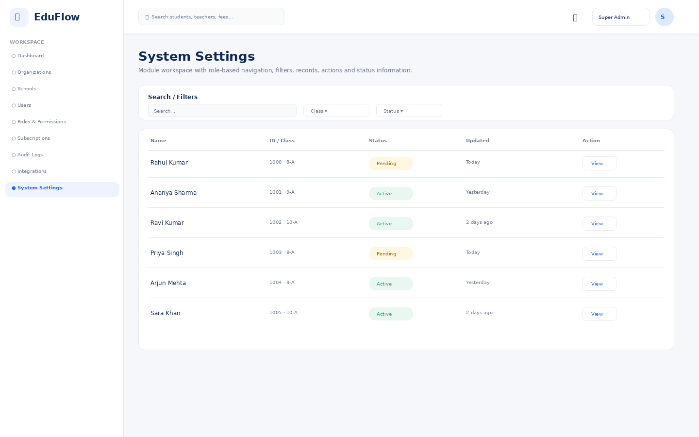
Access notes: Platform-level access across organizations. This role should be tightly restricted and fully audited.

School Owner
18 screens in this role experience.

Dashboard
Role-specific operational overview with KPIs, alerts, charts and quick actions.
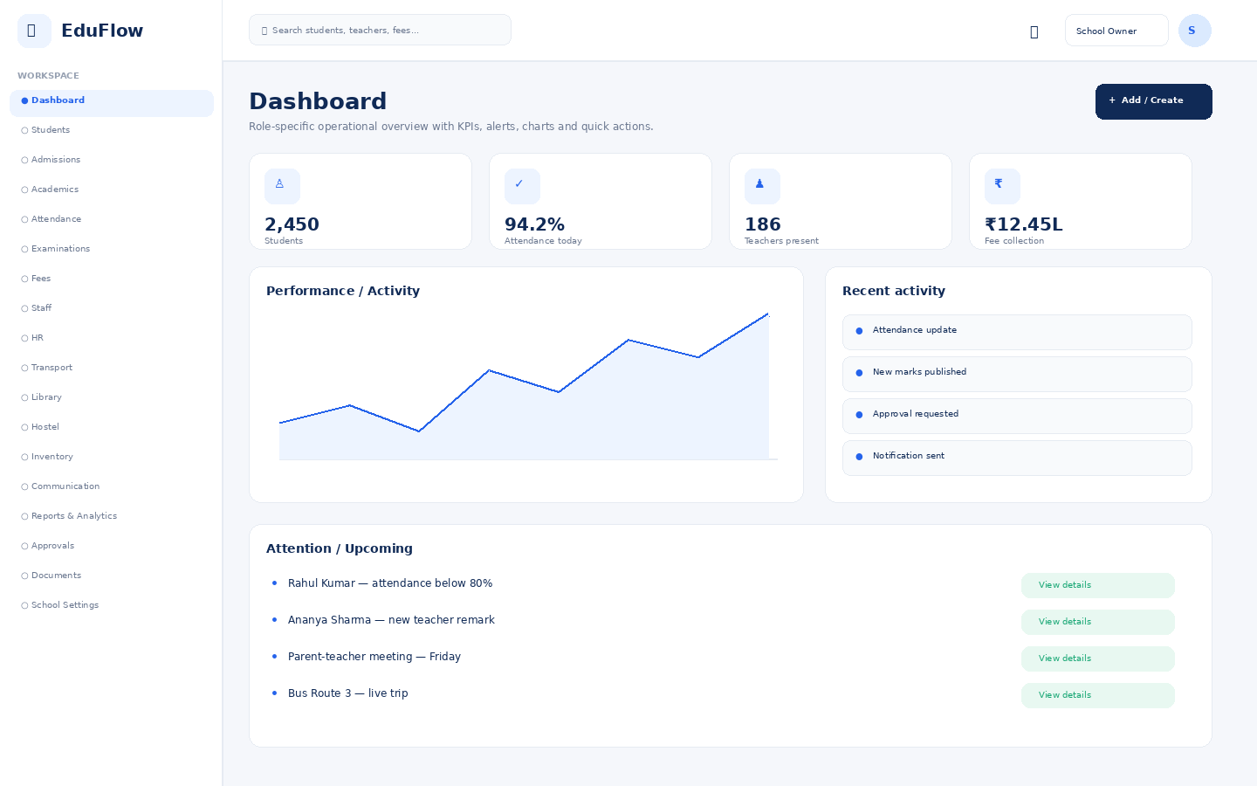
Access notes: Actual access is controlled by role, module permission, action permission and data scope.

Students
Student directory with search, filters, attendance, status and profile access.
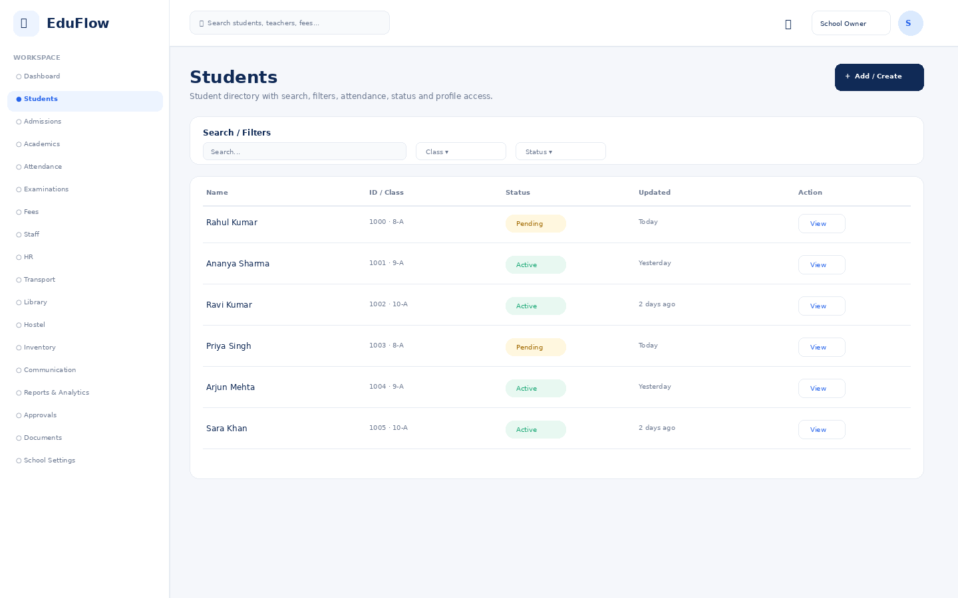
Access notes: Actual access is controlled by role, module permission, action permission and data scope.

Admissions
Module workspace with role-based navigation, filters, records, actions and status information.
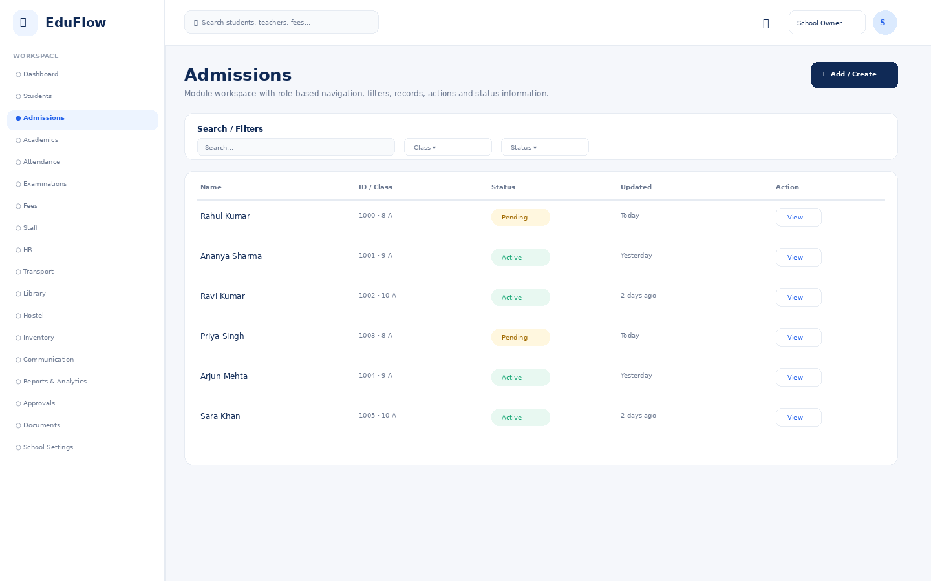
Access notes: Actual access is controlled by role, module permission, action permission and data scope.

Academics
Module workspace with role-based navigation, filters, records, actions and status information.
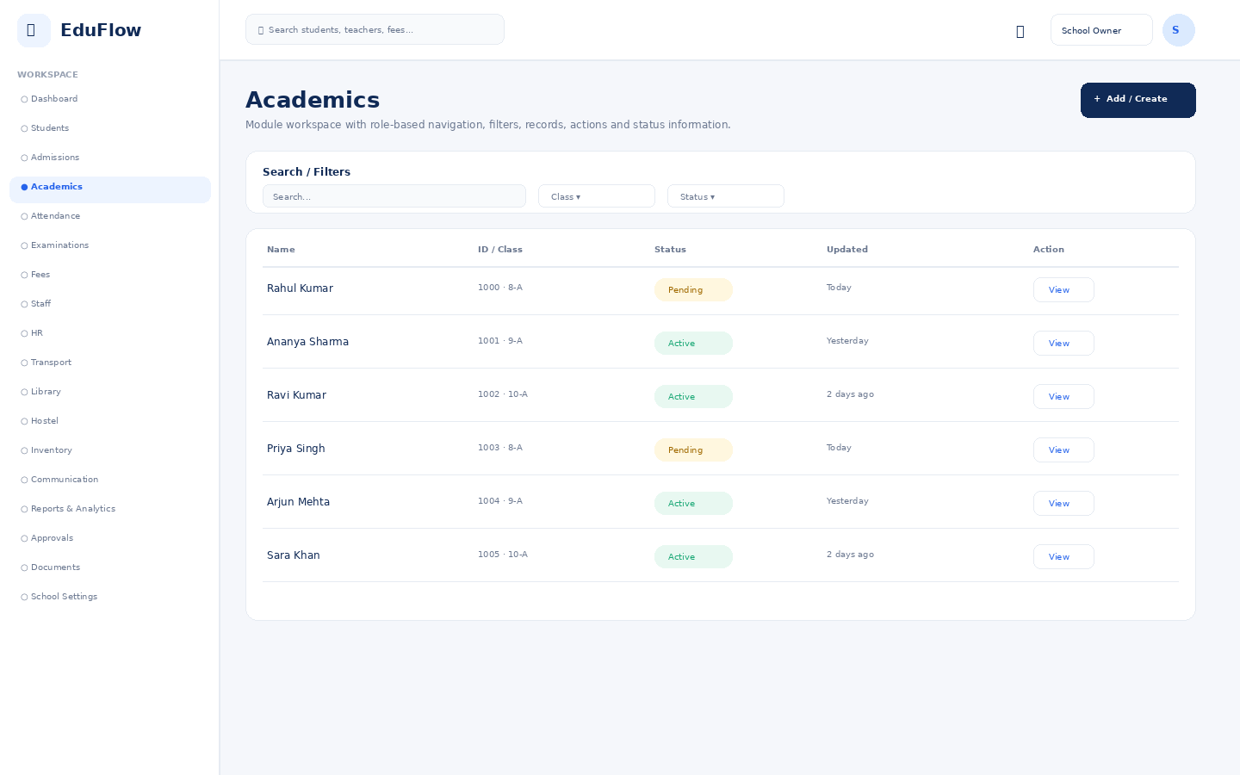
Access notes: Actual access is controlled by role, module permission, action permission and data scope.

Attendance
Daily attendance, absence/late status, trends and correction workflows.
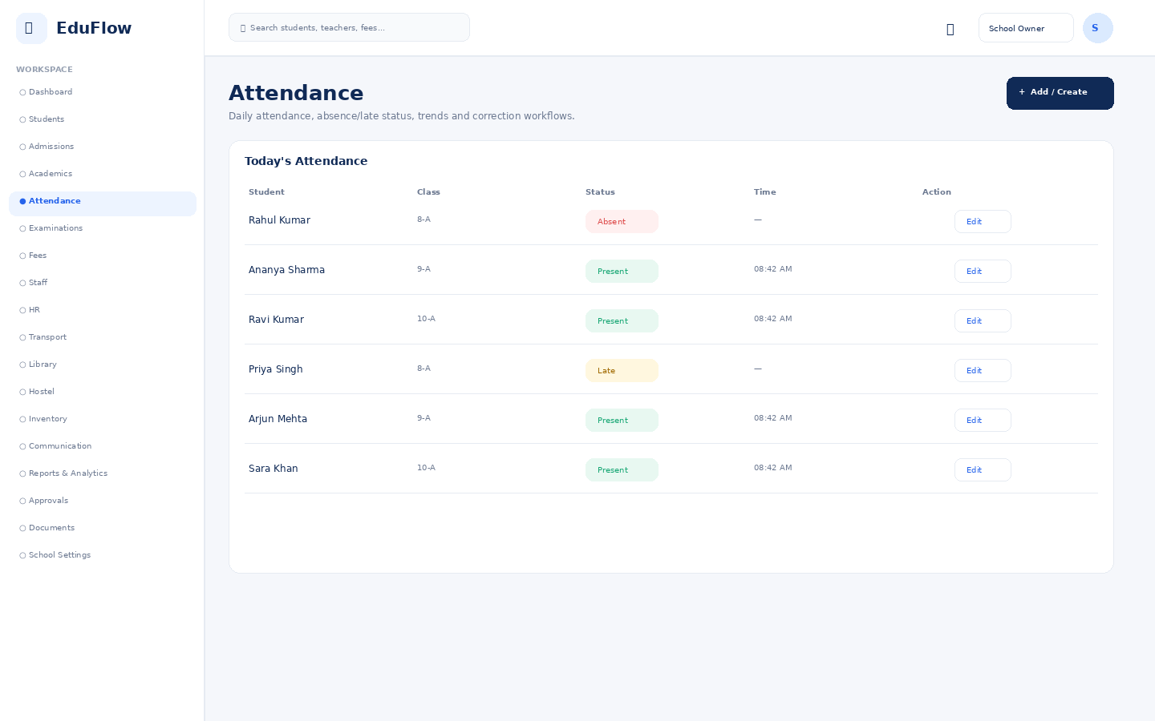
Access notes: Actual access is controlled by role, module permission, action permission and data scope.

Examinations
Exam setup, schedules, marks entry, review and publishing workflows.
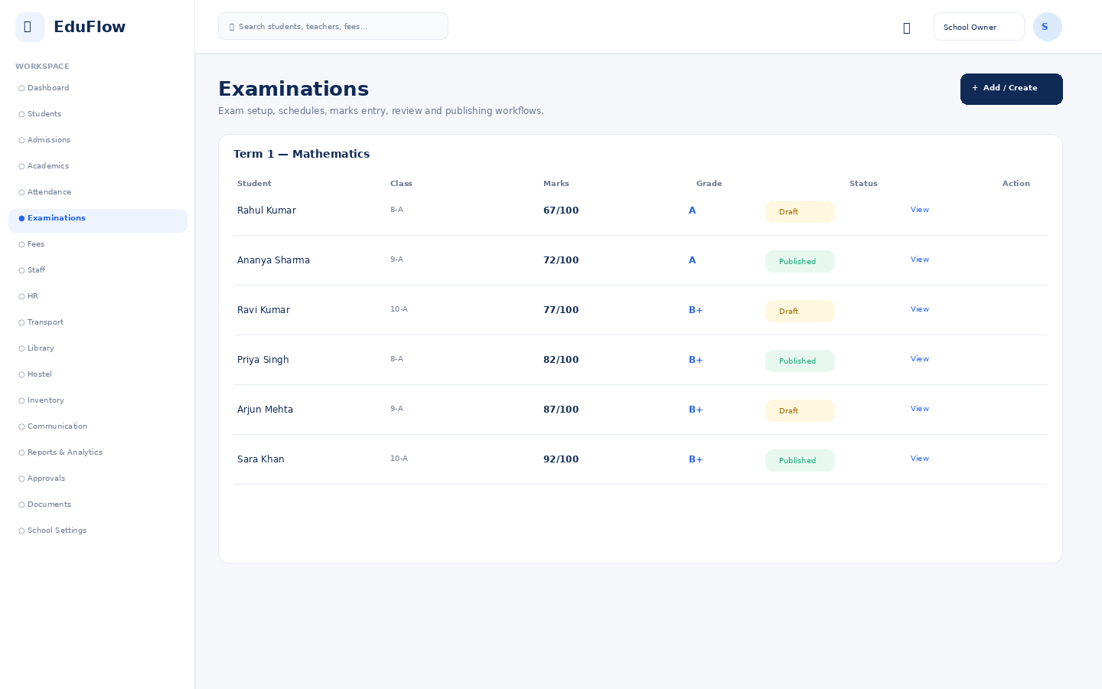
Access notes: Actual access is controlled by role, module permission, action permission and data scope.

Fees
Fee balances, invoices, collections, dues and payment history.
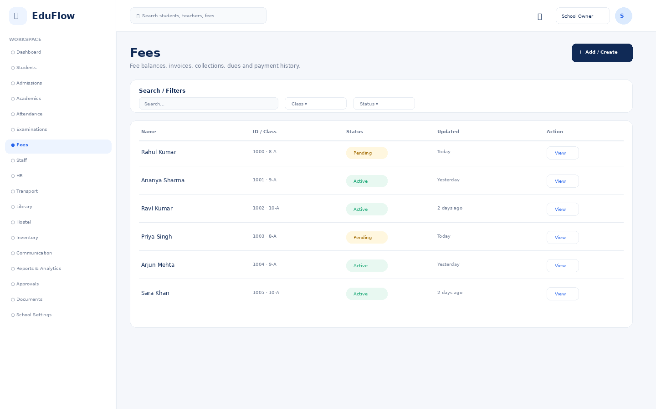
Access notes: Actual access is controlled by role, module permission, action permission and data scope.

Staff
Module workspace with role-based navigation, filters, records, actions and status information.
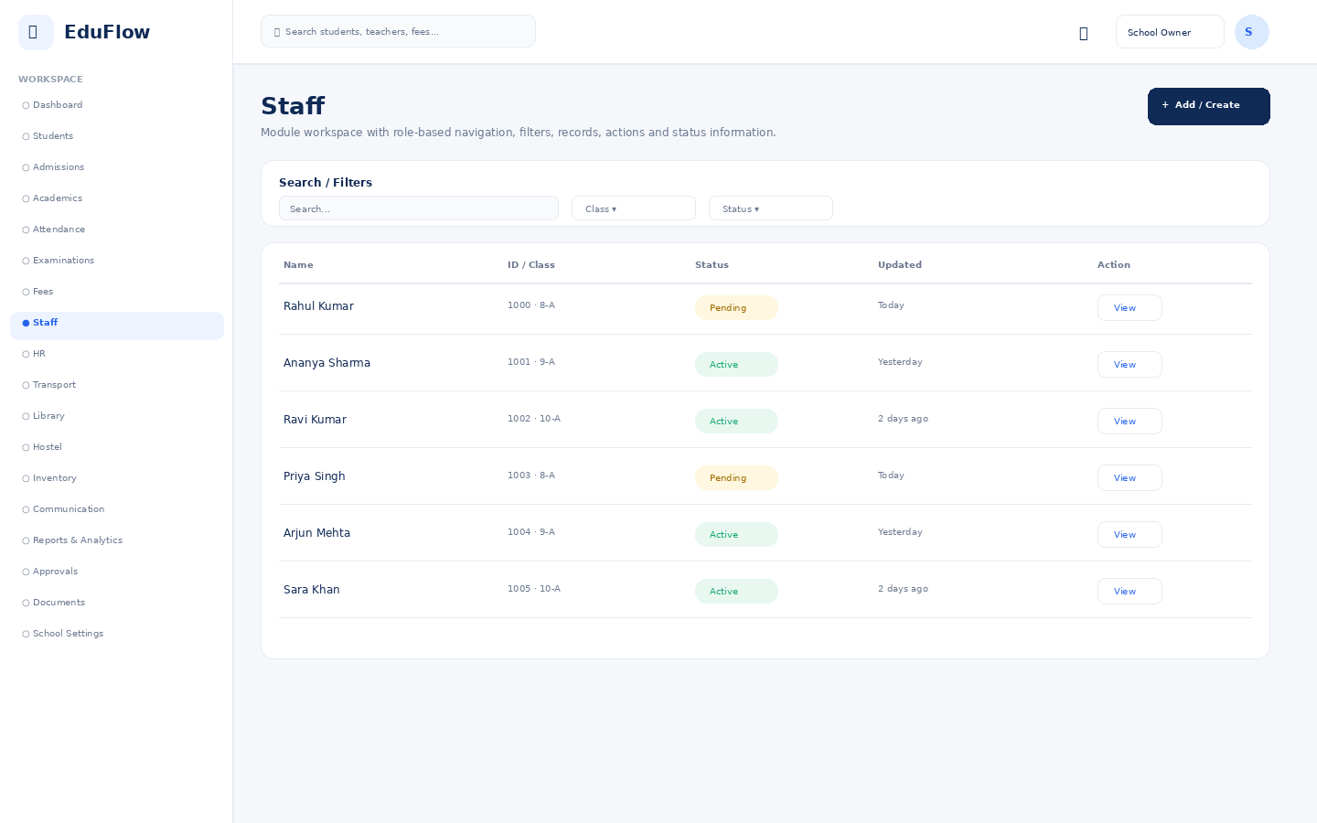
Access notes: Actual access is controlled by role, module permission, action permission and data scope.

HR
Module workspace with role-based navigation, filters, records, actions and status information.
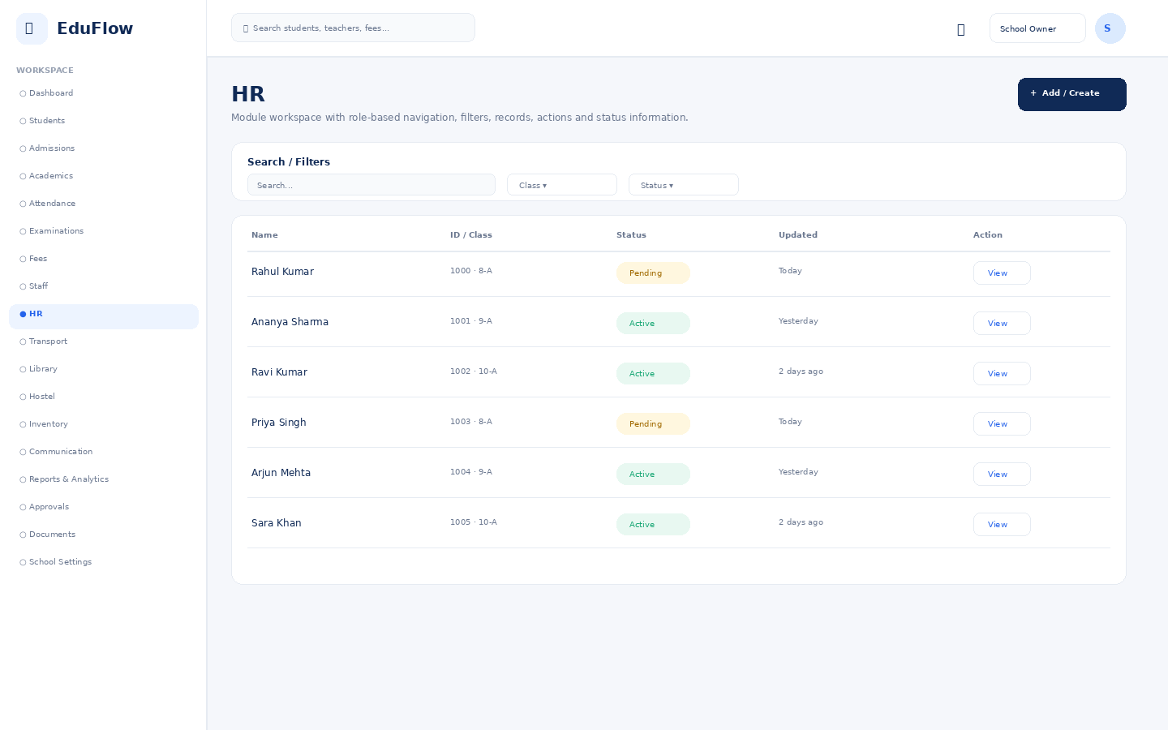
Access notes: Actual access is controlled by role, module permission, action permission and data scope.

Transport
Module workspace with role-based navigation, filters, records, actions and status information.
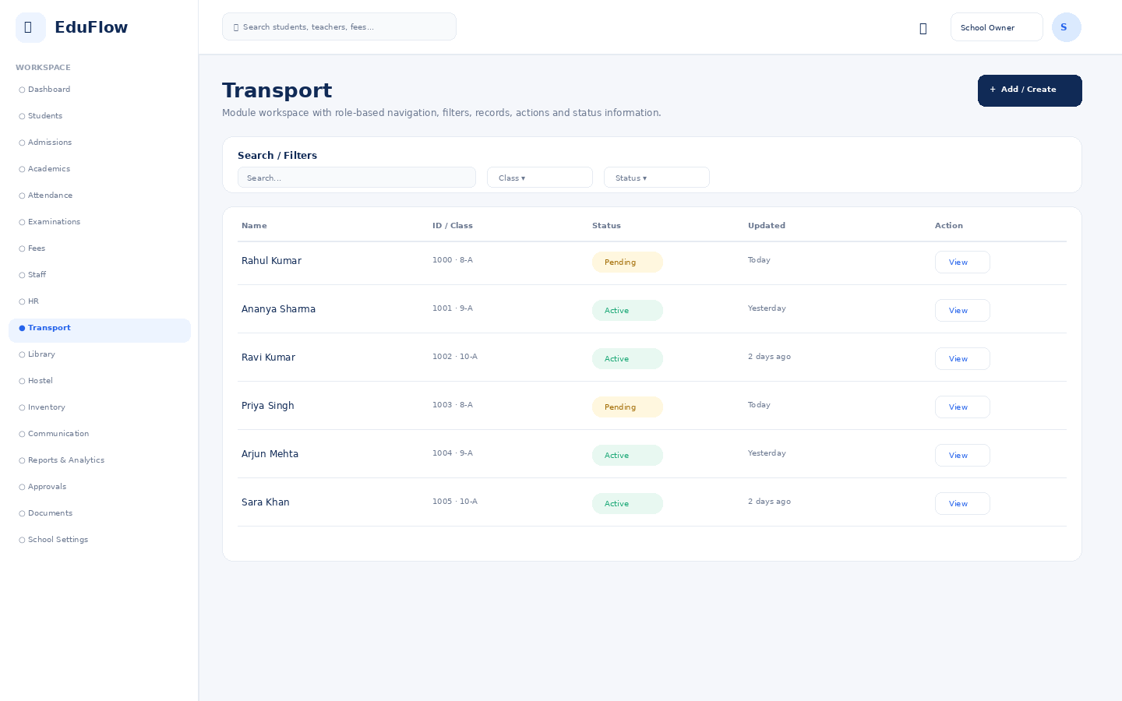
Access notes: Actual access is controlled by role, module permission, action permission and data scope.

Library
Module workspace with role-based navigation, filters, records, actions and status information.
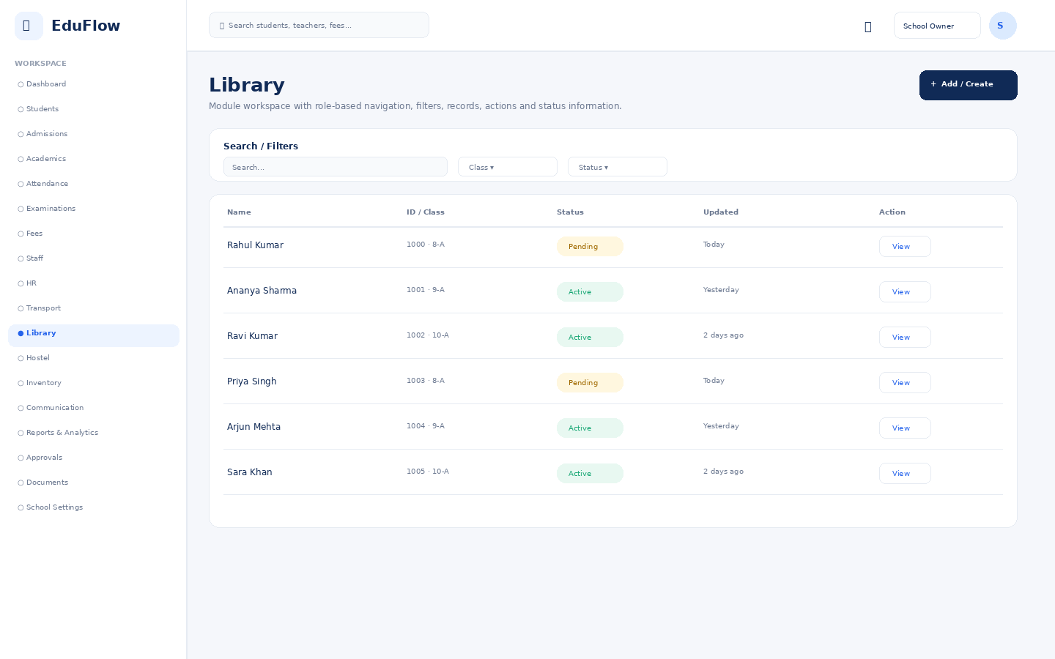
Access notes: Actual access is controlled by role, module permission, action permission and data scope.

Hostel
Module workspace with role-based navigation, filters, records, actions and status information.
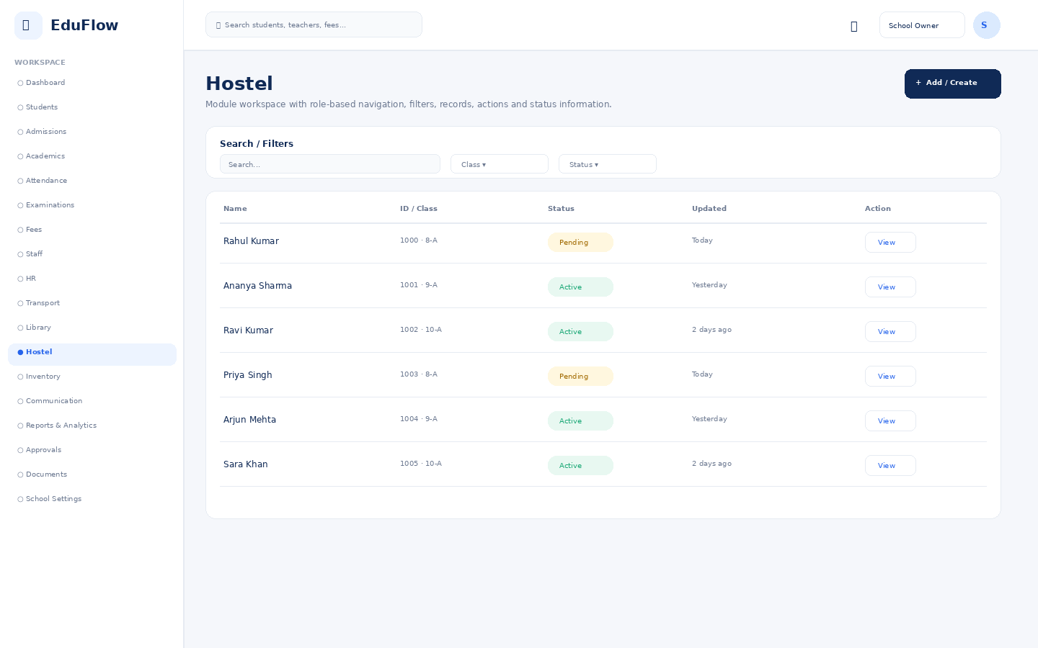
Access notes: Actual access is controlled by role, module permission, action permission and data scope.

Inventory
Module workspace with role-based navigation, filters, records, actions and status information.
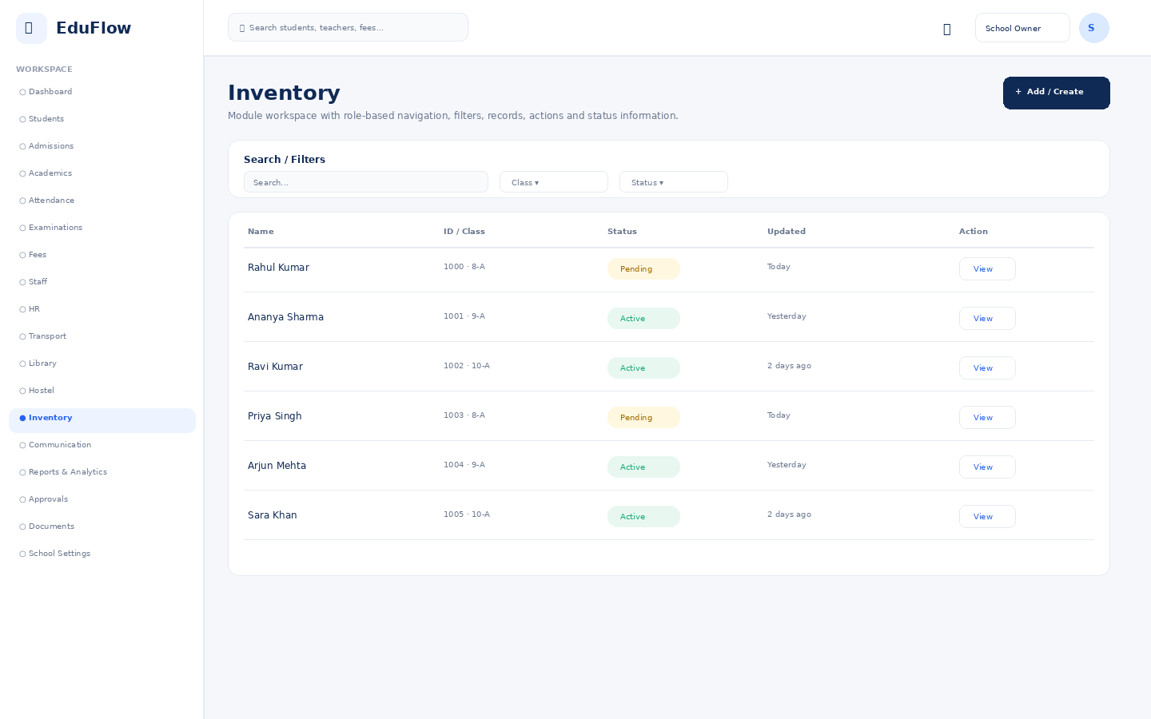
Access notes: Actual access is controlled by role, module permission, action permission and data scope.

Communication
Module workspace with role-based navigation, filters, records, actions and status information.
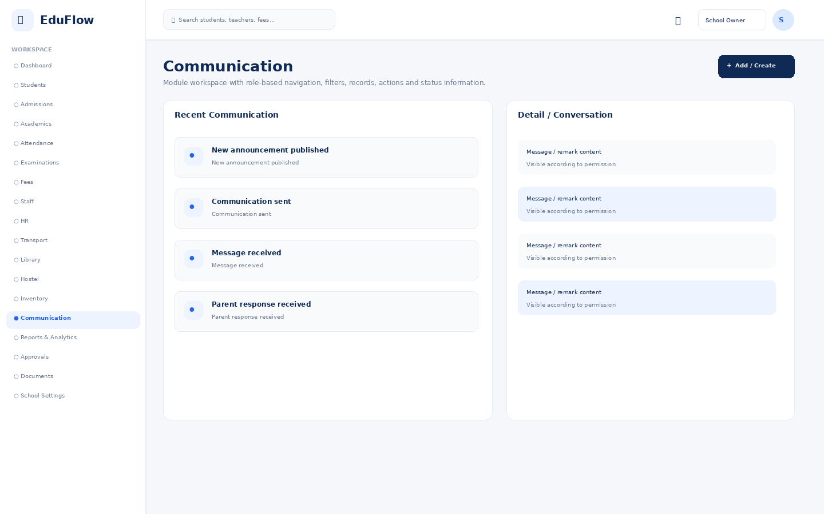
Access notes: Actual access is controlled by role, module permission, action permission and data scope.

Reports & Analytics
Filterable school reports with export-oriented presentation.
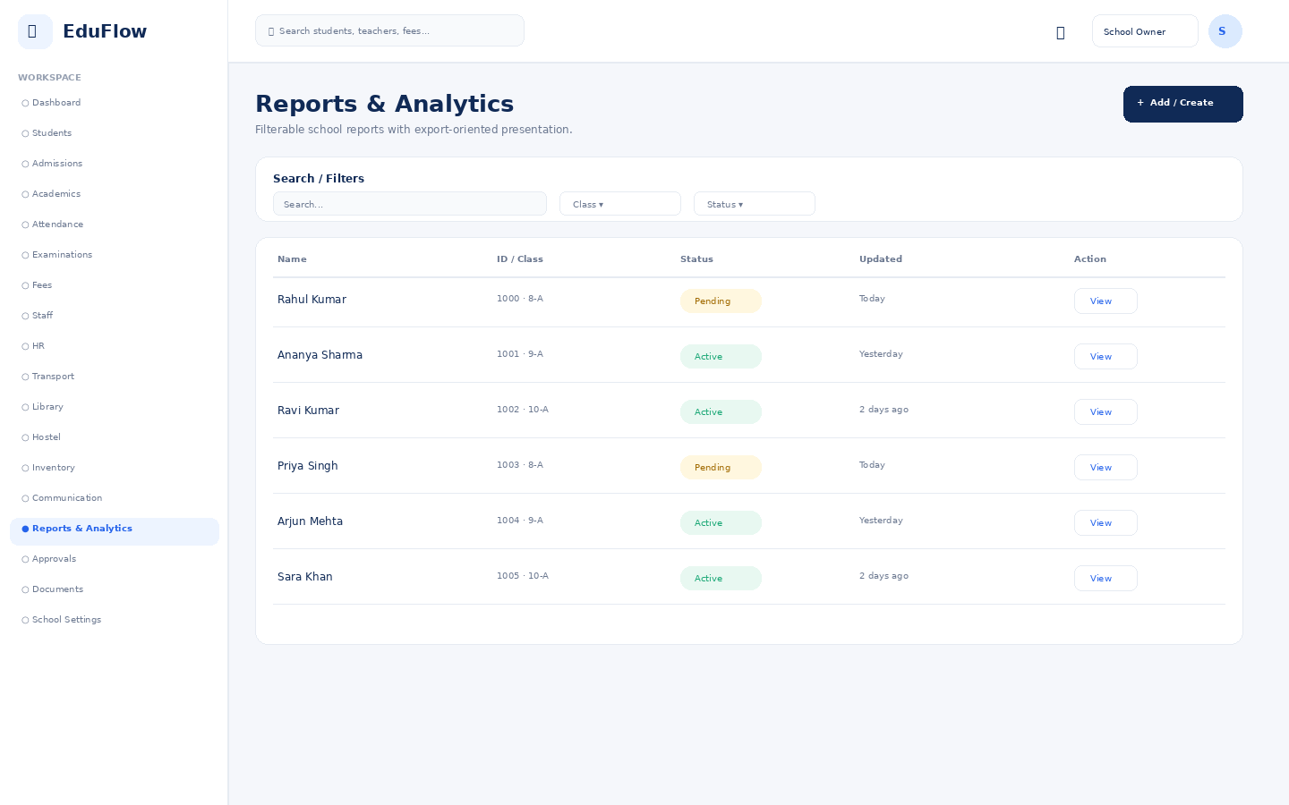
Access notes: Actual access is controlled by role, module permission, action permission and data scope.

Approvals
Central queue for attendance, leave, refunds, admissions and marks approvals.
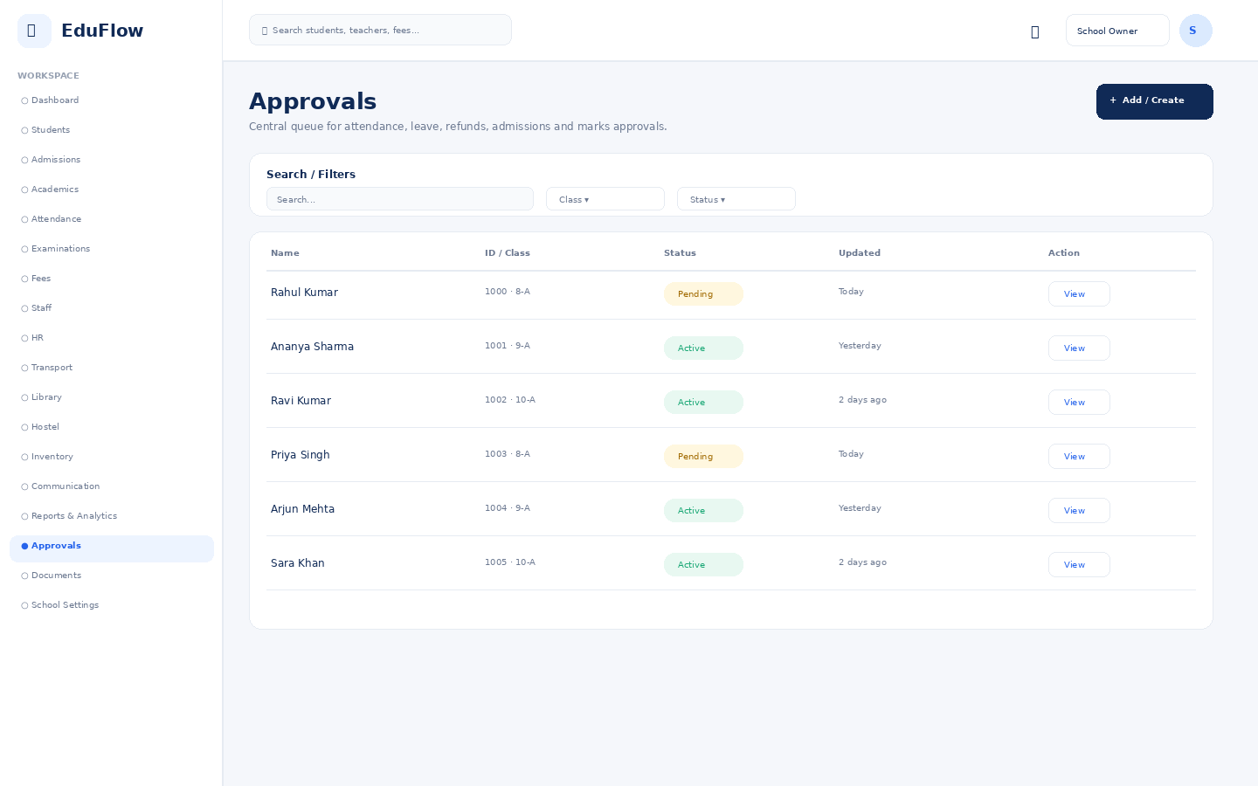
Access notes: Actual access is controlled by role, module permission, action permission and data scope.

Documents
Permission-controlled document repository with view/download/upload actions.
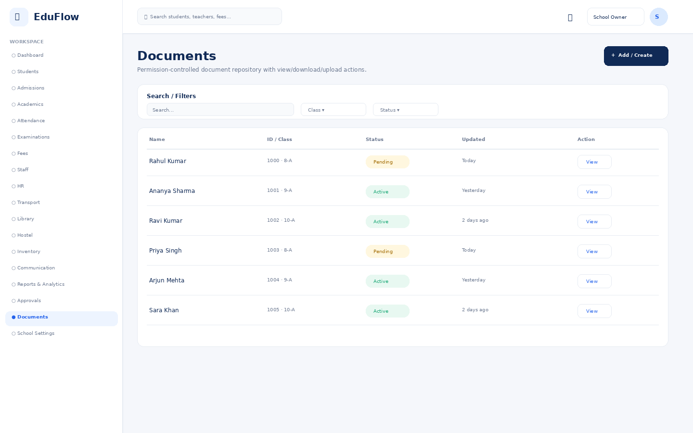
Access notes: Actual access is controlled by role, module permission, action permission and data scope.

School Settings
Module workspace with role-based navigation, filters, records, actions and status information.
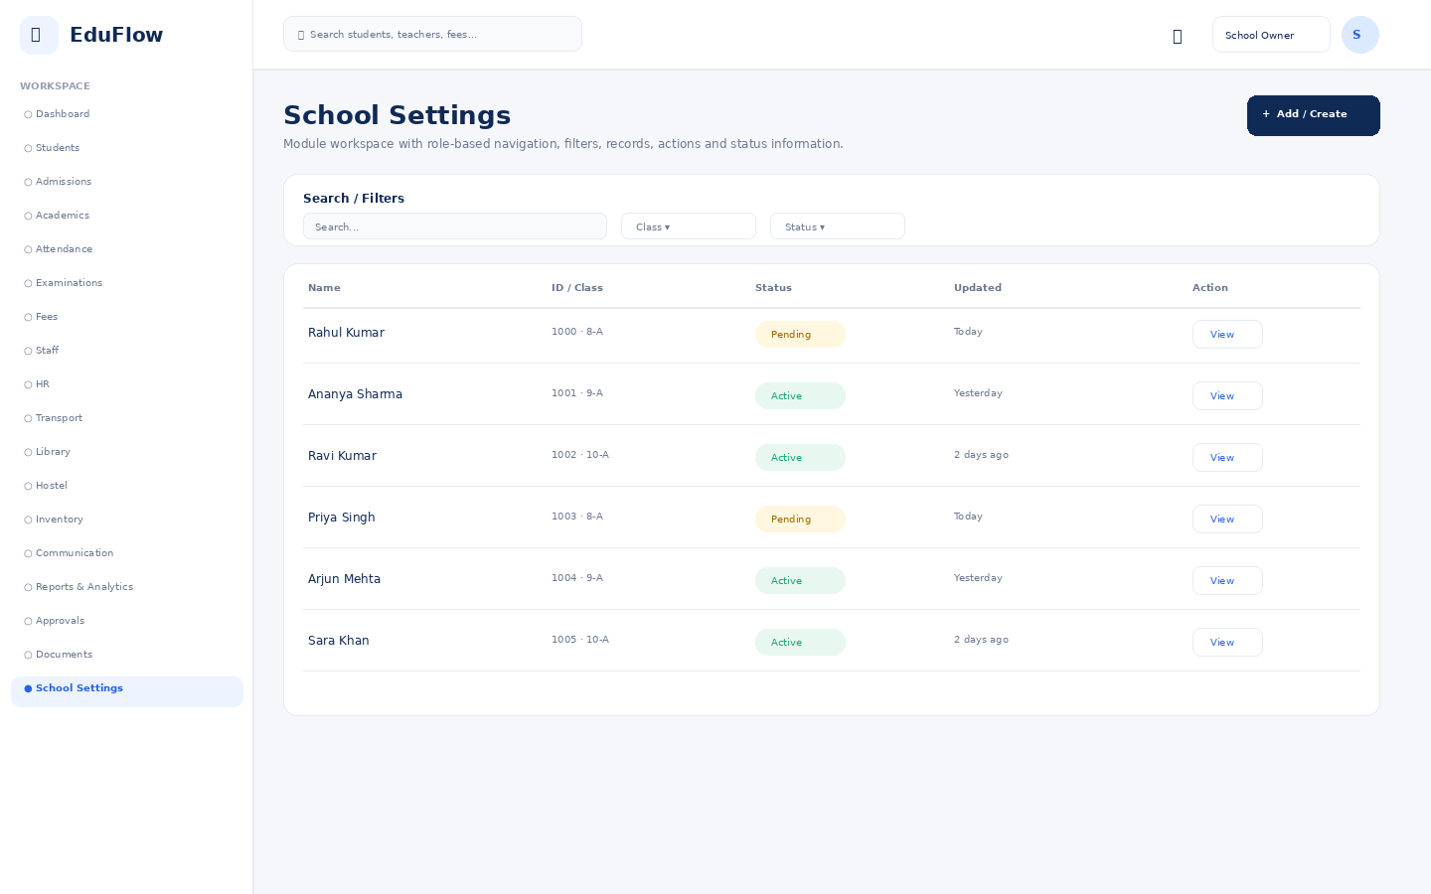
Access notes: Actual access is controlled by role, module permission, action permission and data scope.

Principal
13 screens in this role experience.

Dashboard
Role-specific operational overview with KPIs, alerts, charts and quick actions.
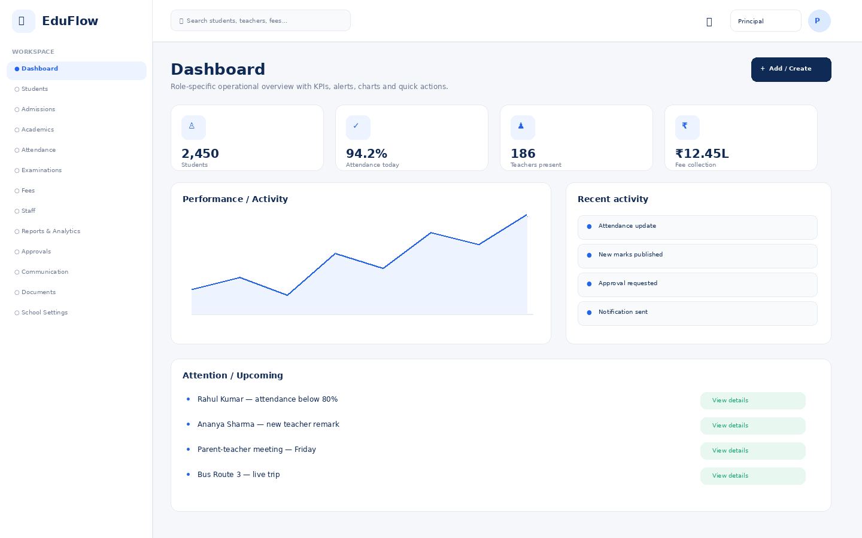
Access notes: Actual access is controlled by role, module permission, action permission and data scope.

Students
Student directory with search, filters, attendance, status and profile access.
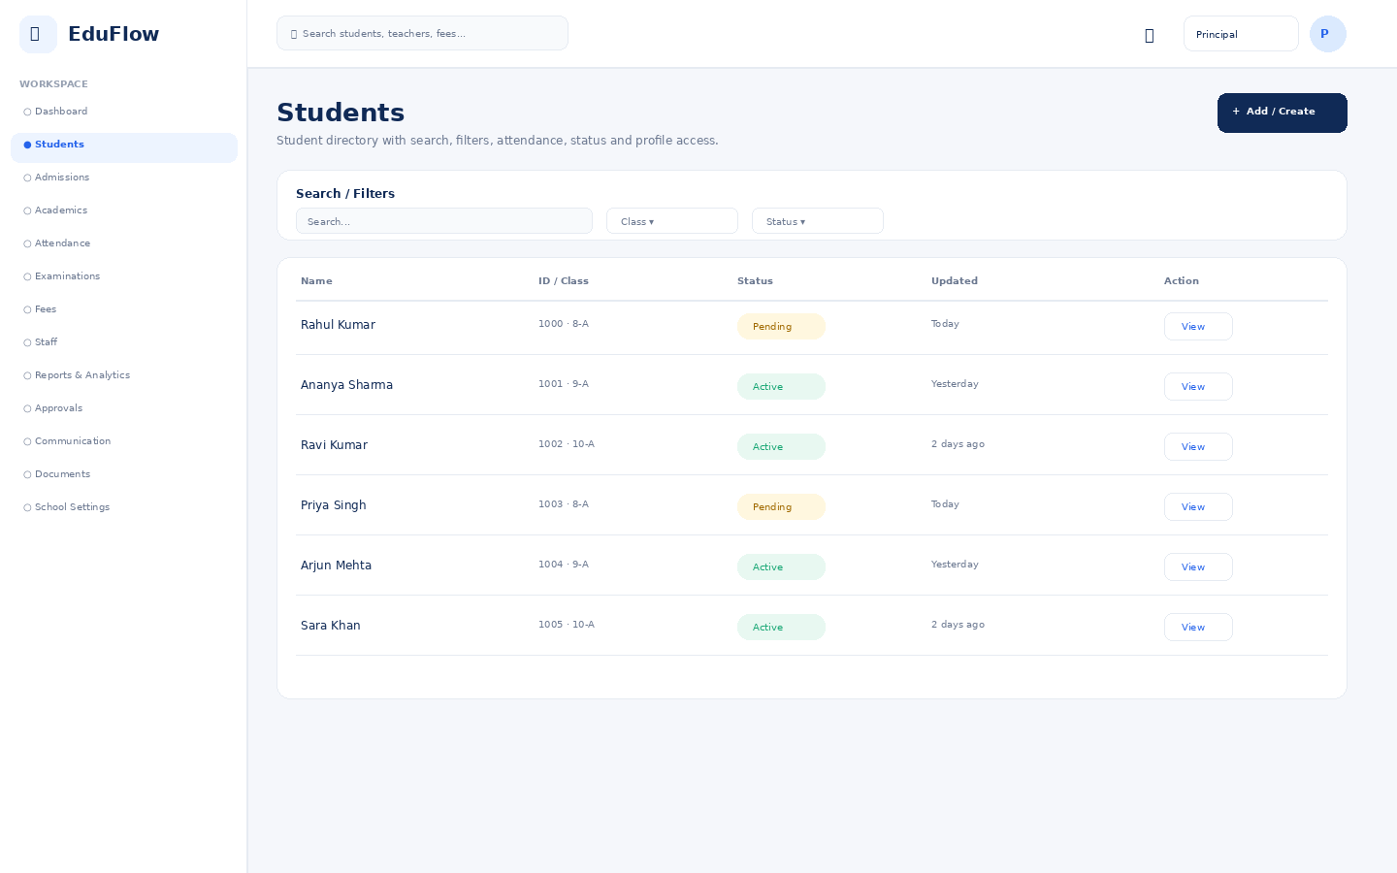
Access notes: Actual access is controlled by role, module permission, action permission and data scope.

Admissions
Module workspace with role-based navigation, filters, records, actions and status information.
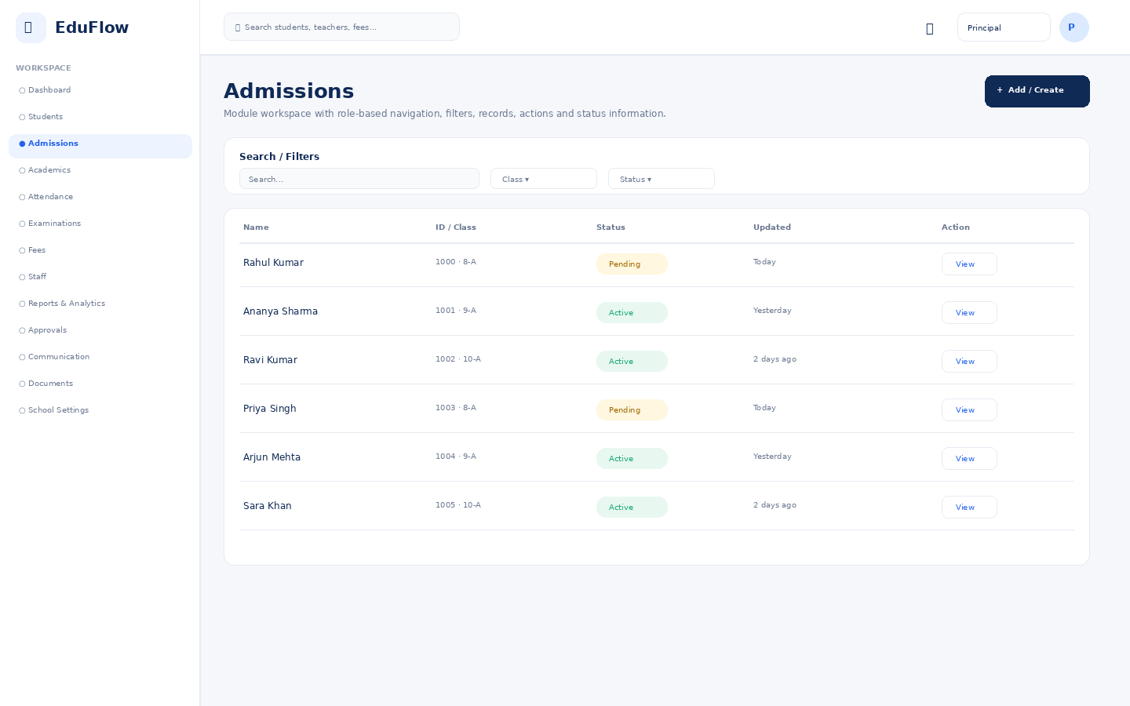
Access notes: Actual access is controlled by role, module permission, action permission and data scope.

Academics
Module workspace with role-based navigation, filters, records, actions and status information.
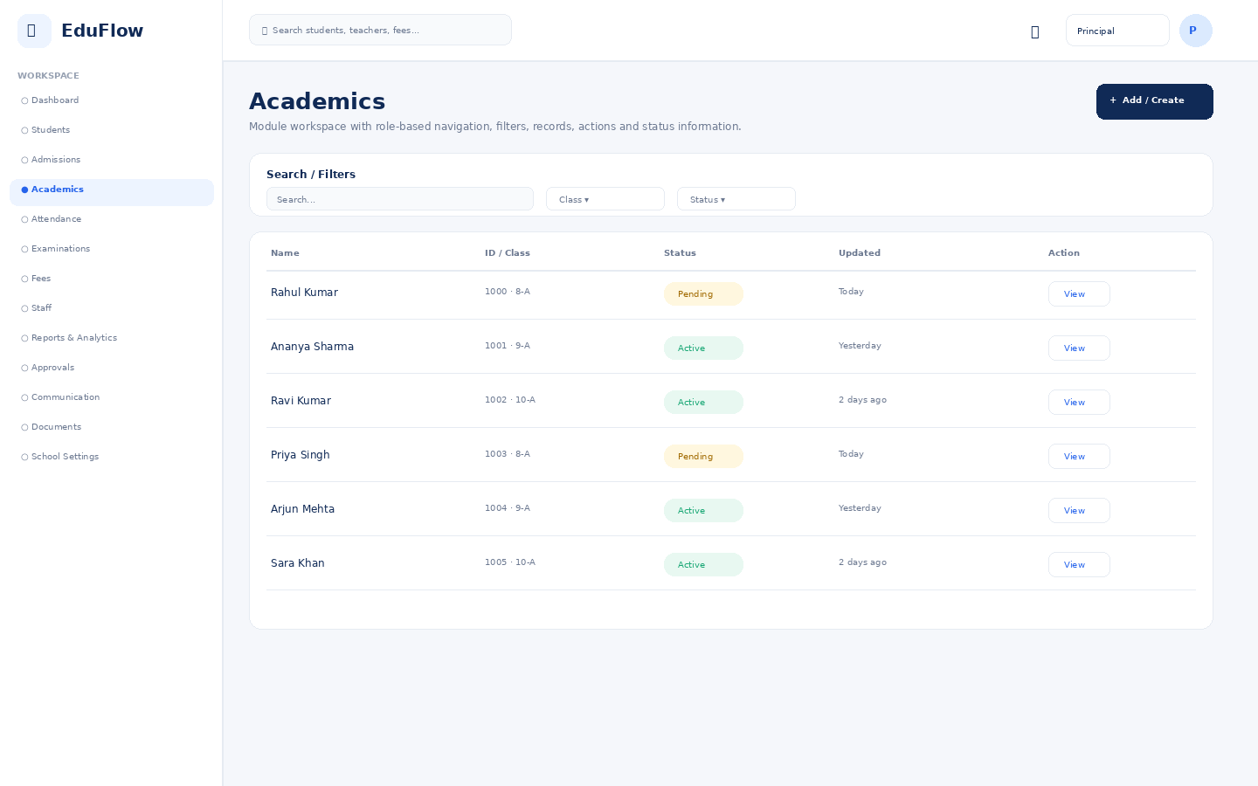
Access notes: Actual access is controlled by role, module permission, action permission and data scope.

Attendance
Daily attendance, absence/late status, trends and correction workflows.
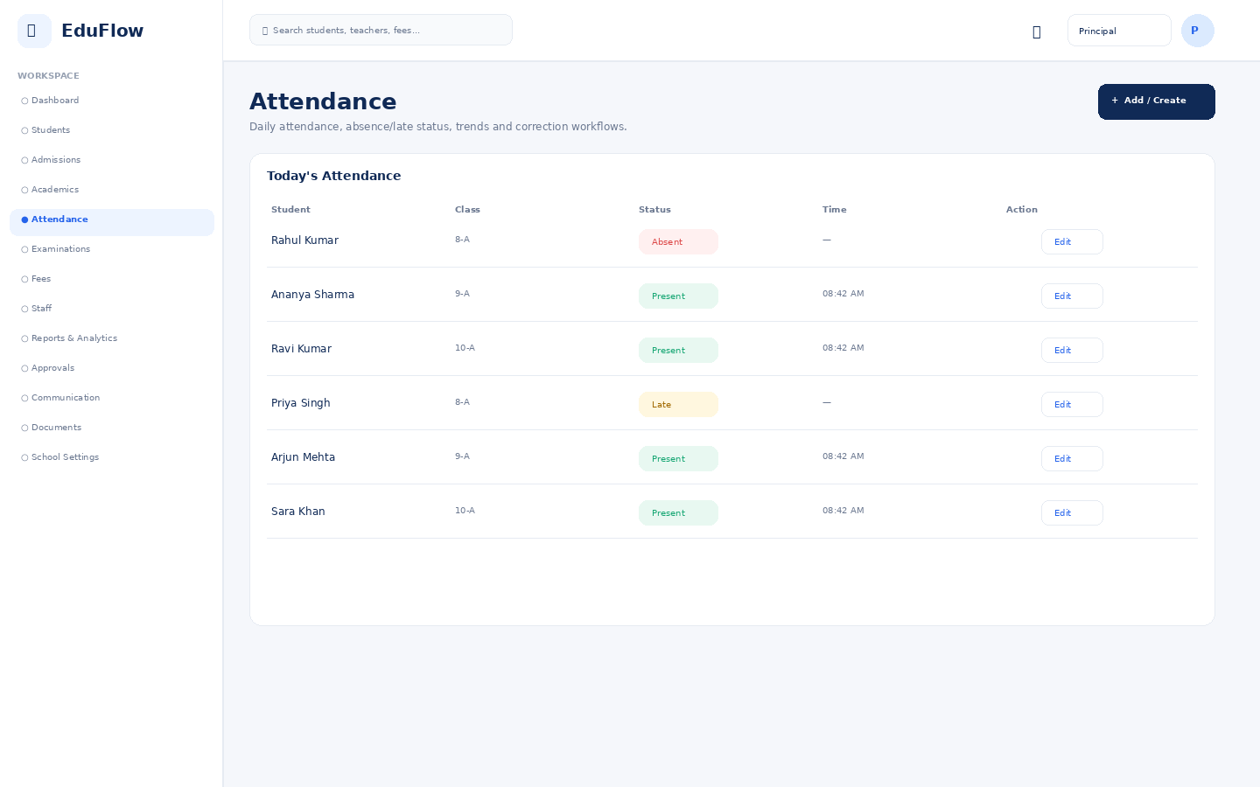
Access notes: Actual access is controlled by role, module permission, action permission and data scope.

Examinations
Exam setup, schedules, marks entry, review and publishing workflows.
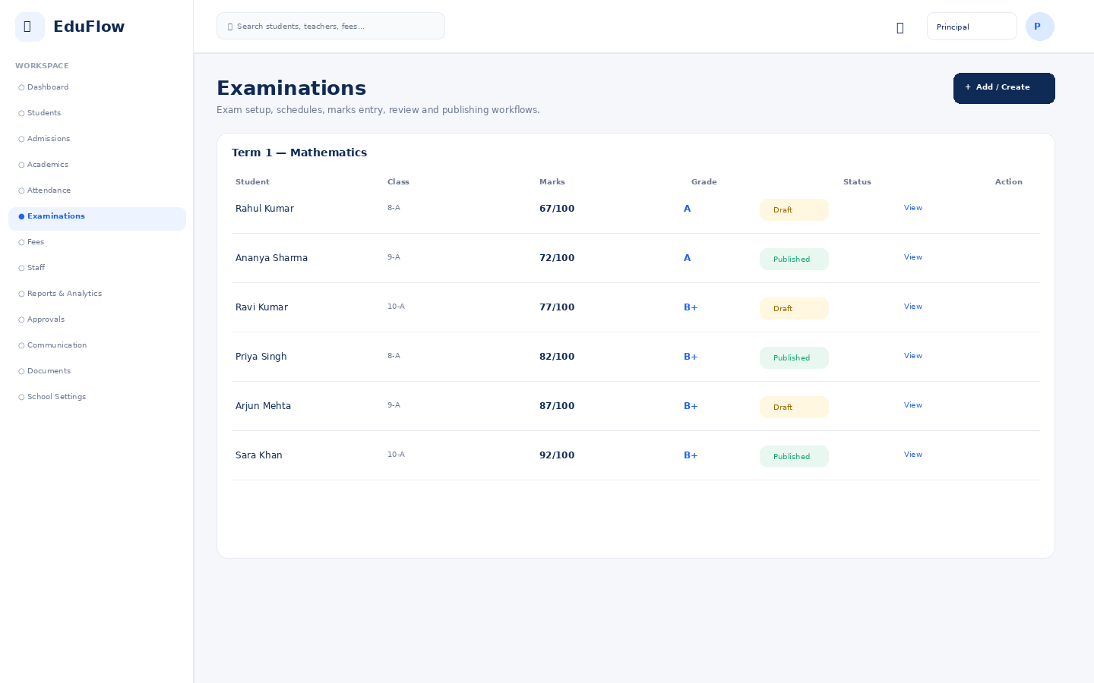
Access notes: Actual access is controlled by role, module permission, action permission and data scope.

Fees
Fee balances, invoices, collections, dues and payment history.
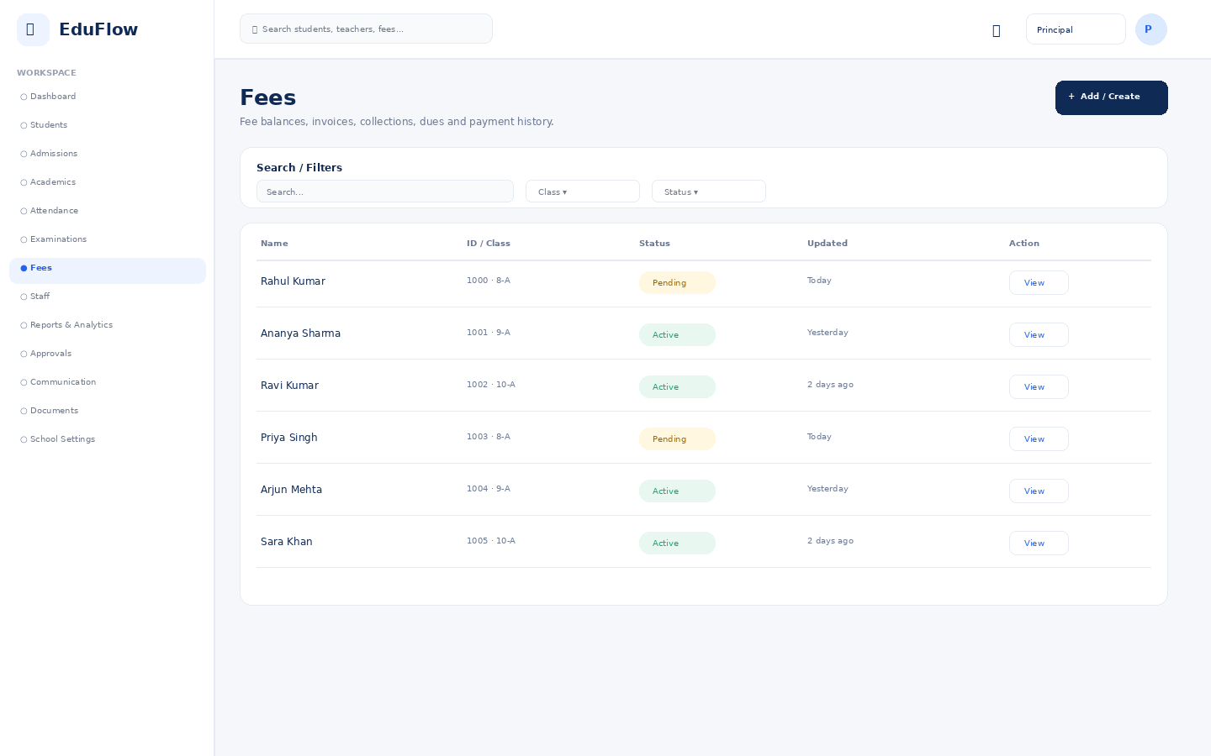
Access notes: Actual access is controlled by role, module permission, action permission and data scope.

Staff
Module workspace with role-based navigation, filters, records, actions and status information.
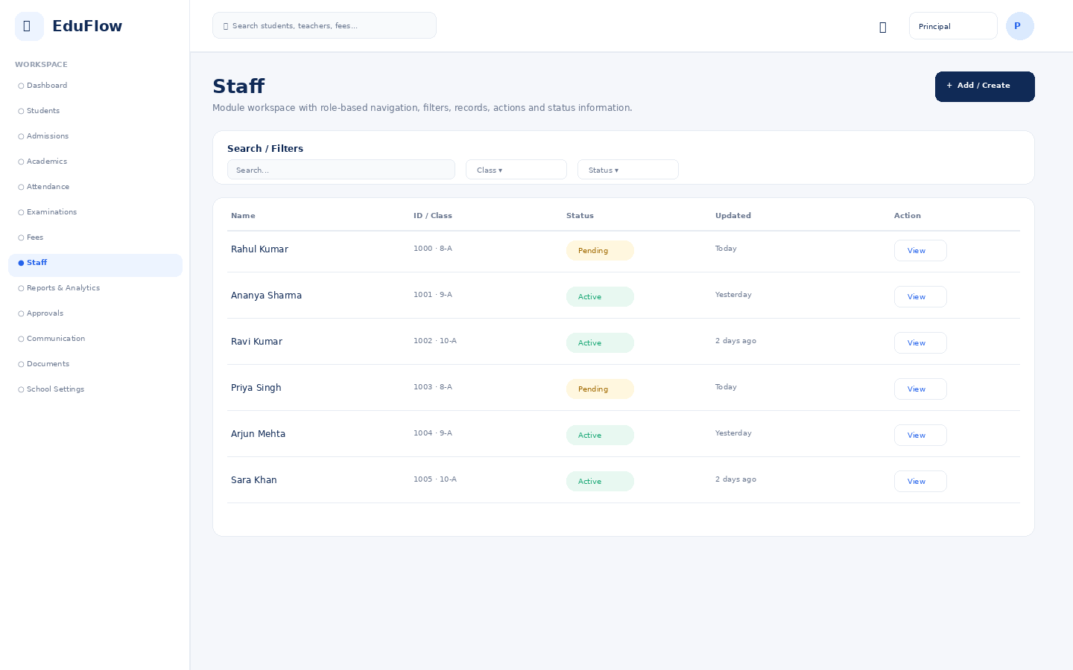
Access notes: Actual access is controlled by role, module permission, action permission and data scope.

Reports & Analytics
Filterable school reports with export-oriented presentation.
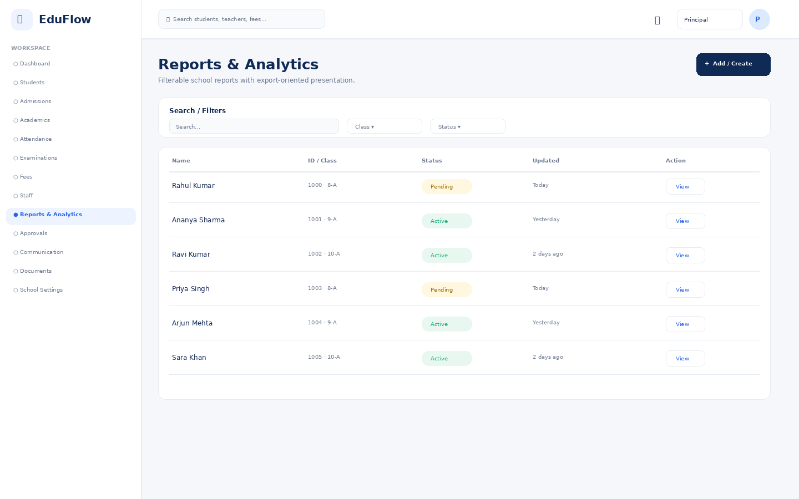
Access notes: Actual access is controlled by role, module permission, action permission and data scope.

Approvals
Central queue for attendance, leave, refunds, admissions and marks approvals.
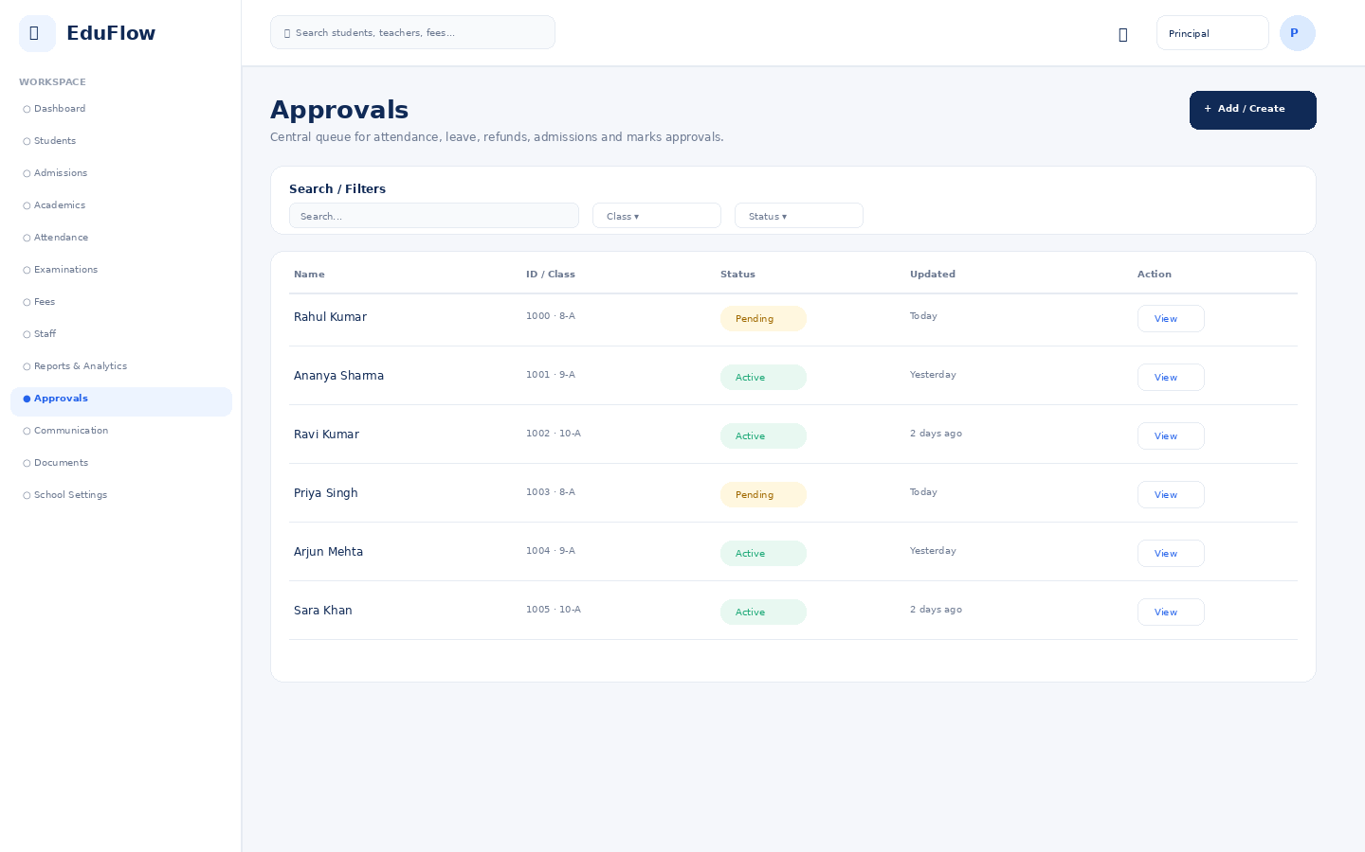
Access notes: Actual access is controlled by role, module permission, action permission and data scope.

Communication
Module workspace with role-based navigation, filters, records, actions and status information.
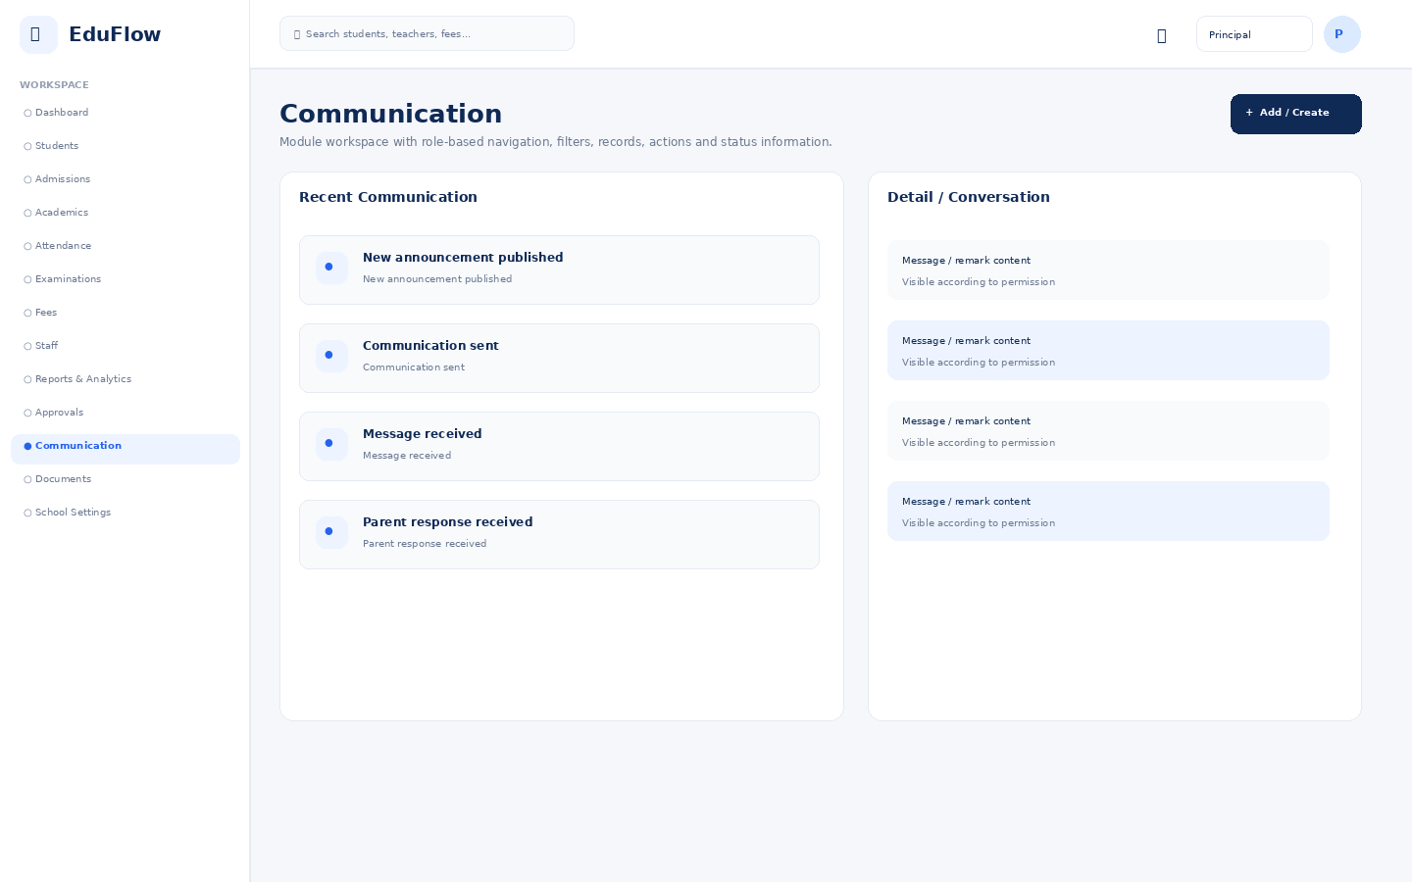
Access notes: Actual access is controlled by role, module permission, action permission and data scope.

Documents
Permission-controlled document repository with view/download/upload actions.
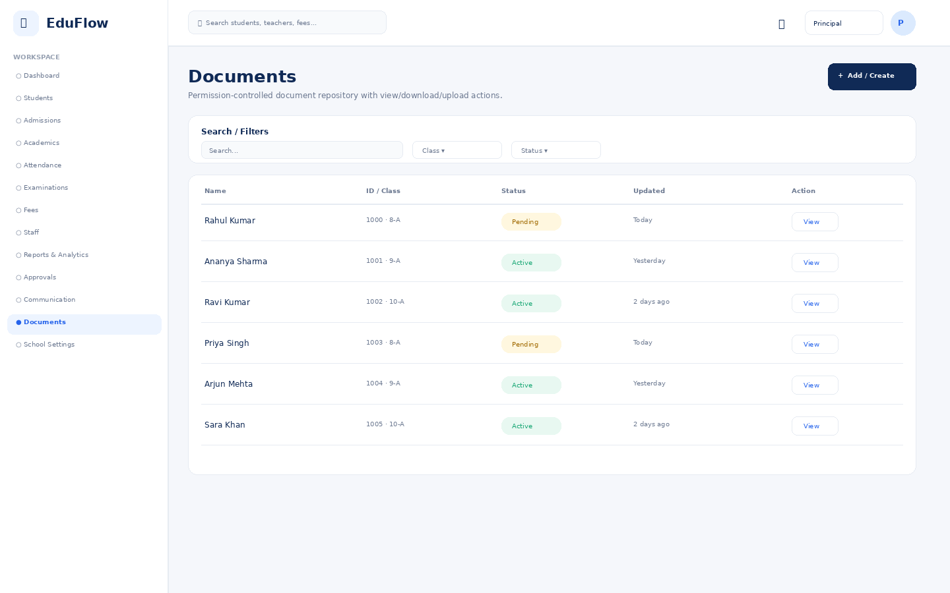
Access notes: Actual access is controlled by role, module permission, action permission and data scope.

School Settings
Module workspace with role-based navigation, filters, records, actions and status information.
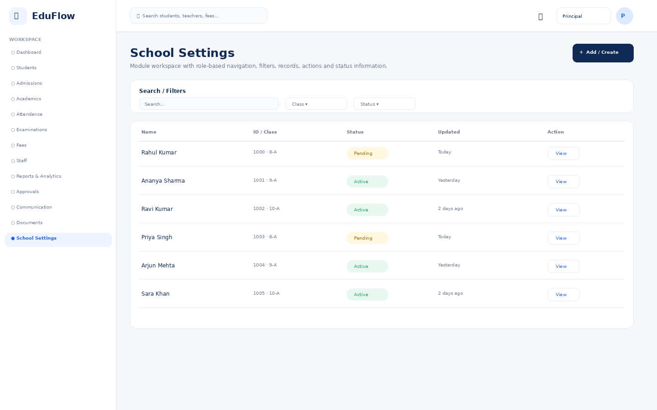
Access notes: Actual access is controlled by role, module permission, action permission and data scope.

Teacher
11 screens in this role experience.

Dashboard
Role-specific operational overview with KPIs, alerts, charts and quick actions.
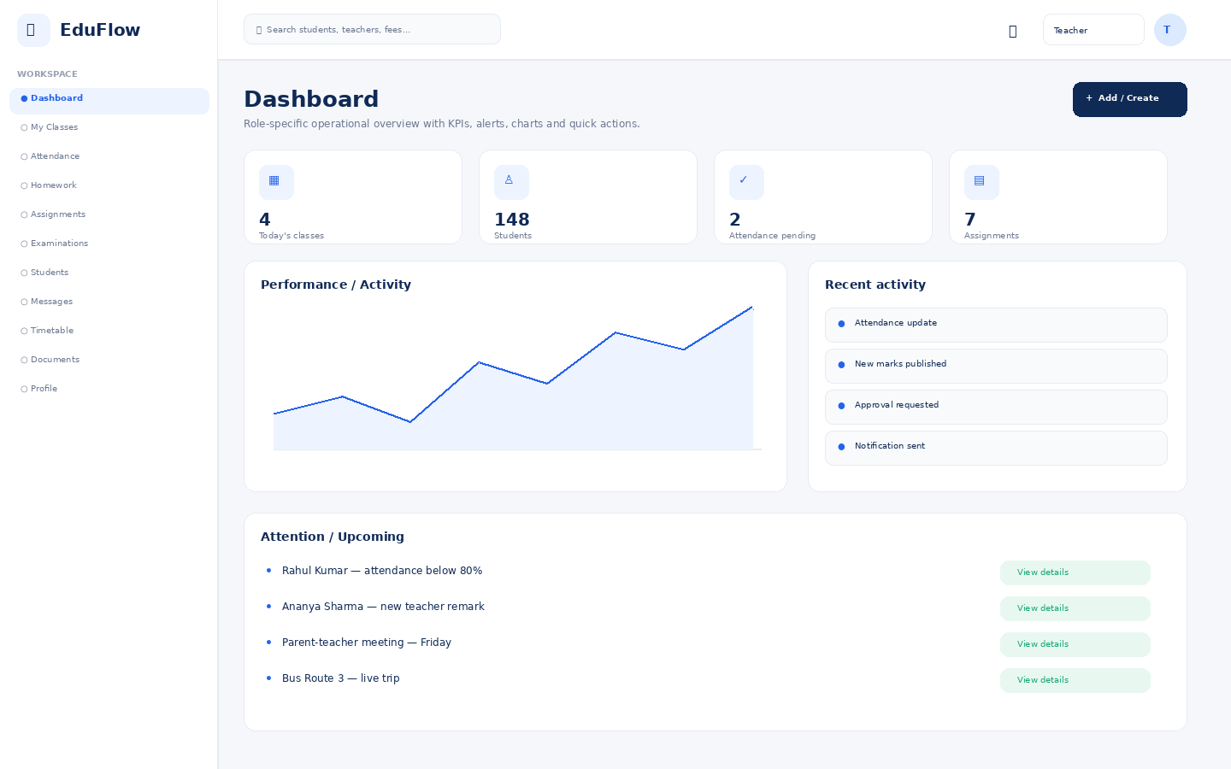
Access notes: Teacher access is limited to assigned classes/subjects and permitted actions. Historical or sensitive changes can require approval.

My Classes
Module workspace with role-based navigation, filters, records, actions and status information.
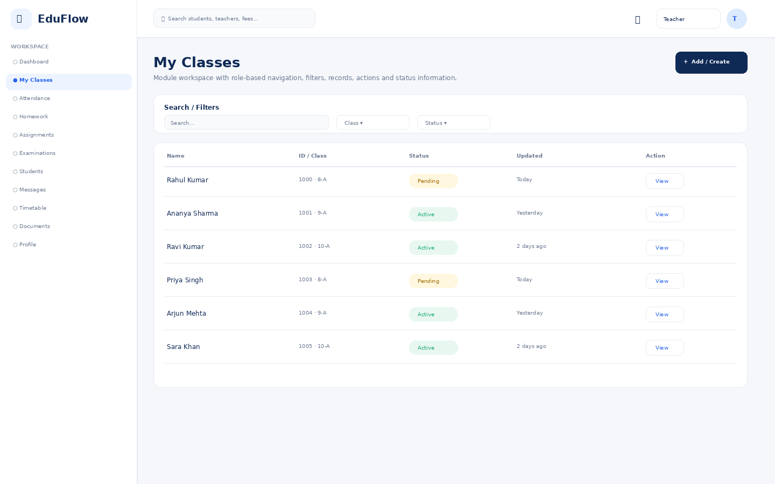
Access notes: Teacher access is limited to assigned classes/subjects and permitted actions. Historical or sensitive changes can require approval.

Attendance
Daily attendance, absence/late status, trends and correction workflows.
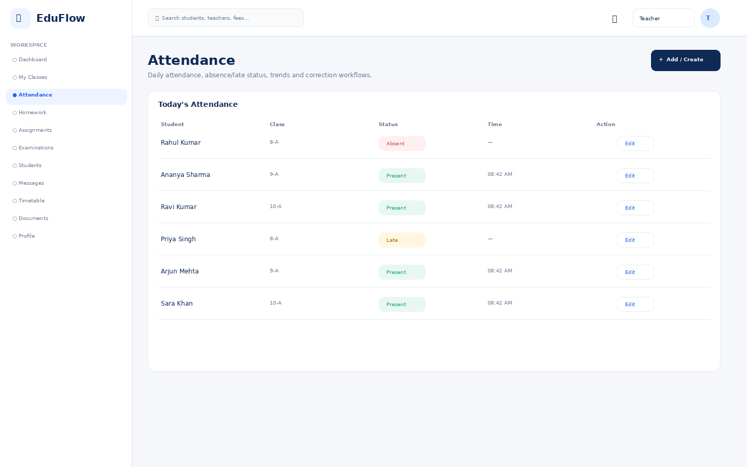
Access notes: Teacher access is limited to assigned classes/subjects and permitted actions. Historical or sensitive changes can require approval.

Homework
Create, publish, submit and review homework.
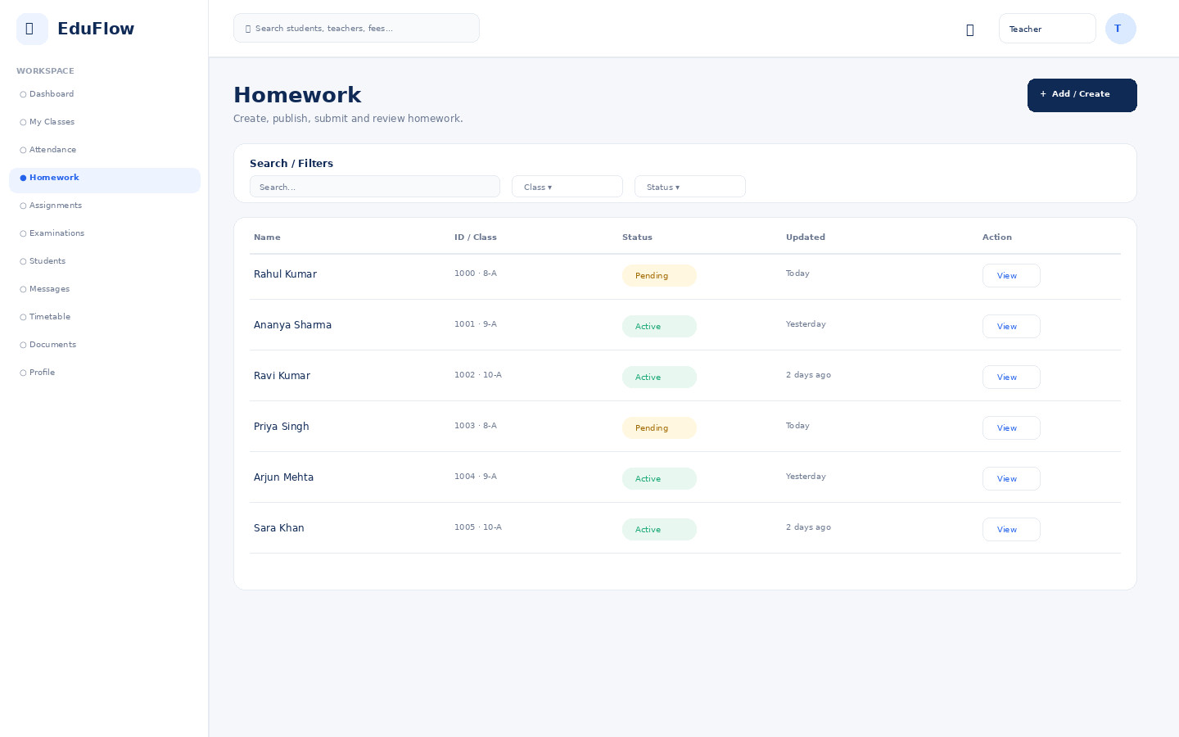
Access notes: Teacher access is limited to assigned classes/subjects and permitted actions. Historical or sensitive changes can require approval.

Assignments
Assignment workflow from creation to submission and review.
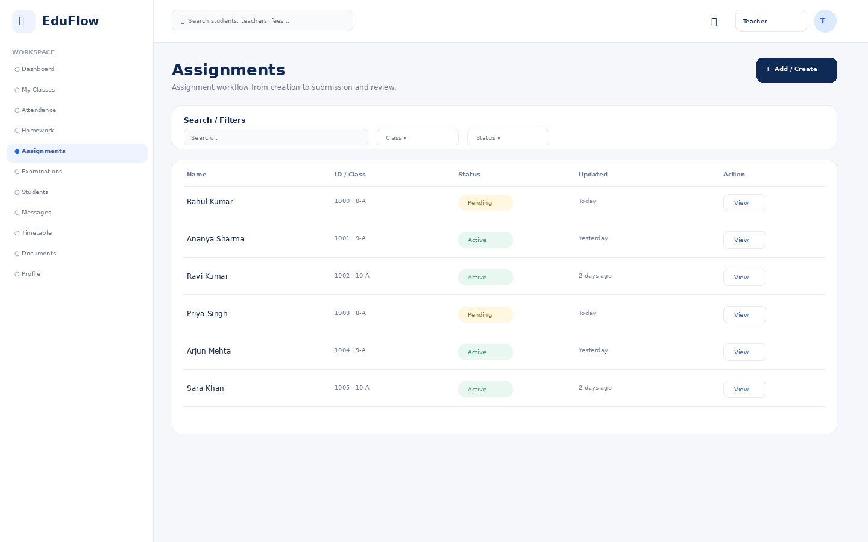
Access notes: Teacher access is limited to assigned classes/subjects and permitted actions. Historical or sensitive changes can require approval.

Examinations
Exam setup, schedules, marks entry, review and publishing workflows.
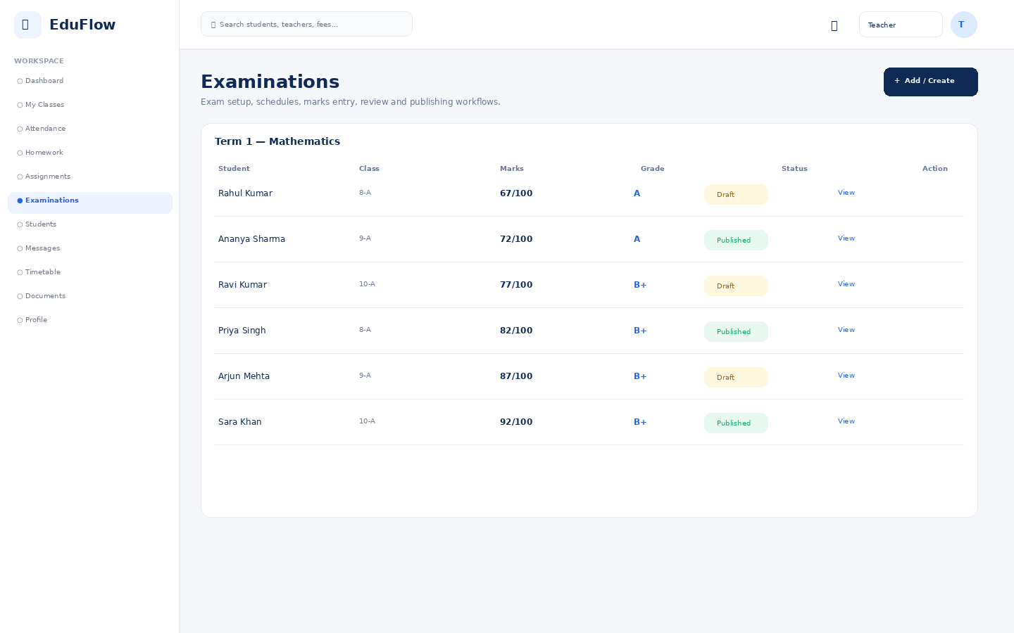
Access notes: Teacher access is limited to assigned classes/subjects and permitted actions. Historical or sensitive changes can require approval.

Students
Student directory with search, filters, attendance, status and profile access.
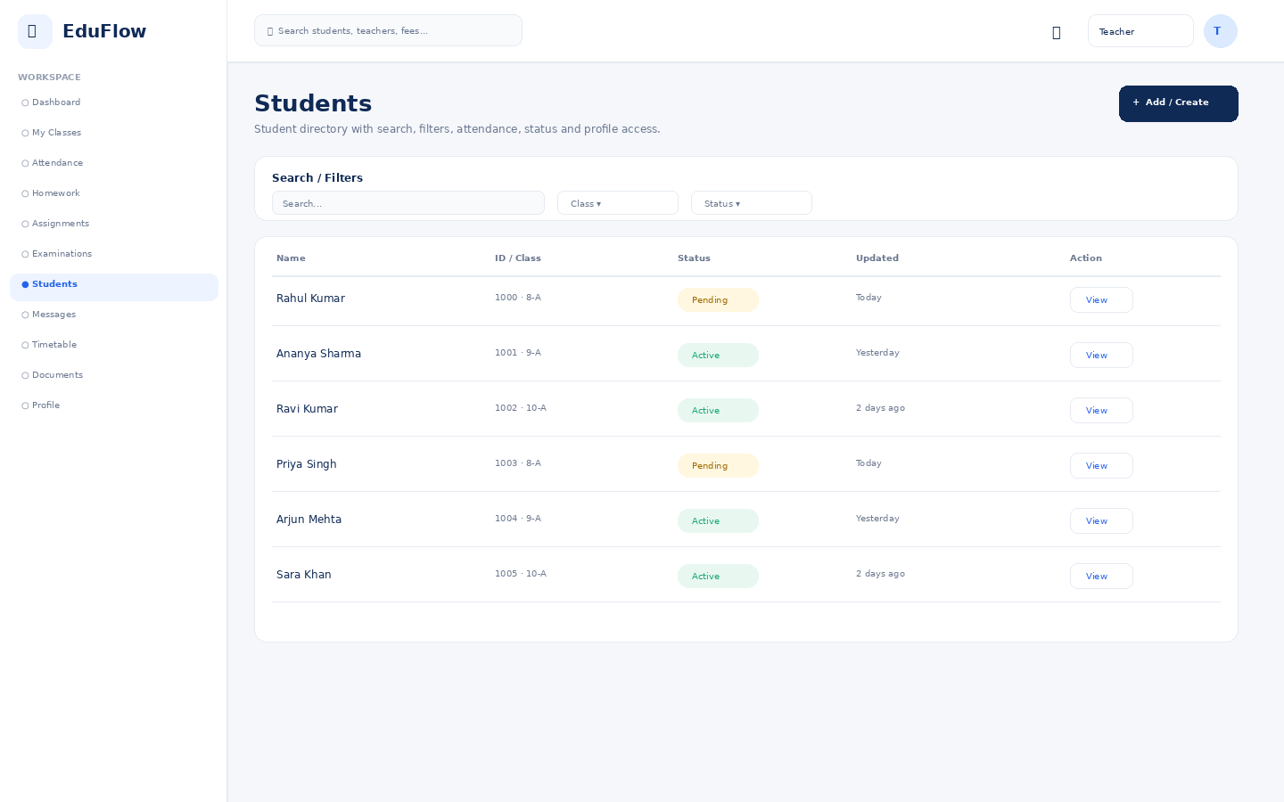
Access notes: Teacher access is limited to assigned classes/subjects and permitted actions. Historical or sensitive changes can require approval.

Messages
Secure role-aware communication between authorized school users and families.
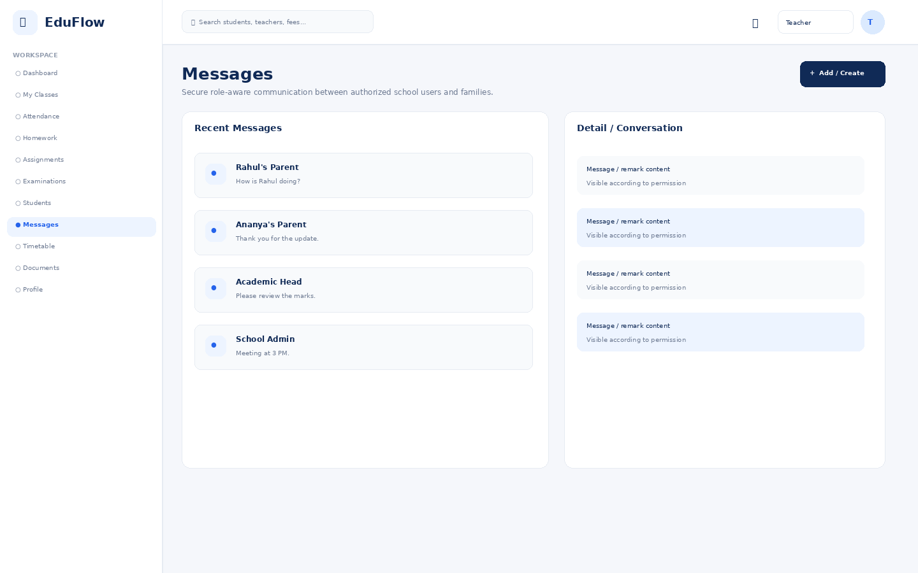
Access notes: Teacher access is limited to assigned classes/subjects and permitted actions. Historical or sensitive changes can require approval.

Timetable
Class/teacher schedule grid with day and period views.
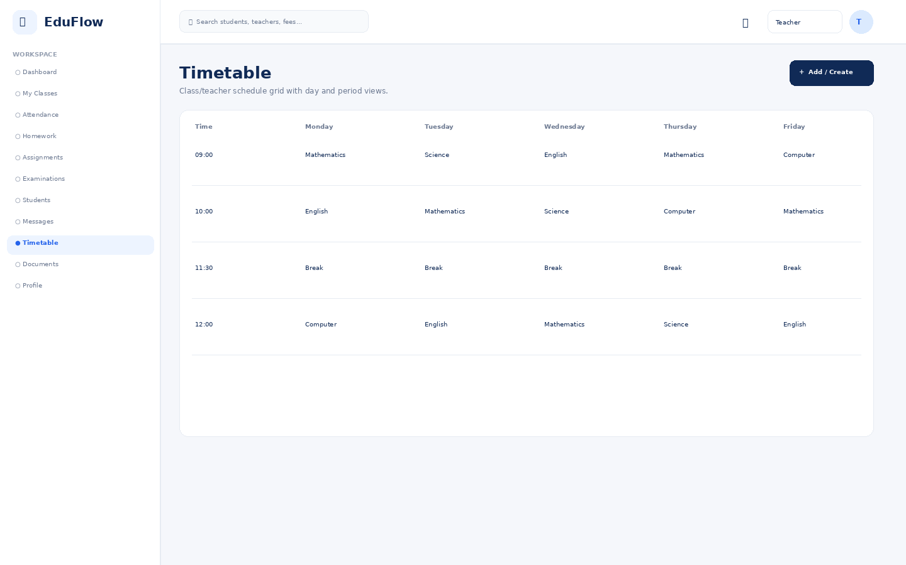
Access notes: Teacher access is limited to assigned classes/subjects and permitted actions. Historical or sensitive changes can require approval.

Documents
Permission-controlled document repository with view/download/upload actions.
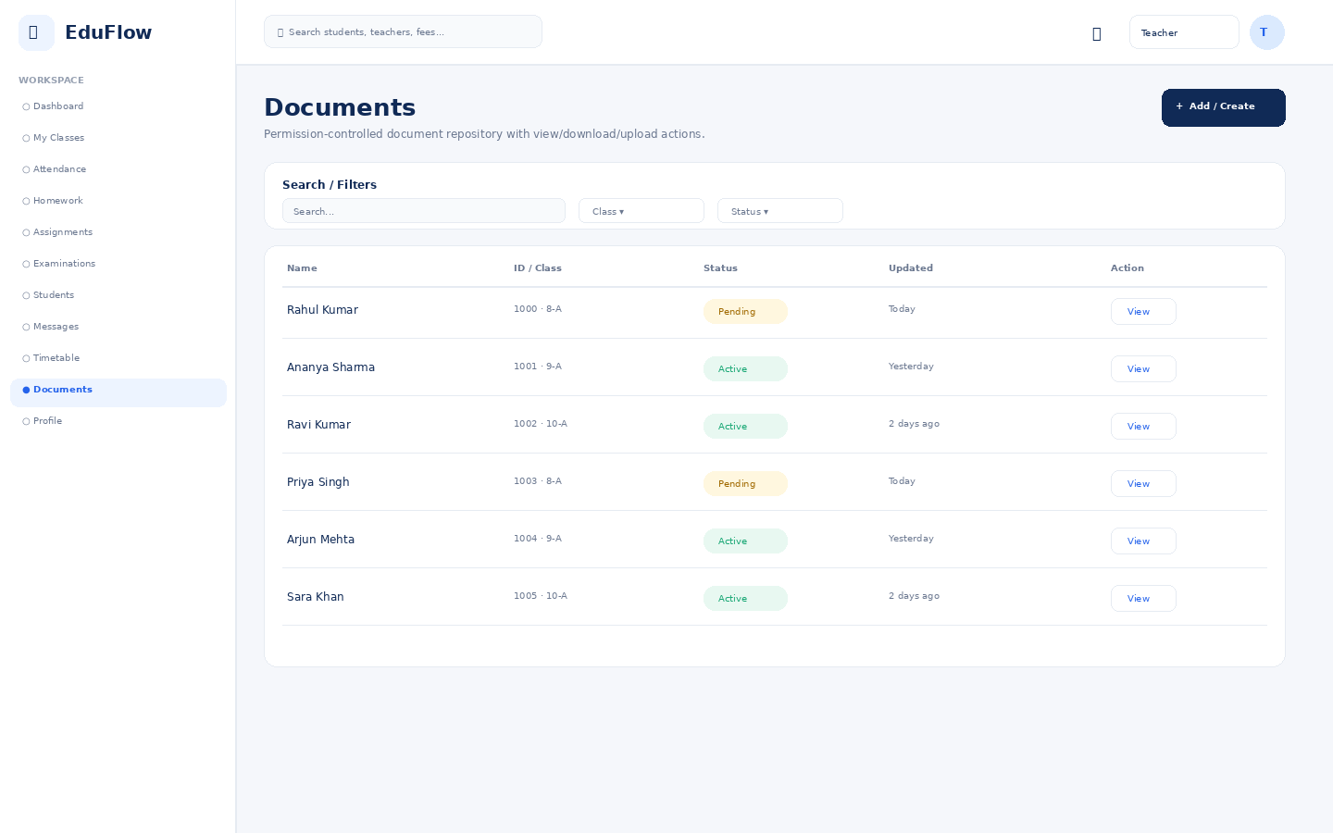
Access notes: Teacher access is limited to assigned classes/subjects and permitted actions. Historical or sensitive changes can require approval.

Profile
User identity, role, school, security and account details.
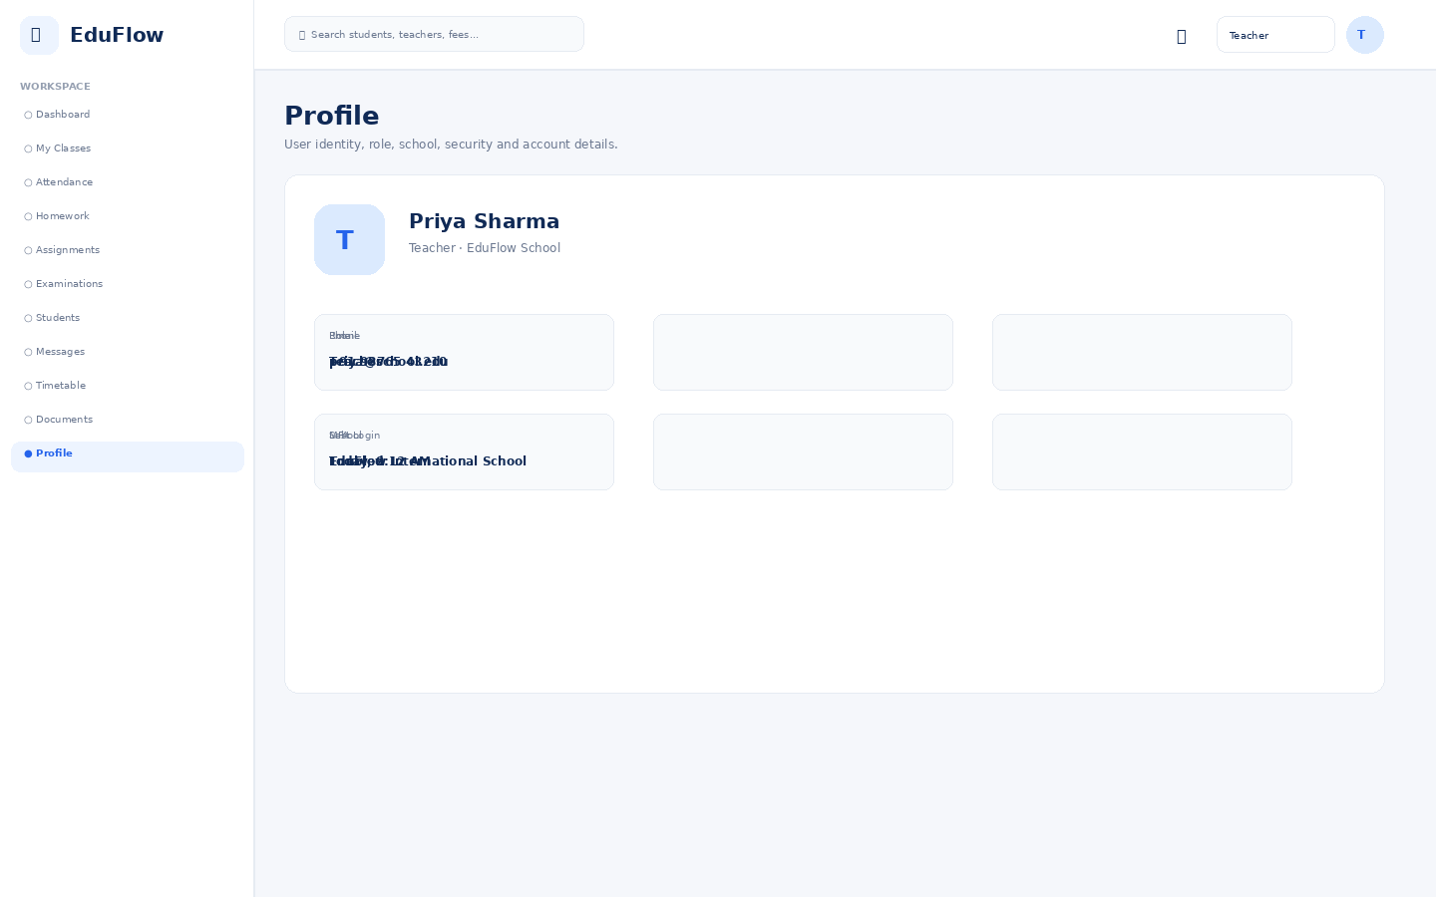
Access notes: Teacher access is limited to assigned classes/subjects and permitted actions. Historical or sensitive changes can require approval.

Parent
13 screens in this role experience.

Dashboard
Role-specific operational overview with KPIs, alerts, charts and quick actions.
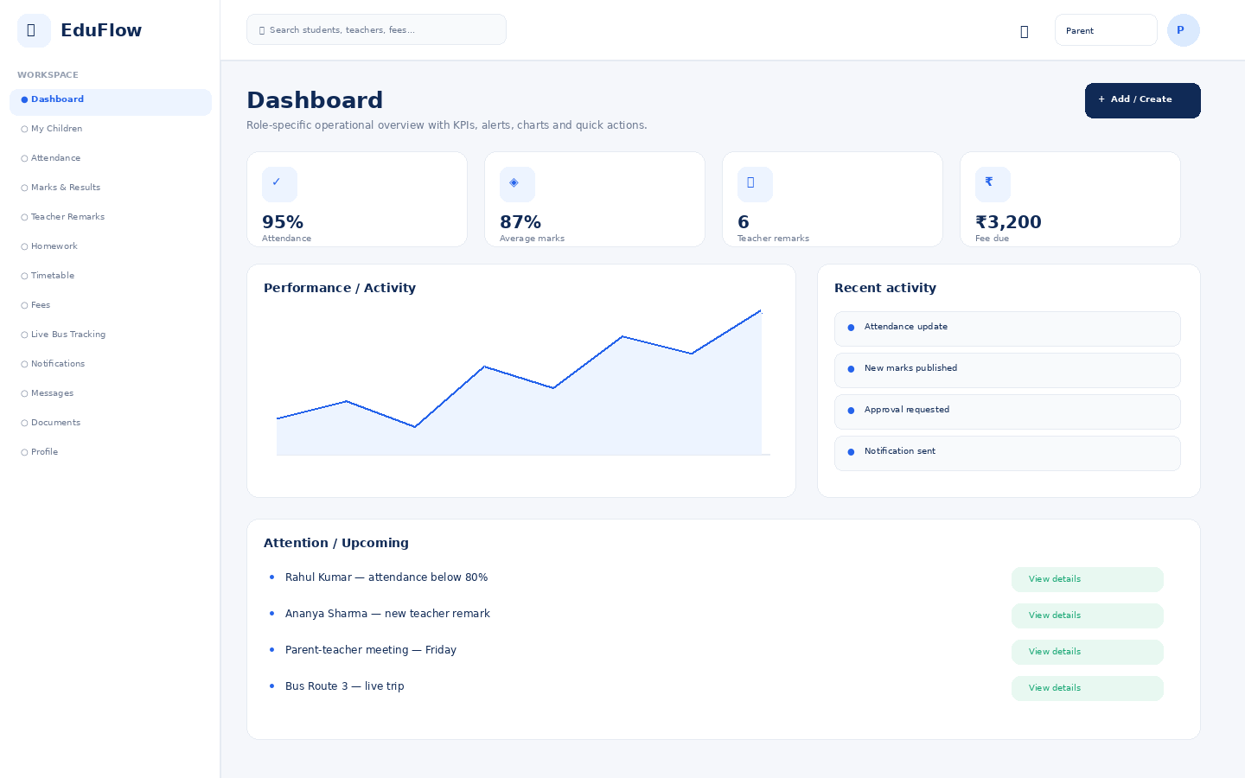
Access notes: Only linked children are visible. Sensitive school-wide data, other students and administrative controls are unavailable.

My Children
Parent-only view of linked children and their school status.
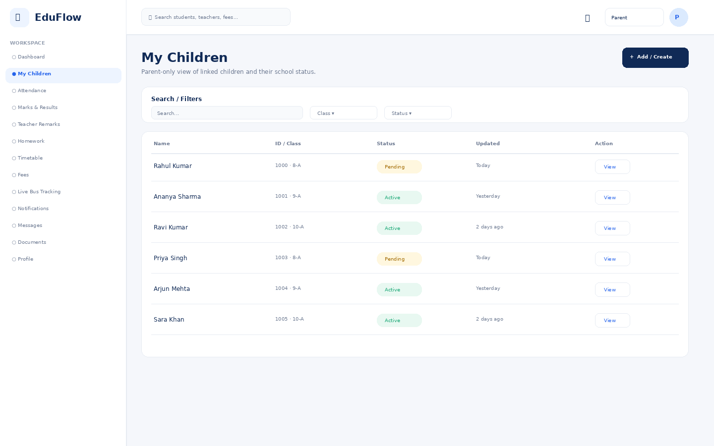
Access notes: Only linked children are visible. Sensitive school-wide data, other students and administrative controls are unavailable.

Attendance
Daily attendance, absence/late status, trends and correction workflows.
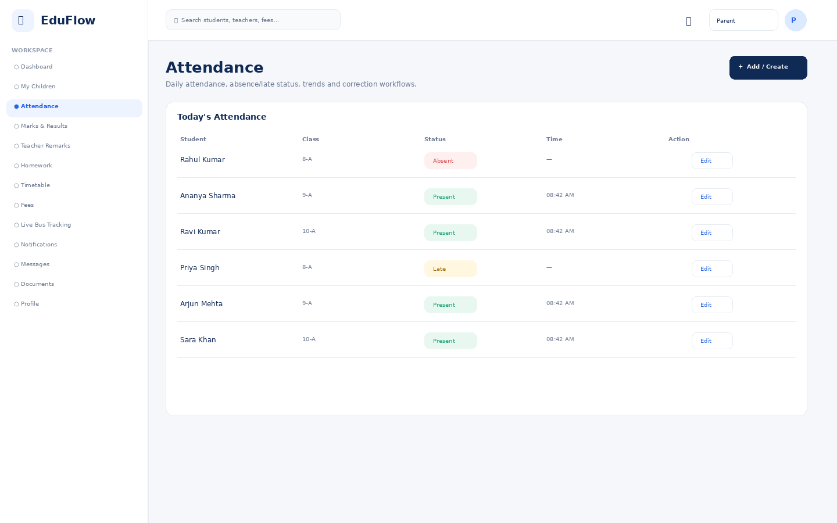
Access notes: Only linked children are visible. Sensitive school-wide data, other students and administrative controls are unavailable.

Marks & Results
Parent/student-facing performance view with marks, grades and report-card access.
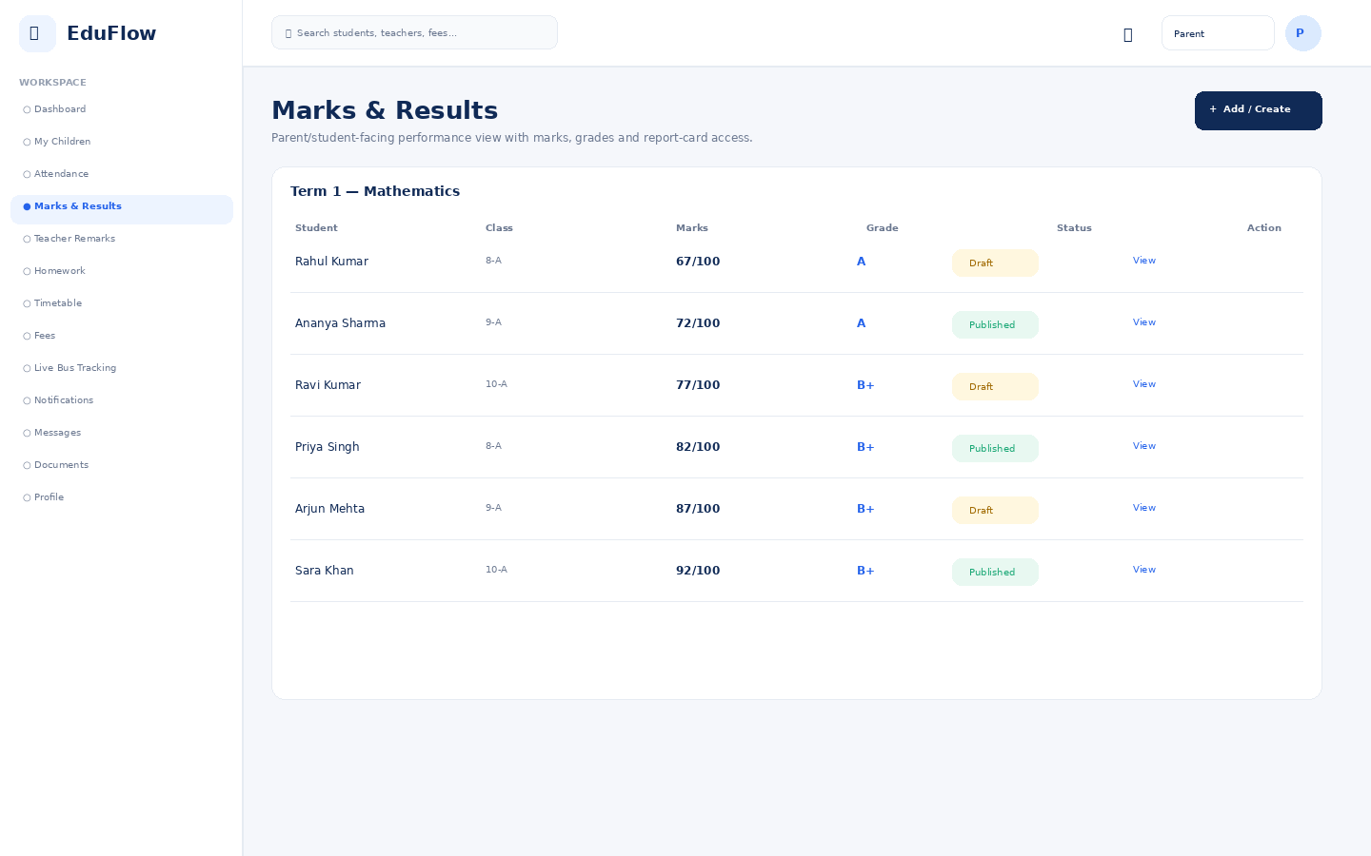
Access notes: Only linked children are visible. Sensitive school-wide data, other students and administrative controls are unavailable.

Teacher Remarks
Teacher feedback visible according to role and data-scope permissions.
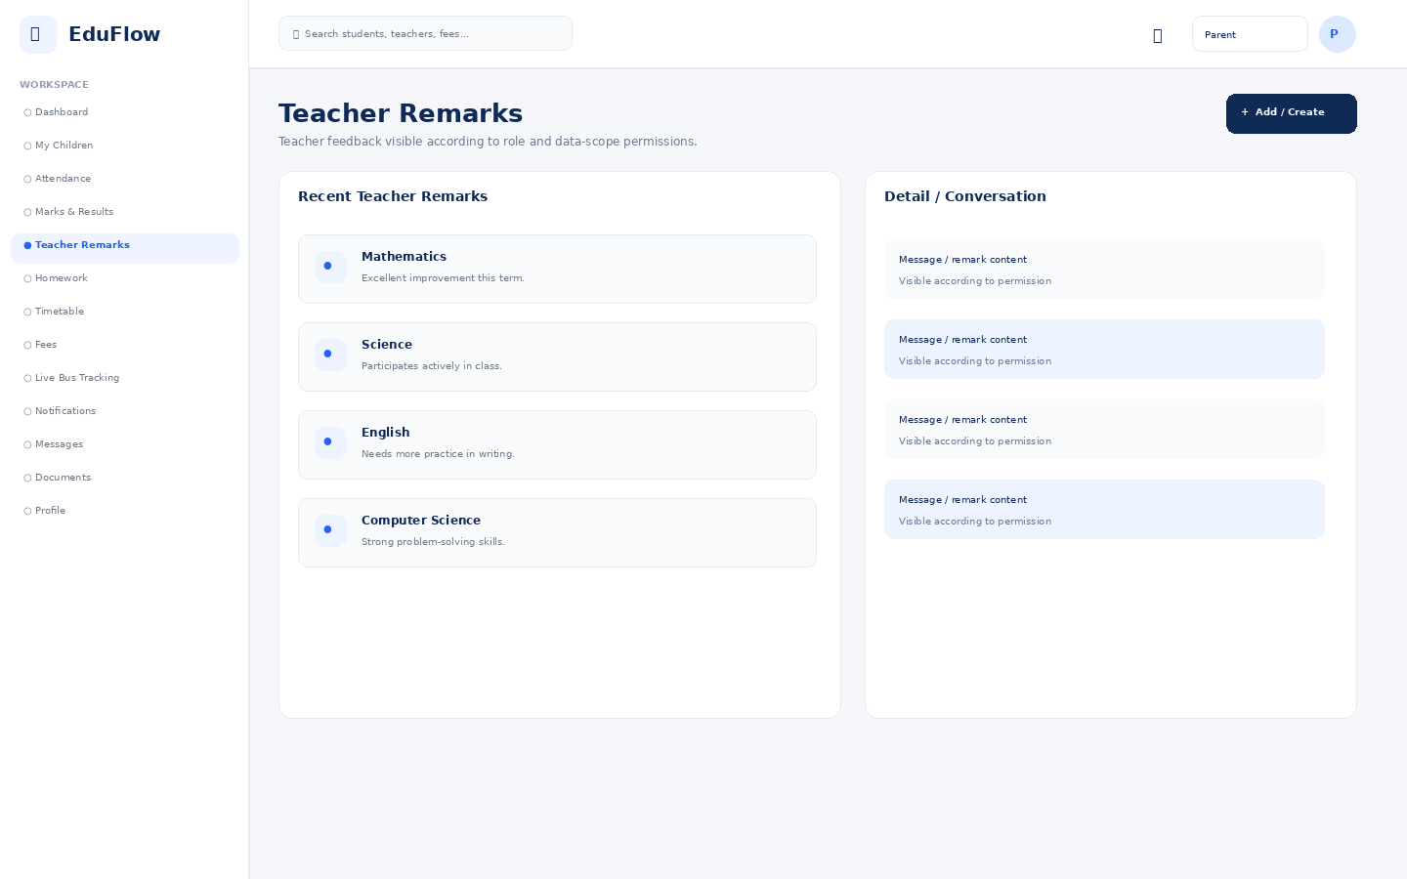
Access notes: Only linked children are visible. Sensitive school-wide data, other students and administrative controls are unavailable.

Homework
Create, publish, submit and review homework.
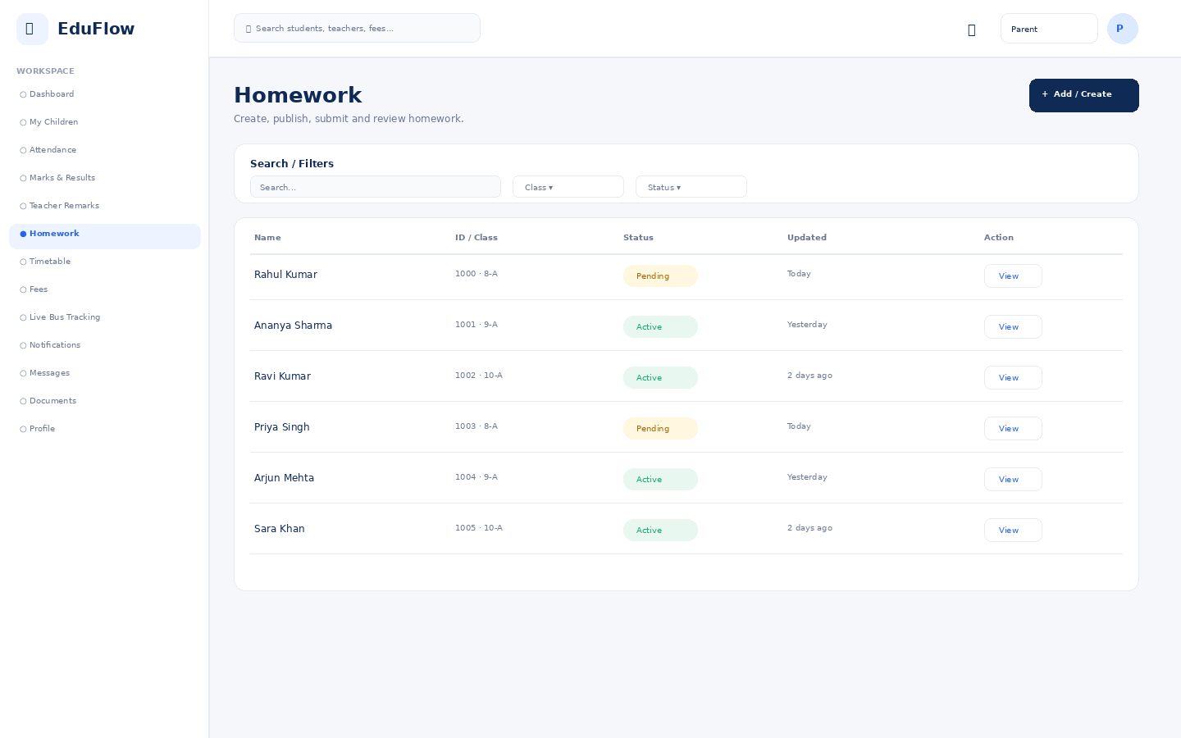
Access notes: Only linked children are visible. Sensitive school-wide data, other students and administrative controls are unavailable.

Timetable
Class/teacher schedule grid with day and period views.
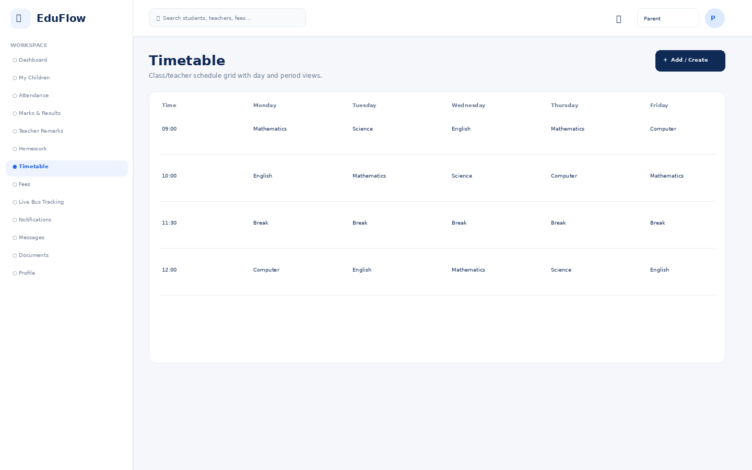
Access notes: Only linked children are visible. Sensitive school-wide data, other students and administrative controls are unavailable.

Fees
Fee balances, invoices, collections, dues and payment history.
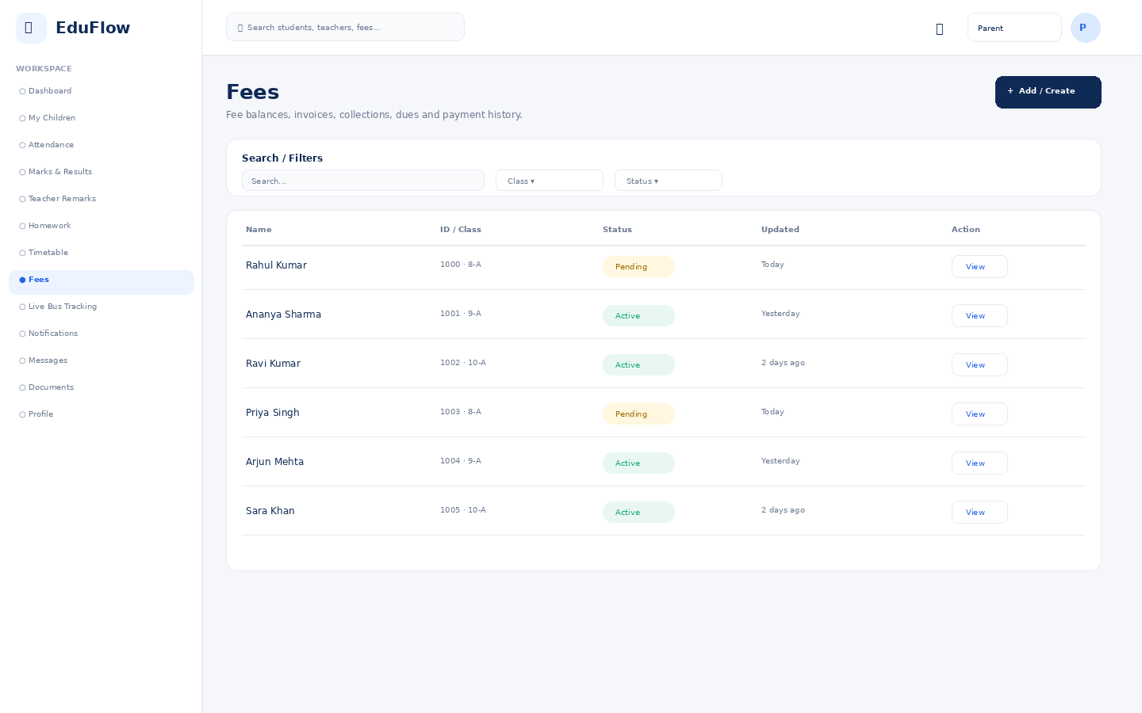
Access notes: Only linked children are visible. Sensitive school-wide data, other students and administrative controls are unavailable.

Live Bus Tracking
Route map, vehicle position, trip progress, next stop and ETA.
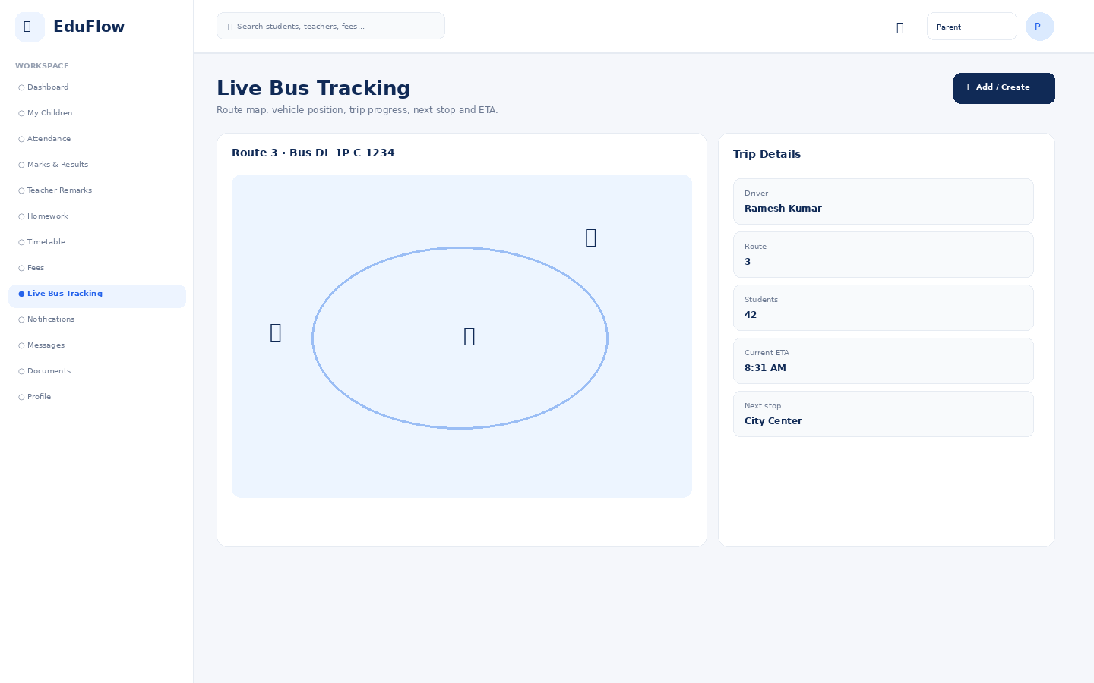
Access notes: Only linked children are visible. Sensitive school-wide data, other students and administrative controls are unavailable.

Notifications
Role-aware alerts for attendance, marks, fees, homework, transport and announcements.
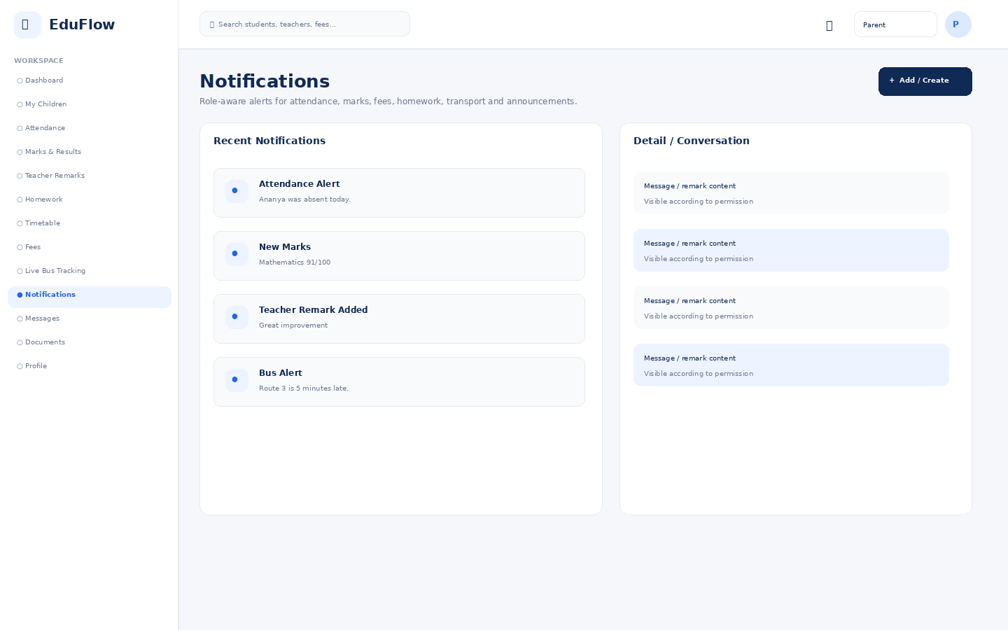
Access notes: Only linked children are visible. Sensitive school-wide data, other students and administrative controls are unavailable.

Messages
Secure role-aware communication between authorized school users and families.
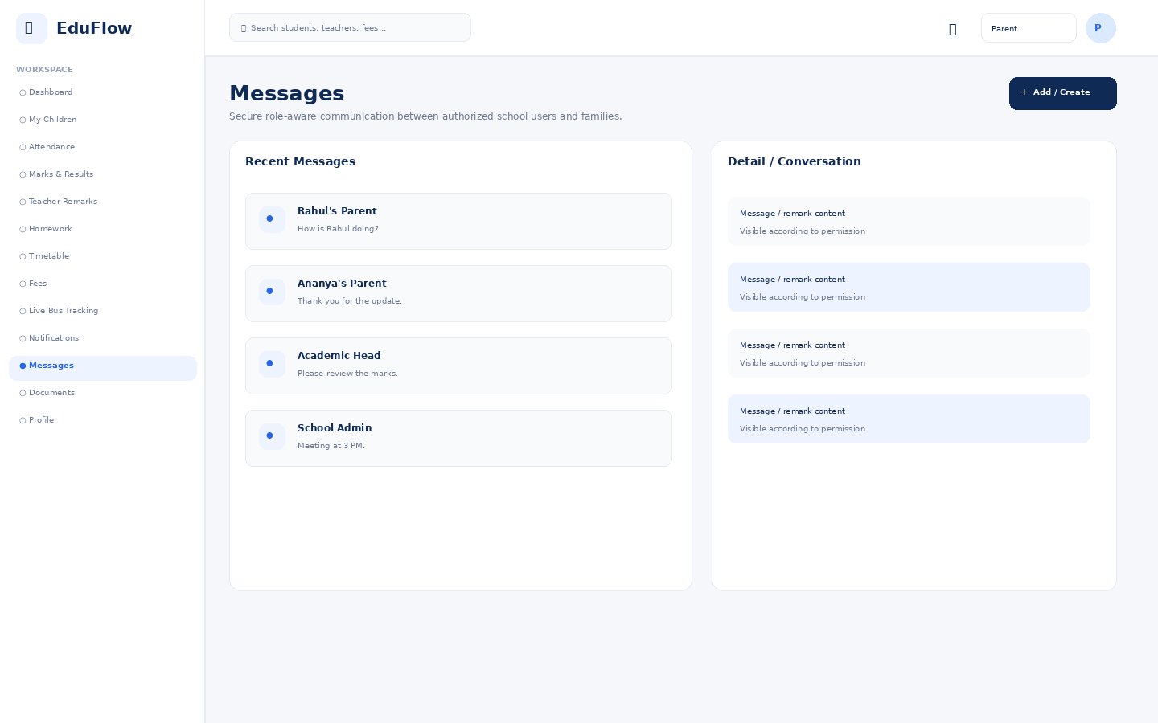
Access notes: Only linked children are visible. Sensitive school-wide data, other students and administrative controls are unavailable.

Documents
Permission-controlled document repository with view/download/upload actions.
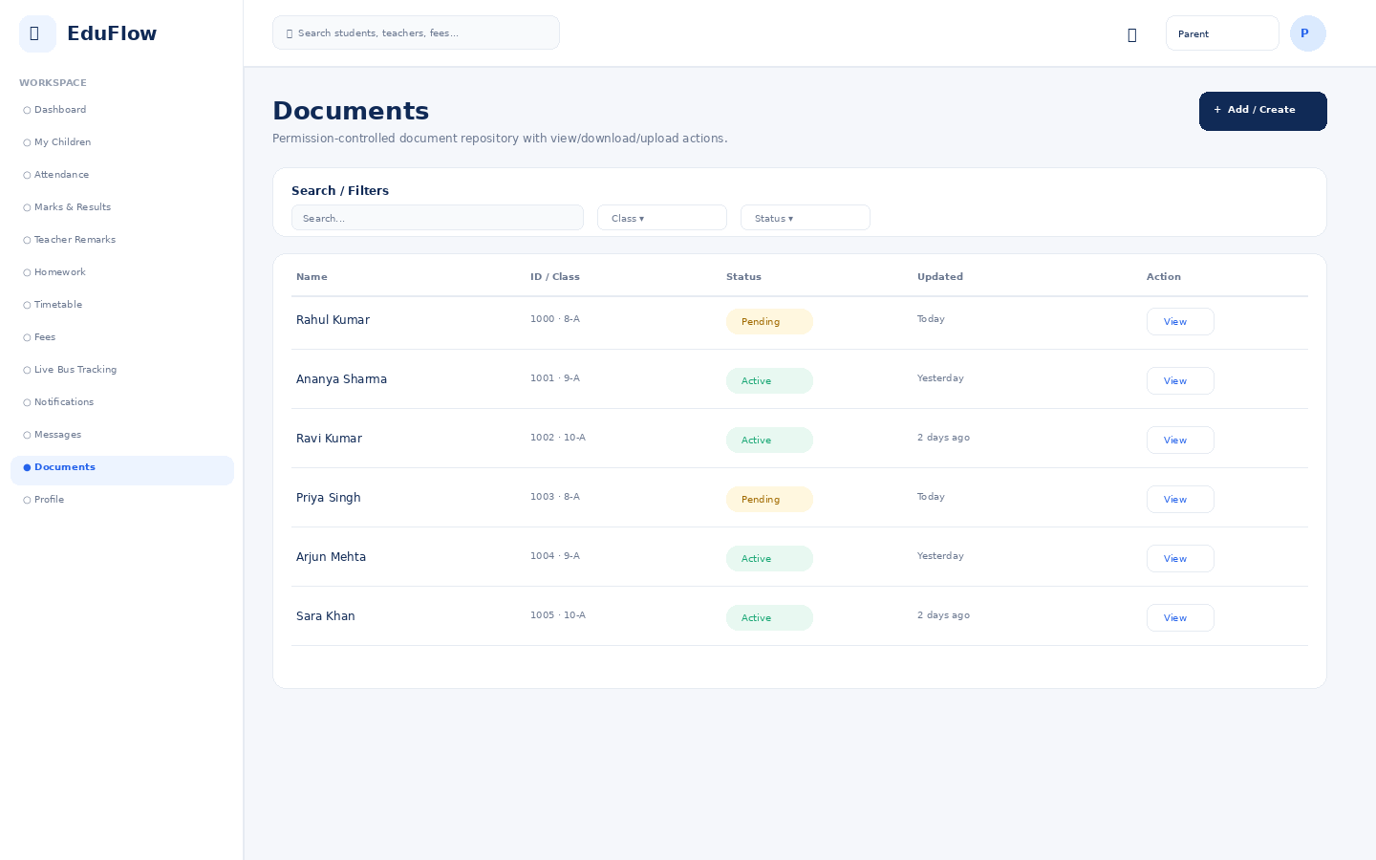
Access notes: Only linked children are visible. Sensitive school-wide data, other students and administrative controls are unavailable.

Profile
User identity, role, school, security and account details.
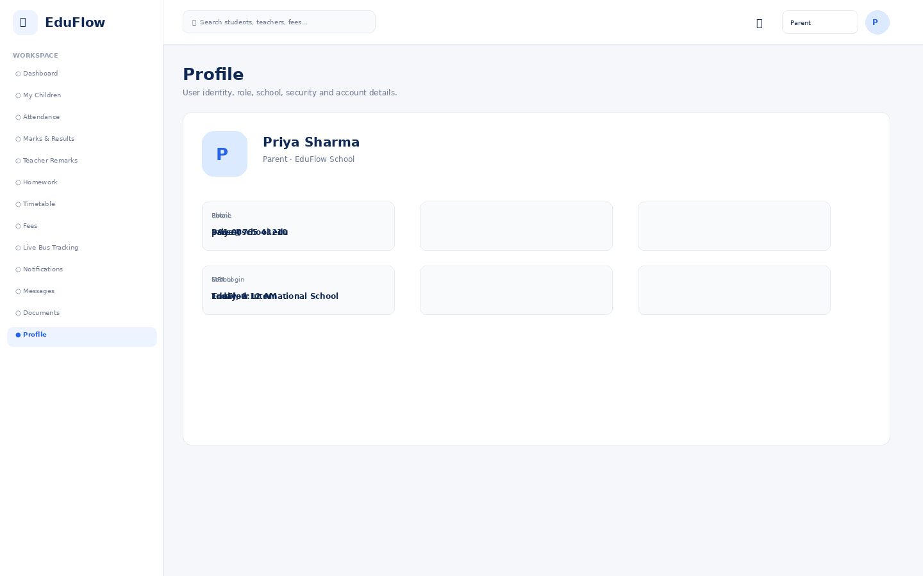
Access notes: Only linked children are visible. Sensitive school-wide data, other students and administrative controls are unavailable.

Student
11 screens in this role experience.

Dashboard
Role-specific operational overview with KPIs, alerts, charts and quick actions.
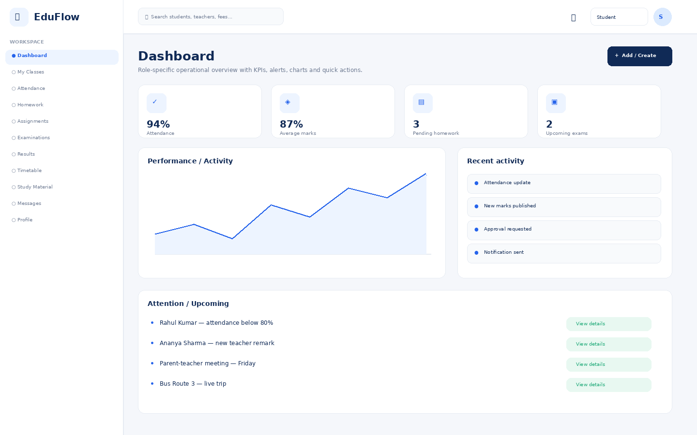
Access notes: Student sees own academic and activity records only; no administrative, financial-management or other-student data.

My Classes
Module workspace with role-based navigation, filters, records, actions and status information.
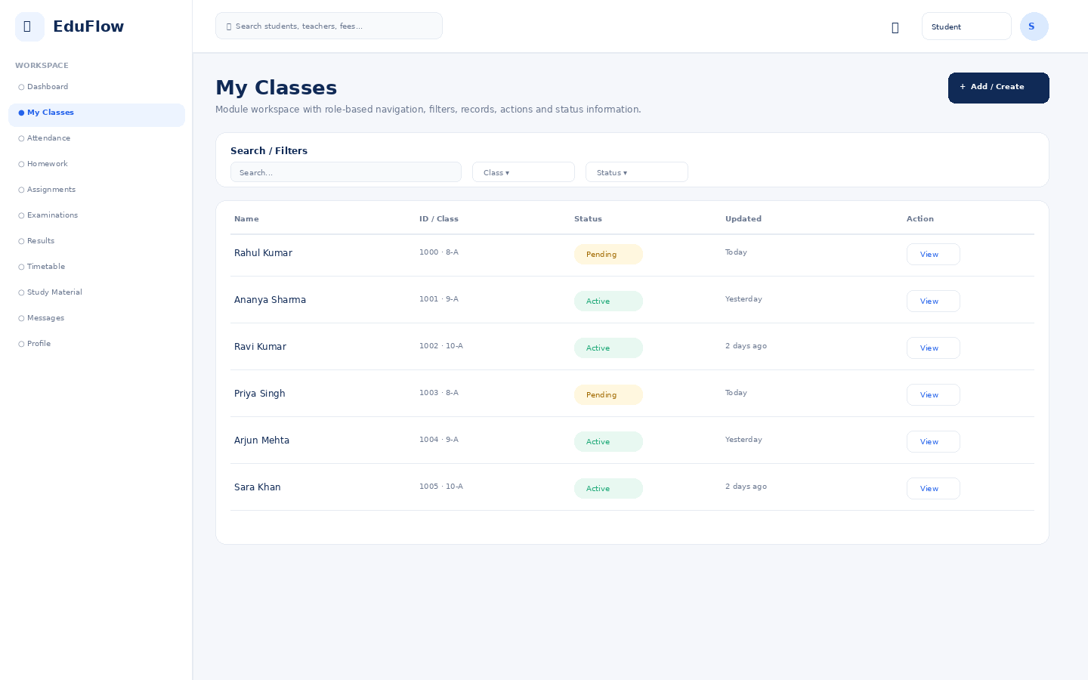
Access notes: Student sees own academic and activity records only; no administrative, financial-management or other-student data.

Attendance
Daily attendance, absence/late status, trends and correction workflows.
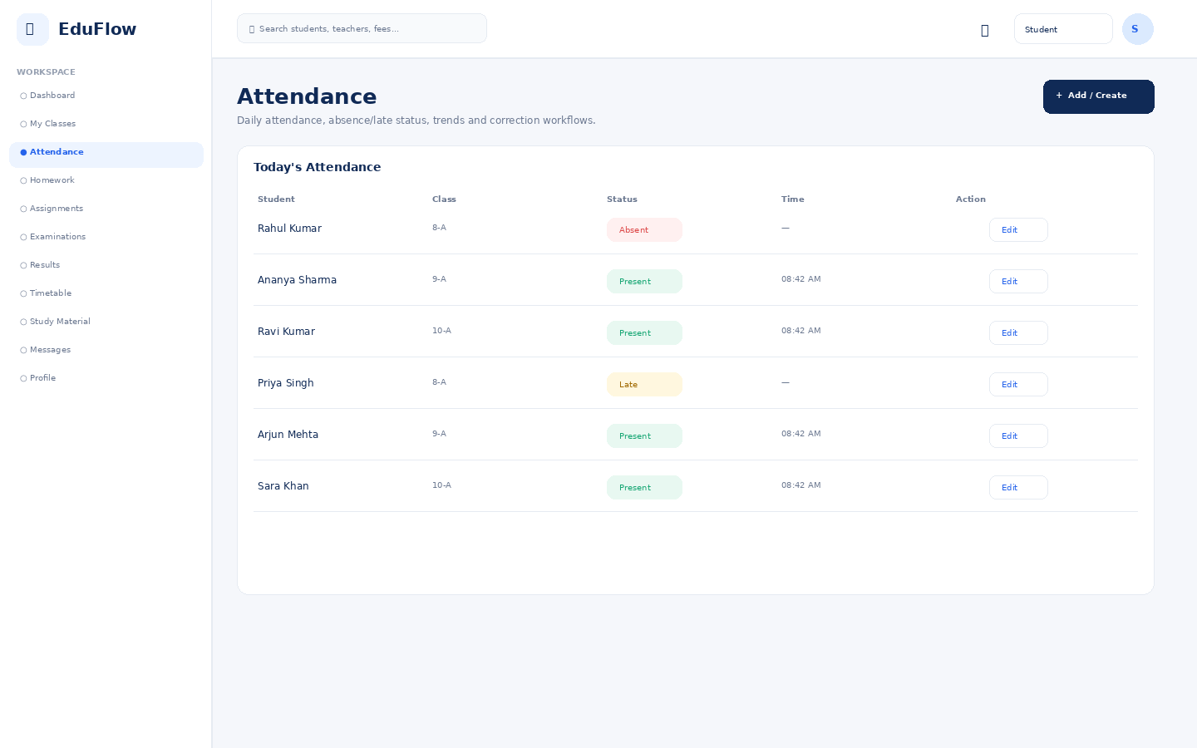
Access notes: Student sees own academic and activity records only; no administrative, financial-management or other-student data.

Homework
Create, publish, submit and review homework.
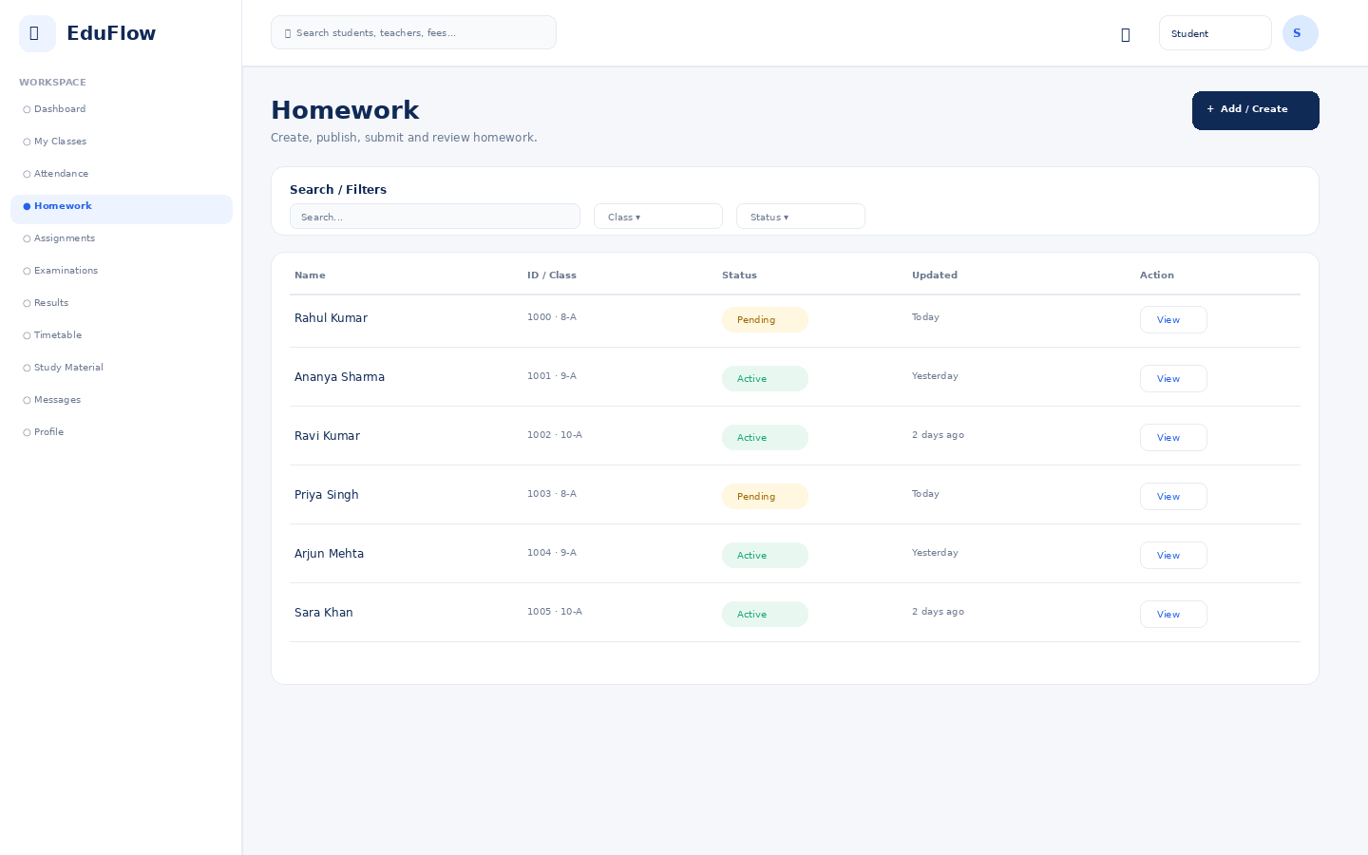
Access notes: Student sees own academic and activity records only; no administrative, financial-management or other-student data.

Assignments
Assignment workflow from creation to submission and review.
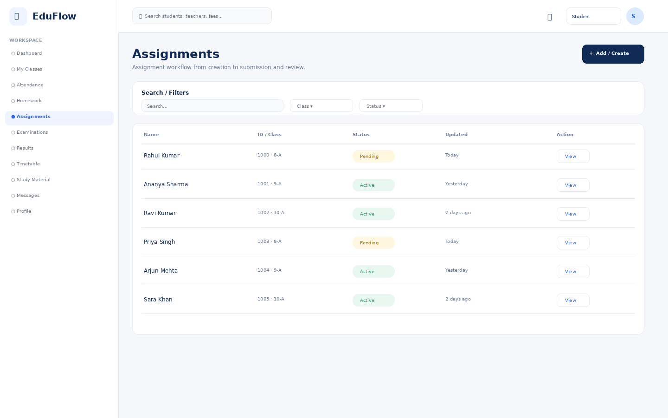
Access notes: Student sees own academic and activity records only; no administrative, financial-management or other-student data.

Examinations
Exam setup, schedules, marks entry, review and publishing workflows.
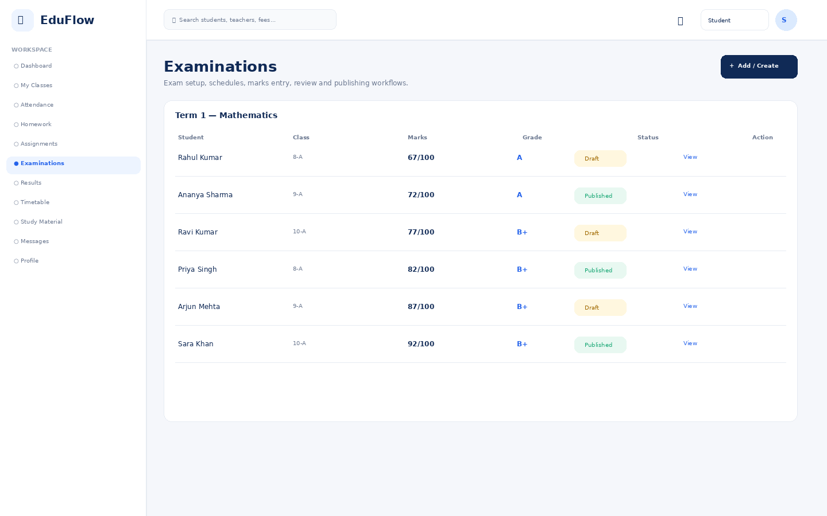
Access notes: Student sees own academic and activity records only; no administrative, financial-management or other-student data.

Results
Module workspace with role-based navigation, filters, records, actions and status information.
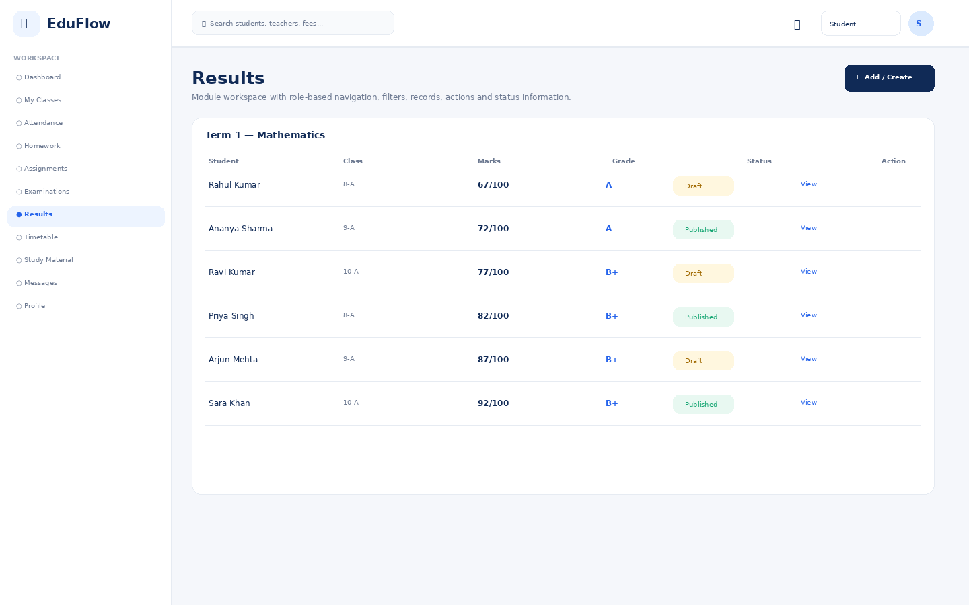
Access notes: Student sees own academic and activity records only; no administrative, financial-management or other-student data.

Timetable
Class/teacher schedule grid with day and period views.
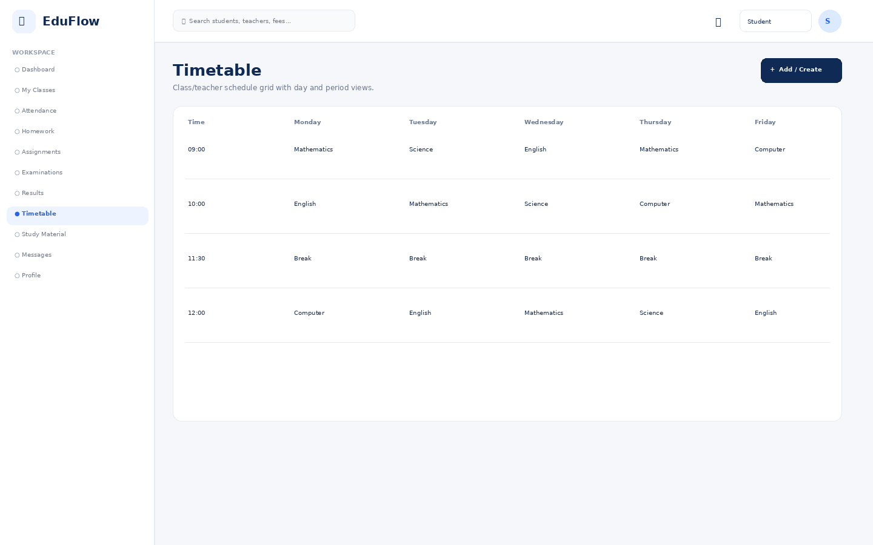
Access notes: Student sees own academic and activity records only; no administrative, financial-management or other-student data.

Study Material
Module workspace with role-based navigation, filters, records, actions and status information.
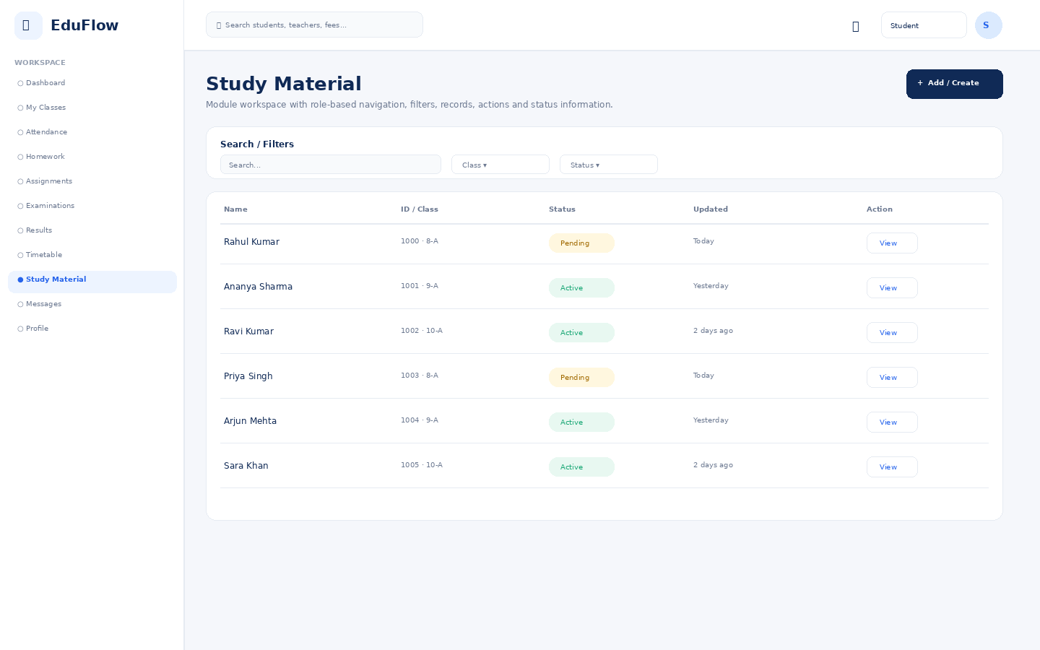
Access notes: Student sees own academic and activity records only; no administrative, financial-management or other-student data.

Messages
Secure role-aware communication between authorized school users and families.
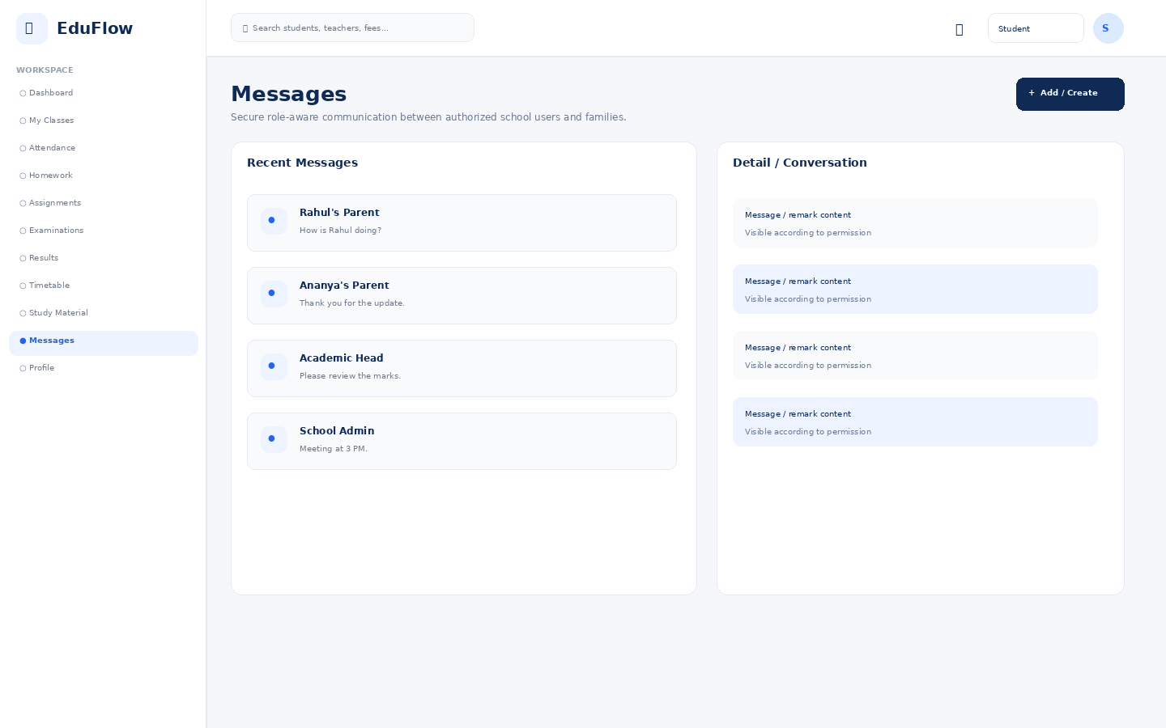
Access notes: Student sees own academic and activity records only; no administrative, financial-management or other-student data.

Profile
User identity, role, school, security and account details.
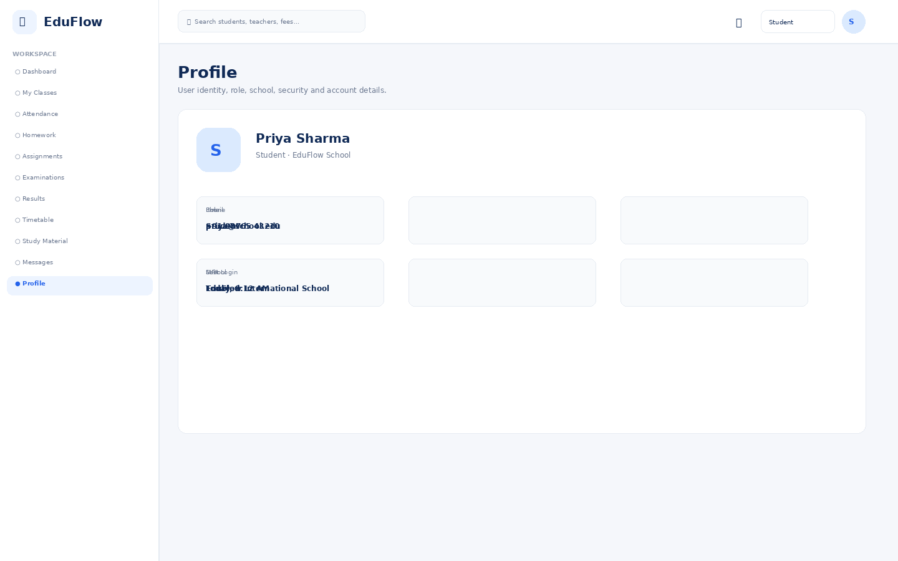
Access notes: Student sees own academic and activity records only; no administrative, financial-management or other-student data.

Accountant
8 screens in this role experience.

Dashboard
Role-specific operational overview with KPIs, alerts, charts and quick actions.
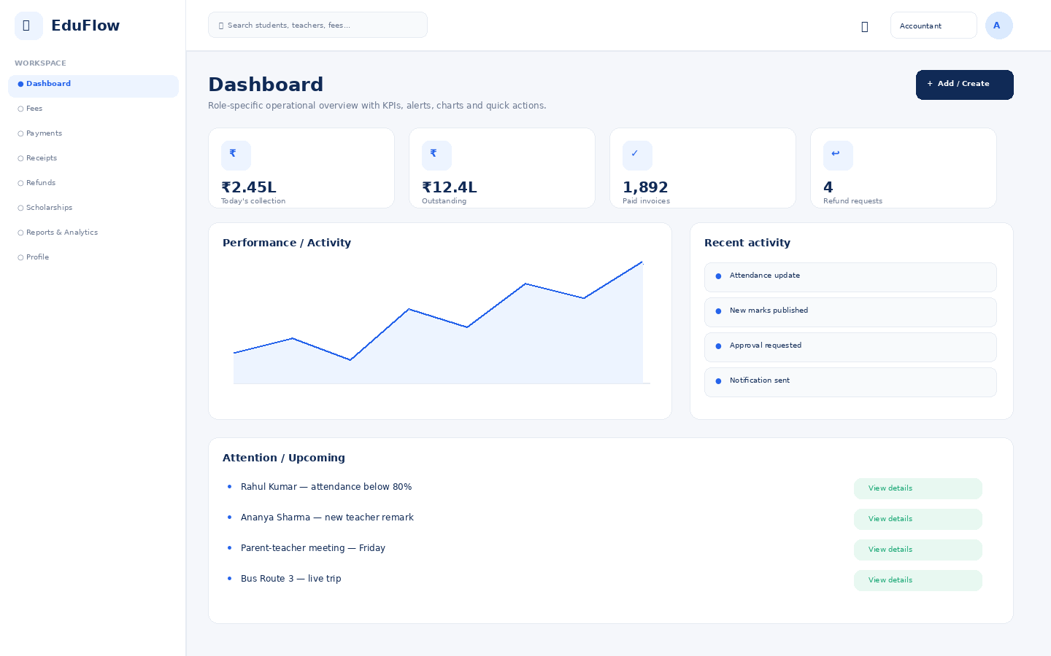
Access notes: Actual access is controlled by role, module permission, action permission and data scope.

Fees
Fee balances, invoices, collections, dues and payment history.
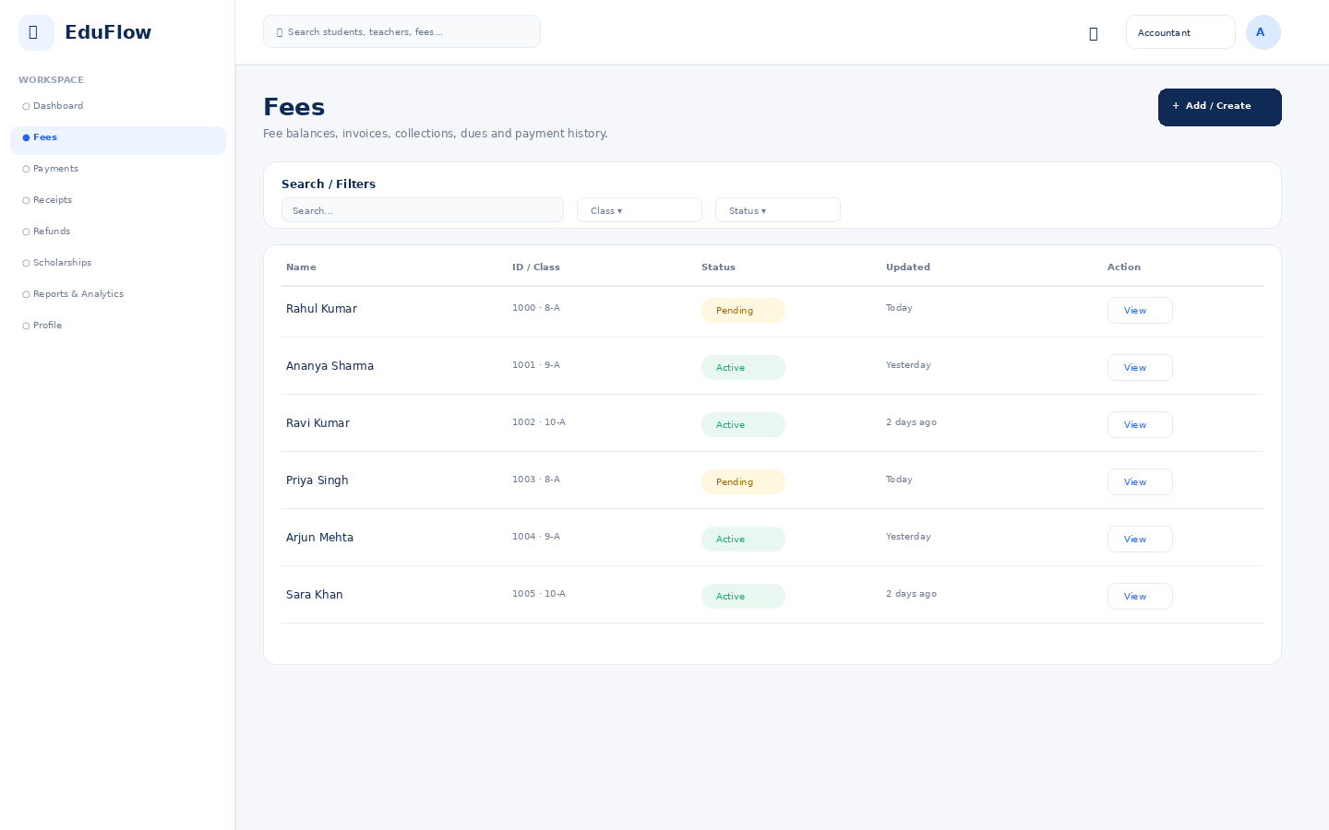
Access notes: Actual access is controlled by role, module permission, action permission and data scope.

Payments
Module workspace with role-based navigation, filters, records, actions and status information.
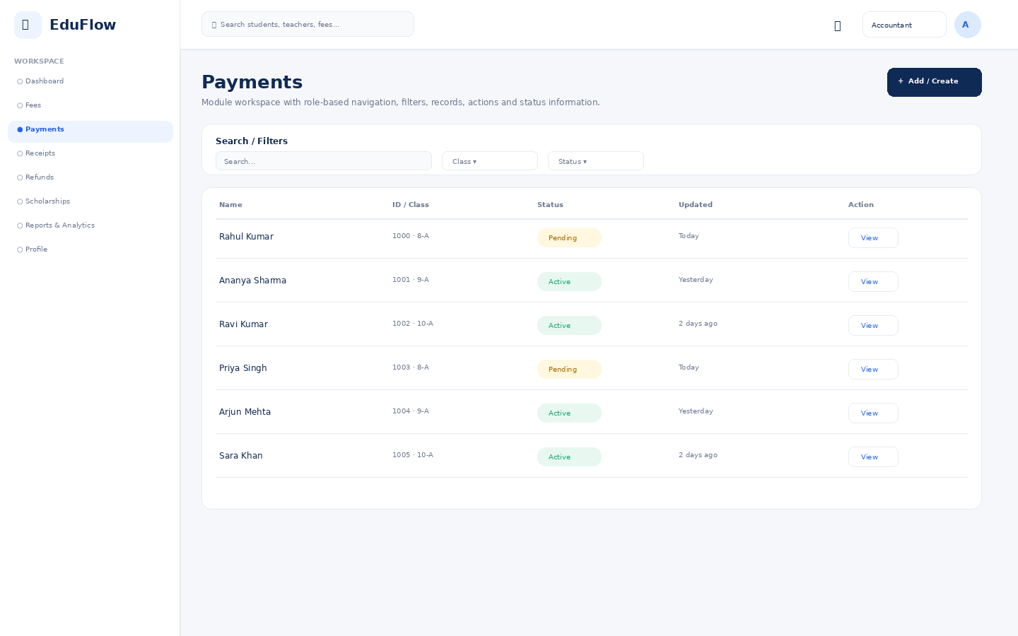
Access notes: Actual access is controlled by role, module permission, action permission and data scope.

Receipts
Module workspace with role-based navigation, filters, records, actions and status information.
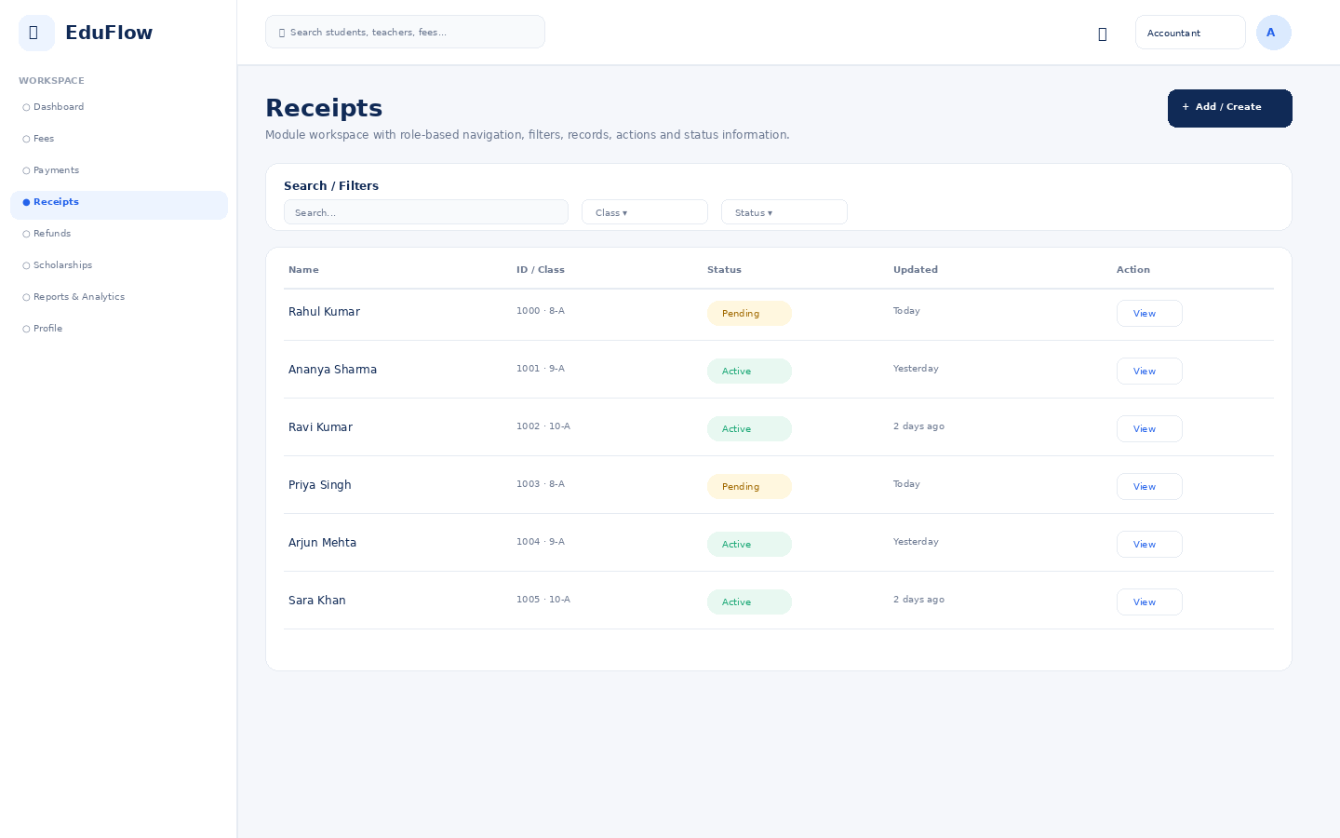
Access notes: Actual access is controlled by role, module permission, action permission and data scope.

Refunds
Module workspace with role-based navigation, filters, records, actions and status information.
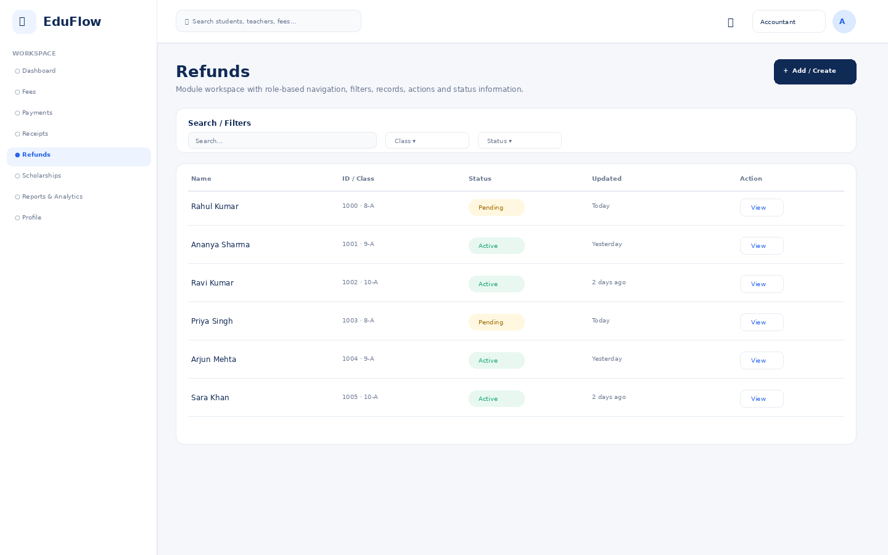
Access notes: Actual access is controlled by role, module permission, action permission and data scope.

Scholarships
Module workspace with role-based navigation, filters, records, actions and status information.
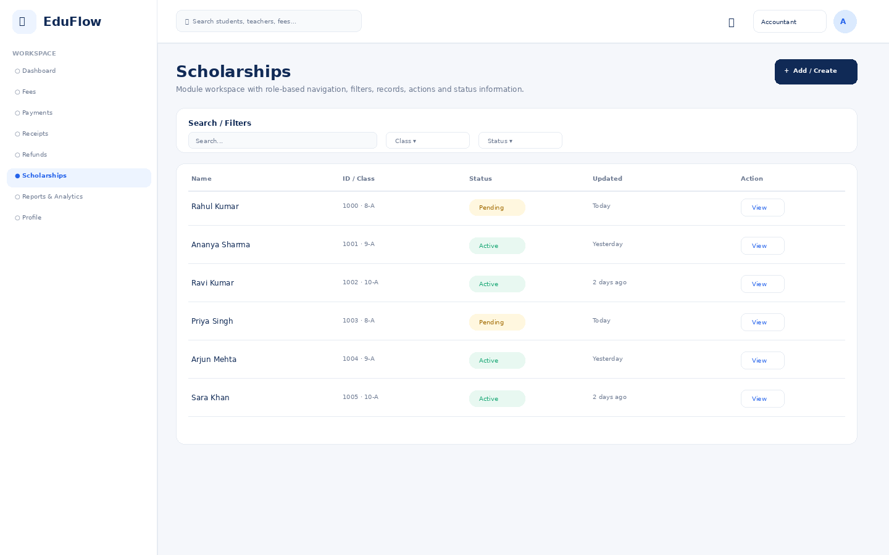
Access notes: Actual access is controlled by role, module permission, action permission and data scope.

Reports & Analytics
Filterable school reports with export-oriented presentation.
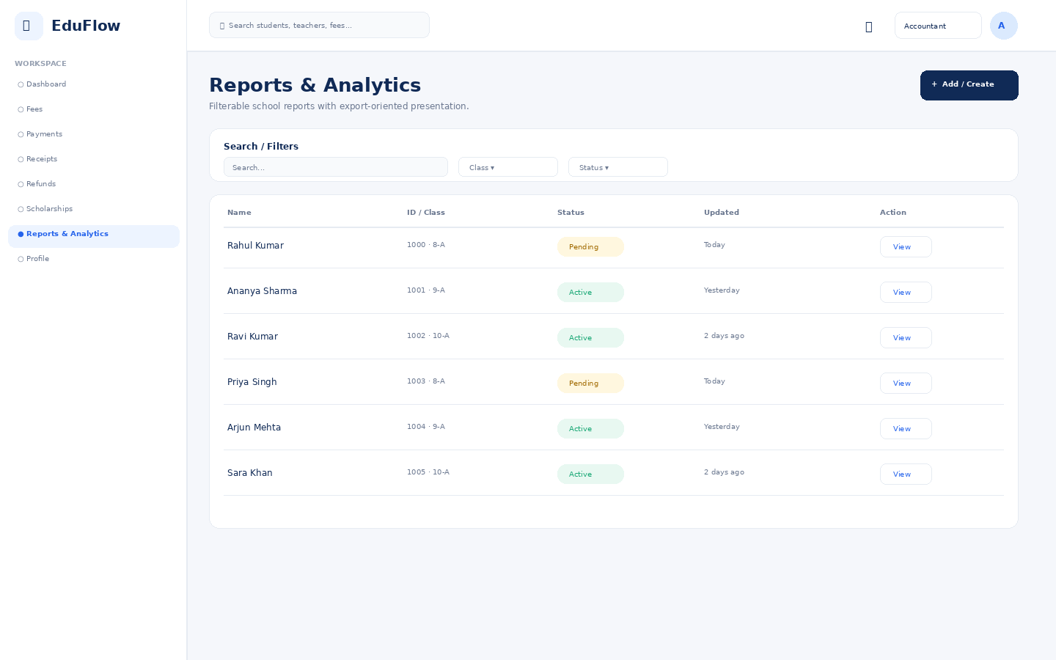
Access notes: Actual access is controlled by role, module permission, action permission and data scope.

Profile
User identity, role, school, security and account details.
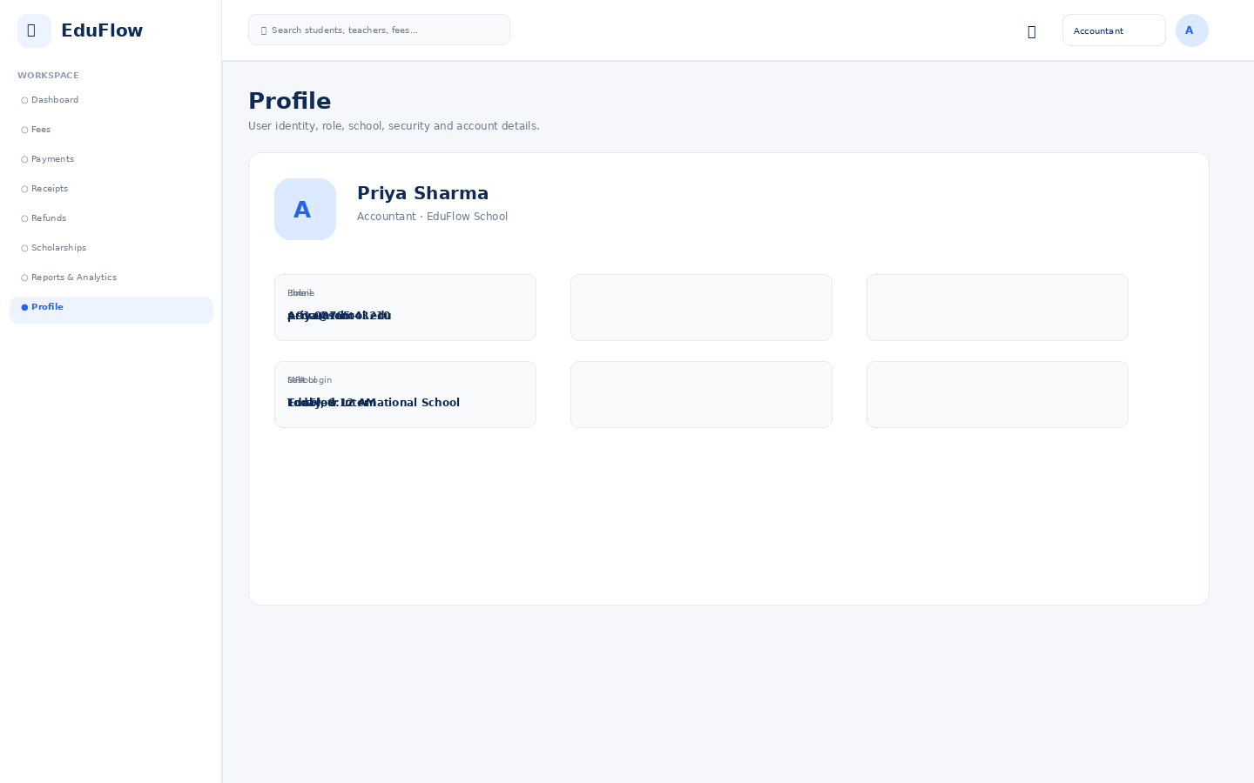
Access notes: Actual access is controlled by role, module permission, action permission and data scope.

HR Manager
9 screens in this role experience.

Dashboard
Role-specific operational overview with KPIs, alerts, charts and quick actions.
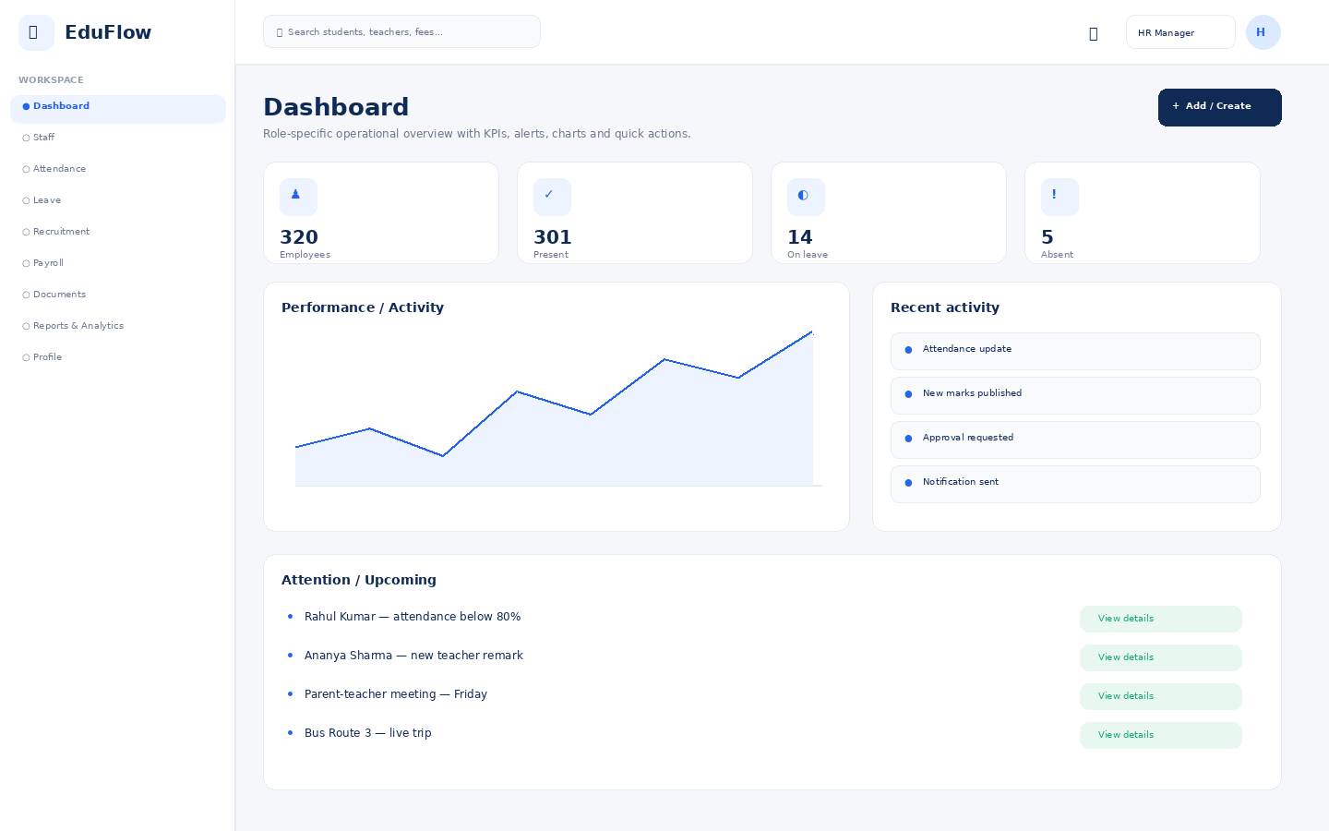
Access notes: Actual access is controlled by role, module permission, action permission and data scope.

Staff
Module workspace with role-based navigation, filters, records, actions and status information.
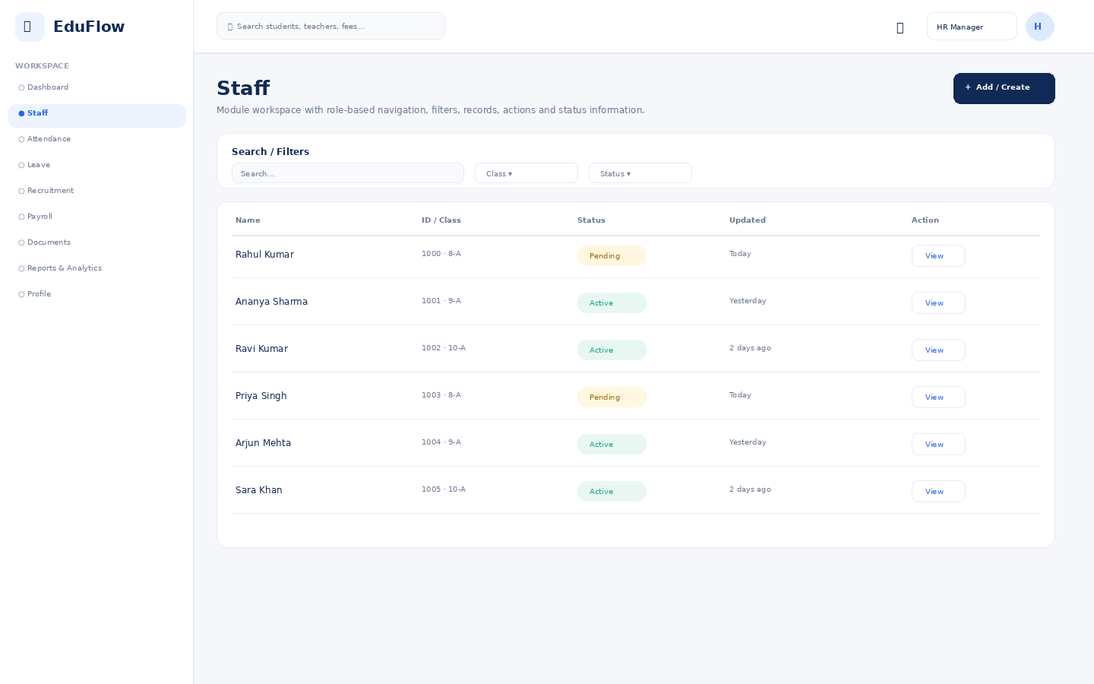
Access notes: Actual access is controlled by role, module permission, action permission and data scope.

Attendance
Daily attendance, absence/late status, trends and correction workflows.
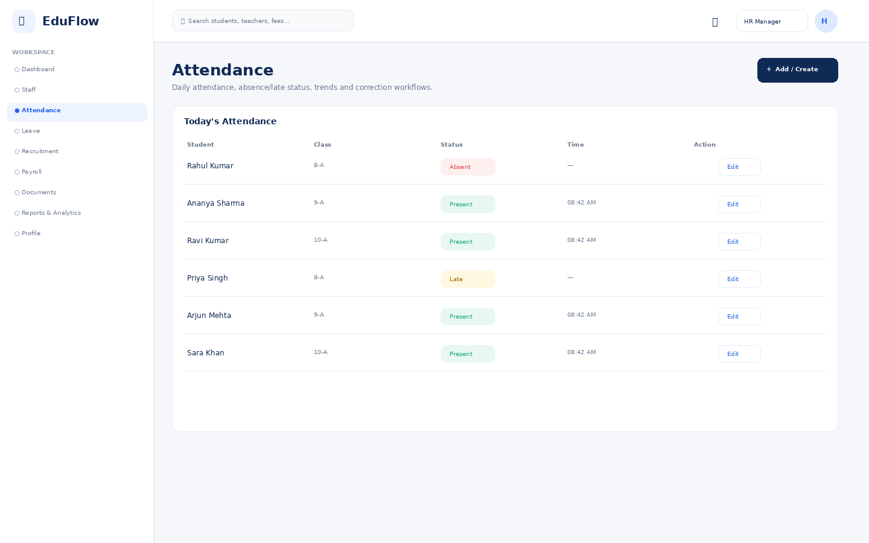
Access notes: Actual access is controlled by role, module permission, action permission and data scope.

Leave
Module workspace with role-based navigation, filters, records, actions and status information.
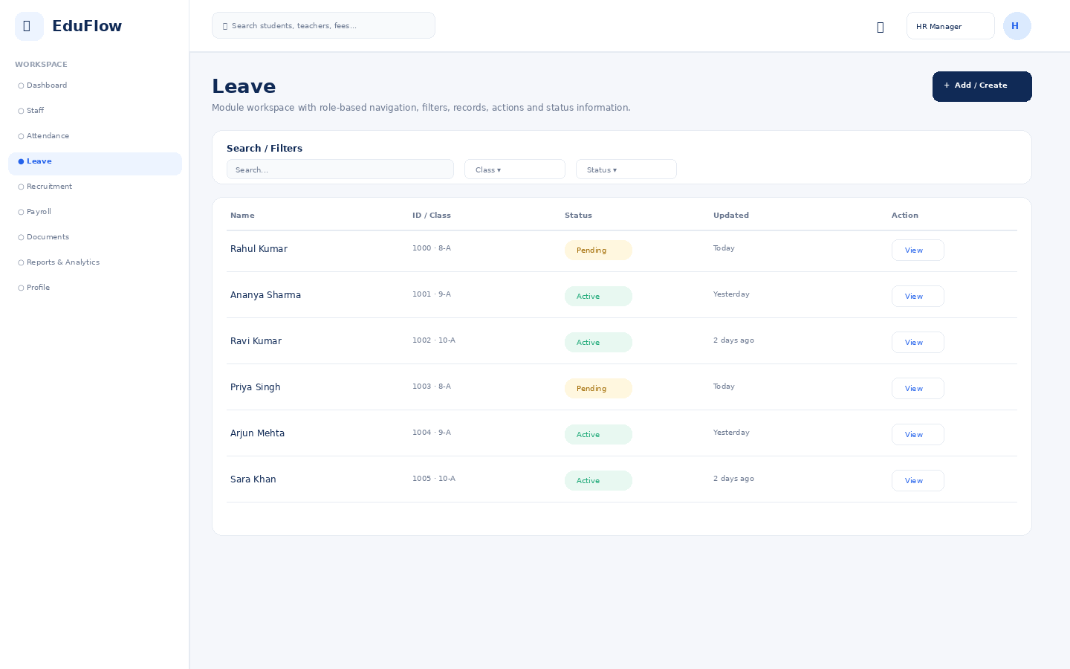
Access notes: Actual access is controlled by role, module permission, action permission and data scope.

Recruitment
Module workspace with role-based navigation, filters, records, actions and status information.
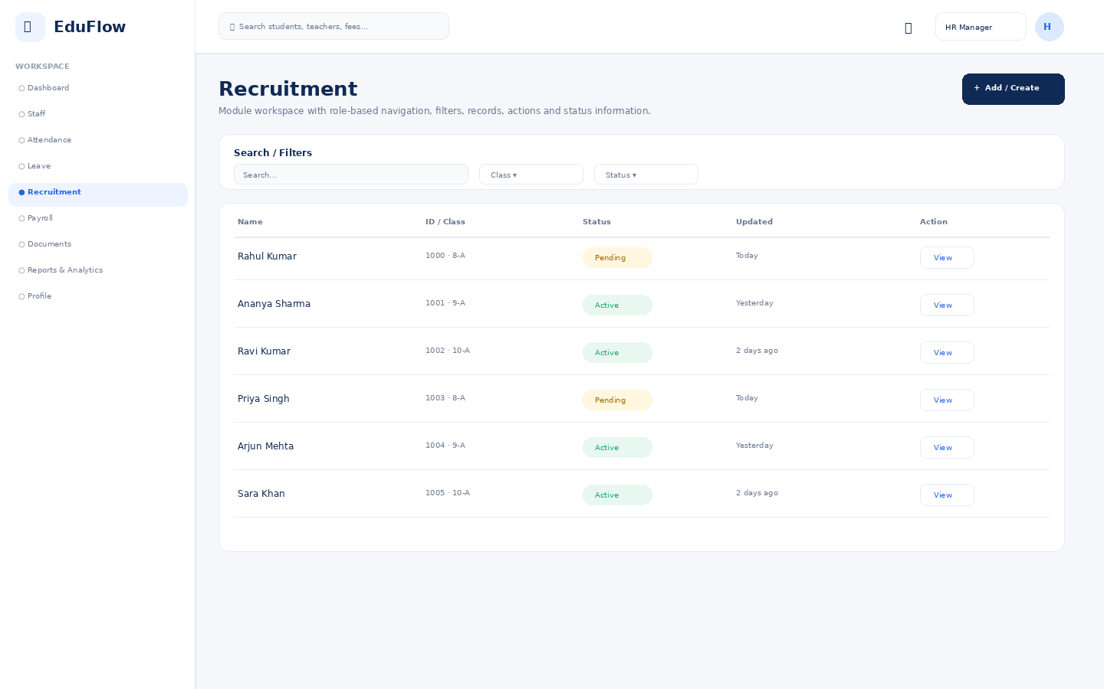
Access notes: Actual access is controlled by role, module permission, action permission and data scope.

Payroll
Module workspace with role-based navigation, filters, records, actions and status information.
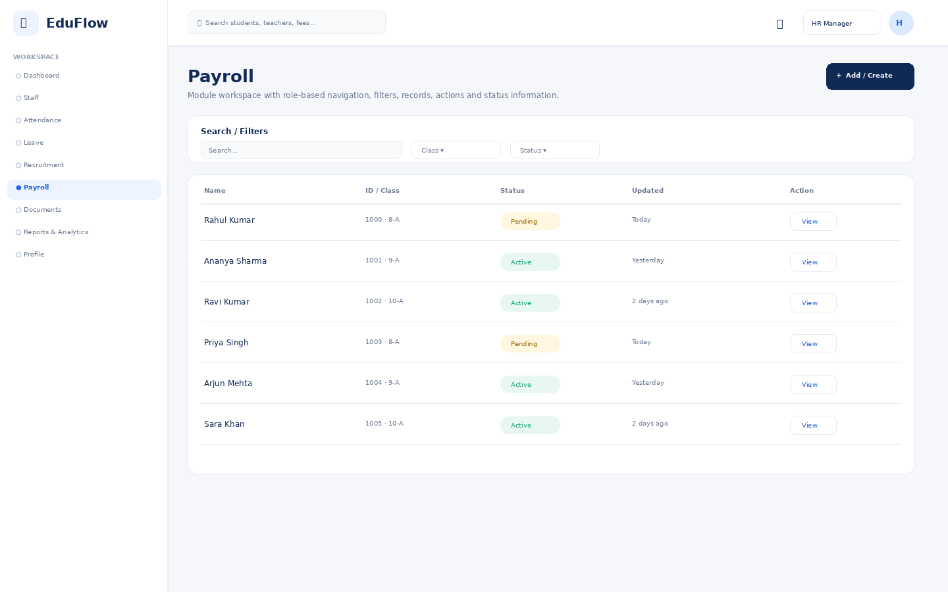
Access notes: Actual access is controlled by role, module permission, action permission and data scope.

Documents
Permission-controlled document repository with view/download/upload actions.
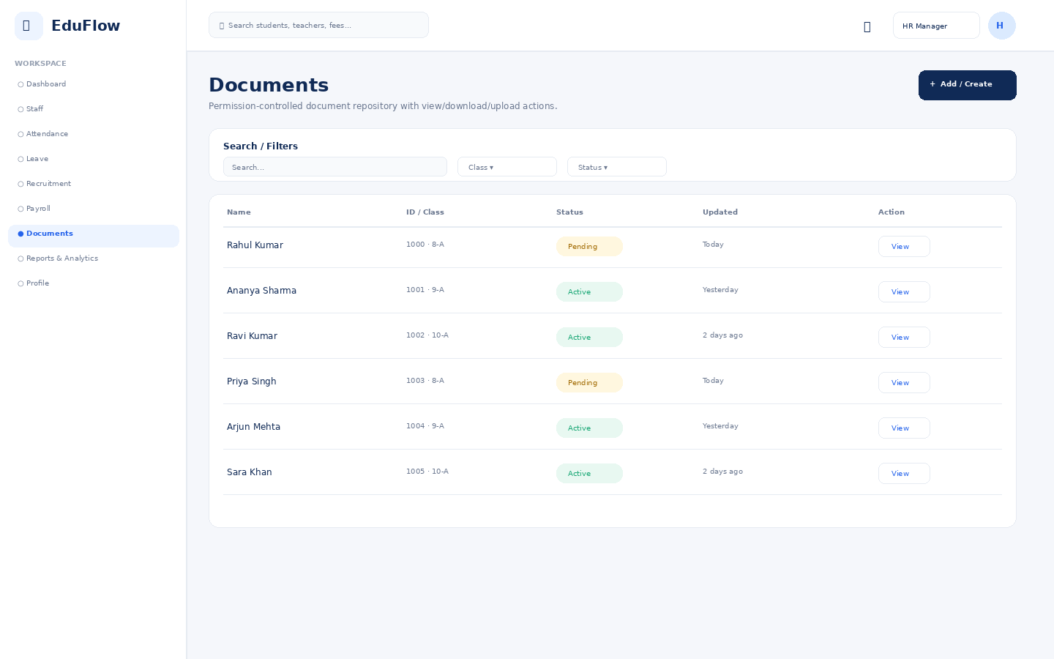
Access notes: Actual access is controlled by role, module permission, action permission and data scope.

Reports & Analytics
Filterable school reports with export-oriented presentation.
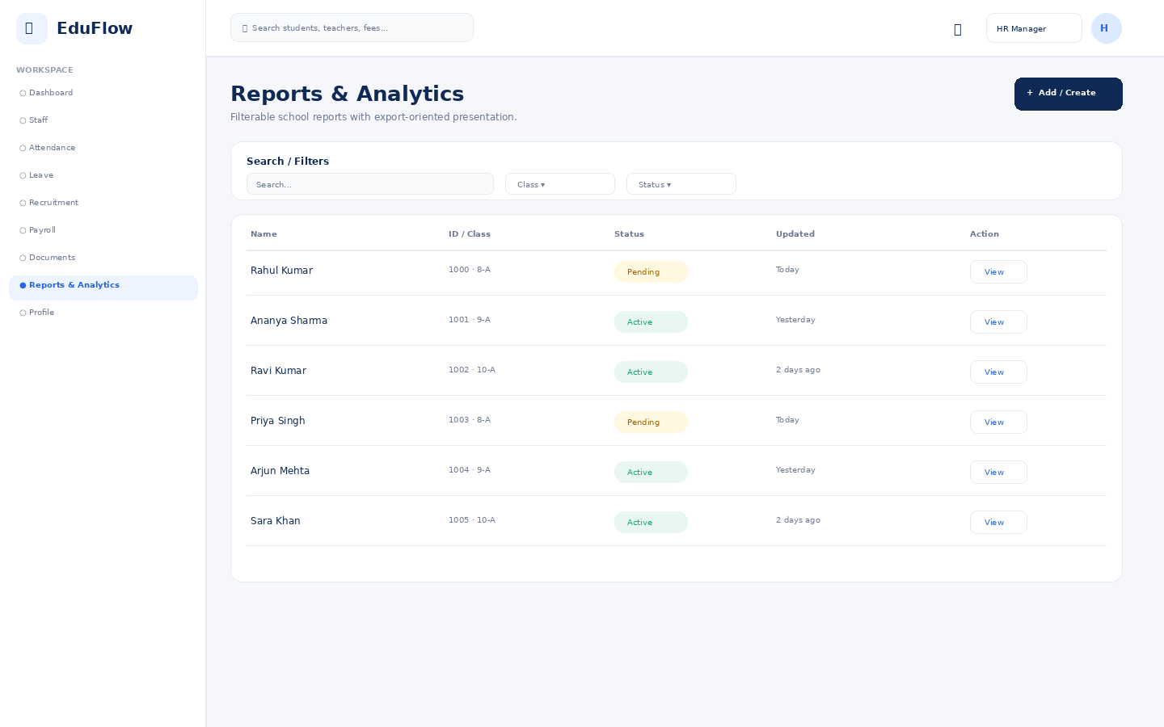
Access notes: Actual access is controlled by role, module permission, action permission and data scope.

Profile
User identity, role, school, security and account details.
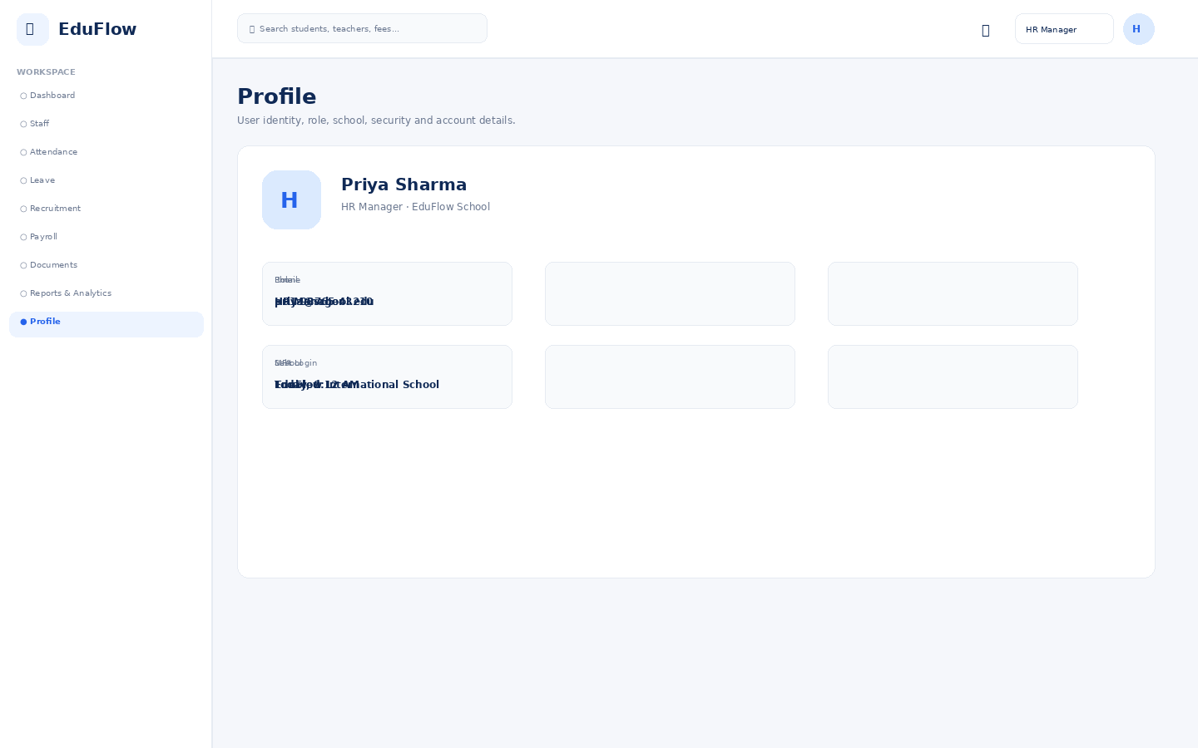
Access notes: Actual access is controlled by role, module permission, action permission and data scope.

Librarian
7 screens in this role experience.

Dashboard
Role-specific operational overview with KPIs, alerts, charts and quick actions.
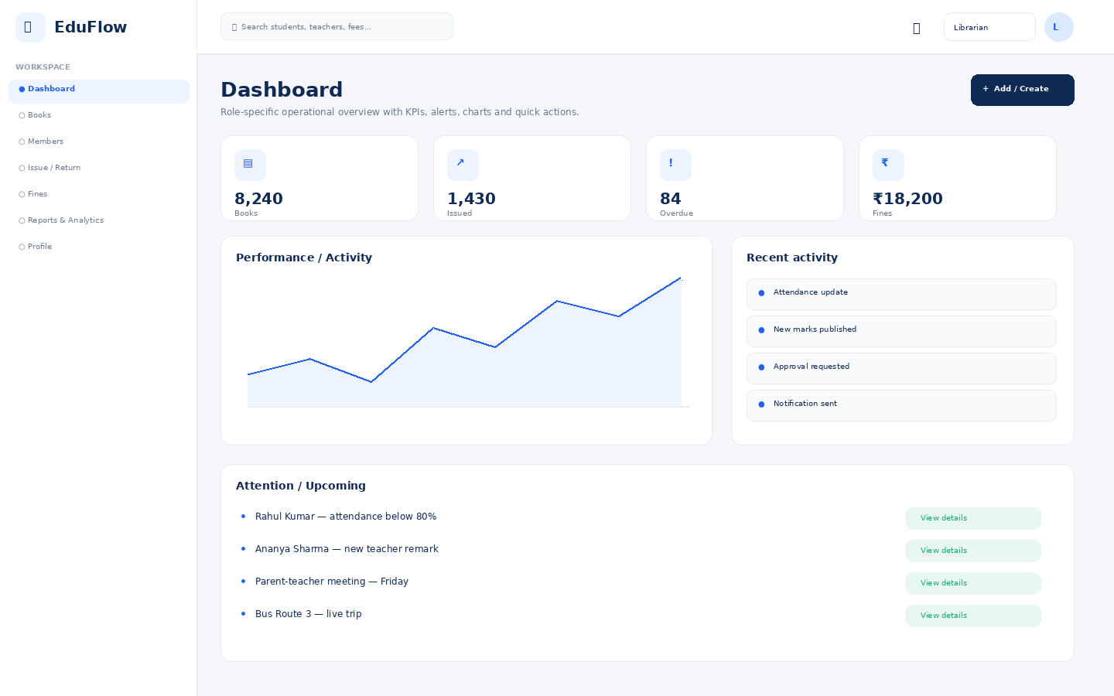
Access notes: Actual access is controlled by role, module permission, action permission and data scope.

Books
Module workspace with role-based navigation, filters, records, actions and status information.
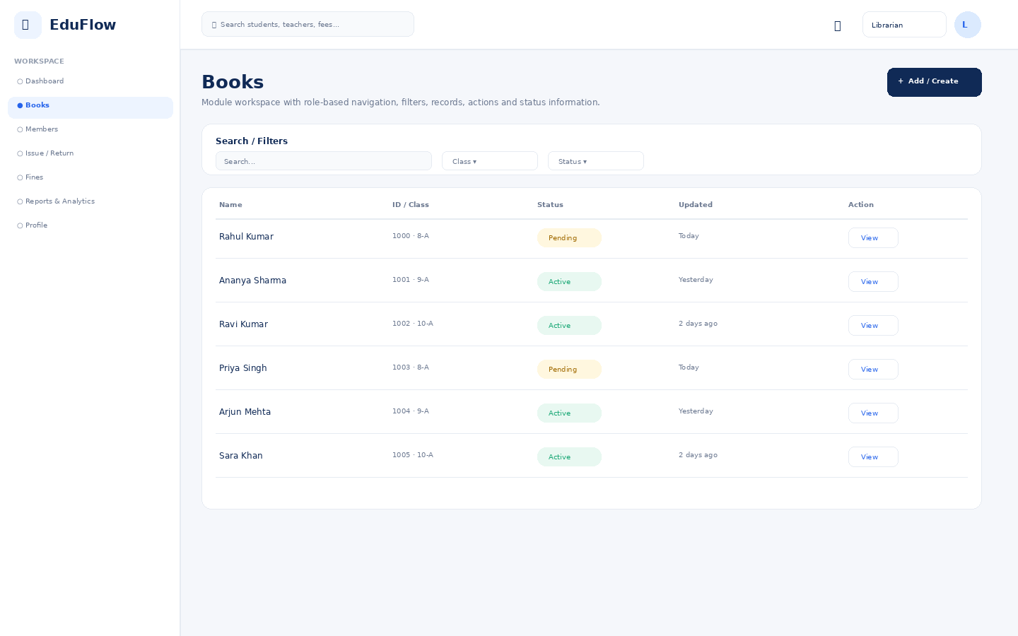
Access notes: Actual access is controlled by role, module permission, action permission and data scope.

Members
Module workspace with role-based navigation, filters, records, actions and status information.
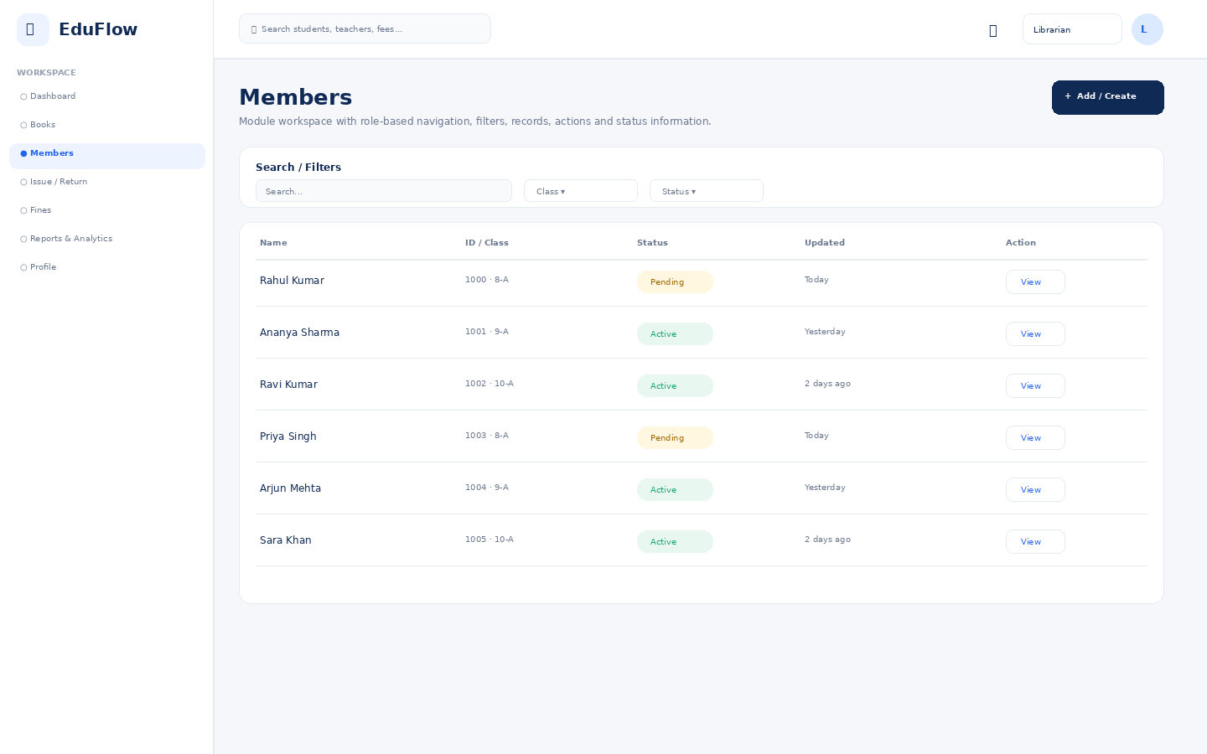
Access notes: Actual access is controlled by role, module permission, action permission and data scope.

Issue / Return
Module workspace with role-based navigation, filters, records, actions and status information.
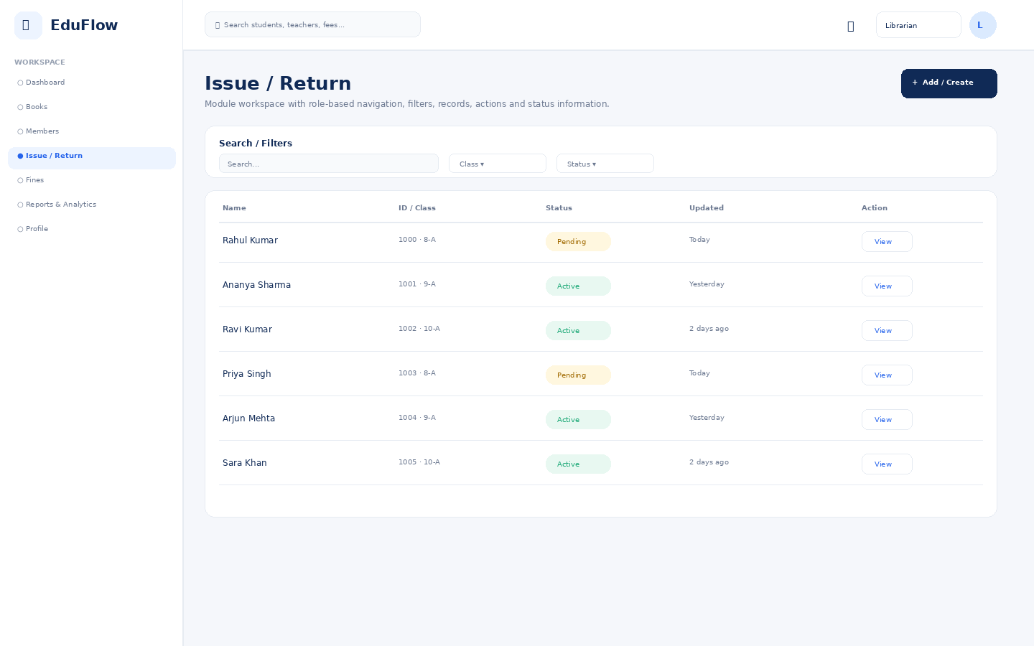
Access notes: Actual access is controlled by role, module permission, action permission and data scope.

Fines
Module workspace with role-based navigation, filters, records, actions and status information.
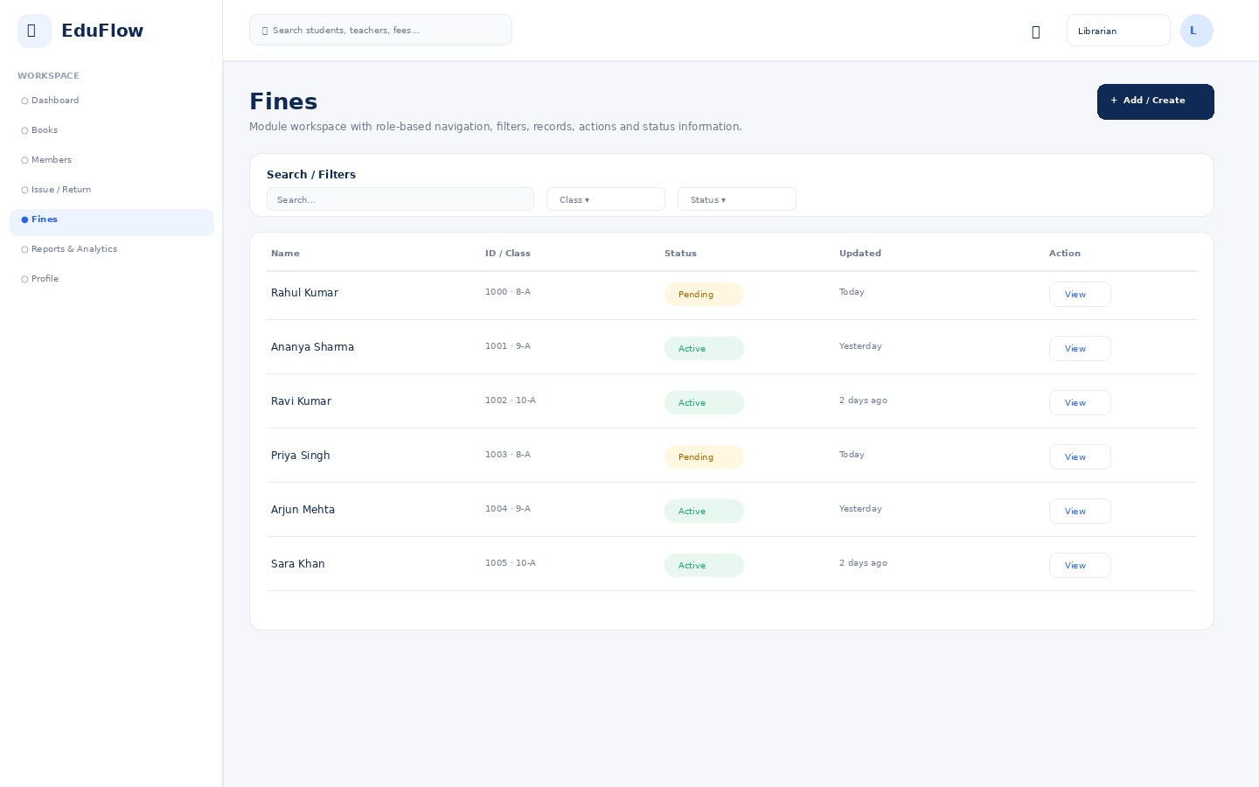
Access notes: Actual access is controlled by role, module permission, action permission and data scope.

Reports & Analytics
Filterable school reports with export-oriented presentation.
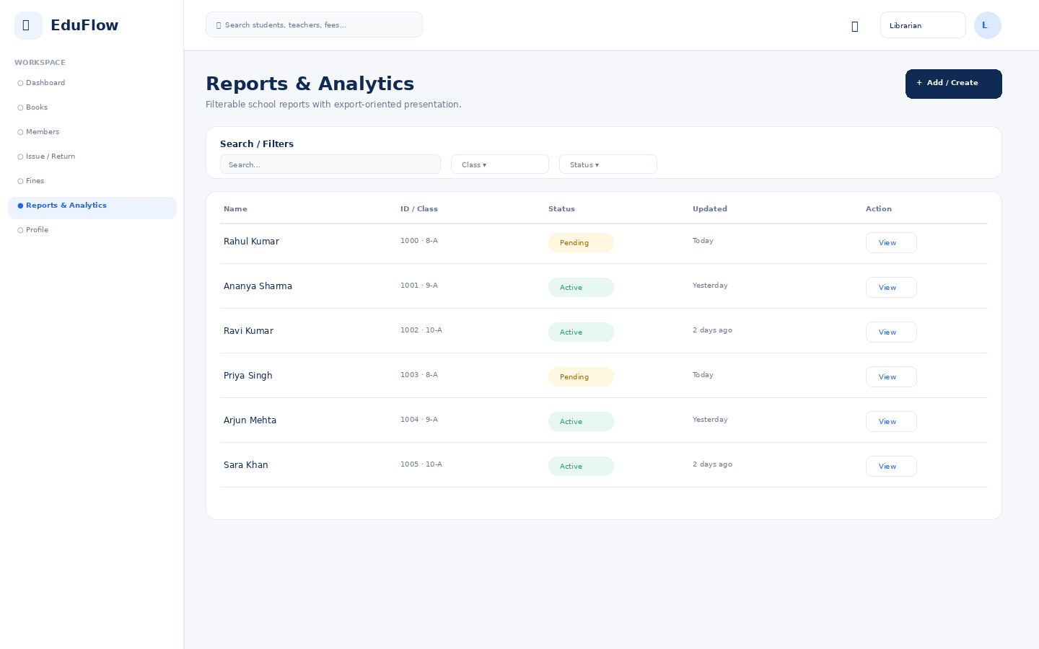
Access notes: Actual access is controlled by role, module permission, action permission and data scope.

Profile
User identity, role, school, security and account details.
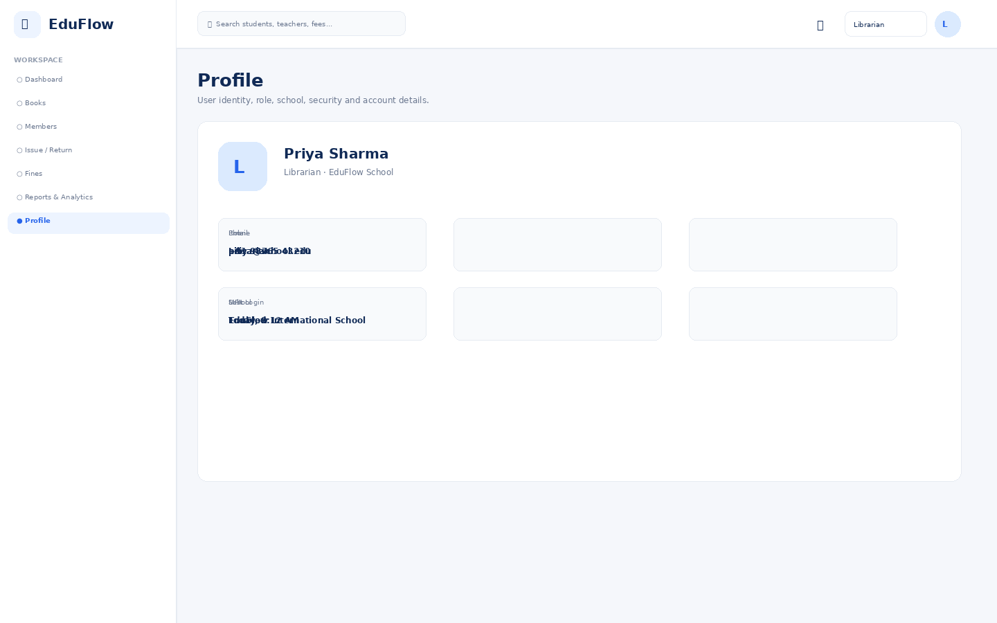
Access notes: Actual access is controlled by role, module permission, action permission and data scope.

Transport Manager
10 screens in this role experience.

Dashboard
Role-specific operational overview with KPIs, alerts, charts and quick actions.
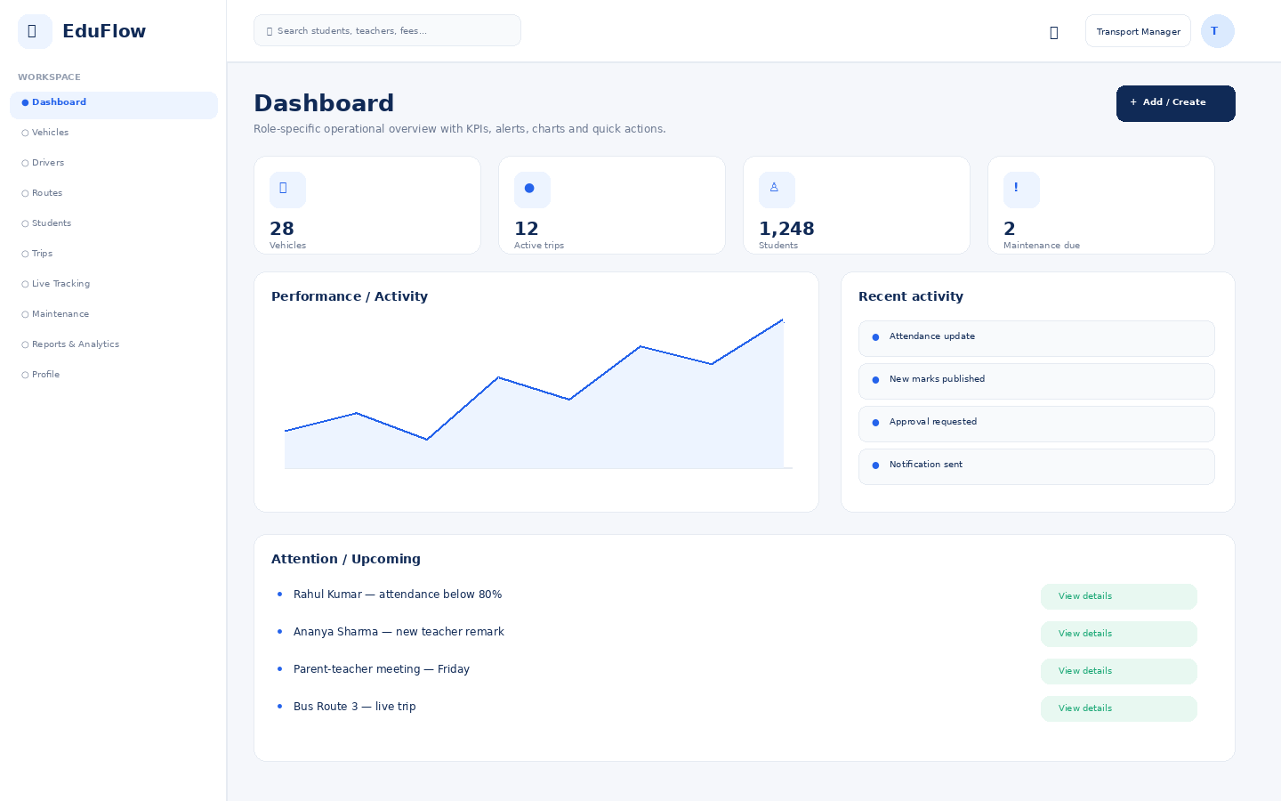
Access notes: Actual access is controlled by role, module permission, action permission and data scope.

Vehicles
Module workspace with role-based navigation, filters, records, actions and status information.
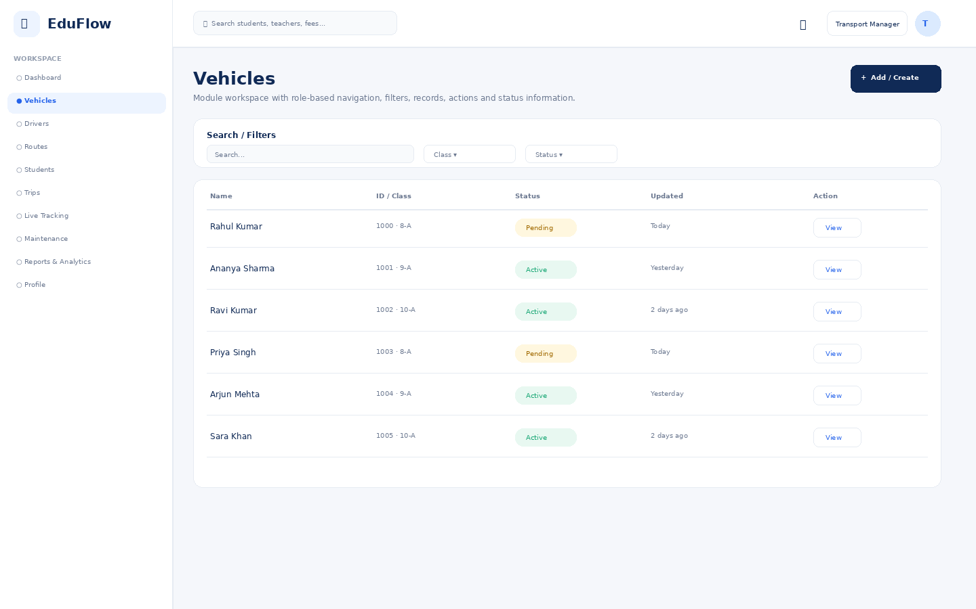
Access notes: Actual access is controlled by role, module permission, action permission and data scope.

Drivers
Module workspace with role-based navigation, filters, records, actions and status information.
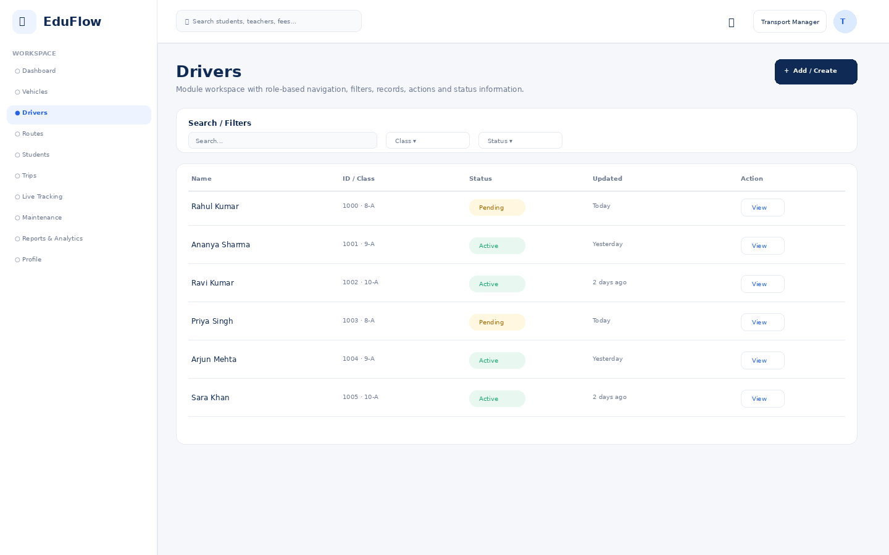
Access notes: Actual access is controlled by role, module permission, action permission and data scope.

Routes
Module workspace with role-based navigation, filters, records, actions and status information.
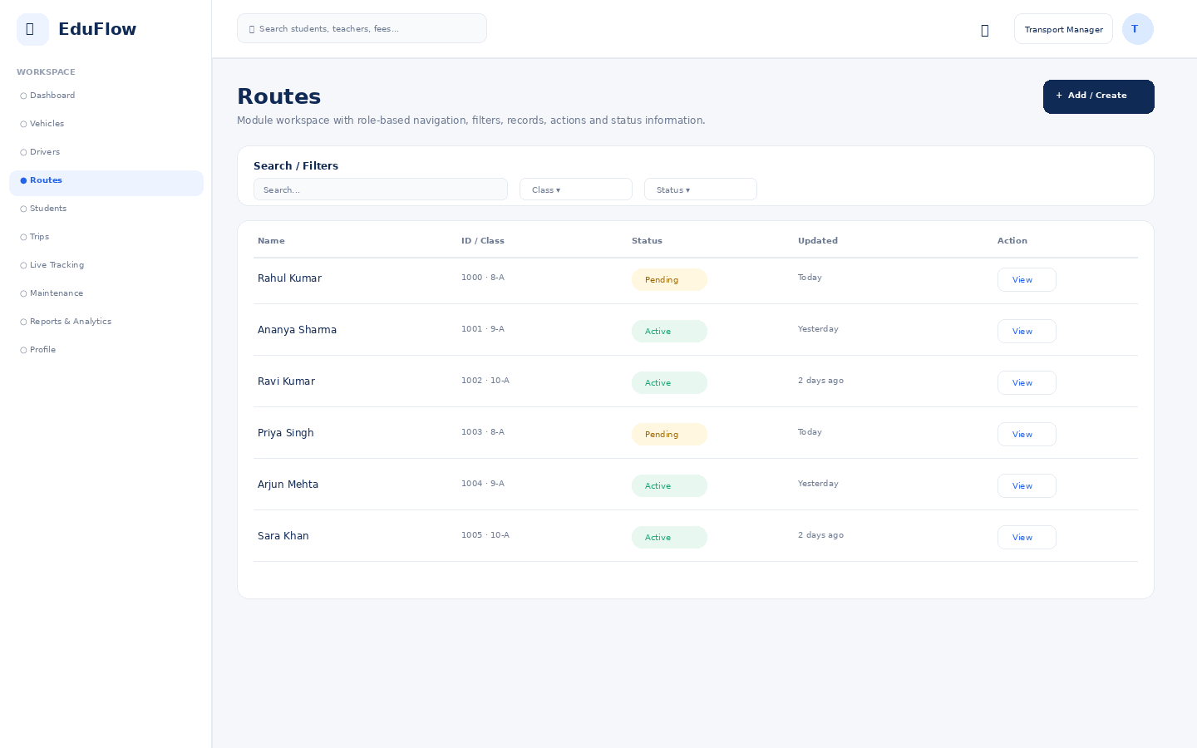
Access notes: Actual access is controlled by role, module permission, action permission and data scope.

Students
Student directory with search, filters, attendance, status and profile access.
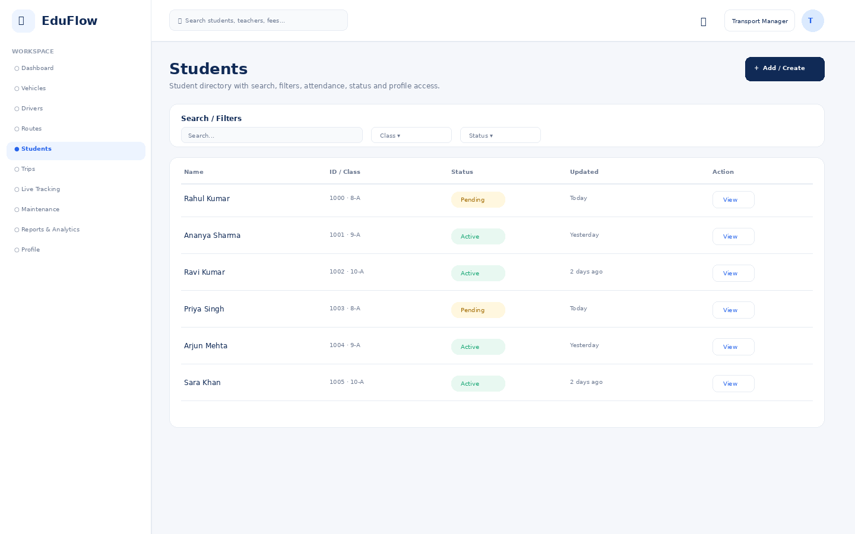
Access notes: Actual access is controlled by role, module permission, action permission and data scope.

Trips
Module workspace with role-based navigation, filters, records, actions and status information.
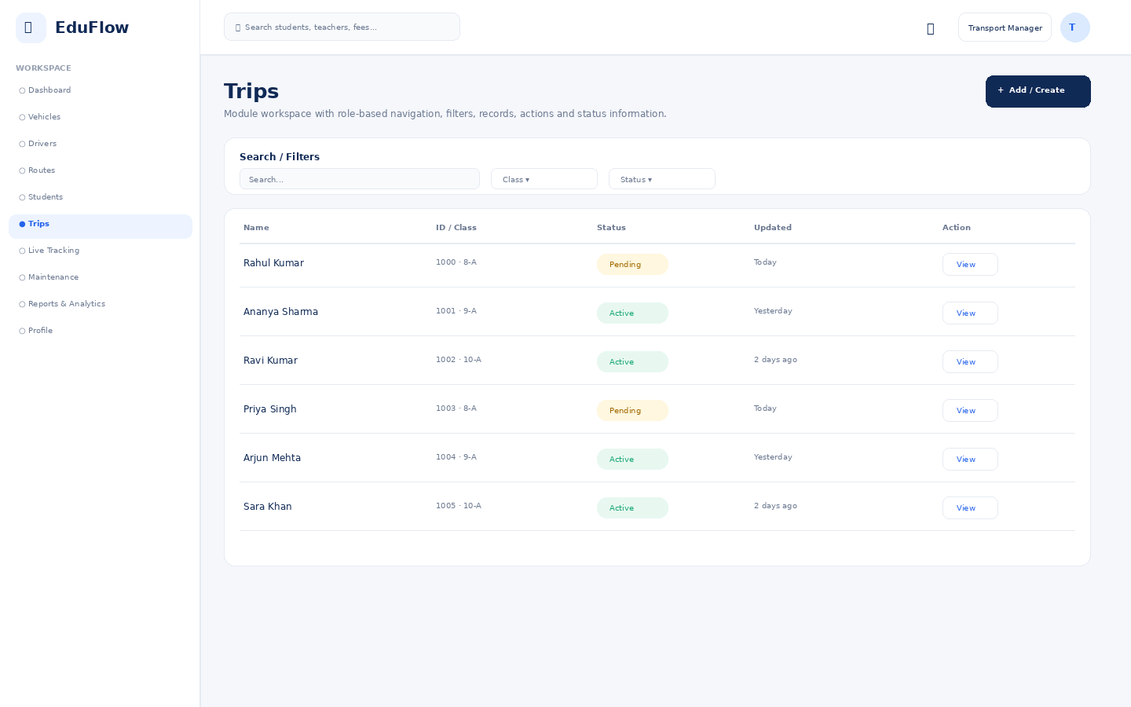
Access notes: Actual access is controlled by role, module permission, action permission and data scope.

Live Tracking
Module workspace with role-based navigation, filters, records, actions and status information.
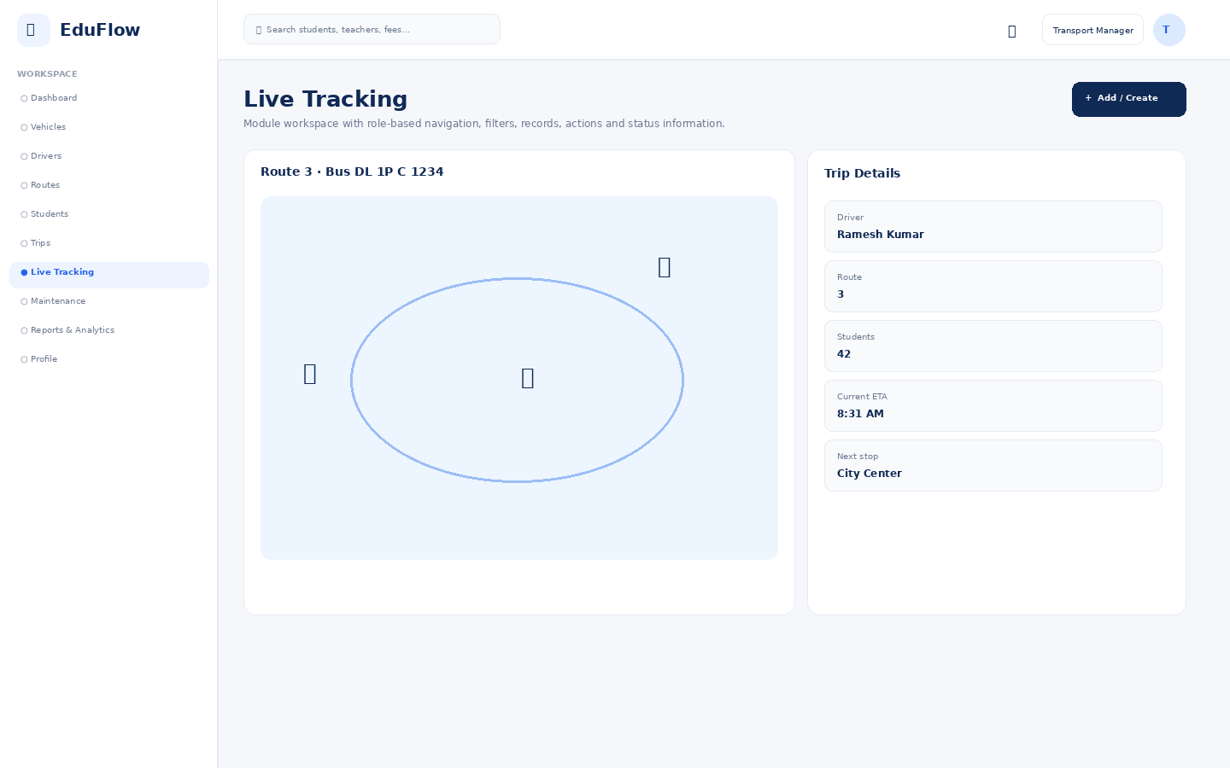
Access notes: Actual access is controlled by role, module permission, action permission and data scope.

Maintenance
Module workspace with role-based navigation, filters, records, actions and status information.
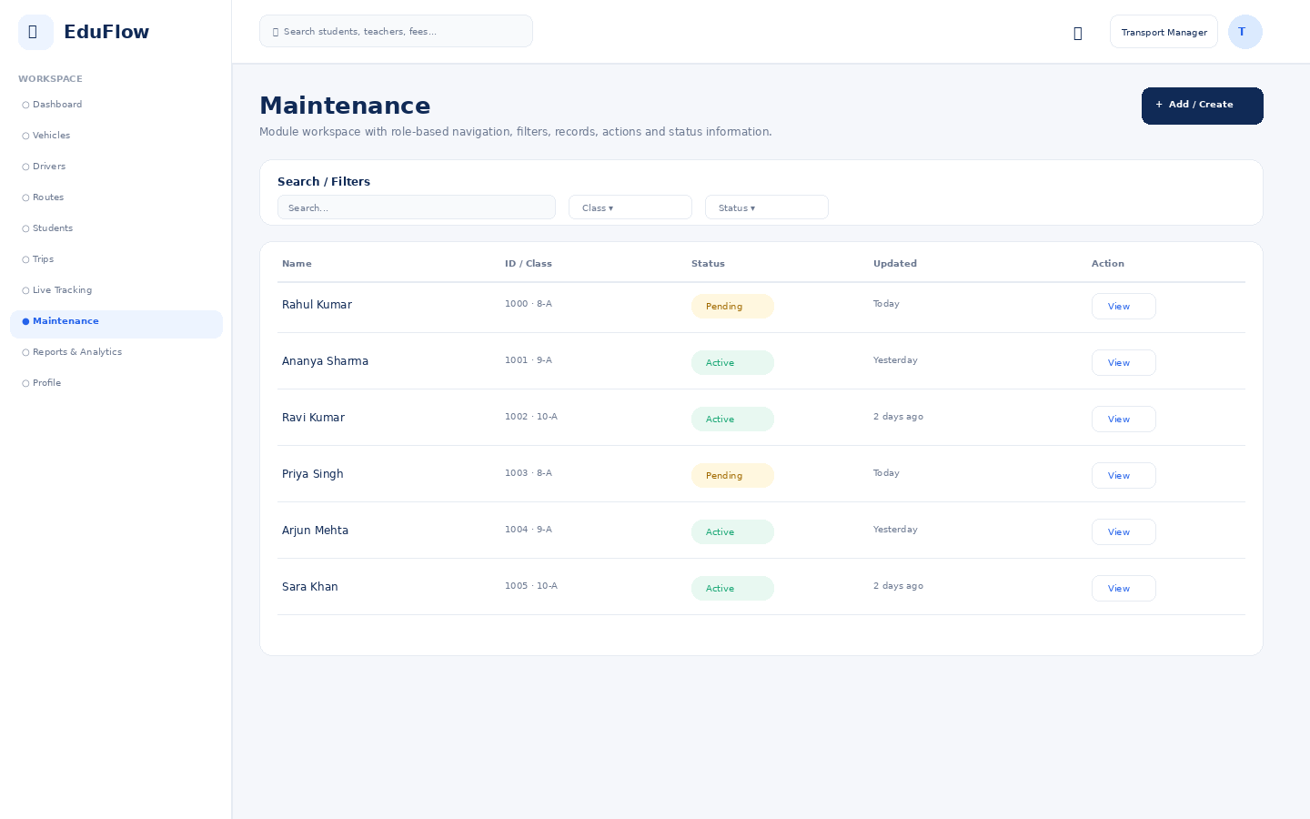
Access notes: Actual access is controlled by role, module permission, action permission and data scope.

Reports & Analytics
Filterable school reports with export-oriented presentation.
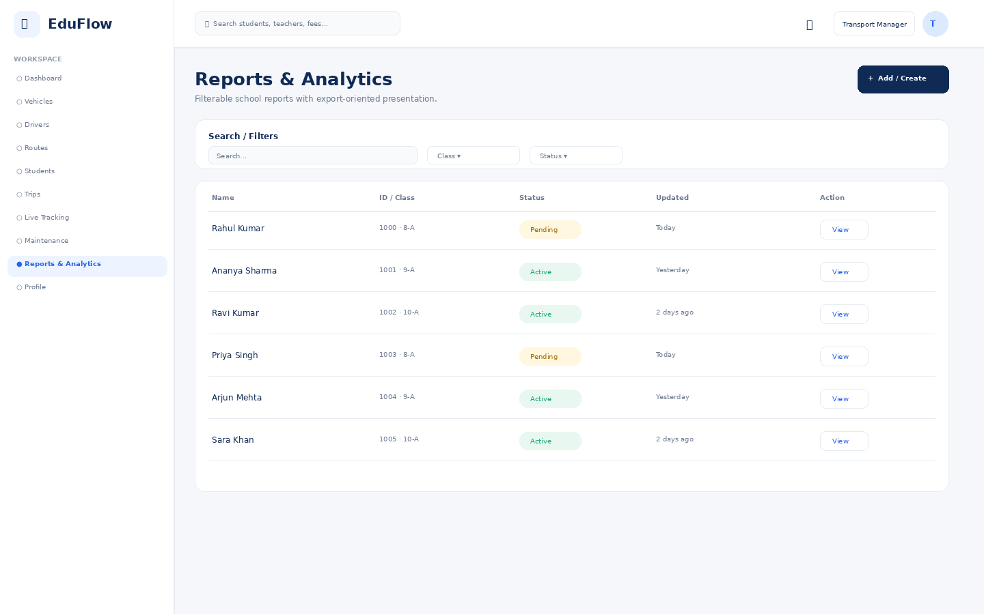
Access notes: Actual access is controlled by role, module permission, action permission and data scope.

Profile
User identity, role, school, security and account details.
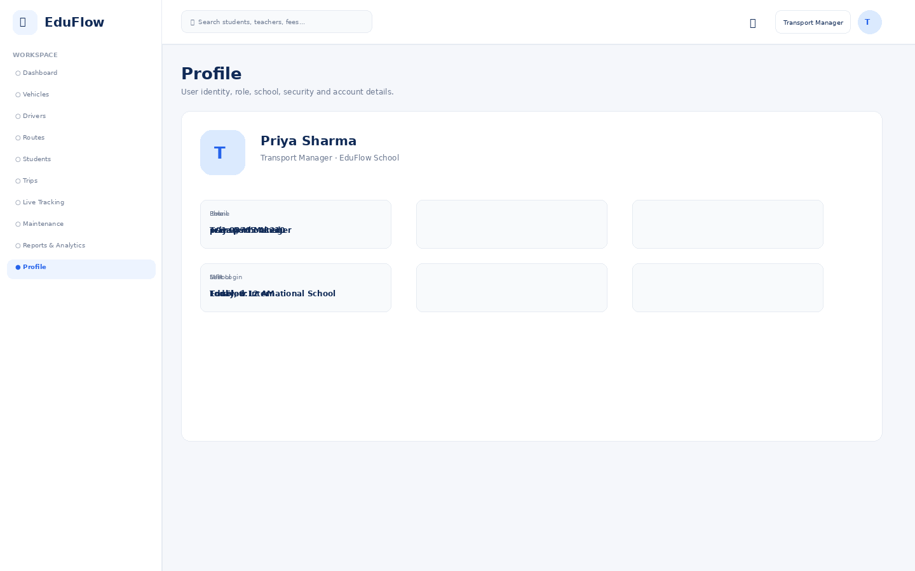
Access notes: Actual access is controlled by role, module permission, action permission and data scope.

Hostel Manager
11 screens in this role experience.

Dashboard
Role-specific operational overview with KPIs, alerts, charts and quick actions.
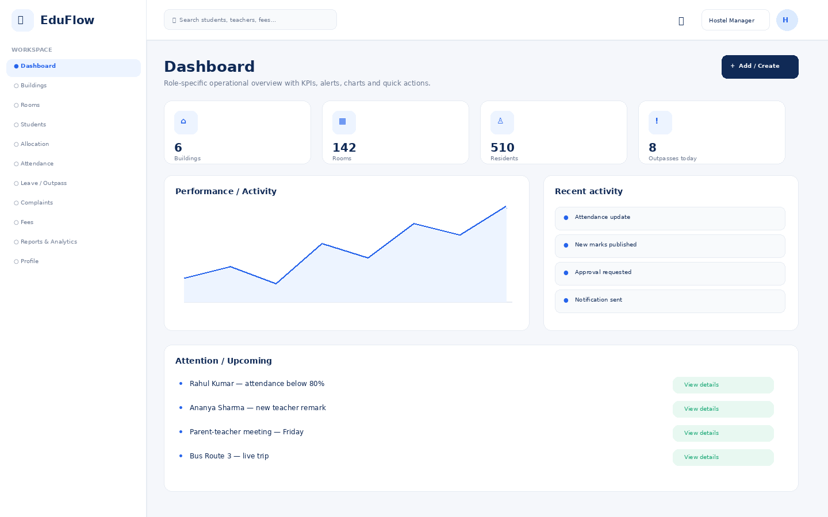
Access notes: Actual access is controlled by role, module permission, action permission and data scope.

Buildings
Module workspace with role-based navigation, filters, records, actions and status information.
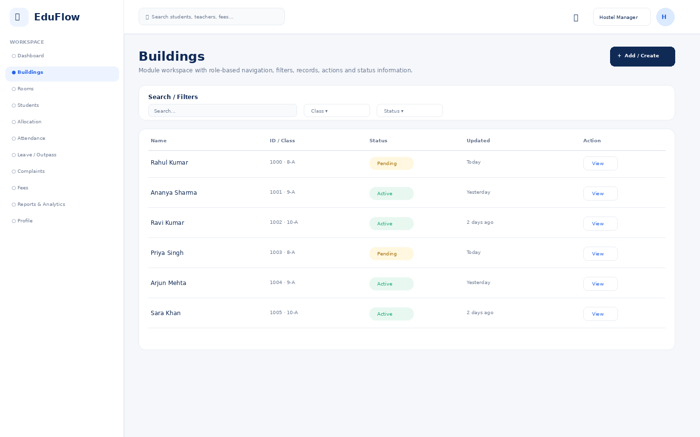
Access notes: Actual access is controlled by role, module permission, action permission and data scope.

Rooms
Module workspace with role-based navigation, filters, records, actions and status information.
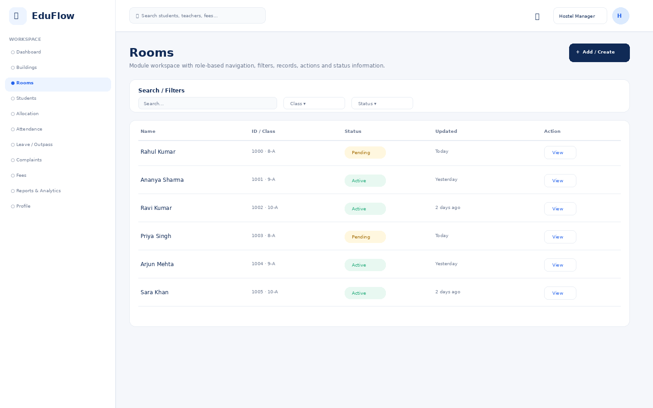
Access notes: Actual access is controlled by role, module permission, action permission and data scope.

Students
Student directory with search, filters, attendance, status and profile access.
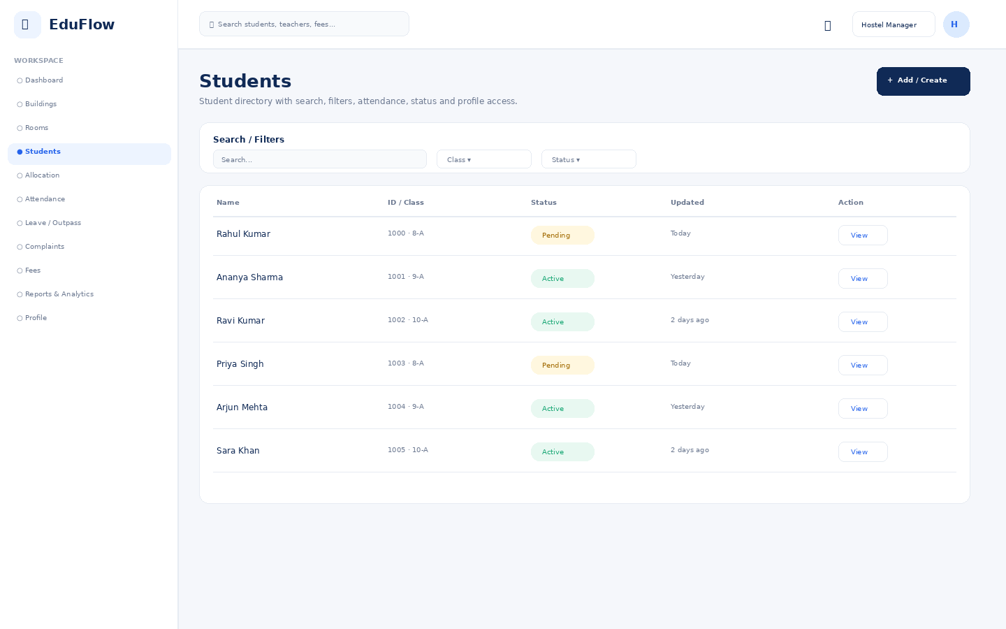
Access notes: Actual access is controlled by role, module permission, action permission and data scope.

Allocation
Module workspace with role-based navigation, filters, records, actions and status information.
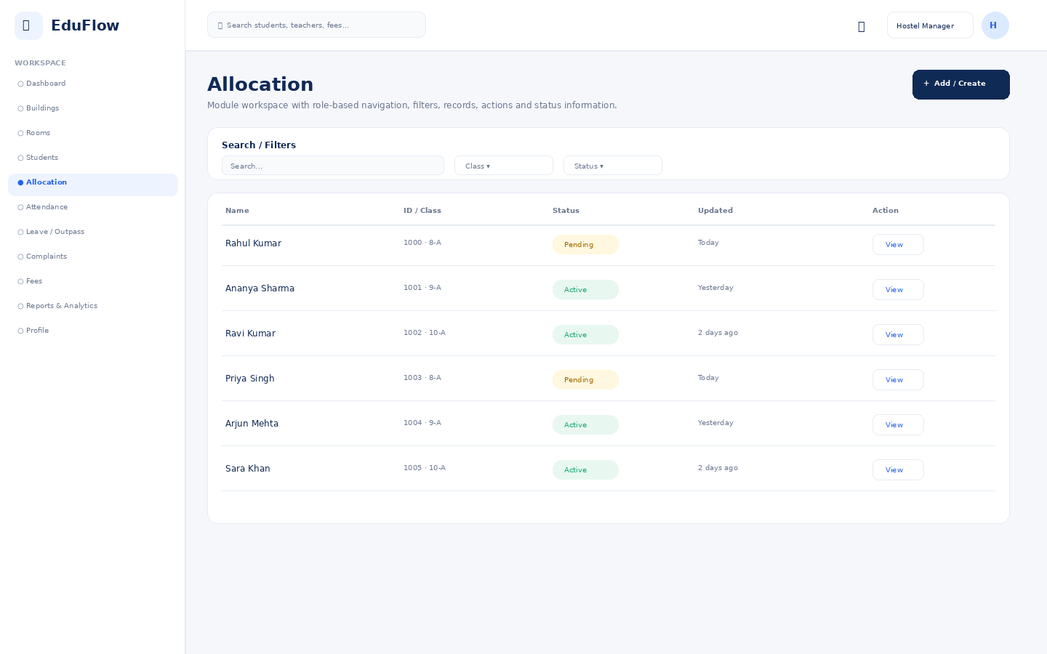
Access notes: Actual access is controlled by role, module permission, action permission and data scope.

Attendance
Daily attendance, absence/late status, trends and correction workflows.
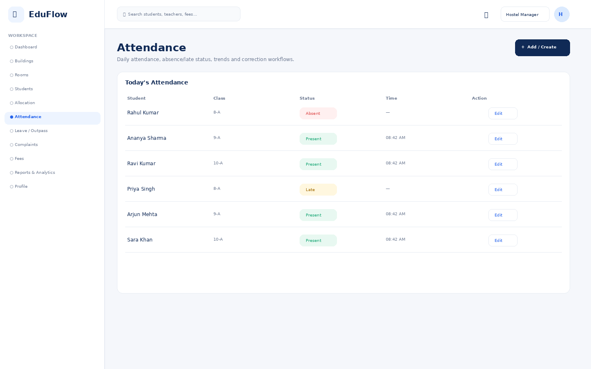
Access notes: Actual access is controlled by role, module permission, action permission and data scope.

Leave / Outpass
Module workspace with role-based navigation, filters, records, actions and status information.
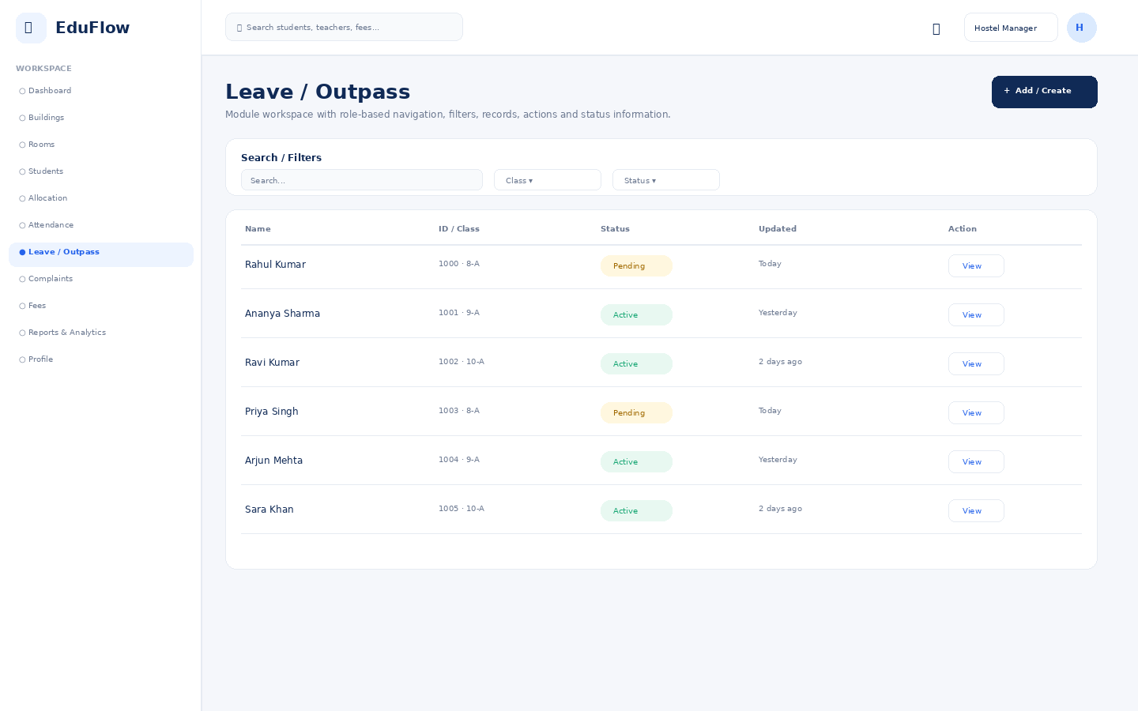
Access notes: Actual access is controlled by role, module permission, action permission and data scope.

Complaints
Module workspace with role-based navigation, filters, records, actions and status information.
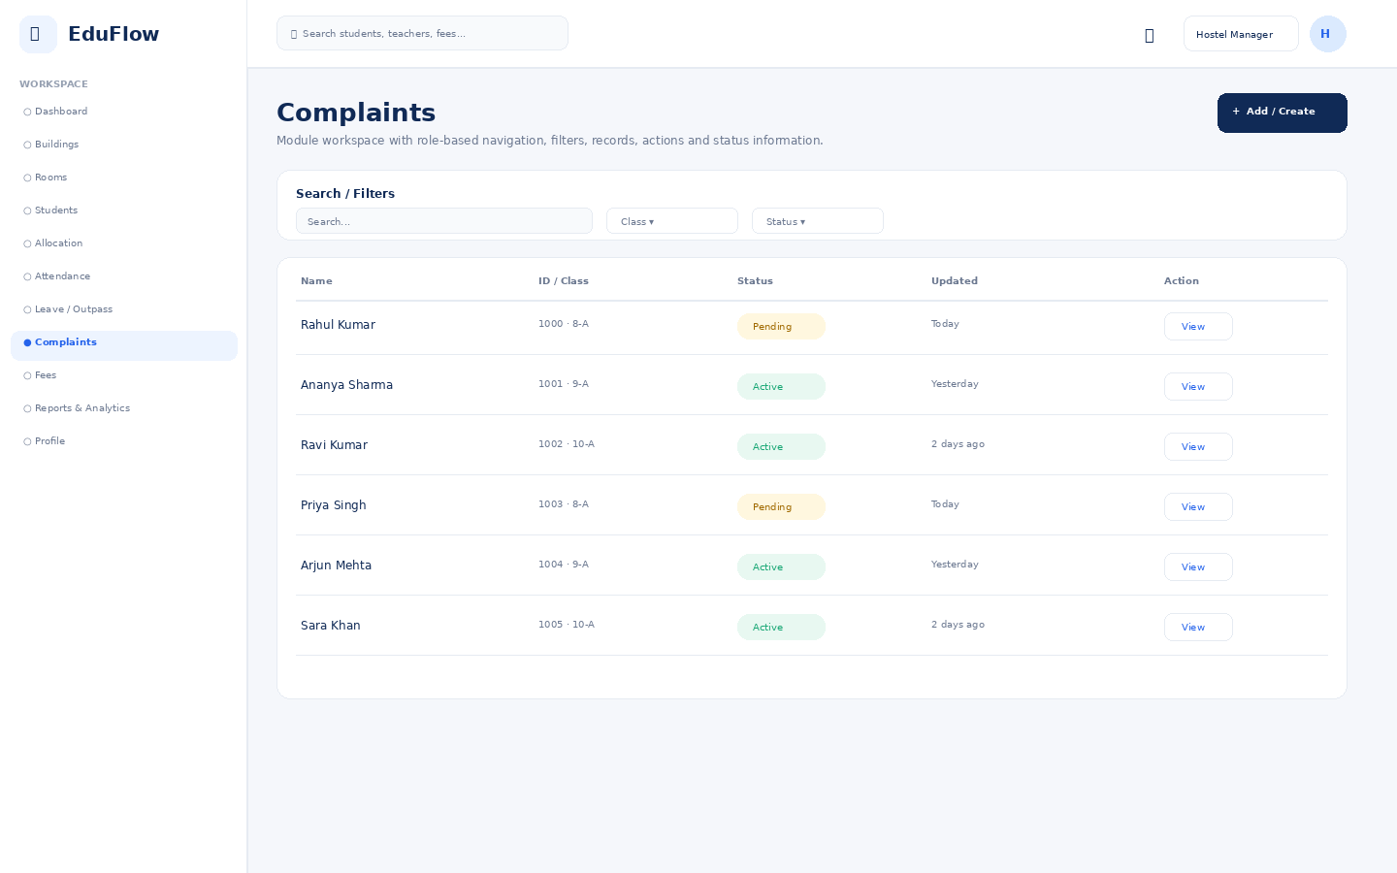
Access notes: Actual access is controlled by role, module permission, action permission and data scope.

Fees
Fee balances, invoices, collections, dues and payment history.
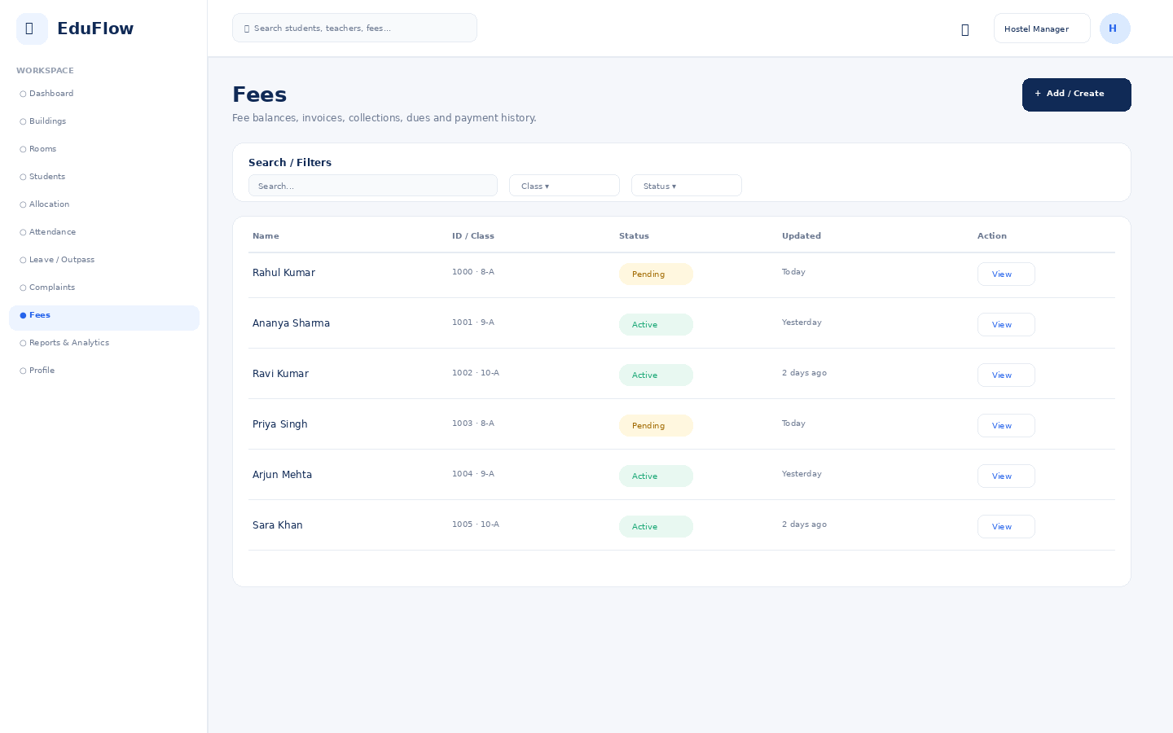
Access notes: Actual access is controlled by role, module permission, action permission and data scope.

Reports & Analytics
Filterable school reports with export-oriented presentation.
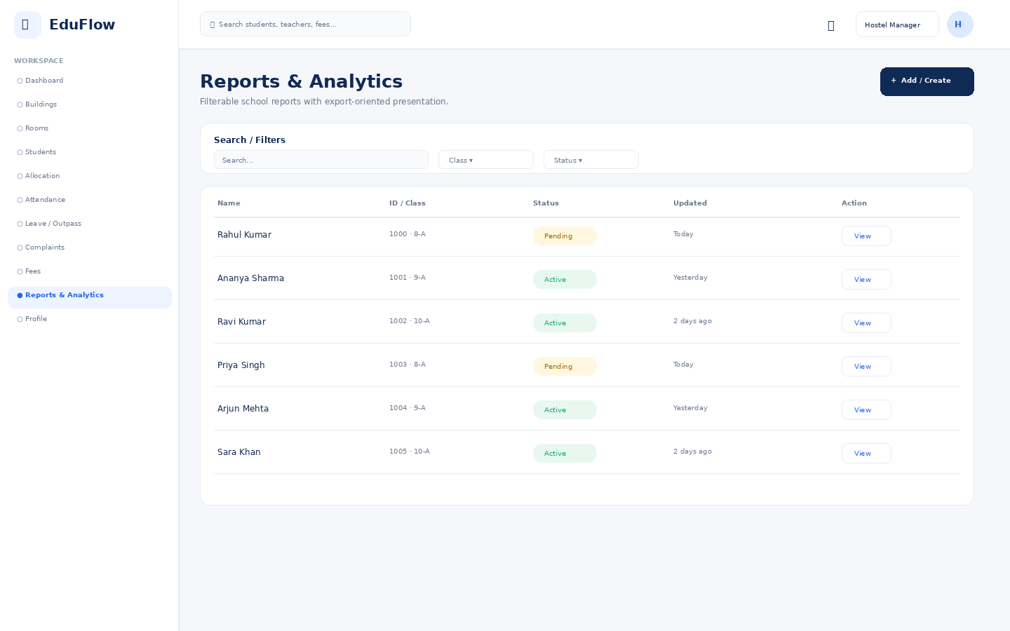
Access notes: Actual access is controlled by role, module permission, action permission and data scope.

Profile
User identity, role, school, security and account details.
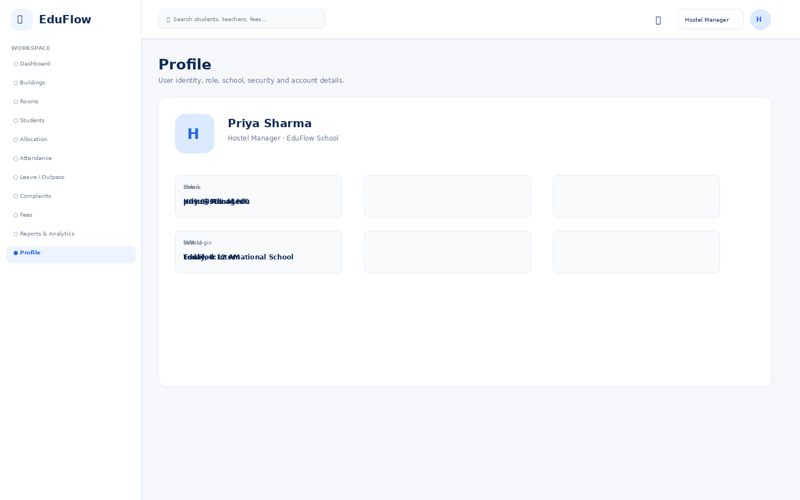
Access notes: Actual access is controlled by role, module permission, action permission and data scope.

4. Screen-Level Access Rules
- View — Can see records allowed by data scope.
- Create — Can create new records in the module.
- Edit — Can modify permitted records.
- Delete / Archive — Should be restricted; archive is preferred for student/staff records.
- Approve — Can approve workflows such as leave, mark corrections and refunds.
- Export — Can export only data explicitly permitted.
- Download — Controls document/report downloads.
- Publish — Controls marks, announcements and academic content publication.

5. Parent App — Required Core Experience
- Dashboard: attendance, average marks, teacher remarks, fees and latest alerts.
- Attendance: daily/monthly view with absence and late notifications.
- Marks & Results: subject marks, grades, progress and report cards.
- Teacher Remarks: latest feedback with date, teacher and visibility.
- Live Bus Tracking: current bus location, route, next stop and ETA.
- Notifications: attendance, marks, homework, fees, bus updates and school announcements.
- Messages: controlled parent-teacher communication.
- My Children: switch between multiple linked children without changing accounts.

6. Recommended Product Rule
Never rely on frontend hiding alone. Every screen, API and data query must enforce authorization on the backend using Role + Permission + Data Scope.
This document is a visual product/UX specification based on the current clickable prototype. Production implementation should add real data, authentication, backend authorization, integrations, responsive mobile flows and complete error/loading/empty states.

