For NGC 7295 comparing my CMD to the webda data is promising. We are clearly seeing a lot of noise in the data, but I think we are also seeing the main sequence curve (blue line in both). This blue line seems to correspond in the 14 to 16 magnitude range for V and from 0 to 0.4 for B-V. Matching stars in this area from the catalog would confirm if we are indeed seeing that main sequence.

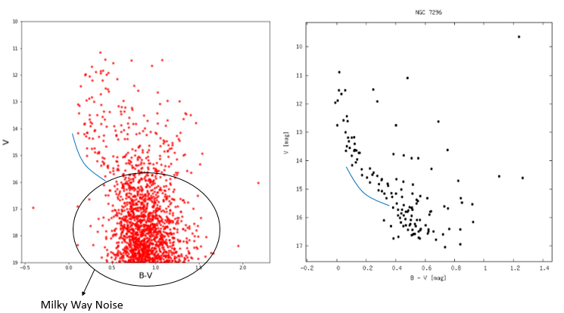

King 20 is as equally promising. We see less noise in the image from the milky way. Additionally we are seeing the same possible main sequence trend this time occurring in the 16 to 18 V magnitude and just over 1 B-V magnitude. We are also seeing a similar scattering of points to the right of this line. Matching stars in this area from the catalog would confirm if we are indeed seeing that main sequence.

