Graphical-budget-planner 1.8.1
Quick Tutorial
version : 2026-08-04 08:16:25

What you have to know before hand
- Future-focused : Graphical-budget-planner focuses on future projections only. It does NOT track/process past incomes/expenses.
- How it works: You define income/expense items (called “Cash Stream Definitions, a.k.a. CSD), which automatically generate financial events. These events generate a "Cash Balance Curve"—a visual projection of your future balance.
- Scenarios : Income/expense definitions are stored in a "scenario" file. You can have many scenario files, but only one is loaded at a given time.
- Analysis module : Use Tools → Analysis to view statistics, distributions, and summaries of your financial events.

Interacting with the Cash Balance Curve
- Zoomed in/out with the mouse scroll wheel. 3 types of zoom operations are possible :
  - Scroll wheel alone : both horizontal and vertical zoom
  - Scroll wheel + SHIFT : horizontal zoom only
  - Scroll wheel + CONTROL : vertical zoom only
- Pan in any direction: Click and drag on the chart with the left mouse button.
- Pan left/right by window: Use the "<" and ">" toolbar buttons to move one full window width.
- Reset scale: Click the "predefined scales" toolbar buttons to quickly reset to standard zoom levels

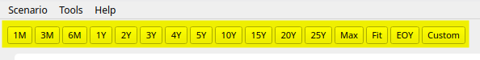
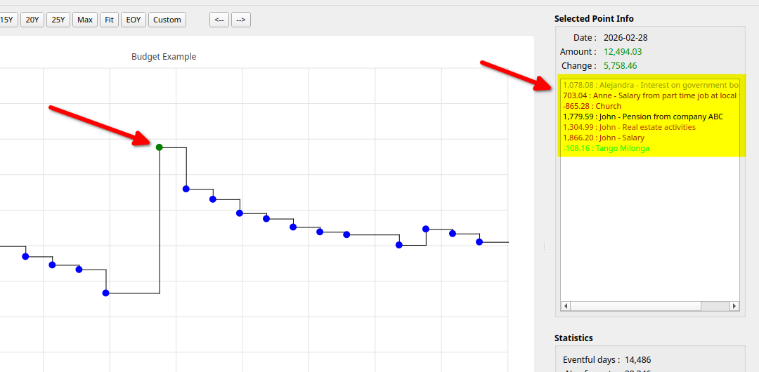
- Click on a data point : The point highlights (green by default), and the right panel shows details including all financial events that occurred on that day. The displayed amount is the previous day's balance plus all transactions for that day.

Creating a new scenario
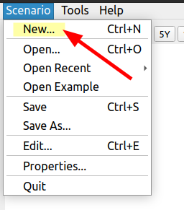

A) Select the “Scenario -> New...” menu

B) Choose the currency to be permanently associated to this new scenario, then press Select button (2) . The new scenario will be created, with empty data. It becomes the “current scenario”.

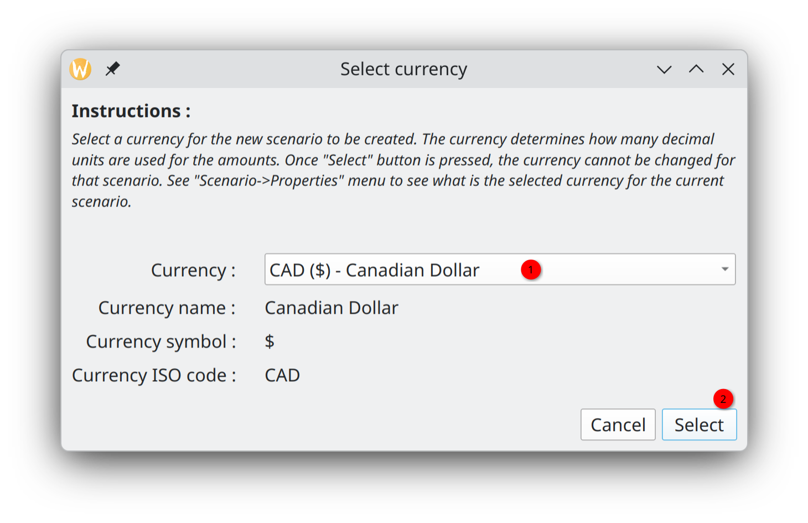

C) Edit the data related to the new scenario. When finished, press “Apply Changes” button (5).

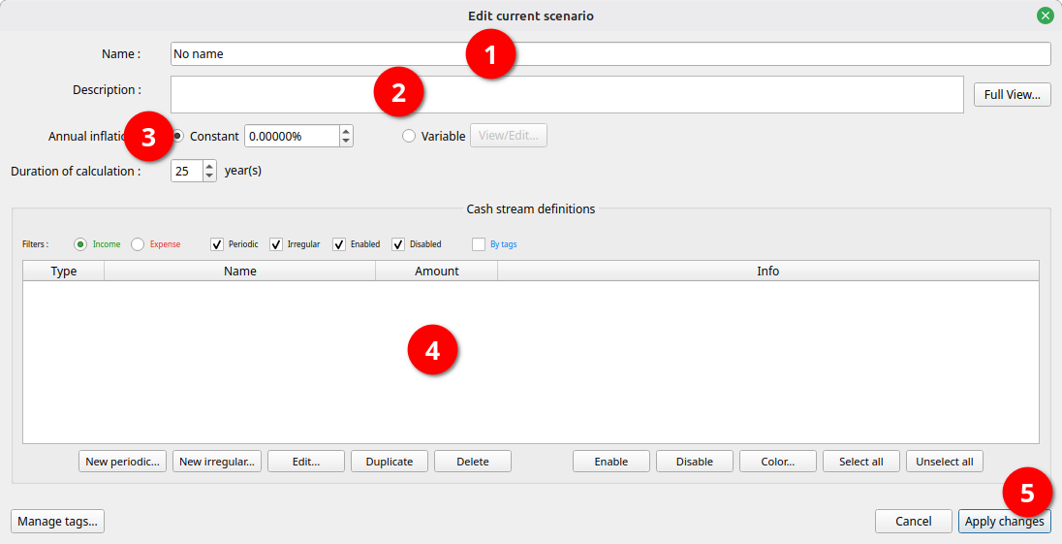
1 : Give a name to the scenario (this is NOT the file name)
2 : Optionally enter a descriptive text.
3 : Define an annual inflation, to be optionally used later in the process of defining incomes/expenses. Leave to default if you don't want to use inflation (0 %).
4 : Define all the incomes / expenses you need in the scenario. There are 2 types of each :

Type | Use When | Examples
Periodic | Amounts repeat at regular intervals | Salary, rent, mortgage, insurance
Irregular | One-time or sporadic transactions | Bonus, gift, car repair, renovation

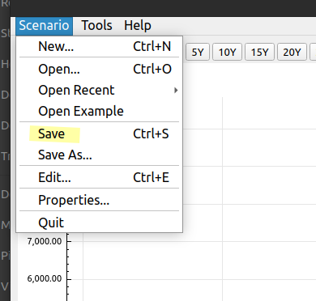

D) Save the scenario into a file if you want the new scenario to be used later

Opening and using an existing scenario

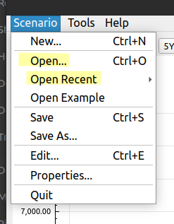

A) Open an existing scenario file using the “Scenario->Open” or “Scenario->Open Recent”

B) Enter the total current cash asset you have as of today. You determine this amount by your own means, e.g. looking at your bank accounts. The Cash Balance curve will start from this amount. This is NOT saved in the scenario file.
You will then see the calculated cash balance curve, derived from all the financial events generated.
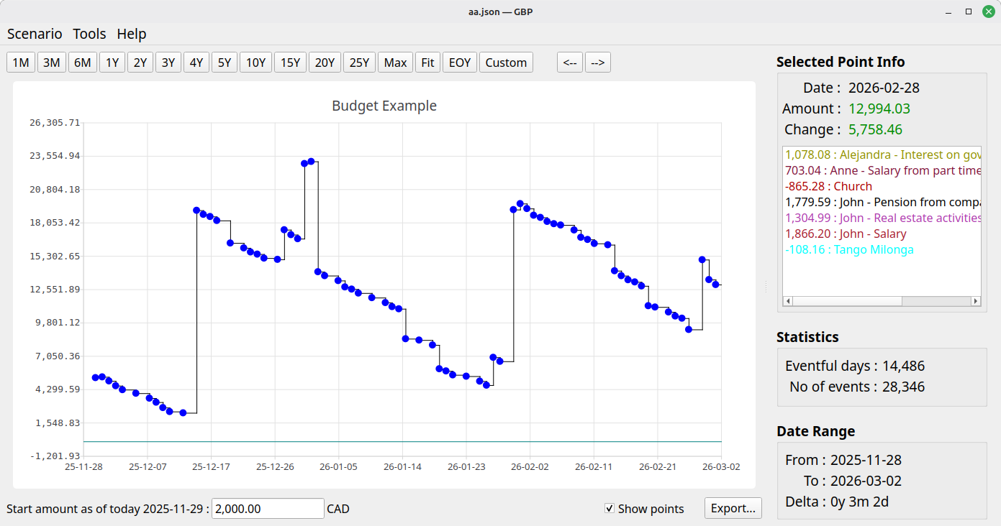

Editing an existing scenario
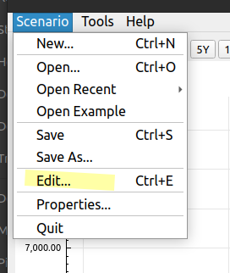

A) Once a scenario is opened, select “Scenario->Edit” menu to bring the “Edit scenario” window.

B) Do all the editing required. Everything can be changed, except the currency.

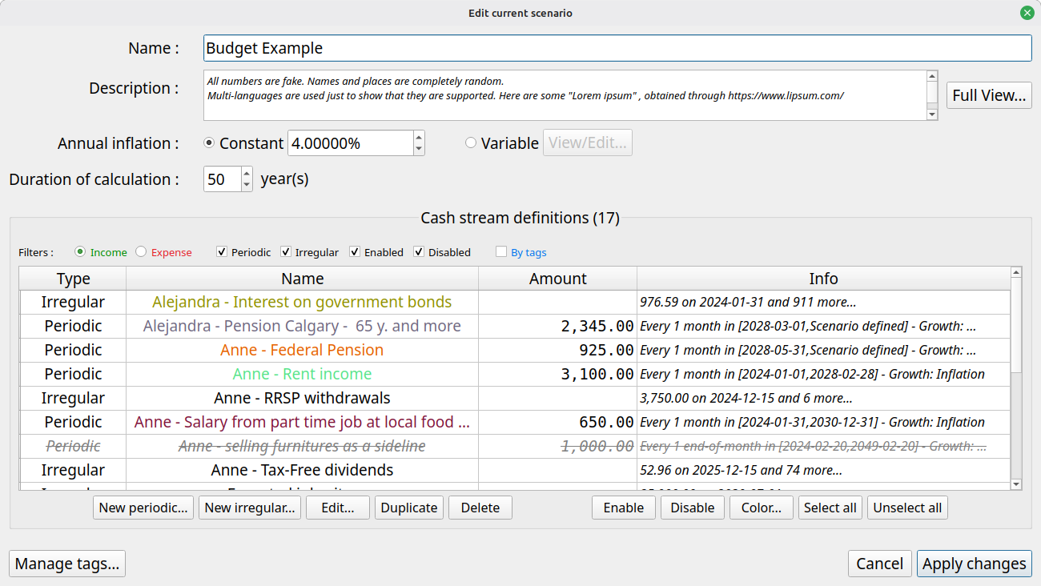
C) Once completed, press “Apply Changes” to update in memory the currently loaded scenario and thus see updates applied to the displayed cash balance curve.

D) To save permanently the modifications made to the scenario, you have to explicitly save it using the “Scenario->Save” menu. Otherwise all changes will be lost when you exit graphical-budget-planner.

Using Tags to categorise Cash Stream Definitions (incomes/expenses)

“Tags” help you organize and categorize your income and expense CSDs. You can assign one or more tags to each CSDs, making it easier to filter, analyze, and manage your financial data.

Creating and Managing Tags

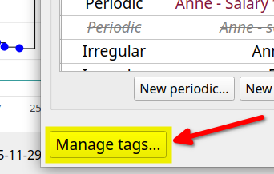
- Use the "Manage Tags" button from the “Edit scenario” window to create new tags for your scenario or assign them to CSDs
- Examples: "Essential", "Discretionary", "Work", "Medical", "Housing"

Using Tags in Analysis

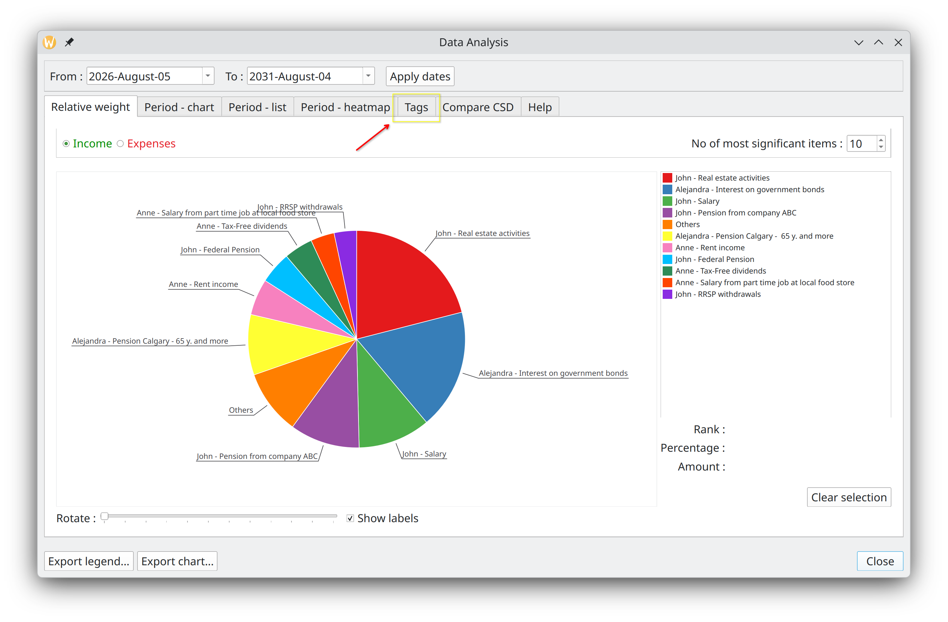
The Analysis module allows you to filter and view financial events by tags, making it easy to see spending patterns for specific categories or understand the impact of tagged CSDs on your overall budget.

Analyzing a scenario
This module, available through the “Tools->Analysis” menu, provides a lot of statistical info about the financial events generated, including :
- the super useful distribution of incomes/expenses by weight (which are the most significants over a certain period of time)
- Monthly and yearly summaries, both in histogram form and exportable tabular form.

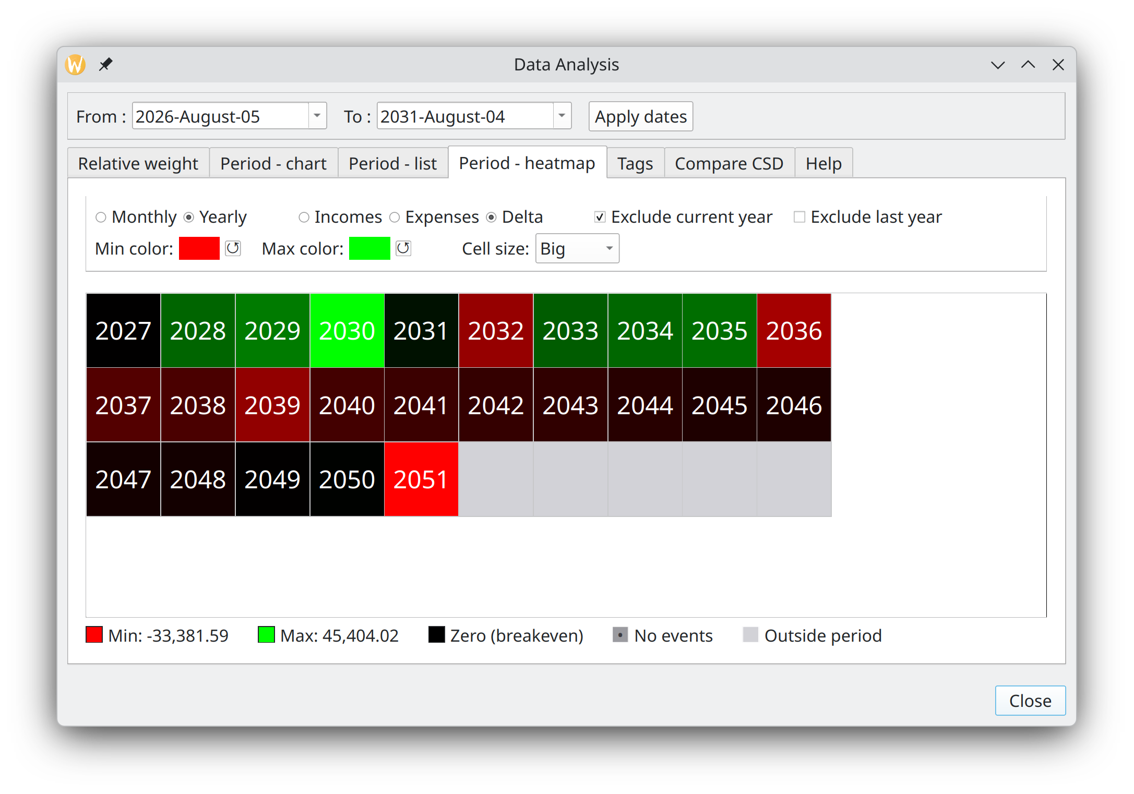

To get more information
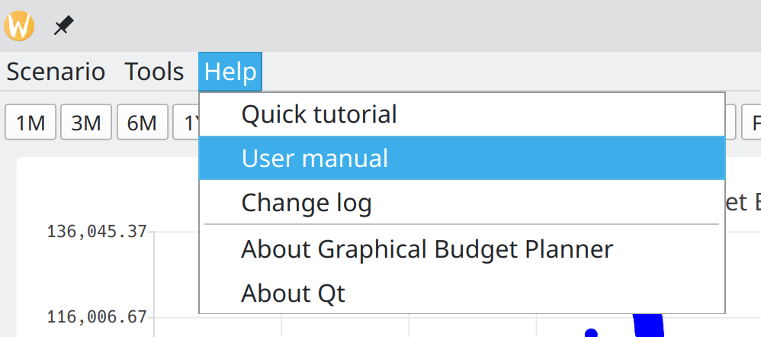

See the User Manual, which provides a great deal of details on every aspect of graphical-budget-planner.

