Welcome to graphical-budget-planner !

It seems you are using this application for the first time, since one cannot detect any configuration file already installed. We hope you will enjoy the experience !

Getting Help

=> Use the “tooltips” available everywhere in the application. Just move the mouse over a button or a control and a small window will appear giving a brief description. This feature can be turned off in the Options.
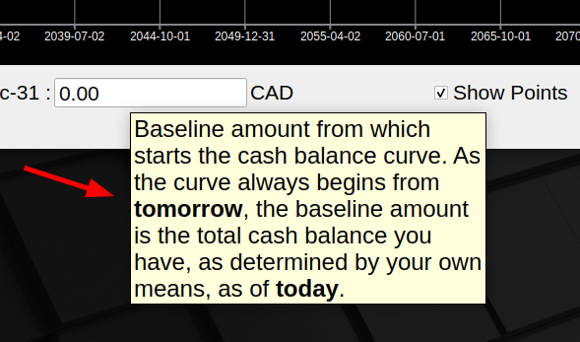

=> Use the "Help menu" to rapidly get access to :
    - Quick tutorial : In 10 minutes, get a good idea of what GBP does
    - User Manual : Explore the fine details of GBP in this fully detailed PDF document
    - List of changes : See what's new for each version of GBP

Getting the source code or the binary


GBP is free & open-source software. Visit GBP web site at :
https://github.com/redmoon1945/gbp

Sending feedback


To contact the author(s) of this software, you can do it either via Github or directly by email (redmoon1945@protonmail.com).

On Github, go to https://github.com/redmoon1945/gbp/issues, use the “Issue” feature. This way, the owner and other collaborators can discuss and resolve the issue or answer your question. To create an issue, navigate to https://github.com/redmoon1945/gbp/issues , then click “New Issue”, and fill in the required information.

