Group Project
Team 5
Database Design and Rational

The original data is in the form of a spreadsheet. Thus there is no referential integrity, format validation a need for Normalization and Optimization.

In designing the databasewe focussed on three main aspects
Linking related data
Through assumptions
Confirmation with product owner
Removing redundancy
Identifying identical columns
Finding functional dependencies
Creating additional tables
Optimization through removal of repetition
e.g. Storing “GSM 800” as AutoNumber “1”

Each member of the team designed a database and then we came togetehr to decide on the best aspects of each.

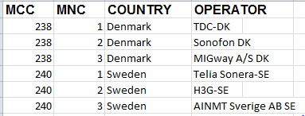
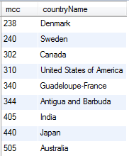
MCCMNC
Country

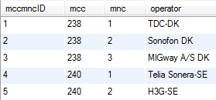

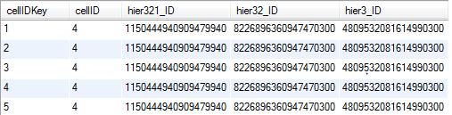
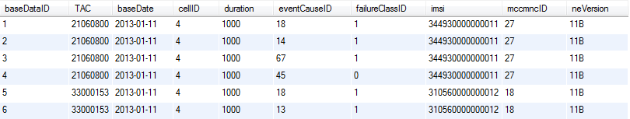
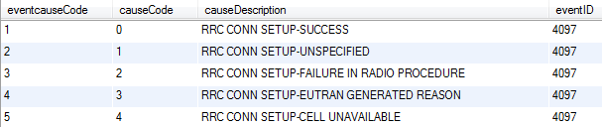
CellTable
EventCause

Repeating fields:
Model = Marketing Name
Manufacturer = Vendor Name
Solution: both Model and Manufacturer columns extracted into their own table(optimisation)

TAC - AccessCapability: 1-to-many relationship
Each access capability stored in a separate table and given an ID

An extra table connecting the TAC(UserEquipmentID ) to the AccessCapabilityID
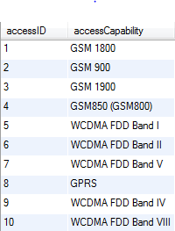
UE_AccessCapability
AccessCapability
