1.0 **Objective**

1.1 To provide instruction on how to make requisition of supplies, equipment or other properties ensuring that items requested matched the description, quality and quantity needed as well as records regarding requisition are maintained.

2.0 **Scope**

2.1 Covers all requisition whether supplies or property needed for business transactions and processed thru the Property and Supplies Department (PSD)

3.0 **Work Instruction**

3.1 **Purchase Requisition**

1. Requisition includes Supplies Request (consumables) and Property Request (equipment and furniture & fixtures) by the Requesting Department. Forms available at the PC Office.
2. All Requisition must be made thru a designated Purchase Requisition Form, duly signed and approved by the Immediate Head.
3. All purchase request must have/or within the set budget. Requisition of supplies and property shall be made on per semester basis, during the first month of the semester thru filing of the requisition form.
4. All purchase of equipments and furniture & fixtures must be made thru purchase requisition form and must be processed only by the P.C/Supplies Officer
5. All purchase request (supplies or property) must be accomplished legibly, completely and specific.
6. Purchase requisitions are processed maximum within seven (7) working days until the arrival and distribution of items, may be subject to exception such as involuntary delays.
7. 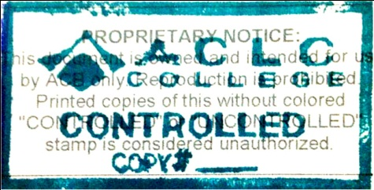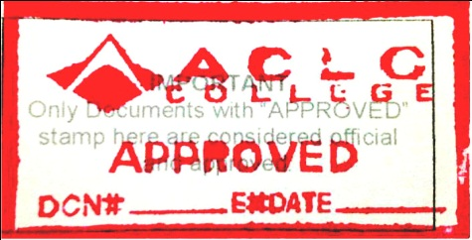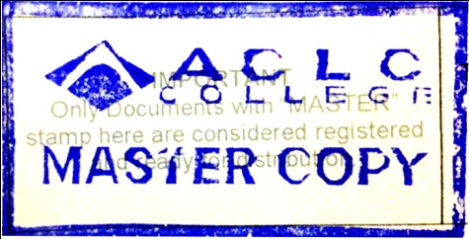
8. When delay is due to fortuitous events, calamity, work environment, etc. in such cases, the P.C/Supply Officer must notify the requesting party immediately upon his/her knowledge of the delays. Notification may be made verbally or written.
9. Delays thru negligence of the P.C/Supply Officer which are grave in nature, notify immediately his/her immediate head.
10. For Cancellation and Modification of requests, to remain legible and readable, accomplish a new supplies and purchase requisition form.

4.0 **References**

4.1 ACB-PRD-PSD-06-00 Purchasing Procedure

5.0 **Records Generated**

5.1 Accomplished and Approved Supplies Requisition Form

5.2 Accomplished and Approved Property Requisition Form

6.0 **Revision History**

|  |  |  |
| --- | --- | --- |
| Version Number | Description of Changes | Effective Date |
| 1 | First Issue | 06/01/2013 |
|  |  |  |

