Afshan ahmed khan
IT-2k19-03
import java.util.*;
import java.util.LinkedList;
import java.util.Queue;

public class queue {
public static void main(String[] args) {
Queue obj = new LinkedList();
Scanner sc = new Scanner(System.in);

for (int i = 0; i <= 5; i++) {
System.out.print("Enter elements of queue ");
obj.add(sc.next());
}

System.out.println("enter any integer element you want to remove");
Object a = sc.next();
obj.remove(a);
System.out.println("enter any String element you want to remove");
String b = sc.next();
obj.remove(b);
System.out.println("printing through foreach loop");

Iterator itr = obj.iterator();
while (itr.hasNext()) {
System.out.println(itr.next());
}
}
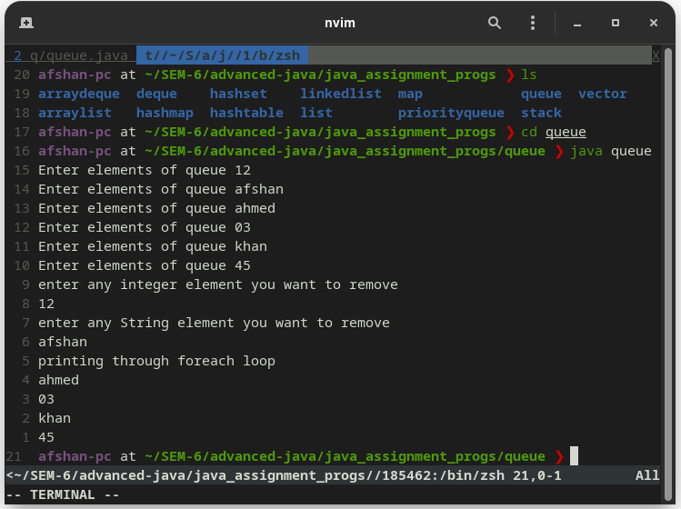
}

import java.util.*;
import java.util.LinkedList;
import java.util.Queue;

public class queue_foreach {
public static void main(String[] args) {
Queue obj = new LinkedList();
Scanner sc = new Scanner(System.in);

for (int i = 0; i <= 5; i++) {
System.out.print("Enter elements of queue ");
obj.add(sc.nextInt());
}

System.out.println("enter any integer element you want to remove");
int a = sc.nextInt();
obj.remove(a);
System.out.println("enter any String element you want to remove");
String b = sc.next();
obj.remove(b);

System.out.println("printing through foreach loop");
for (Object i : obj) {
System.out.println(i);
}
}
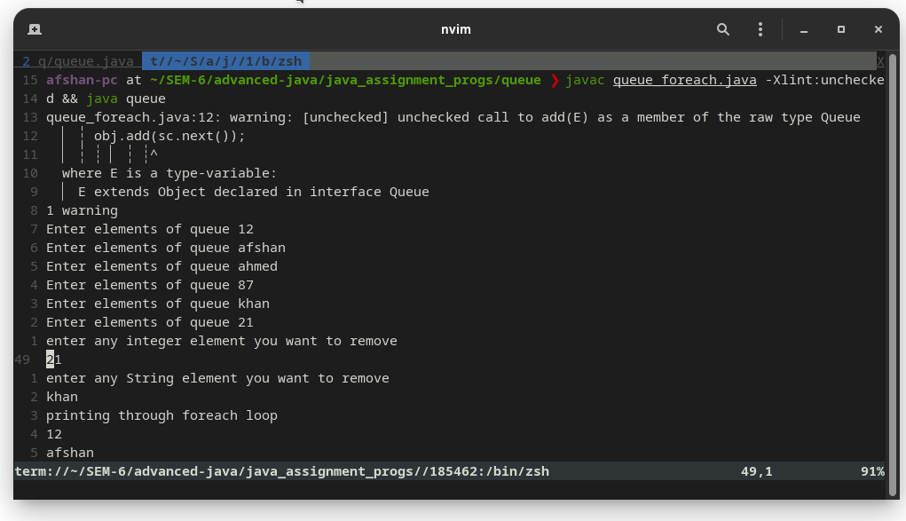
}
import java.util.Iterator;
import java.util.LinkedList;
import java.util.Queue;

public class queue_generic {

public static void main(String[] args) {
Queue<Integer> q = new LinkedList<>();

for (int i = 0; i < 5; i++)
q.add(i);

int removedele = q.remove();
System.out.println("removed element-"
+ removedele);

int head = q.peek();
System.out.println("head of queue-"
+ head);

int size = q.size();
System.out.println("Size of queue-"
+ size);

System.out.println("Traversing through iterators");
Iterator itr = q.iterator();
while (itr.hasNext()) {
System.out.println(itr.next());
}
}
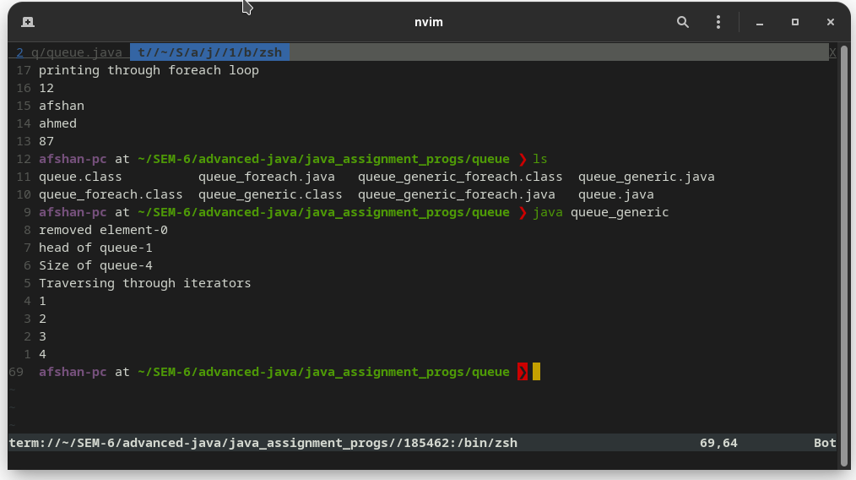
}
import java.util.LinkedList;
import java.util.Queue;

public class queue_generic_foreach {

public static void main(String[] args) {
Queue<Integer> q = new LinkedList<>();

for (int i = 0; i < 5; i++)
q.add(i);

int removedele = q.remove();
System.out.println("removed element-"
+ removedele);

int head = q.peek();
System.out.println("head of queue-"
+ head);

int size = q.size();
System.out.println("Size of queue-"
+ size);

System.out.println("print through foreach loop");
for (Integer i : q) {
System.out.println(i);
}
}
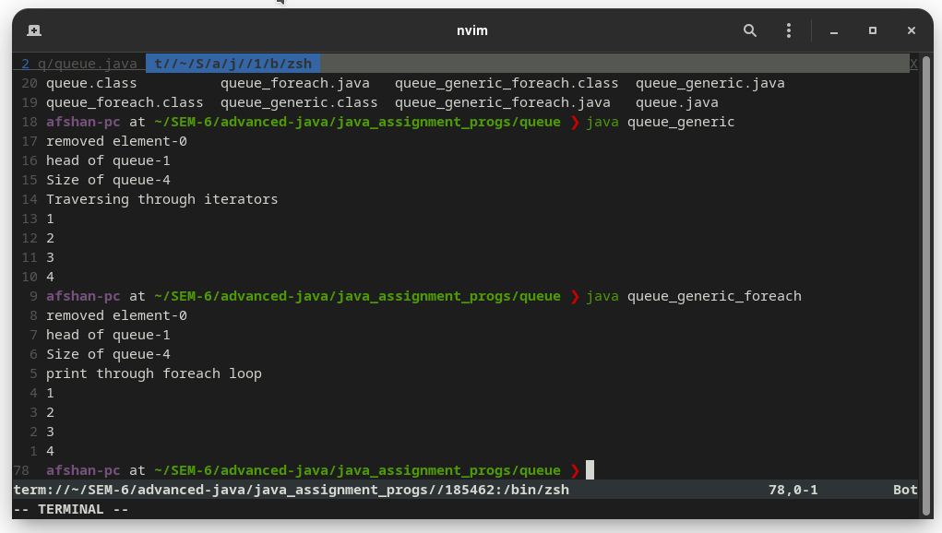
}
import java.util.Arrays;
import java.util.Iterator;

public class array {
public static void main(String args[]){
Object[] myArray = {897,"afshan", 56, 78, 90, "ahmed", 12, 123,"khan", 75};
Iterator iterator = Arrays.stream(myArray).iterator();
while(iterator.hasNext()) {
System.out.println(iterator.next());
}
}
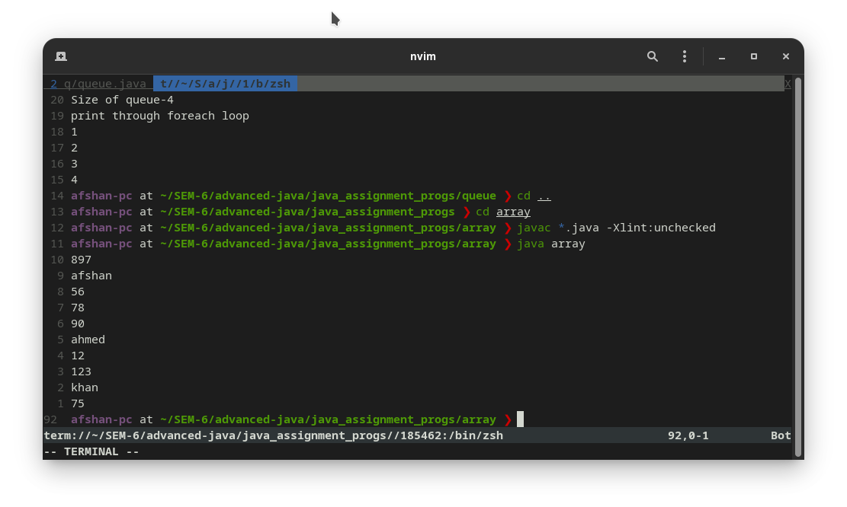
}
import java.util.Arrays;
import java.util.Iterator;

public class array_foreach {
public static void main(String args[]){
Object[] myArray = {897,"afshan", 56, 78, 90, "ahmed", 12, 123,"khan", 75};
for (Object o : myArray) {
System.out.println(o);
}
}
}
import java.util.Arrays;
import java.util.Iterator;

public class array_generic {
public static void main(String args[]){
Integer[] myArray = {897, 56, 78, 90, 12, 123, 75};
Iterator<Integer> iterator = Arrays.stream(myArray).iterator();
while(iterator.hasNext()) {
System.out.println(iterator.next());
}
}
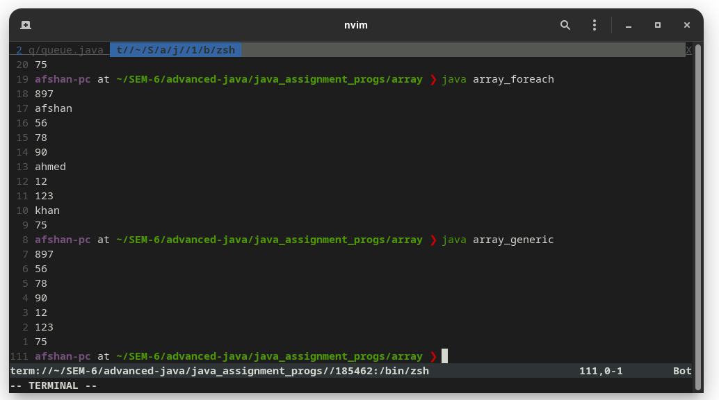
}
import java.util.Arrays;
import java.util.Iterator;

public class array_generic_foreach {
public static void main(String args[]){
Integer[] myArray = {897, 56, 78, 90, 12, 123, 75};
for (Integer i : myArray) {
System.out.println(i);
}
}
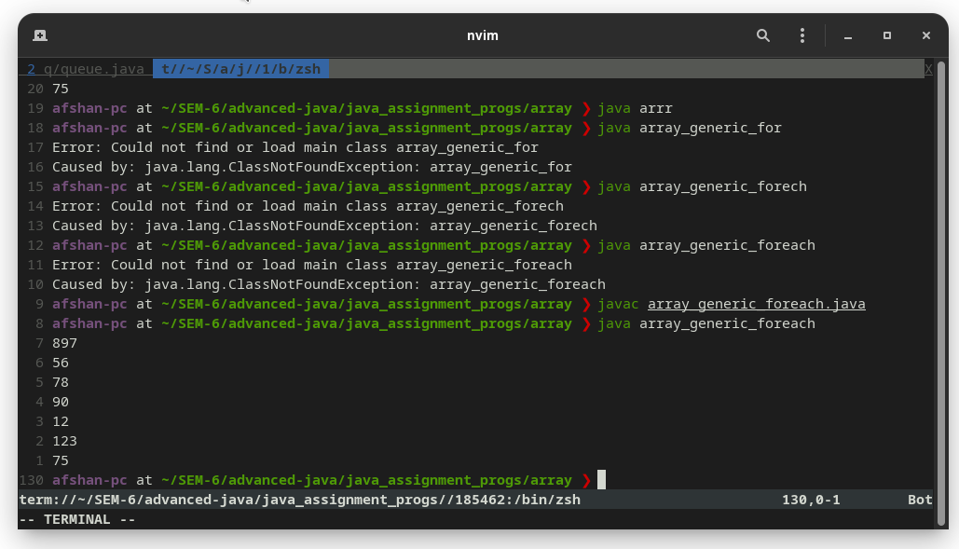
}
import java.util.*;

class arraylist {
public static void main(String args[]) {
ArrayList<String> list = new ArrayList<String>();// Creating arraylist
list.add("rohan"); // Adding object in arraylist
list.add("mohan");
list.add("sohan");
list.add("pawan");
System.out.println("Size of array BEFORE REMOVING " + list.size());

System.out.println(list.remove("rohan"));
// Traversing list through Iterator
Iterator itr = list.iterator();
System.out.println("Now size of array " + list.size());

System.out.println("hash code is" + list.hashCode());

System.out.println("Traversing list through iterator");
while (itr.hasNext()) {
System.out.println(itr.next());
}
}
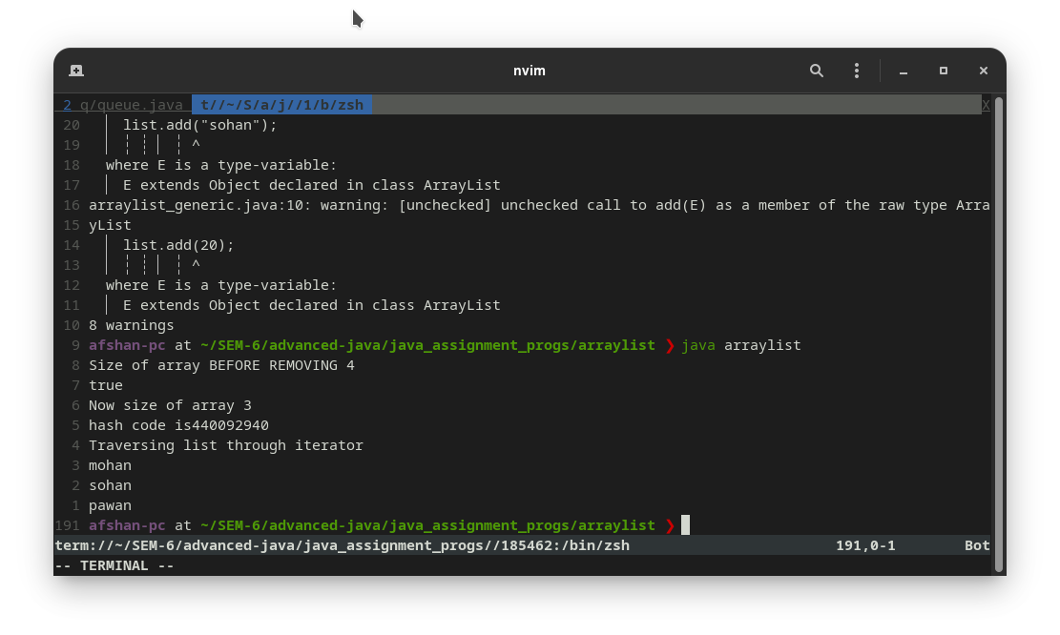
}
import java.util.*;

public class arraylist_generic {
public static void main(String args[]) {
ArrayList list = new ArrayList();

list.add("rohan");
list.add("mohan");
list.add("sohan");
list.add(20);

// Traversing list through Iterator
System.out.println("Traversing list through Iterator");
Iterator itr = list.iterator();
while (itr.hasNext()) {
System.out.println(itr.next());
}
}

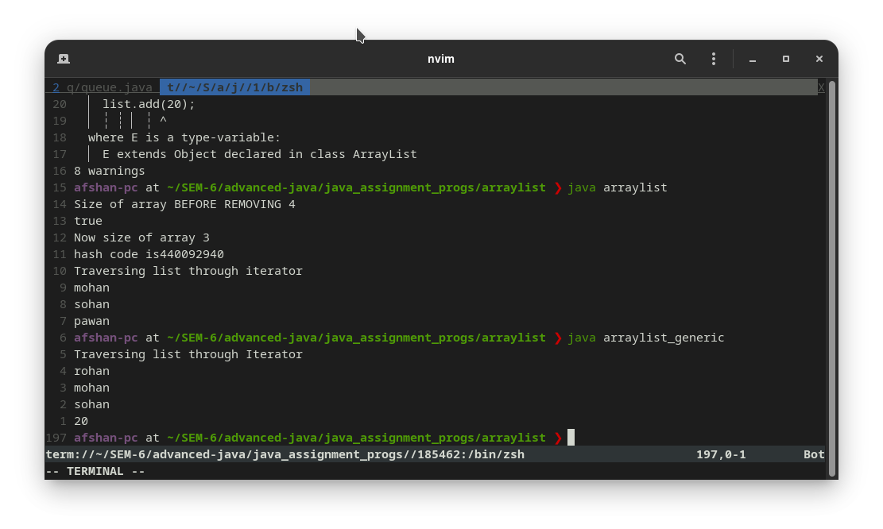
}
import java.util.*;

class arraylist_generic_foreach {
public static void main(String args[]) {
ArrayList list = new ArrayList();

list.add("rohan");
list.add("mohan");
list.add("sohan");
list.add(20);

System.out.println("Travering list through foreach loop");
// Travering list through foreach loop
for (Object str : list)
System.out.println(str);
System.out.println("The clone of list is " + list.clone());
System.out.println("is this list empty T/F :- " + list.isEmpty());
System.out.println("The size of the list is " + list.size());
}

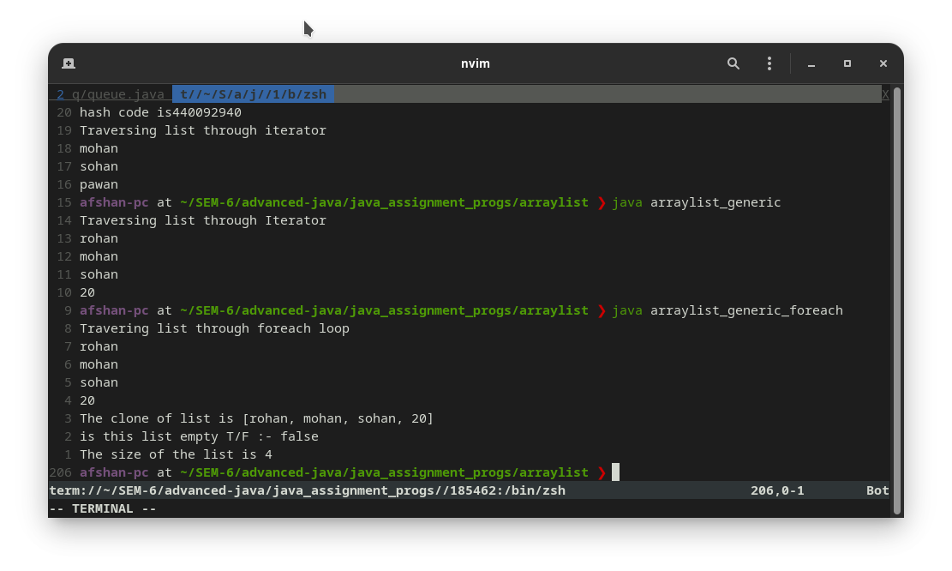
}
import java.util.*;
class arraylist_foreach {
public static void main(String[] args) {
List<Integer> obj = new ArrayList<Integer>();
obj.add(152);
obj.add(343);
obj.add(139);
obj.add(123);
obj.add(358);

System.out.println("Traversing list through foreach loop");
for (Integer str : obj) {
System.out.println(str);
}
Collections.sort(obj);
System.out.println("the assending order is" + obj);
}
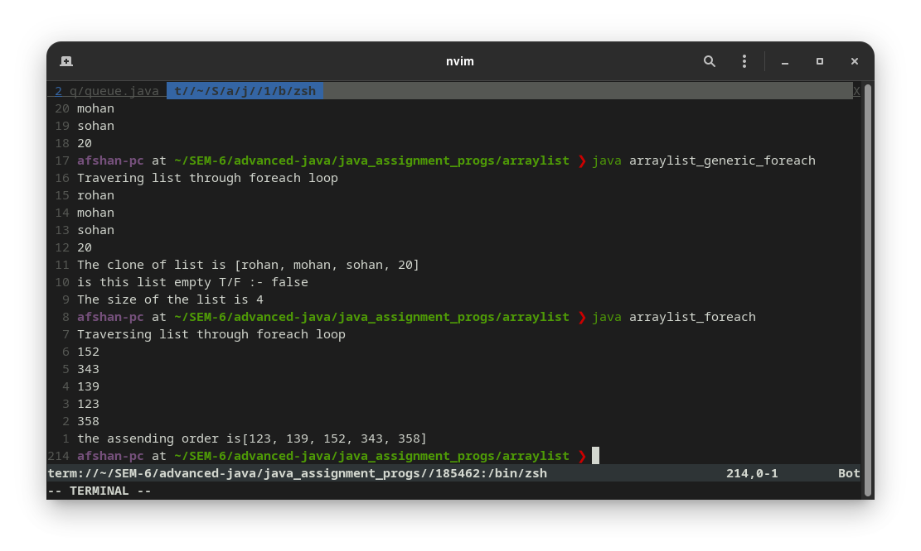
}
import java.util.ArrayDeque;
import java.util.Deque;
import java.util.Iterator;
import java.lang.Object;

public class deque {
public static void main(String[] args) {
// Creating Deque and adding elements
Deque<String> obj = new ArrayDeque<String>();
obj.add("Rohan");
obj.add("Mohan");
obj.add("Rohan");
obj.add("Ajay");
obj.add("Mohan");

System.out.println(obj);
System.out.println("elements contain Rohan ? " + obj.contains("Rohan"));
System.out.println("removing last Mohan" + obj.removeLastOccurrence("Mohan"));
System.out.println(obj);
System.out.println("after removing Rohan");
obj.removeFirstOccurrence("Rohan");
System.out.println(obj);
obj.addFirst("first element");
obj.addLast("last element");

System.out.println("Traversing elements through iterator");
Iterator itr = obj.iterator();
while (itr.hasNext()) {
System.out.println(itr.next());
}
}
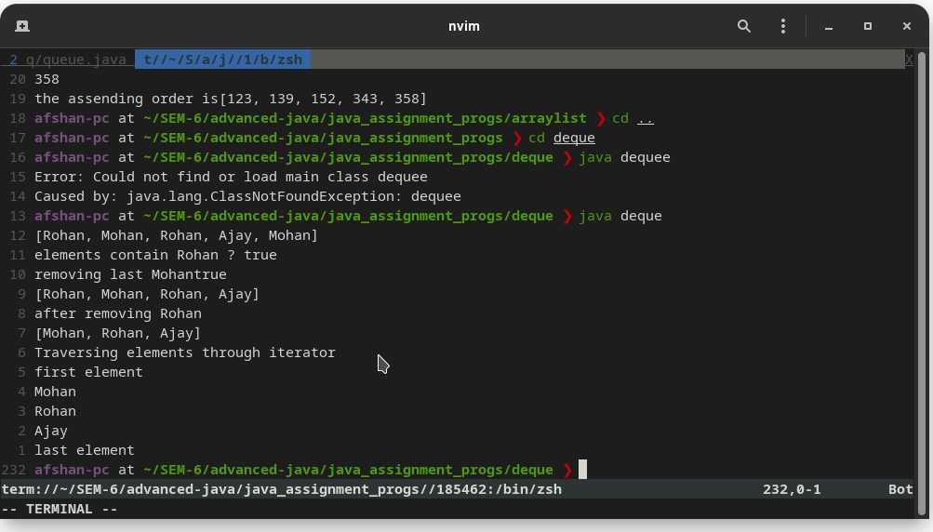
}
import java.util.ArrayDeque;
import java.util.Deque;

public class deque_foreach {
public static void main(String[] args) {

Deque<Integer> deq = new ArrayDeque<>();
deq.offer(5);
deq.offer(6);
deq.add(7);
deq.offerFirst(1);

for (int i : deq) {
System.out.println(i);
}

deq.poll();
System.out.println("after using poll " + deq);
deq.pollFirst();
System.out.println("after using poll first " + deq);
deq.pollLast();
System.out.println("after using polllast " + deq);
}
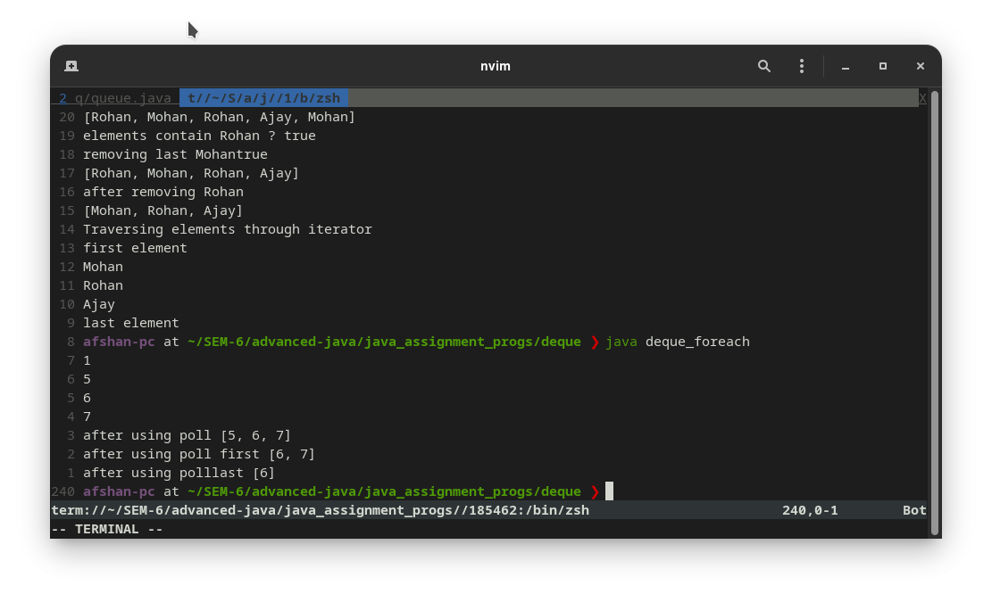
}
import java.util.LinkedList;
import java.util.Deque;
import java.util.Iterator;

public class deque_generic {
public static void main(String[] args) {
Deque obj = new LinkedList();
for (int i = 0; i <= 5; i++) {
int a = i * 3;
obj.add(a);
}
obj.add("afshan");

System.out.println("The queue is: " + obj);
int num1 = (int)obj.removeFirst();
System.out.println("The element deleted from the head is: " + num1);
System.out.println("The queue after deletion is: " + obj);

int head = (int)obj.peek();
System.out.println("The head of the queue is: " + head);

System.out.println("Traversing through iterator");
Iterator itr = obj.iterator();
while (itr.hasNext()) {
System.out.println(itr.next());
}
}
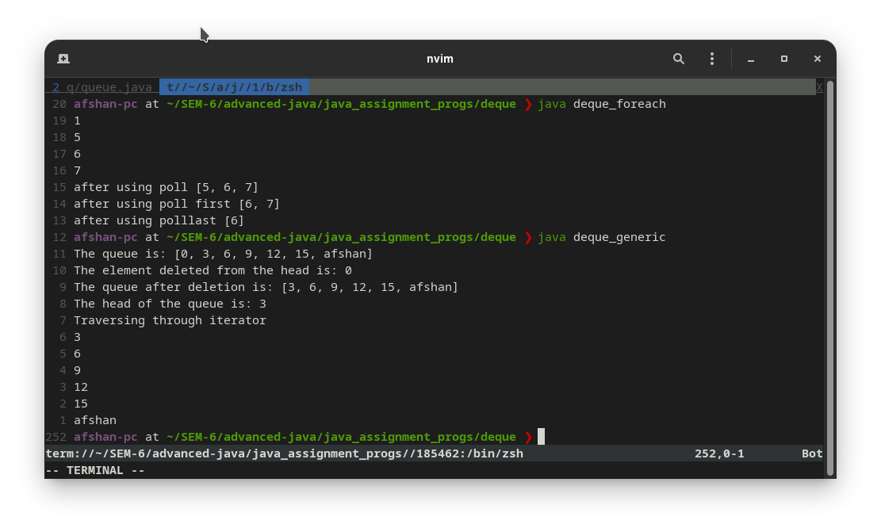
}
import java.util.LinkedList;
import java.util.Deque;

public class deque_generic_foreach {
public static void main(String[] args) {
Deque obj = new LinkedList();
for (int i = 0; i <= 5; i++) {
int a = i * 3;
obj.add(a);
}
obj.add("afshan");

System.out.println("The queue is: " + obj);
int num1 = (int)obj.removeFirst();
System.out.println("The element deleted from the head is: " + num1);
System.out.println("The queue after deletion is: " + obj);

int head = (int)obj.peek();
System.out.println("The head of the queue is: " + head);

System.out.println("Traversing through foreach");
for (Object o : obj) {
System.out.println(o);
}
}
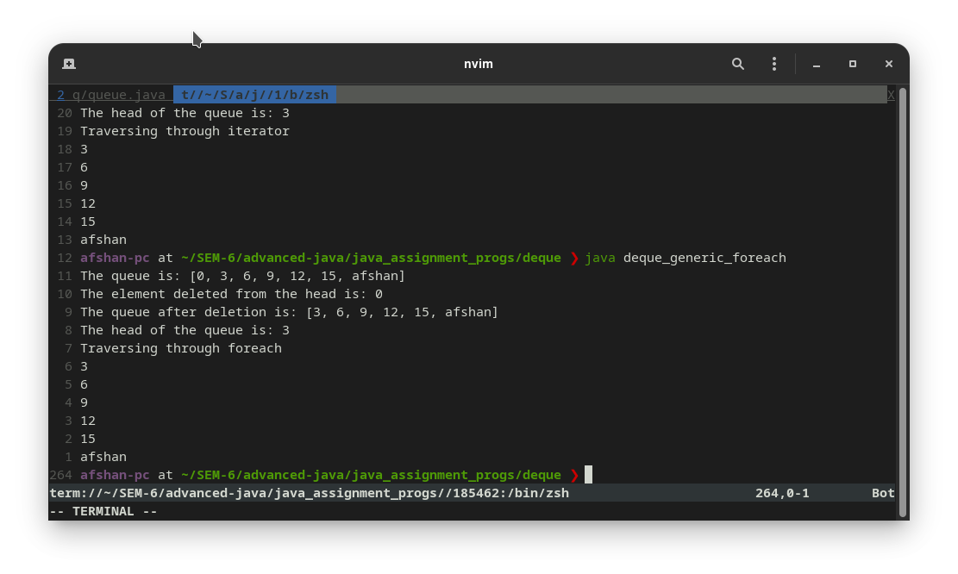
}
import java.util.*;

public class arraydeque {
public static void main(String[] args) {
ArrayDeque<String> obj = new ArrayDeque<String>();
obj.add("rohan");
obj.add("mohan");
obj.add("sohan");
// Traversing elements
System.out.println("Traversing through the iterator");
Iterator<String> itr = obj.iterator();
while (itr.hasNext()) {
System.out.println(itr.next());
}
}
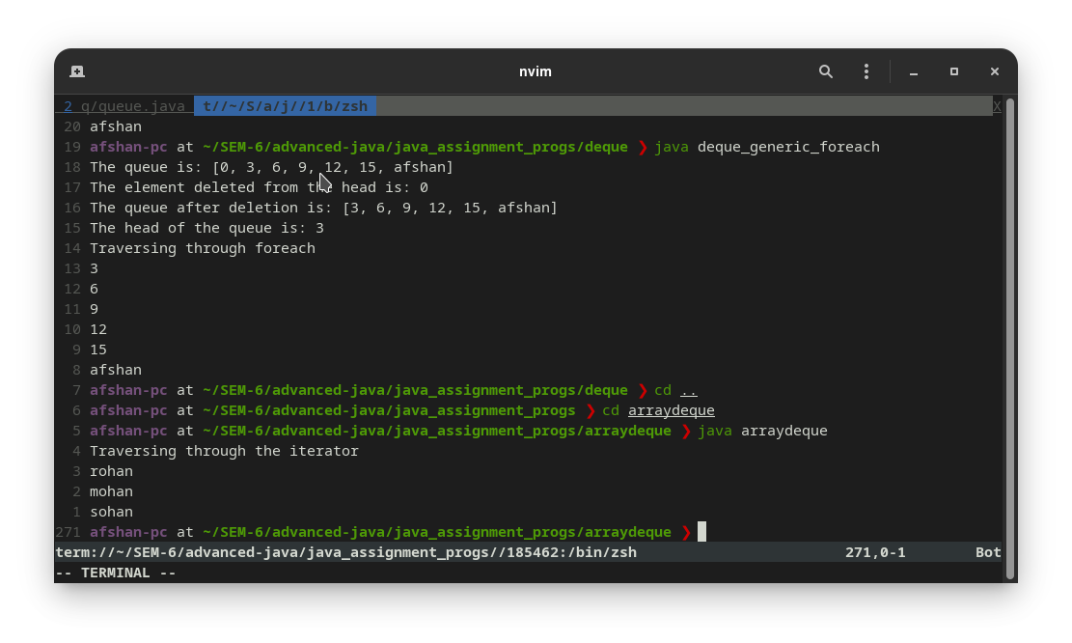
}
import java.util.*;

public class arraydeque_foreach {
public static void main(String[] args) {
ArrayDeque<String> obj = new ArrayDeque<String>();
obj.add("rohan");
obj.add("mohan");
obj.add("sohan");
// Traversing elements

System.out.println("Traversing through the for each loop");
for (String str : obj) {
System.out.println(str);
}
}
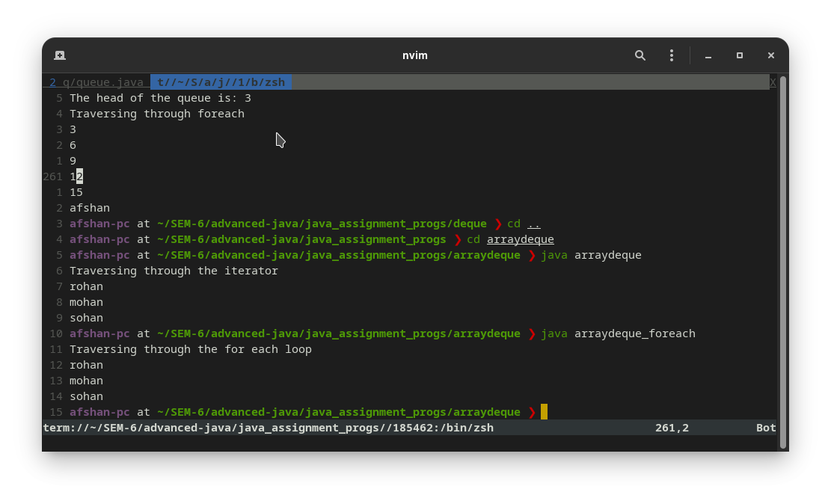
}
import java.util.*;

public class arraydeque_generic {
public static void main(String[] args) {
ArrayDeque obj = new ArrayDeque ();
obj.add("rohan");
obj.add("mohan");
obj.add("sohan");
obj.add(29);

// Traversing elements
System.out.println("Traversing through the iterator");
Iterator<Object> itr = obj.iterator();
while (itr.hasNext()) {
System.out.println(itr.next());
}
}
}

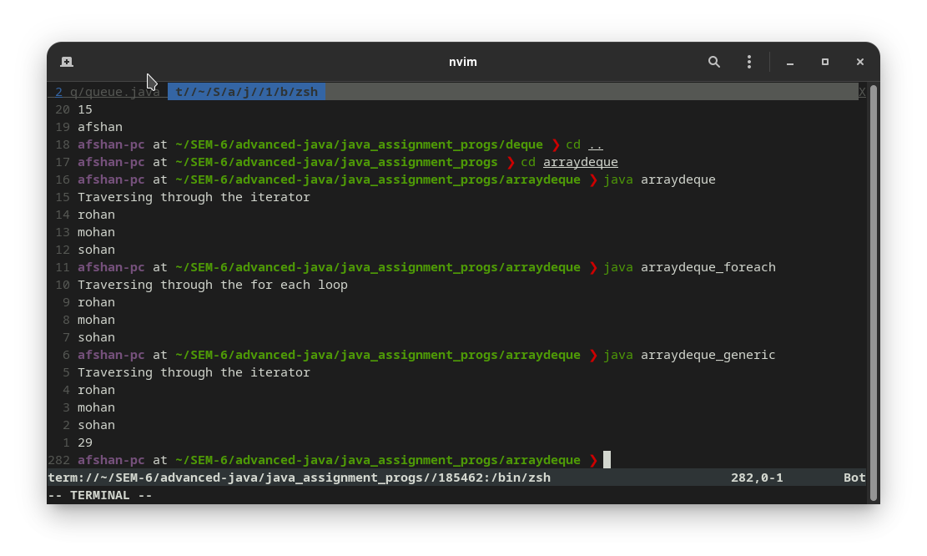
import java.util.*;

public class arraydeque_generic_foreach {
public static void main(String[] args) {
ArrayDeque obj = new ArrayDeque();
obj.add("rohan");
obj.add("mohan");
obj.add("sohan");
obj.add(34);

// Traversing elements
System.out.println("Traversing through the for each loop");
for (Object o : obj) {
System.out.println(o);
}
}
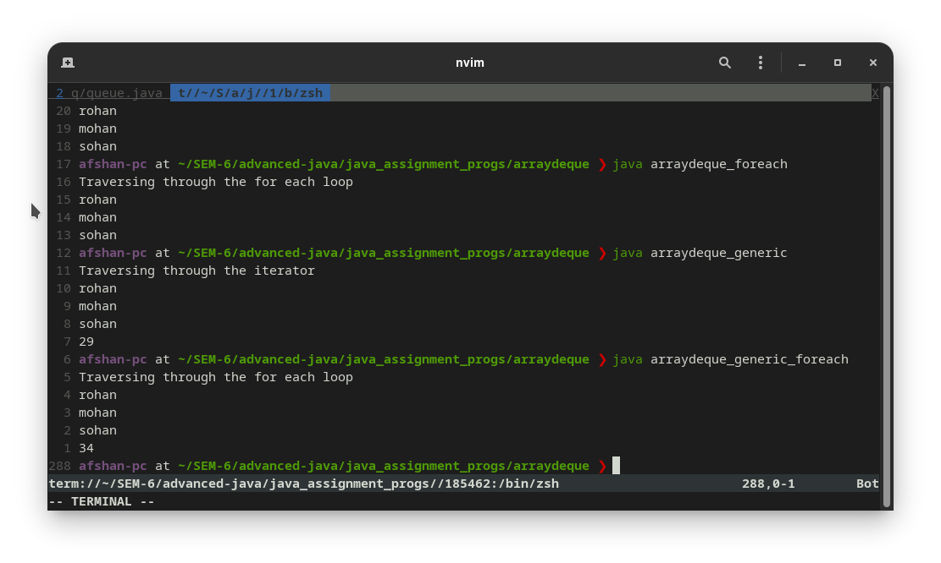
}
import java.util.Iterator;
import java.util.PriorityQueue;

class priorityqueue {
public static void main(String[] args) {

// Creating a priority queue
PriorityQueue numbers = new PriorityQueue();

// Using the add() method
numbers.add(4);
numbers.add(2);
numbers.add("ten");
numbers.add("seven");

// Using the offer() method
numbers.offer(1);
System.out.println("Updated PriorityQueue: " + numbers);

Iterator itr = numbers.iterator();
while (itr.hasNext()) {
System.out.println(itr.next());
}
}
}
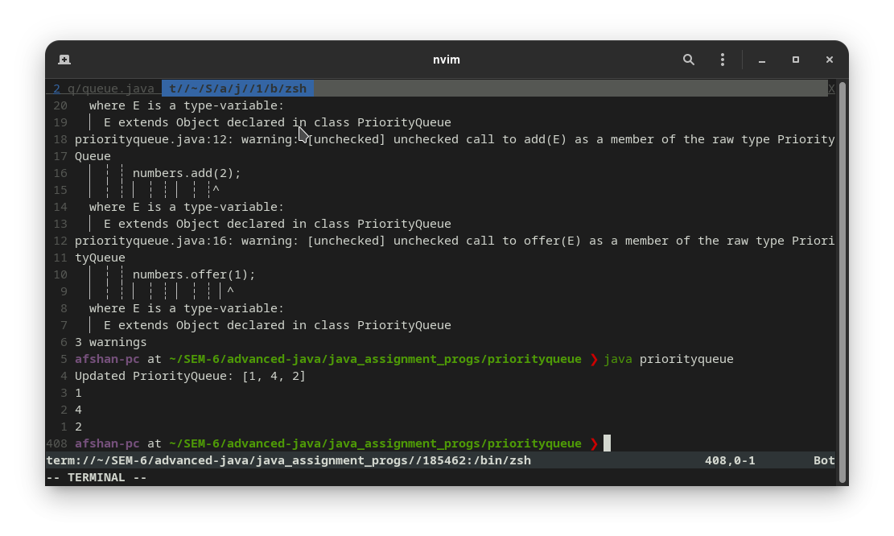
import java.util.PriorityQueue;

public class priorityqueue_foreach {
public static void main(String[] args) {

// Creating a priority queue
PriorityQueue numbers = new PriorityQueue();

// Using the add() method
numbers.add(4);
numbers.add(2);
numbers.add("ten");
numbers.add("seven");

// Using the offer() method
numbers.offer(1);
System.out.println("Updated PriorityQueue: " + numbers);

for (Object o : numbers ) {
System.out.println(o);
}
}
}

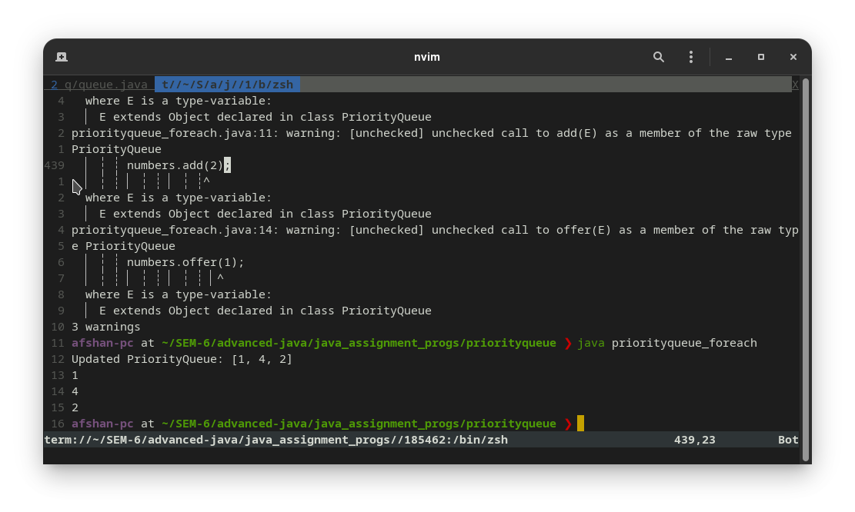
import java.util.Iterator;
import java.util.PriorityQueue;

class priorityqueue_generic_foreach{
public static void main(String[] args) {

// Creating a priority queue
PriorityQueue<Integer> numbers = new PriorityQueue<>();

// Using the add() method
numbers.add(4);
numbers.add(2);
System.out.println("PriorityQueue: " + numbers);

// Using the offer() method
numbers.offer(1);
System.out.println("Updated PriorityQueue: " + numbers);

for (int i : numbers) {
System.out.println(i);
}
}
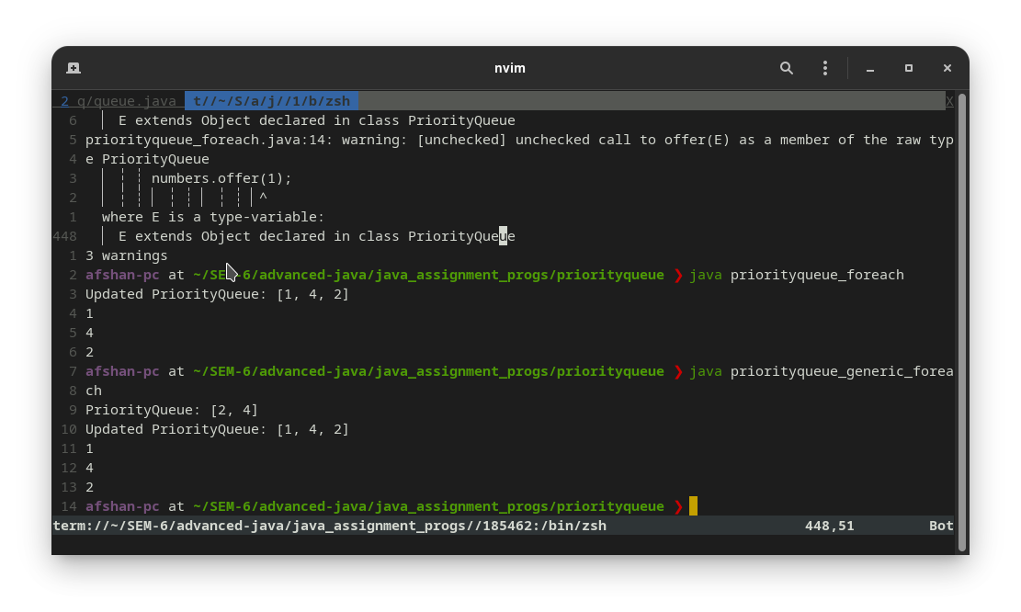
}
import java.util.Iterator;
import java.util.PriorityQueue;

class priorityqueue_generic {
public static void main(String[] args) {

// Creating a priority queue
PriorityQueue<Integer> numbers = new PriorityQueue<>();

// Using the add() method
numbers.add(4);
numbers.add(2);
numbers.add(5);

// Using the offer() method
numbers.offer(1);
System.out.println("Updated PriorityQueue: " + numbers);

Iterator<Integer> itr = numbers.iterator();
while (itr.hasNext()) {
System.out.println(itr.next());
}
}
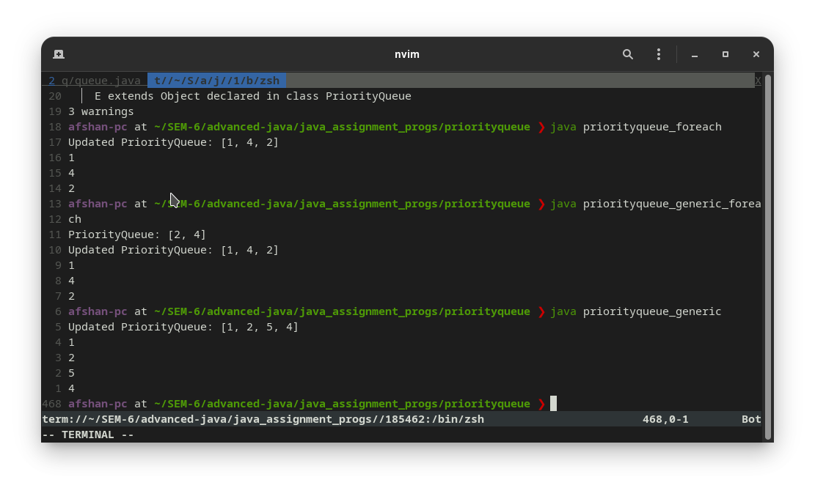
}
import java.util.HashMap;
import java.util.Iterator;
import java.util.Map;
import java.util.Map.Entry;
import java.util.Set;

public class hashmap {
public static void main(String[] args) {
HashMap<Integer,Character> alphabets = new HashMap<>();
alphabets.put(1, 'A');
alphabets.put(2, 'B');
alphabets.put(3, 'C');
alphabets.put(4, 'D');
alphabets.put(5, 'E');
//...

Set<Entry<Integer,Character>> alphabets_entry = alphabets.entrySet();
Iterator<Entry<Integer,Character>> itr = alphabets_entry.iterator();

while (itr.hasNext()) {
System.out.println(itr.next());
}
}
}

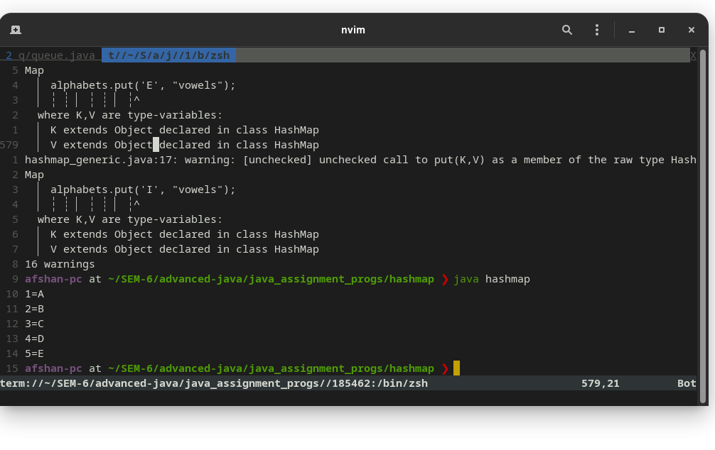
import java.util.HashMap;
import java.util.Map;
import java.util.Map.Entry;
import java.util.Set;

public class hashmap_foreach {
public static void main(String[] args) {
HashMap<Integer,Character> alphabets = new HashMap<>();
alphabets.put(1, 'A');
alphabets.put(2, 'B');
alphabets.put(3, 'C');
alphabets.put(4, 'D');
alphabets.put(5, 'E');
//...

Set<Entry<Integer,Character>> alphabets_entry = alphabets.entrySet();

for (Entry e : alphabets_entry ) {
System.out.println(e);
}
}
}

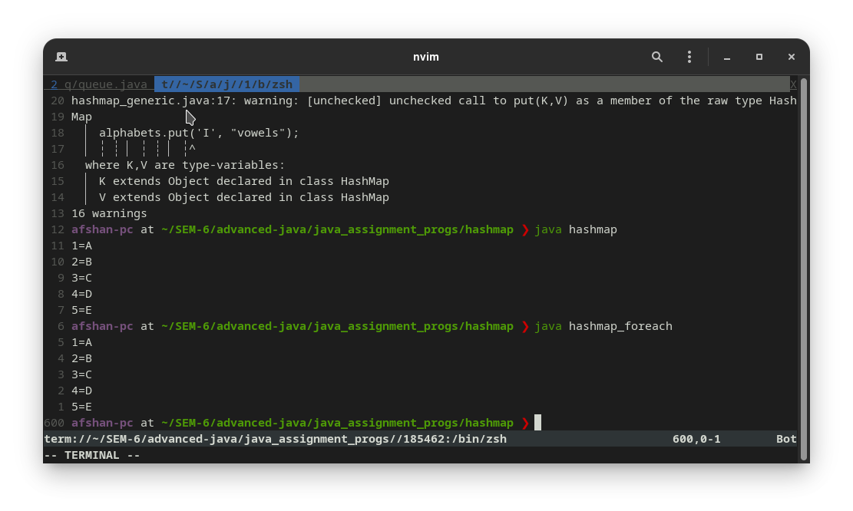
import java.util.HashMap;
import java.util.Iterator;
import java.util.Map;
import java.util.Map.Entry;
import java.util.Set;

public class hashmap_generic {
public static void main(String[] args) {
HashMap alphabets = new HashMap();
alphabets.put(1, 'A');
alphabets.put(2, 'B');
alphabets.put(3, 'C');
alphabets.put(4, 'D');
alphabets.put(5, 'E');
alphabets.put('A', "vowels");
alphabets.put('E', "vowels");
alphabets.put('I', "vowels");

Set alphabets_entry = alphabets.entrySet();
Iterator itr = alphabets_entry.iterator();

while (itr.hasNext()) {
System.out.println(itr.next());
}
}
}

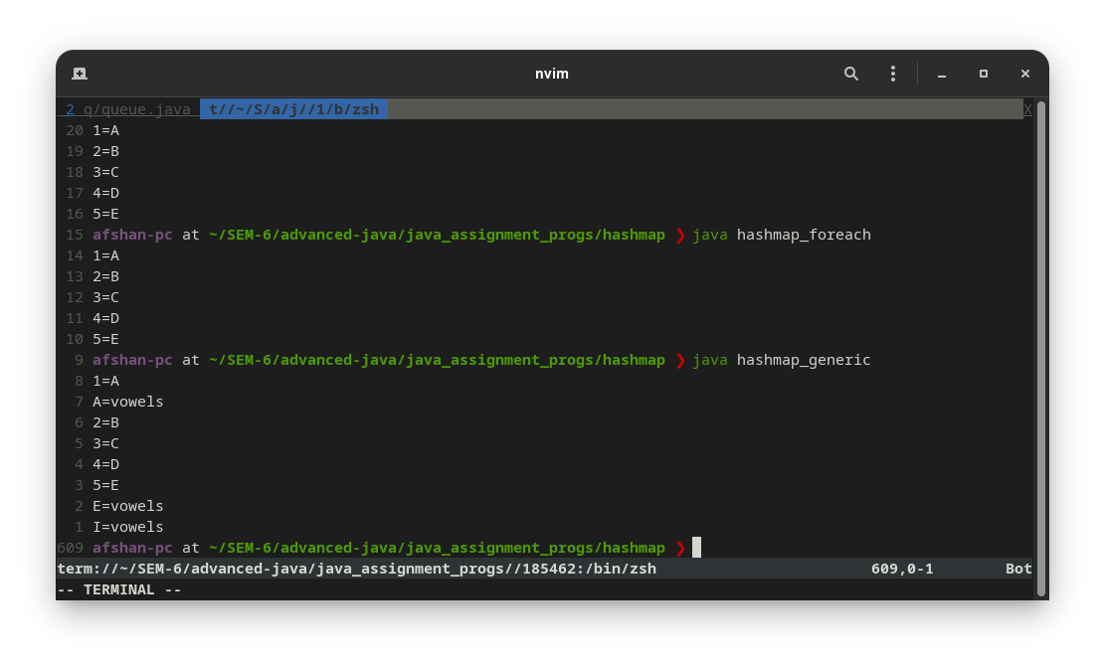
import java.util.HashMap;
import java.util.Iterator;
import java.util.Map;
import java.util.Map.Entry;
import java.util.Set;

public class hashmap_generic_foreach {
public static void main(String[] args) {
HashMap alphabets = new HashMap();
alphabets.put(1, 'A');
alphabets.put(2, 'B');
alphabets.put(3, 'C');
alphabets.put(4, 'D');
alphabets.put(5, 'E');
alphabets.put('A', "vowels");
alphabets.put('E', "vowels");
alphabets.put('I', "vowels");

//...

Set alphabets_entry = alphabets.entrySet();
for (Object o : alphabets_entry) {
System.out.println(o);
}
}
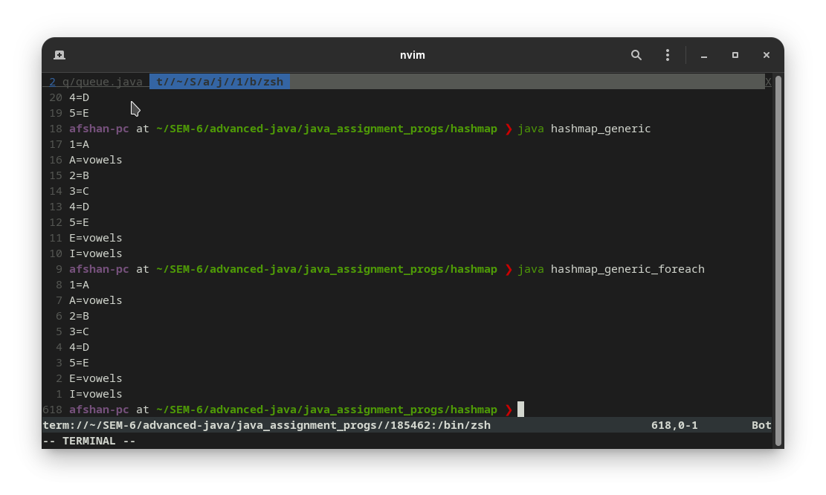
}
import java.util.Hashtable;
import java.util.Iterator;
import java.util.Set;
import java.util.Map.Entry;

public class hashtable {
public static void main(String[] args) {
Hashtable<Integer,String> studentsList = new Hashtable<>();
studentsList.put(1,"afshan");
studentsList.put(2,"rahul");
studentsList.put(3,"vinayak");
studentsList.put(4, "xersex");

Set<Entry<Integer,String>> entryset = studentsList.entrySet();
Iterator<Entry<Integer,String>> itr = entryset.iterator();

while (itr.hasNext()) {
System.out.println(itr.next());
}
}
}

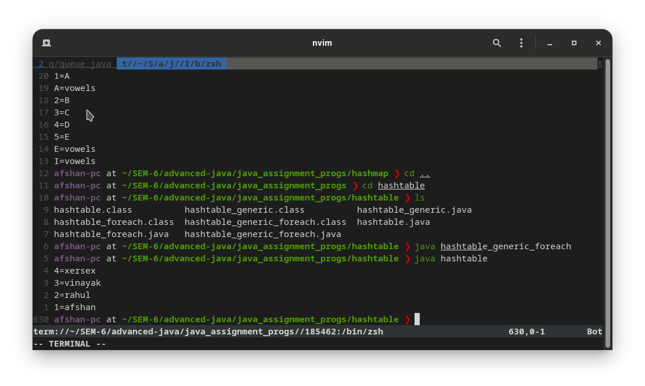
import java.util.Hashtable;
import java.util.Set;

public class hashtable_foreach {
public static void main(String[] args) {
Hashtable<Integer,String> studentsList = new Hashtable<>();
studentsList.put(1,"afshan");
studentsList.put(2,"rahul");
studentsList.put(3,"vinayak");
studentsList.put(4, "xersex");

System.out.println(studentsList);
Set set = studentsList.entrySet();
for (Object o : set) {
System.out.println(o);
}
}
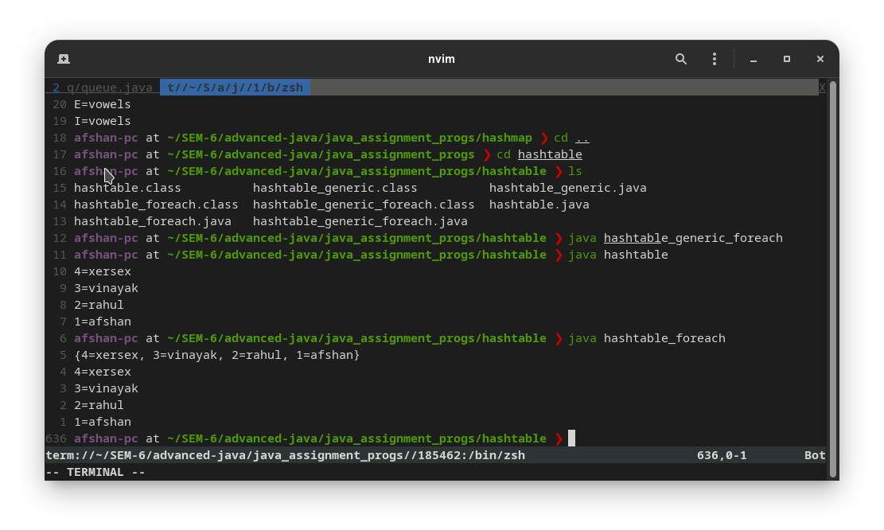
}
import java.util.Hashtable;
import java.util.Iterator;
import java.util.Set;
import java.util.Map.Entry;

public class hashtable_generic {
public static void main(String[] args) {
Hashtable studentsList = new Hashtable();
studentsList.put(1,"afshan");
studentsList.put(2,"rahul");
studentsList.put(3,"vinayak");
studentsList.put(4, "xersex");
studentsList.put("Nil", "Transfer certificate given");
studentsList.put(6, "zeus");

Set entryset = studentsList.entrySet();
Iterator itr = entryset.iterator();

while (itr.hasNext()) {
System.out.println(itr.next());
}
}
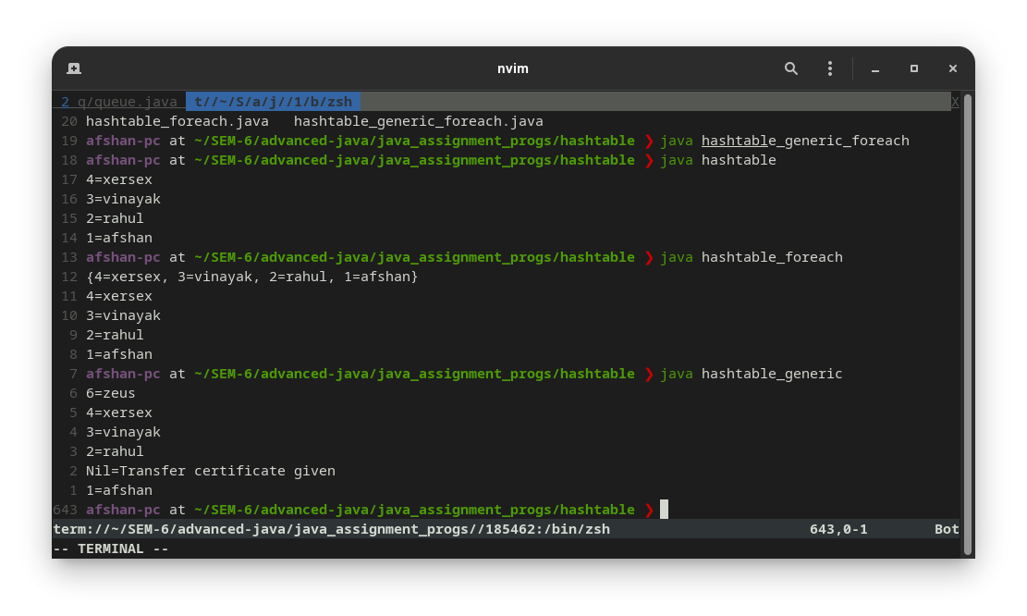
}
import java.util.Hashtable;
import java.util.Iterator;
import java.util.Set;
import java.util.Map.Entry;

public class hashtable_generic_foreach {
public static void main(String[] args) {
Hashtable studentsList = new Hashtable();
studentsList.put(1,"afshan");
studentsList.put(2,"rahul");
studentsList.put(3,"vinayak");
studentsList.put(4, "xersex");
studentsList.put("Nil", "Transfer certificate given");
studentsList.put(6, "zeus");

Set set = studentsList.entrySet();
for (Object o : set) {
System.out.println(o);
}

}
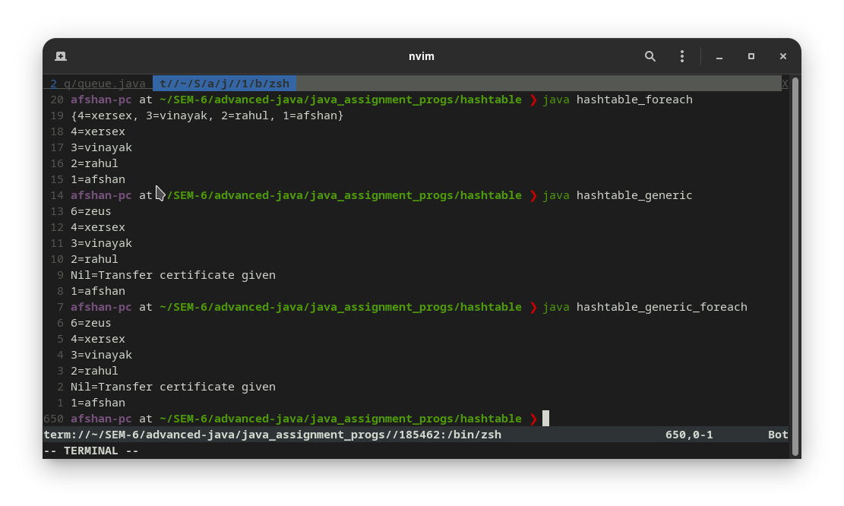
}
import java.util.*;

public class hashset {
public static void main(String[] args) {
HashSet<String> obj = new HashSet<>();
obj.add("rohan");
obj.add("sohan");
obj.add("mohan");
obj.add("konan");
// Traversing elements

Iterator<String> itr = obj.iterator();

while (itr.hasNext()) {
System.out.println(itr.next());
}
}
}

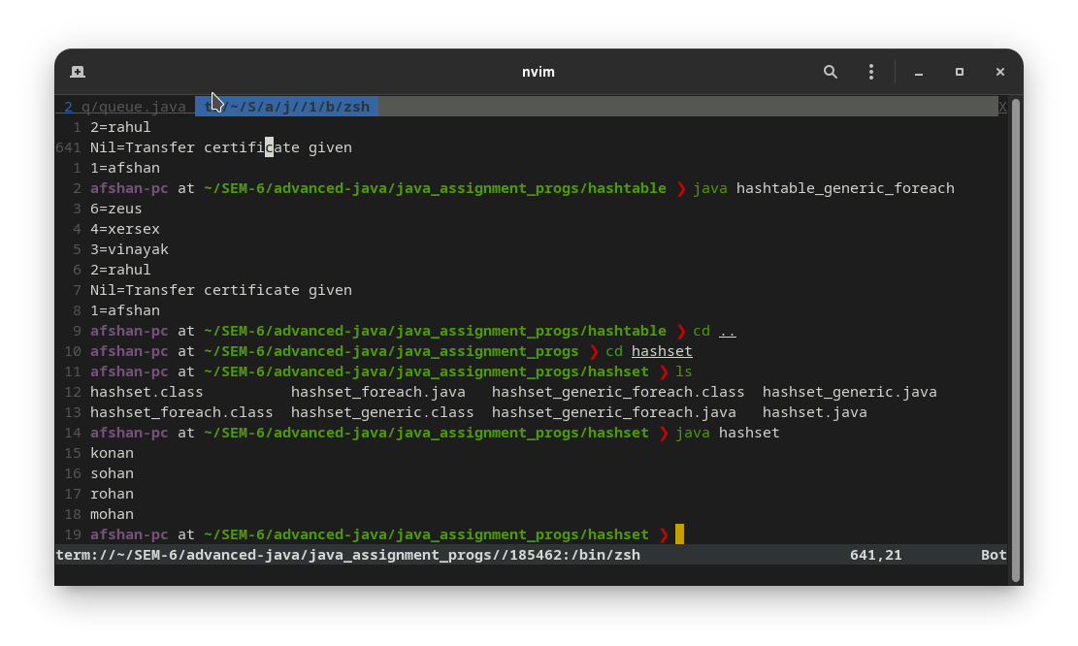
import java.util.*;

public class hashset_foreach {
public static void main(String[] args) {
HashSet<String> obj = new HashSet<>();
obj.add("rohan");
obj.add("sohan");
obj.add("mohan");
obj.add("konan");
// Traversing elements

for (String s : obj) {
System.out.println(s);
}
}
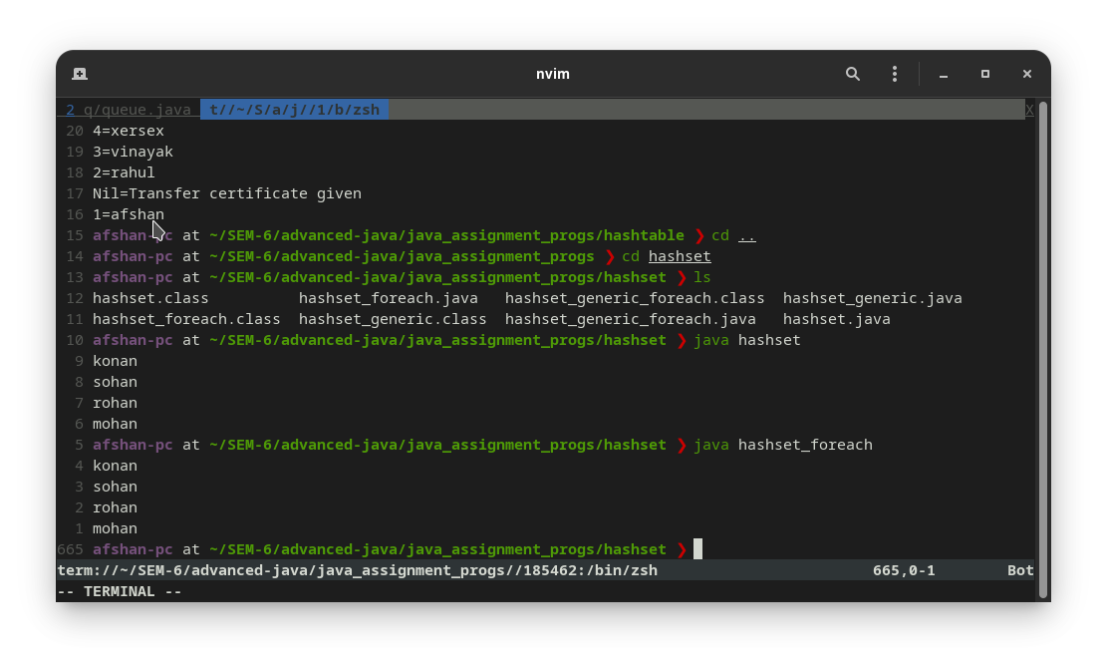
}
import java.util.*;

public class hashset_generic {
public static void main(String[] args) {
HashSet obj = new HashSet();
obj.add("rohan");
obj.add("sohan");
obj.add("mohan");
obj.add("konan");
obj.add(1);
obj.add(2.8);
// Traversing elements

Iterator itr = obj.iterator();

while (itr.hasNext()) {
System.out.println(itr.next());
}
}
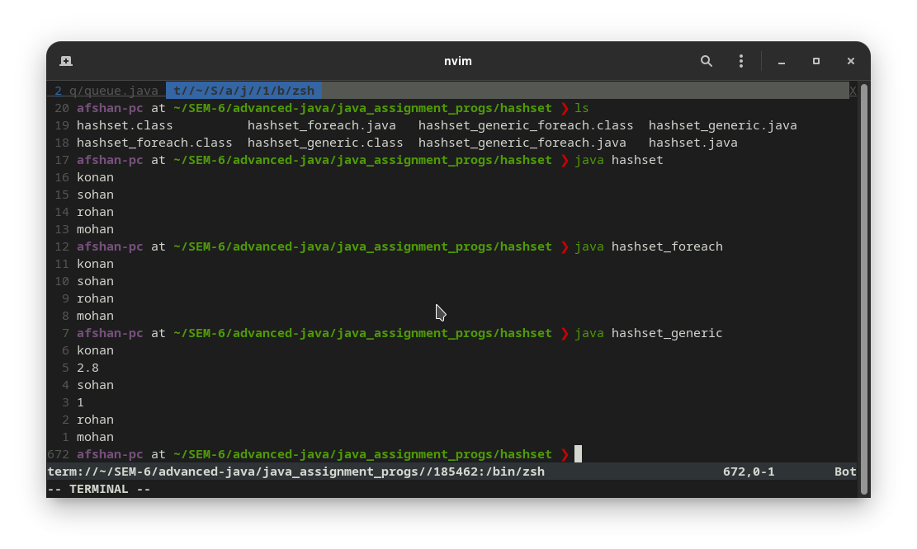
}
import java.util.*;

public class hashset_generic_foreach {
public static void main(String[] args) {
HashSet obj = new HashSet();
obj.add("rohan");
obj.add("sohan");
obj.add("mohan");
obj.add("konan");
obj.add(1);
obj.add(2.8);

// Traversing elements
for (Object o : obj) {
System.out.println(o);
}
}

}

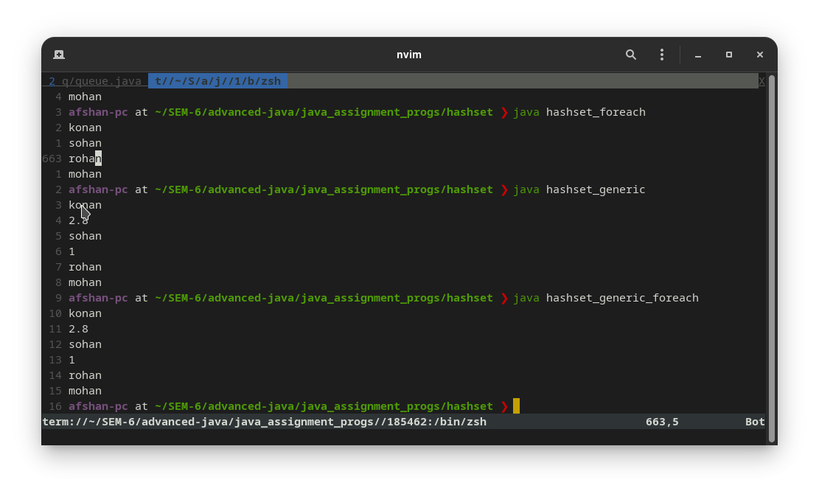
import java.util.*;

public class linkedlist {
public static void main(String args[]) {
LinkedList<String> a1 = new LinkedList<String>();
a1.add("afshan");
a1.add("ahmed");
a1.add("redoc");
a1.add("a2k");

Iterator<String> itr = a1.iterator();
System.out.println("Traversing list through iterator");
while (itr.hasNext()) {
System.out.println(itr.next());
}
}
}

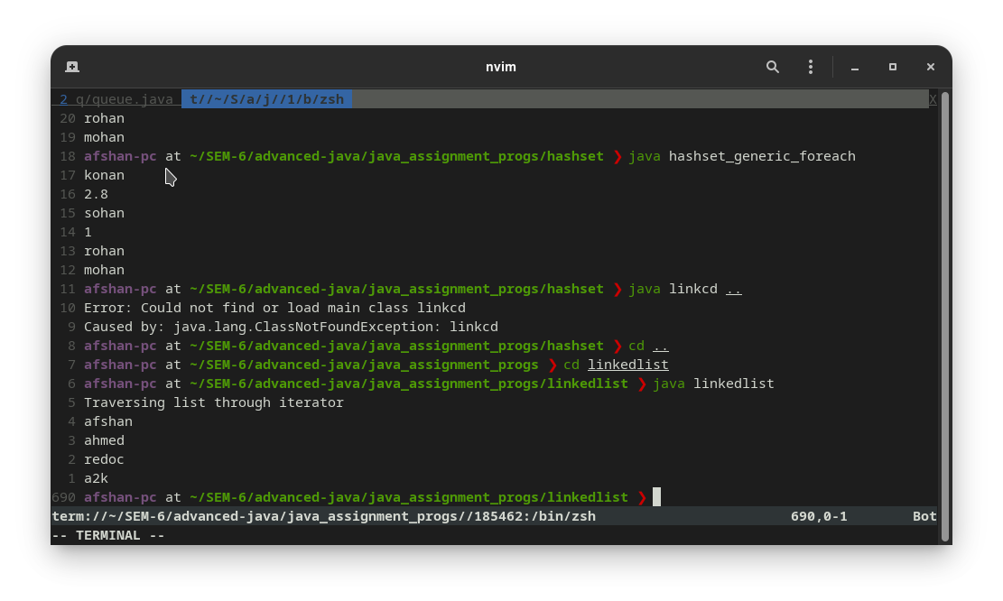
import java.util.*;

public class linkedlist_foreach {
public static void main(String args[]) {
LinkedList<String> a1 = new LinkedList<String>();
a1.add("afshan");
a1.add("ahmed");
a1.add("a2k");
a1.add("coder");

System.out.println("Traversing list through foreach loop");
for (String str : a1) {
System.out.println(str);
}
}
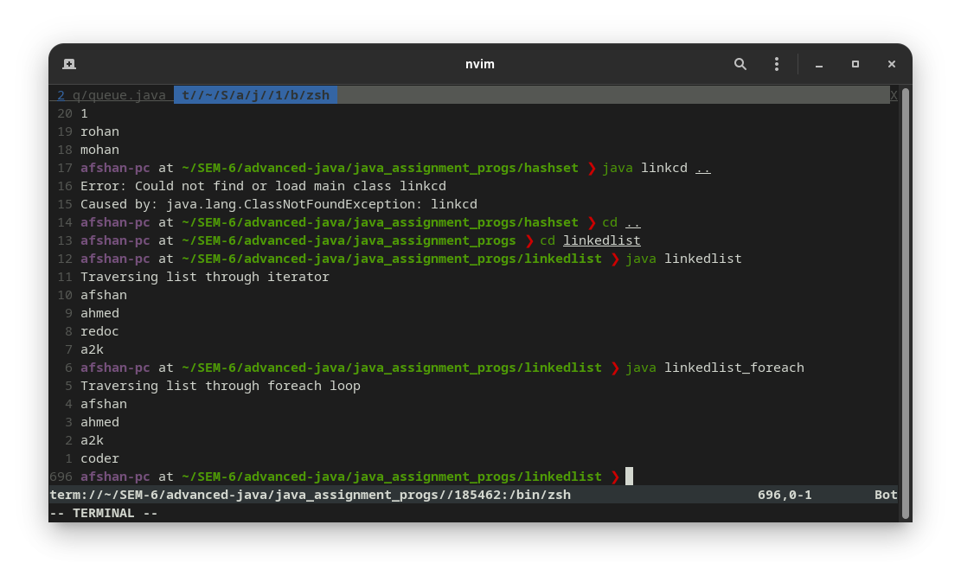
}
import java.util.Iterator;
import java.util.LinkedList;

public class linkedlist_generic {
public static void main(String[] args) {
LinkedList obj = new LinkedList();

obj.add("afshn");
obj.add("banna");
obj.add("ahmed");
obj.add(5);

obj.remove("4.5");
obj.remove(1);
obj.addFirst('A');

System.out.println("list " + obj);

obj.removeFirst();
System.out.println("list after removing first element " + obj);
obj.removeLast();
System.out.println("list after removing the first and last element " + obj);
System.out.println("index of orange is " + obj.indexOf("orange"));

Iterator itr = obj.iterator();
while (itr.hasNext()) {
System.out.println(itr.next());
}
}
}
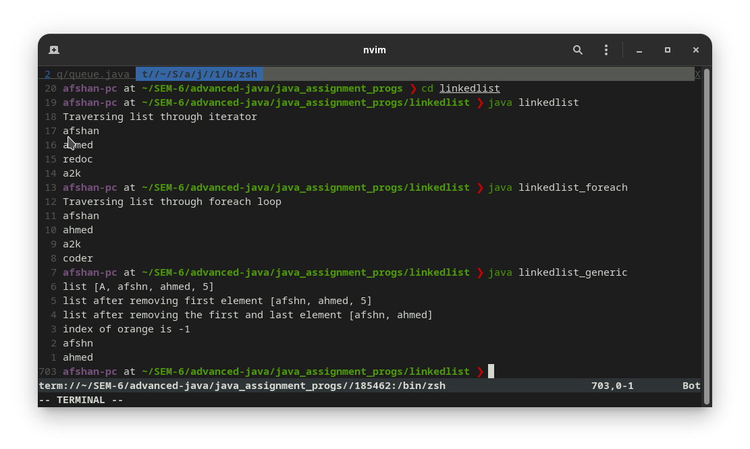
import java.util.*;
import java.util.LinkedList;

public class linkedlist_generic_foreach {
public static void main(String[] args) {

LinkedList obj = new LinkedList<>();
Scanner sc = new Scanner(System.in);
System.out.print("Enter a number- ");
int a = sc.nextInt();
for (int i = 1; i <= 10; i++) {
obj.add(i * a);
}
System.out.println("traversing with foreach loop");
for (Object in : obj) {
System.out.println(in);
}
sc.close();
}
}

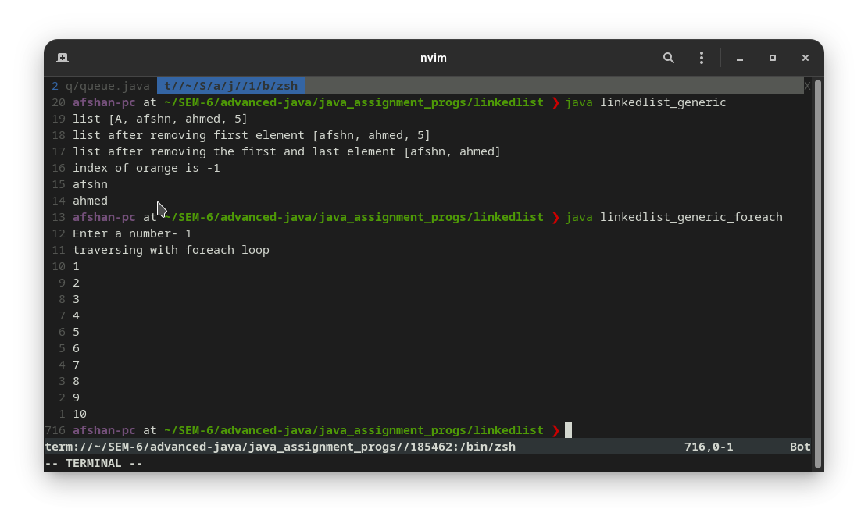
import java.util.Collections;
import java.util.Iterator;
import java.util.Vector;

public class vector {
public static void main(String[] args) {
Vector obj = new Vector();
obj.add("afshan");
obj.add("it-2k19-03");
obj.add("iips davv");
obj.insertElementAt(34, 3);
obj.insertElementAt(14, 4);
obj.insertElementAt(99, 5);
obj.remove(1);
obj.removeElement(34);
System.out.println("the last element of vector list is " + obj.lastElement());
System.out.println(obj);

Iterator itr = obj.iterator();
System.out.println("Traversing through iterators");
while (itr.hasNext()) {
System.out.println(itr.next());
}
System.out.println("On replacing iips-davv ");
obj.set(2, "International institute of proffessional studys");
System.out.println(obj);

System.out.println("the hash code of given vector is " + obj.hashCode());
}
}

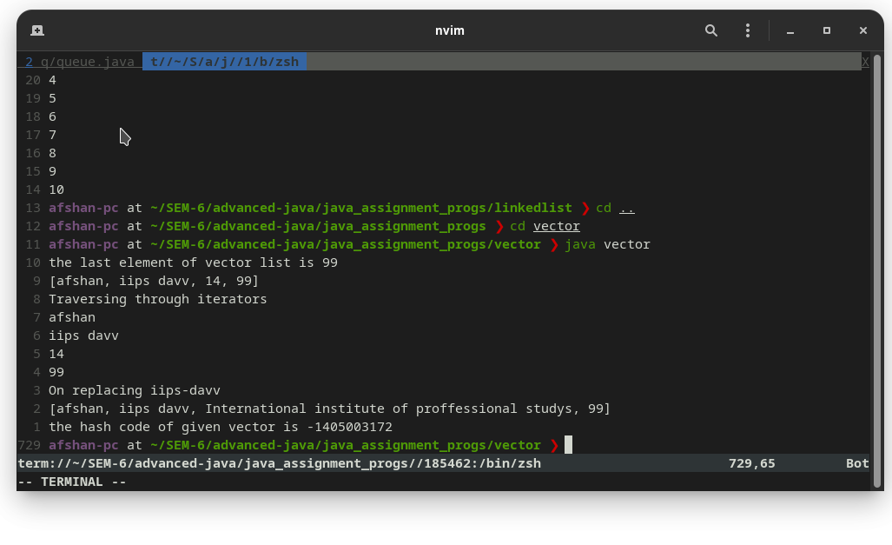
import java.util.*;

public class vector_foreach {
public static void main(String args[]) {
// initial capacity=4
Vector obj = new Vector(4);

obj.add(2);
obj.add("ramesh");
obj.add("suresh");
obj.add("mahesh");
obj.add("kamlesh");
obj.add(1);
// Check size and capacity
System.out.println("Size is: " + obj.size());
System.out.println("Default capacity is: " + obj.capacity());

obj.addElement("mohan");
obj.addElement("sohan");
obj.addElement("rohan");

System.out.println("Size after insertion of more element: " + obj.size());
System.out.println("Capacity after insertion is: " + obj.capacity());

System.out.println("Elements are: " + obj);
// Checking if student is present or not in this vector
if (obj.contains("ramesh")) {
System.out.println("ramesh is present at the index " + obj.indexOf("ramesh"));
} else {
System.out.println("ramesh is not present in the list.");
}
// Get the first element
System.out.println("The first student of the vector list is = " + obj.firstElement());
// Get the last element
System.out.println("The last student of the vector list is = " + obj.lastElement());

System.out.println("student vector list print through for each loop :-");
for (Object i : obj) {
System.out.println(i);
}
}
}
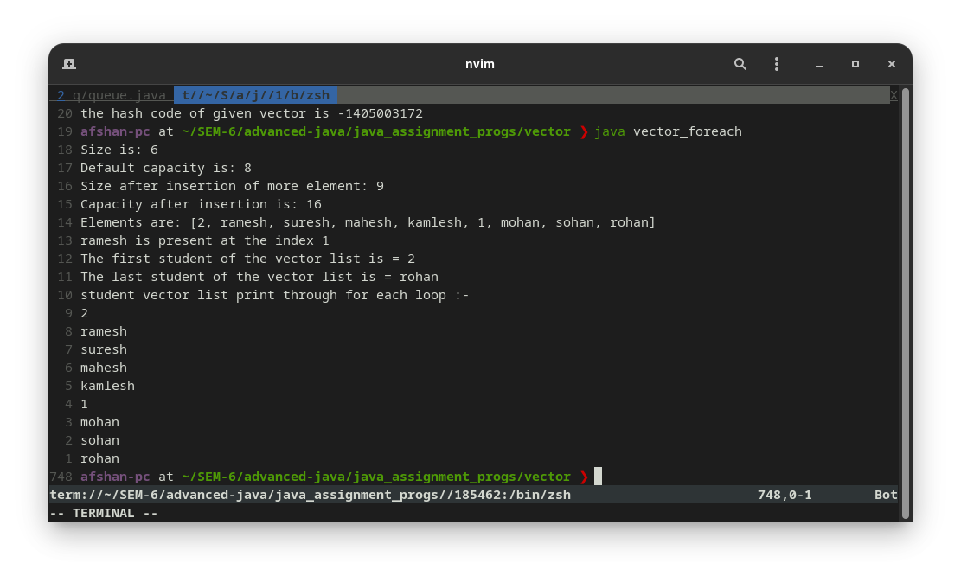
import java.util.*;

public class vector_generic {

public static void main(String[] args) {
Vector<Integer> obj = new Vector<Integer>();
obj.add(5);
obj.add(6);
obj.add(7);
obj.add(1, 45);// in 1st place 45 is inserted
System.out.println("The capacity of vector list is " + obj.capacity());

Iterator<Integer> itr = obj.iterator();
System.out.println(obj);
System.out.println("Traversing vector list through iterator");
while (itr.hasNext()) {
System.out.println(itr.next());
}
obj.clear();
System.out.println("now the list is cleared " + obj);
}
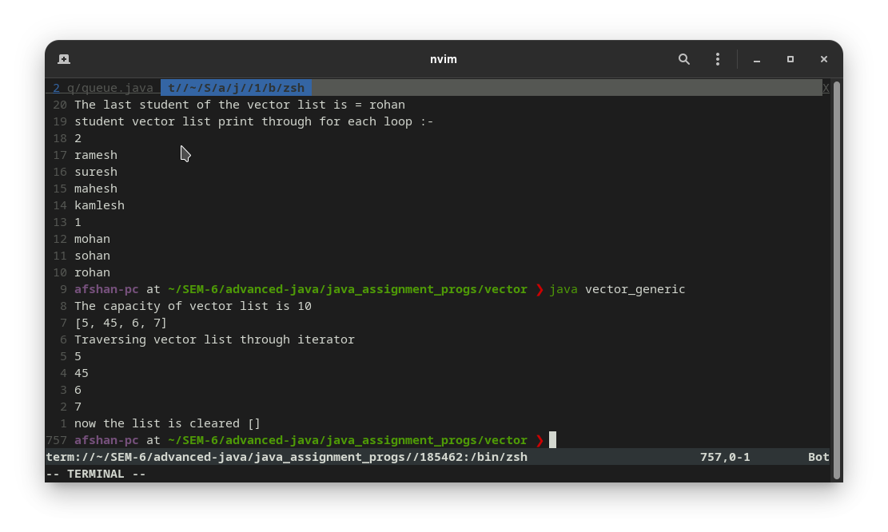
}
import java.util.*;

public class vector_generic_foreach {

public static void main(String[] args) {
Vector<Integer> obj = new Vector<Integer>();
obj.add(5);
obj.add(6);
obj.add(7);
obj.add(1, 45);// in 1st place 45 is inserted
System.out.println("The capacity of vector list is " + obj.capacity());

System.out.println("Traversing vector list through foreach loop");
for (Integer in : obj) {
System.out.println(in);
}
obj.clear();
System.out.println("now the list is cleared " + obj);
}
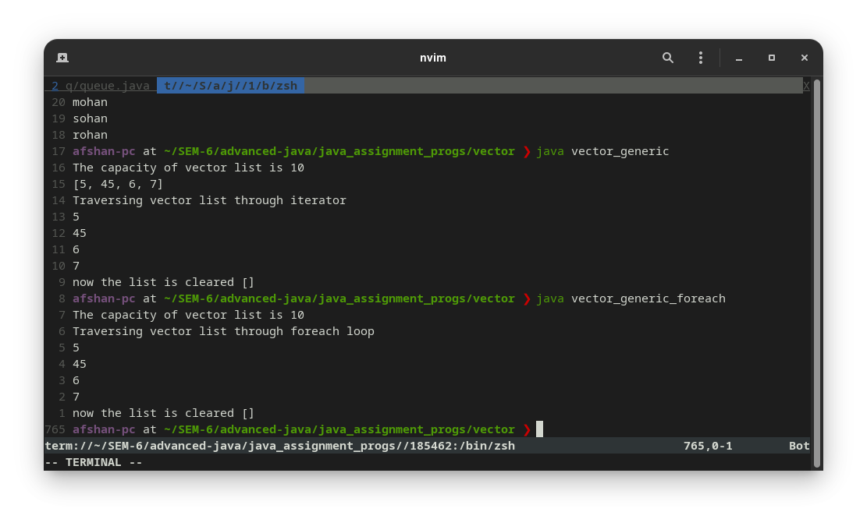
}
import java.util.*;

public class stack {
public static void main(String[] args) {
// Creating a Stack
Stack nos = new Stack();
// pushing values in stack
nos.push("This is the start");
for (int i = 0; i <= 10; i++) {
nos.push(i);
}
nos.push("This is the end");

System.out.println("Traversing with Iterators");
Iterator itr = nos.iterator();
while (itr.hasNext()) {
System.out.println(itr.next());
}

System.out.println("after removing the element at index 1");
nos.removeElementAt(1);
System.out.println(nos);

// printing the stack
System.out.println("Print Stack before pop:");
System.out.println(nos);
System.out.println("Position of 8 from the top is " + nos.search(8));
System.out.println("Position of 10 from the top is " + nos.search(10));

// returning the number at the top of the stack and removing it
System.out.println("pop => " + nos.pop());
System.out.println("pop => " + nos.pop());
System.out.println("pop => " + nos.pop());

// printing the stack
System.out.println("Print Stack after pop:");
System.out.println(nos);
// accessing the number at the top of the stack but not removing it
System.out.println("Number on top of the stack is => " + nos.peek());
// checking if the stack is empty or not
System.out.println("Is stack empty? Ans:" + nos.empty());
}
}
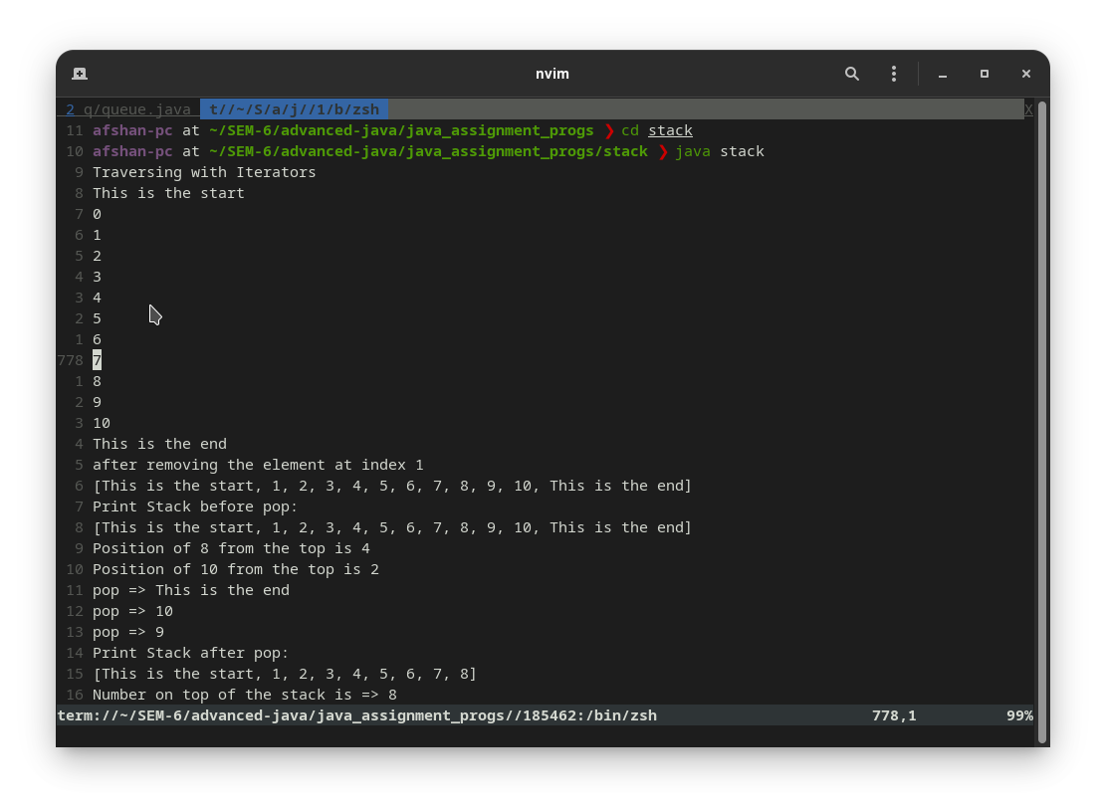
import java.util.Iterator;
import java.util.Stack;

public class stack_generic {
public static void main(String[] args) {
Stack<String> obj = new Stack<>();
obj.push("afshan");
obj.push("ahmed");
obj.push("rohan");
obj.push("mohan");
obj.pop();
System.out.println("size of stack is " + obj.size());
System.out.println("capacity is " + obj.capacity());
System.out.println("is stacj empty?" + obj.empty());
System.out.println("speek of stack -" + obj.peek());
System.out.println("last element of stack is - " + obj.lastElement());
System.out.println("the index of rai is " + obj.search("rai"));

Iterator<String> itr = obj.iterator();

System.out.println("Traversing the stack through the iterator");
while (itr.hasNext()) {
System.out.println(itr.next());
}
}
}

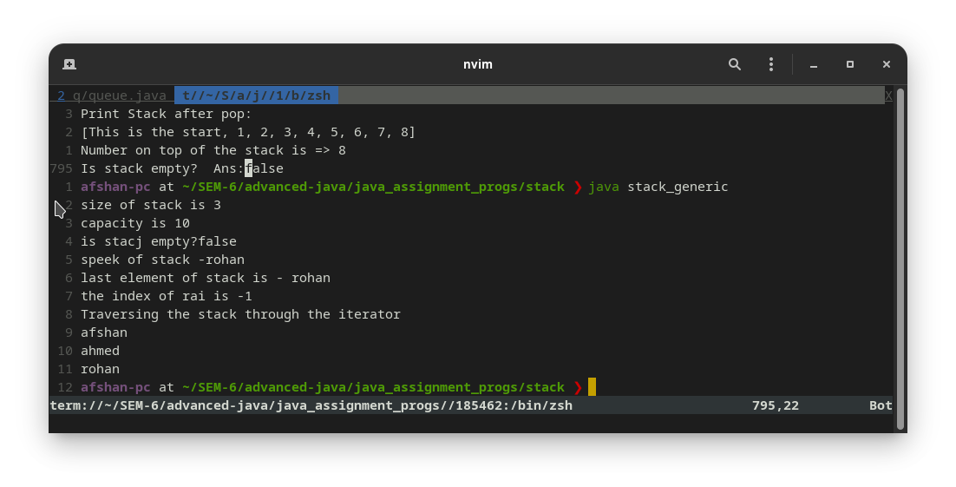
import java.util.Stack;
import java.util.Vector;

public class stack_foreach {
public static void main(String[] args) {
Stack stk = new Stack();
// pushing elements into Stack
stk.push("tomato");
stk.push("brinjal");
stk.push("cauliflower");
stk.push("chilli");
stk.push(1);
stk.push(2);

boolean rsult = stk.empty();
System.out.println("Is the stack empty or not? " + rsult);

int x = stk.size();
System.out.println("The stack size is: " + x);
System.out.println("Stack: " + stk);
// Access element from the top of the stack
Object vegetable = stk.peek();
// prints stack
System.out.println("Element at top: " + vegetable);

System.out.println("By for each loop");
for (Object i : stk) {
System.out.println(i);
}
}

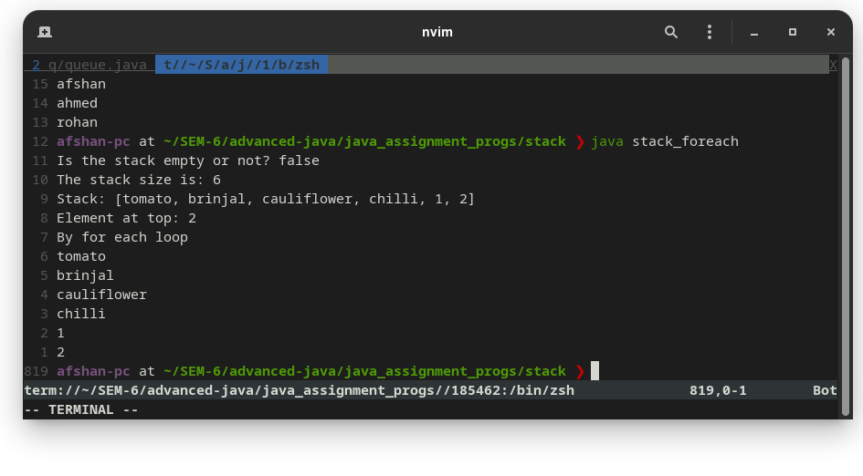
}
import java.util.Stack;

public class stack_generic_foreach {
public static void main(String[] args) {
Stack<String> obj = new Stack<>();
obj.push("afshan");
obj.push("ahmed");
obj.push("rohan");
obj.push("mohan");
obj.pop();
System.out.println("size of stack is " + obj.size());
System.out.println("capacity is " + obj.capacity());
System.out.println("is stacj empty?" + obj.empty());
System.out.println("speek of stack -" + obj.peek());
System.out.println("last element of stack is - " + obj.lastElement());
System.out.println("the index of rai is " + obj.search("rai"));

System.out.println("Traversing the stack through the foreach");
for (String s : obj) {
System.out.println(s);
}
}
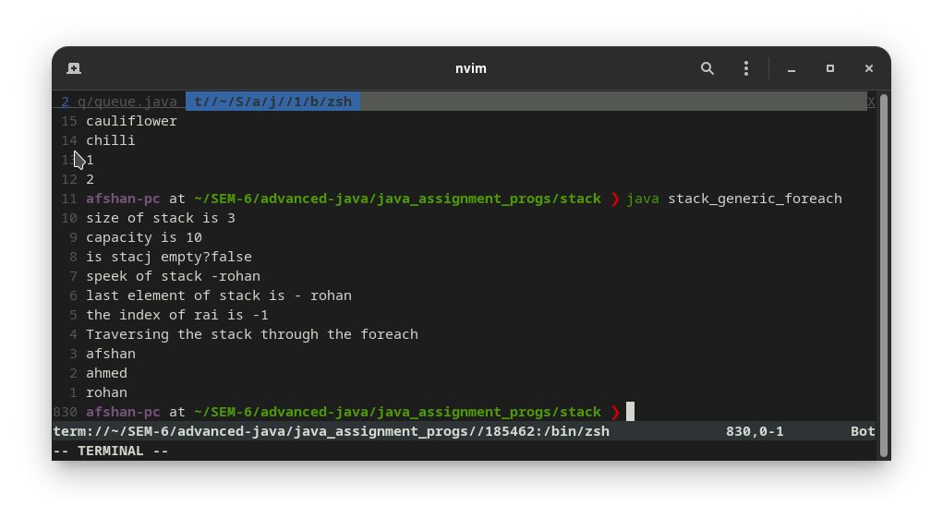
}
import java.util.HashMap;
import java.util.Iterator;
import java.util.Map;
import java.util.Map.Entry;
import java.util.Set;

public class map {
public static void main(String[] args) {
Map<Integer,Character> alphabets = new HashMap<>();
alphabets.put(1, 'A');
alphabets.put(2, 'B');
alphabets.put(3, 'C');
alphabets.put(4, 'D');
alphabets.put(5, 'E');
//...

Set<Entry<Integer,Character>> alphabets_entry = alphabets.entrySet();
Iterator<Entry<Integer,Character>> itr = alphabets_entry.iterator();

while (itr.hasNext()) {
System.out.println(itr.next());
}
}
}

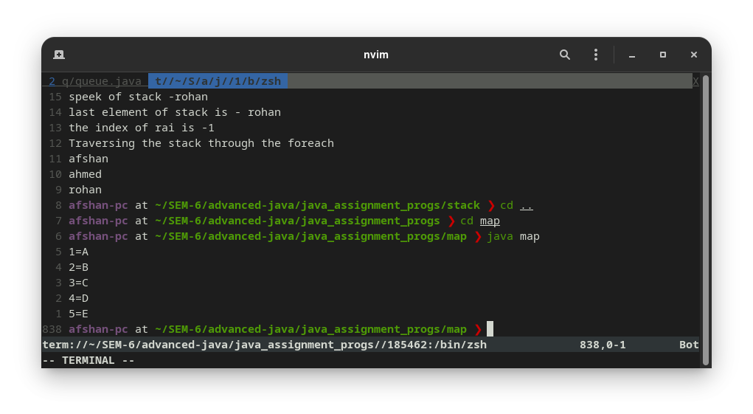
import java.util.HashMap;
import java.util.Iterator;
import java.util.Map;
import java.util.Map.Entry;
import java.util.Set;

public class map_generic {
public static void main(String[] args) {
Map alphabets = new HashMap();
alphabets.put(1, 'A');
alphabets.put(2, 'B');
alphabets.put(3, 'C');
alphabets.put(4, 'D');
alphabets.put(5, 'E');
alphabets.put('A', "vowels");
alphabets.put('E', "vowels");
alphabets.put('I', "vowels");

Set alphabets_entry = alphabets.entrySet();
Iterator itr = alphabets_entry.iterator();

while (itr.hasNext()) {
System.out.println(itr.next());
}
}
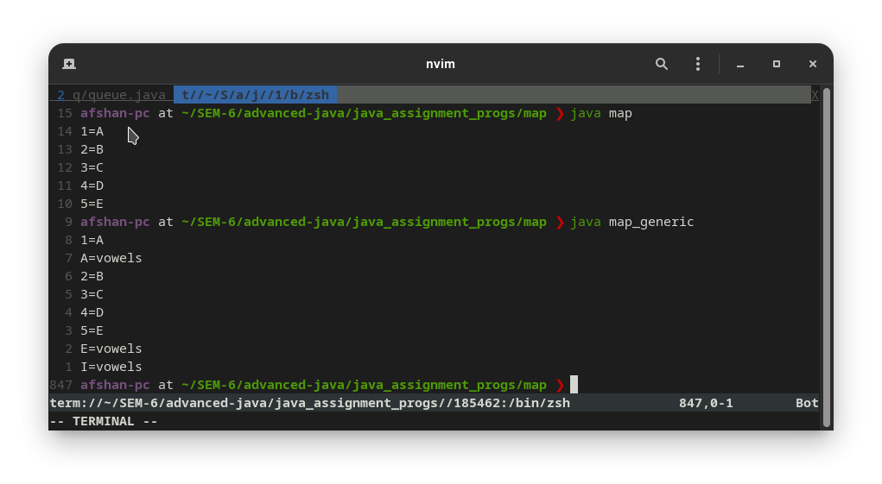
}
import java.util.HashMap;
import java.util.Iterator;
import java.util.Map;
import java.util.Map.Entry;
import java.util.Set;

public class map_generic_foreach {
public static void main(String[] args) {
Map alphabets = new HashMap();
alphabets.put(1, 'A');
alphabets.put(2, 'B');
alphabets.put(3, 'C');
alphabets.put(4, 'D');
alphabets.put(5, 'E');
alphabets.put('A', "vowels");
alphabets.put('E', "vowels");
alphabets.put('I', "vowels");

//...

Set alphabets_entry = alphabets.entrySet();
for (Object o : alphabets_entry) {
System.out.println(o);
}
}
}

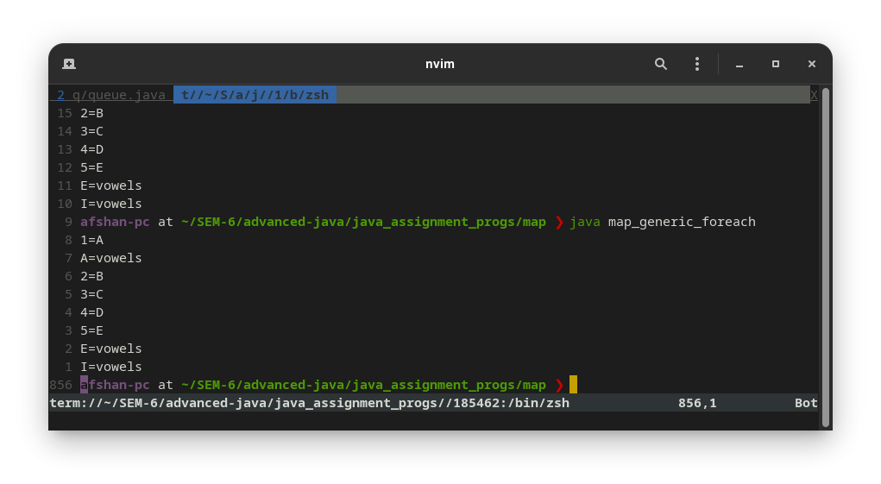
import java.util.HashMap;
import java.util.Map;
import java.util.Map.Entry;
import java.util.Set;

public class map_foreach {
public static void main(String[] args) {
Map<Integer,Character> alphabets = new HashMap<>();
alphabets.put(1, 'A');
alphabets.put(2, 'B');
alphabets.put(3, 'C');
alphabets.put(4, 'D');
alphabets.put(5, 'E');
//...

Set<Entry<Integer,Character>> alphabets_entry = alphabets.entrySet();

for (Entry e : alphabets_entry ) {
System.out.println(e);
}
}



