Android Instrumented Test (Espresso)

This documentation is about testing the UI of Android Applications

Android has mainly two types of tests:

Unit Tests
Unit tests means testing every method/function (or unit) of your code for e.g: given a function, calling it with param x should return y. These tests are run on JVM locally without the need of an emulator or Device.

Instrumentation Testing
Instrumentation tests are used for testing Android Frameworks such as UI,SharedPreferences and So on.Since they are for Android Framework they are run on a device or an emulator.
Instrumentation tests use a separate apk for the purpose of testing. Thus, every time a test case is run, Android Studio will first install the target apk on which the tests are conducted. After that, Android Studio will install the test apk which contains only test related code.

What is Espresso?

Espresso is an instrumentation Testing framework made available by Google for the ease of UI Testing. Compared to other Android user interface (UI) testing tools, Espresso provides synchronization of test actions with the UI. This means that Espresso knows when the UI thread of an application is idle, and will run test code at the appropriate times. Previously, other workarounds were needed (e.g. sleeping for a certain amount of time before executing the next instruction). Since the release of Espresso v2.0, the testing framework is available as part of the Android Support Repository and now supports Junit4.

Setting Up Espresso in Android

Go to your app/build.gradle
1. Add following dependencies

androidTestCompile 'com.android.support.test.espresso:espresso-core:2.2.2', {
exclude group: 'com.android.support', module: 'support-annotations'
}
androidTestCompile 'com.android.support.test:runner:0.5',{
exclude group: 'com.android.support', module: 'support-annotations'
}

2. Add to the same build.gradle file the following line in

android{
...
defaultConfig{
...
testInstrumentationRunner "android.support.test.runner.AndroidJUnitRunner"

}
}

As demonstrated in the image below:

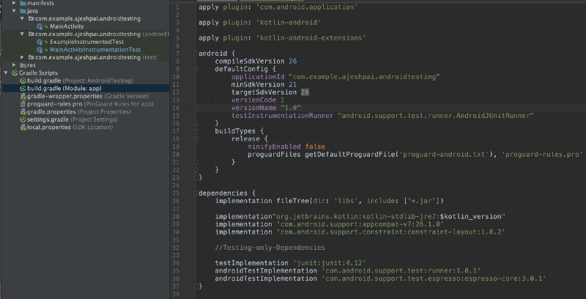
AndroidJUnitRunner is the instrumentation runner. This is essentially the entry point into running your entire suite of tests. It controls the test environment, the test apk, and launches all of the tests defined in your test package.

Note: After adding dependencies in app/build.gradle file, sync the project by clicking sync button in order to take its effect.

Getting Started

In order to test a UI create a new test class in the Location.
module-name/src/androidTest/java/
And annotate it with @RunWith(AndroidJUnit4::class)

The instrumentation runner will process each test class and inspect its annotations. It will determine which class runner is set with @RunWith, initialize it, and use it to run the tests in that class. In Android’s case, the AndroidJUnitRunner explicitly checks if the AndroidJUnit4 class runner is set to allow passing configuration parameters to it.
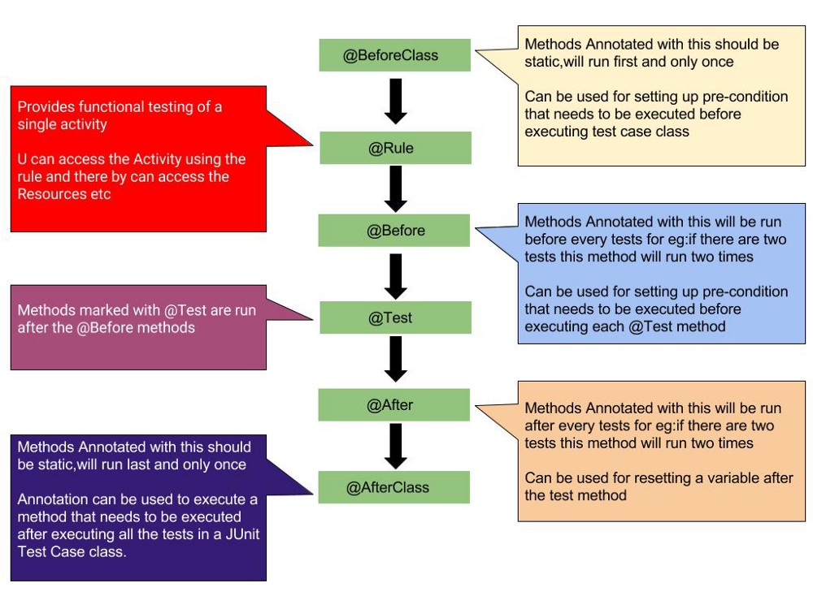
There are 6 types of annotations that can be applied to the methods used inside the test class,which are @Test, @Before, @BeforeClass, @After, @AfterClass, @Rule

Important things to note is that
- The activity will be launched using the @Rule before test code begins
- By default the rule will be initialised and the activity will be launched(onCreate, onStart, onResume) before running every @Before method
- Activity will be Destroyed(onPause, onStop, onDestroy) after running the @After method which in turn is called after every @Test Method
- The activity’s launch can be postponed by setting the launchActivity to false in the constructor of ActivityTestRule, in that case you will have to manually launch the activity before the tests

Note:You can have more than one method annotated with any of the annotations like @Before,@Beforeclass etc. But the order in which JUnit finds methods is not guaranteed.Like if there is two methods annotated with @Before, There is no guarantee which one will be executed.

Writing Tests
The espresso test of a view contains
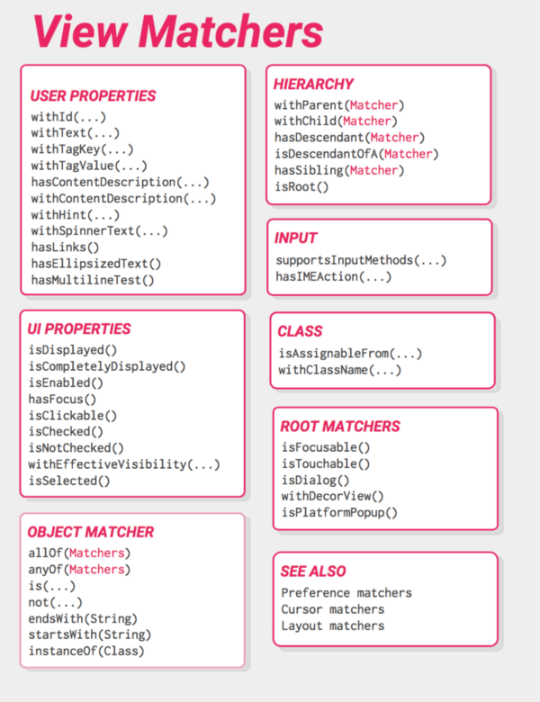
1. Finding a View using a ViewMatcher

Espresso uses onView() method to find a particular view among the View hierarchy. onView()
method takes a Matcher as argument. Espresso provides number of ViewMatchers as showed in above diagram.
Every UI element contains properties or attributes which can be used to find the element with

android:id=“+id/login_button”

2. Performing actions on the view
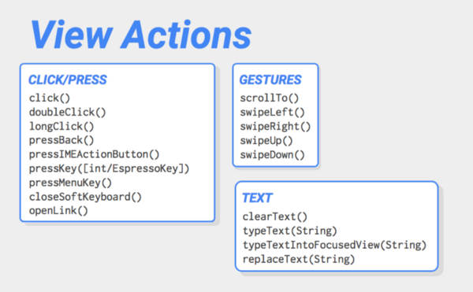
After finding the View you can perform actions on the View or on its Descendant using ViewActions of the Espresso. Some of the Most common actions are click(), clearText() etc.

Note: In cases where the View isn’t directly visible such as in a case where the view is in a scroll view and isn’t you will have to perform the scrollTo() function first and then perform the action.

E.g.
Espresso.onView(withId(R.id.login_button)).perform(click())

3. Checking the ViewAssertions
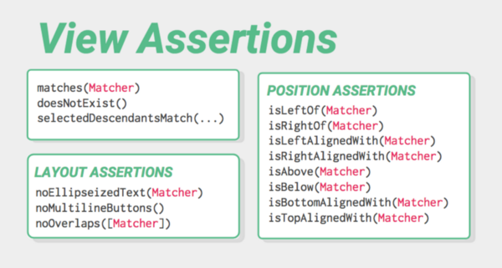
After performing an action on the View we would want to see if the view behaves as we want, this can be done using check(ViewAssertion viewAssert)

E.g. Espresso.onView(withId(R.id.login_result)).check(matches(withText(R.string.login_success)))

The following code demonstrates the usage of the Espresso test framework

package com.vogella.android.espressofirst;

import android.support.test.rule.ActivityTestRule;
import android.support.test.runner.AndroidJUnit4;

import org.junit.Rule;
import org.junit.Test;
import org.junit.runner.RunWith;

import static android.support.test.espresso.Espresso.onView;
import static android.support.test.espresso.action.ViewActions.click;
import static android.support.test.espresso.action.ViewActions.closeSoftKeyboard;
import static android.support.test.espresso.action.ViewActions.typeText;
import static android.support.test.espresso.assertion.ViewAssertions.matches;

import static android.support.test.espresso.matcher.ViewMatchers.withId;
import static android.support.test.espresso.matcher.ViewMatchers.withText;

@RunWith(AndroidJUnit4.class)
public class MainActivityEspressoTest {

@Rule
public ActivityTestRule<MainActivity> mActivityRule =
new ActivityTestRule<>(MainActivity.class);

@Test
public void ensureTextChangesWork() {
// Type text and then press the button.
onView(withId(R.id.inputField))
.perform(typeText("HELLO"), closeSoftKeyboard());
onView(withId(R.id.changeText)).perform(click());

// Check that the text was changed.
onView(withId(R.id.inputField)).check(matches(withText("Lalala")));
}

@Test
public void changeText_newActivity() {
// Type text and then press the button.
onView(withId(R.id.inputField)).perform(typeText("NewText"),
closeSoftKeyboard());
onView(withId(R.id.switchActivity)).perform(click());

// This view is in a different Activity, no need to tell Espresso.
onView(withId(R.id.resultView)).check(matches(withText("NewText")));
}
}

If Espresso does not find a view via the ViewMatcher, it includes the whole view hierarchy into the error message. That is useful for analyzing the problem.

Run your tests
Right click on your test and select Run as below
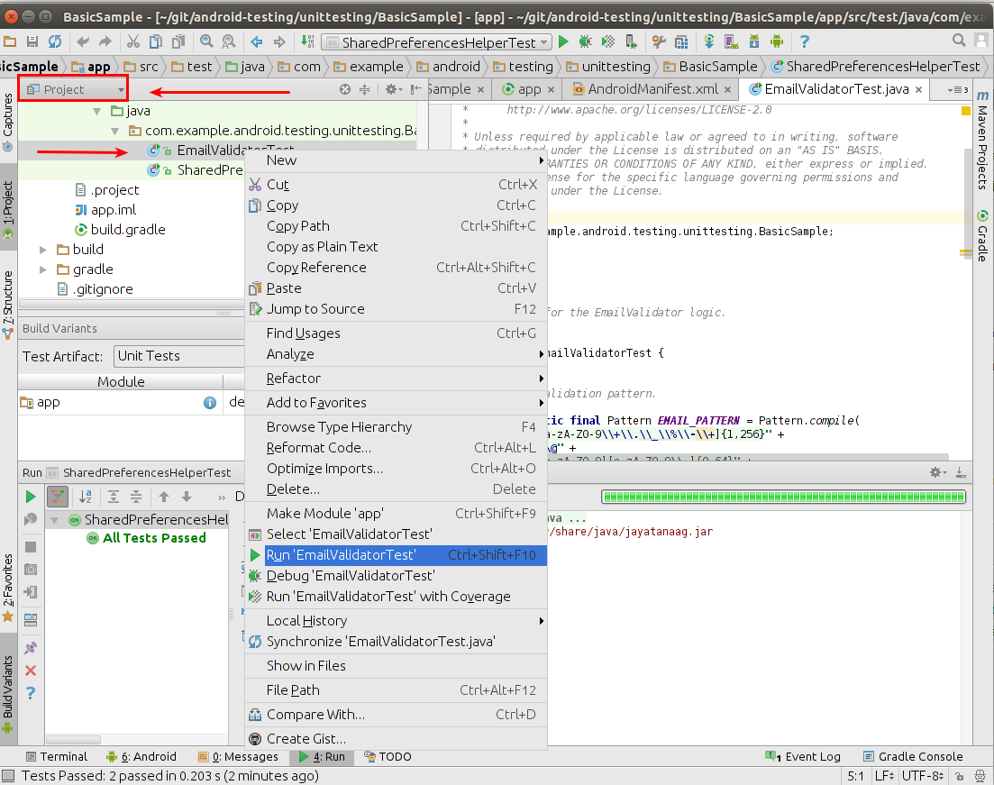

Device Settings
It is recommended to turn off the animation on the Android device which is used for testing. Animations might confusing Espresso’s check for ideling resources.
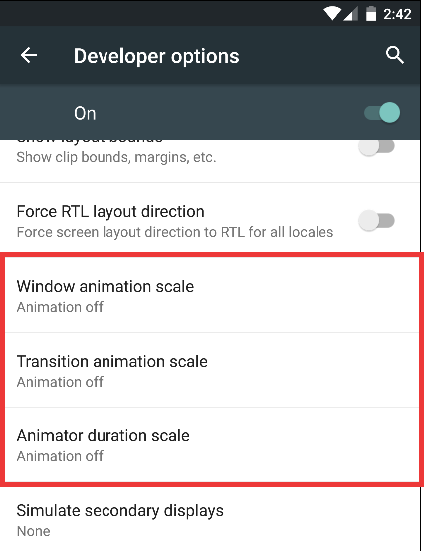

Note: Your tests may not run properly or result in failure if these options are not off.

ViewMatchers List (Frequently used Matchers)
- Using Resource id
  - ViewInteraction done = onView(withId(R.id.id_name));
- Using Visible text
  - ViewInteraction done = onView(withText(“text”));
- Using Content description
  - ViewInteraction done = onView(withContentDescription(“description”));
- Using Hint text
  - ViewInteraction done = onView(withHint(“hint text”));
- Using Spinner text
  - ViewInteraction done = onView(withSpinnerText(“spinner text”));
- Return TextView with links
  - ViewInteraction done = onView(hasLinks());

Use ViewMatchers with combination
If we are not able to uniquely identify an element with a id or a text etc., then we can use combination of two things and we can locate it. So how we can use that combination?
Using allOf
- onView(allOf(withId(R.id.id_name), isDisplayed()));
- onView(allOf(withId(R.id.id_name), isCompletelyDisplayed()));
- onView(allOf(withId(R.id.id_name), isClickable()));
- onView(allOf(withId(R.id.id_name), isChecked()));
- onView(allOf(withId(R.id.id_name), isNotChecked()));
- onView(allOf(withId(R.id.id_name), isEnabled()));
- onView(allOf(withId(R.id.id_name), hasFocus()));
- onView(allOf(withId(R.id.id_name), hasLinks()));
- onView(allOf(withId(R.id.id_name), isSelected()));
- onView(allOf(withId(R.id.id_name), hasContentDescription()));

Object Matchers
- onView(withClassName(endsWith(“text”)));
- onView(withText(startsWith(“text”)));

onData()
onData is used in case of ListView, GridView and AdapterView
onData(withId(“listview_id”)).atPosition(2).check(matches(isDisplayed()));

Root Matchers
- It matches with text on dialog
  - onView(withText(R.string.string_name)).inRoot(isDialog());
- Matches with Root that takes windows focus
  - onView(withText(R.string.string_name)).inRoot(isFocusable());
- Matches with Root which is autocomplete or action bar spinner
  - onView(withText(R.string.string_name)).inRoot(isPlatformPopup());
- Matches with Root that can handle touch events
  - onView(withText(R.string.string_name)).inRoot(isTouchable());
- Matches with Decor view
  - onView(withText(R.string.string_name)).inRoot(withDecorView(isDisplayed()));

Toast Messages
Now a days may app uses Toast Messages and if you are testing android app which displays Toast Messages and you want to write Espresso test case to assert the Toast Message then use this approach.
Check below is the ToastMatcher which identifies the Toast is not part of activity window-

public class ToastMatcher extends TypeSafeMatcher<Root> {

@Override public void describeTo(Description description) {
description.appendText("is toast");
}

@Override public boolean matchesSafely(Root root) {
int type = root.getWindowLayoutParams().get().type;
if ((type == WindowManager.LayoutParams.TYPE_TOAST)) {
IBinder windowToken = root.getDecorView().getWindowToken();
IBinder appToken = root.getDecorView().getApplicationWindowToken();
if (windowToken == appToken) {
return true;
}
}
return false;
}

This ToastMatcher you can use it in your test case like this -

1. Test if the Toast Message is Displayed
onView(withText(R.string.mssage)).inRoot(new ToastMatcher())
.check(matches(isDisplayed()));

2. Test if the Toast Message is not Displayed
onView(withText(R.string.mssage)).inRoot(new ToastMatcher())
.check(matches(not(isDisplayed())));

3. Test id the Toast contains specific Text Message
onView(withText(R.string.mssage)).inRoot(new ToastMatcher())
.check(matches(withText("Invalid Name"));

References:
- https://medium.com/mindorks/android-testing-part-1-espresso-basics-7219b86c862b
- http://www.vogella.com/tutorials/AndroidTestingEspresso/article.html
- http://www.qaautomated.com/2016/01/how-to-test-toast-message-using-espresso.html

