Advanced Python
Week 7

Critical Thinking Assignment 7
Hyperparameter Tuning
Purpose:
For this assignment, I used the Iris dataset to see which k value works best with the KNeighborsClassifier. The k value tells the classifier how many nearby samples to consider when predicting the type of flower. I tested values from 1 through 20 and compared their accuracy using cross-validation.
Pseudocode
- Load the Iris dataset from Scikit-learn.
- Store the flower measurements in X and flower types in y.
- Set up 5-fold stratified cross-validation with shuffled data and a fixed random state.
- Start with an empty best k and best score below zero.
- For each k from 1 through 20, create a KNeighborsClassifier.
- Use cross_val_score to test the classifier on the five folds.
- Calculate and display the average accuracy and standard deviation.
- If the average score is higher than the best score, save the k and score.
- Print the best k and its average accuracy.
Source code
from sklearn.datasets import load_iris
from sklearn.model_selection import StratifiedKFold, cross_val_score
from sklearn.neighbors import KNeighborsClassifier

# Load the Iris flower measurements and labels
iris = load_iris()
X = iris.data
y = iris.target

# Use the same five splits for each k value
folds = StratifiedKFold(n_splits=5, shuffle=True, random_state=42)

best_k = None
best_score = -1
print('Iris KNN Hyperparameter Tuning')
print('Samples:', len(X), '| Features:', X.shape[1])
print('Testing k values from 1 to 20 using 5-fold cross-validation\n')
print('k Average accuracy Standard deviation')
print('------------------------------------------')
for k in range(1, 21):
model = KNeighborsClassifier(n_neighbors=k)
scores = cross_val_score(model, X, y, cv=folds, scoring='accuracy')
average = scores.mean()
print(f'{k:2d} {average:4f} {scores.std():.4f}')
if average > best_score:
best_score = average
best_k = k

print(f'\nBest k:{best_k}')
print(f'Best average cross-validation accuracy: {best_score:.2%}')
print('If multiple k values tie, this program chooses the smallest one.')

ReadMe.md
# Module 7: Hyperparameter Tuning

## Advanced Python – Critical Thinking Assignment

### Project Description

For this assignment, I used the Iris dataset to practice hyperparameter tuning with machine learning. The goal was to find the best k value for the K-Nearest Neighbors (KNN) classification algorithm.

The Iris dataset contains 150 flower samples with four measurements for each flower. The flowers are classified into three different species.

### Python Libraries Used

- Python 3
- Scikit-learn
- NumPy

### How the Program Works

1. Load the Iris dataset using `load_iris()`.
2. Separate the flower measurements and target classifications.
3. Create a loop to test k values from 1 to 20.
4. Use `KNeighborsClassifier` to create a model for each k value.
5. Use `StratifiedKFold` with 5 splits to divide the dataset into training and testing groups.
6. Use `cross_val_score()` to calculate the accuracy for each k value.
7. Calculate the average accuracy for each value of k.
8. Find the k value with the highest average accuracy.
9. Display the results.

### How to Run the Program

First, install the required Python libraries using the terminal:

```bash
python3 -m pip install scikit-learn numpy
```

Run the Python program:

```bash
python3 iris_knn.py
```

### Program Results

After running the program, the best k value was 15, with an average cross-validation accuracy of 98%.

- Best k value: 15
- Average accuracy: 98%
- Number of samples

Screenshots of the VS code executing code

Screenshot: 1: Shows the output of the running program
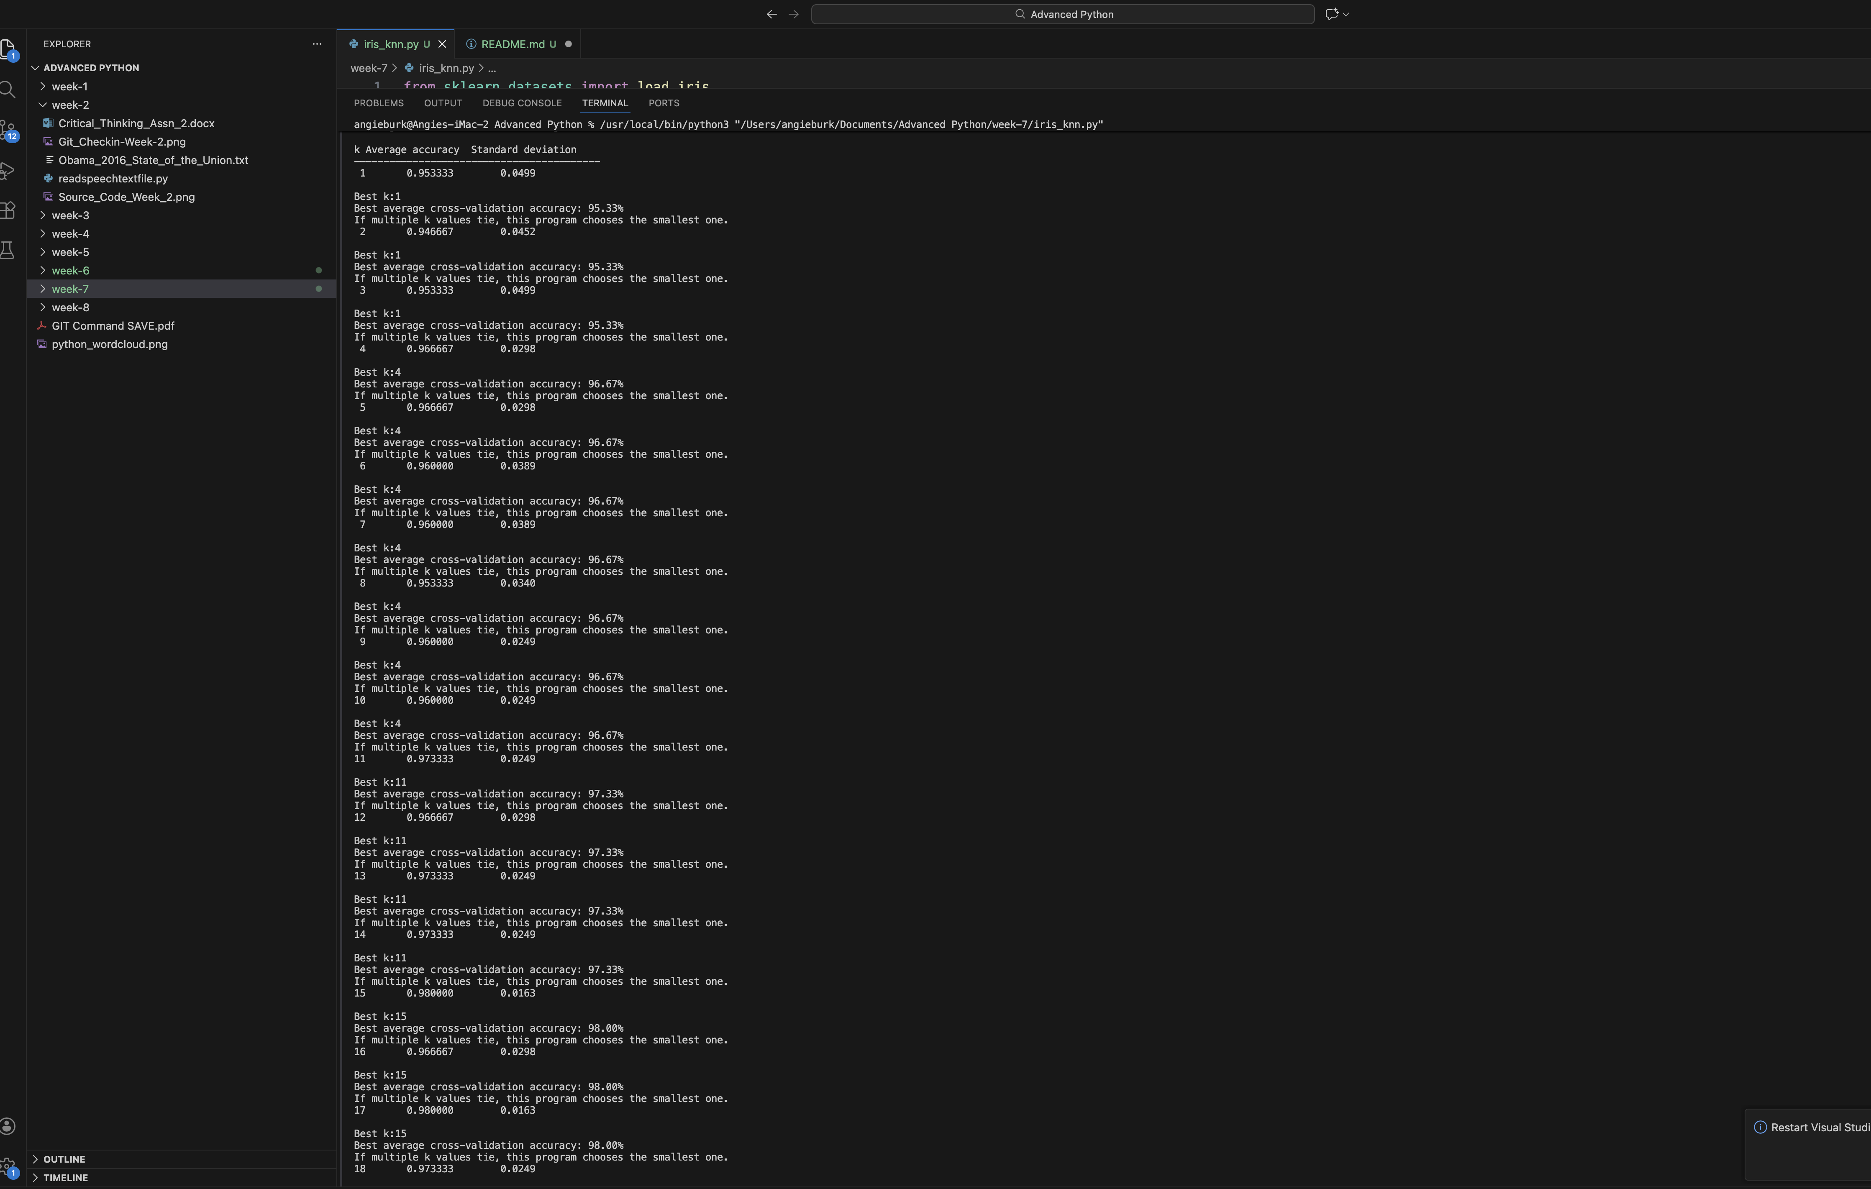

Git Repository

GitHub URL: https://github.com/redpear/Advanced-Python

GitHub URL Week 7:

Screenshot 1: Git Commit
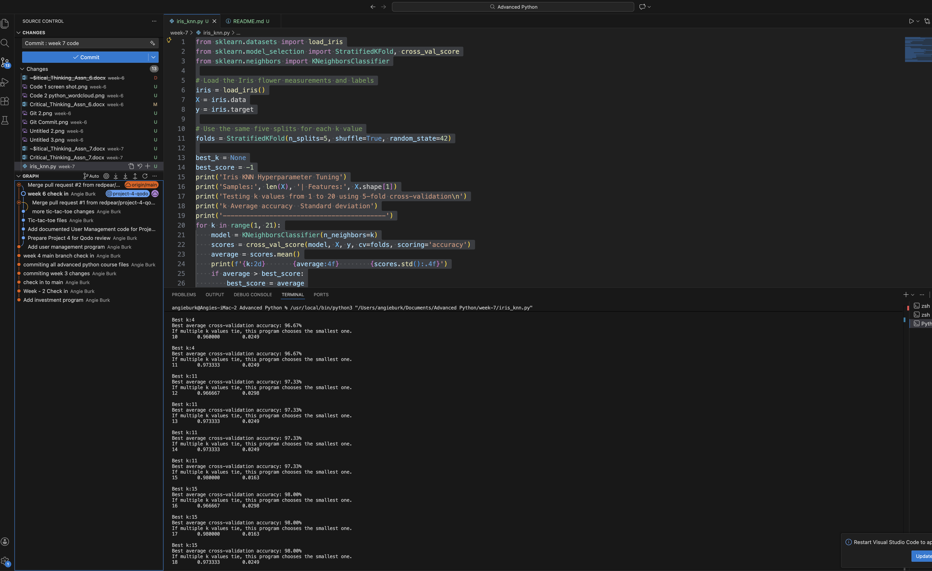

Screenshot 2: Git Committed

Screenshot 3: Git Repository

Results and What I Learned:
The highest average accuracy was 98%, which happened for k=15 and k=17. Since my program keeps the first k with the highest score, it selected k=15. I learned that changing k can change how well a KNN model performs. Cross-validation is helpful because it tests the model on several different parts of the data instead of depending on one split. These results apply to the tested values and this cross-validation setup: I did not use a separate final test set.

How to Run the Program:

