Advanced Python
Week 3

Critical Thinking Assignment 3

Debugging / Try / Catch / Finally

Pseudocode
Community Food Donation Tracker
START
Display the program title
Create an empty list called donations
Ask the user how many donations they want to enter
TRY
Convert the number entered to an integer
IF the number is less than or equal to zero
Display an error message
ELSE
REPEAT for the number of donations
TRY
Ask the user to enter the number of food items donated
Convert the input to an integer

IF the donation is less than zero
Display an error message
ELSE
Add the donation to the donations list

EXCEPT a ValueError
Display a message explaining that a whole number is required

FINALLY
Display that the donation entry was processed

IF the donations list contains donations
Calculate the total number of donated items
Calculate the average donation
Find the largest donation
Find the smallest donation

Display the donation statistics
ELSE
Display that there is no valid donation data
EXCEPT a ValueError
Display a message explaining that the number of donations must be a whole number
FINALLY
Display a message thanking the user for supporting the community
END

Source code

Screenshots of the VS code executing code
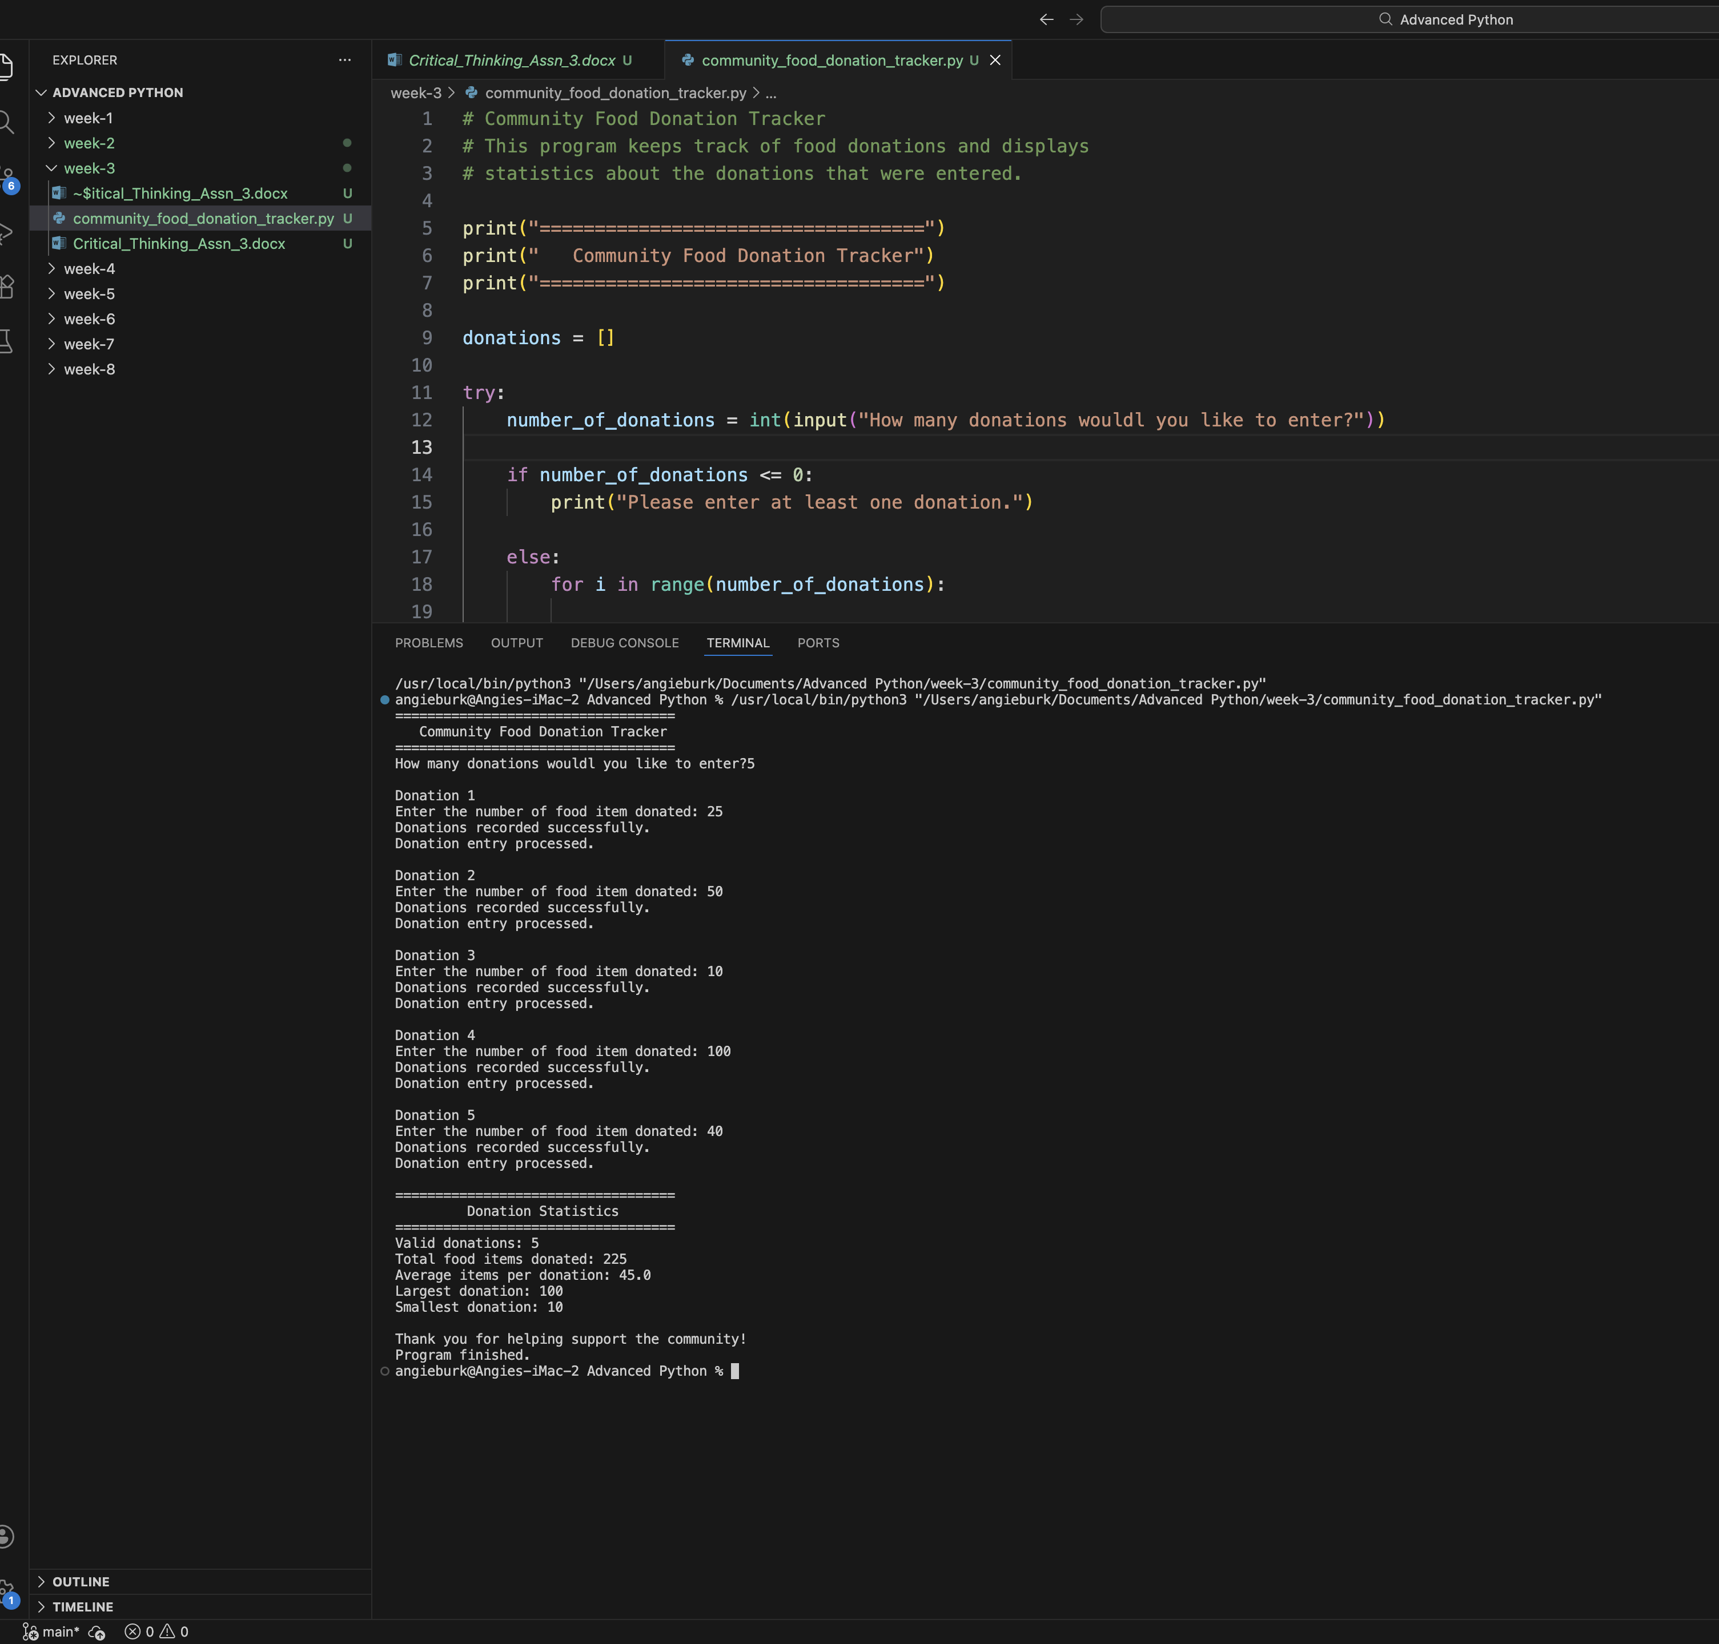

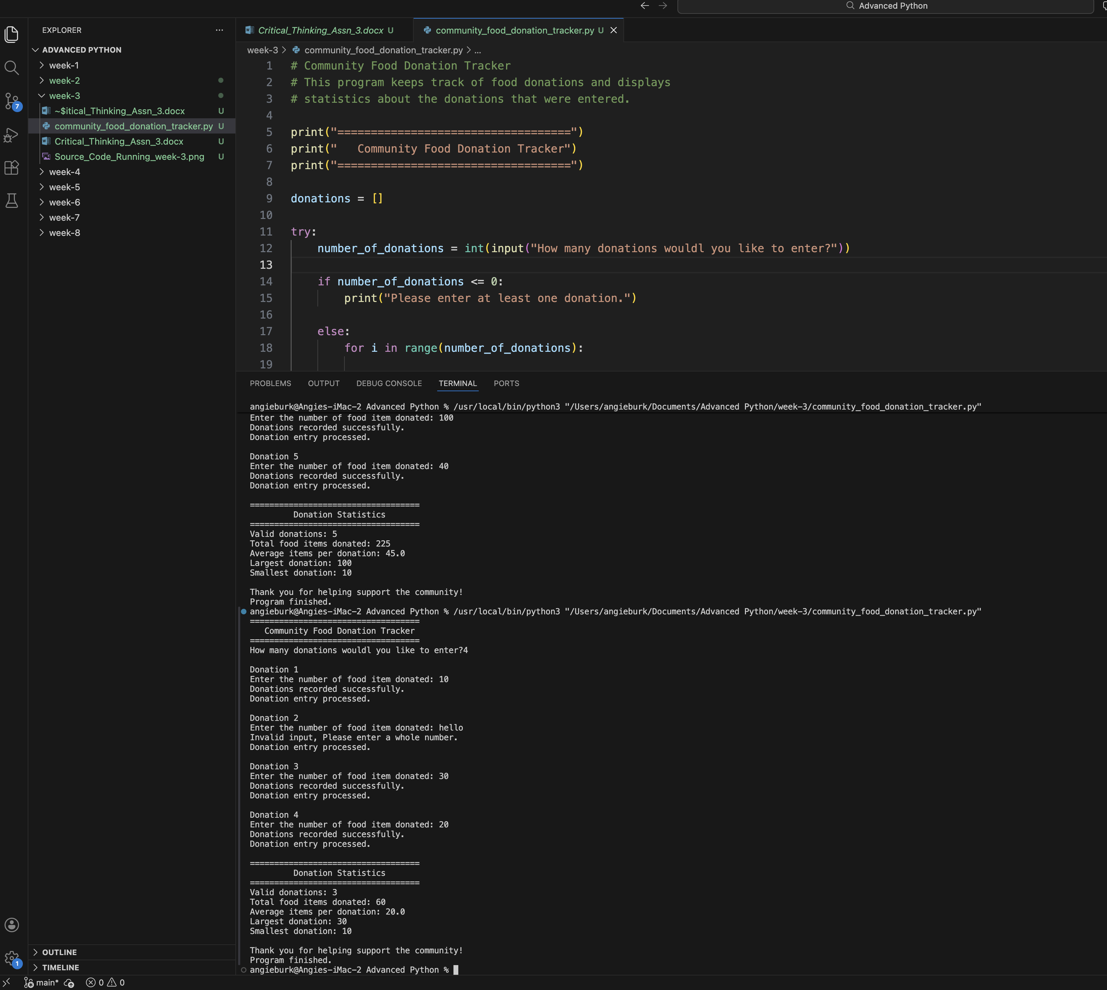

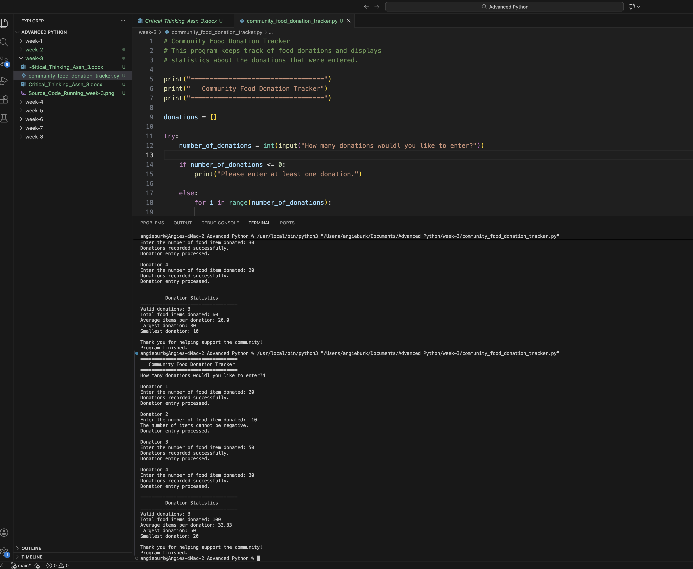

Git Repository

