Advanced Python
Week 2

Critical Thinking Assignment 2

Speech

Pseudocode
START
Import the regular expression module
Import Counter
Open the Obama 2016 State of the Union text file
Read the speech from the file
Close the file
Find all of the words in the speech
Count the total number of words
Count the total number of characters
Set the total word length to 0
FOR each word in the speech
Add the length of the word to the total word length
END FOR
Calculate the average word length by dividing the total word length by the number of words
Split the speech into sentences using periods, exclamation points, and question marks
Set the sentence count to 0
FOR each sentence
IF the sentence is not empty
Add 1 to the sentence count
END IF
END FOR
Calculate the average sentence length by dividing the word count by the sentence count
Create an empty list for lowercase words
FOR each word
Convert the word to lowercase
Add the lowercase word to the list
END FOR
Count how many times each word appears
Find the ten longest words
Display the results
Display the word frequency
Word count
Character count
Average word length
Average sentence length
Display the ten longest words
END

Source code
# START

# Import the regular expression module
import re

# Import Counter
from collections import Counter

# Open the Obama 2016 State of the Union text file
# file = open("Obama_2016_State_of_the_Union.txt", "r")
file = open("/Users/angieburk/Documents/Advanced Python/week-2/Obama_2016_State_of_the_Union.txt", "r")
# Read the speech from the file
speech = file.read()

# Close the file
file.close()

# Find all of the words in the speech
words = re.findall(r'\b\w+\b', speech)

# Count the total number of words
word_count = len(words)

# Count the total number of characters
character_count = len(speech)

# Set the total word length to 0
total_word_length = 0

# FOR each word in the speech
# Add the length of the word to the total word length
# END FOR
for word in words:
total_word_length = total_word_length + len(word)

# Calculate the average word length by dividing the total word length by the number of words
average_word_length = total_word_length / word_count

# Split the speech into sentences using periods, exclamation points, and question marks
sentences = re.split(r'[.!?]', speech)

# Set the sentence count to 0
sentence_count = 0

# FOR each sentence
# IF the sentence is not empty
# Add 1 to the sentence count
# END IF
# END FOR

for sentence in sentences:
if sentence.strip() != "":
sentence_count = sentence_count + 1

# Calculate the average sentence length by dividing the word count by the sentence count
average_sentence_length = word_count / sentence_count

# Create an empty list for lowercase words
lowercase_words = []

# FOR each word
# Convert the word to lowercase
# Add the lowercase word to the list
# END FOR

for word in words:
lowercase_words.append(word.lower())

# Count how many times each word appears
word_frequency = Counter(lowercase_words)

# Find the ten longest words
unique_words = set(lowercase_words)
sorted_words = sorted(unique_words, key=len, reverse=True)
longest_words = sorted_words[:10]

# Display the results
# Display the results
print("STATE OF THE UNION SPEECH ANALYSIS")
print("------------------------------------------")

print("Statistic\t\t\tResult")
print("------------------------------------------")
print("Word Count\t\t\t", word_count)
print("Character Count\t\t\t", character_count)
print("Average Word Length\t\t", round(average_word_length, 2))
print("Average Sentence Length\t\t", round(average_sentence_length, 2))
print

# Display the word frequency
print("\nWORD FREQUENCY")
print("------------------------------------------")
print("Word\t\t\tFrequency")
print("------------------------------------------")

for word, count in word_frequency.items():
print(word, "\t\t\t", count)

# Display the ten longest words
print("\nTOP TEN LONGEST WORDS")
print("------------------------------------------")
print("Word\t\t\tLength")
print("------------------------------------------")

for word in longest_words:
print(word, "\t\t\t", len(word))

# END

Screenshots of the VS code executing code
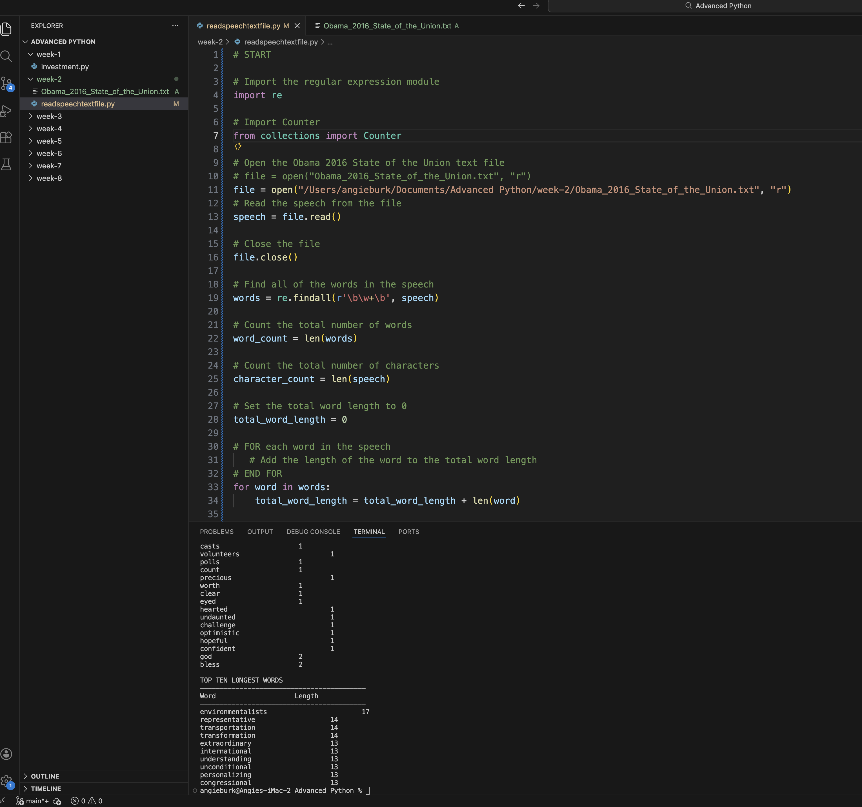
Git Repository

