Advanced Python
Week 4

Critical Thinking Assignment 4

Documentation

Pseudocode

Source code

Screenshots of the VS code executing code

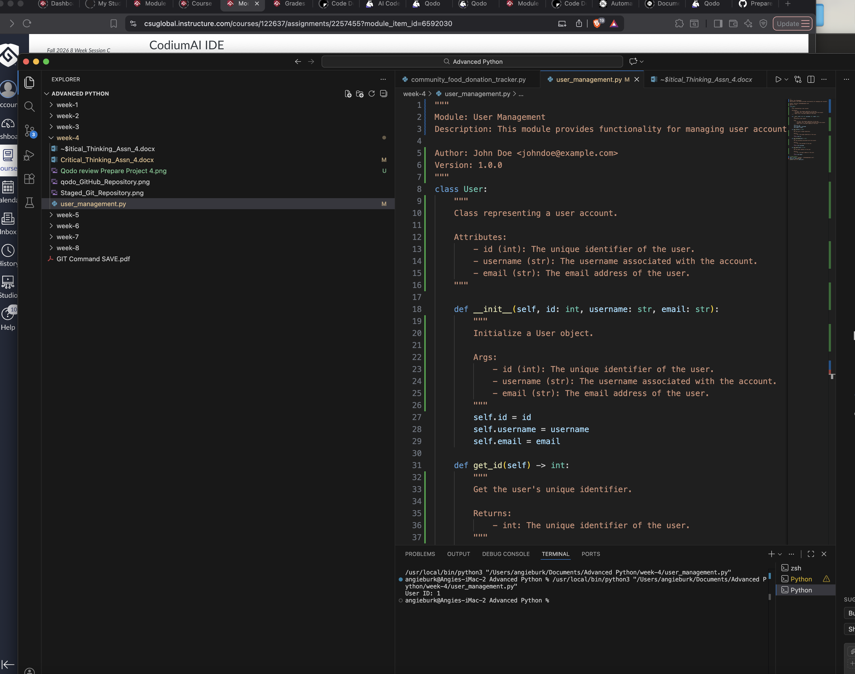

Git Repository

