Advanced Python
Week 5

Critical Thinking Assignment 5

Tic-Tac-Toe with NumPy

Pseudocode
1. Import NumPy and create a 3 by 3 array of empty spaces.
2. Set the first player to X. Display the board and row/column numbers.
3. Ask the current player for a row and column from 0 through 2.
4. If the input is not a whole number, outside the board, or the square is taken, show an error and ask again.
5. Place the player symbol in the chosen empty square and display the board.
6. Check all rows, columns, and the two diagonals for three matching symbols.
7. If the player wins, announce the winner and stop.
8. If every square is filled and there is no winner, announce a draw and stop.
9. Otherwise switch between X and O and repeat.

Source code
import numpy as np

def show_board(board):
print('\n 0 1 2')
for i in range(3):
print(i, ' | '.join(board[i]))
if i < 2:
print(' ---------')
print()

def check_winner(board, player):
for i in range(3):
if np.all(board[i, :] == player):
return True
if np.all(board[:, i] == player):
return True
if np.all(np.diag(board) == player):
return True
if np.all(np.diag(np.fliplr(board)) == player):
return True
return False

def play_game():
board = np.full((3, 3), ' ', dtype='<U1')
player = 'X'
print('Welcome to Tic-Tac-Toe!')
print('Enter row and column numbers from 0 to 2.')
show_board(board)

while True:
print('Player', player, 'turn')
try:
row = int(input('Enter row (0-2): '))
col = int(input('Enter column (0-2): '))
except ValueError:
print('Please enter whole numbers only.\n')
continue

if row < 0 or row > 2 or col < 0 or col > 2:
print('That position is outside the board. Try again.\n')
continue
if board[row, col] != ' ':
print('That square is already taken. Try again.\n')
continue

board[row, col] = player
show_board(board)

if check_winner(board, player):
print('Player', player, 'wins!')
break
if np.all(board != ' '):
print('The game is a draw!')
break
player = 'O' if player == 'X' else 'X'

if __name__ == '__main__':
play_game()

Screenshots of the VS code executing code

Screenshot: 1: Program starts and shows the empty 3X3 board
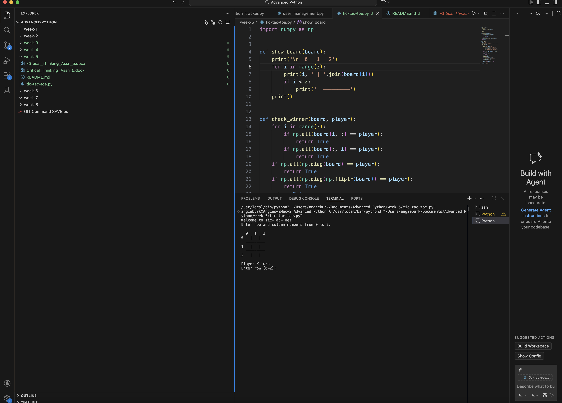

Screenshot 2: Players enter moves and the board updates:
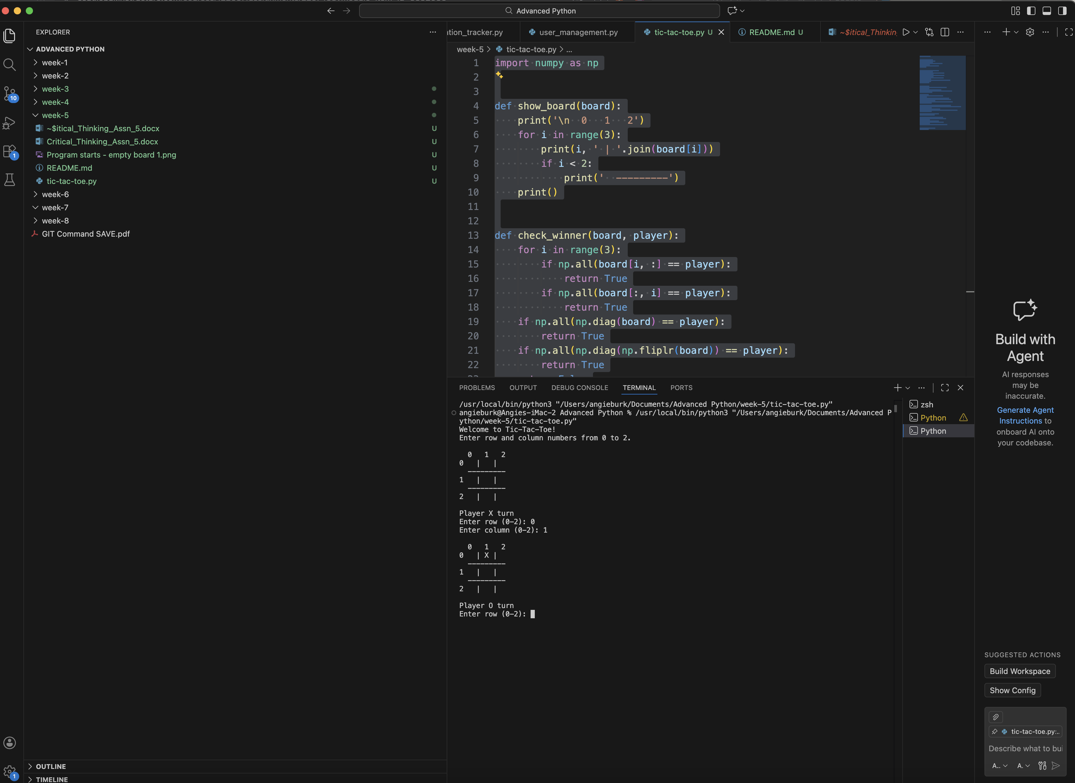

Screenshot 3: A player wins (or the game ends in a draw)
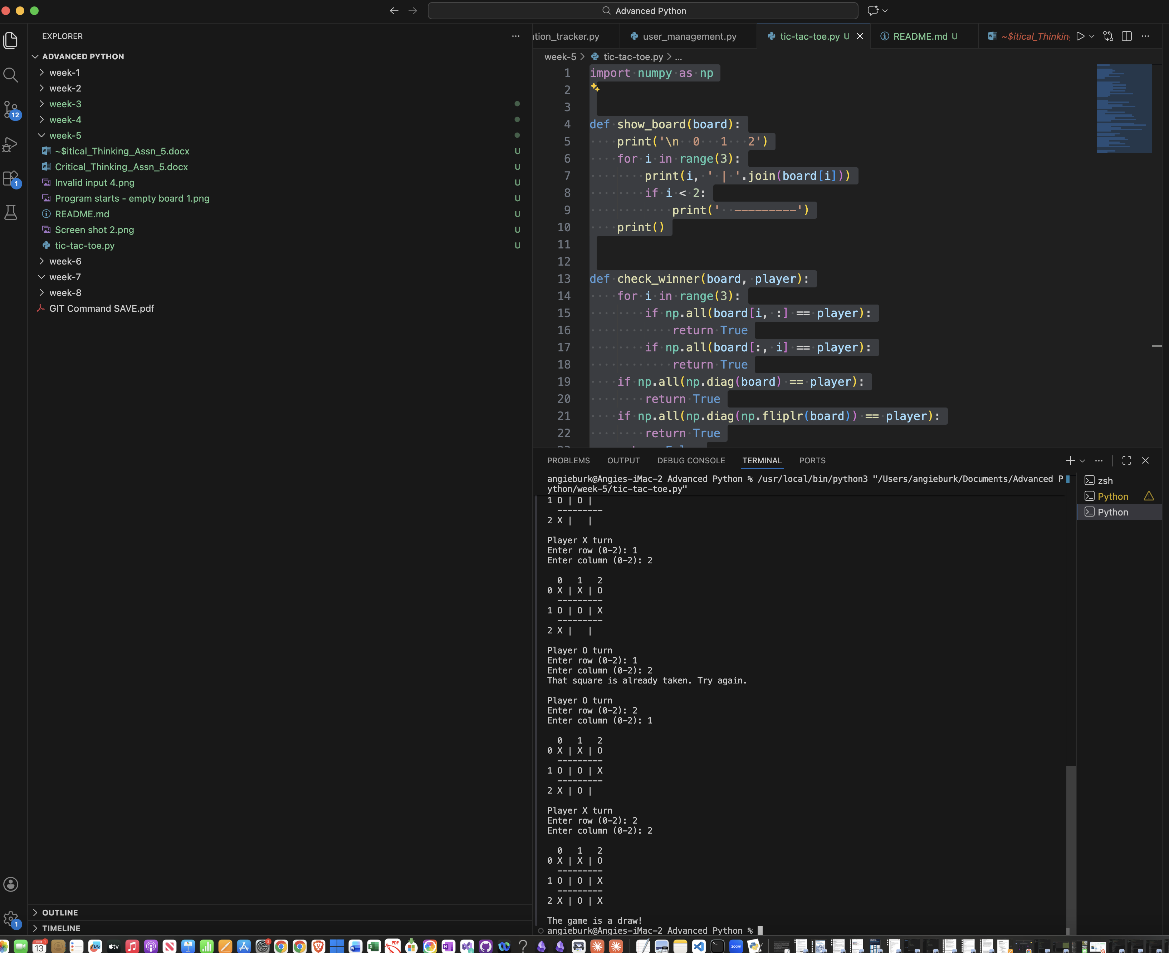

Screenshot 4: Invalid input or occupied-square error

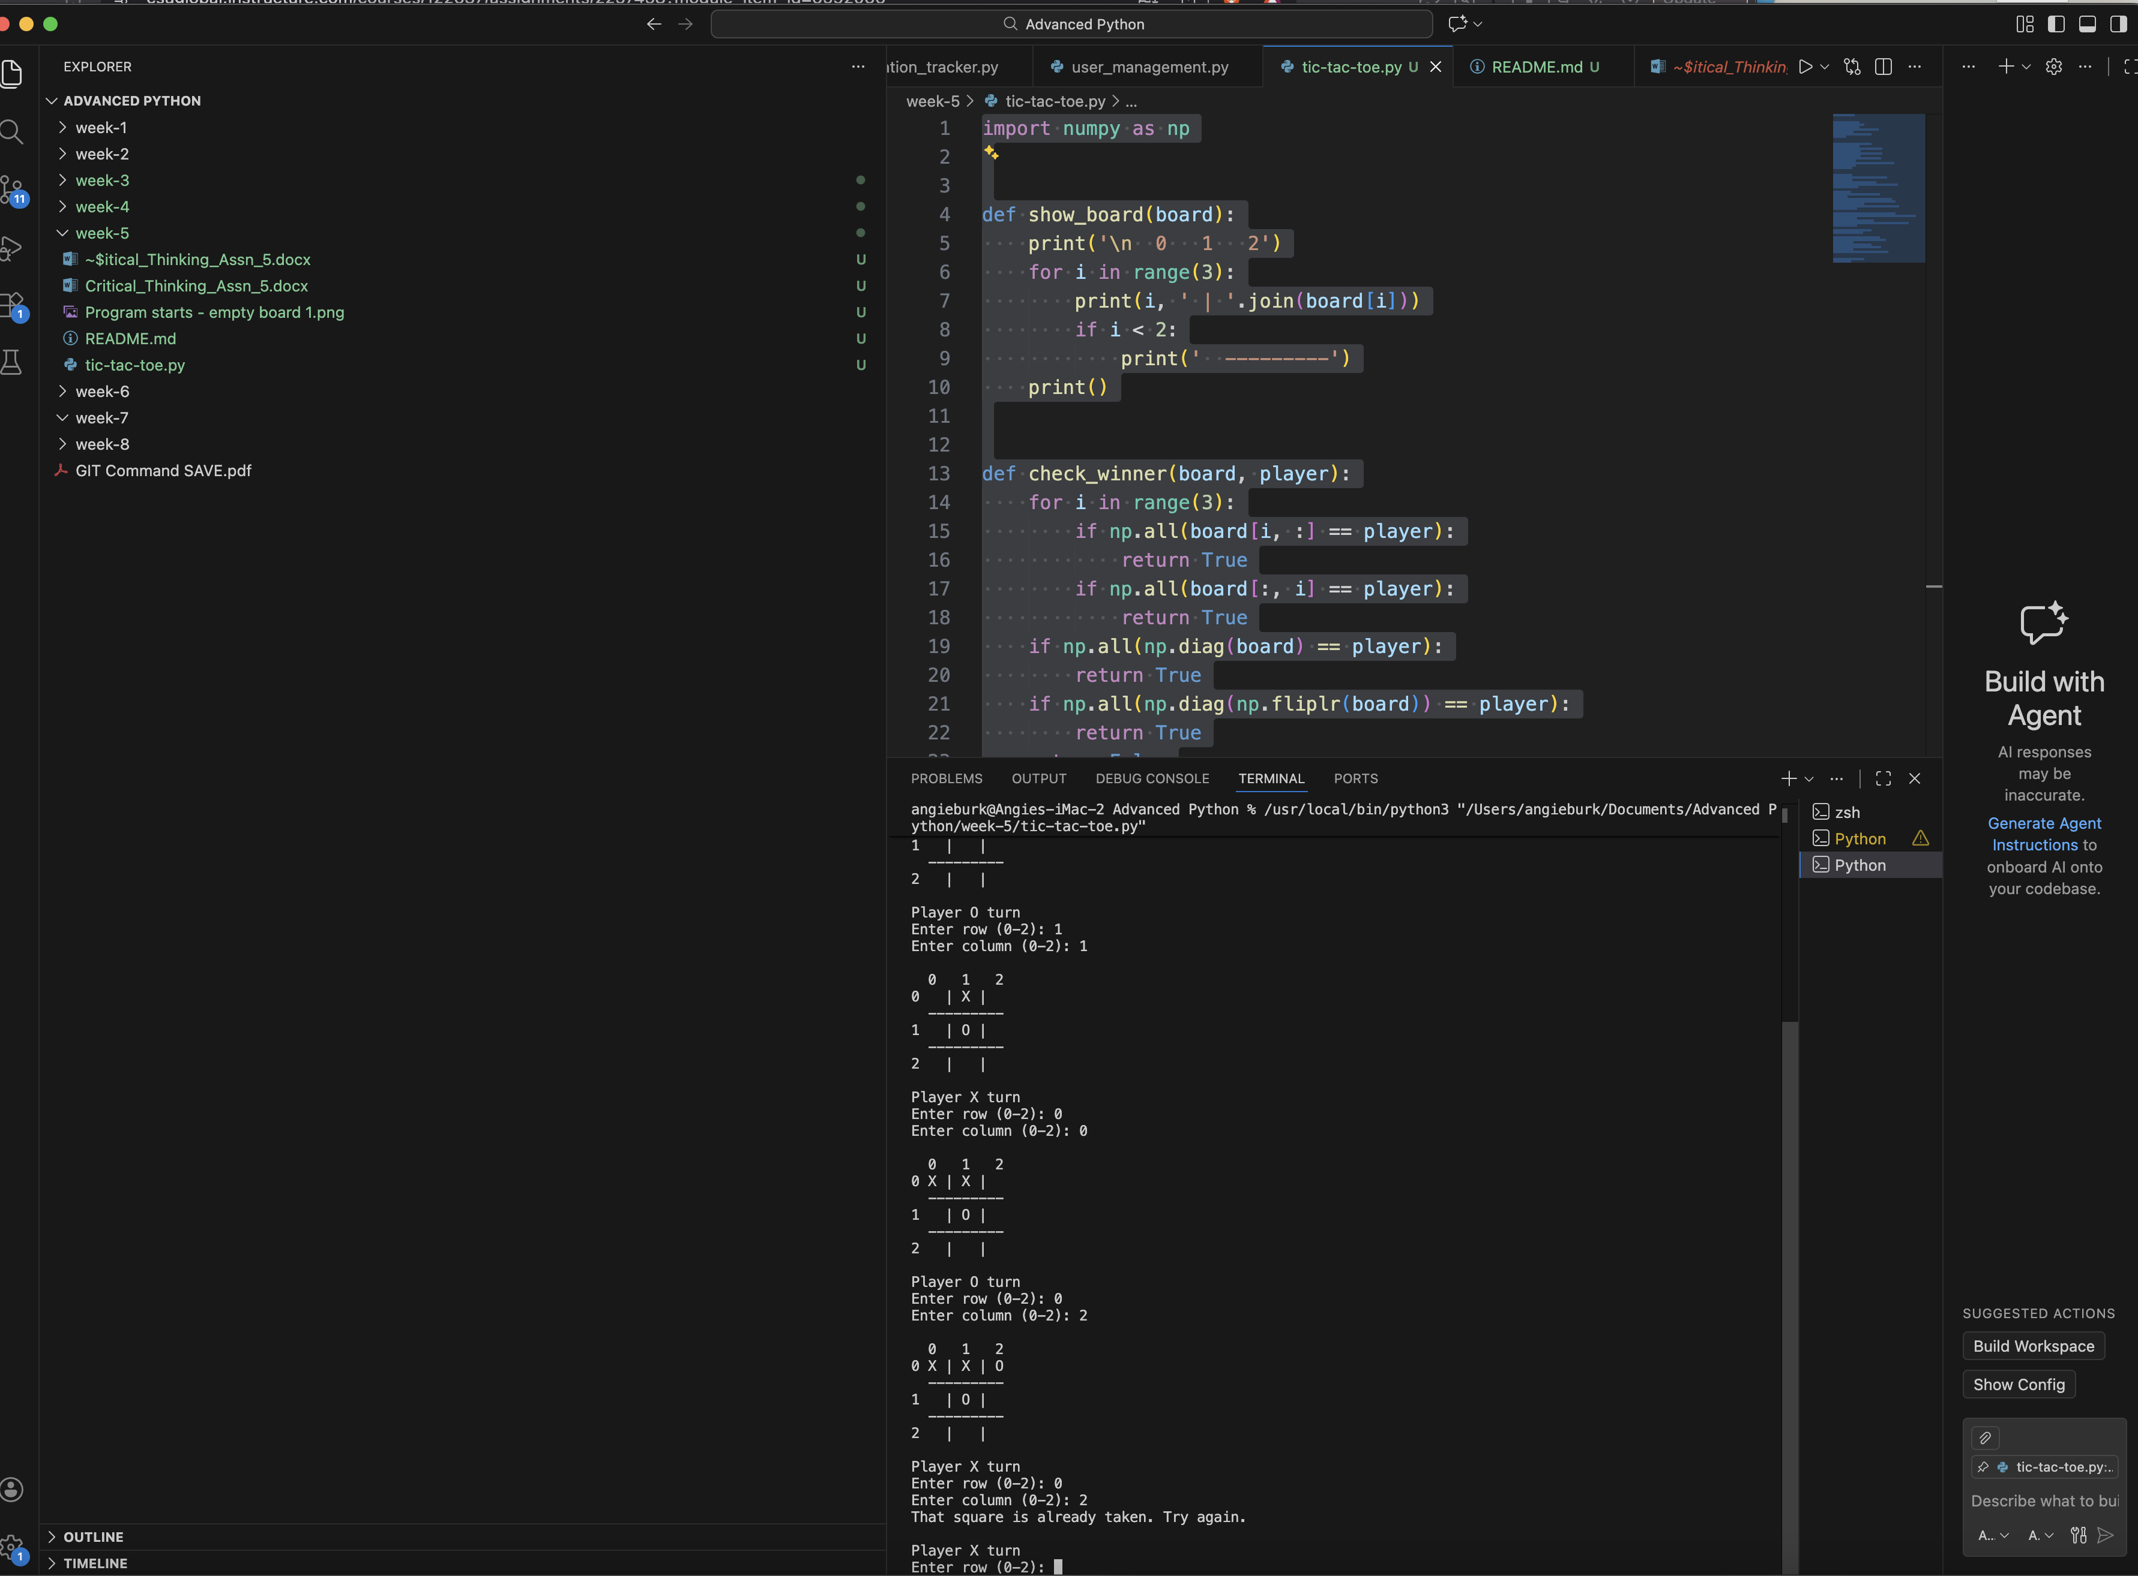

Git Repository

GitHub URL: https://github.com/redpear/Advanced-Python

GitHub URL Week 5: https://github.com/redpear/Advanced-Python/tree/main/week-5

Screenshot 1: Git Commit
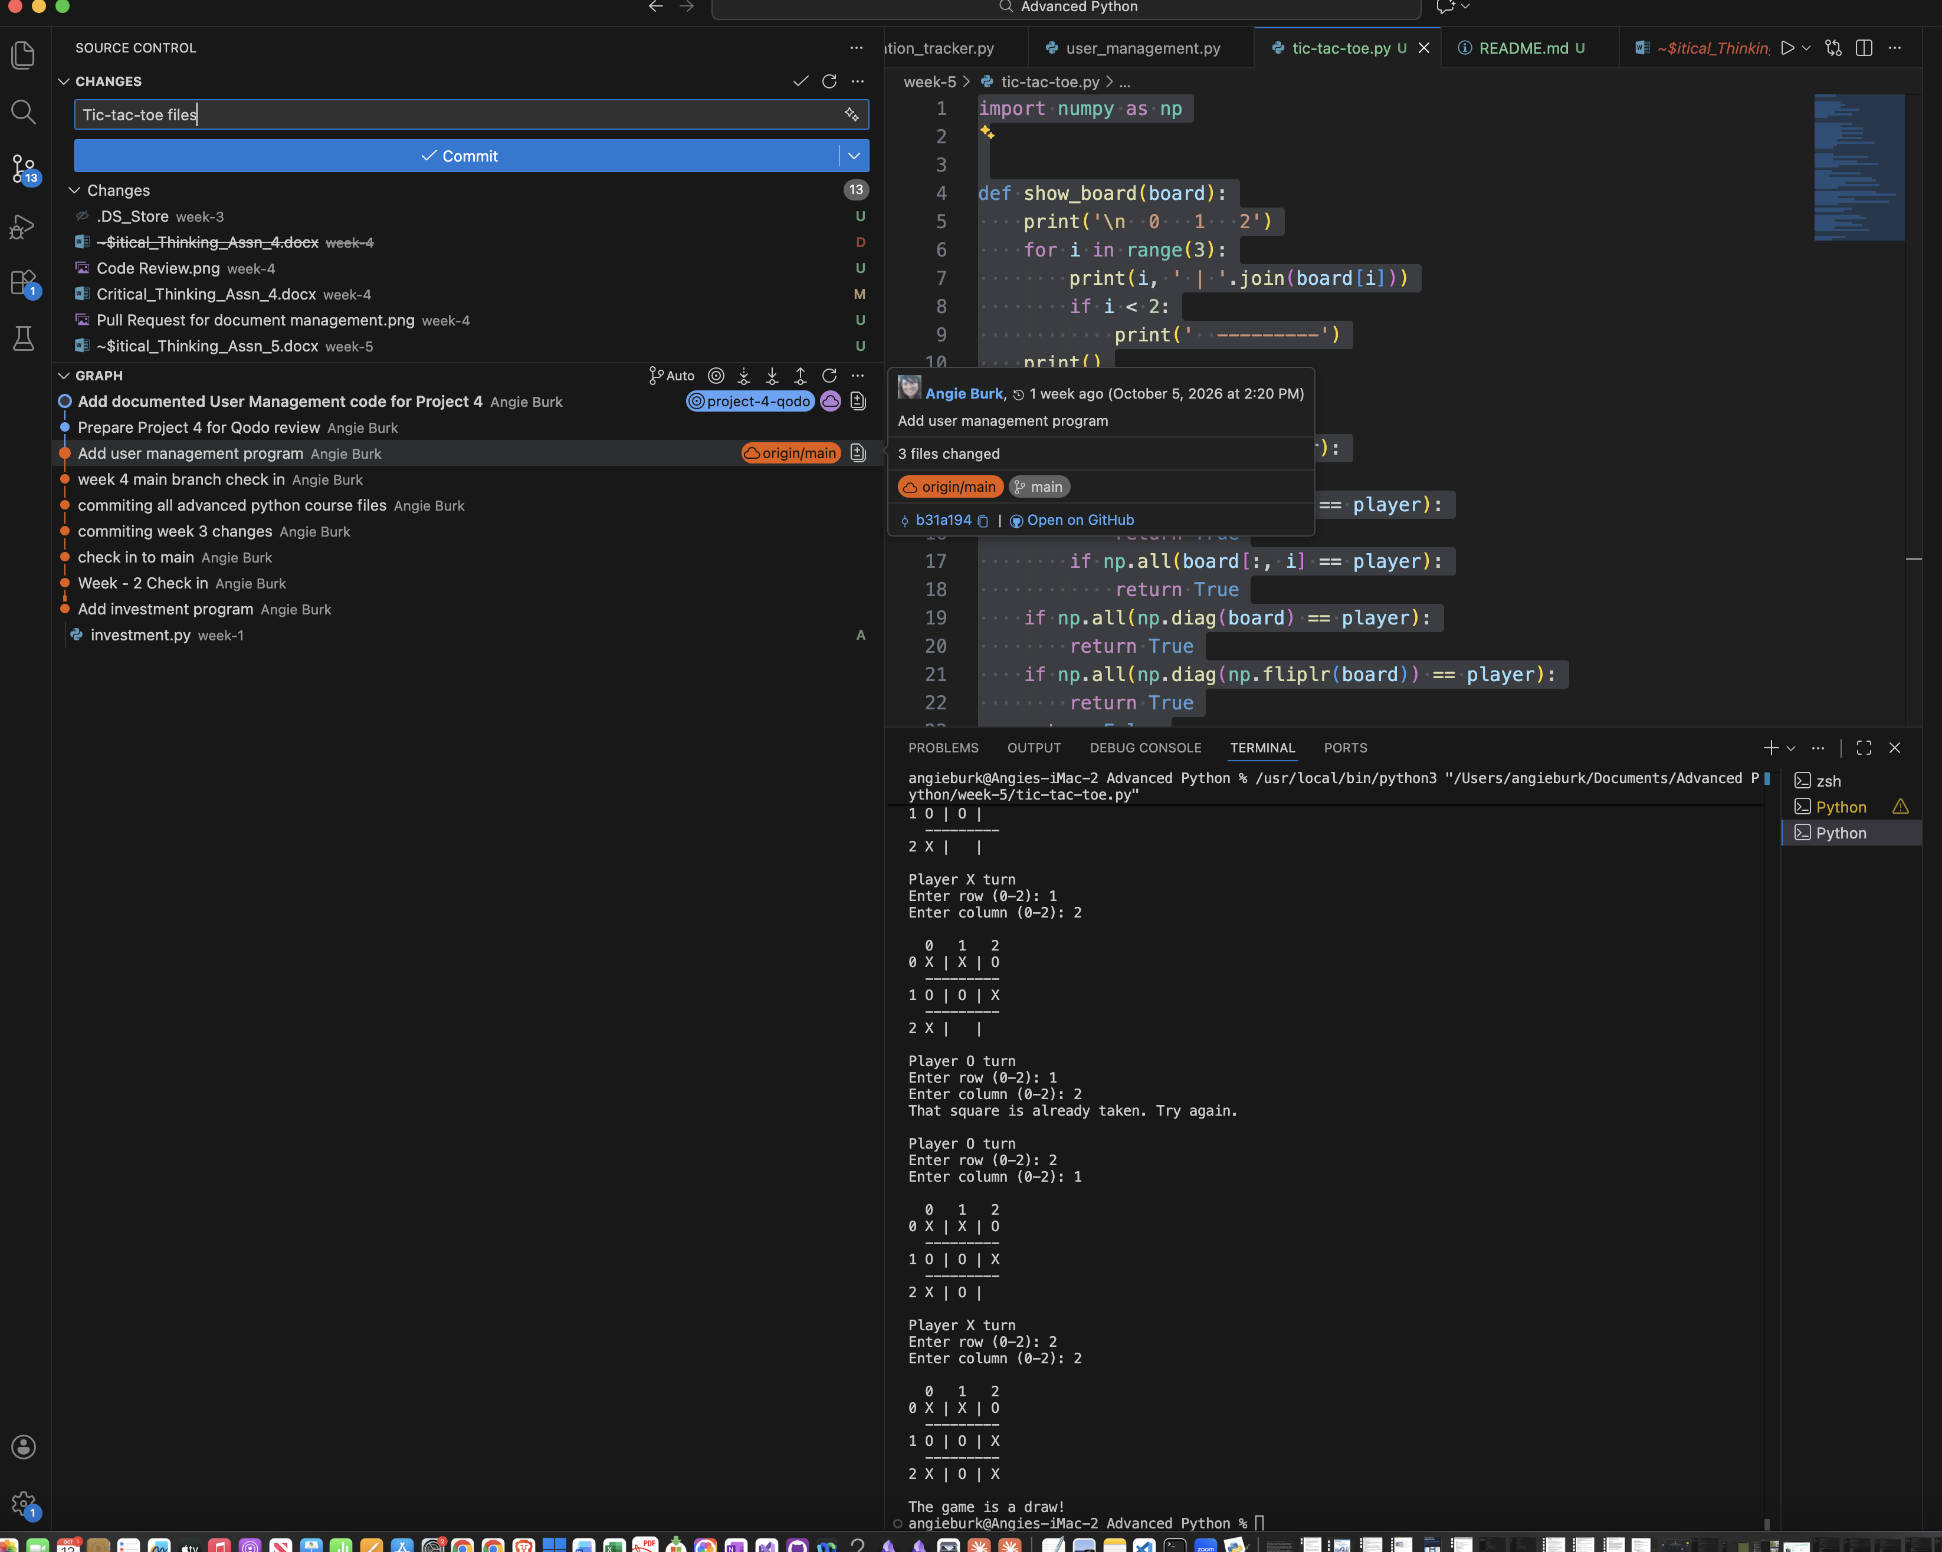

Screenshot 2: Git Committed

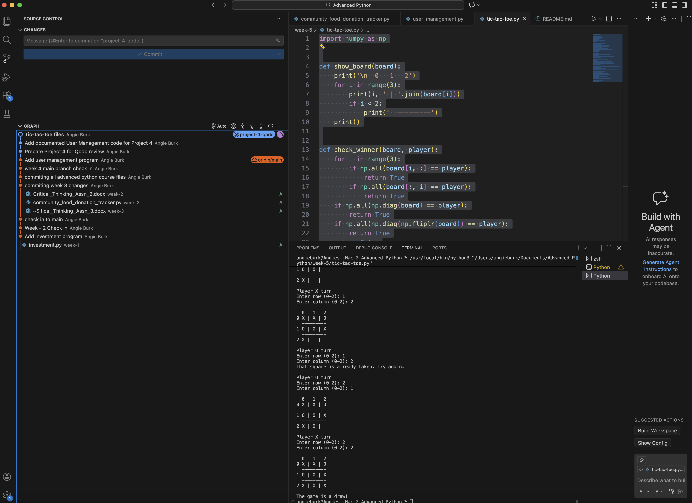

Discussion:
I used NumPy array to store the 3x3 game board. The program asks each player for a row and column and checks whether the move is allowed. After each move, it checks the rows, columns, and diagonals to see whether a player has won. If all square are used without a winner, the program displays a draw. I also used try/except so the game does not crash when someone types a letter instead of a number.

