// assignment 1 - professional skills
// éidhne kennedy
// 21347021

1.
An operating system is the low-level software that supports a computer's
basic functions.
Functions of an OS:
- managing the overall system
- memory management
- process management
- security (user and system level)

Types of operating system:
- single user single task
- single user multi task
- multi user multi task
- multi processor
- real time processor

2.
System software is meant to manage the system resources, whereas
application software performs a specific set of functions to carry out
a task that the user requests.

3.
1) to create a new file titled CS.text, which is 1 kb in size

2) to write the string "Welcome to our CS111 class 2021" to the above file

4.
del deletes the contents of a directory, rmdir deletes the directory
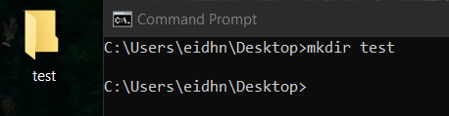
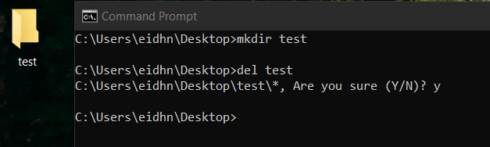

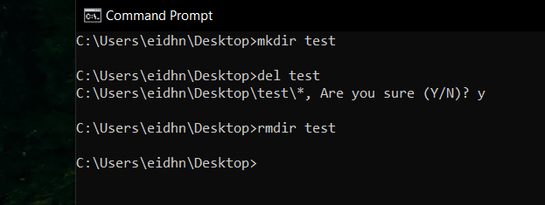
5.
(see screenshots)
