Q1.
i)
latex is a documentation preparation system for high quality typesetting, used mainly in scientific or technical writing, but it can be used for any purpose.

ii)
the menu: area with actions such as download, setting, and help
the create file/folder, upload, rename, and delete buttons
the view options (whether to view in latex or rich text)
recompile and download options: for viewing and obtaining the formatted document
review: allows others to inspect your work
share: allows other team members to work on the same document
submit: allows you to submit your document (to a journal, or other outlet)
chat: used to communicate if a team is working on a single document
sections: shows the main sections of your work

Q2.
i)
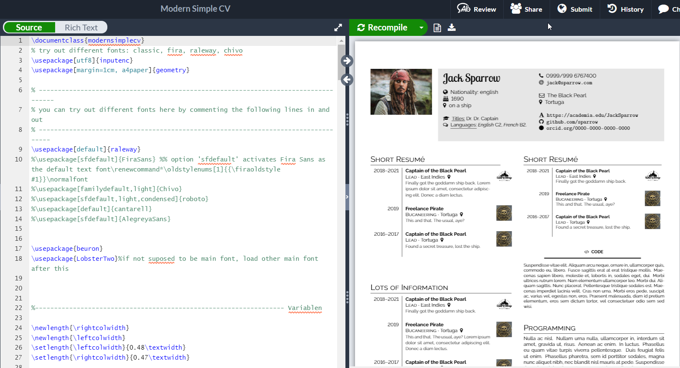
ii)
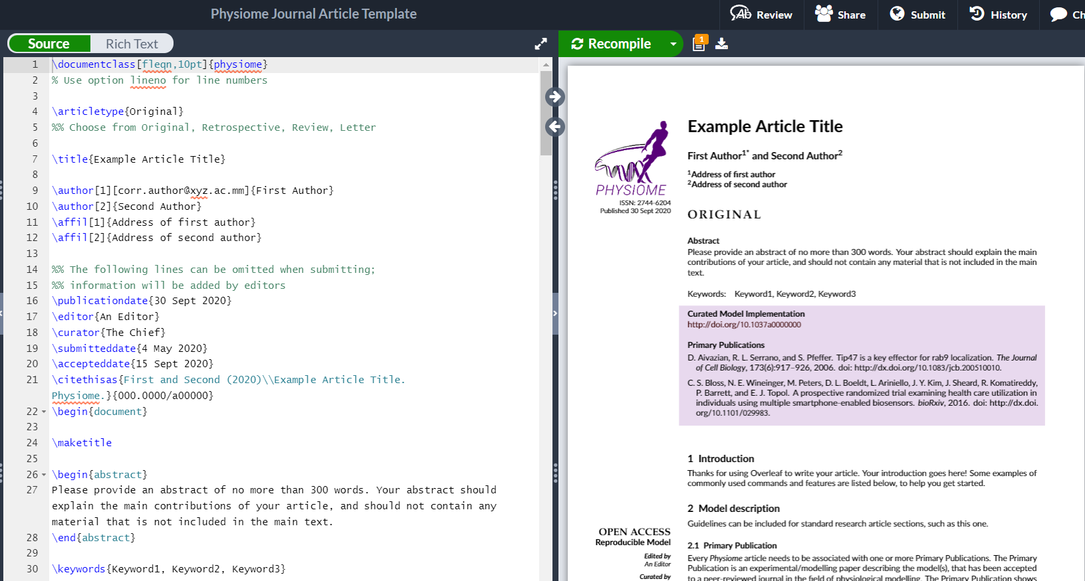
iii)

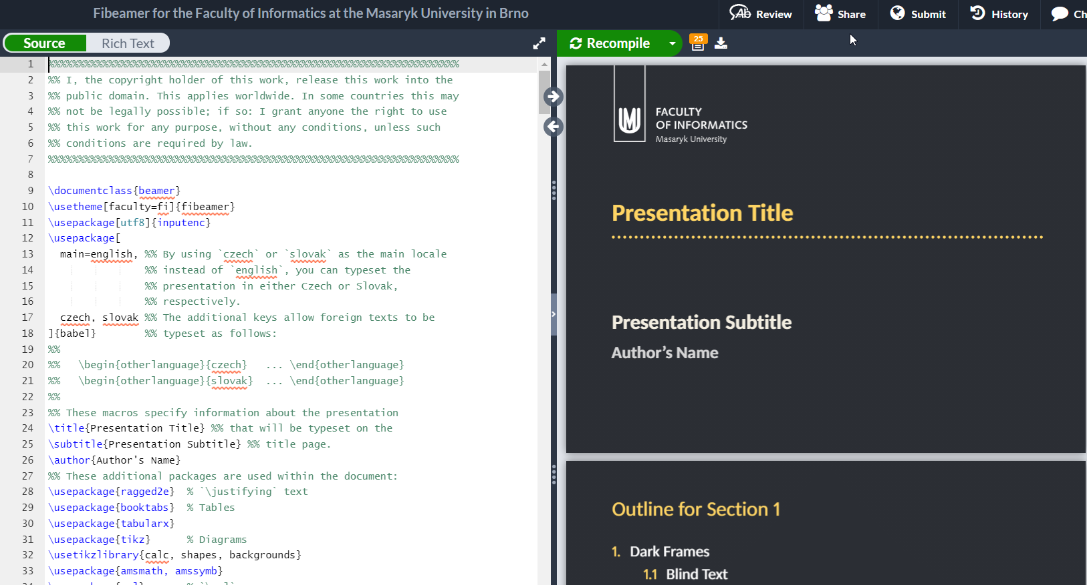
Q3.
i) delete current line, find in document
ii) italic text, bold text
iii) uppercase, lowercase
iv) compile, go to line

