Student Name: | Éidhne Kennedy
ID Number: | 21347021
Degree Name: | GY350 – Computer Science
Assessment: | EE130 EEE-CA-4

A1 | A0 | B1 | B0 |  | W1 | W0
0 | 0 | 0 | 0 |  | 0 | 1
0 | 0 | 0 | 1 |  | 1 | 1
0 | 0 | 1 | 0 |  | 0 | 0
0 | 0 | 1 | 1 |  | 1 | 1
0 | 1 | 0 | 0 |  | 0 | 0
0 | 1 | 0 | 1 |  | 0 | 1
0 | 1 | 1 | 0 |  | 1 | 1
0 | 1 | 1 | 1 |  | 0 | 0
1 | 0 | 0 | 0 |  | 1 | 1
1 | 0 | 0 | 1 |  | 0 | 0
1 | 0 | 1 | 0 |  | 0 | 1
1 | 0 | 1 | 1 |  | 0 | 0
1 | 1 | 0 | 0 |  | 0 | 0
1 | 1 | 0 | 1 |  | 1 | 1
1 | 1 | 1 | 0 |  | 1 | 1
1 | 1 | 1 | 1 |  | 0 | 1

// boolean functions of w_1w_0

w_1 = !a_1 !a_0 b_0 + a_0 b_1 !b_0 + a_1 !a_0 !b_1 !b_0 + a_1 a_0 !b_1 b_0

w_0 = !a_0 !b_1 !b_0 + !a_1 !a_0 b_0 + a_0 !b_1 b_0 + a_0 b_1 !b_0 + a_1 !a_0 !b_0 + a_1 a_0 b_1

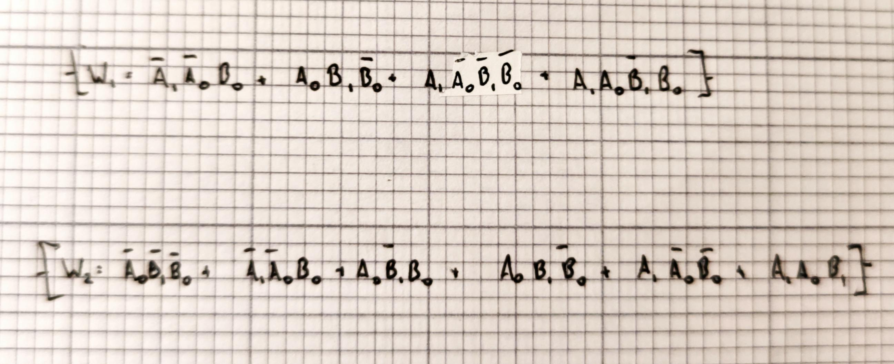

// karnaugh maps
