Database Tables

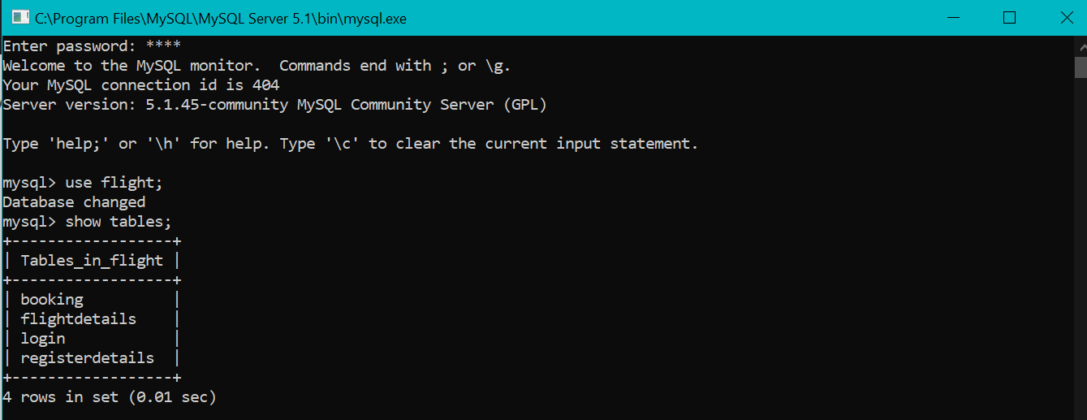

Login Table has login id and passwords.  
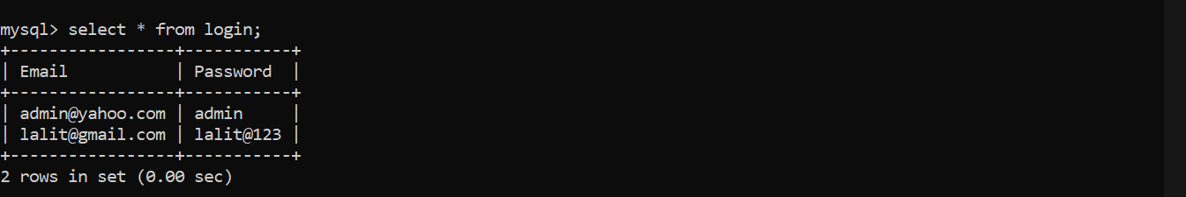

Flight Details Table has all the flight details  
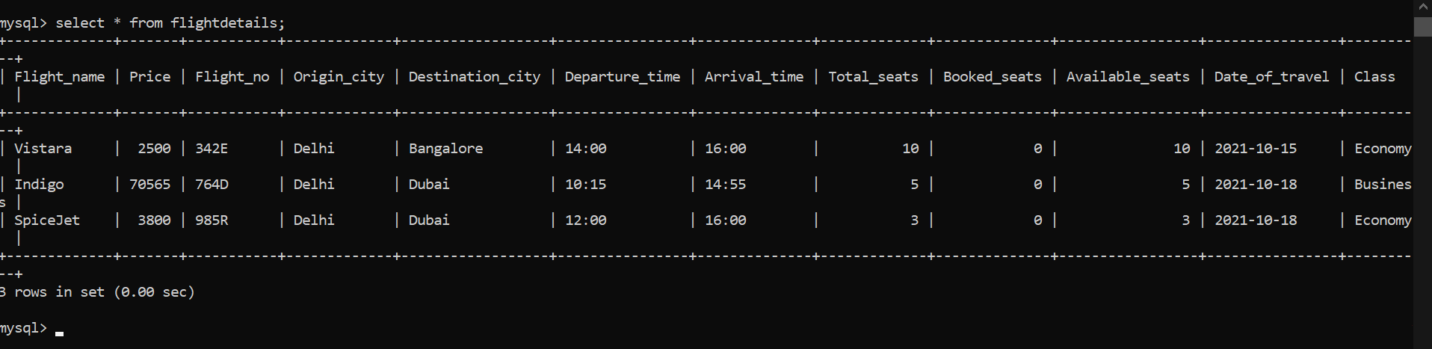

Register Details Table is empty initially.



Booking Table is also empty initially.  


User Login Page at the portal  
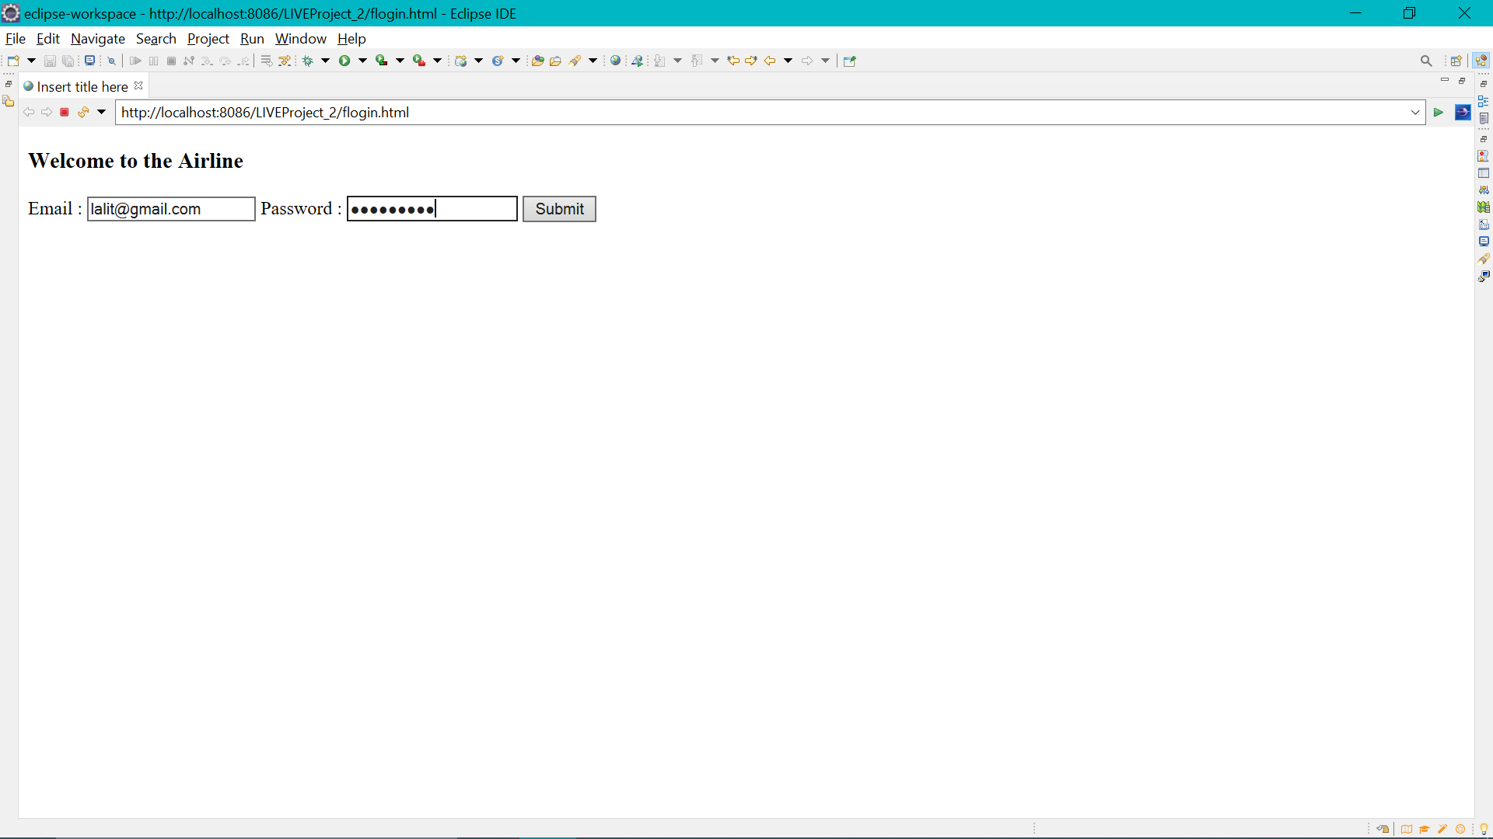

If there are wrong credentials then error message will appear.  
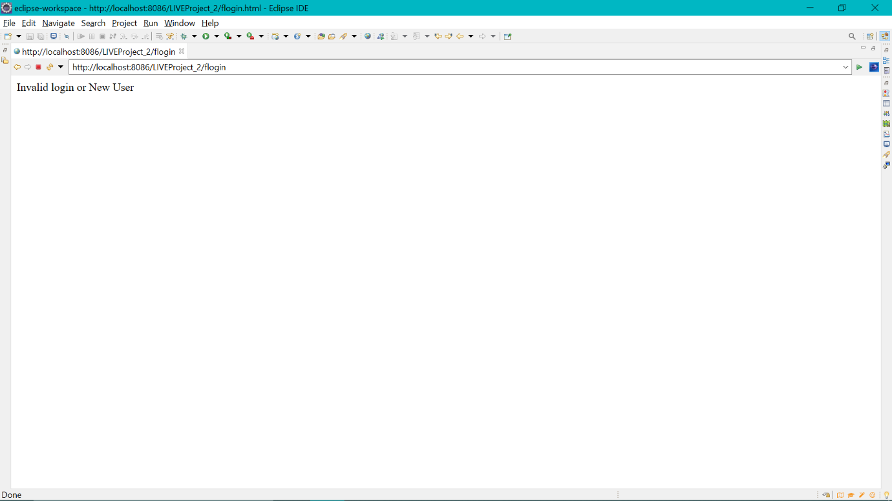

After Entering correct Email and Password search page will appear  
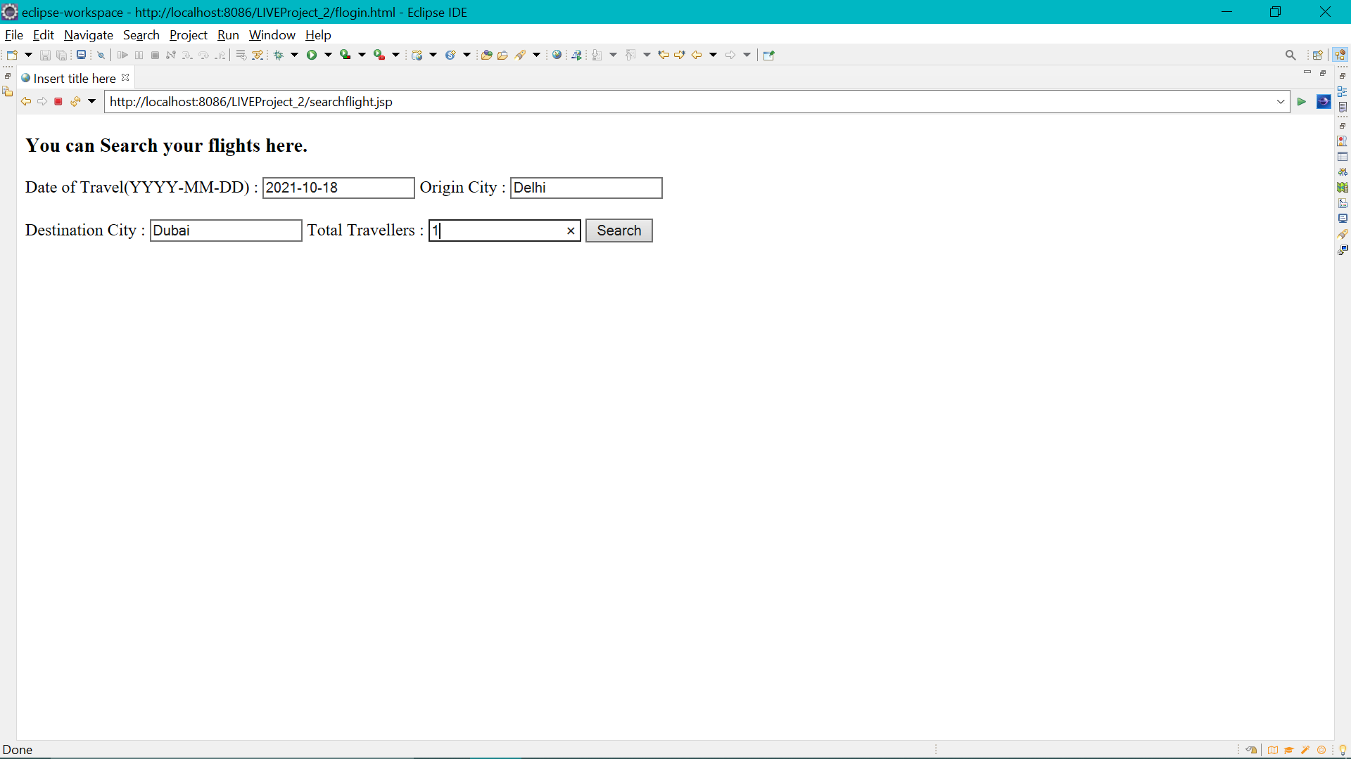

Flight will appear according to search parameters.  
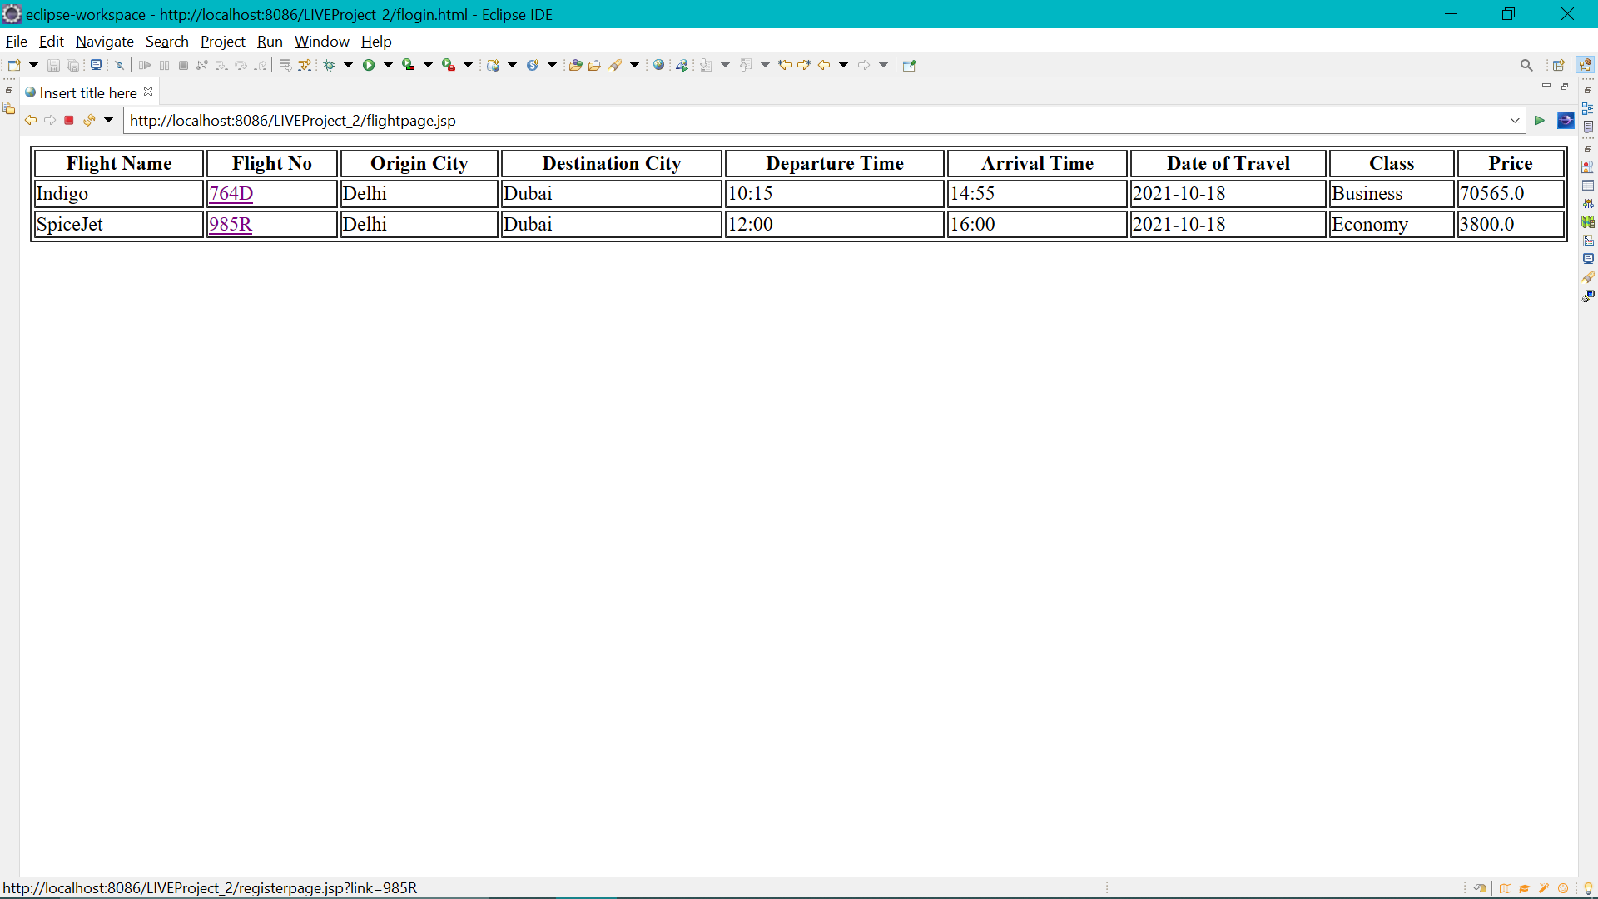

Click on the Flight No. to book the particular flight and enter your personal details. Once done hit Review button.  
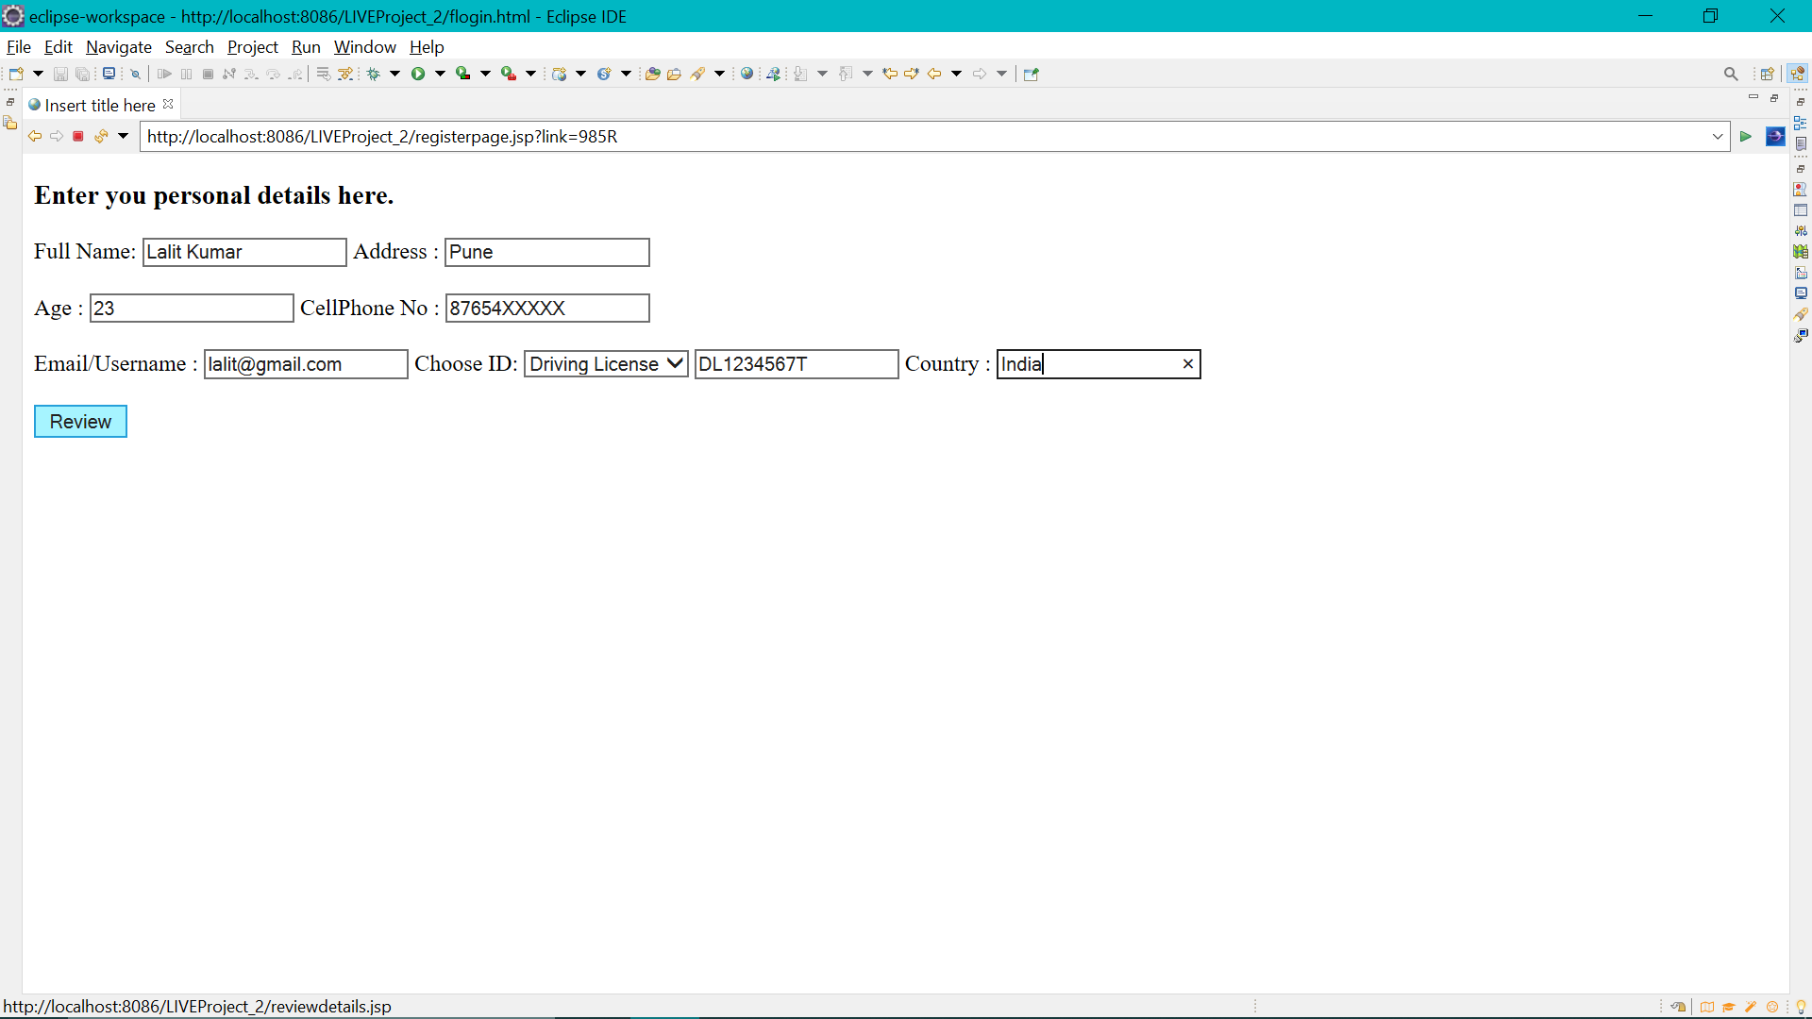

After hitting review button user will be directed to review details page.  
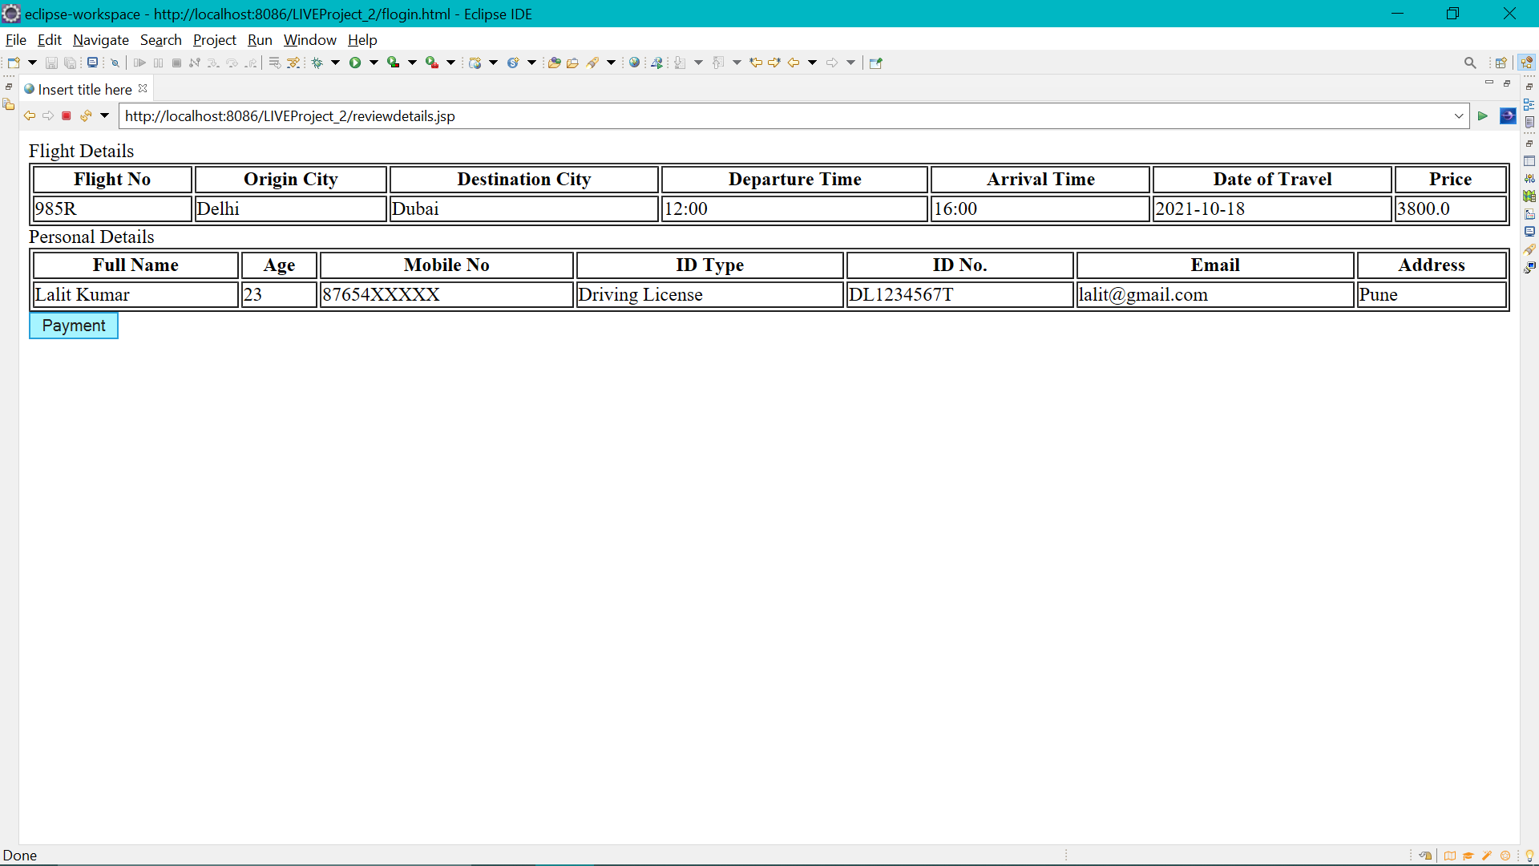

Once user is sure to do payment then dummy page of payment confirmation will be there.  
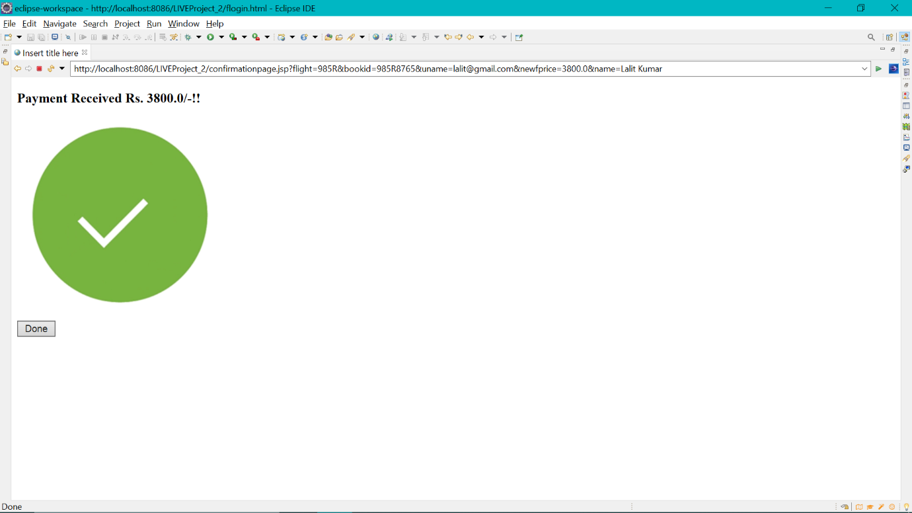

Once the payment received the seat will be booked and will get updated into database. Click on done to receive booking details.  
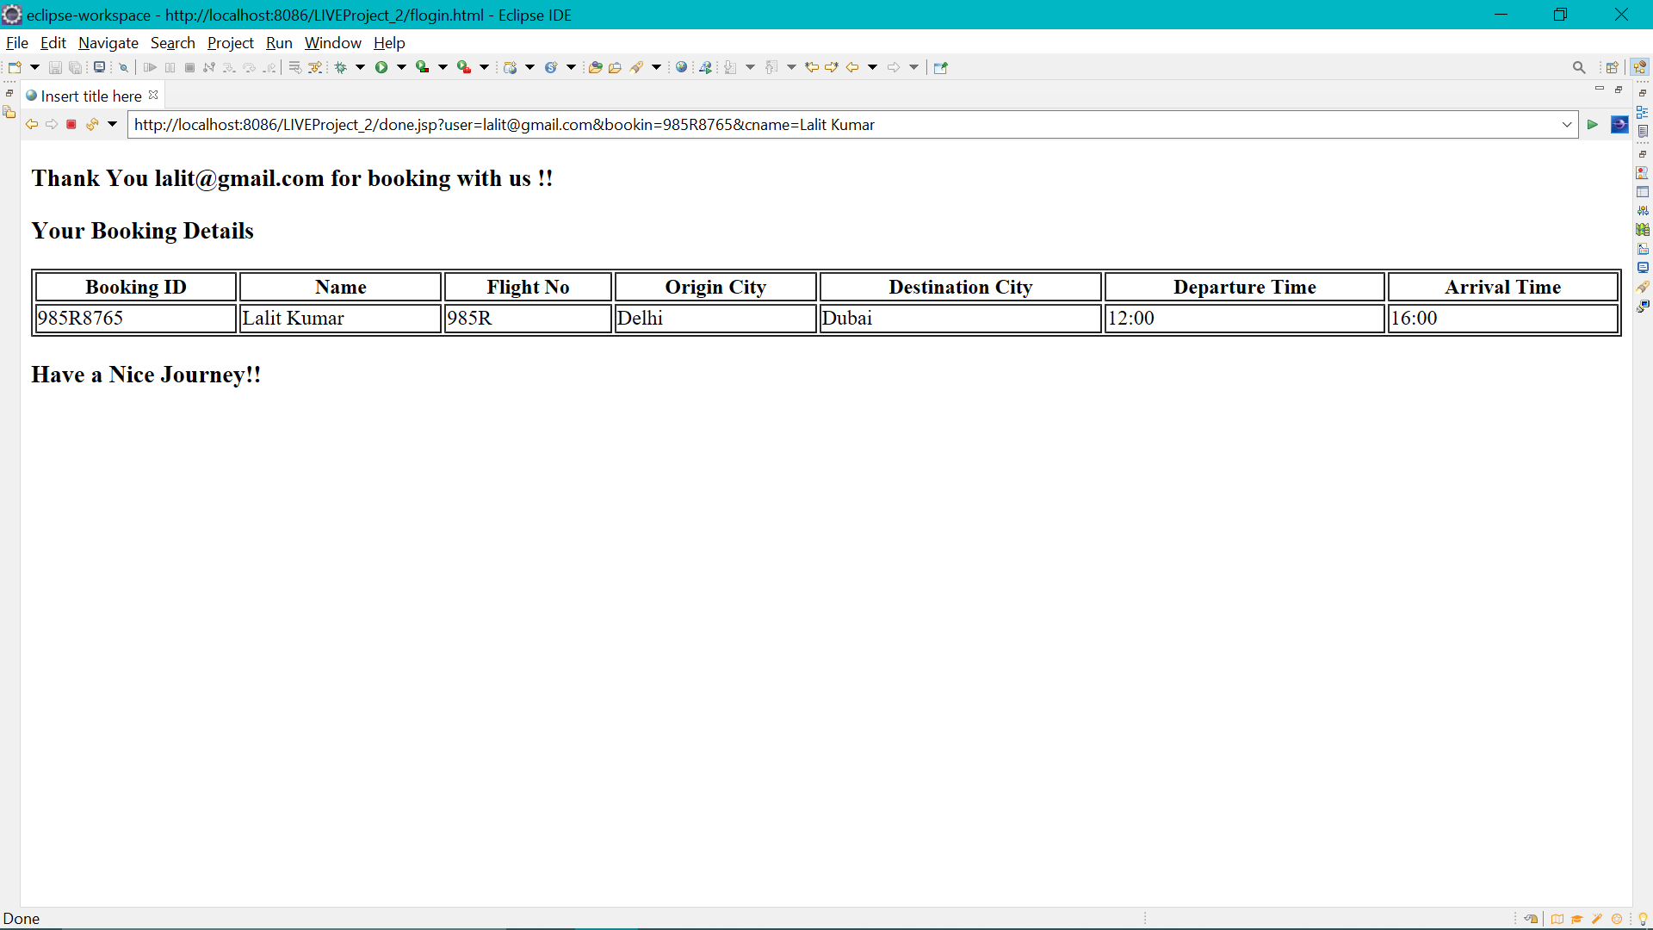

Changes reflected into databases tables.  
Booking Table  
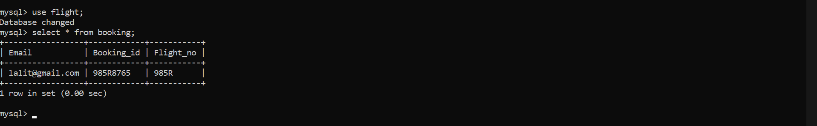

Register Table.  
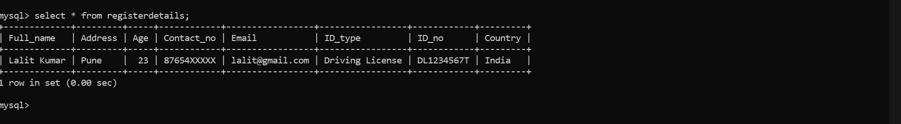

Flight Details Table the number of booked and available seats are updated.  
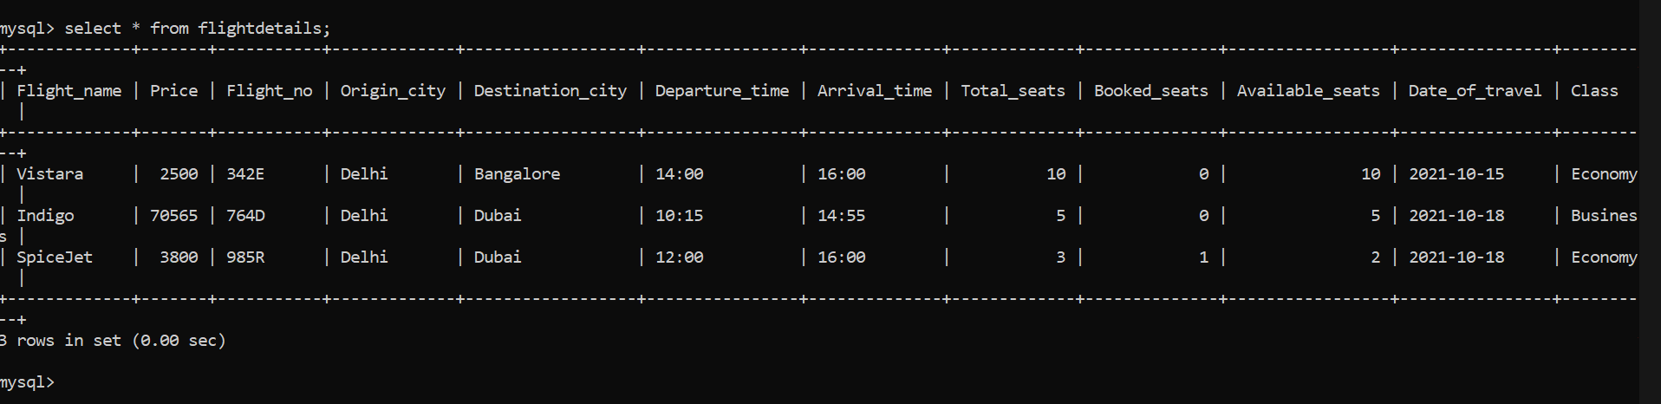

**Admin Page**  
Once the admin enter with correct mail and password admin page will be shown on the screen.  
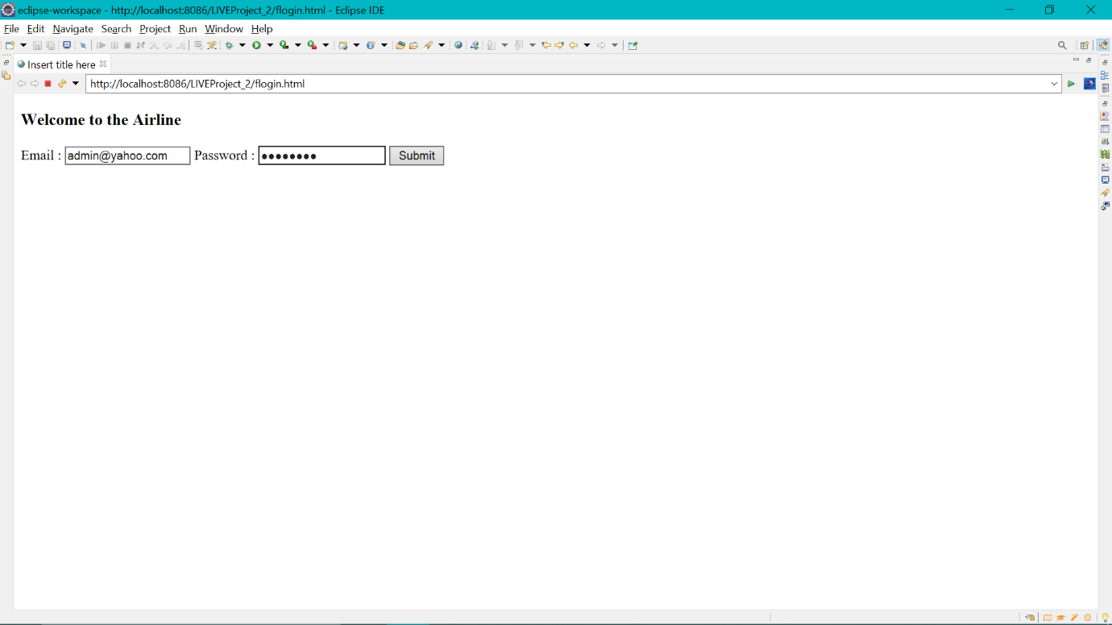

One logged in successfully admin has following options.  
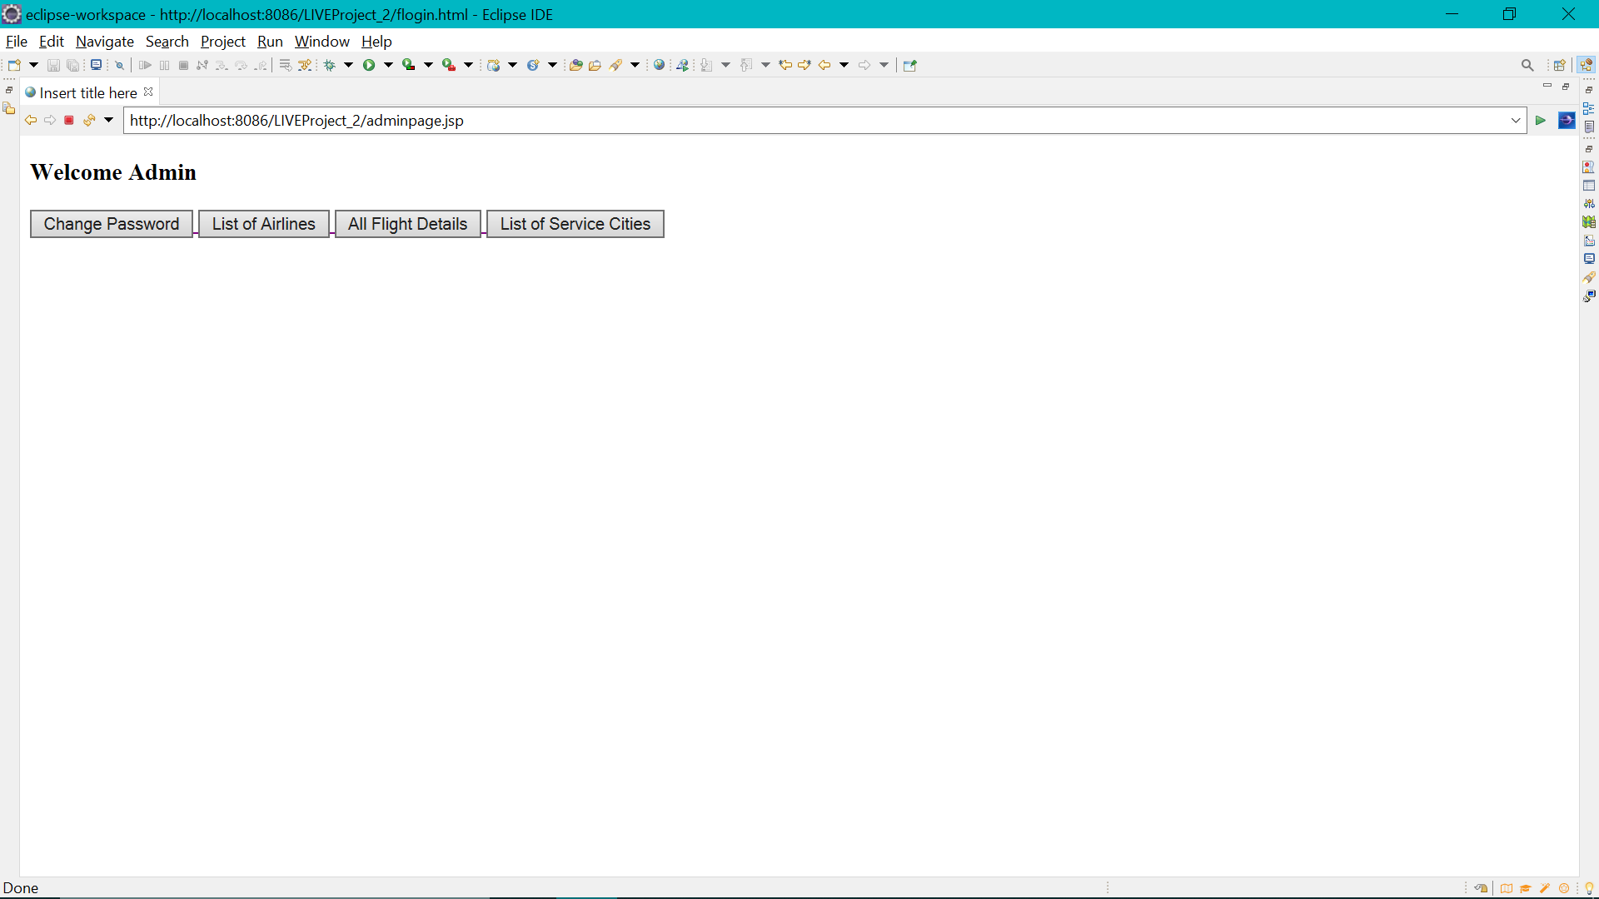

If he wishes to change current password which is admin in login table.

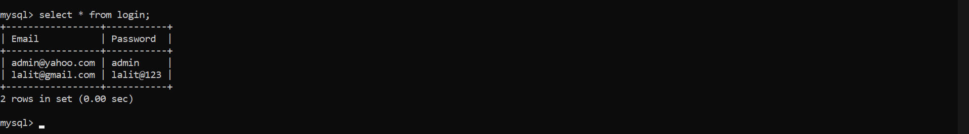

If the admin enter different New Password and Confirm Password then error will be shown.  
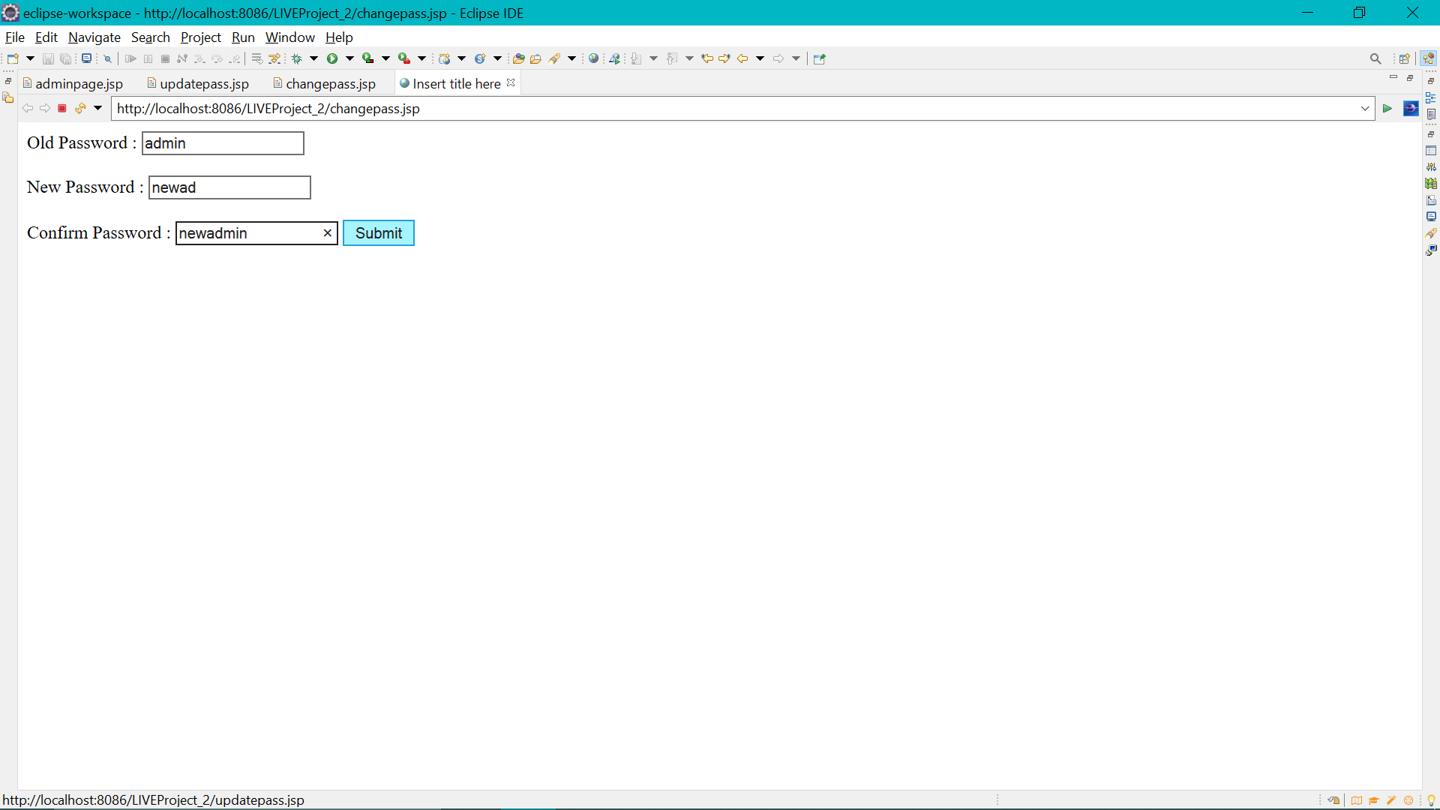  
  
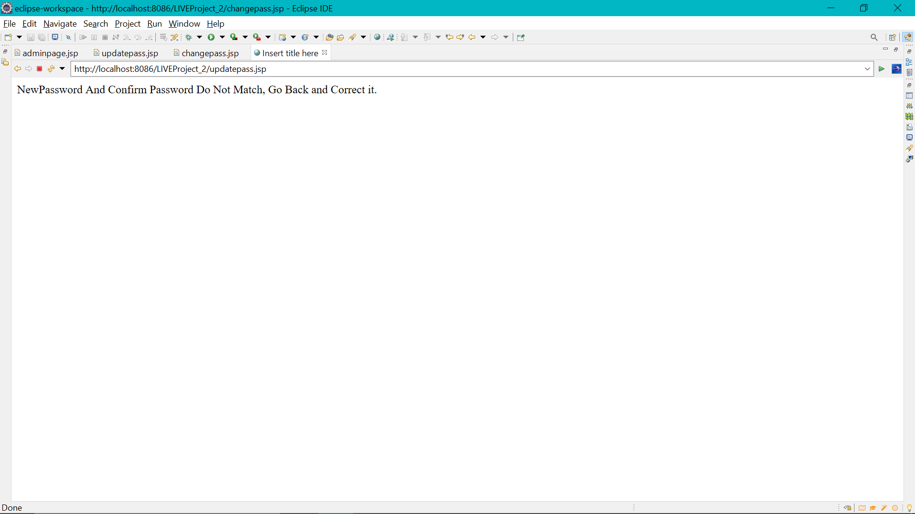

If the values of New Password and Confirm Pasword matches then only password will be changed.

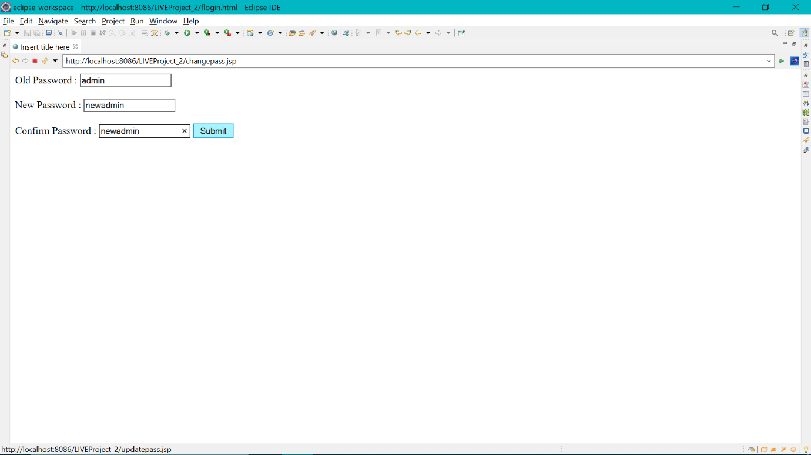

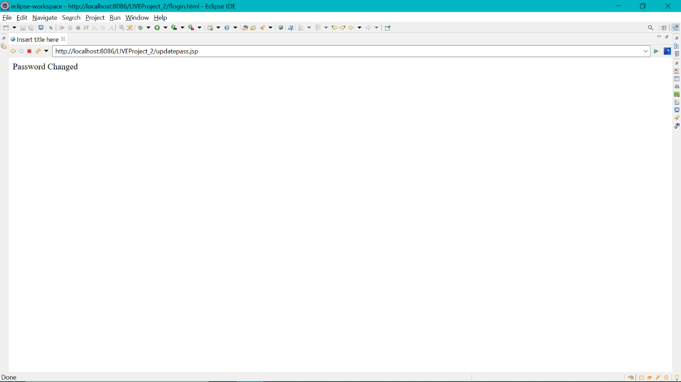

Changes are also reflected into login table.  
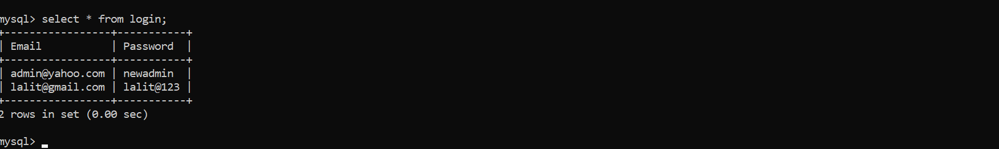

If admin wish to have List of Airlines  
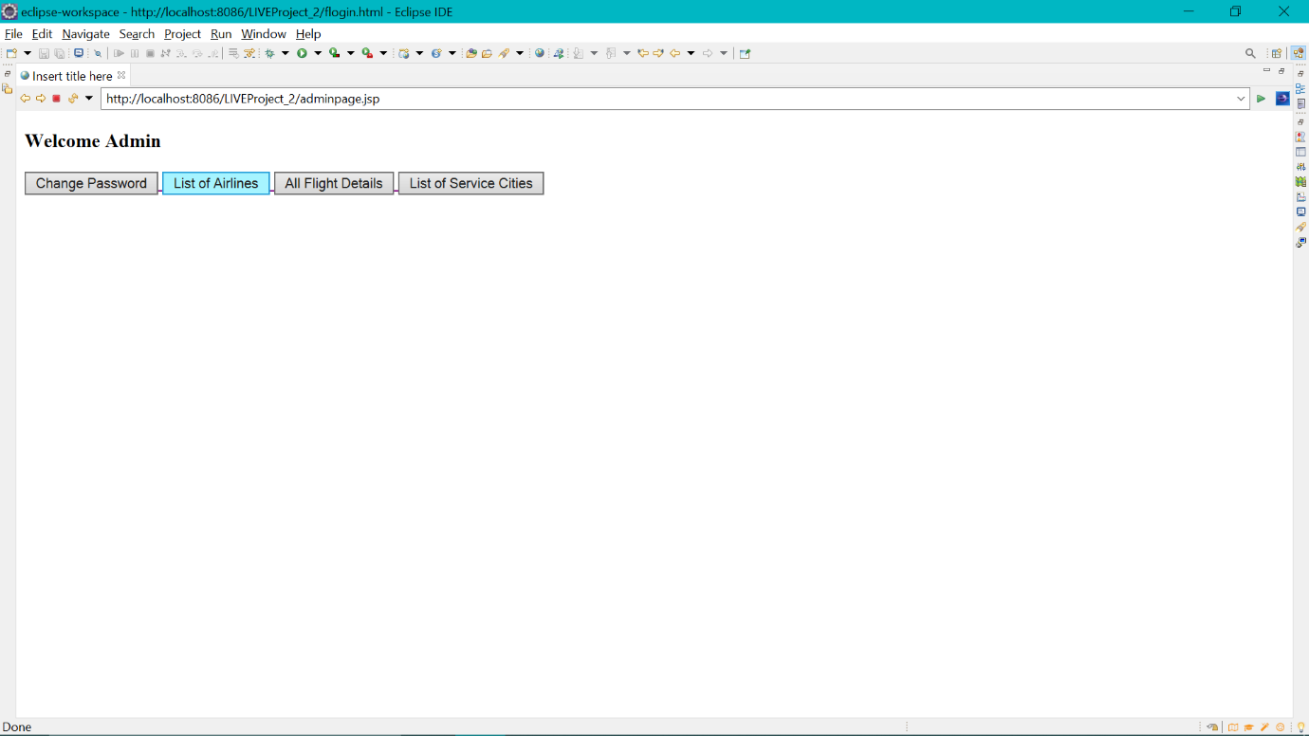

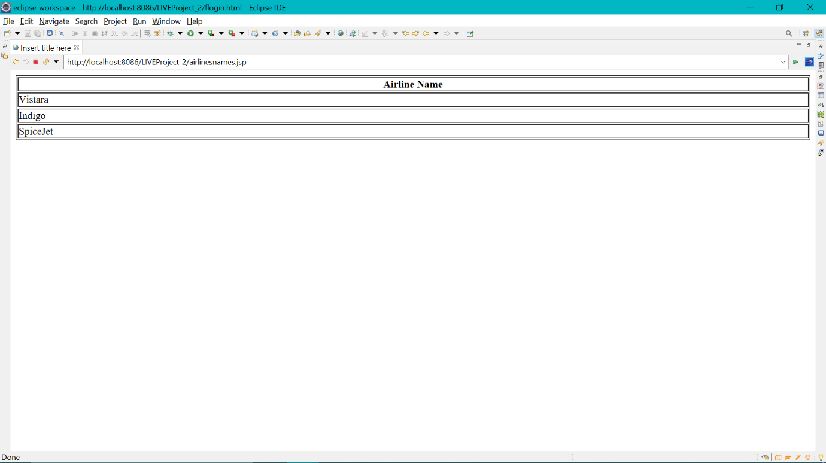

If admin wish to have all Flight details.  
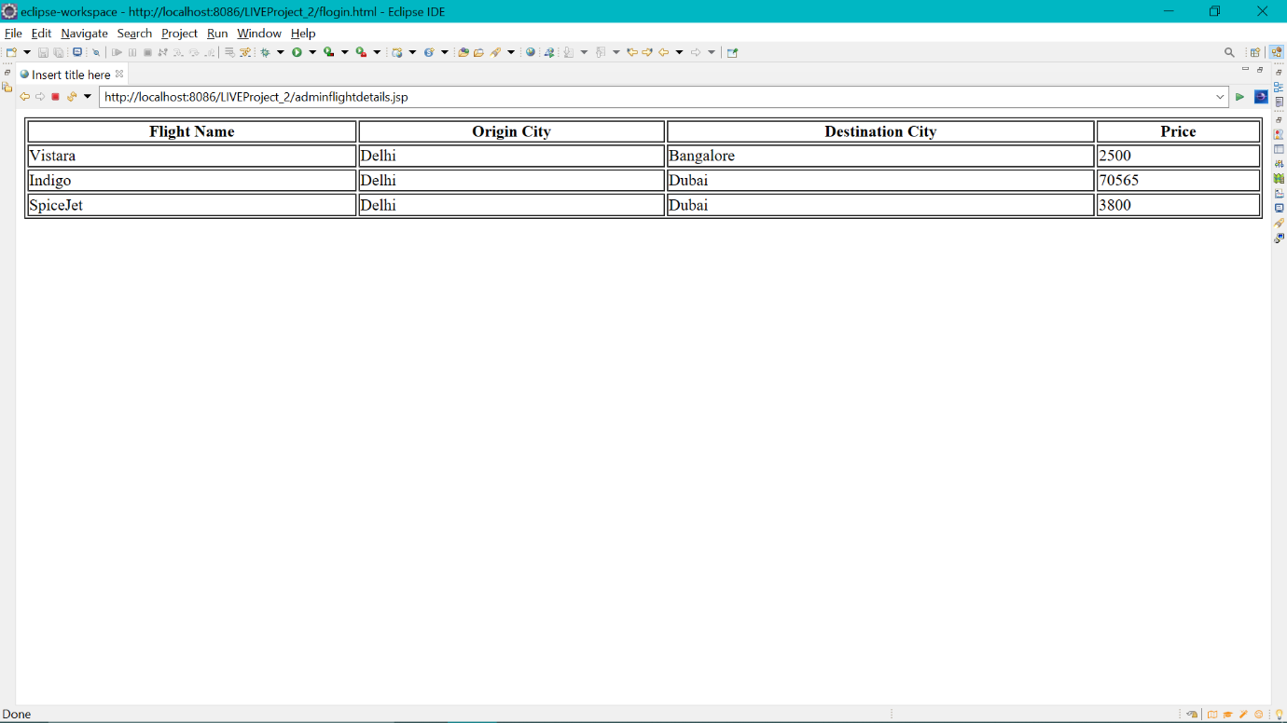

If admin wish to have list of source and destination cities.  
