Kitchen Story  
 (A grocery shopping platform)

The code for the project is hosted on: [GitHub](https://github.com/redrambo9/Lalit_JAVA_FSD_4_CISCO_Viren)  
Developer: **Lalit Kumar**

**Sprint Planning of the Project**

This project is completed in four sprints. The description of individual sprint is as follows:

**Sprint 1:**

* Understanding the functioning and features of the website according to the requirements.

# Sprint 2:

* Creating different components.
  + Home
  + About
  + Contact
  + Select(to select from available varieties of product)
  + Cart
  + Checkout

# Sprint 3:

* Working on these components, service layers, routing, navigation to add the required functionalities.
* Using hardcoded values (static data) to display product results.

# Sprint 4:

* Testing of every added functionality.

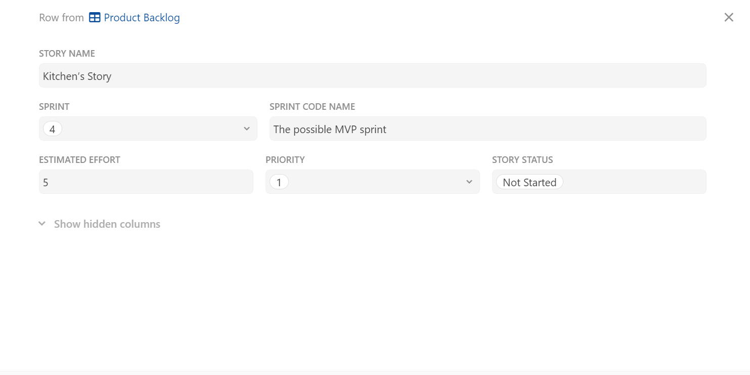

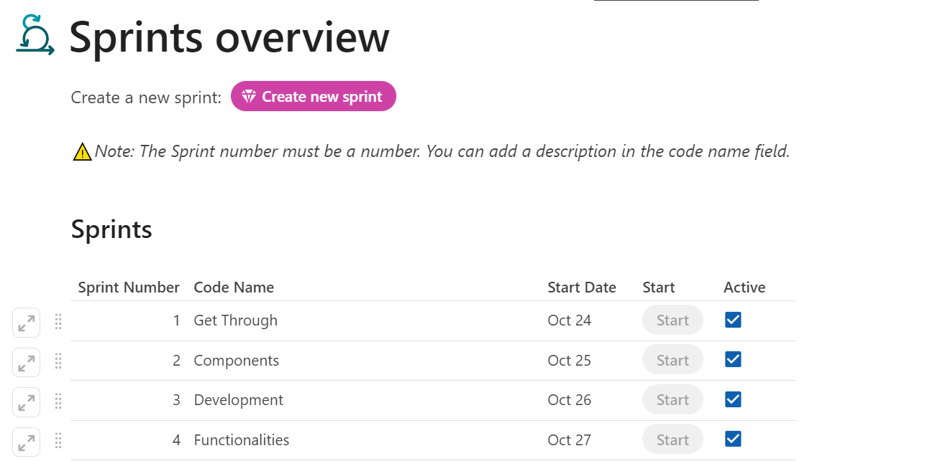

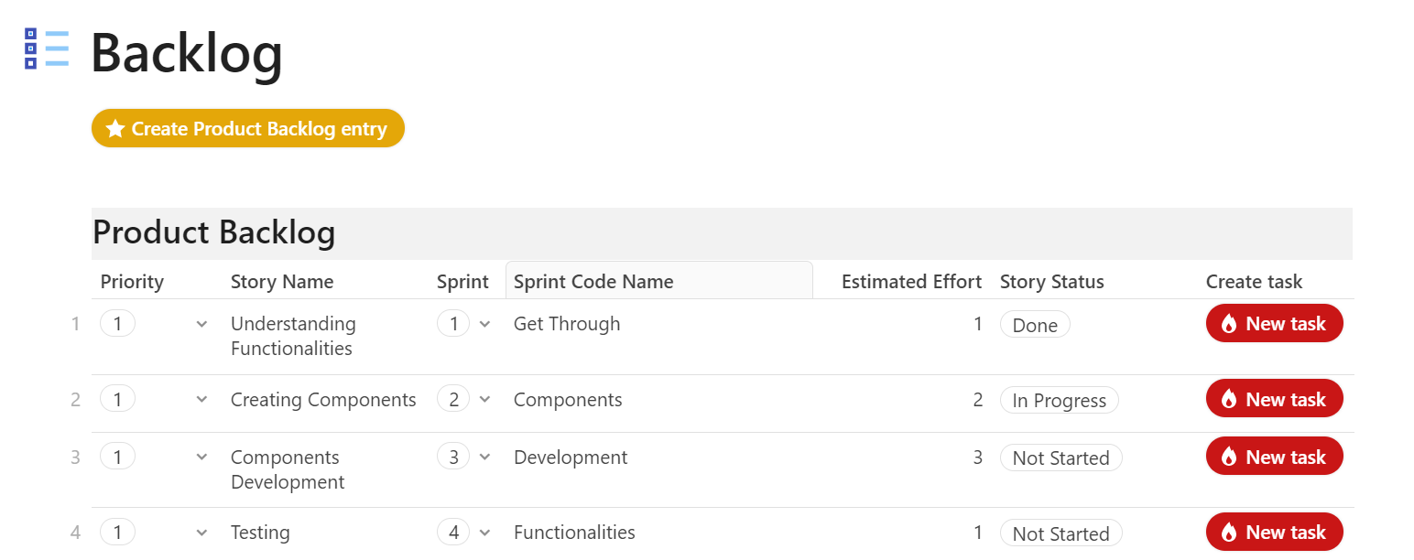

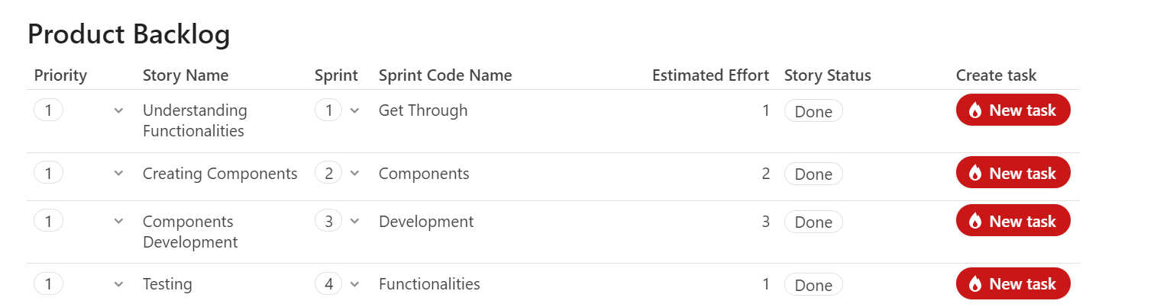

**Technologies Used**

* HTML
* CSS
* Typescript
* ANGULAR
* Visual Studio Code

**Website Features**

The application has the following capabilities:

1. Admin
   * Add Product
   * Delete Product
   * Update Product Details
2. Users
   * Navigate through out the website
   * Search products of their choice
   * Search one product at a time of his/her choice using search bar present at home page.
   * Select products to add into the cart from search results.
   * Payment of the order.
   * Order Id and Transaction are generated.

**Conclusion:**

No database is used to fetch the products details. The website is smoothly working without any kind of error on hardcoded values. As of now only four types of products(Honey, Eggs, Milk, Bread) has been added. Both the admin and user can use any of the defined features.