Homework 3: Fundamentals and Discrete Distributions

108062552廖薏萍

1. How is X distributed ?

This is binomial since we have a fixed number of trials (15 people), since we are using a random sample we can assume the trials are independent (this might not be true if our trial consisted of people who were in the same family, for example), and we can assume that the probability of any given person having no health insurance is 0.20 (same prob. of success for each trial) since even though the problem states that 20% of Americans have no health insurance and we are sampling without replacement, our sample is smaller than 5% of our population. n=15, p = 0.20

X ∼ b(15, 0.2).

1. Find the mean and variance of X.

This is binomial so I can use the formula E[X] = np = 15(0.2) = 3 people.

Since this is binomial I can use the formula: $σ=\sqrt{15\left(0.2\right)(0.8)}=1.55$ people

1. P(X ≥ 2).

P(X≥2) = P(2)+ P(3)+ P(4)+ P(5)+P(6)+P(7)+…+P(15) = 0.231+0.250+0.188+0.103+0.043+0.014+0.003+0.001=0.833

1. Find the p.d.f. of r.v. X.

f(x) = $\frac{13-2x}{36}$, for x = 1, 2, 3, 4, 5, 6

(b) Draw a probability histogram.

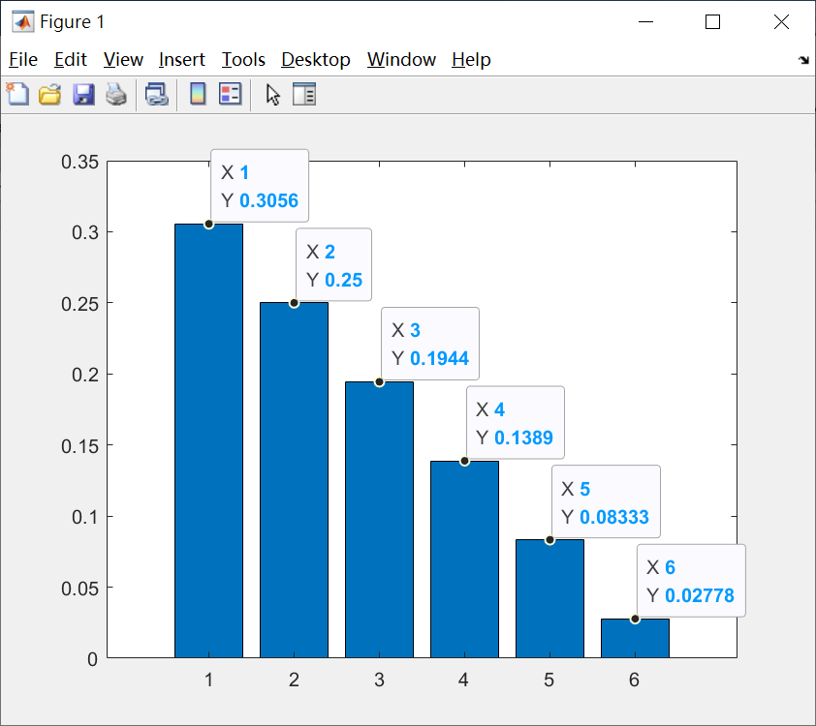

(c) Find the expectation and variance of r.v. X.

Expectation:

$$1∙f\left(1\right)+2∙f\left(2\right)+3∙f\left(3\right)+4∙f\left(4\right)+5∙f\left(5\right)+6∙f\left(6\right)=1∙\frac{11}{36}+2∙\frac{9}{36}+3∙\frac{7}{36}+4∙\frac{5}{36}+5∙\frac{3}{36}+6∙\frac{1}{36}=\frac{91}{36}$$

Variance:

$$\sum{{\left(x-μ\right)}^{2}f\left(x\right)}={\left(1-\frac{91}{36}\right)}^{2}∙\frac{11}{36}+{\left(2-\frac{91}{36}\right)}^{2}∙\frac{9}{36}+{\left(3-\frac{91}{36}\right)}^{2}∙\frac{7}{36}+{\left(4-\frac{91}{36}\right)}^{2}∙\frac{5}{36}+{\left(5-\frac{91}{36}\right)}^{2}∙\frac{3}{36}+{\left(6-\frac{91}{36}\right)}^{2}∙\frac{1}{36}=\frac{2555}{1296}≈1.971$$

(a) $f\left(x\right)=\frac{1}{1000},$ 000 ≤ x ≤ 999

(b) E[X] = $\frac{999}{2}$ = 499.5

(c) Var(X) = $\frac{({10}^{6}-1)}{12}$ = $\frac{333333}{4}$ = 83333.25

(a) Find the mean, E(X).

Poisson Distribution: Let X have a Poisson distribution with mean λ, then

$$Μ(t)=Ε(e^{tX})=\sum_{x=0}^{∞}{e^{tx}\frac{e^{-λ}λ^{x}}{x!}}=\sum_{x=0}^{∞}{e^{-λ}\frac{{\left(λe^{t}\right)}^{x}}{x!}=e^{-λ}∙e^{λe^{t}}=e^{λ\left(e^{t}-1\right)}}$$

E[X] $=Μ'(0) = λ$

(b) Find the variance, Var(X).

Var[X] $=Μ''(0)-{\left[Μ'(0)\right]}^{2}= λ$

(c) Find the mode of the probability density function f.

The mode is the most frequent value in a data set. The following figure is an example of poisson distribution.

The mode is $\left\lfloor λ\right\rfloor$

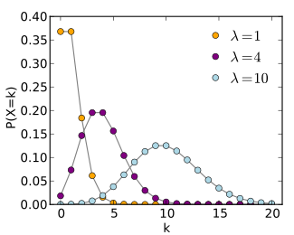

(a)(b)

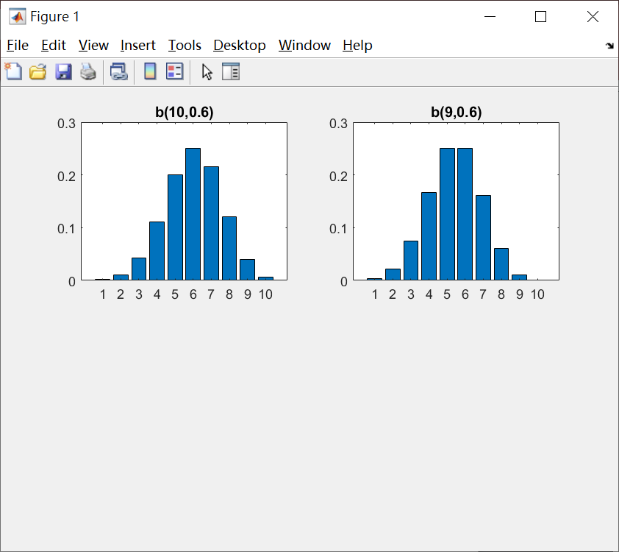

(c) What are the modes of (a) and (b), respectively?

(a)：6

(b)：5、6

(a)(b)

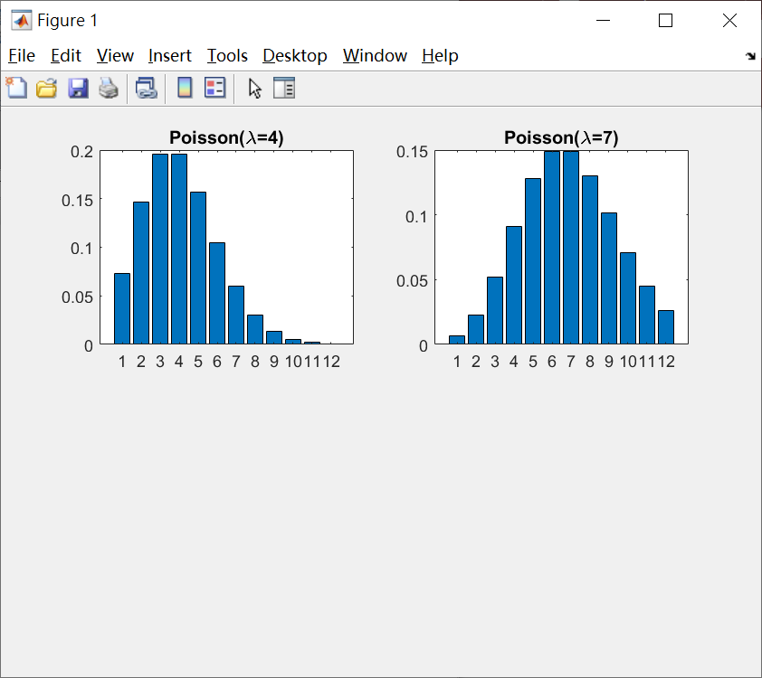

(c) What are the modes of (a) and (b), respectively?

(a)：3、4

(b)：6、7