REVIEW 2: PROJECT REPORT
Agentic Shell — Smart Archive Agent
Course / Project: Operating Systems Project — Agentic Shell | Project Title: Smart Archive Agent
Team Details: Team 12 | Team Members: Kush Aghera (24BCE0149), Sandeep More (24BCE2883)

Chapter 3: System Architecture & Design
3.1 High-Level Architecture
The User-to-Shell Loop: User Input → LLM Processing → Tool Call → System Execution → Feedback
The Smart Archive Agent is Agent #12 of the class-wide Agentic Shell. In the shell, the base shell's LLM reads the user's sentence, chooses one of our tools and its arguments, and our code performs the real operating-system work. The agent can also run on its own, in which case a built-in rule-based planner performs the "LLM processing" stage and produces the same tool calls. Both paths reach the operating system only through one validated entry point, execute_tool().
Loop stage | In the Agentic Shell | When the agent runs on its own
User Input | The user types into the base shell. | The user types at the agent's You: prompt (main.py).
LLM Processing | The shell's LLM reads our tool definitions (get_tools()) and picks tools by function calling. | intent.py and planner.py turn the sentence into an ordered plan of tool calls, offline.
Tool Call | The shell calls execute_tool(name, arguments). | Each plan step is passed to execute_tool().
System Execution | tar, gzip, bzip2, xz and gpg run through subprocess.run() with argument lists. | Same.
Feedback | A result dictionary is returned to the LLM as the tool result. | The result is printed: done lines, output path, entries or error.

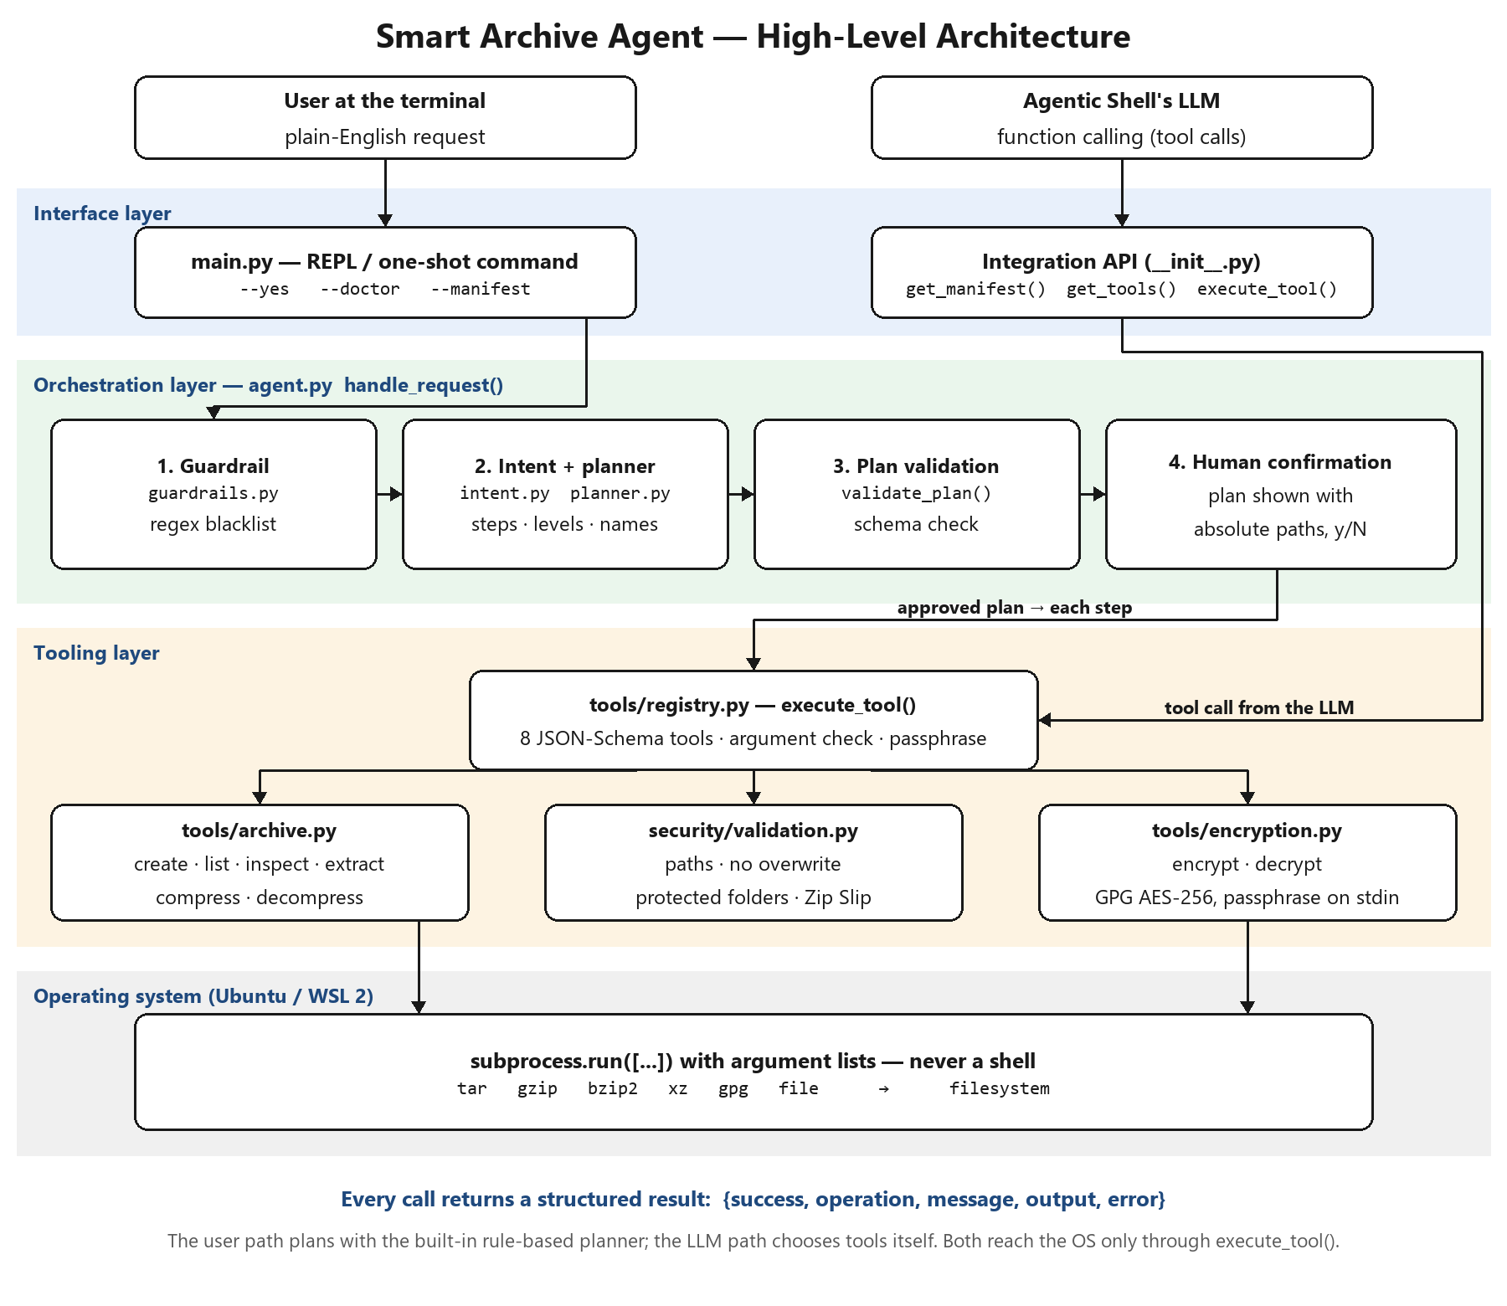
Figure 3.1: High-Level System Architecture of the Smart Archive Agent.
Architecture explanation. Figure 3.1 shows the two entry points at the top: a user at the terminal and the Agentic Shell's LLM. The user path goes through the orchestration layer: a guardrail, the intent recognizer and planner, plan validation and human confirmation. The LLM path skips planning, because the LLM has already chosen the tool, and goes straight to the tool registry. In both cases execute_tool() checks the call against its JSON Schema, the security module re-validates every path, and only then do the archive and encryption modules start Linux utilities. Every call returns the same structured result.
3.2 Component Design
3.2.1 The Interface Layer: Custom REPL (Read-Eval-Print Loop) Environment
The interface layer is implemented in smart_archive_agent/main.py and the run() loop in agent.py. It offers an interactive REPL (a banner, a You: prompt, the proposed plan with absolute paths, a y/N confirmation, a hidden passphrase prompt and formatted results) and a one-shot command mode for scripts. Ctrl+C and end-of-input exit cleanly, and the exit code is 0 on success and 1 on failure.
python3 -m smart_archive_agent # interactive REPL
python3 -m smart_archive_agent "archive ./src" # one request, asks before writing
python3 -m smart_archive_agent --yes "back up ./src" # one request, no confirmation
python3 -m smart_archive_agent --doctor # checks tar, gzip, bzip2, xz, gpg, file
python3 -m smart_archive_agent --manifest # agent description for the shell's router

For integration, the package itself is part of the interface: __init__.py exports get_manifest(), get_tools(), execute_tool() and handle_request(), and agent.json describes the agent to the shell's router (what it handles, what it does not, and what it needs installed).
3.2.2 The Orchestration Layer: Intent Routing
The template lists LangChain, LlamaIndex or a raw MCP client for this layer. We implemented the orchestration directly in Python (agent.py, handle_request()) without a framework, for three reasons: the agent must install on the teacher's machine with no extra packages, every decision must be predictable and auditable for safety review, and open-ended language understanding is already the base shell's LLM's job. The pipeline runs in a fixed order:
Stage | Module | What it does
1. Guardrail | security/guardrails.py | Matches the raw text against a regex blacklist of destructive commands before anything else.
2. Intent recognition | intent.py | Removes file paths from the text, then matches whole-word verb vocabularies in a fixed priority order (decrypt, encrypt, extract, decompress, list, compress, archive). Out-of-scope requests stop here.
3. Planning | planner.py | Builds ordered steps: folders are archived first; "heavily" → level max, "quickly" → fast; missing output names are chosen next to the source; an unencrypted archive the agent created is removed after encryption.
4. Plan validation | planner.validate_plan() | Checks every step against the tool schemas; a clean-up step may delete only a file created earlier in the same plan.
5. Confirmation and execution | agent.run_plan() | Shows the plan, waits for y, runs the steps in order, and stops at the first failure, reporting completed steps.

3.2.3 The Tooling Layer: Safe System Functions
The tooling layer exposes eight archive functions as tools. Each tool is declared in tools/registry.py with a name, a description written for an LLM, and a JSON Schema for its parameters, which is the same structure an MCP server uses to declare tools. get_tools() returns these declarations in generic, OpenAI-compatible or Anthropic format, and execute_tool() runs one call. The tools are not yet served over the MCP protocol itself; that wrapper is listed as future work. File-management functions for other domains, system monitoring and network configuration belong to other agents of the shell.
Tool | Python function | Linux backend | Key arguments
create_archive | archive.create_archive() | tar with gzip / bzip2 / xz (tar -I), or Python zipfile | source_path, output_path, compression, level
list_archive | archive.list_archive() | tar -tf, zipfile | archive_path
inspect_archive | archive.inspect_archive() | file -b, tar -tf, zipfile | archive_path
extract_archive | archive.extract_archive() | Python tarfile / zipfile after a full member check | archive_path, destination_path
compress_file | archive.compress_file() | gzip, bzip2, xz | source_path, output_path, algorithm, level
decompress_file | archive.decompress_file() | gzip -d, bzip2 -d, xz -d | source_path, output_path
encrypt_file | encryption.encrypt_file() | gpg --symmetric --cipher-algo AES256 | source_path, output_path (+ passphrase)
decrypt_file | encryption.decrypt_file() | gpg --decrypt | source_path, output_path (+ passphrase)

Compression levels: fast = gzip -1 / xz -1, normal = gzip -6 / xz -6, max = gzip -9 / bzip2 -9 / xz -9e.
3.2.4 Result Handling & Diagnostics
Every tool and every request returns one dictionary: success (bool), operation (str), message (str, for people), output (path produced), plus entries for listings, steps and plan for multi-step requests, missing when a detail could not be found, and error on failure. execute_tool() never raises: exceptions inside a tool are turned into success = false with an error message, so neither the REPL nor the base shell can be crashed by a failing operation. The same dictionary can be sent back to an LLM as the tool result with json.dumps().
3.3 Security & Guardrail Framework
3.3.1 The "Human-in-the-Loop" Validation Mechanism
No file is written until a person has seen and approved the complete plan. Before any step that writes, the agent prints every step with absolute source and destination paths and waits for y; anything else cancels with "Nothing was changed". Read-only requests (list, inspect) run without asking. Passphrases for encryption and decryption are always typed by the person at a hidden prompt (asked twice when encrypting); they never come from an LLM. When the agent is embedded in the base shell, handle_request(confirm=…, passphrase=…) lets the shell show the plan and collect the passphrase in its own interface.
3.3.2 Command Sanitization and Regex-Based Blacklisting of Destructive Commands
User text is never executed as a command. Utilities are started with subprocess.run() and an argument list (never shell=True), so characters such as ; | $( ) are passed as plain data. In addition, the raw request is checked against a regex blacklist before planning, so a destructive request is refused outright instead of being partially carried out:
Pattern (examples) | Refused as
rm -rf …, rm -fr … | recursive forced delete
mkfs, mkfs.ext4 | filesystem formatting
dd if=… | raw disk write
:(){ :|:& };: | fork bomb
> /dev/sda | raw block-device overwrite
chmod -R 777 / | world-writable root filesystem
shutdown, reboot, poweroff, halt | system power control
format / wipe / erase … disk, drive, everything | disk wipe request
delete everything, delete all files | mass deletion request
; rm, | bash, `…`, $( … ) | shell command injection
a bare / as a path | operation on the whole root filesystem

Further guards apply inside every tool, whichever path the call came from:
- Protected locations: never writes into /bin, /boot, /dev, /etc, /lib, /lib64, /proc, /sbin, /sys, /usr or /var/lib.
- No overwrites: an existing output is never replaced; source and output must differ; an archive cannot be written inside the folder being archived.
- Zip Slip prevention: every member of an archive is resolved against the destination and must stay inside it; symbolic and hard links inside tar archives are refused; the destination folder is created only after the whole archive passes.
- Schema validation of tool calls: unknown tools, missing or extra arguments, wrong types and invalid values (for example level = "ultra") are rejected before anything runs.
- Least privilege: the agent runs as a normal user and never uses sudo.
Chapter 4: Implementation Methodology
4.1 Development Environment & Tech Stack
Item | Choice
Programming Language | Python. The code uses Python 3.8+ syntax and only the standard library (subprocess, tarfile, zipfile, getpass, json, re, pathlib); developed and tested with Python 3.14.4.
Operating System | Ubuntu 26.04.1 LTS on Windows Subsystem for Linux 2 (Windows 11). Targets any Ubuntu or Debian machine.
LLM Provider | Provided by the base Agentic Shell, which owns the LLM. get_tools() exports our tool definitions in OpenAI-compatible format (also accepted by local Ollama) and Anthropic Claude format. The agent itself makes no LLM calls and needs no API key; offline requests use the built-in planner.
SDKs | None required. The MCP Python SDK is not used; the tool declarations follow the same JSON Schema structure, so an MCP server wrapper can be added without changing the tools.
System Utilities | GNU tar 1.35, gzip, bzip2, XZ Utils 5.8.3, GnuPG 2.4.8, file.
Testing | pytest 9.1.1 (58 automated tests) and benchmarks/evaluate.py for accuracy, latency and error recovery.
Packaging & Integration | pyproject.toml (pip install from GitHub, smart-archive-agent command), agent.json manifest, INTEGRATION.md and a runnable integration example.
Tools | Visual Studio Code with the WSL extension, Git and GitHub.

4.2 Step-by-Step Implementation
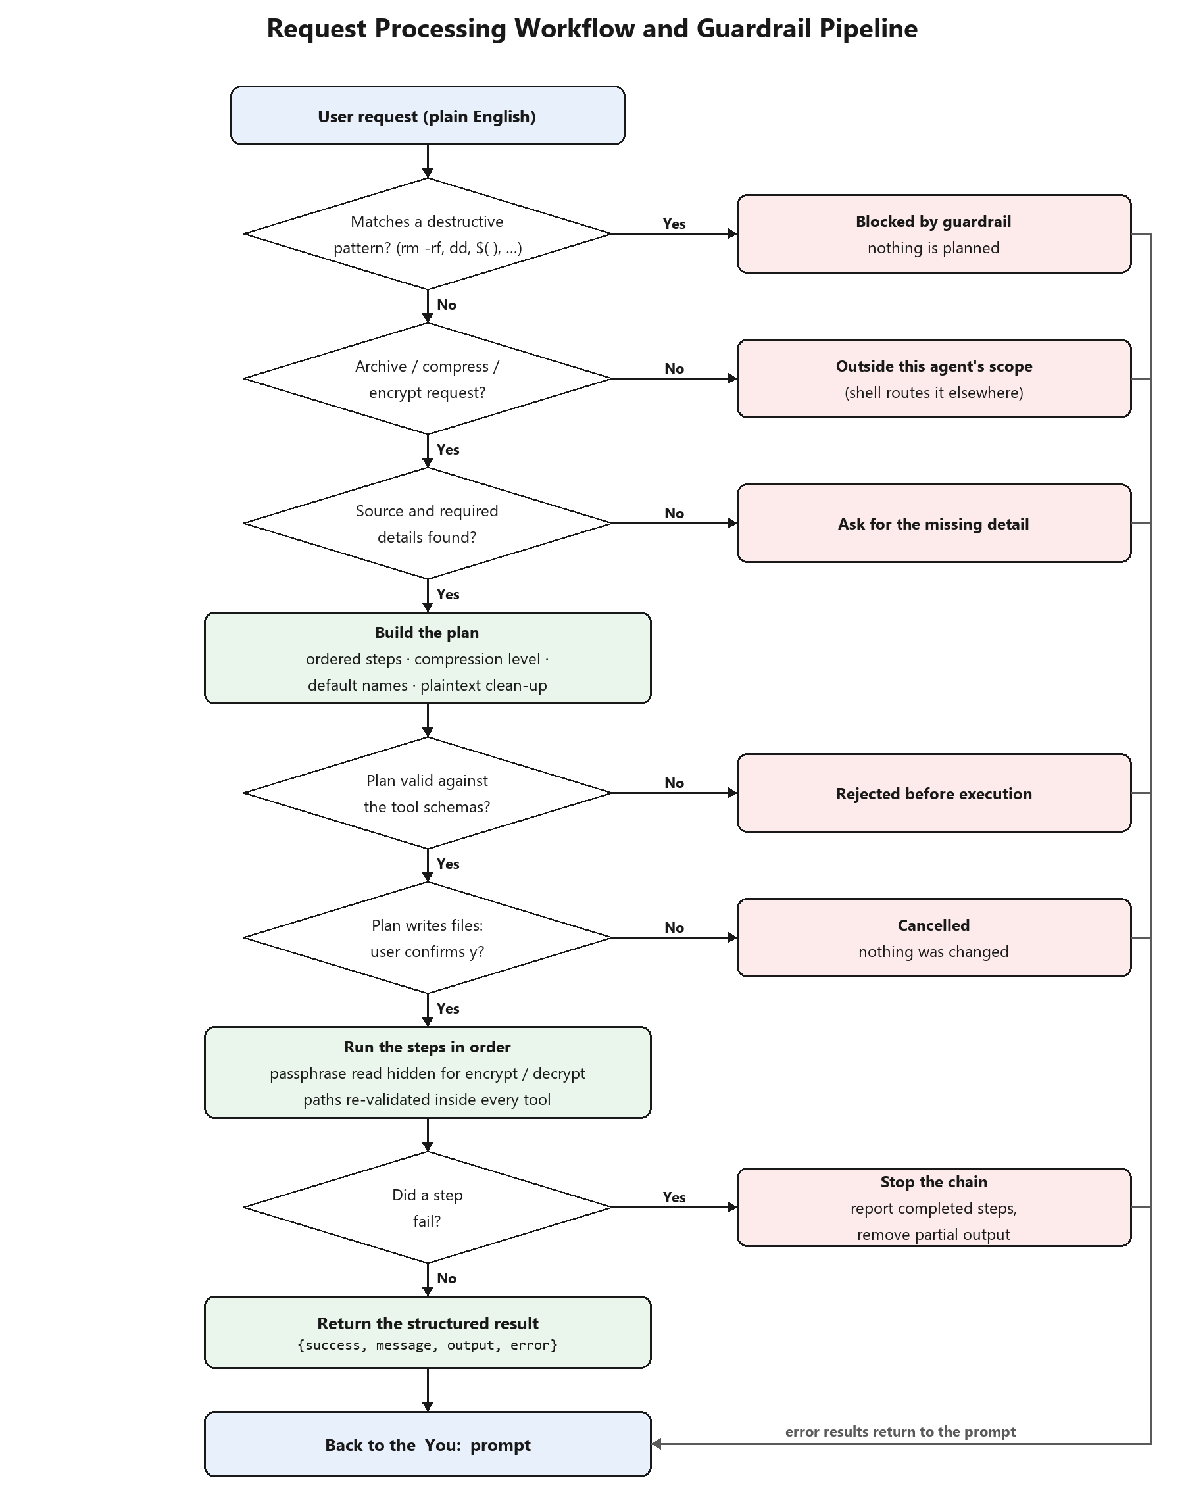
Figure 4.1: End-to-End Request Processing Workflow and Guardrail Pipeline.
Figure 4.1 shows how one request travels through the agent. Each decision has a safe exit on the right (blocked, out of scope, missing detail, rejected, cancelled, or a failed step) that returns a structured error and goes back to the prompt without changing any file. The implementation was built in four steps.
Step 1: Setting up the base CLI prompt loop
main.py parses the command line (interactive, one-shot, --yes, --doctor, --manifest, --version) and agent.run() implements the REPL: read a line, pass it to handle_request() with a terminal confirmation and a hidden passphrase prompt, print the result with print_result(), and repeat until exit, Ctrl+C or end of input. The --doctor check lists any missing Linux tool with the exact apt install command, so the agent can be checked quickly on any lab machine.
Step 2: Building the MCP-style tool layer to expose safe system functions
archive.py and encryption.py implement the eight operations as plain Python functions that validate their paths and return result dictionaries. tools/registry.py then declares each one for function calling (TOOL_SCHEMAS) and provides execute_tool(), the only entry point that runs a tool. The template's examples list_directory and get_system_stats correspond in our domain to list_archive and inspect_archive, which read an archive without changing anything. A prefix option (smart_archive__create_archive) keeps our tool names unique among the 35 agents.
Step 3: Prompt engineering for exact tool matching and JSON format enforcement
For the LLM path, every tool description and parameter description is written so that a model can choose the right tool and values from everyday wording, and JSON Schema enforces the format:
"level": {"type": "string", "enum": ["fast", "normal", "max"],
"description": "Compression effort. Use 'max' when the user says heavily, maximum
or as small as possible; 'fast' for quick; otherwise 'normal'."}
"required": ["source_path", "output_path"], "additionalProperties": false

check_arguments() enforces the schema on every call (unknown tool, missing or extra argument, wrong type, value outside the enum), and execute_tool() also accepts the JSON string that LLM APIs return. For the offline path, intent.py matches whole words in a fixed priority order after removing file paths from the text, so "zip" is not found inside "gzip" and "tar" is not found inside "backup.tar.xz". Recognition accuracy was measured on phrasings never used for tuning (Review 3, Section 5.2.1).
Step 4: Implementing the command execution wrapper and output formatter
All utilities run through one wrapper that uses an argument list, captures output, applies a 600-second timeout, closes standard input and turns failures into readable errors:
subprocess.run(["tar", "-I", "xz -9e -T0", "-cf", output, "-C", parent, name],
check=True, capture_output=True, text=True,
timeout=600, stdin=subprocess.DEVNULL)
# passphrase is sent on standard input, never as an argument
gpg --batch --yes --no-symkey-cache --pinentry-mode loopback \
--passphrase-fd 0 --symmetric --cipher-algo AES256 \
--output <file>.gpg <file>

run_plan() executes the steps in order, records which files each step produced (so the clean-up step can delete only those), stops at the first failure and removes any partial output. print_result() formats the dictionary for the terminal as done lines, the output path, archive entries and errors. Testing and measured results of this implementation are reported in Review 3 (Chapter 5).
References
[1] Python Software Foundation, "subprocess — Subprocess management," Python 3 documentation. Available: https://docs.python.org/3/library/subprocess.html
[2] Free Software Foundation, "GNU tar: an archiver tool," manual for GNU tar 1.35. Available: https://www.gnu.org/software/tar/manual/
[3] W. Koch et al., "The GNU Privacy Guard (GnuPG) Documentation." Available: https://gnupg.org/documentation/
[4] JSON Schema, "JSON Schema specification." Available: https://json-schema.org/
[5] OpenAI, "Function calling guide." Available: https://platform.openai.com/docs/guides/function-calling
[6] Anthropic, "Model Context Protocol specification." Available: https://modelcontextprotocol.io/
[7] OWASP Foundation, "Path Traversal." Available: https://owasp.org/www-community/attacks/Path_Traversal
[8] Python Software Foundation, PEP 706, "Filter for tarfile.extractall." Available: https://peps.python.org/pep-0706/
Appendix B: Implementation Evidence — Review 2 Stage
This appendix shows the implementation described in Chapters 3 and 4 as it exists in the repository: the commit history of the build, the size of each module, the key source code, and real output from the code.
B.1 Commit History of the Implementation (Stage 2)
Between 16 and 20 October 2026 each module was rewritten and committed separately, followed by tests, diagrams and documentation:
Table B.1: Implementation commits, 16–20 October 2026 (from git log).
Commit | Date and time | Author | Change | Size
7856c51 | 16 Oct 2026 11:15 | Kush Aghera | updated validation logic | 2 files, +30 / −225 lines
000e677 | 16 Oct 2026 16:30 | Kush Aghera | updated archive tools | 2 files, +135 / −327 lines
70aa599 | 17 Oct 2026 10:45 | Kush Aghera | updated encryption tools | 1 file, +38 / −176 lines
d14e9e3 | 17 Oct 2026 15:20 | Kush Aghera | updated intent router | 1 file, +61 / −209 lines
c39ecda | 18 Oct 2026 11:40 | Kush Aghera | updated agent loop | 1 file, +58 / −547 lines
a7a5f08 | 18 Oct 2026 16:15 | Kush Aghera | updated main cli | 2 files, +19 / −253 lines
6d403e4 | 19 Oct 2026 10:10 | Kush Aghera | updated project dependencies | 2 files, +5 / −4 lines
87ab7ae | 19 Oct 2026 14:45 | Kush Aghera | added test cases | 2 files, +161 / −60 lines
018788e | 19 Oct 2026 17:20 | Kush Aghera | cleaned old tests | 4 files, +0 / −329 lines
a1fff6e | 20 Oct 2026 09:30 | Kush Aghera | added design diagrams | 2 files (binary: .docx / .pdf / .png)
9114e3b | 20 Oct 2026 10:45 | Kush Aghera | added project memory | 1 file, +39 / −0 lines
bfe5279 | 20 Oct 2026 11:50 | Kush Aghera | added review templates | 3 files (binary: .docx / .pdf / .png)
c97944d | 20 Oct 2026 13:15 | Kush Aghera | updated project readme | 1 file, +88 / −54 lines
67f6a44 | 20 Oct 2026 13:45 | Kush Aghera | added reference guide | 1 file, +122 / −0 lines
c8f53ca | 20 Oct 2026 13:55 | Kush Aghera | polished project readme | 1 file, +138 / −93 lines

B.2 Source Code Size by Module
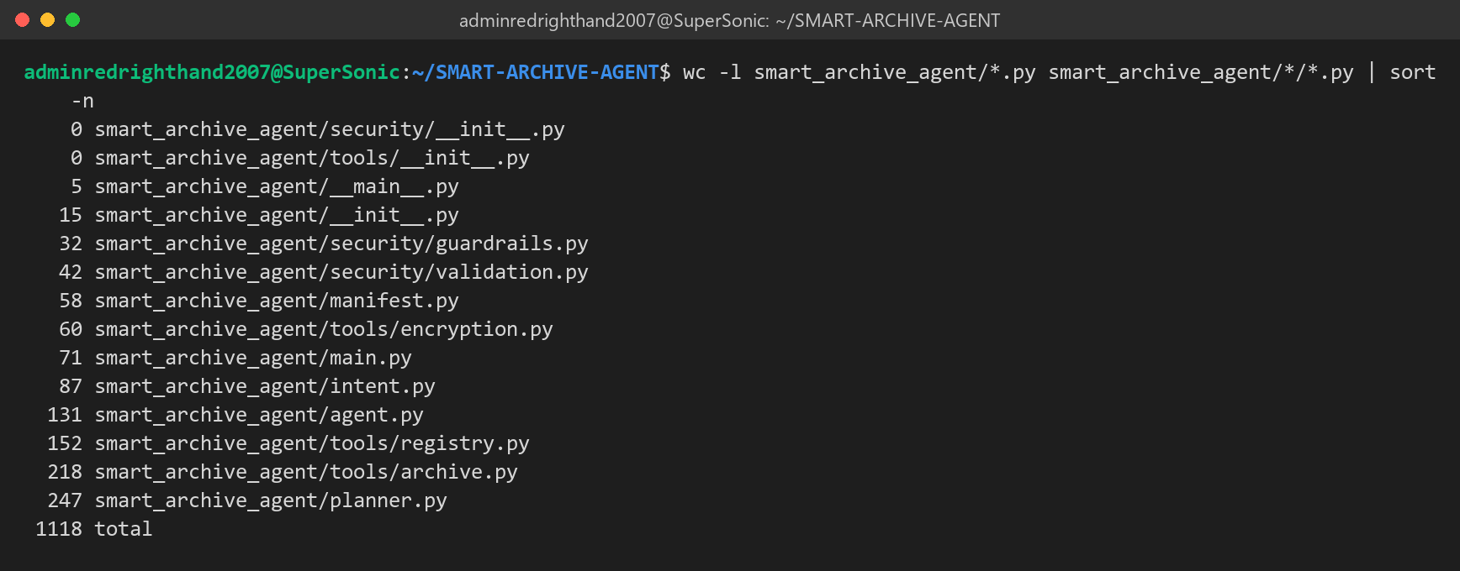
Figure B.1: Lines of code in each module of the smart_archive_agent package (1,118 lines in total).
B.3 Key Source Code Excerpts
The excerpts below are copied from the repository with their real line numbers.
Guardrail: regex blacklist checked before any planning (Section 3.3.2)
6 DESTRUCTIVE_PATTERNS = [
7 (re.compile(r"\brm\s+-[a-z]*r[a-z]*f|\brm\s+-[a-z]*f[a-z]*r", re.I), "recursive forced delete (rm -rf)"),
8 (re.compile(r"\bmkfs(\.\w+)?\b", re.I), "filesystem formatting (mkfs)"),
9 (re.compile(r"\bdd\s+if=", re.I), "raw disk write (dd)"),
10 (re.compile(r":\(\)\s*\{\s*:\|:&\s*\};:"), "fork bomb"),
11 (re.compile(r">\s*/dev/(sd|nvme|hd)\w*", re.I), "raw block-device overwrite"),
12 (re.compile(r"\bchmod\s+(-R\s+)?777\s+/(\s|$)", re.I), "world-writable root filesystem"),
13 (re.compile(r"\b(shutdown|reboot|poweroff|halt)\b", re.I), "system power control"),
14 (re.compile(r"\b(format|wipe|erase|destroy)\b.*\b(drive|disk|partition|system|everything)\b", re.I),
15 "disk wipe request"),
16 (re.compile(r"\bdelete\s+(everything|all\s+files|all\s+my\s+files)\b", re.I), "mass deletion request"),
17 (re.compile(r"(?:^|\s)/\*?(?:\s|$)"), "operation on the whole root filesystem (/)"),
18 (re.compile(r"[;&|`]\s*(rm|sudo|curl|wget|bash|sh)\b|\$\(", re.I), "shell command injection"),
19 ]
20
21 # Output locations the agent will never write into, even if the user asks.
22 # /root is deliberately absent: it is the home folder when the shell runs as root.
23 PROTECTED_DIRS = ("/bin", "/boot", "/dev", "/etc", "/lib", "/lib64", "/proc",
24 "/sbin", "/sys", "/usr", "/var/lib")
25
26
27 def check_request(text: str) -> str | None:
28 """Return a refusal reason if the request matches a destructive pattern."""
29 for pattern, reason in DESTRUCTIVE_PATTERNS:
30 if pattern.search(text):
31 return reason
32 return None

Listing B.1: Destructive-command patterns and check_request(). Source: smart_archive_agent/security/guardrails.py, lines 6–32 (commit 92304e8 on GitHub).
Planner: chaining archive, compression level and encryption (Section 3.2.2)
166 wants_encrypt = ENCRYPT_RE.search(words) is not None
167 named_archive = named_out is not None and archive_format_for(named_out) is not None
168 wants_archive = (op == "create_archive" or source_abs.is_dir() or named_archive
169 or PACKAGE_RE.search(words) is not None)
170 wants_compress = COMPRESS_RE.search(words) is not None
171
172 steps: list[Step] = []
173 packed = None
174 if wants_archive:
175 fmt = (archive_format_for(named_out) if named_archive else None) or ("zip" if ZIP_FORMAT_RE.search(words) else algorithm or ("gz" if level == "fast" else "xz"))
176 packed = named_out if named_archive else str(_unique(source_abs.parent / (source_abs.name + EXTENSIONS[fmt])))
177 steps.append(Step("create_archive", {"source_path": source, "output_path": packed,
178 "compression": fmt, "level": level},
179 f"bundle into one {fmt} archive ({level} compression)"))
180 elif wants_compress:
181 algo = algorithm or ("gz" if level == "fast" else "xz")
182 packed = named_out or str(_unique(Path(str(source_abs) + "." + algo)))
183 steps.append(Step("compress_file", {"source_path": source, "output_path": packed,
184 "algorithm": algo, "level": level},
185 f"compress with {algo} ({level} level)"))
186 if wants_encrypt:
187 enc_source = packed or source
188 enc_out = gpg_out or (named_out if packed is None else None) or str(_unique(Path(str(_abs(enc_source)) + ".gpg")))
189 steps.append(Step("encrypt_file", {"source_path": enc_source, "output_path": enc_out},
190 "encrypt with GPG AES-256"))

Listing B.2: How one sentence becomes an archive step and an encryption step. Source: smart_archive_agent/planner.py, lines 166–190 (commit 92304e8 on GitHub).
Tool layer: the single validated entry point (Section 3.2.3)
128 def execute_tool(name: str, args: dict, passphrase: str | None = None) -> dict:
129 """Run one tool call. Never raises: failures come back as {'success': False, ...}.
130
131 `name` may carry the TOOL_PREFIX; `args` may be a dict or the JSON string an LLM API returns.
132 """
133 if isinstance(name, str) and name.startswith(TOOL_PREFIX):
134 name = name[len(TOOL_PREFIX):]
135 if isinstance(args, str):
136 try:
137 args = json.loads(args)
138 except ValueError:
139 return {"success": False, "operation": name, "error": "arguments are not valid JSON",
140 "message": "The tool call was rejected before execution."}
141 problems = check_arguments(name, args)
142 if problems:
143 return {"success": False, "operation": name, "error": "; ".join(problems),
144 "message": "The tool call was rejected before execution."}
145 try:
146 kwargs = dict(args)
147 if name in NEEDS_PASSPHRASE:
148 kwargs["passphrase"] = passphrase or ask_passphrase(name)
149 return FUNCTIONS[name](**kwargs)
150 except Exception as exc:
151 return {"success": False, "operation": name, "error": str(exc),
152 "message": "The operation could not be completed. Review the error and try again."}

Listing B.3: execute_tool() validates every call and never raises. Source: smart_archive_agent/tools/registry.py, lines 128–152 (commit 92304e8 on GitHub).
Zip Slip check before anything is written (Section 3.3.2)
139 root = destination.resolve()
140
141 def check(name: str) -> None:
142 target = (root / name).resolve()
143 if target != root and root not in target.parents:
144 raise ValidationError("Archive contains a path that escapes the destination.")
145
146 # Every member is checked before the destination is created or anything is written.
147 if zipfile.is_zipfile(archive):
148 with zipfile.ZipFile(archive) as zf:
149 for name in zf.namelist():
150 check(name)
151 destination.mkdir(exist_ok=True)
152 zf.extractall(destination)
153 else:
154 with tarfile.open(archive, "r:*") as tf:
155 for member in tf.getmembers():
156 check(member.name)
157 if member.issym() or member.islnk():
158 raise ValidationError("Archive contains links; extraction stopped for safety.")

Listing B.4: Every archive member is checked before the destination is created. Source: smart_archive_agent/tools/archive.py, lines 139–158 (commit 92304e8 on GitHub).
Passphrase handling for GPG (Section 4.2, Step 4)
8 GPG_BASE = ["gpg", "--batch", "--yes", "--no-symkey-cache", "--pinentry-mode", "loopback",
9 "--passphrase-fd", "0"]
10
11 def _gpg(args: list[str], passphrase: str, failure: str) -> None:
12 try:
13 subprocess.run(GPG_BASE + args, input=passphrase + "\n", check=True,
14 capture_output=True, text=True, timeout=600)
15 except FileNotFoundError as exc:
16 raise RuntimeError("GPG is not installed. Install it with: sudo apt install gnupg") from exc
17 except subprocess.CalledProcessError as exc:
18 lines = (exc.stderr or exc.stdout or "").strip().splitlines()
19 detail = lines[-1].replace("gpg: ", "", 1) if lines else "" # Python 3.8: no removeprefix
20 if "bad session key" in detail.lower() or "bad passphrase" in detail.lower():
21 detail = "wrong passphrase"
22 raise RuntimeError(f"{failure} ({detail})" if detail else failure) from exc

Listing B.5: The passphrase reaches gpg on standard input, never as an argument. Source: smart_archive_agent/tools/encryption.py, lines 8–22 (commit 92304e8 on GitHub).
B.4 A Tool Definition as the LLM Receives It
Output of get_tools("openai", prefixed=True) for the first tool, exactly as the Agentic Shell's LLM receives it (Section 4.2, Step 3):
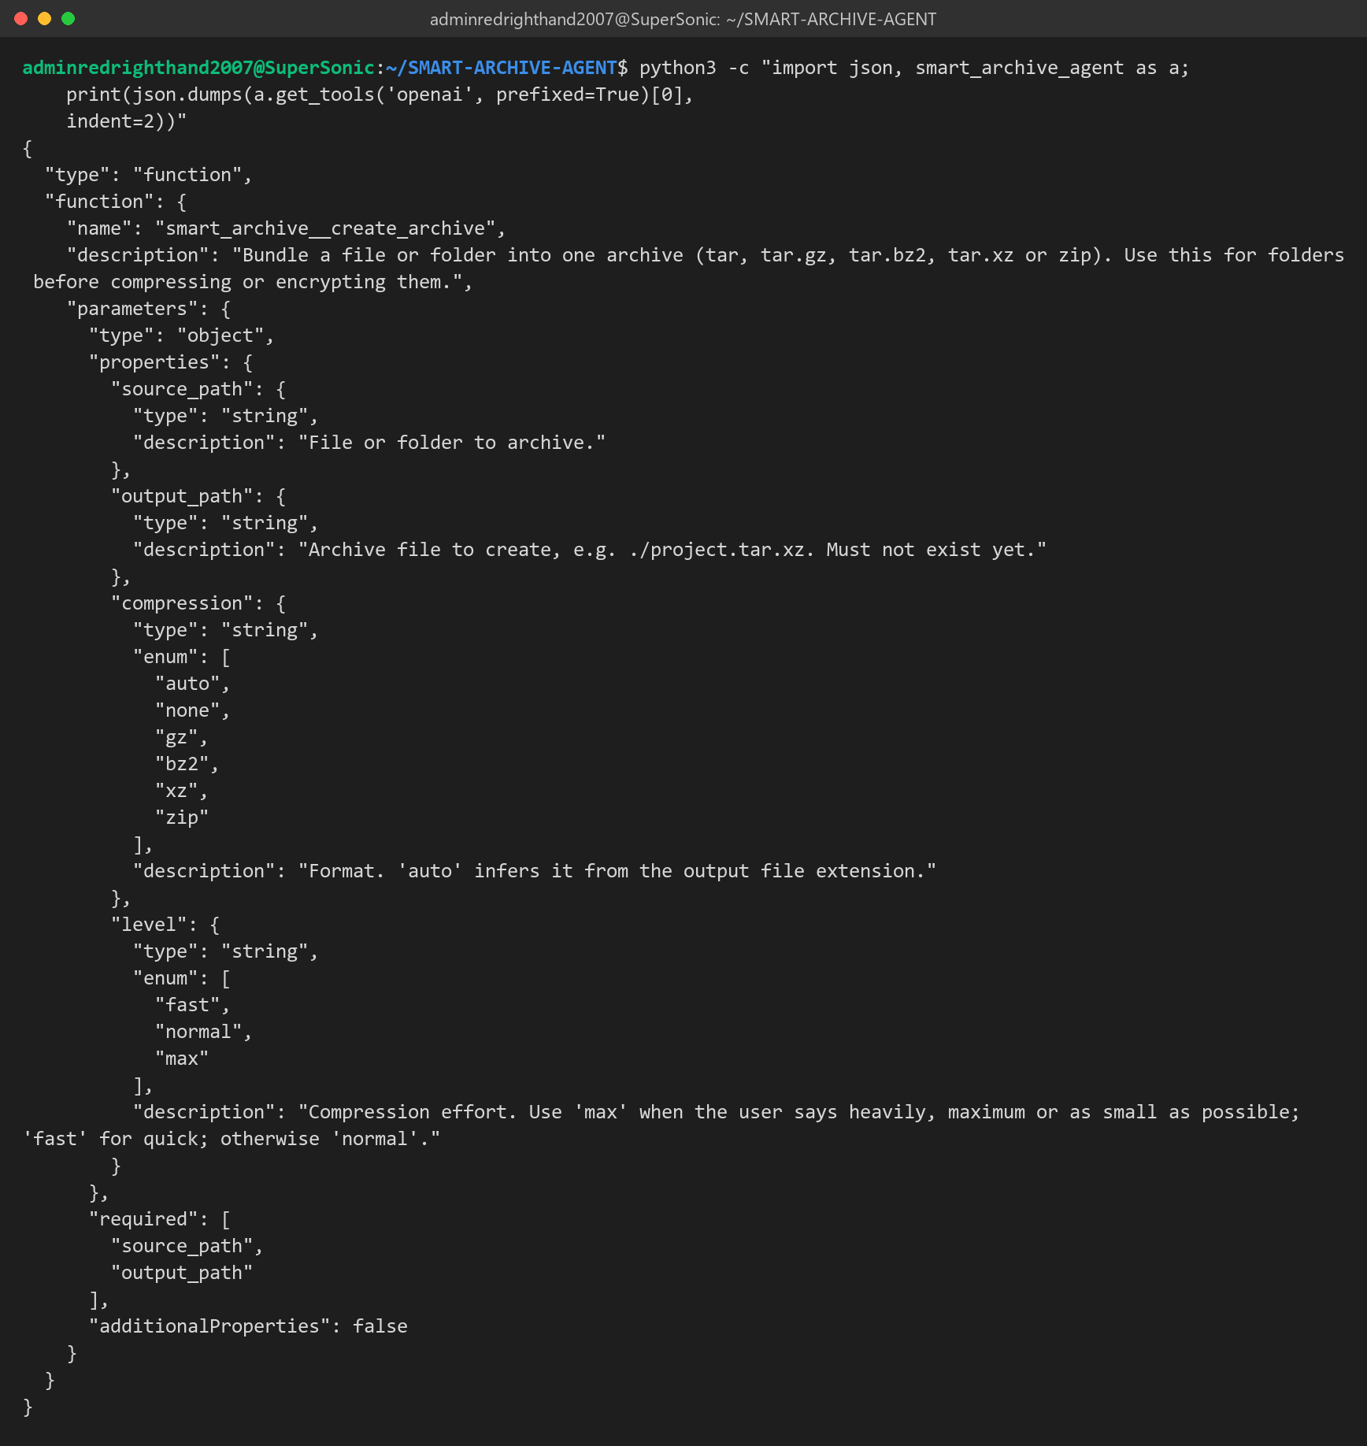
Figure B.2: The create_archive tool definition in OpenAI-compatible function-calling format.
B.5 The Plan Built for the Brief's Request
Planning only, nothing executed: the brief's sentence becomes three steps with level max, and the encryption step takes the archive step's output as its input.
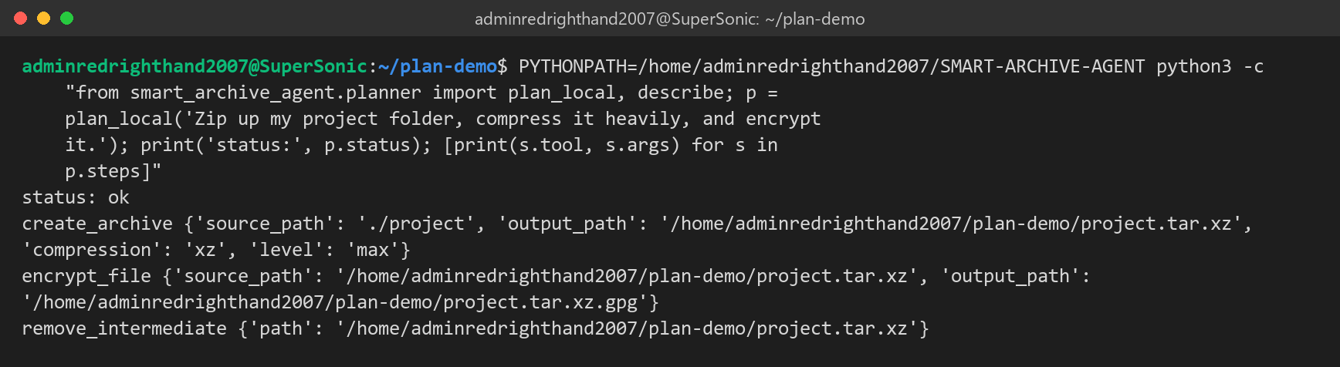
Figure B.3: plan_local() output for "Zip up my project folder, compress it heavily, and encrypt it."
B.6 Integration Example Run
examples/agentic_shell_example.py imitates the base shell: it loads the agent, offers its tools, routes the request and runs two LLM-style tool calls, then the offline planner path:
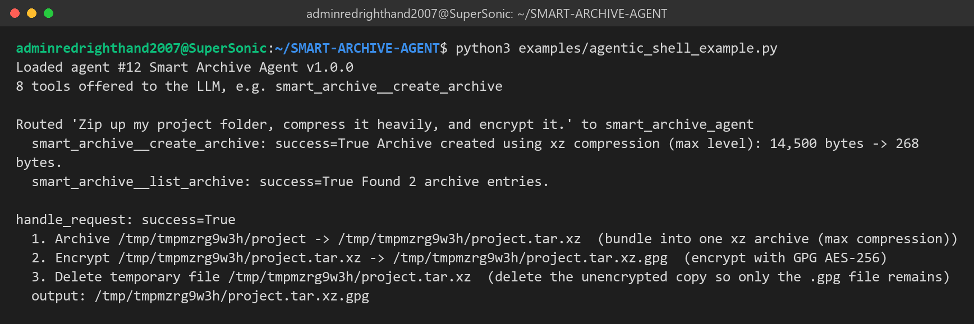
Figure B.4: Real output of the integration example.

