

**Course Information**

Course Title: Digital Image Processing

Section: 2

Course Instructor: Dr. Ahmed Wasif Reza

Professor

Department of Computer Science & Engineering

**Lab-02**

**Student’s Information**

**Name:** Md. XXXXXXXX

**ID: XXXXXXXXXX**

**Department:** Computer Science & Engineering

**Date of Submission: 28 February 2022**

**Lab 2**

1. Adjust the histogram of the following image to match the reference image using histogram matching. Show the histogram of original, reference, and output images.

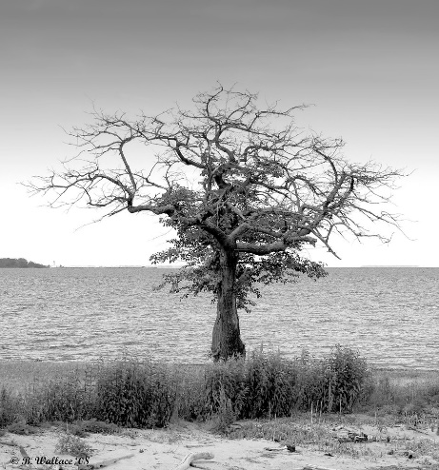 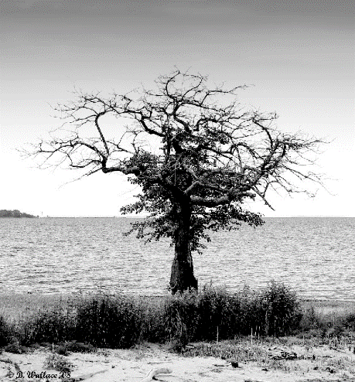

Code:

Output:

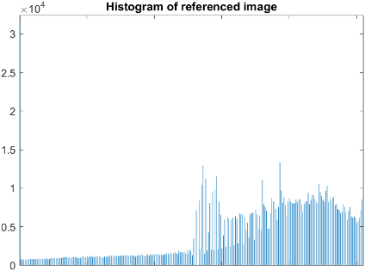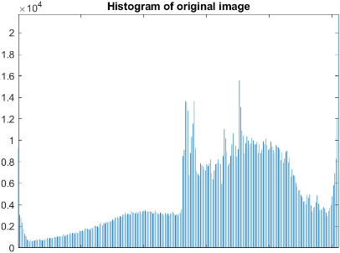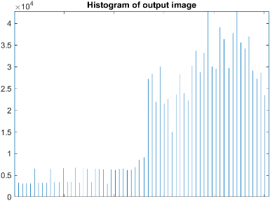

1. Change the contrast of the image using histogram equalization. Show the histogram of both input and output images.

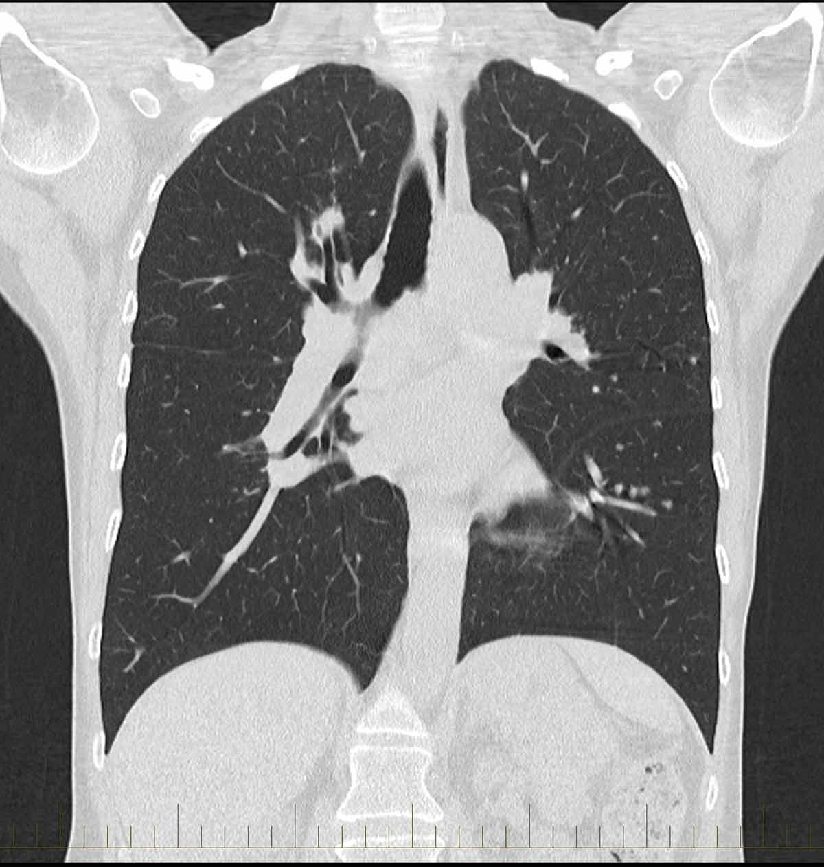

Code: 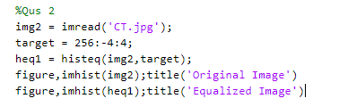

Output:

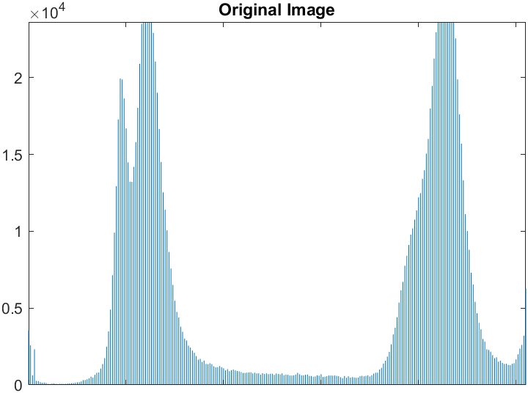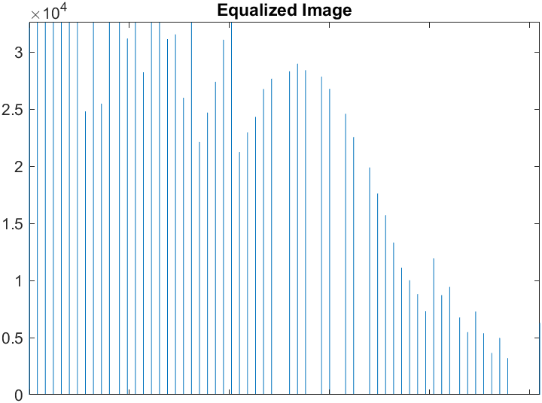

1. Apply salt and pepper noise to the following image and remove the noise using min and max filtering technique. Show input and output side by side.

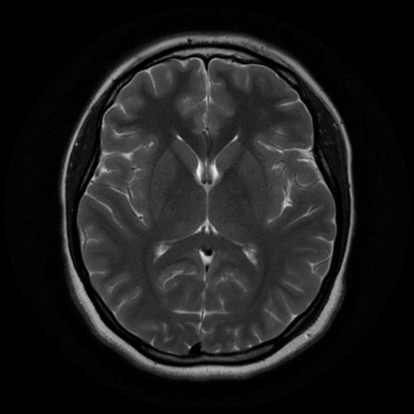

Code:

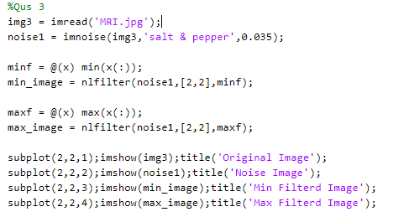

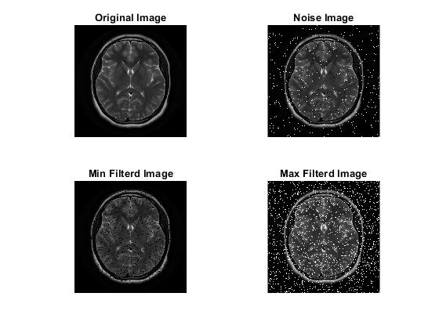

1. Apply Gaussian noise to the following image and remove the noise using Gaussian filtering. Show input and output side by side.

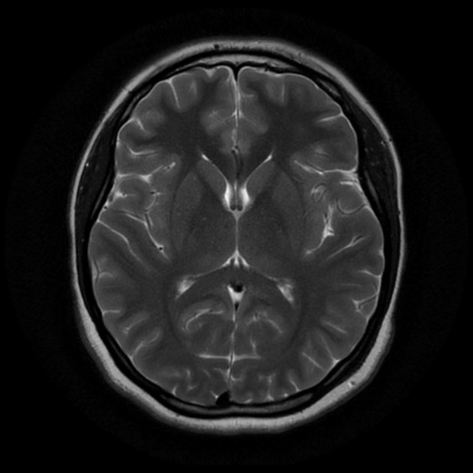

Code:

Output:

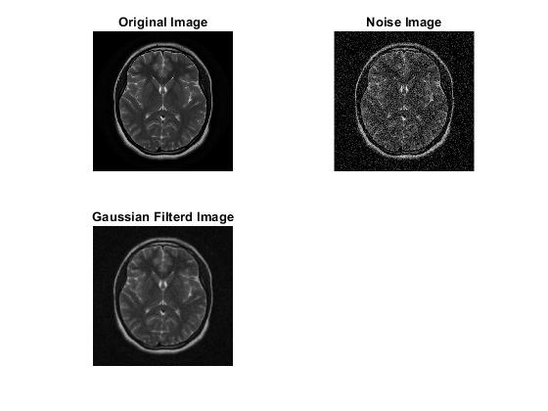

1. Apply any noise to the following image and restore it using:
2. Box filtering
3. Average filtering
4. Median filtering

Show input and output side by side. Also show the comparison between the 3 techniques. Mention which method works better than others.

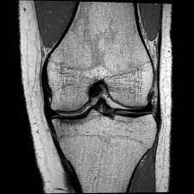

Code:

Output:

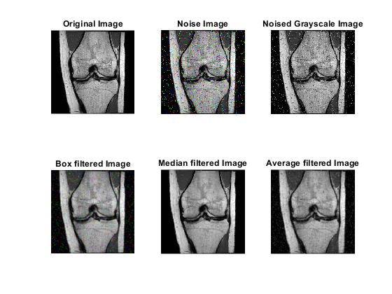

6. Adjust the contrast of the following image.

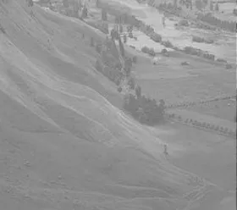

Code:

Output:

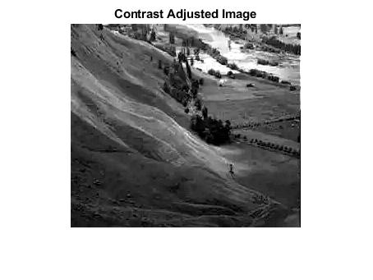

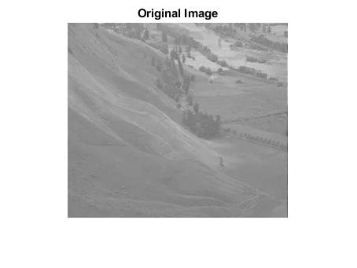

7. Brighten the following image

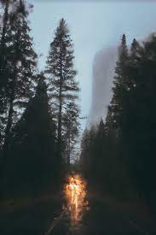

Code

Output

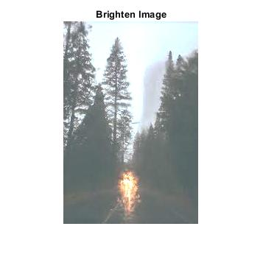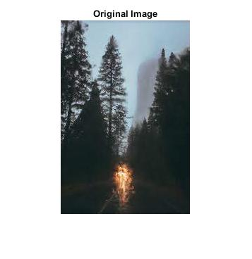

8. Quantize the Grayscale image by 8 levels.

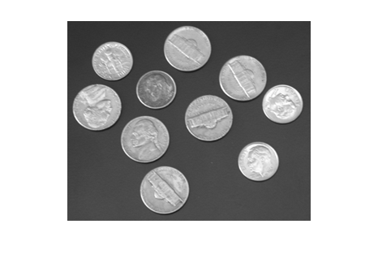

Code:

Output:

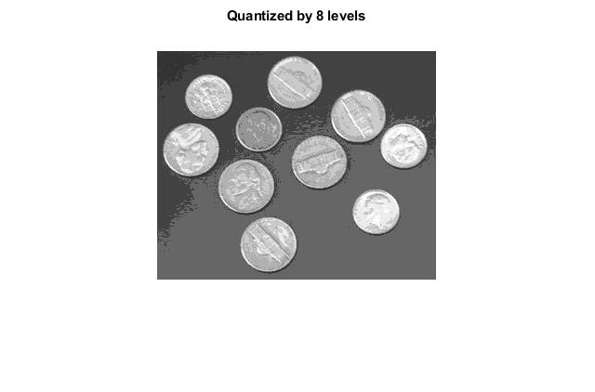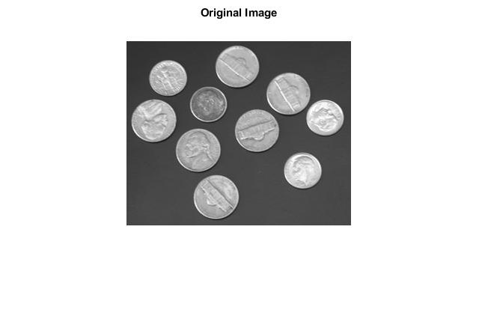

9. Using the following image, solve questions a - f.

1. Read and show the image.
2. Show the matrix form of the image.
3. Show the pixel information by hovering the cursor on the image.
4. Find the value of the pixel (10, 78).
5. Show the size of the image.
6. Show the all the information of the image.

Codes:

Output:

a)

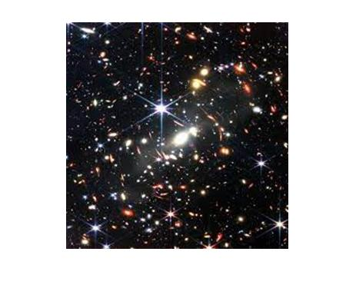

B)

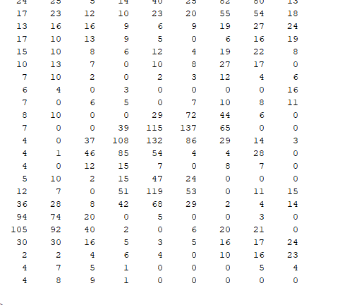

c)

d)

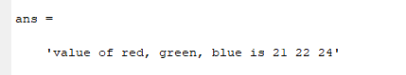

e)

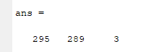

f)

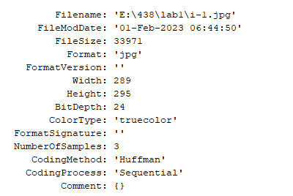

10. Using the following images, solve questions a - i.

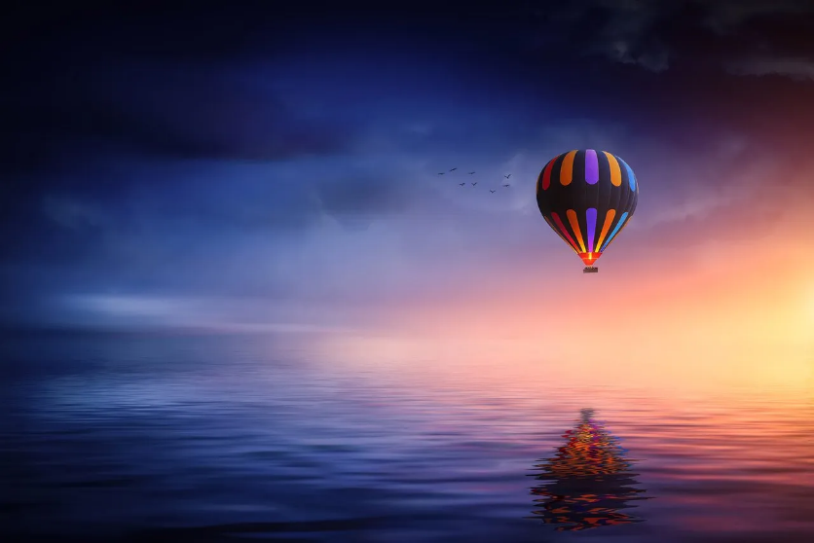

RGB Image

Grayscale Image



Indexed Image

* 1. Read and show all three types of images (RGB, Grayscale, and Indexed).
  2. Turn the RGB image to Grayscale image.
  3. Turn the Indexed image to Grayscale image.
  4. Turn the Indexed image to RGB image.
  5. Convert the Grayscale image to a Binary image.
  6. Show the inverted form of that Binary image.
  7. Show the histogram of the Grayscale image.
  8. Invert the RGB image.
  9. Blur the RGB image.

Codes:

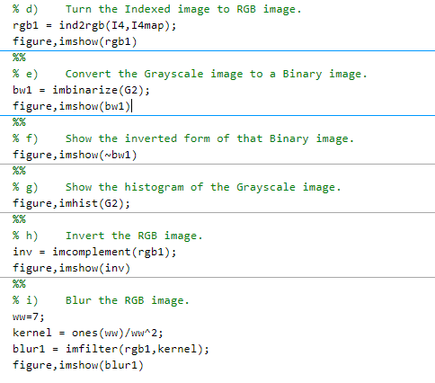

**Output**:

a)

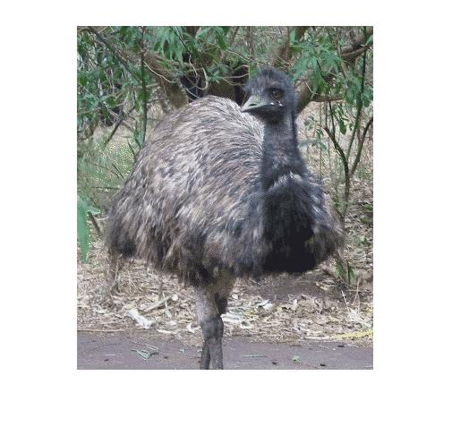

b)

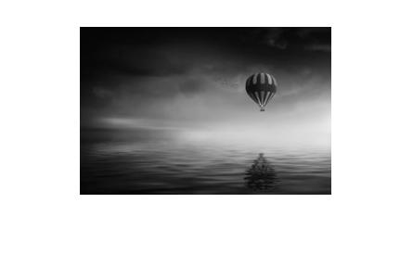

c)

d)



e)

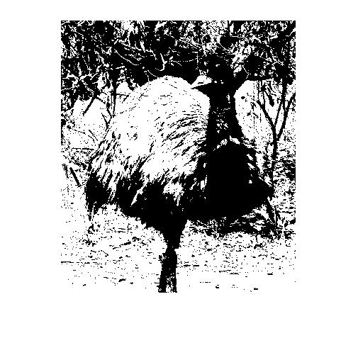

f)

g)

h)

i) 