

**Course Information**

Course Title: Digital Image Processing

Section: 2

Course Instructor: Dr. Ahmed Wasif Reza

Professor

Department of Computer Science & Engineering

**Lab-03**

**Student’s Information**

**Name:** XXXXXXXX

**ID:** XXXXXXXX

**Department:** Computer Science & Engineering

**Date of Submission: 14 March 2023**

**Question 1**

Sharpen the following image by applying the following:

**Unsharp Masking**

Code:

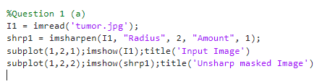

Output:

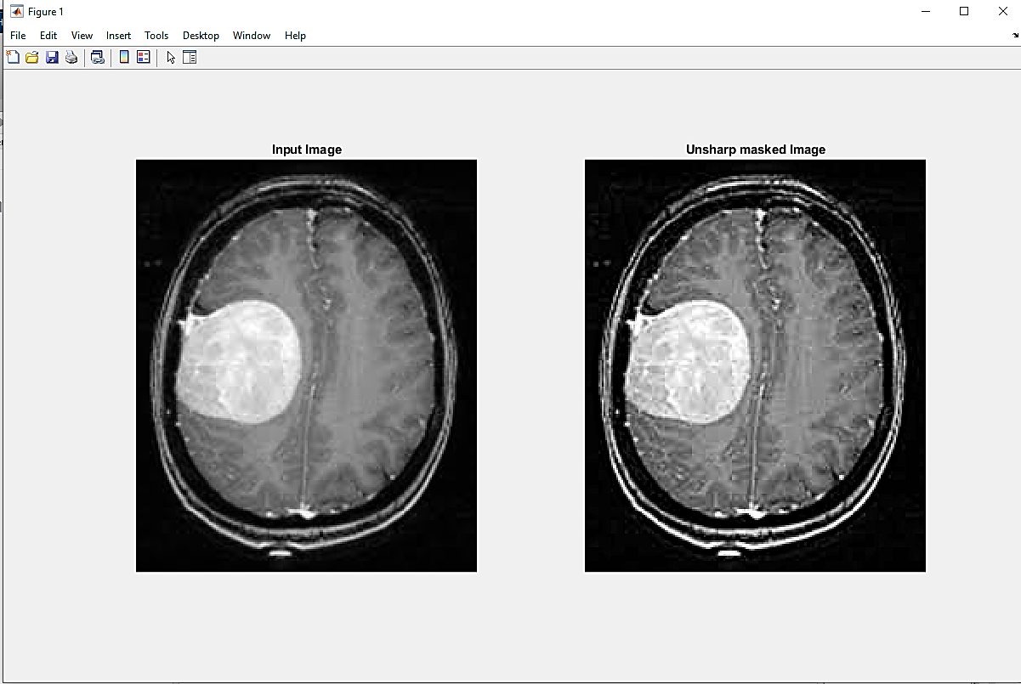

**High Boost Filtering**

Code:

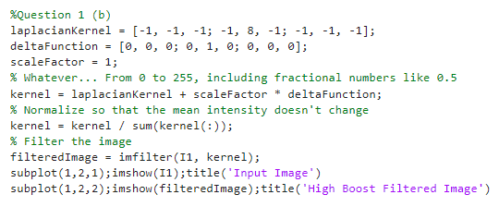

Output:

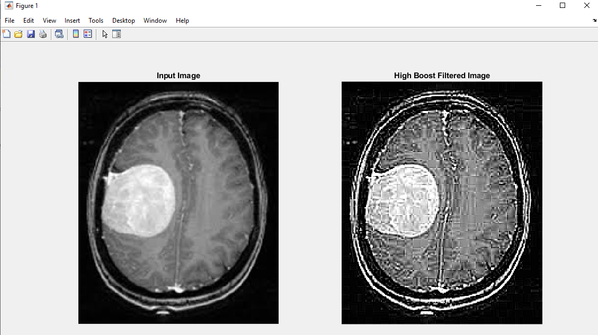

**Question 2**

Sharpen the following image using the concept of **Laplacian Filtering**.

Code:

Output:

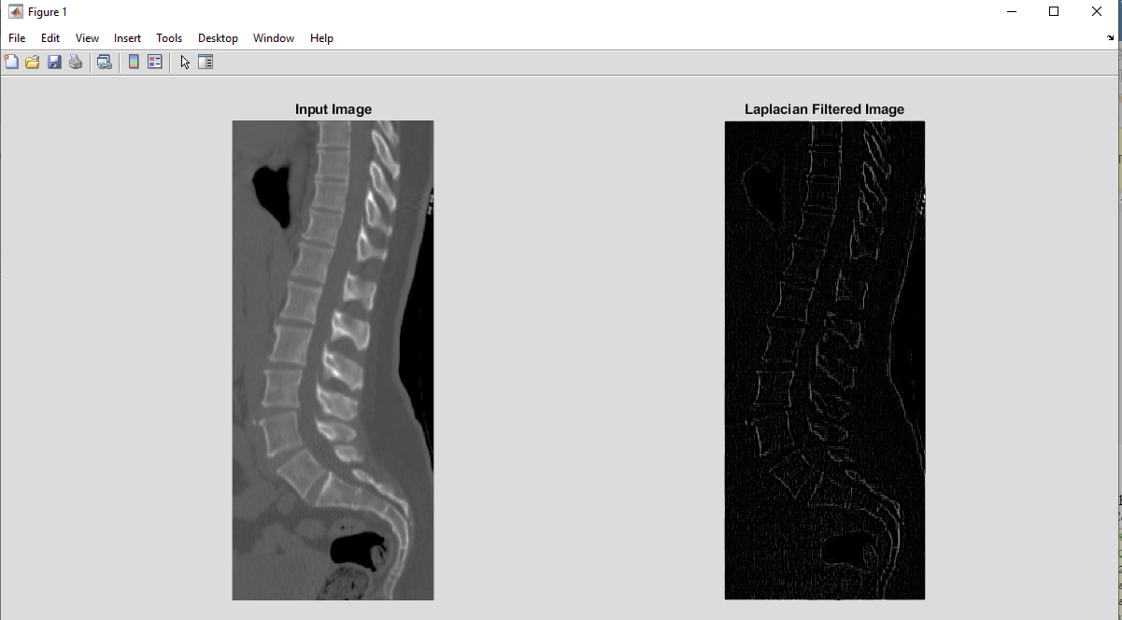

**Question 3**

Use **Roberts-cross** operators to detect the edge of the following image.

Code:

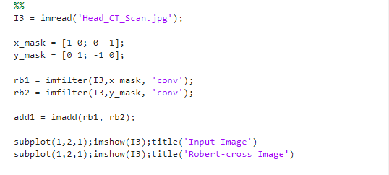

Output:

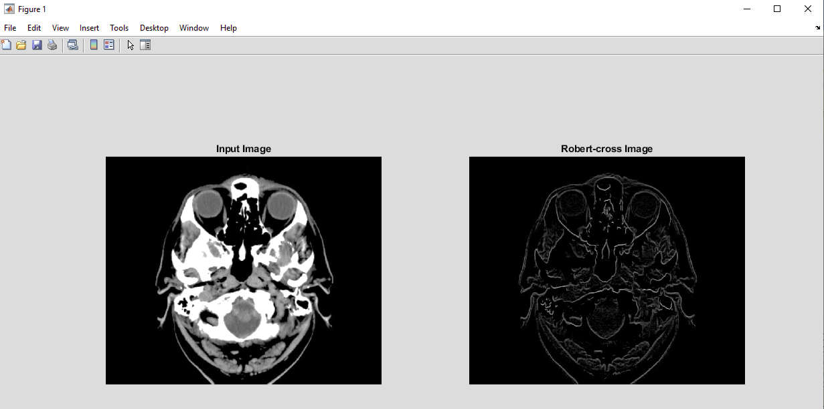

**Question 4**

Use **Sobel** operators to detect the edge of the image from problem 3.

Code:

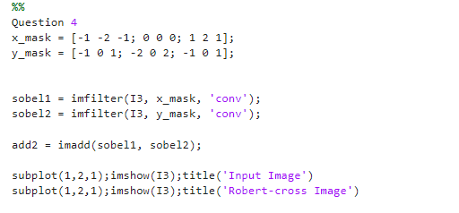

Output:

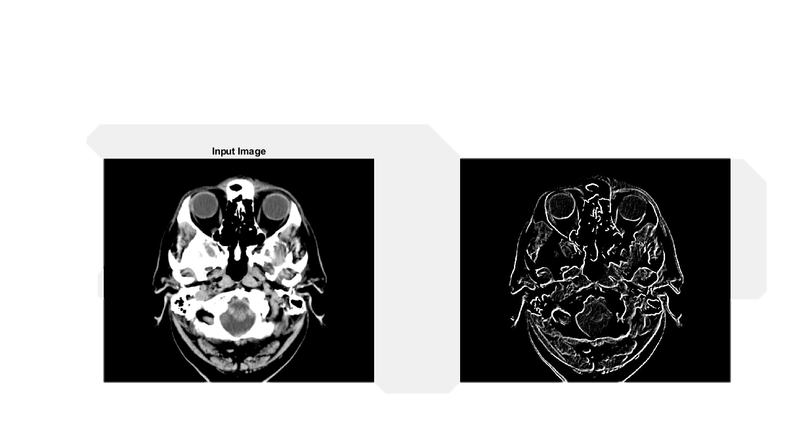

**Question 5**

Use **Prewitt** operators to detect the edge of the image from problem 3.

Code:

Output:

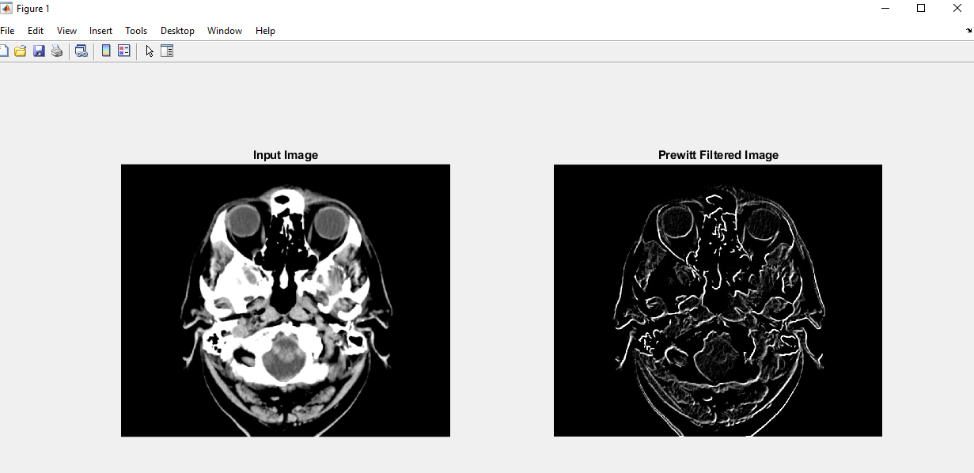

**Question 6**

Show performance comparison among High Boost, Unsharp, Laplacian Roberts-cross, Sobel and Prewitt filtering for edge detection – find out which one is better for the given images.

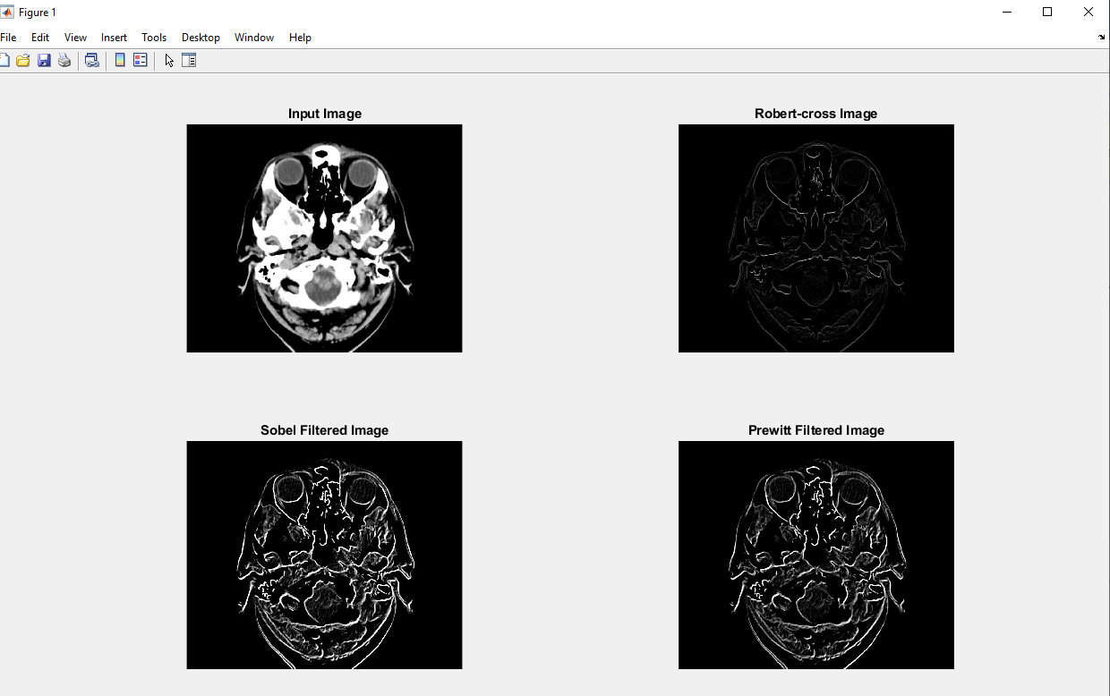

As we can see from the output, the Prewitt operator performs better in my opinion if we want to extract edges. As a result, the center region is smoothed while the edges are highlighted. It helps with improved object recognition.