cm — Company Name Matching
A company name matching system that finds the best match for a given company name against a reference list. It combines deterministic scoring (token overlap, fuzzy similarity, acronym detection) with optional semantic embeddings and LLM arbitration via Google Gemini on Vertex AI.
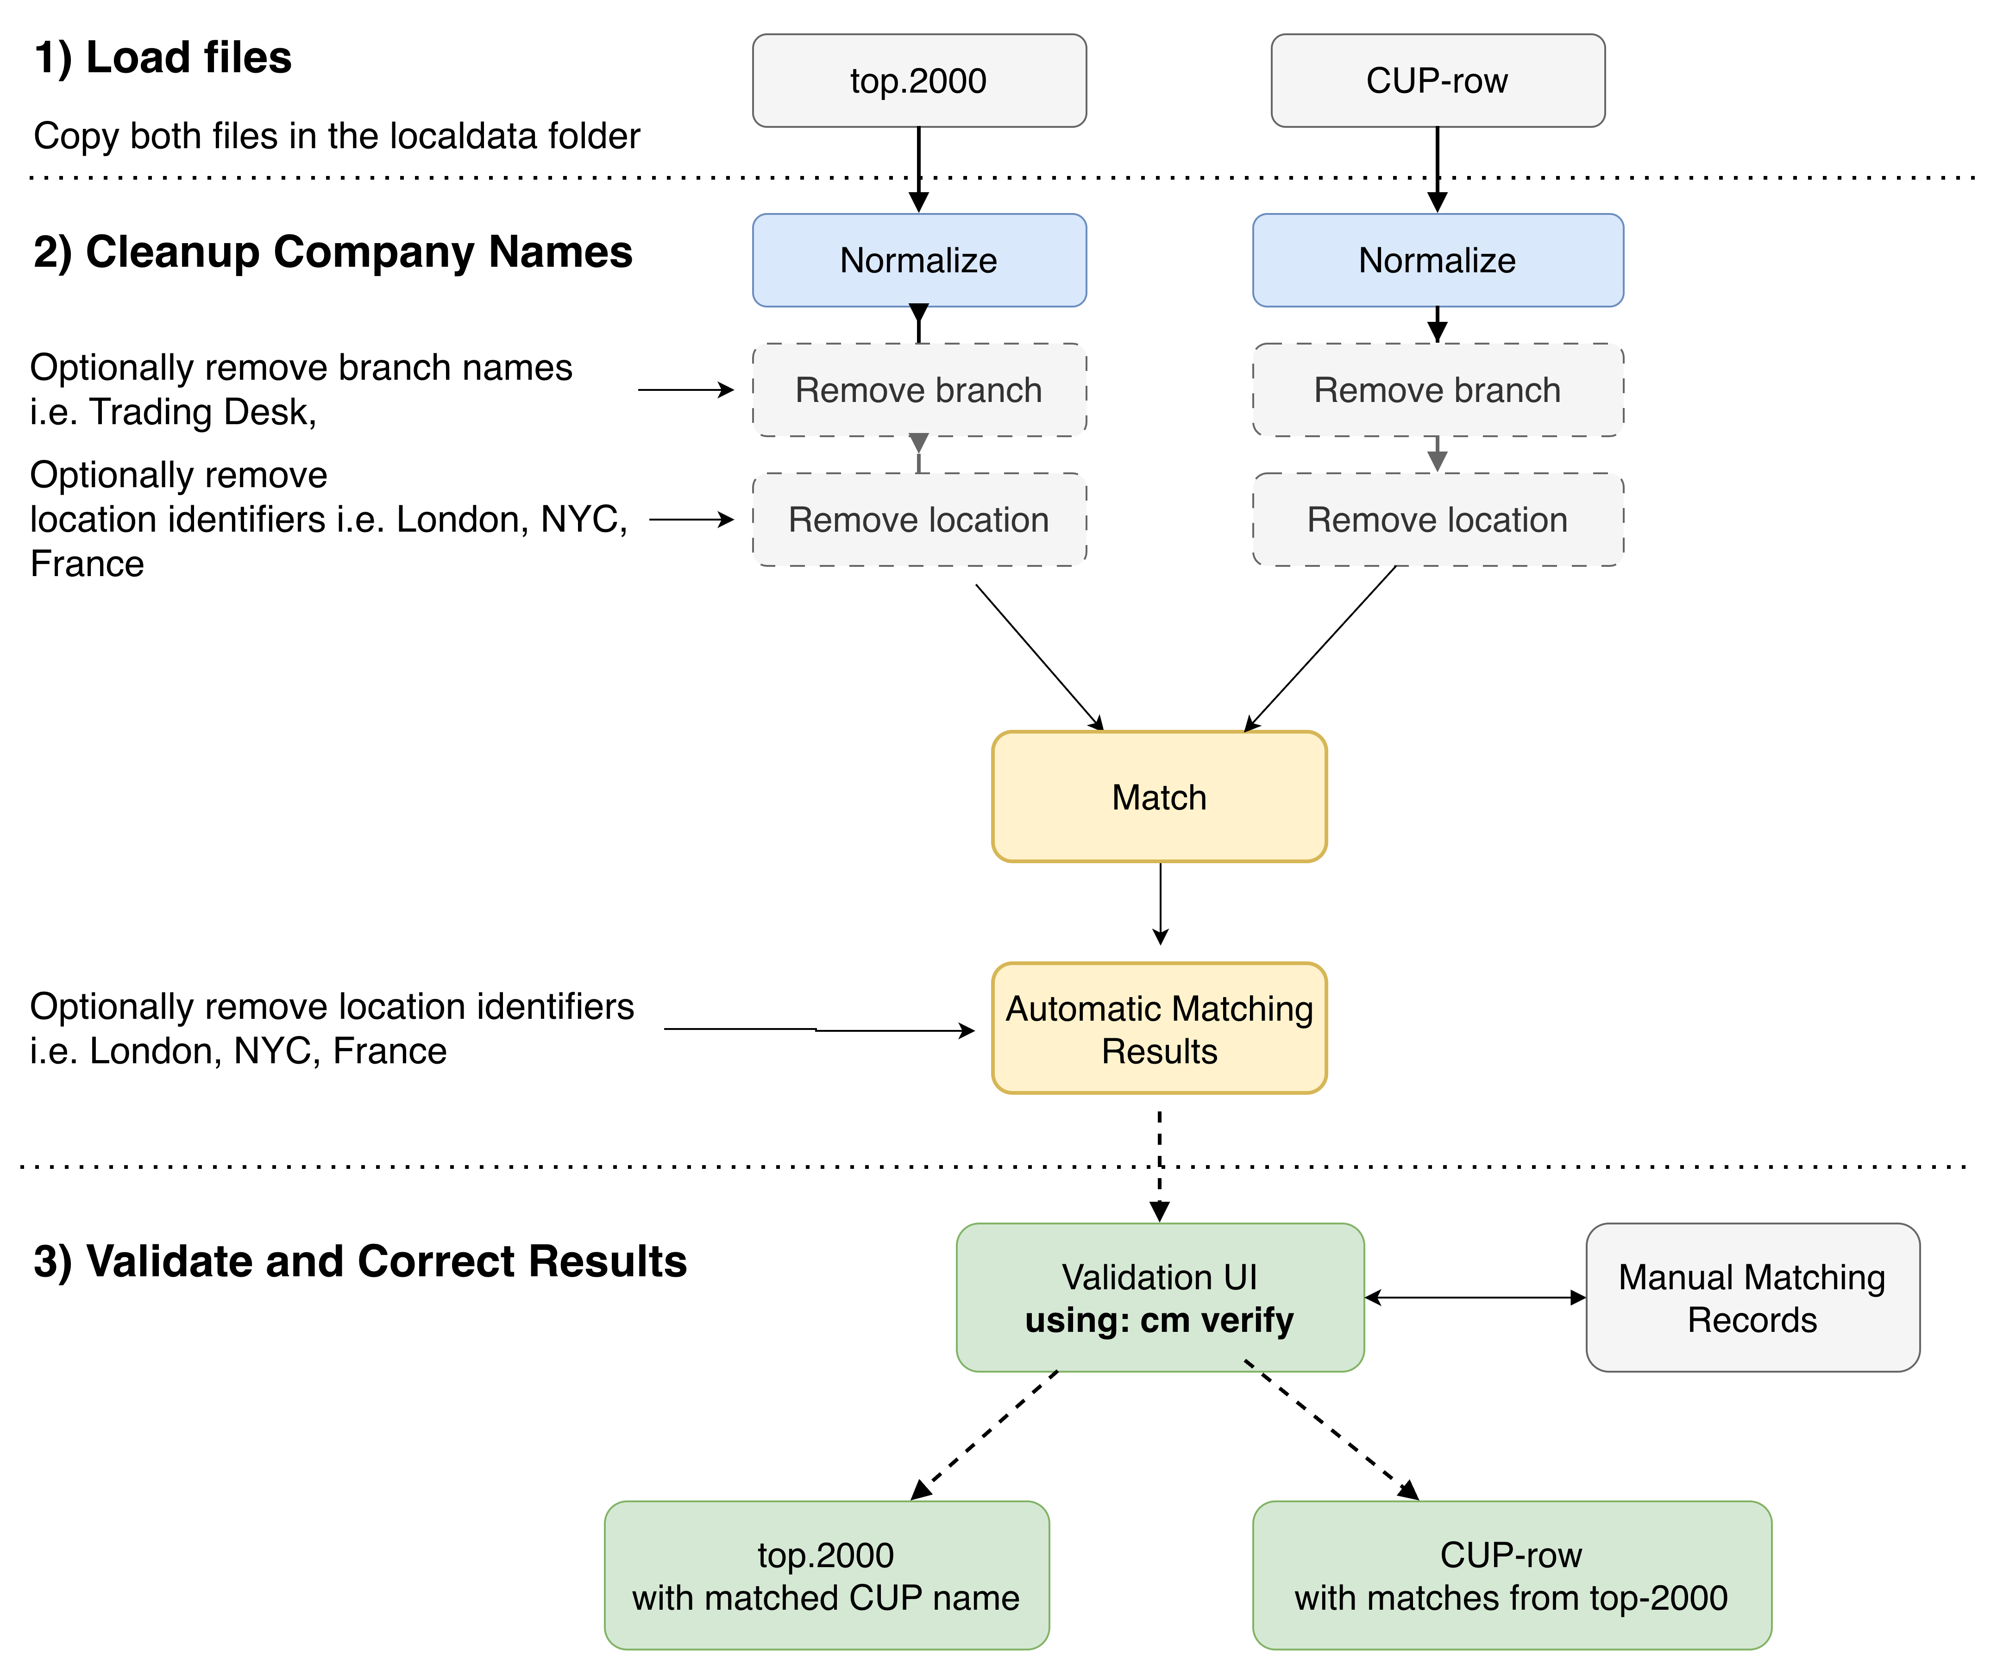 Automated matching pipeline.

How It Works
The matcher runs a 4-stage pipeline for each input name:

Stage 1: Candidate Generation
Narrows down the full reference list to a manageable set of candidates using two strategies:
- Lexical blocking — groups names by shared n-gram keys and retrieves candidates that share blocking keys with the query.
- Embedding ANN (when Gemini is enabled) — computes vector embeddings for all names using text-embedding-004, then retrieves the nearest neighbors by cosine similarity. This catches semantic matches that lexical blocking would miss (e.g. abbreviations, translations).

Stage 2: Scoring
Each candidate is scored against the query using a weighted combination of:
Feature | Weight | Description
Token overlap | 0.35 | Jaccard-style overlap of core tokens
Fuzzy similarity | 0.30 | RapidFuzz token-sort ratio
Acronym signal | 0.20 | Detects when one name is an acronym of the other
Semantic similarity | 0.15 | Cosine similarity of embeddings (0 if disabled)
Penalties are applied for numeric mismatches and very short names.

Stage 3: Decision Bands
The top-scored candidate is classified into one of three decisions:
- MATCH — score >= 0.92 and margin over runner-up >= 0.06
- NO_MATCH — score <= 0.75
- REVIEW — everything in between (ambiguous)

Stage 4: LLM Arbitration (optional)
When Gemini is enabled, REVIEW cases are sent to gemini-2.0-flash for a second opinion. The LLM receives structured evidence (original names, tokens, feature scores) and returns a JSON verdict (SAME, DIFFERENT, or UNSURE with a confidence score). Gating rules prevent wasteful calls:
- Both sides must have at least 2 core tokens (or the call is skipped)
- Numeric conflicts are never sent to the LLM
- A global call cap (default 50) limits total LLM usage per run

Setup
uv sync

Gemini / Vertex AI Authentication
The Gemini providers use Vertex AI with Application Default Credentials (ADC). No API key is needed — authenticate with gcloud auth application-default login:
# One-time: install gcloud CLI
# https://cloud.google.com/sdk/docs/install
# Authenticate
gcloud auth application-default login
# Set your GCP project
gcloud config set project <YOUR_PROJECT_ID>
The project is resolved from (in order): 1. GOOGLE_CLOUD_PROJECT environment variable 2. gcloud config get-value project
The location defaults to us-central1 (override with GOOGLE_CLOUD_LOCATION).

Usage
# Full pipeline with Gemini (embeddings + LLM arbitration)
uv run cm match
# Deterministic only (no Gemini calls)
uv run cm match --no-gemini
# Group-based matching (deduplicates identical A names first)
uv run cm match --group
# Custom file paths
uv run cm match --top path/to/top.xlsx --cup path/to/cup.xlsx --output results.xlsx

Input Files
- --top — Excel file with company names to match in column A
- --cup — Excel file with reference names in column CUP_NAME (and CUP_ID for output)

Output
An Excel file with columns:
Column | Description
A_name | Original input name
matched_CUP_NAME | Best match from reference list (if MATCH)
matched_CUP_ID | CUP_ID of the matched reference
decision | MATCH, NO_MATCH, or REVIEW
score | Composite similarity score (0–1)
runner_up_score | Score of the second-best candidate
reasons | Scoring breakdown

Interactive UI for verification
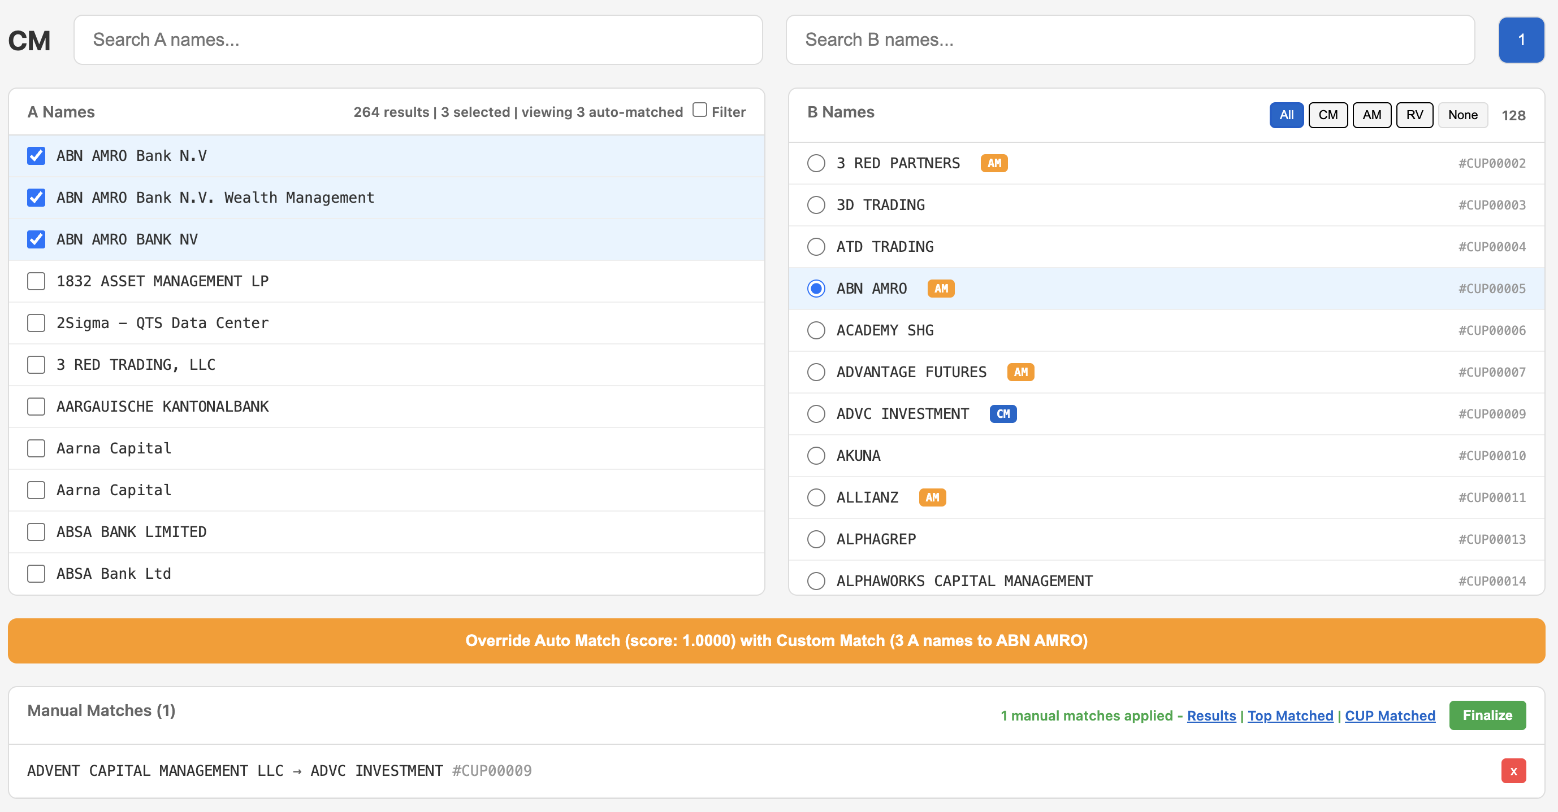 Interactive matching UI.

Commands

cm match
Run the matching pipeline to match company names from file A against reference names in file B.
# Full pipeline with Gemini (embeddings + LLM arbitration)
uv run cm match
# Deterministic only (no Gemini calls)
uv run cm match --no-gemini
# Group-based matching (deduplicates identical A names first)
uv run cm match --group
# Display matches on screen
uv run cm match --show
# Custom file paths
uv run cm match --top path/to/top.xlsx --cup path/to/cup.xlsx --output results.xlsx
# Include manual matches from a JSON file
uv run cm match --matches manual_matches.json
Options:
Option | Default | Description
--top | localdata/top_2000_unmapped.xlsx | Excel file with names to match (column A)
--cup | localdata/CUP_raw_data.xlsx | Excel file with reference names (columns CUP_NAME, CUP_ID)
--output | localdata/matching_results.xlsx | Output Excel file path
--matches | manual_matches.json | Path to manual matches JSON file
--group | off | Group identical A names and match once per unique name
--show | off | Display matches on screen after processing

cm dupes
Find duplicate names in both input files. Useful for data quality checks before matching.
# Find duplicates (exact match)
uv run cm dupes
# Find duplicates with normalization (groups by normalized form)
uv run cm dupes --no institution --no location
Options:
Option | Default | Description
--top | localdata/top_2000_unmapped.xlsx | Excel file with names to check (column A)
--cup | localdata/CUP_raw_data.xlsx | Excel file with reference names (column CUP_NAME)

cm clean
Generate cleaned versions of names with different normalization levels. Outputs Excel files showing original names alongside various normalized forms.
# Generate cleaned files
uv run cm clean
# Filter and display names matching a string (instead of writing files)
uv run cm clean --filter "bank"
uv run cm clean -f "securities"
# Custom input/output paths
uv run cm clean --top input.xlsx --output-top cleaned_top.xlsx
Options:
Option | Default | Description
--top | localdata/top_2000_unmapped.xlsx | Excel file with names (column A)
--cup | localdata/CUP_raw_data.xlsx | Excel file with reference names (column CUP_NAME)
--output-top | localdata/top_cleaned.xlsx | Output path for cleaned top file
--output-cup | localdata/cup_cleaned.xlsx | Output path for cleaned cup file
--filter, -f | none | Filter and display names matching this string (case-insensitive)

cm verify
Launch an interactive web UI for manual verification and matching. Opens a browser to review matches, search reference names, and create manual match overrides.
# Start the verify UI
uv run cm verify
# Custom port
uv run cm verify --port 9000
# Custom file paths
uv run cm verify --top input.xlsx --cup reference.xlsx --results results.xlsx
Options:
Option | Default | Description
--top | localdata/top_2000_unmapped.xlsx | Excel file with names to match (column A)
--cup | localdata/CUP_raw_data.xlsx | Excel file with reference names
--matches | manual_matches.json | Path to manual matches file (read/write)
--results | localdata/matching_results.xlsx | Path to automatic matching results (for displaying auto-matches)
--port | 8765 | Server port

cm finalize
Apply manual matches to automatic matching results. Creates a final output file with manual overrides merged in.
# Finalize with defaults
uv run cm finalize
# Custom paths
uv run cm finalize --results auto_results.xlsx --matches manual.json --output final.xlsx
Options:
Option | Default | Description
--results | localdata/matching_results.xlsx | Path to automatic matching results
--matches | manual_matches.json | Path to manual matches JSON file
--output | localdata/finalized_matching_results.xlsx | Output path for finalized results

Global Options
These options are available for all commands:
Option | Default | Description
--log-level | INFO | Set logging level (DEBUG, INFO, WARNING, ERROR)
--no-gemini | off | Disable Gemini providers (use deterministic matching only)
--no CATEGORY | none | Strip words from a category during normalization (repeatable)
Normalization categories (use with --no):
- institution — Bank, Trust, Securities, etc.
- location — Country and city names
- stopwords — Common words (The, And, Of, etc.) — enabled by default
Example:
uv run cm match --no institution --no location

Configuration Files
The data/ directory contains configuration files that control normalization and matching behavior. All .txt files use a simple one-word-per-line format; .json files use key-value mappings.

Word Lists (.txt files)
File | Purpose
stopwords.txt | Common words stripped during normalization (the, of, and, for, a, an). Always applied.
designators_global.txt | Legal entity suffixes stripped from all names (inc, corp, ltd, llc, gmbh, ag, etc.). Always applied.
institution.txt | Financial institution terms (bank, capital, securities, fund, trust, etc.). Stripped when --no institution is used.
location.txt | Geographic terms (usa, europe, asia, germany, apac, emea, etc.). Stripped when --no location is used.
branch.txt | Branch/business type words (similar to institution). Used for specialized matching scenarios.
acronym_collision.txt | Short strings that commonly collide as false-positive acronyms (abc, aaa, aab). Excluded from acronym detection.

JSON Configuration
File | Purpose
designator_aliases.json | Maps abbreviations to canonical forms before stripping. Examples: "inc." → "inc", "l.l.c." → "llc", "intl" → "international".
replacements.json | Character replacements applied early in normalization. Currently maps & and + to and.

Customization
To add words to a category, edit the corresponding .txt file (one word per line, lowercase). Changes take effect on the next run.
Example — add “holdings” to the institution list:
# data/institution.txt
bank
...
holdings

Programmatic Usage
from cm import Matcher, MatchConfig, GeminiEmbeddingProvider, GeminiLLMProvider
from cm.gemini import _make_client
client = _make_client()
matcher = Matcher(
config=MatchConfig(),
embedding_provider=GeminiEmbeddingProvider(client),
llm_provider=GeminiLLMProvider(client),
)
matcher.preprocess_b(["Acme Corp", "Globex Inc", ...])
result = matcher.match_one("ACME Corporation")
print(result.decision, result.score)

