**RS-WISP-04-01: Two Impuse Rendezvous**

**WorkerInSpace**

**Hongseok Kim**

**2/5/2025**

# I. Scope

In RS-WISP-02, we have demonstrated the C-W equation for Two-Impuse Rendezvous. For defining operation modes, we have to define multiple functions for these delta-v maneuvers. Furthermore, we should structurize the process of rendezvous process in multiple block diagrams. In this document, the role of Two-Impuse Rendezvous and I/O structure is defined, and corresponding function is described. From these function, we can proceed the simulation in multiple environments and multiple simulation setups.

# II. Two Impulse Rendezvous Procedure

## II.1 I/O Structure

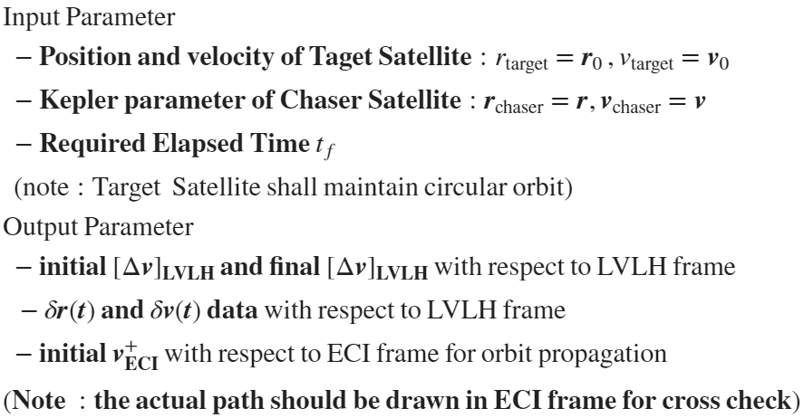

## II.2 Two Impulse Rendezvous Algorithm

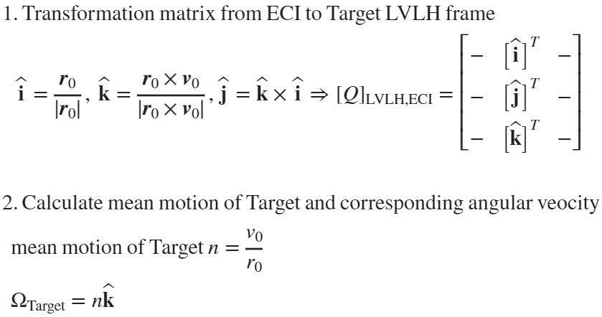

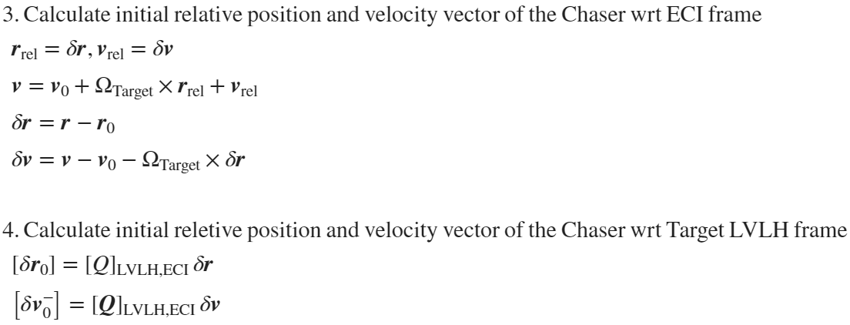

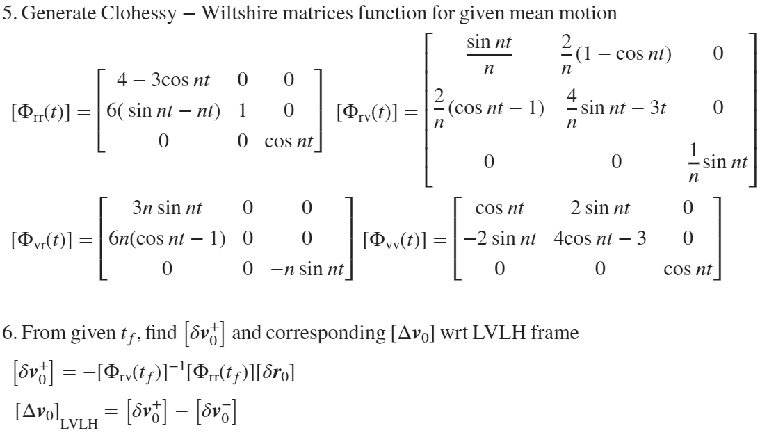

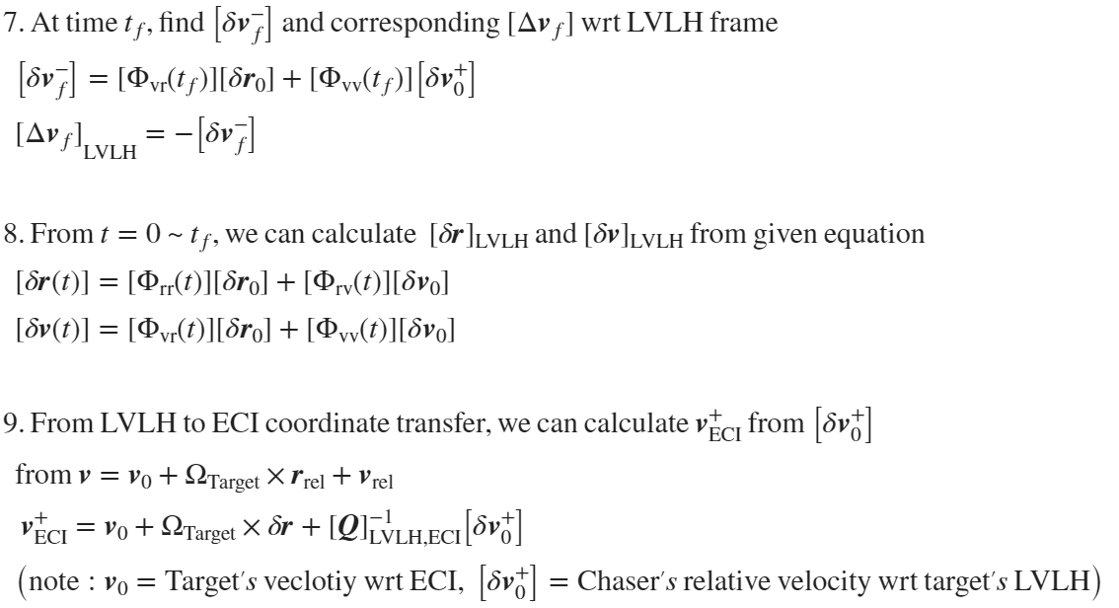

# III. Matlab function demonstration

function [Delta_v_0, Delta_v_f, delta_r_t_mat, delta_v_t_mat, v_plus_ECI] = two_impulse_rendezvous(r_target, v_target, r_chaser, v_chaser, tf)

r_0 = r_target;

v_0 = v_target;

r = r_chaser;

v = v_chaser;

% Reference Frame of the Target

i_hat = r_0/norm(r_0);

j_hat = v_0/norm(v_0);

k_hat = cross(i_hat, j_hat);

% Transformation Matrix from ECI to Space Station Frame

Q_LVLH_ECI = [i_hat';j_hat';k_hat'];

% Position vector of the spacecraft relative to the space station (ECI)

delta_r = r - r_0;

n = norm(v_0)/norm(r_0);

Omega_target = n * k_hat;

delta_v = v - v_0 - cross(Omega_target, delta_r);

% Relative position vector at the beginning of the rendezvous maneuver

delta_r_0 = Q_LVLH_ECI * delta_r;

% Relative velocity just before launch into the rendezvous trajectory is

delta_v_0_minus = Q_LVLH_ECI * delta_v;

% Calculate Clohessy-Whiltshire matrix for t = t_f = 28800s and n

nt = n*tf;

Phi_rr_tf = [4 - 3*cos(nt), 0, 0;

6*(sin(nt) - nt),1,0;

0,0, cos(nt)];

Phi_rv_tf = [sin(nt)/n, 2/n * (1 - cos(nt)), 0;

2/n*(cos(nt)-1), 4/n*sin(nt)-3*tf,0;

0,0,1/n*sin(nt)];

Phi_vr_tf = [3*n*sin(nt),0,0;

6*n*(cos(nt)-1),0,0;

0,0,-n*sin(nt)];

Phi_vv_tf = [cos(nt), 2*sin(nt),0

-2*sin(nt), 4*cos(nt)-3, 0;

0,0,cos(nt)];

delta_v_0_plus = -inv(Phi_rv_tf) * Phi_rr_tf * delta_r_0;

delta_v_f_minus = Phi_vr_tf * delta_r_0 + Phi_vv_tf * delta_v_0_plus;

% Delta-v at the beginning of the rendezvous maneuver

Delta_v_0 = delta_v_0_plus - delta_v_0_minus;

% Delta-v at the conclusion of the maneuver

Delta_v_f = [0;0;0] - delta_v_f_minus;

% Drawing Reference Chaser Trajector wrt Target

t_vector = linspace(0,tf);

delta_r_t_mat = zeros(length(t_vector),3);

delta_v_t_mat = zeros(length(t_vector),3);

for timestep = 1:length(t_vector)

t = t_vector(timestep);

nt = n*t;

Phi_rr_t = [4 - 3*cos(nt), 0, 0;

6*(sin(nt) - nt),1,0;

0,0, cos(nt)];

Phi_rv_t = [sin(nt)/n, 2/n * (1 - cos(nt)), 0;

2/n*(cos(nt)-1), 4/n*sin(nt)-3*t,0;

0,0,1/n*sin(nt)];

Phi_vr_t = [3*n*sin(nt),0,0;

6*n*(cos(nt)-1),0,0;

0,0,-n*sin(nt)];

Phi_vv_t = [cos(nt), 2*sin(nt),0

-2*sin(nt), 4*cos(nt)-3, 0;

0,0,cos(nt)];

delta_r_t = Phi_rr_t * delta_r_0 + Phi_rv_t * delta_v_0_plus;

delta_v_t = Phi_vr_t * delta_r_0 + Phi_vv_t * delta_v_0_plus;

delta_r_t_mat(timestep,:) = delta_r_t';

delta_v_t_mat(timestep,:) = delta_v_t';

end

v_plus_ECI = v_0 + cross(Omega_target, delta_r) + delta_v_0_plus\Q_LVLH_ECI;

end

# IV. Matlab Function Test

%% Input Parameters

% Target Information

Target.a = 300+6378;

Target.e = 1e-5;

Target.i = 40;

Target.RAAN = 20;

Target.AOP = 0;

Target.TA = 60;

% Chaser Information

Chaser.a = 6378 + (318.5 + 515.51)/2;

Chaser.e = (6378+515.51)/Chaser.a-1;

Chaser.i = 40.130;

Chaser.RAAN = 19.819;

Chaser.AOP = 70.662;

Chaser.TA = 349.65;

% Timing of Docking

t_f = 28800;

%% Main Algorithm

% Change to ECI frame

% rv data of the target wrt ECI

[r_target, v_target] = kepler2ijk_hs(Target.a, Target.e, Target.i, Target.RAAN, Target.AOP, Target.TA);

% rc data of the chaser wrt ECI

[r_chaser, v_chaser] = kepler2ijk_hs(Chaser.a, Chaser.e, Chaser.i, Chaser.RAAN, Chaser.AOP, Chaser.TA);

[Delta_v_0, Delta_v_f, delta_r_t, delta_v_t, v_plus_ECI] = two_impulse_rendezvous(r_target, v_target, r_chaser, v_chaser, t_f)

Delta_v_0 = *3×1*

0.0294

-0.0667

0.0130

Delta_v_f = *3×1*

0.0258

0.0005

0.0244

delta_r_t = *100×3*

20.0303 20.2865 19.9531

21.5214 6.0269 21.1097

20.5068 -8.3946 19.8978

17.1003 -21.3140 16.4532

11.6842 -31.2357 11.1624

4.8661 -37.0005 4.6191

-2.5889 -37.9157 -2.4425

-9.8442 -33.8328 -9.2300

-16.0859 -25.1640 -14.9818

-20.6135 -12.8361 -19.0526

⋮

delta_v_t = *100×3*

0.0093 -0.0468 0.0080

0.0008 -0.0503 -0.0001

-0.0077 -0.0479 -0.0082

-0.0155 -0.0400 -0.0153

-0.0214 -0.0275 -0.0207

-0.0250 -0.0117 -0.0238

-0.0258 0.0055 -0.0243

-0.0236 0.0223 -0.0220

-0.0189 0.0368 -0.0172

-0.0120 0.0472 -0.0105

⋮

v_plus_ECI = *3×3*

13.2732 -7.4962 -8.9281

21.0754 0.3060 -1.1259

23.0776 2.3083 0.8764

# Appendix 1: Bundle functions (kepler2ijk, ijk2kepler)

function [r,v] = kepler2ijk_hs(a,e,inc,RAAN,AOP,theta)

mu = 398600.4415;

RAAN = RAAN/180*pi;

inc = inc/180*pi;

AOP = AOP/180*pi;

theta = theta/180*pi;

R_3_AOP = [cos(AOP), sin(AOP),0;

-sin(AOP), cos(AOP),0;

0, 0,1];

R_1_inc = [1, 0, 0;

0, cos(inc), sin(inc);

0,-sin(inc), cos(inc)];

R_3_RAAN = [cos(RAAN), sin(RAAN),0;

-sin(RAAN), cos(RAAN),0;

0, 0,1];

Q_rotation = R_3_AOP * R_1_inc * R_3_RAAN;

p = Q_rotation(1,:);

q = Q_rotation(2,:);

w = Q_rotation(3,:);

p_value = a*(1-e^2);

r = p_value* (cos(theta)*p + sin(theta) *q)/(1+e*cos(theta));

r = r';

v = sqrt(mu/p_value)*(-sin(theta)*p+(e+cos(theta))*q)';

end

function [a, e, inc, RAAN, AOP, theta] = ijk2kepler_hs(r,v)

mu = 398600.4415;

h = cross(r,v); % Angular Velocity Vector

z = [0,0,1]';

n = (cross(z,h))/(norm(cross(z,h))); % Normal Vector

e_vector = ((cross(v,h))/mu) - r/(norm(r)); % Eccentricity vector

a = (-mu)/((norm(v))^2 - 2*mu/norm(r)); % 1. Semi-major axis

e = norm(e_vector); % 2. Eccentricity

inc = acos(dot(z,h)/norm(h)) / pi *180; % 3. Inclination

RAAN = atan2(n(2),n(1)); % 4. RAAN

RAAN = RAAN / pi * 180;

AOP = acos((dot(n,e_vector))/norm(e_vector)); % 5. Argument of periapse

if(e_vector(3)<0)

AOP = 2*pi - AOP;

end

AOP = AOP/pi*180;

theta = acos((dot(r,e_vector))/(norm(r)*norm(e_vector))); % 6. True anomaly

if(dot(r,v) < 0)

theta = 2*pi-theta;

end

theta = theta / pi * 180;

end