**RS-WISP-04-02 Glideslope Transfer**

**WorkerInSpace**

**Hongseok Kim**

**2/6/2025**

# I. Scope

When a chaser vehicle is required to apprach a target vehicle, an inbound glideslope guidance is invoked. In this scenario, thruster activity near the target is to be minimized to avoid plume impingement on the target vehicle and contamination of its surfaces. In addition, as a chaser approches the target, its relative velocity must diminish to certain safe limits. These requirements are fulfilled by designing a guidance trajectory wherein the range rate is proportional to the range. Such guidance trajectories are formulated in this document.

* **Note: in a glideslope with continuous thrusting, this relationship, although linear for the most part, is nonlinear near the end. In this document, a linear relationship between the range and range rate is postulated to be the mission design goal, whether the motion is in-plane or out-of-plane.**

## II. Background Knowledge for Inbound Decelerating Glideslope

Following vectors are demonstrated with respect to LVLH frame of target satellite

* At , the chaser satellite is located at , with its relative velocity equal to .
* The chaser vehicle is required to arrive at  in a transfer time  with a velocity specified hereafter.
* A straight line from  to , denoted the vector , is the most natural commanded path for this transfer.

Let , measured from the target center of mass, be the commanded location of the chaser on this path at time , .

* Then the boundary values of  are , .
* The vector  emanates from the tip of the vector  and it defines the commanded location of the chaser on the straight path from  to .
* The boundary conditions of  are , , and, at any time , 

Because  and , the direction cosine of the vector  is given by:



The direction of the strait path is then given by the unit vector , and the scalar distance , the distance to go, along the vector , is .

* The glideslope guidance specifies the distance to go, , as a function of time , so that the chaser is commanded to reach  from  in a period  with the arrival commanded velocity  where , less than zero, is some predetermined safe relative speed of the chaser at the distance  from the target.

As the distance to go diminished, the speed must diminish with it.

* Here,  is obtained by differentiating , treating the LVLH frame as an inertial nonrotating frame.
* The following linear relationship between  and  is , where the parameter , yet to be determined, is the slope of  vs .
* The boundary conditions of  and  are 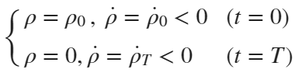
* The initial distance to go, , the initial commanded velocity , and the final commanded arrival velocity  , are all known or specified.
* The slope  is then equal to 

The commanded path  corresponds to a varying commanded acceleration , and because  is decreasing with time, the acceleration (actually deceleration) also decreases with time. These features of the glideslope scheme are desirable.

* With the boundary conditions , the solution of  is  and the transfer time  is



## II.1 Inbound Glideslope Procedure

The algorithm to move the chaser from  to  can be developed now as follows.

* Let the number of thrusters firing to travel from   to  in time  be  and the uniform interval between any two successive purses be .
* The thrusters are, thus, fired at time , and the th pulse pushes the chaser from  to  , where

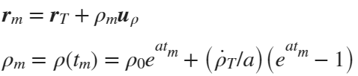

* The arrival velocity at th location is , and, in accordance with , the departure velocity  to travel from  to  is



* The incremental velocity at  is then , and the chaser will arrive at  with velocity  equal to



The actual path of the chaser will not be along the vector , but rather will result from the differential spherical gravitational force in Clohessy-Wiltshire equations.



Because the interval between any two successive pulses is the same, the spacecraft will mover progressively slower as it approaches the target.

## III.2 I/O Structure

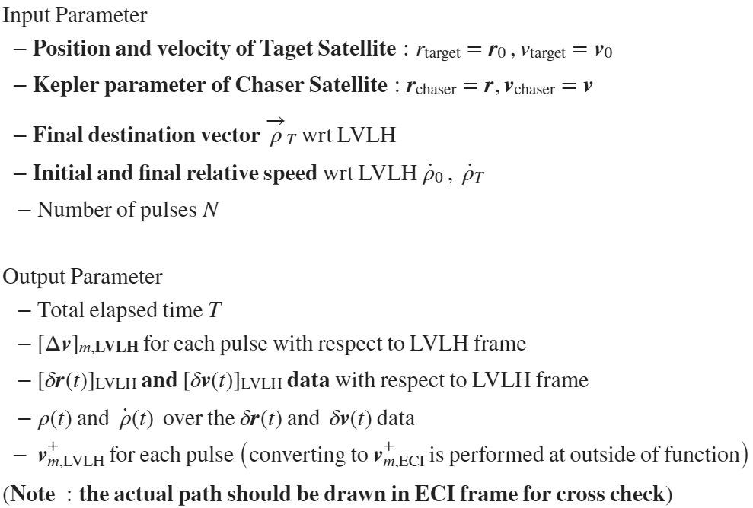

## III.3 Glideslope Transfer Algorithm

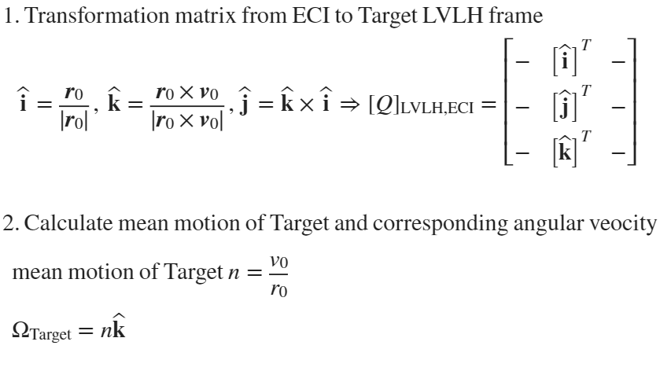

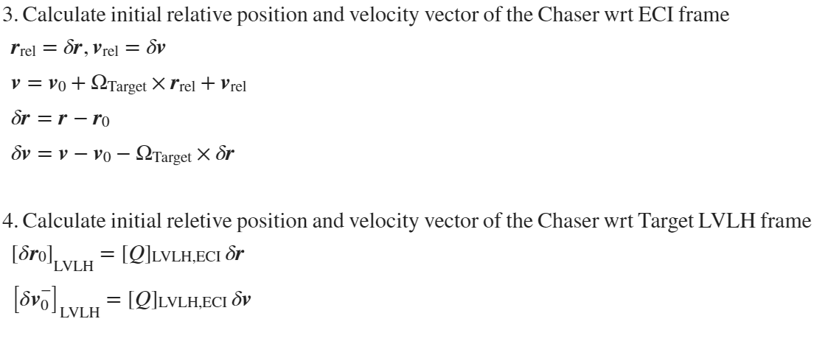

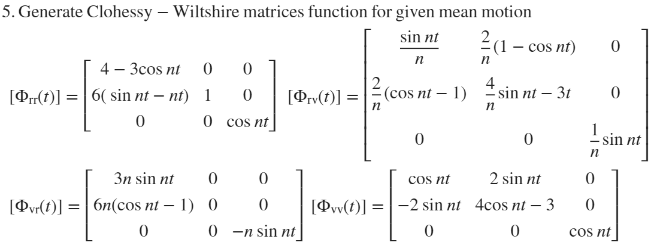

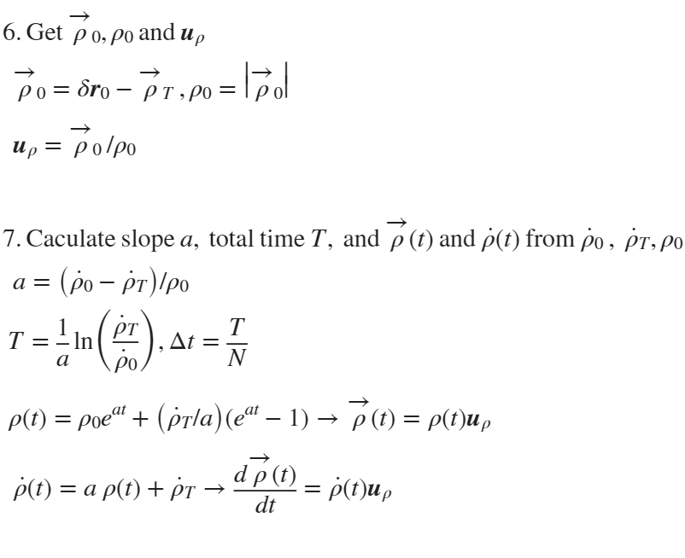

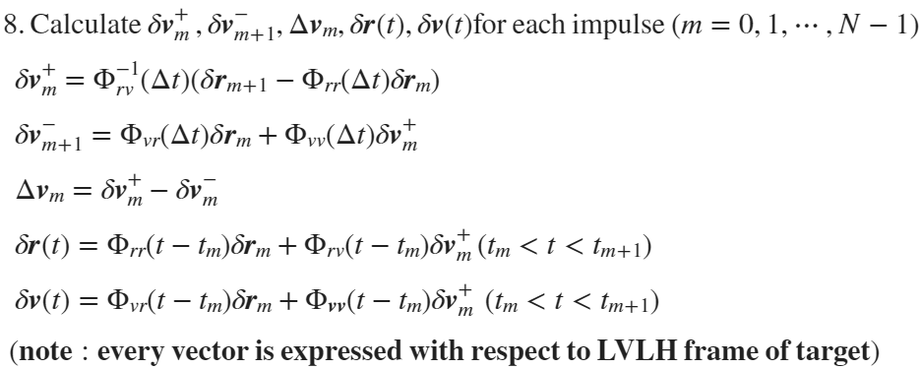

# IV. Matlab function Demonstration