1.1 Science and Technology

Benefits of Science and Technology:
- Improve health
- Prolong lifespan
- Makes lives more comfortable and convenient
- Enable people all over the world to communicate
- Reduce damage caused by natural disasters

Abuses of Science and Technology
- Pollute environment
- Destroy lives
- Deplete nature’s resources
- Upset the balance or ecosystem in nature
Basically should be the opposite of benefits

What can science not do?
Science cannot:
- Give life to non-living things
- Predict the future
- Explain religion-related matters

a1.2 Safety in the Lab
Safety Signs to memorise:
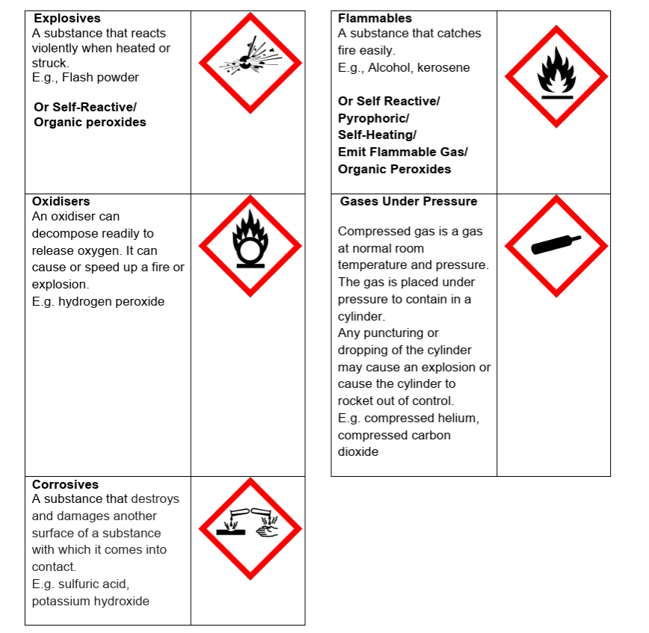
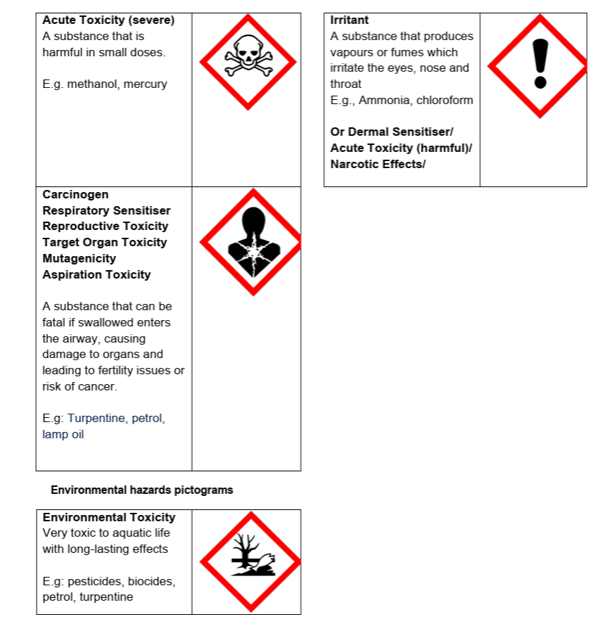

Apparatus in a lab:
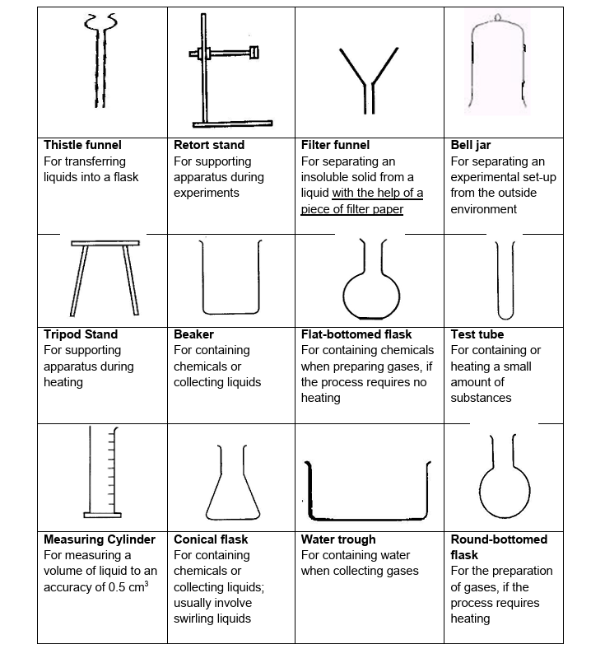
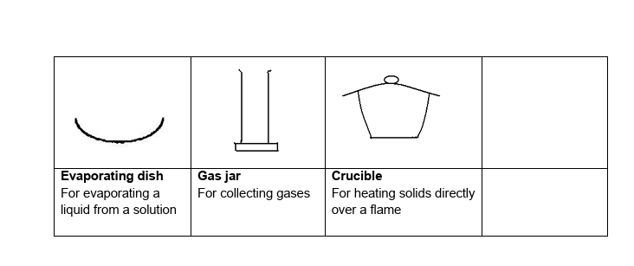
Bunsen Burner set-up:
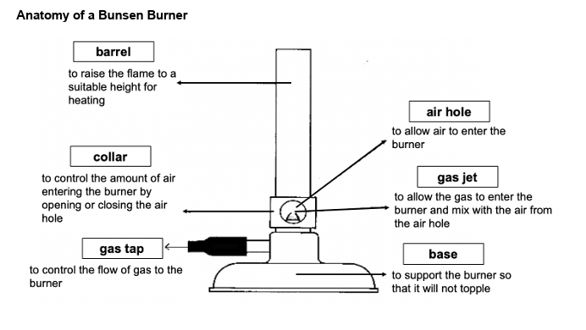

Luminous-flame VS non-luminous flame
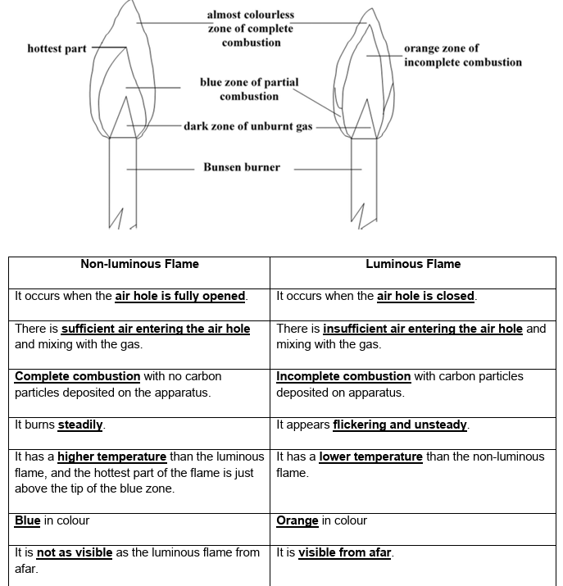

Explaining strike-back:
Strike back occurs when too much air enters the air hole. The flame burns at the gas jet instead of the top of the barrel.

