Physical Quantities and Measurements

Physical Quantities and Units
are made up of:
- Numerical Values
- Units

Units include:

Base Quantities
obtained by: Measuring Instruments
have: Base SI units, such as:
- Time (Seconds → s)
- Length (Meters → m)
- Mass (Kilograms → km)
- Temperature (Kalvin → K)
- Current (ampere → A)
- Amount of substance (moles → mol)
- Luminous Intensity (candela → cd)

Derived Quantities
such as:
- Area
- Volume
- Speed
have: Derived units

Prefixes
Prefix | Symbol | Factor
pico | p | 10^-12
nano | n | 10^-9
micro | μ | 10^-6
milli | m | 10^-3
centi | c | 10^-2
deci | d | 10^-1
kilo | k | 10^3
mega | M | 10^6
giga | G | 10^9
tera | T | 10^12

Measuring Instruments
Instrument | Range | Precision
Metre ruler | 0 to 100cm | 0.1cm
Digital Caliper | 0 to 15cm | 0.01cm
Digital micrometre screw gauge | 0 to 2.5cm | 0.01mm

Parallax Error
- Where you place your eyes affect your reading
- Position your eyes perpendicular to the marking.
- Make sure your eyes are parallel to the liquid level

Other Measuring Instruments
- Electric balance: 0.1 g or 0.01 g in terms of precision
- Thermometer: 0.5 degree celsius in terms of precision

Processing Data
Equipment | Volume Range | Accuracy | Notes
Measuring cylinder | Various sizes (50 ml, 100 ml, 200 ml, etc.) | ±0.5 cm³ | Least precise of the volume tools
Burette | Variable, dispensed volume | ±0.05 cm³ | Has a tap at the bottom to control liquid flow — most precise for variable volumes
Pipette | Fixed volumes (10.0 cm³ or 25.0 cm³) | Fixed volume, high precision | Used to deliver one exact volume, not variable amounts
Timer | — | 1 d.p. (e.g. 13.3 s) | Measures time, not volume

The number of decimal places of the answer is the same as the least decimal places' number when rounding.
Applies to:
- Addition
- Subtraction
- Average
The number of significant places of the answer is the same as the least significant places' number when rounding.
Applies to:
- Multiplication
- Division

Pendulum

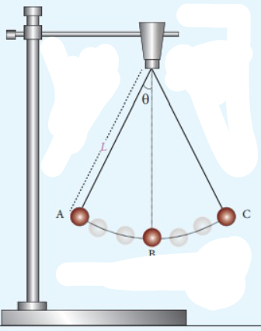

l
- Complete oscillation: Y to X to Z to X to Y where the bob returns to its original position, Or X to Y to X to Z to X
- Time taken for the pendulum to complete an oscillation is the period.
- The pendulum is only affected by the length of the string.

