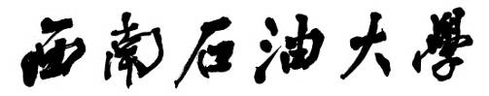

**本科毕业设计（论文）**

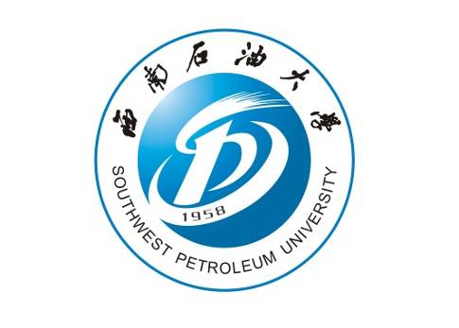

|  |  |  |  |
| --- | --- | --- | --- |
| **题目：** | **实时空气质量监控系统的设计与实现** | | |
| **学生姓名** | **戴瑞** | **学　号** | **201305040130** |
| **教学院系** | **计算机科学学院** | | |
| **专业年级** | **物联网工程2013级** | | |
| **指导教师** | **杨明根** | **职　称** | **工程师** |
| **单　　位** | **西南石油大学** | | |
|  | | |
| **完成日期** | **2017年6月2日** | | |

Southwest Petroleum University

Graduation Thesis

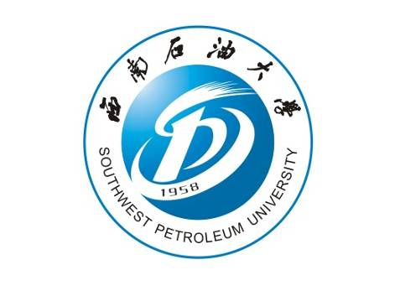

**Design and Realization of Real-time Air Quality Monitoring System**

**Grade**：**2013**

**Name：DaiRui**

**Specialty：The Internet of things engineering**

**Instructor： YangMinggen**

**School of Materials Science and Engineering**

**2017-6-****2**