CSCI 2271 Computer Systems

Assignment 9: Threads

Due Friday, May 10

Download the file basicsearch.c from Canvas. This program searches a text string, looking to see if it contains an instance of a pattern string. The following screenshot helps to explain how it is used.

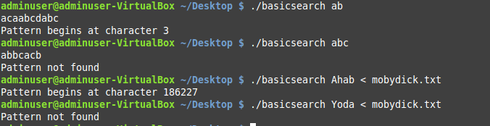

This screenshot shows four calls to the program. In the first call, the program searches for the pattern "ab" in the text "acaabcdabc". The program prints that the pattern starts at character 3, because it treats the first character as character 0. In the second call, the program searches for "abc" in the text "abbcacb" and prints that the pattern was not found.

Note that the program gets the pattern and text strings differently. The pattern is passed to the program via a command-line argument. The text comes from the standard input. In particular, the program reads the standard input, one character at a time, until EOF is encountered. Recall that you enter EOF from the keyboard by beginning a new line and entering the CONTROL-D keys. (If that doesn't work, try CONTROL-Z.)

The third and fourth calls to basicsearch make use of input redirection. You can download mobydick.txt from Canvas. The "<" on the command line says to read from that file as if it were the standard input.

You should now examine the code of basicsearch.c. It is comprised of four simple steps. Steps 1 and 2 obtain the pattern and text strings, respectively, saving each one in an array. Step 3 performs the search. And step 4 prints the results.

Note in step 2 that the text string will stop reading after 1,000,000 characters if necessary. That is, we assume that the text can fit in an array of size 1,000,000. For our purposes, this is a completely reasonable assumption.

The real work is performed in step 3. The for-loop considers every possible location in the text where the pattern might start, passing that location to the function searchPosition. If searchPosition ever returns 1, then the search ends, and the winning location is placed into the variable result. If the function never returns 1, then the variable result gets the value -1.

Your job is to write a version of basicsearch.c, called threadsearch.c. Your program will perform steps 1, 2, and 4 the same as basicsearch.c. It will perform step 3, however, using multiple concurrent threads. These threads will cooperate in how they examine the possible locations in the text where the pattern might begin. In particular, each searcher thread should do the following:
- Pick a location that has not been chosen by any other thread, and mark it as chosen. (If all possible locations have been already chosen, then quit.)
- Call the function searchPosition to determine if the pattern begins at that location.
- If the pattern is found, place the "winning" location in the variable result, quit, and do what you need to do to ensure that all the other threads also quit.
- If the pattern is not found, pick another location and repeat.

You are responsible for deciding how the threads should communicate, and what the critical sections are. Please write comments in your code explaining your design decisions.

Use a #define statement to specify how many searcher threads get created. Your code should work correctly for any reasonable number of threads.

NOTES:
- It is important that your threads communicate exactly as specified. For example, it is NOT OK to pre-assign each thread a portion of the array to check; they MUST choose their next starting location only after finishing their current one.
- Your code should use locking to ensure that two threads do not inadvertently choose the same starting location. However, you should not use locking when it is not needed. For example, it is not necessary or desirable to call searchPosition from within a critical section.
- Suppose that the pattern appears multiple times in the text. Since many threads will be searching the text concurrently, the first match found may not be the same one that basicsearch.c finds. This is ok.

HINT: If you are having trouble getting started, pretend you are a thread. How do you decide which location to choose next? How do you mark a location as chosen? How do you decide that it is time to quit? How do you tell other threads that it is time to quit? What global variables are needed?

When you are finished, submit your file threadsearch.c to Canvas.

