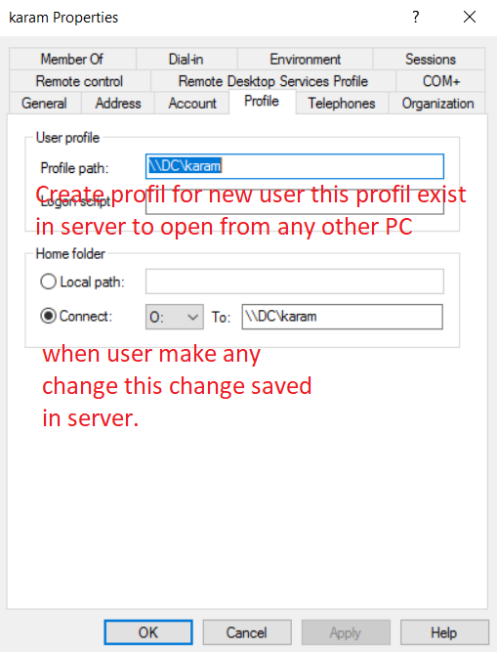
Microsoft Terminal Services Consol

