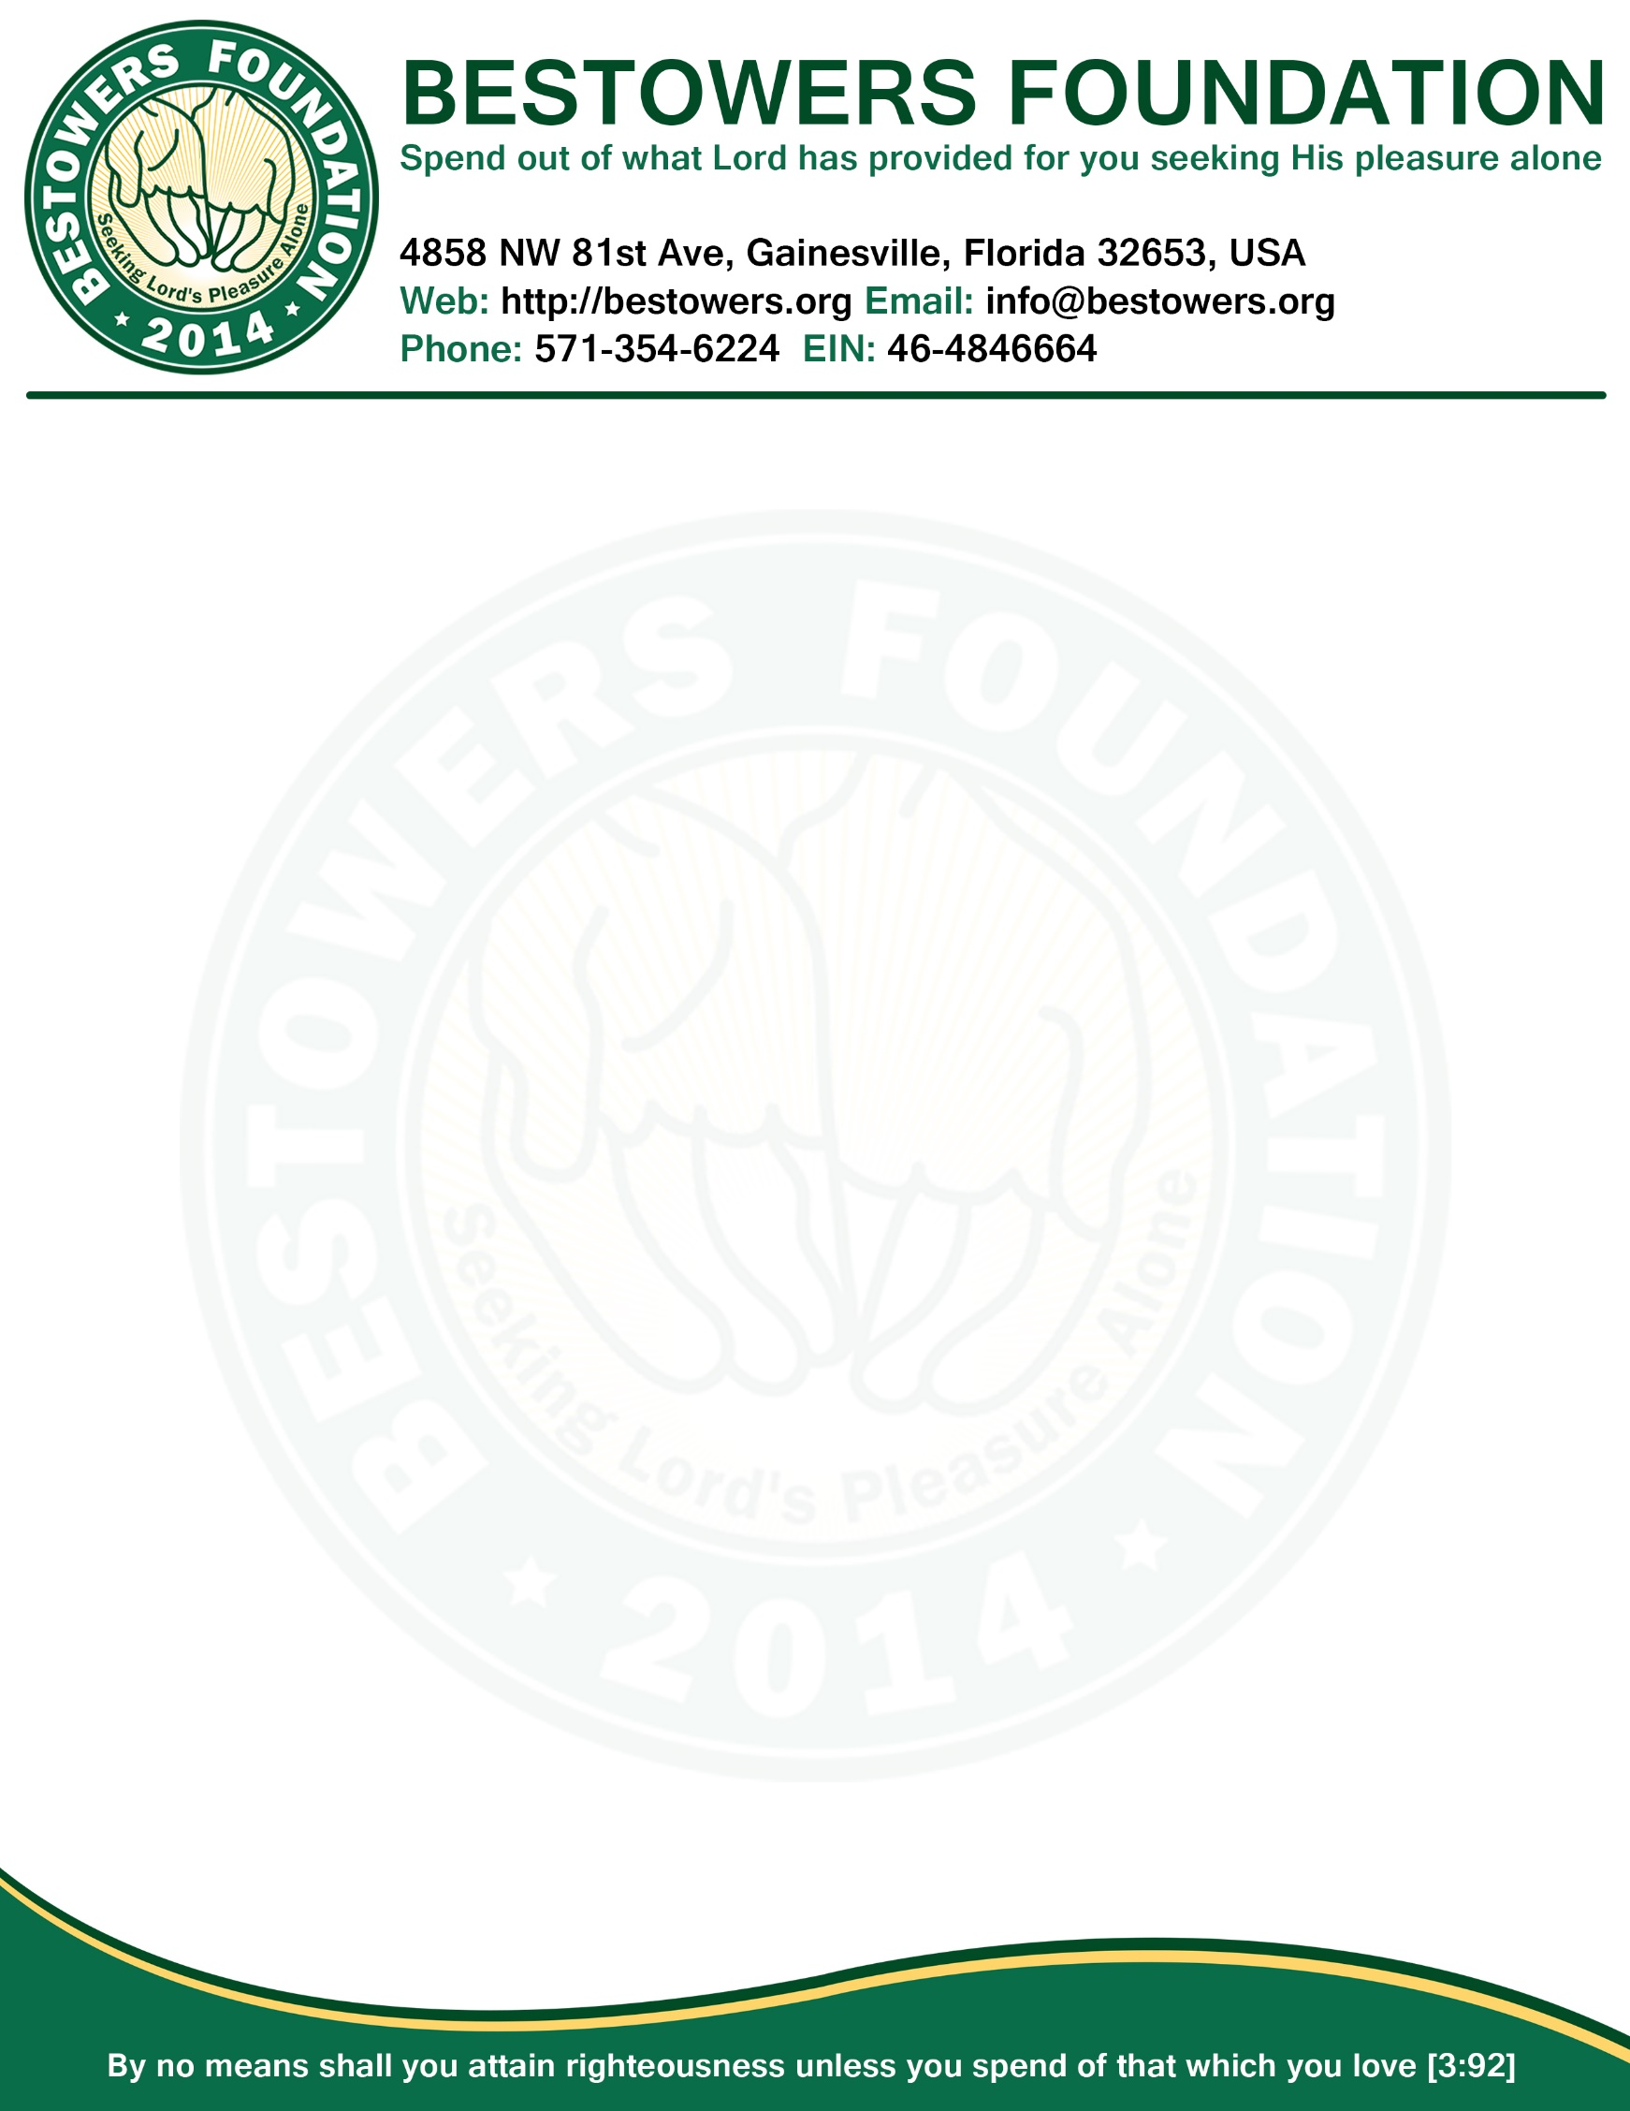

**ANNUAL FINANCIAL REPORT 2014** *Date: Jan 1, 2015*

|  |  |
| --- | --- |
| **INCOME – FISCAL YEAR 2014** | |
| **Item** | **Amount** |
| Gifts, grants, and contributions received | $6,500.17 |
| Annual Tournament fees received | $740.00 |
| **Total Income:** | **$7,240.17** |

|  |  |
| --- | --- |
| **EXPENSE – FISCAL YEAR 2014** | |
| **Item** | **Amount** |
| Service to house of Lord | $2,823.32 |
| Office supplies and Bank Checkbooks | $24.84 |
| Legal (Registration, IRS, Tax filing) | $505.00 |
| Scholarship for Needy Student | $830.00 |
| Enhancement of religion | $169.95 |
| Grant for unprivileged people | $703.00 |
| Fundraising | $589.18 |
| Paypal Transaction fees | $3.71 |
| **Total Expense:** | **$5649.00** |

|  |  |
| --- | --- |
| **BALANCE – FISCAL YEAR 2014** | |
| **Item** | **Amount** |
| Total Income | $7240.00 |
| Total Expense | $5649.00 |
| **Ending Balance As of Dec 31, 2014:** | **$1591.00** |



**Secretary**

**Bestowers Foundation**