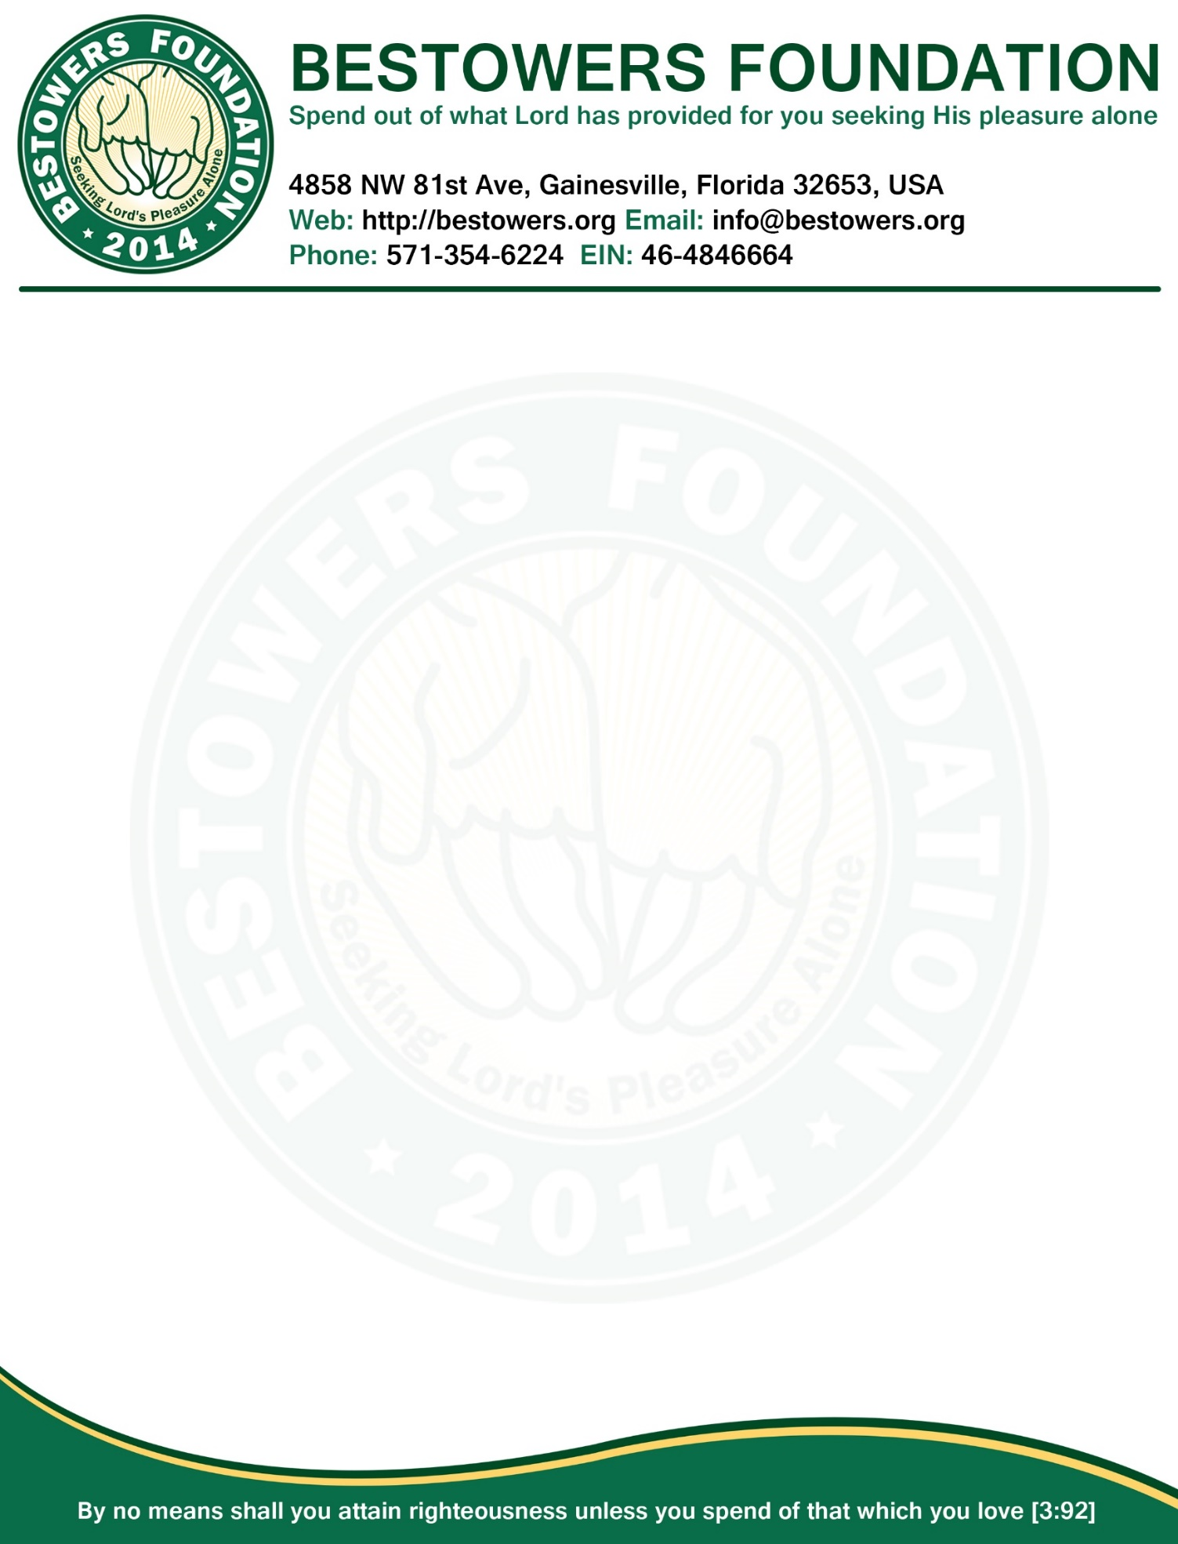

**Minutes, Board of Directors Meeting**

**Date:** Tuesday, June 09, 2015

**Time:** 7:30 PM

**Location**: 4858 NW 81st Ave, Gainesville, FL 32653

**Present:**Reza Nabi, President & Secretary

MA Halim Miah, VP

**Absent:** 1

1. **Call to order**: at 7:35 PM by presiding officer Reza Nabi.
2. **Quorum:** two of three Board members present (2 required.)
3. **Reading and Approval of Minutes:** Minutes of the May 09, 2015 Board meeting accepted as previously published and posted on foundation website and approved by unanimous consent.
4. **President’s Report**
   1. Announcement of “The Patient Person of the year” grant 2015 has been made via email and also posted to the the website. Reza Nabi will follow-up during month of Ramadan to encourage people to submit their nominees.
   2. Unanimously decided that Bestowers Foundation will give “ramadan grant” to at least 1 unprivileged family or person who is conscious of Allah(swt) to buy food during the month of Ramadan so that said family or person can do fasting comfortably. Candidate for said grant will be based on nomination wherein nominator has to submit the nomination form to [info@bestowers.org](mailto:info@bestowers.org) along with name, phone, address and picture of the nominee. Directors will select at least one recipient of said grant from the pool of nominees based on some interview, if possible.
5. **New Business**
   1. Reza Nabi will make announcement to all bestowers and post this announcement to website.
6. **Open Forum**
   1. Next annual meeting tentatively set for July 18, 2015.
7. **Adjournment**
   1. There being no further business, President Reza Nabi declare meeting adjourned by unanimous consent.
   2. Meeting Adjourned at 8:15 PM

|  |  |
| --- | --- |
| Respectfully submitted by,  /Reza Nabi/  Secretary | Adopted by the Board in the meeting  Of June 09, 2015  ____________________________  (Signature of the Presiding Officer) |